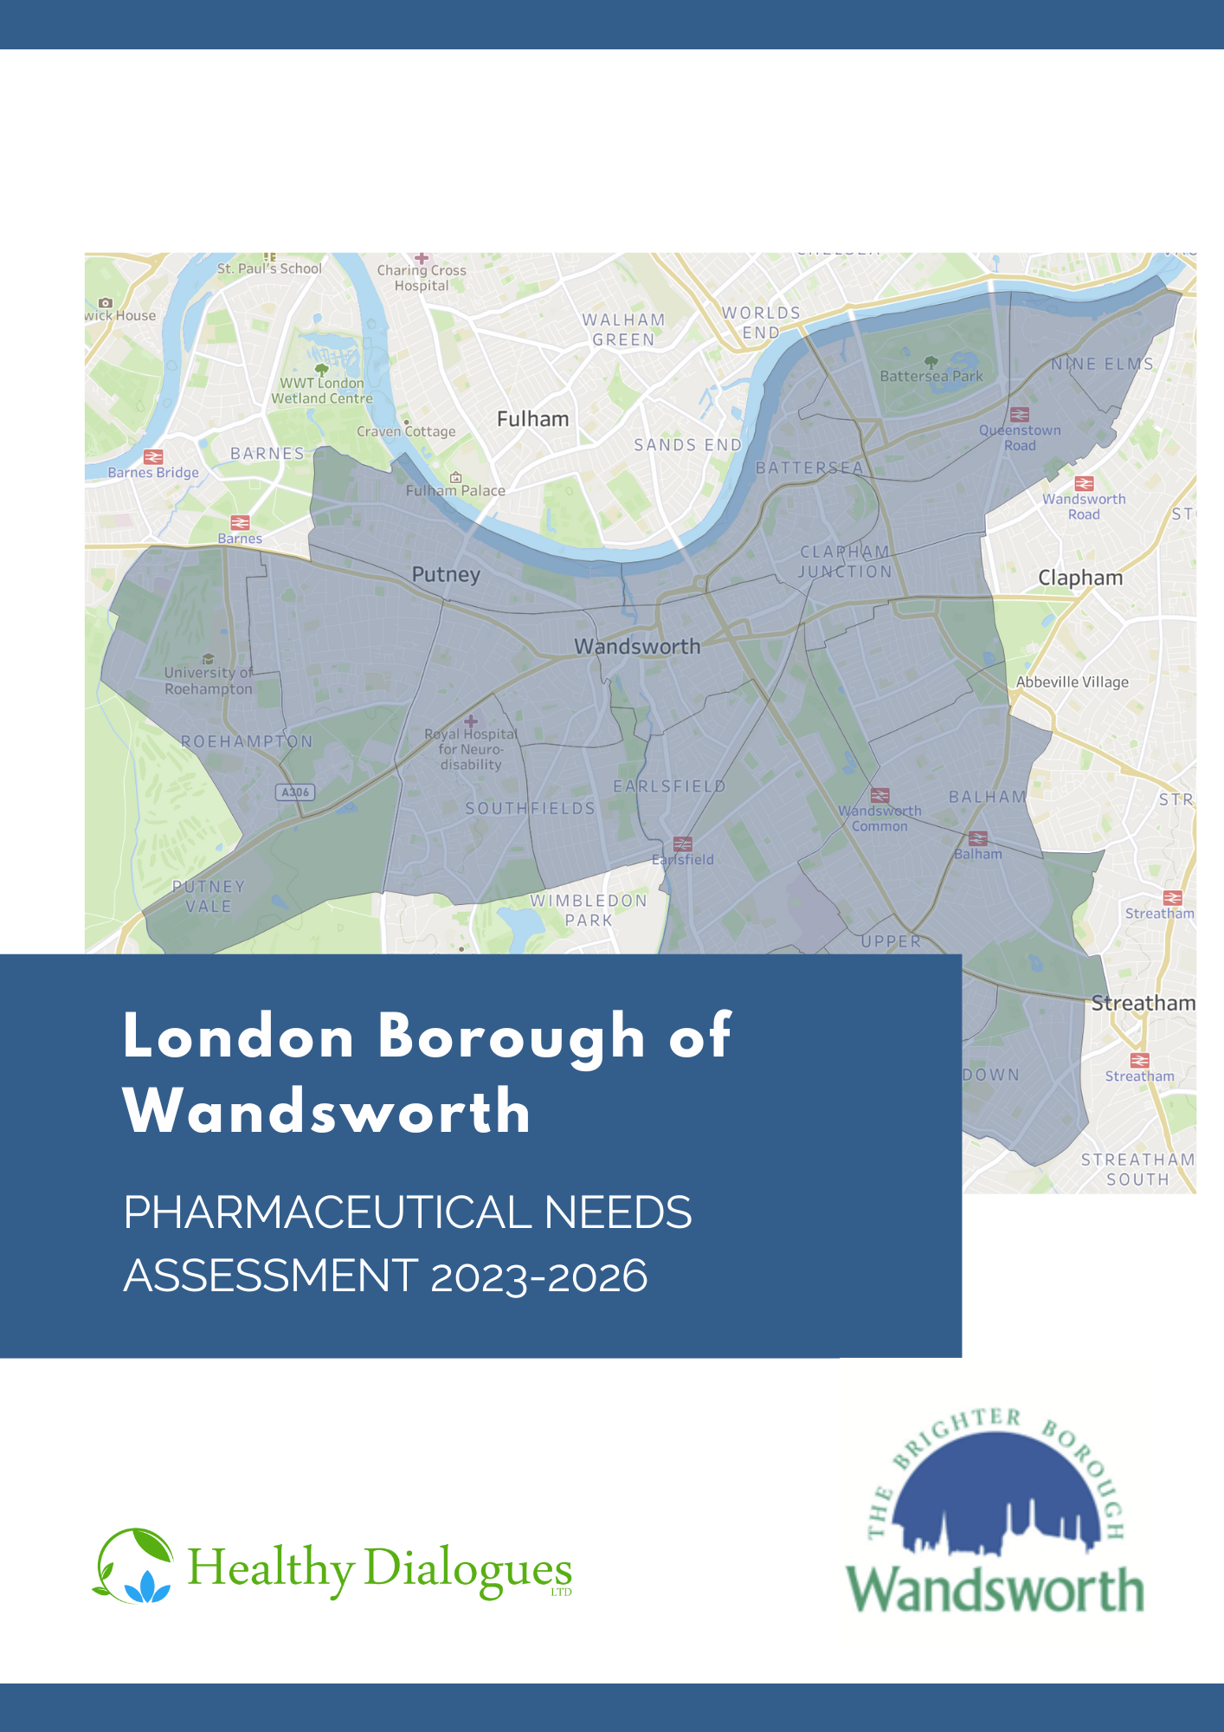
The London Borough of Wandsworth Pharmaceutical Needs Assessment 2023-2026

Executive Summary

Introduction
All Health and Wellbeing Boards (HWB) have a statutory responsibility to publish and keep up to date a statement of needs for pharmaceutical services for their population every three years. This is called the Pharmaceutical Needs Assessment (PNA). The purpose of the PNA is twofold, namely to:
- support NHS England in their decision-making related to applications for new pharmacies, or changes of pharmacy premises and/or opening hours.
- support local commissioners in decisions regarding services that could be delivered by community pharmacies to meet the future identified health needs of the population
This PNA provides an overview of the demographics and health and wellbeing needs of the Wandsworth population. It also captures patients’ and the public’s views of pharmacy services they access. It assesses whether the current provision of pharmacies and the commissioned services they provide meet the needs of the Wandsworth residents and whether there are any gaps, either now or within the lifetime of the document, from the date of its publication to the 21st June 2026. It assesses current and future provision with respect to:
- Necessary Services, i.e., current accessibility of pharmacies and their provision of Essential Services
- Other Relevant Services and Other Services including Advanced and Enhanced Pharmacy Services. These are services commissioned by NHS England, South West London ICB, or the London Borough of Wandsworth.

Methodology
In July 2022, a steering group of key stakeholders was established to oversee the development of the PNA with overall responsibility of ensuring it met the statutory regulations. The process included:
- a review of the current and future demographics and health needs of the Wandsworth population determined on a locality basis, drawing from the Wandsworth JSNA
- a survey to Wandsworth patients and the public on their use and expectations of pharmaceutical services and an equality impact assessment
- a survey to Wandsworth pharmacy contractors to determine their capacity to fulfil any identified current or future needs
- an assessment of the commissioned Essential, Advanced, Enhanced and Other pharmaceutical services provided in Wandsworth.
The PNA consultation draft was published for a 60-day formal consultation between the period of 14th December 2022 to the 13th February 2023. Responses to the consultation were considered by the steering group before final publication of the PNA in March 2023.

Findings

Key population demographics of Wandsworth
The London Borough of Wandsworth is a South West London borough with an estimated population of 327,010. This population is projected to increase by 2.2% to 334,231 in the lifetime of this PNA. The largest increase will be seen in Queenstown ward due to 4,476 new dwelling developments planned in the area (Housing-led population projections, 2021).
While there is less deprivation in Wandsworth compared to England as a whole, there are pockets of deprivation across the borough. In total, eight of the borough’s 179 LSOAs are among the most deprived 20% in England (Ministry of Housing, Communities & Local Government).

Key population health needs of Wandsworth
Overall, life expectancy and healthy life expectancy for both males and females in Wandsworth is similar to the national picture. COVID-19, circulatory diseases and cancers were the biggest causes of life expectancy gap between the most and least deprived in the borough. Wandsworth is doing better than or similar to, national figures in terms of the risk-taking behaviours explored in this PNA. However, there were a couple of areas of concern (OHID, Public Health Outcomes Framework, 2022). These were:
- low flu vaccination coverage for the over 65 and ‘at risk’ populations in Wandsworth
- low screening coverage for cervical, breast and bowel cancers

Patient and public engagement
A patient and public survey was disseminated across Wandsworth to explore how people use their pharmacy and their views on specific ‘necessary’ pharmaceutical services. A total of 188 people responded.
The majority of respondents chose their pharmacy because it is where their GP sends their prescriptions, it is in a good location, and they are happy with the overall experience provided by the pharmacy. Nearly all respondents (96%) can reach their pharmacy in 20 minutes or less. No substantial differences or identified needs were found amongst protected characteristics groups and pharmacy usage.

Health and Wellbeing Board statements on service provision
There are 60 community pharmacies located within the London Borough of Wandsworth. There is also a further 111 located within a mile of Wandsworth’s borders.
The PNA steering group, on behalf of the Health and Wellbeing Board has assessed whether the current and future pharmacy provision meets the health and wellbeing needs of the Wandsworth population. It has also determined whether there are any gaps in the provision of pharmaceutical service either now or within the lifetime of this document, from the date of its publication to the 21st June 2026.
The London Borough of Wandsworth is well served in relation to the number and location of pharmacies and is supported by a wealth of pharmacy provision in neighbouring boroughs.
There is good access to essential, advanced, enhanced and other pharmaceutical services for the residents of Wandsworth with no gaps in the current provision of these services identified.
However, there will be a need for future provision of essential services in Queenstown Ward where there are planned new dwelling developments and a new health centre opening. This will lead to an increase on the demand for pharmacy provision in the area which will need to be monitored and addressed.
Contents

Executive Summary 1
Introduction 1
Methodology 1
Findings 2
Key population demographics of Wandsworth 2
Key population health needs of Wandsworth 2
Patient and public engagement 3
Health and Wellbeing Board statements on service provision 3
Glossary of terms 9
Chapter 1 - Introduction 10
Context 10
Purpose of the Pharmaceutical Needs Assessment 10
The minimum requirements of the PNA 11
Circumstances under which the PNA is to be revised or updated 12
Consultation 12
Chapter 2 - Strategic context 14
National context 14
Integration and Innovation. Department of Health and Social Care’s legislative proposals for a Health and Care Bill: 14
The NHS Long Term Plan (2019) 14
Next Steps for Integrated Primary Care: Fuller Stocktake Report 2022 15
Health Equity in England: Marmot review 10 years on 15
Public Health England (PHE) Strategy 2020-2025 15
Community Pharmacy Contractual Framework (CPCF) 2019/20-2023/24 16
Pharmacy Integration Programme 16
Local context 16
Wandsworth Joint Strategic Needs Assessment (2021) 16
Healthy Eating, Weight and Nutrition Plan (2022-2026) 17
Wandsworth Sexual Health Strategy (2019-2024) 17
Adult Physical Activity Plan (2021-2031) 17
Summary Box 18
Chapter 3 - The development of the PNA 19
Geographical coverage 19
Patient and public survey 21
Pharmacy contractor survey 21
Governance and steering group 21
Regulatory consultation process and outcomes 21
Chapter 4 - Population demographics 23
About the area 23
Demography 24
Population size and density 24
Age gender and structure 25
Ethnicity and diversity 26
Population growth 29
Wider determinants of health 31
Poverty 32
Air quality/climate change 33
Summary of population demographics 34
Chapter 5 - Population health needs 35
Life expectancy and healthy life expectancy 35
Major risk factors 37
Improving healthy weight 38
Physical activity 39
Smoking 39
Sexual health 39
Teenage conceptions 40
Alcohol consumption 40
Substance misuse 41
Mental health and wellbeing (including loneliness and isolation) 41
Vaccinations 43
Flu vaccinations 43
Major health conditions 43
COVID-19 45
Circulatory diseases 45
Cancer 46
Patient groups with specific needs 47
Dementia 47
Summary of population health needs 47
Chapter 6 - Patient and public survey 48
Wandsworth communications engagement strategy 48
Whole population approach 48
Targeted approach 49
Survey results 49
Equality impact assessment 55
Age 55
Ethnicity 56
Gender 57
Pregnancy and maternity/parental leave 57
Employment status 58
Disability or impairment 58
Sexual orientation 59
Relationship Status 60
Summary of the patient and public engagement and equality impact assessment 62
Chapter 7 - Provision of pharmaceutical services 63
Pharmaceutical service providers 63
Community pharmacies 64
Dispensing appliance contractors 64
GP dispensing practices 65
Distance selling pharmacies 65
Local pharmaceutical services 65
Accessibility 65
Distribution and choice 65
Opening times 72
Essential services 79
Dispensing 79
Advanced pharmacy services 79
New medicines service 80
Community pharmacy seasonal influenza vaccination 82
Community pharmacist consultation service 84
Hypertension case-finding service 86
Community pharmacy hepatitis C antibody testing service 86
Community pharmacy smoking cessation service 86
Appliance use reviews 86
Stoma appliance customisation service 87
Summary of the Advanced Pharmacy Services 88
Enhanced pharmacy services 88
London seasonal influenza vaccination service 88
Bank holiday rota service 89
COVID-19 vaccination service 89
Summary of other NHS pharmacy services 89
Other NHS pharmacy services 90
Needle exchange service 90
Supervised consumption service 92
Emergency contraception service 94
Chlamydia screening service 95
Chlamydia treatment service 97
Out of hours palliative care dispensing & medicines advice 99
Summary of other NHS pharmacy services 99
Additional considerations from contractor survey responses 99
Languages spoken in pharmacies 99
Chapter 8 - Conclusions and statements 101
Current provision 101
Current access to essential services 101
Current access to advanced services 102
Current access to enhanced pharmacy services 103
Current access to Other NHS pharmacy services 104
Future Provision 104
Future access to essential services 105
Future access to advanced services 106
Future access to enhanced services 106
Future access to other NHS pharmacy services 106
Improvements and better access 107
Current and future access to essential services 107
Current and future access to advanced services 107
Current and future access to enhanced pharmacy services 107
Current and future access to other NHS pharmacy services 108
Appendix A – PNA Steering Group ToR 109
Appendix B – Pharmacy provision within Wandsworth and one mile of its border 112
Appendix C - Consultation report 124

Glossary of terms
A&E – Accident and emergency
AF – Atrial fibrillation
AUR – Appliance use review
BAME – Black, Asian and minority ethnic
COPD – Chronic obstructive pulmonary disease
COVID-19 – Coronavirus disease 2019
CPCF – Community Pharmacy Contractual framework
CPCS – Community Pharmacist Consultation Service
CVD – Cardiovascular disease
DAC – Dispensing appliance contractor
DHSC – Department of Health and Social care
DSP – Distant selling pharmacy
GLA – Greater London Authority
GP – General Practitioner
HEWNP – Healthy eating, weight, and nutrition plan
HIV – Human immunodeficiency virus
HWB – Health and wellbeing board
IAPT – Improving access to psychological therapies
ICB – Integrated care board
ICS – Integrated care system
IMD – Index of Multiple Deprivation
JSNA – Joint strategic needs assessment
LA – Local authority
LMC – Local medical committee
LPC – Local pharmaceutical committee
LPS – Local pharmaceutical services
LSOA – Lower super output area
MSM – Men who have sex with men
NHS – National Health Service
NMS – New medicines service
ONS – Office for national statistics
PCN – Primary care network
PHE – Public Health England
PhIF – Pharmacy integration fund
PSNC – Pharmaceutical Services Negotiating Committee
PNA – Pharmaceutical needs assessment
QOF – Quality Outcomes Framework
SAC – Stoma appliance customisation
STI – Sexually transmitted infection
SWL – South West London

Introduction

Context
              - Community pharmacies are key in providing quality healthcare in the centre of local communities. As one of the most frequented healthcare settings in England, they are often patients first point of contact and for some their only contact with a healthcare professional.
              - This PNA was conducted at a time of substantial change within the health and social care landscape with the creation of the South West London Integrated Care Board. This includes an increased use and acknowledgement of community pharmacies within newly developed primary care networks, ensuring greater opportunities for patient engagement.
              - It was also conducted at a time of a drop of staffing levels across the sector in England. Provision of services can be affected by a lack of available and suitably accredited pharmacists. Pharmacy contractors are often struggling to ensure that their pharmacy has enough appropriately skilled and qualified staff to provide safe and effective pharmacy services to the public.

Purpose of the Pharmaceutical Needs Assessment
              - The provision of NHS Pharmaceutical Services is a controlled market. All pharmacists and dispensing appliance contractor who wish to provide NHS Pharmaceutical Services, must apply to NHS England to be on the Pharmaceutical List of the Health and Wellbeing Board.
              - The purpose of the Pharmaceutical Needs Assessment (PNA) is to plan for the commissioning of pharmaceutical services and to support the decision-making process in relation to new applications or change of premises of pharmacies. This includes:
- Supporting the ‘market entry’ decision making process (undertaken by NHS England) in relation to applications for new pharmacies or changes of pharmacy premises.
- Inform local plans for the commissioning of specific and specialised pharmaceutical services
              - The PNA can also be used by the HWB to:
- Inform interested parties of the pharmaceutical needs in the borough and enable work on planning, developing and delivery of pharmaceutical services for the population
- Inform discussions with pharmacy contractors to provide services within areas where they are needed and limit duplication of services in areas where provision is adequate.

The minimum requirements of the PNA
              - This PNA covers the period between the date of its publication to 21st June 2026. It replaces the PNA published by Wandsworth HWB in 2018. The development and publication of this PNA has been carried out in accordance with regulations and associated guidance, including:
- The NHS Pharmaceutical Services and Local Pharmaceutical Services Regulations 2013
- Department of Health Information Pack for Local Authorities and Health and Wellbeing Boards
              - As outlined in the 2013 regulations, this PNA must include a statement of the following:
- Necessary Services – Current Provision: services currently being provided which are regarded to be “necessary to meet the need for pharmaceutical services in the area”. This includes services provided in the county as well as those in neighbouring counties.
- Necessary Services – Gaps in Provision: services not currently being provided which are regarded by the HWB to be necessary “in order to meet a current need for pharmaceutical services”.
- Other Relevant Services – Current Provision: services provided which are not necessary to meet the need for pharmaceutical services in the area, but which nonetheless have “secured improvements or better access to pharmaceutical services”.
- Improvements and Better Access – Gaps in Provision: services not currently provided, but which the HWB considers would “secure improvements, or better access to pharmaceutical services” if provided.
- Other Services: any services provided or arranged by the local authority, NHS England, the ICB, an NHS trust or an NHS foundation trust which affects the need for pharmaceutical services in its area or where future provision would secure improvement, or better access to pharmaceutical services specified type, in its area.
- Future need: the pharmaceutical services that have been identified as services that are not provided but which the health and wellbeing board is satisfied need to be provided in order to meet a current or future need for a range of pharmaceutical services or a specific pharmaceutical service.
              - Additionally, the PNA must include a map showing the premises where pharmaceutical services are provided and an explanation of how the assessment was made. This includes:
- How different needs of different localities have been taken into account
- How needs of those with protected characteristics have been taken into account
- Whether further provision of pharmaceutical services would secure improvements or better access to pharmaceutical services
- A report on the 60-day consultation of the draft PNA.

Circumstances under which the PNA is to be revised or updated
              - The PNA will be updated every three years so that it reflects the need for pharmacy services and any changes as they arise.
              - The Health and Wellbeing Board are also required to revise the PNA publication if they deem there to be significant changes in pharmaceutical services before 21st June 2026.
              - Not all changes in a population or an area will result in a change to the need for pharmaceutical services. If the HWB becomes aware of a minor change that means a review of pharmaceutical services is required, the HWB will issue supplementary statements to update the PNA.

Consultation
              - A draft PNA must be put out for consultation for a minimum of 60 days prior to its publication. The 2013 Regulations list those persons and organisations that the HWB must consult, they include:
- Any relevant local pharmaceutical committee (LPC) for the HWB area
- Any local medical committee (LMC) for the HWB area
- Any persons on the pharmaceutical lists and any dispensing GP practices in the HWB area
- Any local Healthwatch organisation for the HWB area, and any other patient, consumer and community group, which in the opinion of the HWB has an interest in the provision of pharmaceutical services in its area
- Any NHS Trust or NHS Foundation Trust in the HWB area
- NHS England
- Any neighbouring Health and Wellbeing board.
              - The draft PNA was presented for consultation on the 14th December 2022 to the 13th of February 2023. All comments received are shown in Appendix C and considered in the final PNA report.

Strategic context
              - This section summarises key policies, strategies and reports which contribute to our understanding of the strategic context for community pharmacy services at a national level and at a local level.

National context

Integration and Innovation. Department of Health and Social Care’s legislative proposals for a Health and Care Bill:
              - With the population growing in size, people living longer, but also suffering from more long-term health conditions, and challenges from the COVID-19 pandemic, there is a greater need for the health and social care system, including pharmacies, to work together to provide high quality care. This paper sets out the legislative proposals for the Health and Care Bill which capture the learnings from the pandemic.

The NHS Long Term Plan (2019)
              - As health needs change, society develops, and medicine advances, the NHS needs to ensure that it is continually moving forward to meet these demands. The NHS Long Term Plan (2019) (NHS LTP) introduces a new service model for the 21st century.
              - Community pharmacists will play a crucial role in supporting people with high-risk conditions such as atrial fibrillation (AF) and cardiovascular disease (CVD). The NHS will support community pharmacists to case-find, e.g., hypertension case-finding. Pharmacists within PCNs will undertake a range of medicine reviews, including educating patients on the correct use of inhalers, and supporting patients to reduce the use of short acting bronchodilator inhalers and to switch to clinically appropriate, smart inhalers. As part of preventative healthcare and reducing health inequalities, community pharmacists will support patients to take their medicines as intended, reduce waste, and promote self-care.

Next Steps for Integrated Primary Care: Fuller Stocktake Report 2022
              - The Fuller stocktake report commissioned by NHS chief executive Amanda Pritchard, outlines a vision for primary care and provides practical steps that integrated care system leaders should take, to create a shift that will build more resilience within general practice. The vision focuses on four main areas: neighbourhood teams aligned to local communities, streamlined and flexible approaches for people who require same-day urgent care, proactive and personalised care from a multi-disciplinary team in neighbourhoods for people with complex needs, and more joined-up approaches to prevention at all levels. The report also recognises what is already working well in general practice and areas for improvement.

Health Equity in England: Marmot review 10 years on
              - The objectives outlined in the Marmot review are intended to ensure that the healthy life expectancy gap between the least deprived and most deprived are reduced. More specific to health, community pharmacists are uniquely placed at the heart of communities to support patients to provide the public a range of public health interventions, weight management services, smoking cessation services and vaccination services. At present the role of community pharmacies provide a pivotal role in promoting healthier lifestyle information and disease prevention.

Public Health England (PHE) Strategy 2020-2025
              - The Office for Health Improvement and Disparities (OHID) have pledged to promote a healthier nation by taking action on working to reduce preventable risk factors for ill health. Community pharmacies have an important role in driving and supporting these objectives as they provide the public with services around healthy weight and weight management, smoking cessation, and can provide information and advice around healthy start for children and families.

Community Pharmacy Contractual Framework (CPCF) 2019/20-2023/24
              - This is an agreement between the Department of Health and Social Care (DHSC), NHSE&I and the Pharmaceutical Services Negotiating Committee (PSNC) and describes a vision for how community pharmacy will support delivery of the NHS Long Term Plan. The CPCF highlights and develops the role of pharmacies in urgent care, common illnesses, and prevention. It aims to “develop and implement the new range of services that we are seeking to deliver in community pharmacy”, making greater use of Community Pharmacists’ clinical skills and opportunities to engage patients.

Pharmacy Integration Programme
              - The pharmacy integration fund (PhIF) was established in 2016 to accelerate the integration of pharmacy professionals across health and care systems to deliver medicine optimisation for patients, and for clinical pharmacy services to be integrated into primary care networks. The Pharmacy Integration Programme is currently providing support to various workstreams whereby pharmacy professionals thrive within an integrated multi-disciplinary team across primary and community settings.

Local context

Wandsworth Joint Strategic Needs Assessment (2021)
              - The Joint Strategic Needs Assessments (JSNA) analyse the health needs of populations to help inform the commissioning decisions around health, well-being, and social care services within local authority areas. The JSNA is often split into three sections; start well, live well and age well, and presents the localised data for Wandsworth which can be found on the Wandsworth JSNA.

Healthy Eating, Weight and Nutrition Plan (2022-2026)
              - This is the first healthy eating, weight, and nutrition plan (HEWNP) for Wandsworth, and is a 5-year plan to promote a healthy weight and lifestyle to tackle health inequalities in the borough. The plan has three stands: restricting advertising and promotion of high fat, sugar and salt, promoting procurement and catering of healthy food and localities, and promoting healthier eating and drinking initiatives based on best practice, resident insights and evidence.

Wandsworth Sexual Health Strategy (2019-2024)
              - Poor sexual health is often concentrated within vulnerable populations such as young people, men who have sex with men (MSM) and people from Black and minority ethnic populations (BME) which further marginalises. There are five strategic priorities; promoting healthy sexual behaviour and reducing risky behaviours, reduce STI rates with targeted interventions for at-risk groups, reduce unintended pregnancies, reduce under 18 conceptions, and work towards eliminating late diagnosis of HIV.

Adult Physical Activity Plan (2021-2031)
              - This plan focuses on a whole systems approach for Wandsworth by creating active people, active communities, and active environments. Wandsworth and its partners will seek to increase the number of knowledgeable, motivated, skilled residents creating regular physical activity habits, to create opportunities for inactive families and people facing health inequalities, to create equitable access for all residents to engage in physical activity, to support the delivery of prevention aims, and to support the councils aim to become carbon neutral and greenest inner-London council by 2030.

The Wandsworth Sexual Health Story 2020: Service delivery in primary care settings
              - This is a report of the sexual health services delivered by GP practices and pharmacies in Wandsworth. The report focuses on service demand and provision during 2018-2019, and will help to inform procurement of services in primary care settings from 2020 and beyond. The report found that sexual health services should continue to be delivered within primary care settings but work should be done to ensure services are situated where demand is high.

Summary Box
Community pharmacies have a unique place with the potential to work with local residents and communities, to meet some of the ambitions outlined within the national and local strategies. For example, promoting healthier life choices, improving and increasing access to local services, and contributing to the development of prevention and early interventions around specific health conditions, including sexual health screening can be supported by community pharmacies. The role of community pharmacies in supporting these strategies are referred throughout this PNA.

The development of the PNA
              - The London Borough of Wandsworth HWB commissioned delivery of its PNA to Healthy Dialogues through a competitive tender process. The governance of the production of this PNA was managed by the PNA steering group and the Directorate of Adult Social Care and Public Health of Richmond & Wandsworth Councils. The decisions in the production of this PNA have been delegated by the HWB to the steering group.
              - This PNA has been developed using a range of information sources to describe and identify population needs and current service provision from the network of community pharmacies (see Table 3.1). This includes:
- Nationally published data
- The Wandsworth Joint Strategic Needs Assessment
- Local policies and strategies
- A survey to Wandsworth pharmacy providers
- A survey to the patients and public of Wandsworth
- Local Authority and SWL ICB commissioners
              - These data have been collated to illustrate the Wandsworth population, current and future health needs and how pharmaceutical services can be used to support the HWB to improve the health and wellbeing of our population.
              - This PNA was published for public consultation between the 14th December 2022 and 13th February 2023. All comments received were considered for the final PNA publication. They are summarised in a consultation report in Appendix C.

Geographical coverage
              - PNA regulations require that the HWB divides its area into localities as a basis for structuring the assessment. A ward-based structure was used as it is in-line with available data at ward level such as demography, health needs and service provision commissioned by both the London Borough Wandsworth and NHS commissioners.
              - As of May 2022, new ward boundaries came into effect, resulting in some name and boundary changes, as well as an increase in the overall number of wards. These are They are presented on the council website (https://www.wandsworth.gov.uk/the-council/elections-voting-and-registration/constituencies-and-wards/). All ward-level data presented in this PNA are aligned to the ward boundaries prior to May 2022 as demographic and health data is not yet available for these new ward boundaries. Both previous and current ward boundaries are showing in Figure 3.1 below.
Figure 3.1: London Borough of Wandsworth electoral wards, previous and current
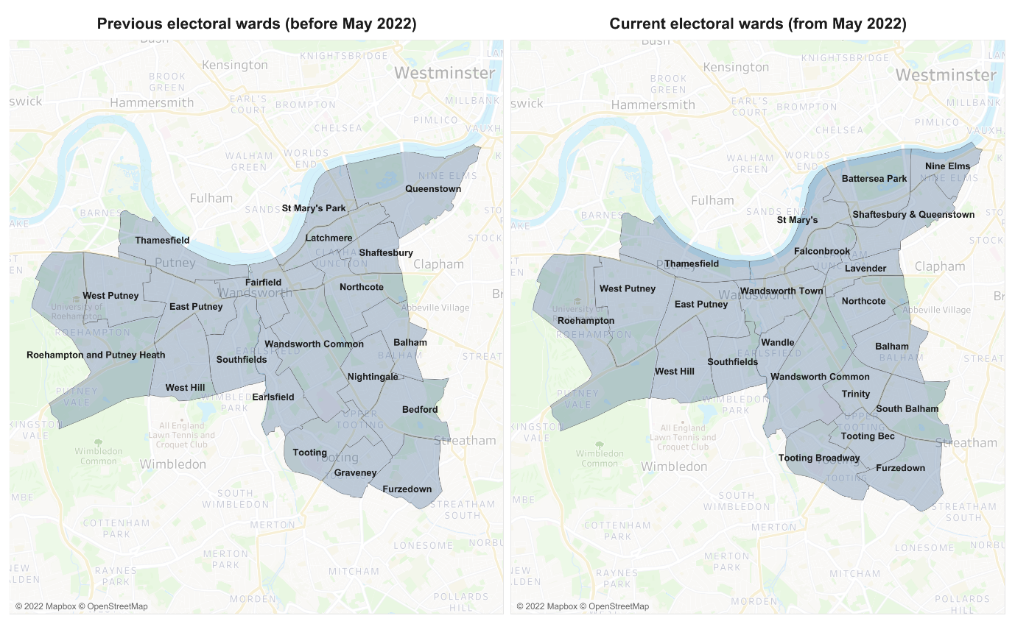
              - Provision and choice of pharmacies is determined by using 1-mile radius from the centre of the postcode of each pharmacy. This is approximately a 20-minute walk from the outer perimeter of the buffer zone created. The 1-mile radius approach illustrates where there is pharmacy coverage and areas without coverage (for example, see Figure 6.1).
              - In addition, 20-minutes travel time by public transport is also considered as being a reasonable measure to identify variation and choice. Where the population are within 1-mile of a pharmacy or can reach a pharmacy within 20-minutes travel time by public transport then the pharmacy provision is considered ‘good’.
              - Other factors are considered when determining if there is sufficient pharmacy provision. These include proximity to GP practices, current and future population density, housing developments, changes in healthcare provision, deprivation levels and opening times.

Patient and public survey
              - Patient and public views and experiences were collated in the form of a survey to understand how people use their pharmacies, what they use them for and their views of the pharmacy provision. 188 Wandsworth residents and workers responded to the survey, their views were explored, including detailed analysis of the Protected Characteristics. The findings from the survey are presented in Chapter 6 of this PNA.

Pharmacy contractor survey
              - The contractor survey was sent all to the community pharmacies within Wandsworth to capture data on services provided and opportunities for future commissioning. 47 out of 57 (82%) pharmacy contractors responded. The results from this survey are referred to throughout this document.

Governance and steering group
              - The development of the PNA was advised by a Steering group whose membership included representation from:
- The London Borough of Wandsworth Public Health Team
- The London Borough of Richmond Public Health Team
- South West London Integrated Care Board
- Wandsworth, Merton and Sutton LPC
- Kingston and Richmond LPC
- Healthwatch Richmond
- Healthwatch Wandsworth
- Healthy Dialogues
              - The Terms of Reference of the Steering Group presented in Appendix A.

Regulatory consultation process and outcomes
              - This PNA will be shared for statutory consultation on the 14th December, 2022 for 60 days. All comments will be drafted into a consultation report for the steering group and will be considered and incorporated into the final PNA report to be published in March 2023.

Population demographics
              - This chapter presents an overview of the population demographics of the London Borough of Wandsworth that are likely to impact on the need for pharmaceutical services. It includes exploration of the characteristics of its residents, expected population growth and the wider determinants of health.
              - All the maps that follow present the size of population in relation to different factors such as population density, deprivation, and life expectancy. They are displayed in gradients, where the lower the value, the lighter the colour. The gradients are also displayed as legends on each map.

About the area
              - Wandsworth is named from the river Wandle, which flows into the Thames near Wandsworth. The borough was formed in 1965 by uniting the previous metropolitan borough of Battersea with two-thirds of what previously comprised Wandsworth.
              - The current borough encompasses Roehampton, Putney, Wandsworth, Earlsfield, Battersea, Tooting, and parts of Clapham and Balham.
              - Wandsworth is home of the University of Roehampton, the largest of the London Universities.
              - Wandsworth also has the second-largest prison in Britain, Wandsworth Prison, which is situated there.
              - To the east, the borough is bordered by the London Borough of Lambeth, to the south by the London Boroughs of Merton as well as Kingston upon Thames, to the west by the London Borough of Richmond upon Thames, and to the north (across the river Thames) by three boroughs: the London Boroughs of Hammersmith and Fulham, the Royal Borough of Kensington and Chelsea, and the City of Westminster.
              - The London Borough of Wandsworth has 1,700 acres of green space which is the most of any inner London borough. Along with public gardens, grass verges on council property, churchyards, and historic burial sites, thirty-four parks including commons, eight allotments, and five cemeteries. Battersea Park, Wandsworth Common, and Tooting Commons are three Metropolitan open spaces under Wandsworth's jurisdiction.

Demography

Population size and density
              - The Greater London Authority estimates that there are 327,010 residents in the borough in 2022 (Housing-led Population Projections).
              - Wandsworth has a population density of 100.1 people per hectare, ranking it 12th among London’s 32 boroughs.
              - St. Mary’s Park is the ward with the highest population density while Roehampton & Putney Health has the lowest (see Figure 4.1).

Figure 4.1: Population Density of the London Borough of Wandsworth per hectare by Ward

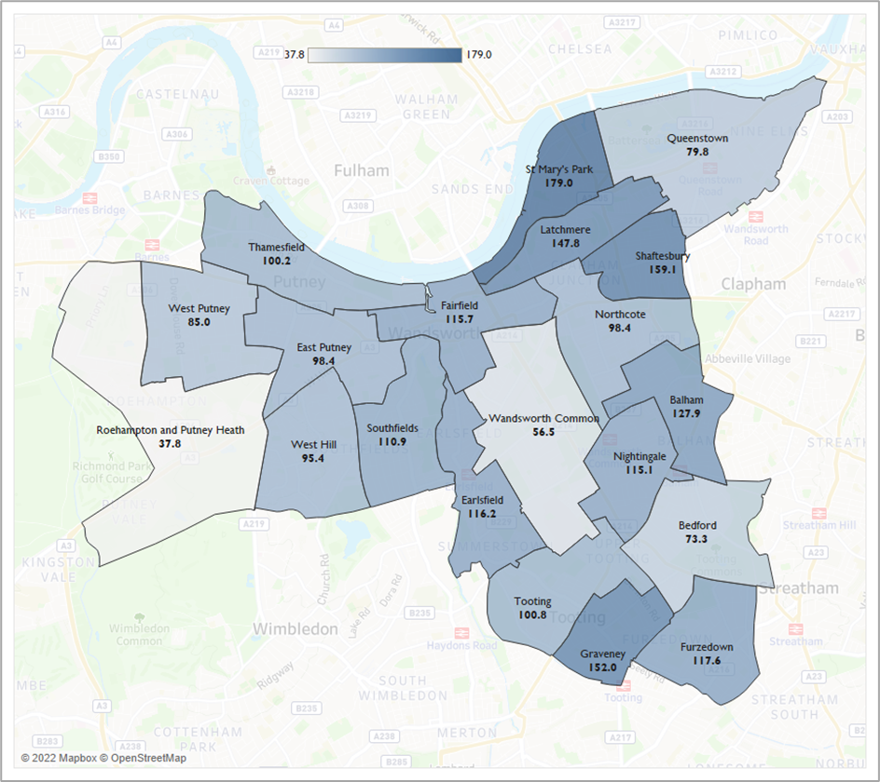
Source: GLA, Housing-led Population Projections

Age gender and structure
              - Overall, there are similar numbers of males and females living in the borough (52% female and 48% male). The difference in gender proportions is largest among the older populations, likely due to the longer life expectancy of females. The average age of the population is 35, which is comparable to the overall London average age of 36 (GLA population estimates).
              - 17.7% of the Wandsworth population are under 16 years old, which is slightly below the national average (19.2%).
              - The proportion of working-age population is higher in Wandsworth than that of the rest of London, with 72.1% of the population between the ages of 16 and 64.
              - 10.2% of Wandsworth residents are aged 65 and over. This is lower than London overall (12.5%). Figure 4.2 presents a breakdown of the age and gender of Wandsworth residents (ONS 2020 Mid-Year Estimates).
Figure 4.2: Proportion of resident by age-band and gender, Mid-year 2020 estimates for Wandsworth
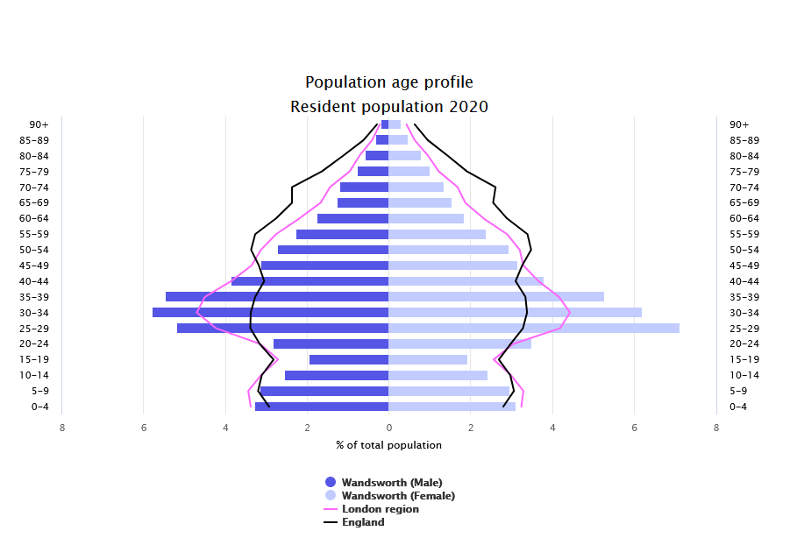
Source: PHE, 2022 (based on mid-2020 population estimates)

              - Southfields ward has the greatest representation of those aged 0-15 while West Putney has the highest proportion of older adults (Figure 4.3).

Figure 4.3: Population Age Groups by Ward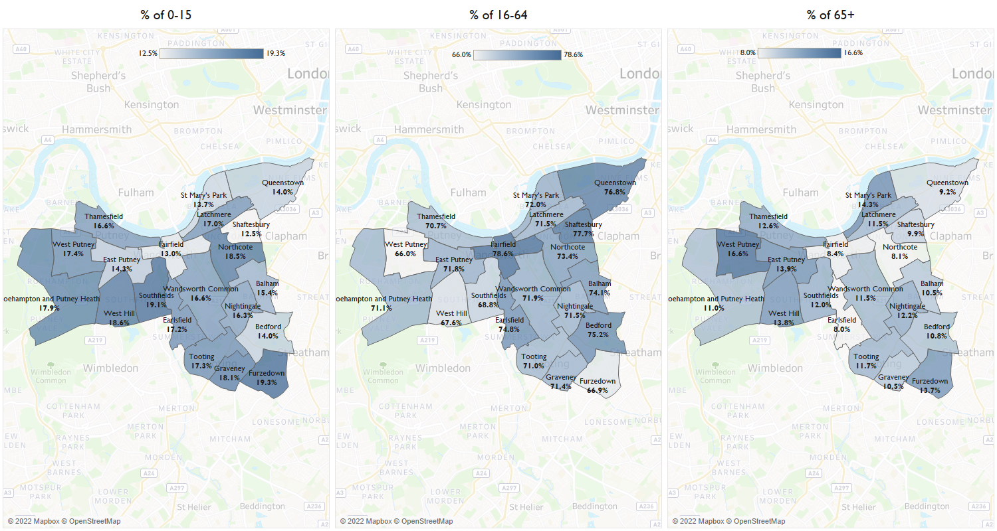
Source: GLA (Housing-Led Population Projections)

Ethnicity and diversity
              - Areas where diversity is higher correlate with areas of higher levels of deprivation and poorer health. Pharmacy staff often reflect the social and ethnic backgrounds of the community they serve making them approachable to those who may not choose to access other health care services. ¹⁶
              - NICE Guidance highlights that community pharmacies can impact on health inequalities in several ways. For example, it recommends that community pharmacists take into consideration how a patient’s personal factors may impact on the service they receive. Personal factors would include, but not limited to, gender, identity, ethnicity, faith, culture, and any disability. It also recommends that community pharmacists make use of any additional languages staff members may have.
              - A quarter (25%) of the Wandsworth resident population are from Black, Asian and Minority Ethnic Groups. 12% of residents identify as Black, while 6% are Asian (Table 4.1).
Table 4.1: Ethnic population breakdown for Wandsworth, London and the UK
Area | White | Asian | Black | Mixed/ Other
Wandsworth | 74.9% | 5.9% | 12.1% | 7.1%
London | 59.2% | 18.4% | 11.9% | 10.6%
United Kingdom | 85.9% | 7.3% | 3.3% | 3.5%
Source: ONS Annual Public Survey, 2019

              - Wards with the highest representation of the Black, Asian and Minority Ethnic populations are in the southern tip of the borough; 52.7% of the population of Tooting and 46.4% of those from Graveney are from Black, Asian and Minority Ethnic groups. Thamesfield has the lowest representation with 12.3%.

Figure 4.4: Percentage of black and ethnic minority groups by wards in Wandsworth, 2011
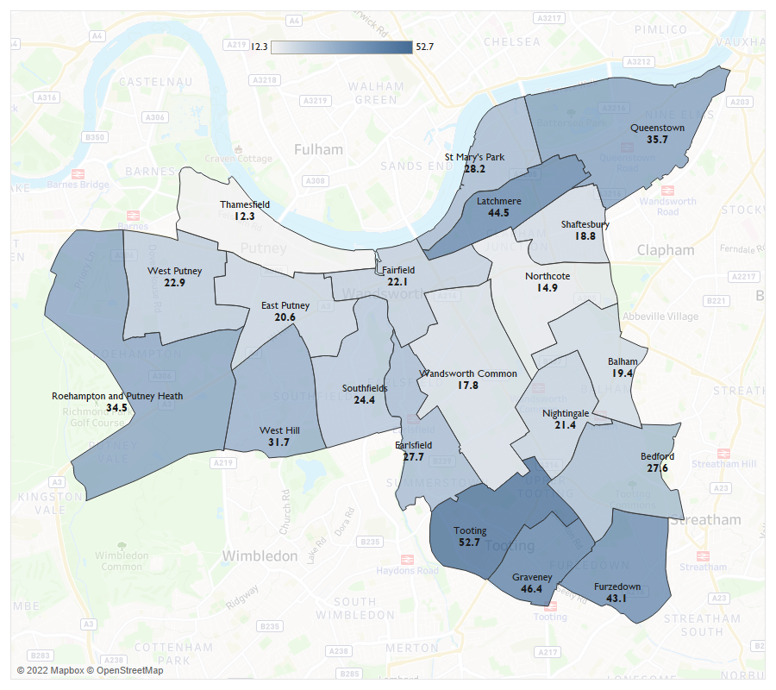
Source: ONS, Census 2011

              - 17.4% of the borough’s residents who are aged 3+ state their main language is not English (2011 census). This is lower than the London average which stands at 22.1%.
              - Polish and Urdu are the most commonly spoken languages after English (Table 4.2).
Table 4.2: Proportion of languages spoken in Wandsworth – Top 10
Language | Percentage
English | 82.6%
Polish | 2.1%
South Asian Language: Urdu | 1.6%
French | 1.4%
Spanish | 1.2%
Portuguese | 1.0%
Italian | 1.0%
African Language: Somali | 0.8%
German | 0.6%
Arabic | 0.5%
Source: ONS Census, 2011

              - Figure 4.5 shows a breakdown of the population who do not speak English well or at all. As can be seen, wards with the greatest population of residents not proficient in English, such as Wandsworth Common, are also those with the greatest representation of Black, Asian and Minority Ethnic groups.

Figure 4.5: Percentage of people that cannot speak English well or at all by ward in Wandsworth in 2011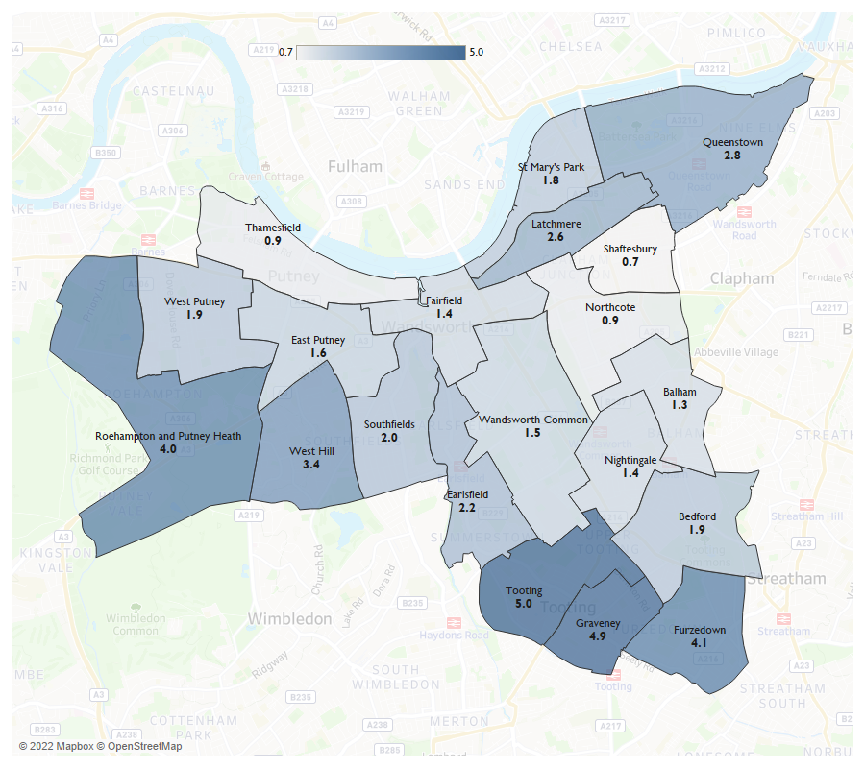
Source: ONS, Census 2011

Population growth
              - Any population increases sustained in the lifetime of this PNA need to be taken into consideration. Population increases will likely place increased demands on community pharmacy services with different population groups having different needs.
              - The population of Wandsworth is expected to increase by 2.2% during the lifetime of the PNA (2023 to 2026) to stand at 334,231 by 2025 (GLA, Housing-led population projections – Identified Capacity Scenario, 2021). These figures are based on mid-year population estimates and assumptions such as births, deaths, and migration.
              - Queenstown will experience the largest increase in its population size, expanding from 23,038 in 2022 to 25,505 by 2025, a 16.8% increase (see Figure 4.6 and Table 4.3). In the next 10 years the ward will see a total increase of 63.5%.
              - Bedford, on the other hand, will see a 0.6% decrease in its population in the lifetime of this PNA.

Figure 4.6: Population of Wandsworth resident by ward – 2022 vs 2025

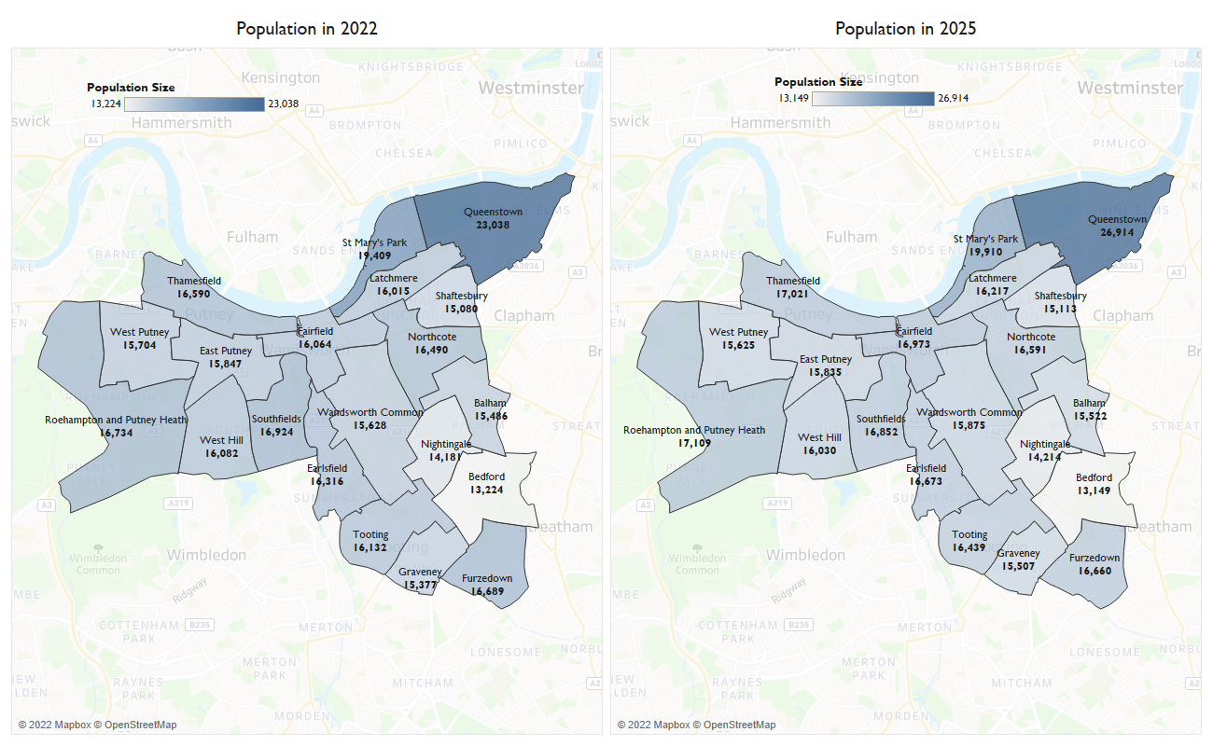
Source: GLA, Housing-led population projections – Identified Capacity Scenario, 2021

Table 4.3: Projected population changes by ward between 2022 - 2025
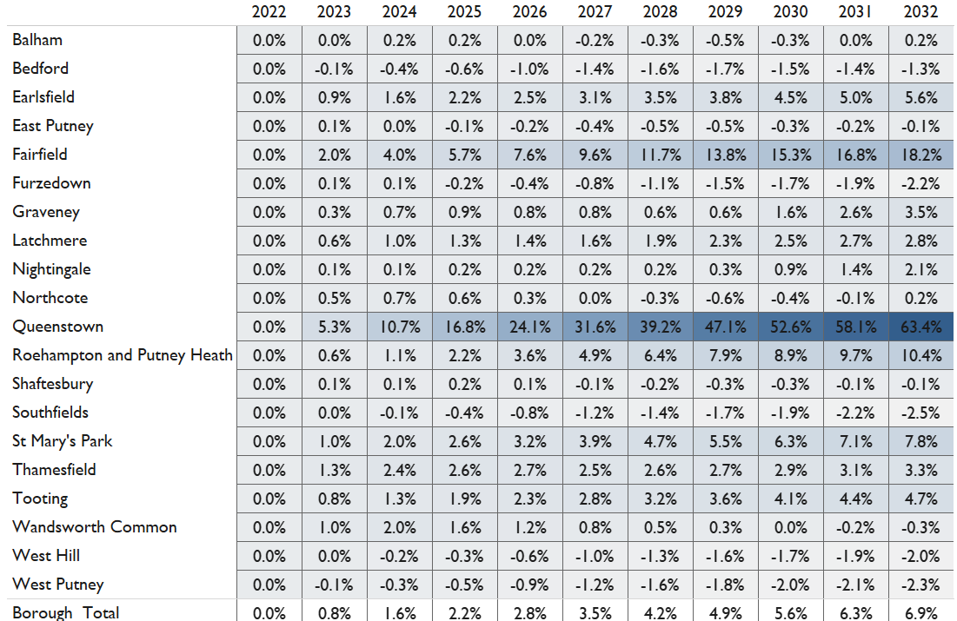
Source: GLA, Housing-led population projections – Identified Capacity Scenario, 2021

              - The London Borough of Wandsworth is expected to deliver a large amount of housing over the next three years. Alongside Camden it has the 2nd highest housing targets in London with 7,800 planned units over the plan period. The majority of these will be in the northeast of the borough, in Queenstown Ward with 4,476 planned over the next three years. Fairfield Ward has the 2nd largest number of units planned with 1,207 over the next three years (see table 4.4).
              - The largest developments are listed below:
- Royal Mail Group Site, Ponton Road (Nine Elms Park) in Queenstown Ward with 1,725 net units planned
- New Covent Garden Market, Nine Elms Lane in Queenstown Ward with 981 net units planned
- B and Q Depot, Smugglers Way in Fairfield Ward with 554 units planned
- Market Towers, 1 Nine Elms Lane (One Nine Elms) Queenstown Ward with 494 units planned
- Homebase, Swandon Way in Fairfield Ward with 480 units planned
- South Lambeth Goods Depot, Cringle St./Battersea Park Rd., Kirtling Street (Battersea Power Station) in Queenstown Ward with 425 units planned
              - It should be noted that many of these developments are proposed developments. Not all the units will be complete in the anticipated time and not all have received planning permission.
Table 4.4: Planned housing development units in Wandsworth Wards between 2022/23 and 2024/25.
Ward | 2022/23 | 2023/24 | 2024/25 | Total per Ward
Balham | 14 | 14 | 11 | 38
Bedford | 29 | 7 | 6 | 39
Earlsfield | 36 | 105 | 21 | 160
East Putney | 20 | 21 | 19 | 44
Fairfield | 57 | 583 | 570 | 1,207
Furzedown | 29 | 21 | 39 | 90
Graveney | 31 | 33 | 12 | 75
Latchmere | 4 | 288 | 45 | 336
Nightingale | 32 | 18 | 10 | 49
Northcote | 223 | 21 | 11 | 92
Queenstown | 1,134 | 1,886 | 1,455 | 4,467
Roehampton and Putney Heath | 5 | 39 | 24 | 55
Shaftesbury | 32 | 6 | 5 | 42
Southfields | 29 | 17 | 105 | 148
St Mary's Park | 60 | 148 | 68 | 273
Thamesfield | 224 | 30 | 14 | 260
Tooting | 49 | 20 | 17 | 81
Wandsworth Common | 108 | 107 | 106 | 313
West Hill | 4 | 14 | 4 | 22
West Putney | 8 | 4 | 4 | 13
Total | 2,126 | 3,379 | 2,545 | 7,800
Source: London Borough of Wandsworth, 2022

Wider determinants of health
              - There are a range of social, economic and environmental factors that impact on an individual’s health behaviours, choices, goals and ultimately health outcomes. These are wider determinants of health which are outlined in Fair Society, Healthy Lives: (The Marmot Review) and later The Marmot Review 10 Years On . They include factors such as deprivation, education, employment and fuel poverty.
              - The Index of Multiple Deprivation (IMD) is a well-established combined measure of deprivation based on a total of 37 separate indicators that encompass the wider determinants of health and reflect the different aspects of deprivation experienced by individuals living in an area. The 37 indicators fall under the following domains: Income Deprivation, Employment Deprivation, Health Deprivation and Disability, Education, Skills and Training Deprivation, Barriers to Housing and services, Living Environment Deprivation and Crime.
              - Wandsworth has 179 neighbourhoods (LSOAs). The borough’s overall average IMD decile figure is 6.2 compared to the national one of 5.5. This means that there is less deprivation in Wandsworth than in England as a whole.
              - As seen in figure 4.7 there are small pockets of deprivation in the borough, with 8 of the borough’s 179 LSOAs among the most deprived 20% in all of England (deprivation deciles of 1 or 2). These pockets are widespread rather than being centred around one area.
Figure 4.6: IMD deciles in Wandsworth by LSOA, 2019
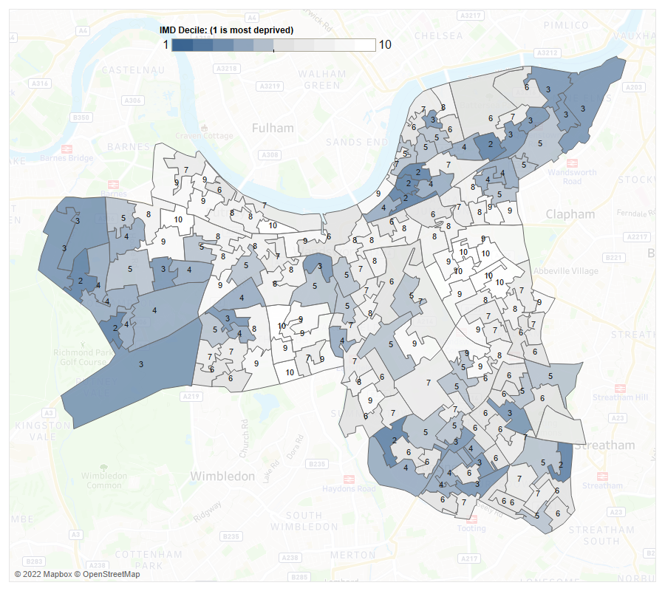
Source: Ministry of Housing, Communities & Local Government

Poverty
              - Wandsworth has the 13th highest rate of long-term unemployment within the working age population in the region. 2.2 per 1,000 people of the working age population of the borough are long-term unemployed in 2021/22. This equates to 516 individuals and is substantially higher than the England rate of 1.9 per 1,000 (OHID, Public Health Outcomes Framework, 2022).
              - 7,086 (11.8%) children residing in the borough were from relative low-income families in 2020/21. This is a similar proportion to London and England where 16.6% and 18.5% of children were from low-income families in London and England respectively (OHID, Public Health Outcomes Framework, 2022).
              - In 2020, 8.6% of people did not have enough income to afford sufficient fuel. This is lower than the regional rate of 11.5% and the national rate of 13.2% (OHID, Public Health Outcomes Framework, 2022).

Air quality/climate change
              - While air pollution is not often perceptible, the risks it causes are correlated to a lower life expectancy and a range of health conditions. There is strong evidence that air pollution cause stroke, exacerbates asthma, increased risk of cardiovascular disease, and poor lung development. Furthermore, individuals with lower incomes are more likely to live in densely populated areas with greater levels of noise and air pollution and have pre-existing medical conditions.
              - NO2 and Particle Matter (PM) are two of the most harmful pollutants to human health. PM is a mixture of solid and liquid droplets that is produced as a result of burning fuel, smokestacks, vehicles, and building sites. One of the biggest threats to health is PM with a diameter of less than 10 micrometres (PM2.5). PM2.5 may penetrate deeply into the lungs and can even enter the bloodstream, which can have a variety of adverse consequences on health and wellbeing. The average human hair has a diameter of roughly 70 micrometres, whereas PM2.5 and 10 are smaller.
              - In 2020, the annual concentration of fine particulate matter in Wandsworth, adjusted to account for population exposure was 9.9 μg/m3. This is higher than London, 9.6 μg/m3 and England 7.5 μg/m3 thus placing the borough within the worst quintile in England.
              - Moreover, within the same year the fraction of mortality attributable to particulate air pollution in Wandsworth was 7.4%. These rates were higher than regional figures, 7.1% but higher than that national, 5.6%.

Summary of population demographics
The London Borough of Wandsworth is a South West London Borough with a population of 291,881 residents. It has a higher working age population and lower children and older adult population than the rest of London. A quarter of the population are from Black, Asian and minority ethnic communities.

In the lifetime of this PNA, the population of the borough is expected to grow by 2.2%. Much of this predicted population growth is because of the planned housing developments in Queenstown Ward and Fairfield Ward.

Overall, there is less deprivation in Wandsworth than England as a whole. However, there are small pockets of deprivation across the borough.

Population health needs
              - This chapter presents an overview of the health and wellbeing needs of the population of Wandsworth, with a particular focus on topics that community pharmacies can support. It looks at life expectancy and healthy life expectancy in Wandsworth and includes an exploration of major risk factors and major health conditions.

Life expectancy and healthy life expectancy
              - Life expectancy is a statistical measure of how long a person is expected to live. In the Borough of Wandsworth, life expectancy is similar to national figures. The 2018-2020 life expectancy for males at birth in the borough is 80 years, and 84.3 years for females, similar to the national figures of 79.4 and 83.1 for males and females respectively (OHID, Public Health Profiles, 2022).
              - Healthy life expectancy at birth is the average number of years an individual should expect to live in good health considering age-specific mortality rates and the prevalence of good health in their area. The healthy life expectancy for males in the borough is 65.4, similar to national figures. For females, it is 70.1, higher than national figures (see figure 5.1) (2018-20, OHID, Public Health Profiles, 2022).
Figure 5.1: Life expectancy and healthy life expectancy in years for males and females in Wandsworth in 2018-20
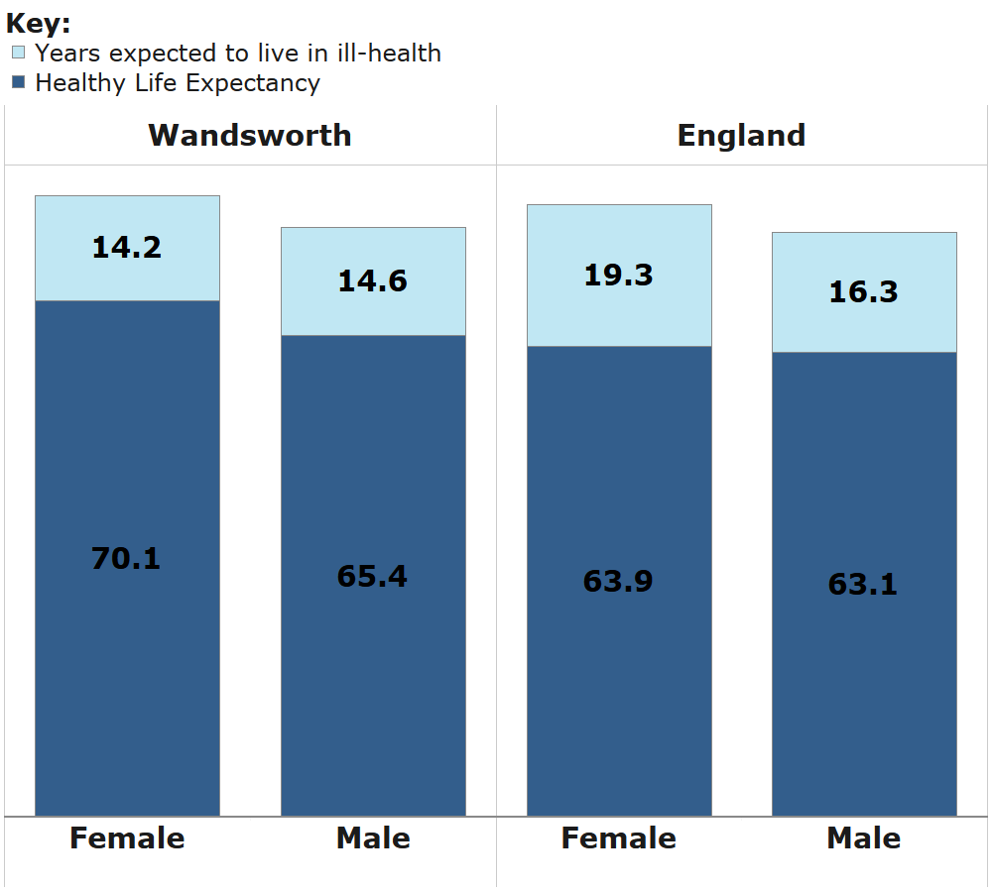
Source: OHID, Public Health Profiles, 2022
              - The figures for the variation in life expectancy across Wandsworth is among the best quintile for England. The inequality in life expectancy at birth is the measure of the absolute difference in life expectancy between the most and least deprived areas. In Wandsworth, there is a 5.9-year life expectancy gap for men and a 5.8-year gap for women between those who live in the most deprived areas and the least deprived areas (2018-20). In comparison to the national figures of 9.7 and 7.9 for males and females respectively, females in Wandsworth are significantly lower.
              - As shown in Figure 5.2, life expectancy is highest in for females in East Putney ward with 85.3 and lowest in St Mary’s Park ward with 81.6. For males, it is highest in Northcote with 85.1 and lowest in Latchmere ward with 78.8.
Figure 5.2: Life expectancy at birth of Males and Females by Ward in Wandsworth, 2015-19
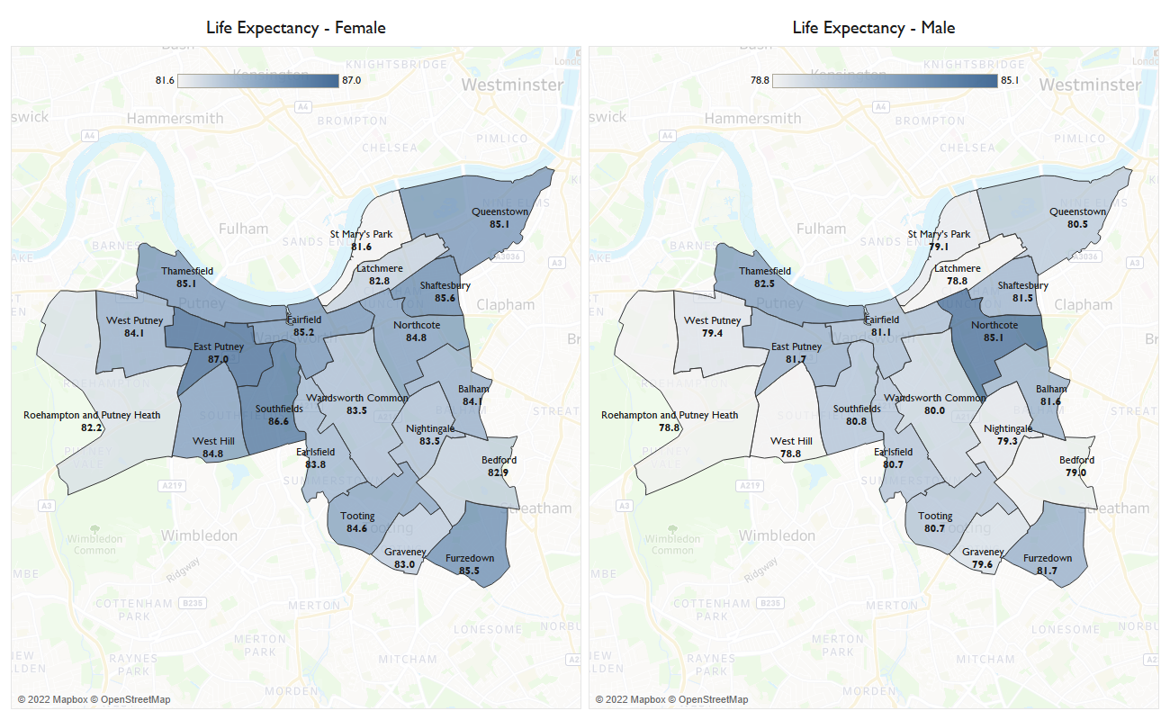
Source: OHID, Local Authority Health Profiles, 2022

Major risk factors
              - Community pharmacies often sit within the heart of communities. They provide a ‘walk-in’ access to their service provision making them ideally placed to offer opportunistic screening and brief interventions for better health and wellbeing.
              - The Healthy Living Pharmacy framework requires community pharmacies to have trained health champions in place to deliver interventions on major risk factors such as smoking cessation and weight management and provide well-being and self-care advice. The interventions are about engaging members of the public, by using every interaction as an opportunity for health promotion, making every contact count, and signposting to other relevant services.
              - As part of the essential services they provide, pharmacies also support national public health campaigns and offer signposting for patients to local health, wellbeing, and social care support services. Locally, pharmacies can signpost people to the Wandsworth Wellbeing hub Website.
              - This next section of the chapter explores lifestyle factors that can impact on a person’s health and wellbeing that pharmacies can support through the Healthy Living Pharmacy framework and signposting. It includes, improving healthy weight, physical activity, smoking, sexual health, alcohol consumption and substance misuse.

Improving healthy weight
              - Healthy Eating and Nutrition Plan for Wandsworth is key plan under the council’s
Prevention Framework (2021-2025). It has committed delivering a whole systems approach to addressing the levels of obesity in the borough. This includes working with, and enabling partners to work jointly together, and target
those most impacted by health inequalities to improve their
health.
              - The Pharmacy Quality Scheme (PQS) 2022/2023 ensures that pharmacies have undertaken training to enable them to understand management of obesity. They must also proactively provide weight management advice and onward referral to local weight management support such as tier 2 services or the NHS Digital Weight Management Programme.
              - Obesity is recognised as a major determinant of premature mortality and avoidable ill health. The estimated proportion of adults who are overweight or obese in Wandsworth in 2020/2021 was 49.7%, placing it as the eighth lowest borough in London. Wandsworth figures are significantly better than England average where 63.5% of adults are overweight or obese (OHID, Public Health Profiles, 2022).
              - Between 2017/18 to 2019/20, 1,130, 18.6%, 4- to 5-year-olds were classified as overweight or obese, this places Wandsworth as one of the lowest brough in London. Over a lustrum the trend has been consistent (OHID, Public Health Profiles, 2022).
              - 33.0% of Year 6 children in Wandsworth were overweight or obese in that same timeframe, placing the borough the fourth lowest recorded in the region. Wandsworth is significantly better than the London average of 38.0% and on par with the national average of 34.6% (OHID, Public Health Profiles, 2022).

Physical activity
              - Three quarters of adults (76.5%) residing in the borough are considered physically active, meaning they engage in 150 minutes or more of moderate physical activity per week. This is higher than the national figure of 65.9%. This places the borough as the best in the region. People who have a physically active lifestyle reduce their risk of obesity, diabetes, osteoporosis and some cancers, and enjoy improved mental health (OHID, Public Health Profiles, 2022).

Smoking
              - Smoking is the leading cause of preventable death in the world. 8.1% of adults surveyed in Wandsworth in 2020 smoke. In comparison to London and England rates of 11.1% and 12.1% adults who smoke respectively, Wandsworth has the 5th lowest rate in the region (OHID, Public Health Profiles, 2022).
              - In 2019, 19.2% of adults aged 18 – 64 years who work in routine or manual occupation were surveyed to be current smokers in the group. This is similar to the London rate of 20.7% and the England rate of 24.5.
              - Pharmacies can support people to stop smoking by providing advice, dispensing of nicotine replacement therapy products, and signposting to local stop smoking services.

Sexual health
              - Wandsworth is the nineth highest in sexually transmitted infection (STI) diagnosis rate in London. In 2021, 4,478 (1,358 per 100,000) residents under 25 years received a new diagnosis of an STI (excluding chlamydia). This is significantly higher than the England rate of 394 per 100,000, and higher than the London rate of 935 per 100,000 (OHID, Public Health Profiles, 2022).
              - In 2021, chlamydia was detected in 2,308 per 100,000 population 15 - to 24-year-olds who accessed sexual health services. This equates to a rate of 776 per 100,000, lower than England rate of 1,334 per 100,000 and the London rate of 1,673 per 100.000 (OHID, Public Health Profiles, 2022).
              - In 2021, there were 1,151 residents in Wandsworth living with an HIV diagnosis in 2021. This equates to 5.04 per 100,000 people which is significantly higher than national rates, but slightly below the regional rate. Between 2019-2021, 42.2% of cases were diagnosed late, similar to the London proportion of 38.6%.
              - Late diagnosis carries an increased risk of poor health and death, and the chance of onward transmission. 81.8 % of those newly diagnosed with HIV start antiretroviral therapy within 91 days of diagnosis (2019-21 figures), similar to England figures. 97.7% achieve virological success meaning they have achieved an undetectable viral load (OHID, Public Health Profiles, 2022).

Teenage conceptions
              - The rate of teenage conceptions is of concern. There were 45 under-18 conceptions in the borough in 2020, equating to a rate of 12 per 1,000 population (crude rate), the 9th highest in London (OHID, Public Health Profiles, 2022).

Alcohol consumption
              - Alcohol consumption contributes to morbidity and mortality from a diverse range of conditions. 29.5 per 100,000 deaths in the region are alcohol-related, which is just below the London and England rates of 32.2 and 37.8 per 100,000 deaths respectively. The borough is the nineth lowest in the region (OHID, Local Alcohol Profiles for England, 2022).
              - 367 admissions per 100,000 hospital admissions in 2020/21 were alcohol related, this is a lower rate than England’s rate of 456 admissions per 100,000 hospital admissions but higher than London, 348 per 100,000 (OHID, Local Alcohol Profiles for England, 2022).
              - In 2020, Wandsworth ranked the 2nd most prosperous borough in London for individuals successfully completing alcohol treatment. 48.7% of alcohol users completed their structured treatment successfully and did not re-present to treatment within 6 months, this outcome has been consistent over the past decade.

Substance misuse
              - Substance misuse is linked to mental health issues such as depression, disruptive behaviour and suicide. In Wandsworth, 52.5 per 100,000 hospital admissions for 15- to 24-year-olds in the period 2018/19 to 2020/21 were due to substance misuse, this is similar to rate in London of 56.5 per 100,000 and lower than the national rate of 81.2 per 100,000 (OHID, Public Health Profiles, 2022).
              - Where there is a local need, pharmacies can be commissioned to provide needle and syringe exchange services to reduce the risk of infections in those who inject drugs. Pharmacies can also be commissioned to provide supervised consumption of medicines to treat addiction, for example, methadone.
              - The proportion of opiate users in Wandsworth who have successfully completed drug treatment is above national figures, placing the borough as the 4th most successful in the region. 8.9% of users had effectively completed treatment in the borough, this trend has been continuous over the years. London has a success rate of 5.5% and England 4.7% (OHID, Public Health Profiles, 2022).

Mental health and wellbeing (including loneliness and isolation)
              - The Wandsworth Mental Health Need Assessment identified a large growing mental health need in the borough. Improving mental health and wellbeing is a priority for Wandsworth. The needs assessment recommends increasing access to advice, guidance, and targeted early intervention to meet unmet mental health needs with key stakeholders NHS South West London Integrated Care Board and South West London Integrated Care System.

Common mental health disorders
              - Common mental illnesses include depression, general anxiety disorder, panic disorder and phobias among others. In 2020/21, 8.5% of GP register patients (18+) in Wandsworth were recorded to have depression. This is lower than regional figures and the national figures of 8.7% and 12.3% respectively. However, the trend does show that rates are increasing within the borough and nationally. (OHID, Common Mental Health Disorders, 2022).

Serious mental health disorders
              - Severe mental illnesses include disorders that produce psychotic symptoms and severe forms of other disorders such as depression and bipolar disorder. Premature mortality in adults with severe mental illness was 97.3 per 100,000 population in 2018-20. Similar to the England rate of 103.6 and the London rate of 102.5 per 100,000. This premature mortality rate for the borough shows to be increasing yearly (NHS Digital Mental Health Services Data Set, 2022).
              - During 2020/2021, Wandsworth had the 10th highest hospital admissions for mental health conditions in the region. 69.3 per 100,000 under 18s were admitted to hospital. This was an increase in comparison to the previous year (62.1 per 100,000). The average rate in London was, 61.3 per 100,000 and England, 87.5 per 100,000.
              - Within the same year, Wandsworth had the 7th highest rate of hospital admissions as a result of self-harm in 10 – 24-year-olds in London. The rate, 259.7 per 100,000 was higher in comparison to the previous year, and to London 210.5 per 100,000. However, lower than the national figure 421.9 per 100,000.

Isolation and loneliness
              - In 2019/2020, 24.74% of adults responded to “Always / often” or “ Some of the time” feeling lonely. This was similar to the London rate of 23.69% and the England rate of 22.26% (Active Lives Adult Survey, Sport England 2022).
              - In 2019/2020, when asked "Thinking about how much contact you've had with people you like, which of the following statements best describes your social situation?" with the answer "I have as much social contact as I want with people I like”, 41.8% of over 18-year old social care users within Wandsworth reported to have as much social contact as they would like. This is similar to the regional and national rates of 42.9% and 45.9% respectively (Adult Social Care Outcomes Framework, 2022).
              - Similarly, when asked adult social care users over 65 years, 685 (40.6.%) responded with the answer "I have as much social contact as I want with people I like”. This was similar to the regional and national rates 40.1% and 43.4% respectively (Adult Social Care Outcomes Framework, 2022).

Vaccinations
              - Due to their flexibility of opening hours and convenient locations pharmacies are well placed to support efforts to improve uptake of some vaccinations such as the flu and COVID-19 vaccinations.

Flu vaccinations
              - Influenza, usually referred to as the flu, is a virus-based sickness that spreads by droplet infection. People who are more likely to experience major side effects from contracting the flu are encouraged to be vaccinated. Flu vaccinations can reduce sickness and hospital admissions in these populations since immunisation is one of the most effective healthcare strategies currently accessible. The demand on primary care services and hospital admissions throughout the winter should be reduced by increasing the adoption of the flu vaccination among these high-risk groups.
              - The uptake of flu vaccinations in Wandsworth is within the worst percentile for over 65s. In 2021/22, 69.8% of Wandsworth over 65s were vaccinated, the 16th lowest in flu vaccinations within this age category in London. This is lower than both the London and England rates of 70.8% and England, 82.3% respectively.
              - Only 44.4% of the ‘at risk’ populations are vaccinated against flu. While this is higher than the London rate of 42.5% it is lower than the England coverage rate of 52.9%.
              - In 2021/22, 56.8% of Wandsworth primary school-age children received their flu vaccination, placing it as the 9th highest rate in the region. This is higher than the overall rate of London 50.4%, but marginally lower in comparison to the rate of England 57.4% respectively (OHID, Public Health Profiles, 2022).

Major health conditions
              - A good indicator of what health conditions have a bigger impact in Wandsworth is the causes of life expectancy gap between the most deprived and least deprived populations within a borough.
              - It shows that COVID-19 is the biggest cause of the difference in life expectancy between deprivation quantiles in both males and females in Wandsworth. It accounts for 21.4% and 34.5% of the gap respectively.
              - For females, cancer and circulatory diseases are the next biggest causes accounting for 24.4%, 13.9% of the gap respectively. Cancer and circulatory diseases also account for the next biggest causes in the gap for males, accounting for 21.3% and 14.6% of the gap respectively.
              - COVID-19, Circulatory diseases and cancer are explored next in this chapter.
Figure 5.3: Life expectancy gap between the most deprived quintile and the least deprived quintile for Wandsworth, by broad cause of death, 2020-2021
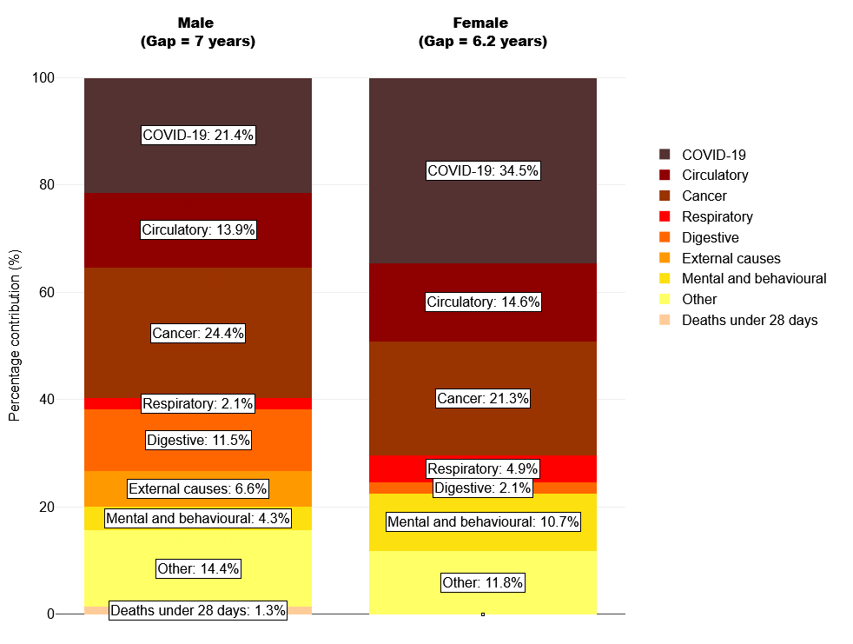Source: OHID, based on ONS death registration data (provisional for 2021) and 2020 mid-year population estimates, and Department for Levelling Up, Housing and Communities Index of Multiple Deprivation, 2019

COVID-19
              - COVID-19 was the leading cause of death in England in 2020, but the pandemic had a much greater impact on mortality in some areas than in others. From the 20th of March 2020 to the 1st of December 2022 there were 682 deaths in Wandsworth where COVID-19 was mentioned on the death certificate.

COVID-19 vaccinations
              - COVID-19 vaccines can reduce the risk of serious illness, hospital admissions and even death from COVID-19. They also reduce the risk of spreading COVID-19 to others.
              - As of 27th June 2022, 69.4% of residents in Wandsworth (aged 12 years and over) had received their first vaccine dose, 66.2% received their second dose and 52.6% received their booster or 3rd dose. This is similar to the vaccine uptake in London overall, with 68.9%, 64.7% and 47.1% respectively (COVID data, GOV UK, 2022).

Circulatory diseases

Cardiovascular diseases considered preventable
              - Circulatory diseases include cardiovascular diseases such as heart disease and stroke. The under-75 mortality rate for cardiovascular disease considered preventable is 30.1 deaths per 100,000 population (three-year range, 2017-19). This is similar to the national and regional rates of 27.5 and 28.1 deaths per 100,000 population. (OHID, 2022).

Stroke
              - Wandsworth had the 4th lowest stroke prevalence in London in 2020/21. 0.9% of the GP-registered population in Wandsworth have had stroke or transient ischaemic attack at some point in their lives. The London prevalence is 1.1% and the national prevalence is 1.8% of the GP registered population (QOF, 2022).

Coronary heart disease
              - In 2020/21 1.4%, 5,477, GP registered patients had a heart disease or stroke, similar to the London rate of 1.9% and substantially lower than the England rate of 3% (QOF, 2022).

Cancer
              - In England, cancer is the leading cause of death for those under 75. Wandsworth is the 10th highest borough in London with fatalities in under 75s from cancer that are considered preventable. In 2020, 50.6 per 100,000 population were reported. This is similar to London, with 45.1 deaths per 100,000 and England with 51.5 deaths per 100,000 population.

Cancer screening
              - A concentrated effort in both prevention and treatment is required to guarantee that the rate of early cancer death is reduced. Often patients will visit their pharmacy with cancer symptoms they may be concerned about. Cancer screening can help find cancer at an early stage, making it easier to treat or cure a cancer. Community pharmacies can support the promotion of cancer screening programmes and signpost patients with concerns to their GP for further clinical assessment and diagnosis.
              - Cancer screening coverages are significantly lower in Wandsworth in comparison to national figures (OHID, Public Health Profiles, 2022). In 2021:
- 61.2% of women aged 25-49 were screened for cervical cancer compared with 68% nationally. The recent trend shows this figure to be continually decreasing and getting worse.
- 68.7% of women aged 50-64 were screened for cervical cancer compared with 74.7% nationally.
- 52.5% women aged 53 to 70 were screened for breast cancer, compared with 64% nationally.
- 60.1% of men and women aged 60 to 74 were screened for bowel cancer, compared to 65.2% nationally.

Patient groups with specific needs

Dementia
              - In 2020/2021, 1,737 people were registered with dementia in Wandsworth, this equates to 0.4% of the GP registered population. In comparison to London (0.5%) national rates (0.7%), it is lower (OHID, Public Health Profiles, 2022).
              - Early diagnosis is important in enabling people to access the right services and support early and live well with dementia. Community pharmacies can play an important role in identifying people experiencing cognitive difficulties and signpost them to the support they need.
              - Wandsworth is the 7th highest rate of emergency admissions in London for people living with dementia over 65 years. In 2019/20 there were 1,515 admissions for people with dementia, this equates to 4,820 per 100,000 population. This is lower than the England rate of 3,517 per 100,000 population (OHID, Public Health Profiles, 2022).

Summary of population health needs
Overall, the health and wellbeing of Wandsworth is similar to the national picture. Life expectancy and healthy life expectancy are similar to national figures.
This chapter explores the major risk factors and health conditions that affect Wandsworth residents. For most risk factors Wandsworth is doing better or similar to national figures. However, Wandsworth does have a significantly higher STI diagnosis rate than England and a lower flu vaccination coverage rate for over 65s and the ‘at risk’ population.
In terms of major health conditions, COVID-19, circulatory diseases and cancers were the biggest causes of life expectancy gap between the most and least deprived in the borough. Wandsworth screening coverage rates for cancers were significantly lower than England.

Patient and public survey
              - This chapter presents the results of the patient and public engagement survey that was carried out in Wandsworth between 10th October 2022 and 17th November 2022. From this, an equality impact assessment was conducted by reviewing the use and experiences of pharmacy use specific to protected characteristic groups that were engaged with during this process.
              - A “protected characteristic” is a characteristic listed in section 149(7) of the Equality Act 2010. There are also certain vulnerable groups that experience a higher risk of poverty and social exclusion than the general population. These groups often face difficulties that can lead to further social exclusion, such as low levels of education and unemployment or underemployment.
              - The patient and public engagement survey was used to engage with patients and the public to understand their use and experiences of local pharmacies. The survey was approved for use with the local population of Wandsworth by the PNA Steering Group.

Wandsworth communications engagement strategy

Whole population approach
              - Working closely with the steering group and the London Borough of Wandsworth Communications Team, the survey was distributed widely across Wandsworth over the period of 10th October 2022 until 17th November 2022. In total we engaged with 188 residents, workers and students of Wandsworth.
              - To promote the survey, the London Borough of Wandsworth Communications Team shared it on their website and resident newsletter and Healthwatch Wandsworth shared the survey on their website and social media pages, such as Twitter. The survey was also shared on social media through community Facebook groups. Citizens Advice Wandsworth were provided with the survey link and asked to circulate it among their contacts and the Wandsworth Community Empowerment Network were sent the survey link and wording and asked to disseminate the survey among contacts.

Targeted approach
              - To ensure that seldom heard groups and groups who share protected characteristics were reached, a targeted approach was developed for the survey engagement. The community engagement manager for Wandsworth Council was provided with the survey link and asked to circulate it among contacts. Groups that were engaged with included voluntary and charity sector organisations.
              - The following groups were identified and approached for survey engagement:
- Faith-based organisations: Islamic Culture and Education Centre and Hindu Society were provided with the survey link and wording and asked to disseminate the survey. Ahmadiyya Muslim Association Elays Network were contacted to arrange a meeting and disseminate the survey.
- Ethnic Minorities: Association of Somali Women and Children were sent the survey link and wording and asked to circulate the survey. Wandsworth Asian Women’s Association were contacted to arrange a meeting and disseminate the survey.
- Age: Hestia Age Activity Centre were contacted to arrange a meeting and disseminate the survey.
- Mental Health: Canerows were contacted to arrange a meeting and disseminate the survey
- Food sharing and community kitchen: Waste Not Want Not and Battersea Canteen were contacted to arrange a meeting, provided with the survey link and wording and asked to disseminate the survey.

Survey results
              - When asked how often they use their pharmacy, 44.7% of respondents stated that they use it a few times a month, 27.7% reported using it once a month, a further 13.8% respondents use it once in 3 months, 9% once a week, 2.1% once every 6 months and 0.5% less than once a year (figure 6.1).
Figure 6.1: Survey responses on frequency of pharmacy use, 2022.
          - 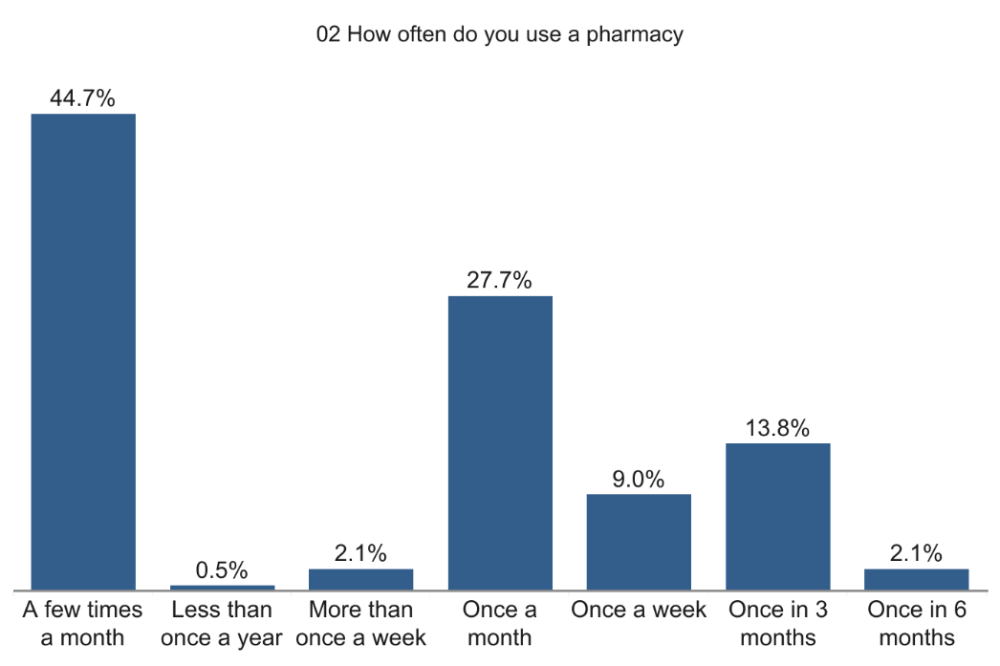
              - Most respondents (82.4%) chose their pharmacy because it is where their GP sends their prescriptions, while 78.7% reported it as being in a good location and close to their work or home, and 76.1% are happy with the overall service provided (figure 6.2).
Figure 6.2: Survey responses on reasons for pharmacy use, 2022.
            - 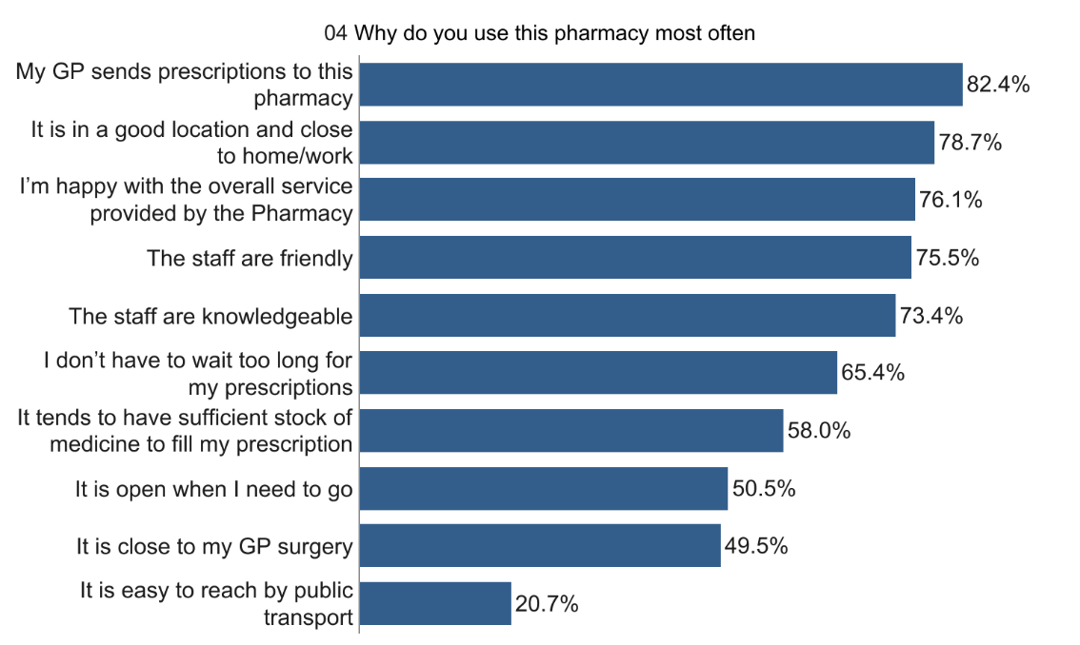
              - Most respondents (96.3%) stated that they use a pharmacy for themselves, while 39.6% use one for their partner or spouse, 15.5% for their children, 7% for another family member, 6.4% for their parent/parents, and 3.2% for their friend or neighbour (figure 6.3).
Figure 6.3: Survey responses on whom the pharmacy is used for, 2022.
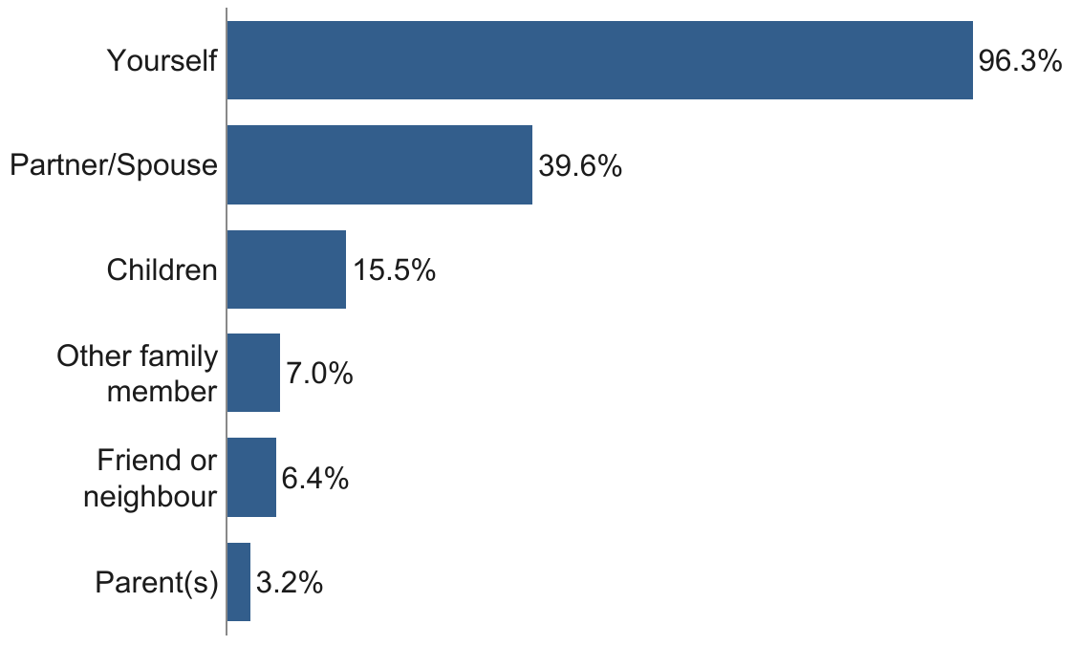
              - The majority 109 (58%) respondents spend between 5 and 20 minutes travelling to their pharmacy, with 71 (37.8%) saying it takes them less than 5 minutes and eight residents (4.3%) reporting it taking between 20 and 60 minutes to travel to their pharmacy (figure 6.4).
Figure 6.4: Survey responses on length of the journey to travel to their pharmacy, 2022.
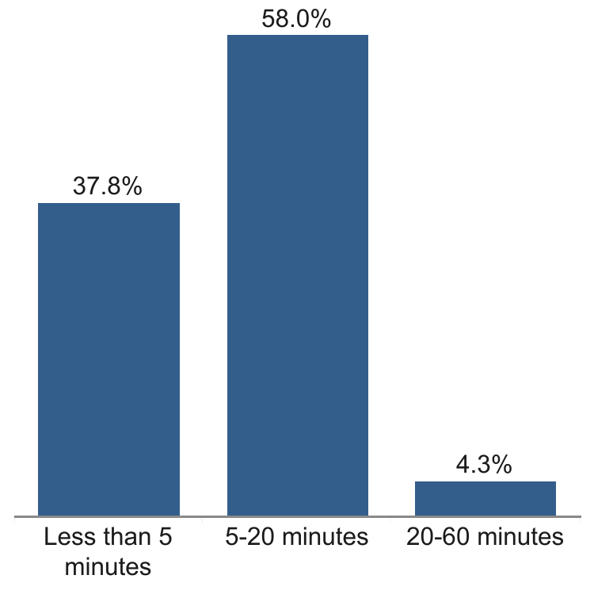
              - When asked how satisfied they were with their journey to reach their pharmacy, most of the respondents (79.3%) were very satisfied and a further 11.7% were somewhat satisfied, while 8% reported being neither satisfied nor dissatisfied, 0.5% were somewhat dissatisfied and 0.5% were very dissatisfied (figure 6.5).
Figure 6.5: Survey responses on level of satisfaction with the journey to their pharmacy, 2022.
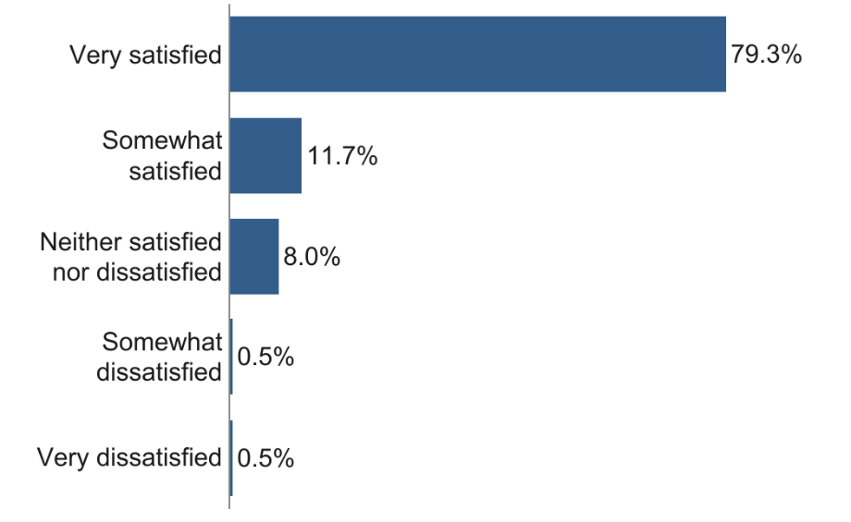
              - The majority of respondents (86.2%) stated that they walk to their pharmacy, 19.7% use a car, 11.7% travel by bus, 3.7% cycle, 1.1% use a mobility scooter/wheelchair, 0.5% use the underground and a further 0.5% said ‘other’ (figure 6.6).
Figure 6.6: Survey responses on how respondents travel to their chosen pharmacy, 2022.
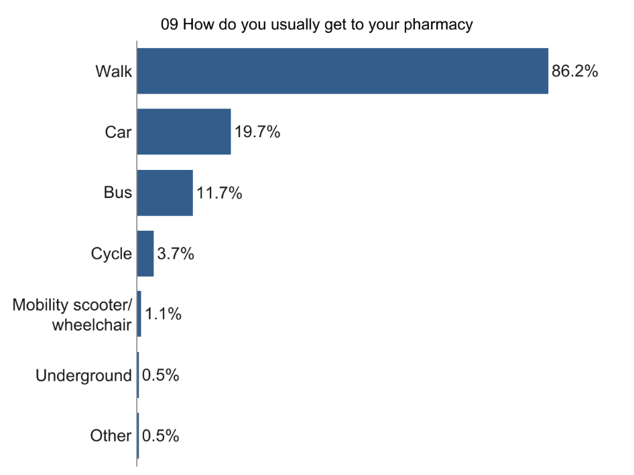
              - Most respondents prefer to go to their pharmacy on a weekday (48.4%) or either a weekday or a weekend (47.9%), while 3.7% prefer to visit at the weekend (figure 6.7). When asked what times they prefer to go to their pharmacy, the majority (66.3%) said between 9am-12pm, 55.6% stated between 2pm-5pm, 46% prefer between 12pm-2pm, 27.8% prefer 5pm-9pm, 4.3% prefer 6am-9am and 2.1% said between 9pm-6am (figure 6.8).
Figure 6.7: Survey responses on the preferred day for pharmacy use, 2022.
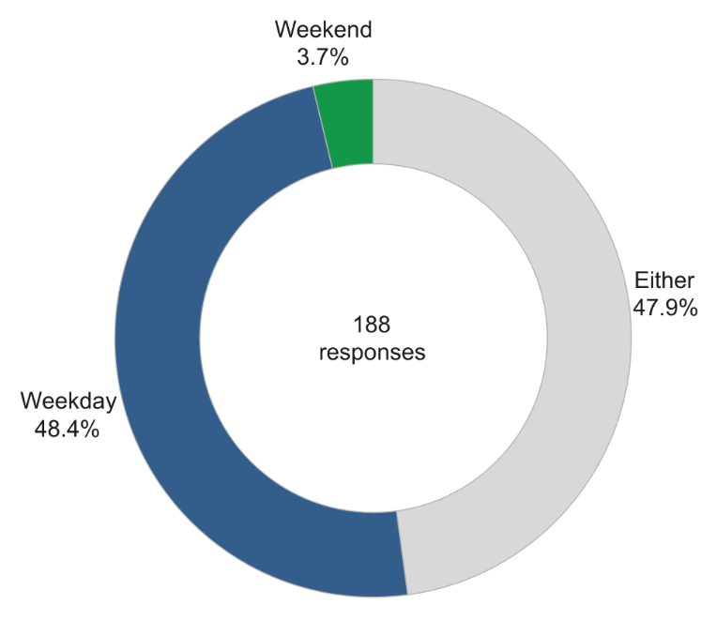

Figure 6.8: Survey responses on the time of day preferred to go to their pharmacy by respondents of the London Borough of Wandsworth, 2022.
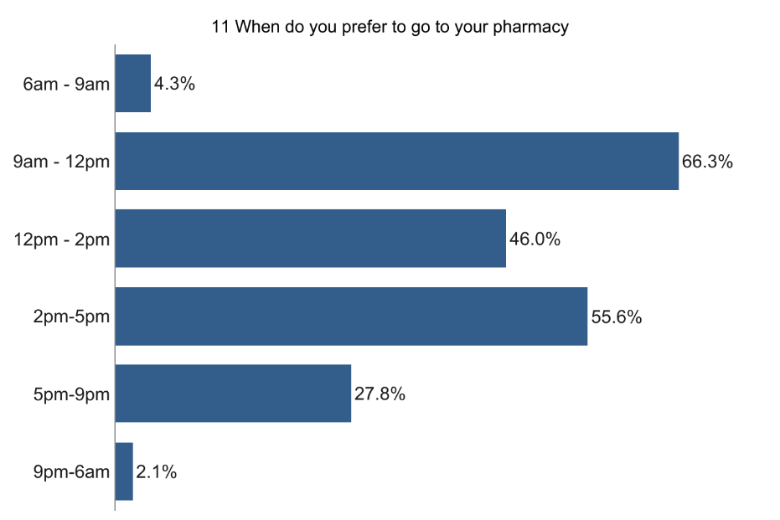
              - If they could not access their pharmacy to collect a prescription, 51.6% respondents said they would go on another day, while 38.6% responded that they can always access their pharmacy, 5.4% would go to another pharmacy, 2.7% use delivery and 1.6% stated ‘other’ (figure 6.9).
Figure 6.9: Survey responses on they would do if they had no access to collect their prescription from their pharmacy, 2022.
          - 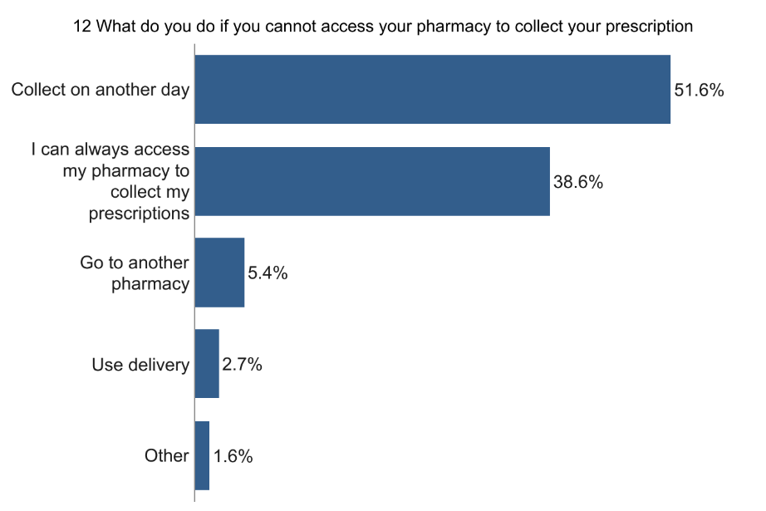
              - At times of no access to their usual pharmacy for minor ailments and or advice, 47.8% respondents said that they can always access their pharmacy, 23.3% go to another pharmacy, 18.3% go to a GP or a walk-in centre, 10% call 111 and 0.6% go to the hospital (figure 6.10).
Figure 6.10: Survey responses on what they would do if they had no access to their pharmacy for minor ailments and/or advice, 2022.
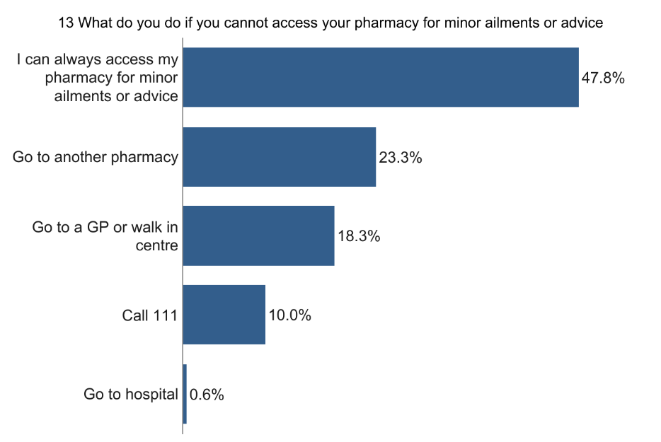
              - Of those who do use an online pharmacy, 65.4% use one for repeat prescriptions, 15.4% for one-off prescriptions, 15.4% for non-prescribed medications, and 3.8% responded with ‘other’ (figure 6.11).

Figure 6.11: Survey responses on the reason for use of online pharmacies, 2022.
      - 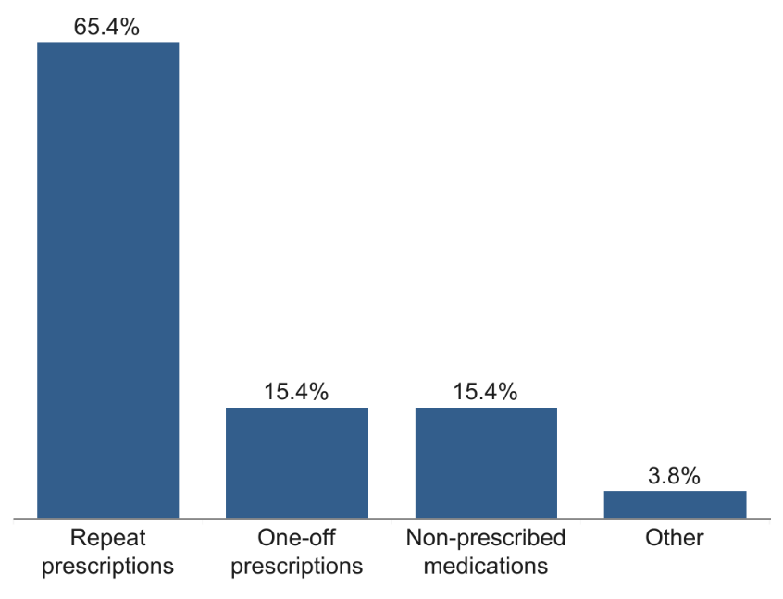
              - Many Wandsworth residents were happy with the services provided at their pharmacy. However, some respondents would like additional services to be available, including:
- Vaccinations, especially COVID-19 and flu vaccinations
- Health screenings, such as blood tests, blood pressure checks and skin checks
- Home delivery
- Other health services, such as ear wax removal, counselling, and a menopause service
- Opening hours on Saturdays

Equality impact assessment
              - This next section explores the Wandsworth patient and public survey responses by different groups representing protected characterises, looking at where there are similarities and differences between groups.

Age
              - To understand any differences between age groups, we compared differences between those aged over 65 (n=105), and individuals aged 65 and under (n=81).
              - There were no differences between age groups in frequency of use of pharmacies, reasons for choosing pharmacies, travel to their pharmacy or preference for day of the week for visiting their pharmacy.
              - Those over 65 were less likely (2.9%) to use a pharmacy for children than those under 65 (30.9%).
              - Those under 65 were more likely to have a preference for using a pharmacy between 5pm and 9pm (44.4%) than those over 65 (14.4%).

Ethnicity
              - Only a small number of respondents were from an ethnic minority background. We compared the survey responses from those from white ethnic groups (87.7%; n=164), Asian ethnic groups (3.7%; n=7), Black ethnic groups (3.2%; n=6), and mixed ethnic groups (1.1%; n=2) (figure 6.12).
Figure 6.12: A breakdown of ethnic groups of Wandsworth respondents, 2022
              - 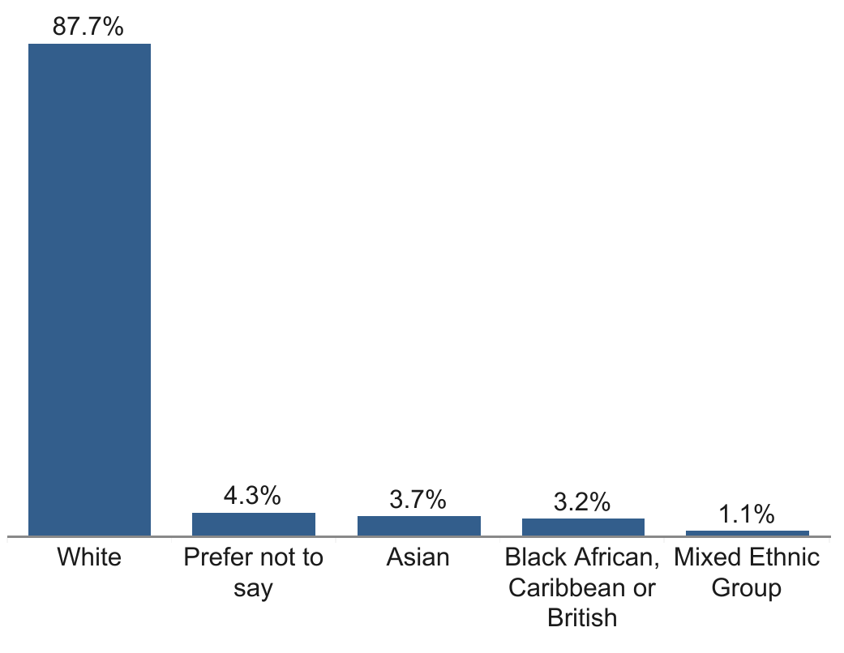
              - There were no differences between ethnic groups in frequency of pharmacy use, who they use a pharmacy for, method of travel or day and time preferences for accessing the pharmacy.
              - Those from a White ethnic group were less likely to state that they chose their pharmacy because it is easy to reach by public transport (18.3%).

Gender
              - The majority of respondents (69.9%) identified as female (n=130), with males making up the second biggest group (28.5%; n=53) (figure 6.13).
Figure 6.13: A breakdown of the gender of Wandsworth respondents, 2022
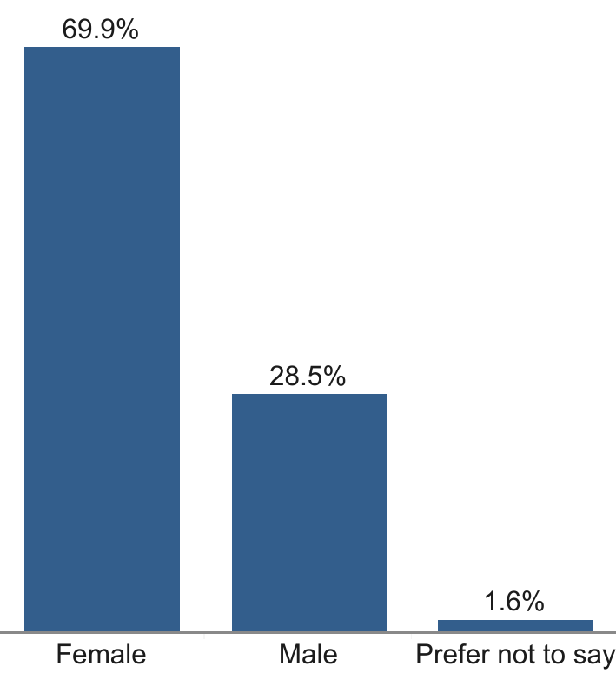

              - There were no differences in gender for frequency of pharmacy use, reasons for choosing a pharmacy, who they are accessing the pharmacy for, their travel or preference for time and day of the week to visit a pharmacy.

Pregnancy and maternity/parental leave
              - When asked if they were pregnant, 177 (97.8%) individuals responded that they were not, with three (1.7%) preferring not to say and only one (0.6%) reporting that they were.
              - When asked if they were breastfeeding, 173 (97.7%) said that they were not, with three (1.7%) preferring not to say and one person (0.6%) stating they were.
              - There were no difference reasons for choosing their pharmacy or travel to their pharmacy.

Employment status
              - Most respondents (n=106; 56.4%) were retired, while 23.9% (n=45) were in full-time employment, 10.6% (n=20) were in part-time employment, 4.8% (n=9) respondents preferred not to say, while 2.1% (n=4) were unemployed, and 2.1% were full-time or part-time carers (n=4) (figure 6.14).
Figure 6.14: A breakdown of the employment status of respondents in Wandsworth, 2022
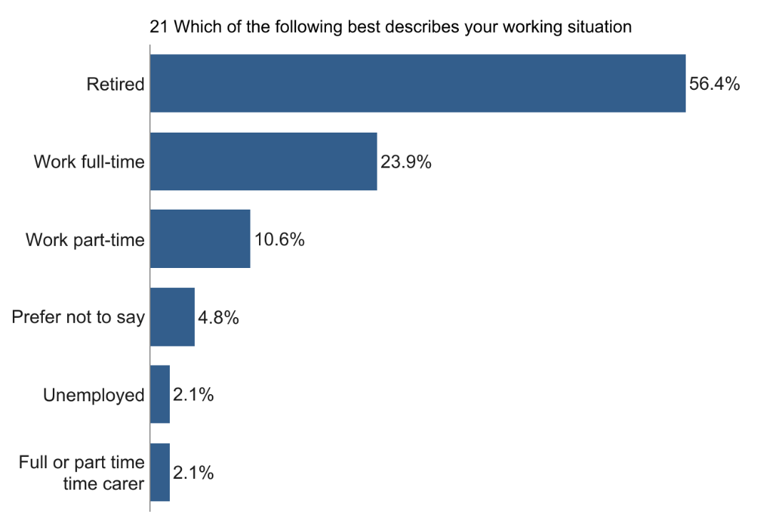
              - There were no differences in frequency of pharmacy use, reasons for choosing their pharmacy, time taken to travel to pharmacy, satisfaction with the journey or preference for day of the week.
              - Full-time or part-time carers were less likely to use a pharmacy for themselves (50%) and were less likely to walk to their pharmacy (25%).
              - Those in full-time employment were more likely to state 5pm-9pm as a preferred time to use their pharmacy (60%).

Disability or impairment
              - A breakdown of disabilities and impairments among the respondents found that 140 (74.5%) Wandsworth respondents did not consider themselves to have a disability, while 36 (19.1%) said that they did and 12 (6.4%) preferred not to say (Figure 6.15).
Figure 6.15: A breakdown of disability of Wandsworth survey respondents, 2022
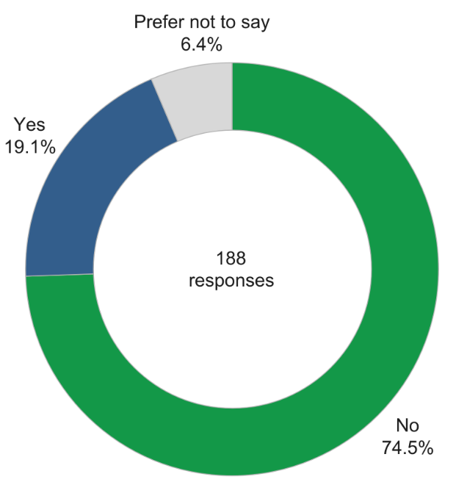
              - There were no differences between those with a disability and those without a disability for frequency of pharmacy use, reasons for choosing their pharmacy, who they use their pharmacy for, travel time, method of travel, journey satisfaction or preference for when they access their pharmacy.

Sexual orientation
              - The majority of respondents (83.5%) identified as heterosexual/straight (n=157), with 11.7% preferring not to say (n=22), 3.2% identifying as a gay man (n=6), 1.1% responding as bisexual (n=2) and 0.5% reporting that they were a gay woman/lesbian (n=1) (Figure 6.16).
Figure 6.16: A breakdown of sexual orientation of Wandsworth respondents, 2022.
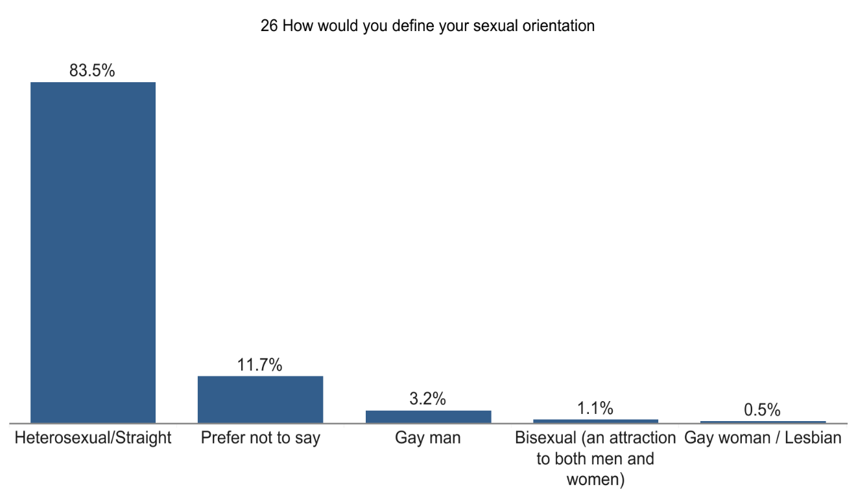
              - There were no differences between time taken to travel to pharmacy or preference in day for accessing a pharmacy.
              - Those identifying as bisexual were more likely to be neither satisfied or dissatisfied with their journey (100%). They were also more likely to prefer visiting a pharmacy between 5pm-9pm (100%) and 9pm-6am (50%).
              - Those identifying as a gay woman/lesbian were more likely to use a pharmacy for their partner/spouse and were more likely to use a car to travel to their pharmacy (100%).

Relationship Status
              - A large proportion (43.6%) of respondents were married (n=82), while 37.8% were single (n=71), 12.8% preferred not to say (n=24), 3.2% were co-habiting (n=6), 2.7% were in a civil partnership (n=5) (figure 6.17).
Figure 6.17: A breakdown of relationship status of Wandsworth respondents, 2022
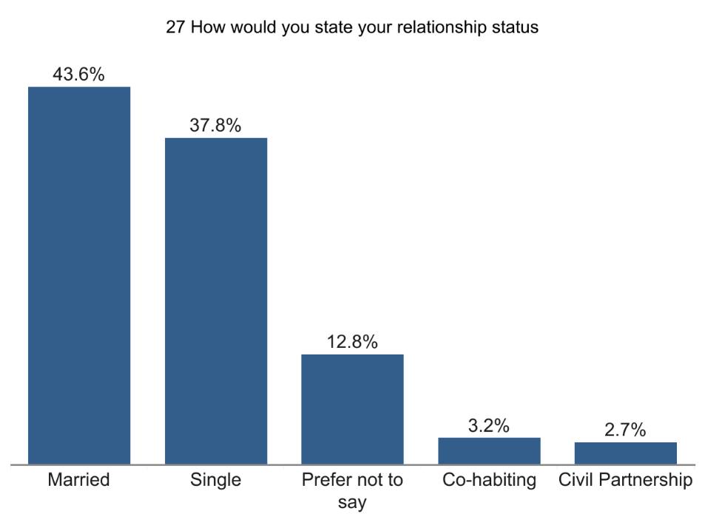
              - There were no differences between relationship statuses for frequency of pharmacy use, method of travel, travel time and journey satisfaction or preference for time of day to access their pharmacy.
              - Those in a civil partnership were less likely to choose their pharmacy because it is close to their GP surgery (20%).
              - Those who were co-habiting were more likely to prefer using a pharmacy on a weekday (100%) and were less likely to prefer using a pharmacy on either a weekday or a weekend (0%).

Summary of the patient and public engagement and equality impact assessment
For patient and public engagement, a survey was carried out in Wandsworth to understand how residents, workers and students use pharmacies across the borough. This examined how people use their pharmacies, as well as how and when they access them. An exploration into the health needs of people with protected characteristics and vulnerable groups was also conducted from this survey.

The survey received 188 responses from residents, workers and students of Wandsworth. Most respondents reported using their pharmacy once a month or a few times a month, which was most often for themselves. Wandsworth residents typically chose their pharmacies because it is where their GP sends their prescriptions, and it is in a good location or close to home/work.

The majority of respondents can reach their pharmacy in 5-20 minutes, with most of them choosing to walk there. Most respondents were very satisfied with their journey to their pharmacy. Wandsworth respondents generally preferred to access their pharmacy on a weekday or either a weekday or weekend, with the most popular times for this being between 9am-12pm and 2pm-5pm.

No substantial differences or identified needs were found amongst protected characteristics groups and pharmacy usage.

Provision of pharmaceutical services
              - This chapter identifies and maps the current provision of pharmaceutical services to access the adequacy of provision of such services. The information in this chapter was collected up until February 2023.
              - The chapter assesses the adequacy of the current provision of necessary services by considering:
- Different types of pharmaceutical service providers
- Geographic distribution and choice of pharmacies, both within and bordering the borough
- Opening hours
- Dispensing
- Provision of essential, advanced and enhanced services

Pharmaceutical service providers
              - As of February 2023, there are 60 pharmacies in Wandsworth that hold NHS contracts, all of which are community pharmacies. They are presented in the map in Figure 7.1 below. All the pharmacy providers in the borough as well as those within one mile of its borders are also listed in Appendix B.
Figure 7.1: Map of pharmaceutical service providers in Wandsworth, February 2023
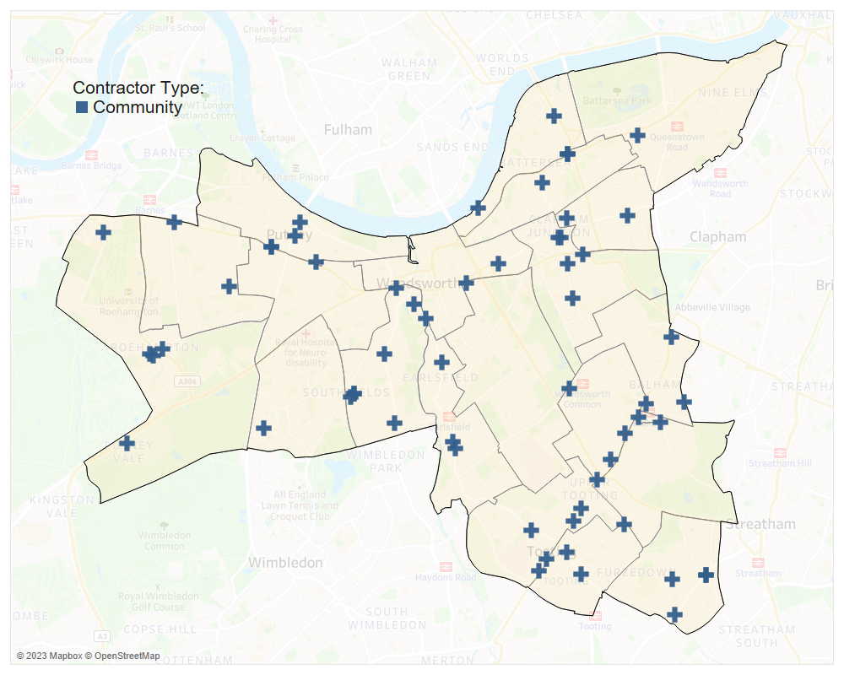
Source: NHS England, 2023

Community pharmacies
              - The 60 community pharmacies in Wandsworth equates to 1.8 community pharmacies per 10,000 residents (based on a 2022 population estimate of 327,010). This ratio is below the London and England averages, both of which stand at 2.2 based on 2014 data (LGA, 2022) .

Dispensing appliance contractors
              - A DAC (dispensing appliance contractor) is a contractor that specialises in dispensing prescriptions for appliances, including their customisation. They cannot dispense prescriptions for drugs. The are no DACs in Wandsworth’s pharmaceutical list.

GP dispensing practices
              - There are no GP dispensing practices in Wandsworth. Dispensing doctors provide services to patients mainly in rural areas and often where there are no community pharmacies or where access is restricted.

Distance selling pharmacies
              - Distance selling pharmacies (DSPs) are pharmacies that receive prescriptions, either electronically or via the post, dispense them at the pharmacy, then deliver them to patients through the mail or using shipping couriers. Under the 2013 regulations, they are not allowed to provide essential services on a face-to-face basis. There are no DSPs in Wandsworth.

Local pharmaceutical services
              - Local pharmaceutical services (LPS) contracts allow NHSE to commission services from a pharmacy, which are tailored to specific local requirements. No areas in Wandsworth have been designated as LPS areas, therefore there are no LPS contracts within Wandsworth.

Accessibility

Distribution and choice
              - The PNA Steering Group agreed that the maximum distance for residents of Wandsworth to access pharmaceutical services, should be no more than one mile. This distance equates to about a 20-minute walk.
              - Figure 7.2 below shows the 60 community pharmacies in Wandsworth, as well as the 111 located within one mile of the borough’s border, and therefore considered to serve Wandsworth residents. In addition to Figure 7.2, all these pharmacies are shown in Appendix B. This shows that all parts of Wandsworth are within 1 mile of a community pharmacy.
Figure 7.2: Distribution of community pharmacies in Wandsworth and within 1 mile of the borough boundaries, with their 1-mile coverage
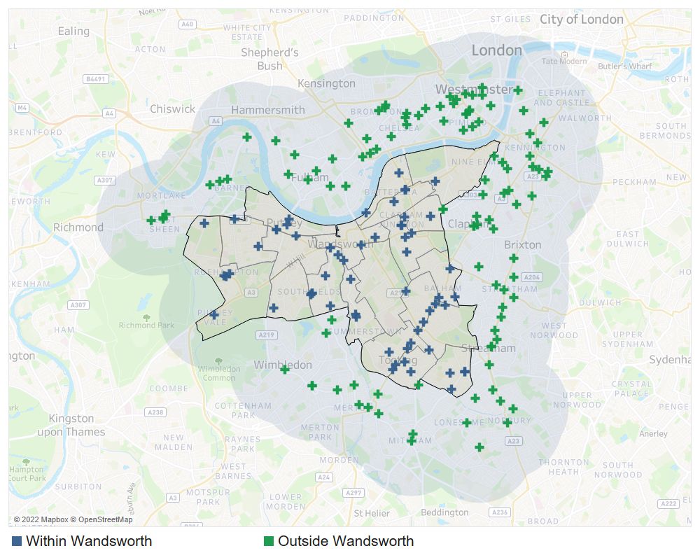
Source: NHS England, 2023

              - Additionally, all residents in Wandsworth can reach a pharmacy within 20 minutes using public transport, attesting to the accessibility of the pharmacy provision in the borough. Figure 7.3 presents the coverage of the Wandsworth pharmacies in relation to access using public transport. Coverage of the pharmacies is presented in green while Wandsworth is presented with an orange border. A total of 1,252,912 people inside and outside the borough can reach a Wandsworth pharmacy by public transport within 20 minutes (OHID, SHAPE Atlas Tool, 2022).

Figure 7.3: Areas covered by 20-minute travel time by public transport to a Wandsworth pharmacy from within and outside the borough
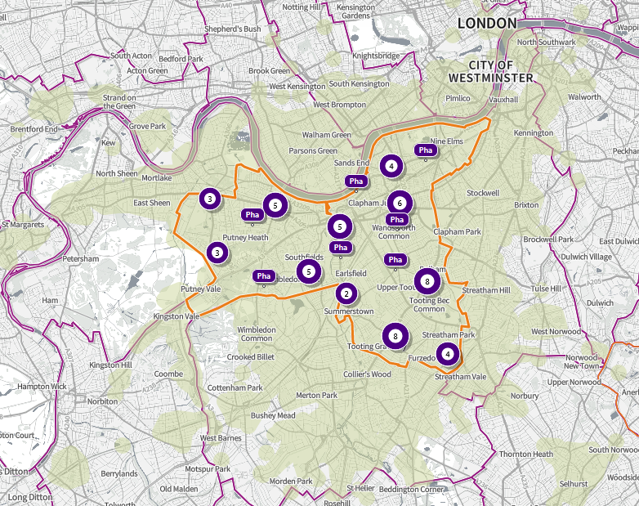Source: OVID, Strategic Health Asset Planning and Evaluation Atlas Tool, 2023

              - The geographic distribution of the pharmacies by electoral and the pharmacy to population ratio is shown in Table 7.1. As seen, with the exception of East Putney, all Wandsworth wards have a community pharmacy within them. East Putney, however, is well served by pharmacies in neighbouring wards as seen in Figure 7.2 earlier.
Table 7.1: Distribution of community pharmacies by ward
Ward | Number of Community Pharmacies | Population Size | Community Pharmacies per 10,000
Southfields | 8 | 16,924 | 4.7
Tooting | 5 | 16,132 | 3.1
Thamesfield | 5 | 16,590 | 3.0
Roehampton and Putney Heath | 5 | 16,734 | 3.0
Northcote | 5 | 16,490 | 3.0
Nightingale | 5 | 14,181 | 3.5
Furzedown | 4 | 16,689 | 2.4
St Mary's Park | 4 | 19,409 | 2.1
Earlsfield | 3 | 16,316 | 1.8
Balham | 3 | 15,486 | 1.9
West Putney | 2 | 15,704 | 1.3
Shaftesbury | 2 | 15,080 | 1.3
West Hill | 1 | 16,082 | 0.6
Wandsworth Common | 1 | 15,628 | 0.6
Queenstown | 1 | 23,038 | 0.4
Latchmere | 1 | 16,015 | 0.6
Fairfield | 1 | 16,064 | 0.6
Bedford | 1 | 13,224 | 0.8
East Putney | 0 | 15,847 | 0.0
Borough Total | 60 | 327,010 | 1.8
Source: NHSE & GLA, 2023

              - Residents tend to fill their prescriptions at local pharmacies. NHSE data shows that in 2021-22, 86.7% (4,715,360) of items prescribed by GPs in Wandsworth were dispensed by community pharmacies within the borough. The next largest boroughs where prescriptions from Wandsworth were dispensed were Merton (3.6%), Lambeth (2.5%) and Surrey (0.9%).

Pharmacy distribution in relation to population density
              - Figure 7.4 shows pharmacy locations in relation to population density. It shows that there a greater amount of choice of community pharmacies in areas where the population density is higher.
Figure 7.4: Pharmacy locations in relation to population density by ward in Wandsworth 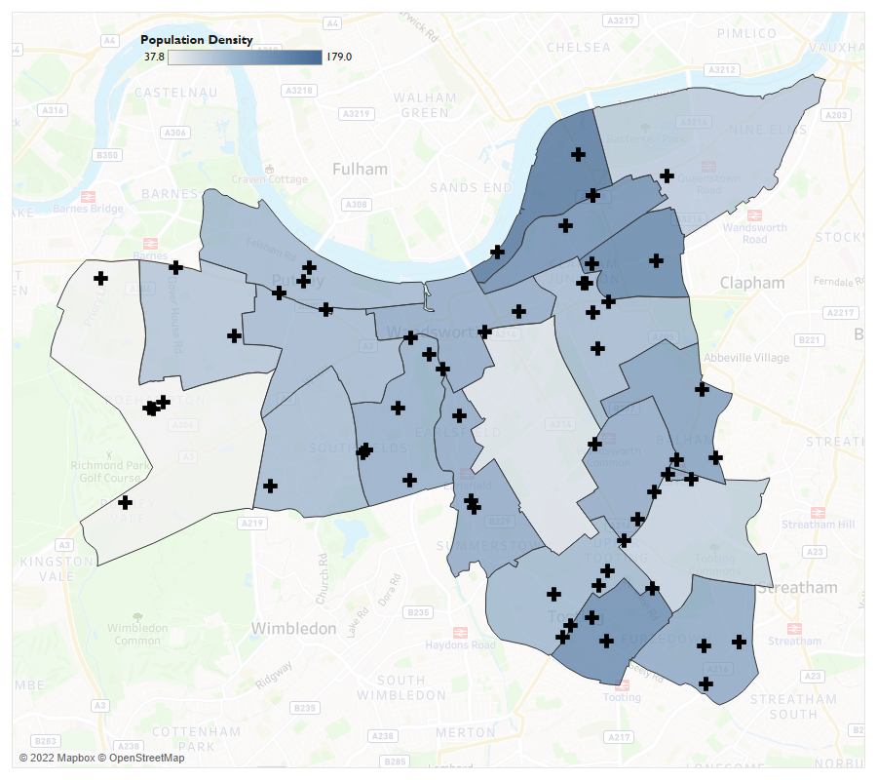
Source: GLA (Land Area, and Population Density and NHSE)

Pharmacy distribution in relation to GP surgeries
              - It is essential that community pharmacies can fully engage with GPs and PCNs to maximise service provision for their patients and residents. There are 39 GP practices within nine PCNs in Wandsworth. Each of these networks have expanded neighbourhood teams which will comprise of range of healthcare professionals including GPs, district nurses, community geriatricians, Allied Health Professionals, and pharmacists.
              - There is a pharmacy within an accessible distance of all GP practices in Wandsworth as shown in Figure 7.5.
Figure 7.5: GP practices in Wandsworth and their 1-mile coverage, February 2023
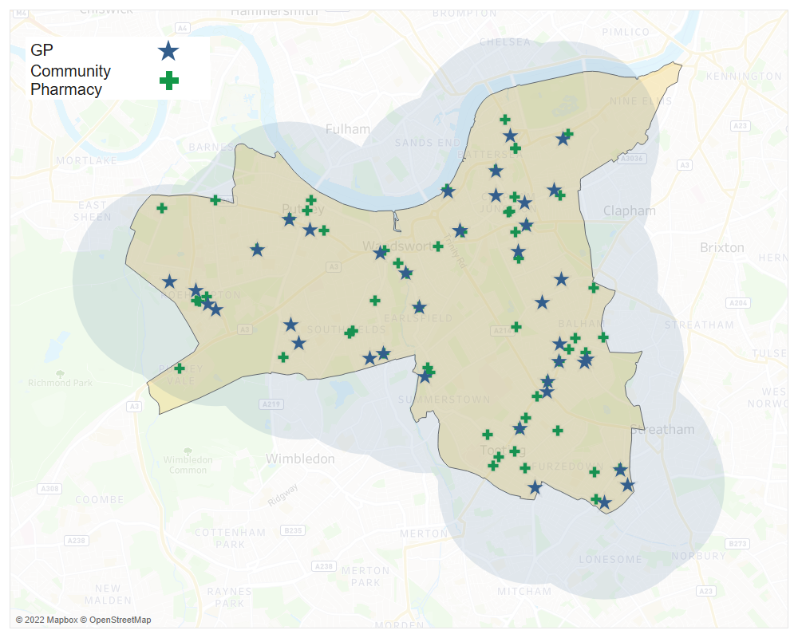
Source: NHSE, 2023

              - There is a new healthcare facility in development for Queenstown Ward (known as Nine Elms Ward from May 2022). It will be located at Sleaford Street close to the Battersea Power Station site as shown in Figure 7.6. It is expected to open in the Summer of 2024.
              - Figure 7.6 shows the location of the new healthcare centre in relation to existing pharmacies within 1-mile reach. There are 10 pharmacies within 1-mile of a pharmacy, south of the River Thames.
Figure 7.6: New Sleaford Street health centre and its 1-mile radius in relation to pharmacies, February 2023
Source: NHSE, 2023

              - Of those pharmacies, four are within 1-mile walking distance. These are presented in Table 7.2 below. The closest pharmacy to the new health centre will be Halls Chemist, 240 Wandsworth Road. This pharmacy will be a 13-minute walk away.
Table 7.2: Pharmacies within 1-mile of the new Sleaford Health Centre, February 2023
Pharmacy Name | Address | Distance from Health Centre on foot | Approximate walking time
Halls Chemist | 240 Wandsworth Road, Battersea, London, SW8 2JS | 0.7 miles | 13 minutes
Day Lewis Pharmacy | 299-303 Battersea Park Rd, Battersea, London, SW11 4LX | 0.9 miles | 17 minutes
Lloyds pharmacy | 62 Wandsworth Road, London, SW8 2LF | 0.9 miles | 18 minutes
Springfield Pharmacy | 110 Union Road, SW8 2SH | 1 mile | 19 minutes
 |  |  | Source: NHSE, 2023

Pharmacy distribution in relation to Index of Multiple Deprivation
              - Figure 7.7 displays pharmacy locations in relation to deprivation deciles. It shows that all areas of high deprivation are within accessible distance to a pharmacy.
Figure 7.7 Pharmacy locations in relation to deprivation deciles in Wandsworth, 2022 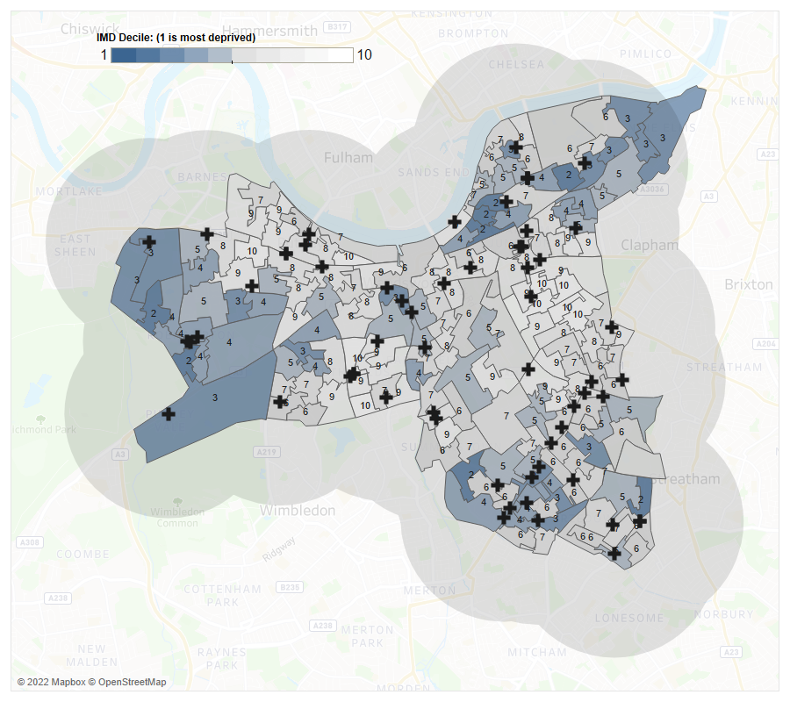
Source: MHCLG & NHSE

Opening times
              - Pharmacy contracts with NHS England stipulate the core hours during which each pharmacy must remain open. Historically these have been 40-hour contracts (and some recent 100-hour contracts). A pharmacy may stay open longer than the stipulated core opening hours, these are called supplementary hours.
              - Opening hours were obtained from NHS England in October 2022.

100-hour pharmacies
              - NHS England do not have any 100-hour pharmacies (core hour) on their list for Wandsworth. However, there are seven 100-hour pharmacies which are outside the borough, but within 1 mile of its border (Figure 7.8).
Figure 7.8: 100-hour pharmacies and their 1-mile coverage, February 2023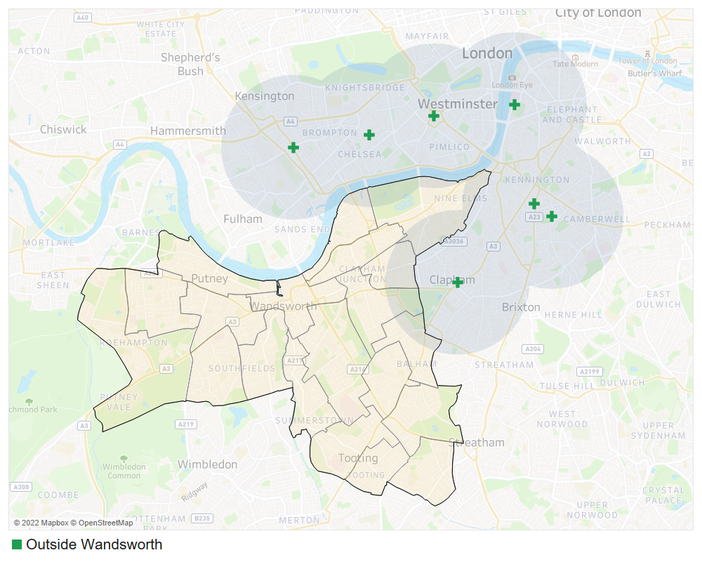
Source: NHSE, 2023

Early morning opening
              - Ten pharmacies are open before 9am on weekdays within the borough, with another 32 that are within 1 mile of the borough’s border. These are shown in Figure 7.9 and Table 7.3.
Figure 7.9: Pharmacies that are open before 9am on weekdays and their 1-mile coverage, October 2022 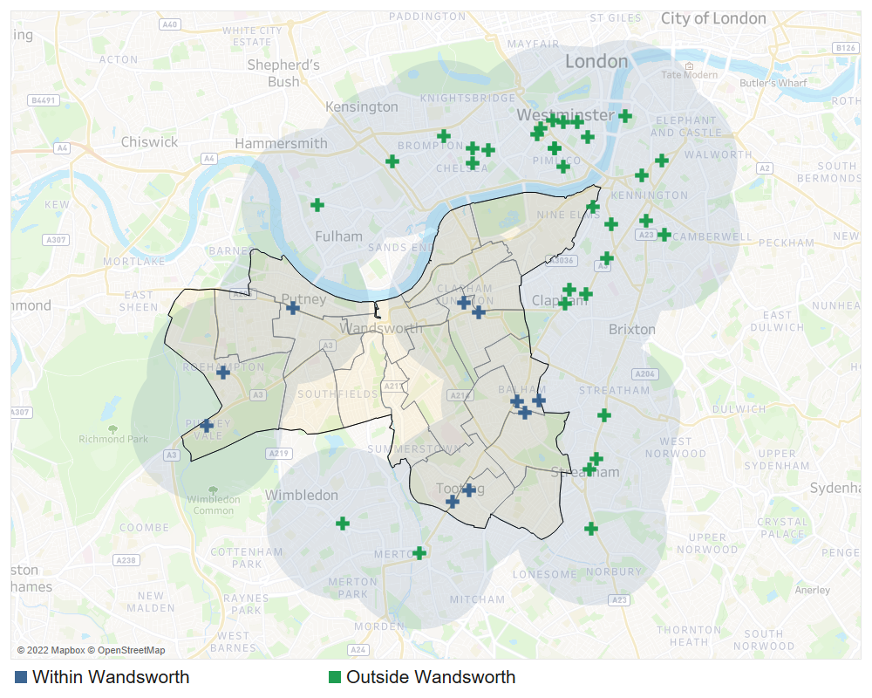
Source: NHSE, 2022

Table 7.3: Community pharmacies open before 9am on weekdays in Wandsworth
Pharmacy | Address | Ward
Boots | 153/155 Balham High Road, London, | Balham
Pharmalite Limited | 296 Cavendish Road, Balham | Balham
Barrons Chemist | 158A Tooting High Street, Tooting | Tooting
Superdrug Pharmacy | 36 St. Johns Road, Battersea, London | Northcote
Boots | 59/61 Mitcham Road, London, | Graveney
Paydens Pharmacy | 266A Upper Richmond Road, Putney | Thamesfield
Asda Pharmacy | Asda Superstore, 31 Roehampton Vale, Roehampton | Roehampton and Putney Heath
Paydens Pharmacy | 100 Bedford Hill, Balham | Bedford
Well | 31A Danebury Avenue, Roehampton | Roehampton and Putney Heath
Robards Dispensing Chemist | 15 Battersea Rise | Northcote
 |  | Source: NHSE, 2022

Late evening closure
              - There are 7 pharmacies in the borough that are still open after 7pm on weekdays, with 26 other pharmacies within 1 mile of Wandsworth (Figure 7.10 and Table 7.4).
Figure 7.10: Community Pharmacies that are open after 7pm on weekdays and their 1-mile coverage, February 2023
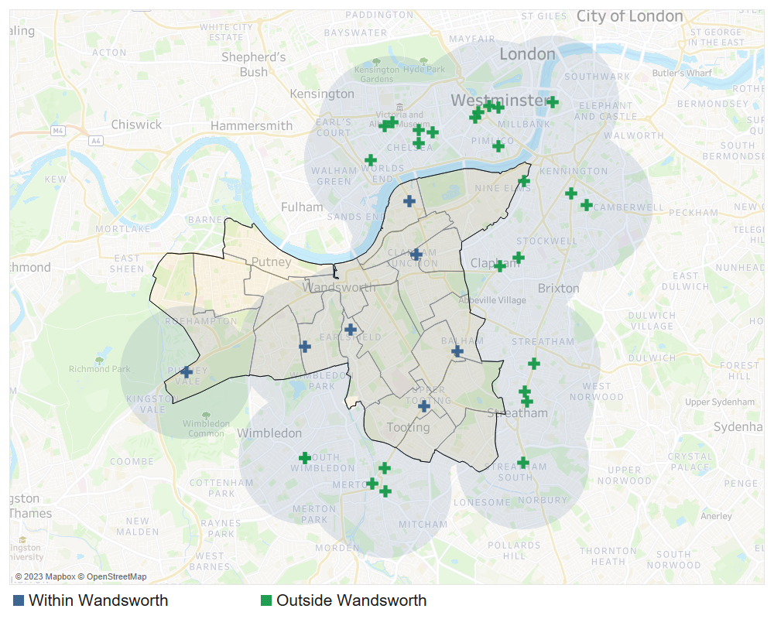
NHSE, 2023

7.4: Community pharmacies closing after 7pm on weekdays in Wandsworth
Pharmacy | Address | Ward
Boots | 153/155 Balham High Road, London, | Balham
Boots | 31-33 Replingham Road, Southfields, London | Southfields
Healthchem (Battersea) Ltd | 166-168 Battersea Bdge Rd, London, | St Mary’s Park
Tooting Pharmacy Practice | 175 Upper Tooting Road, London, | Tooting
Asda Pharmacy | Asda Superstore, 31 Roehampton Vale, Roehampton | Roehampton and Putney Heath
Barkers Chemist | 245 Garratt Lane, Wandsworth | Earlsfield
Boots | 21/23 St. Johns Road, Clapham Junction, London | Shaftesbury
Source: NHSE, 2023

              - In terms of travel distance, 100% of Wandsworth residents live within 20-minute reach of an early opening and late closing pharmacy by public transport (OHID, SHAPE Atlas Tool, 2022).

Saturday opening
              - A large majority of the community pharmacies in Wandsworth (50/60) have Saturday opening hours. There are an additional 100 near the borough’s borders that are also open on Saturday (Figure 7.11 and Table 7.5).
Figure 7.11: Community Pharmacies open on Saturday and their 1-mile coverage, February 2023
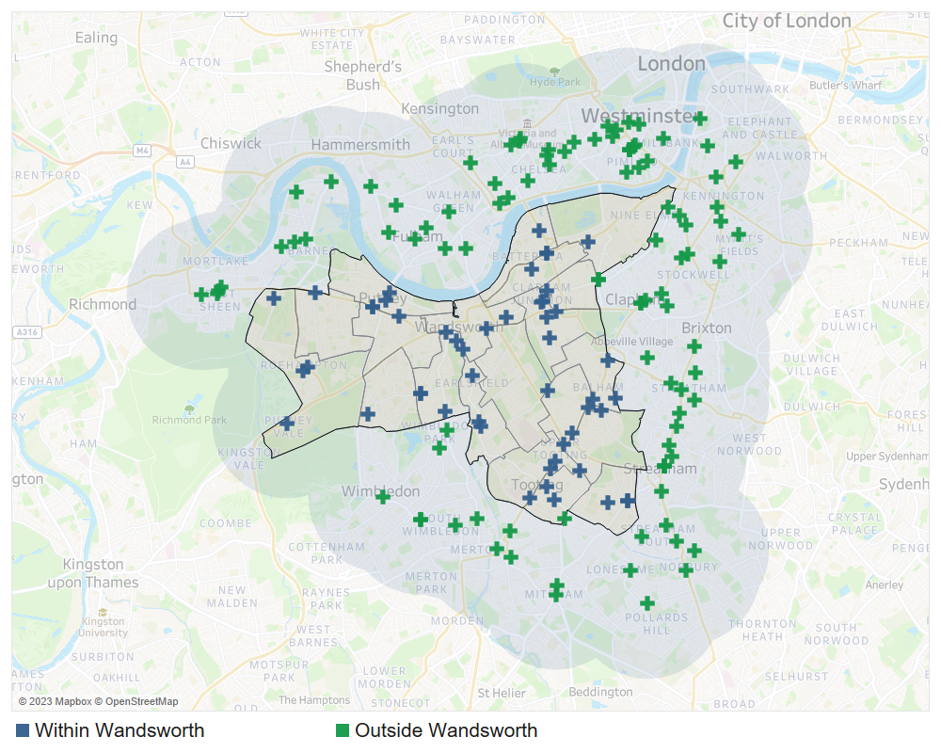
Source: NHSE, 2023

Table 7.5: Number of Community Pharmacies open on Saturday in Wandsworth by Ward, October 2022
Ward | Number of Community Pharmacies
Southfields | 6
Thamesfield | 5
Northcote | 5
Roehampton and Putney Heath | 4
Nightingale | 4
Tooting | 3
St Mary's Park | 3
Graveney | 3
Furzedown | 3
Earlsfield | 3
Balham | 3
West Putney | 1
West Hill | 1
Wandsworth Common | 1
Shaftesbury | 1
Queenstown | 1
Latchmere | 1
Fairfield | 1
Bedford | 1
Source: NHSE, 2023

Sunday opening
              - Overall, as shown in Figure 7.12 and Table 7.6, there is a good range of Sunday opening hours offered to Wandsworth residents. Nine pharmacies are open on a Sunday within the borough, with another 29 open in boroughs around Wandsworth within 1 mile of its border.
Figure 7.12: Pharmacies open on a Sunday and their 1-mile coverage, February 2023
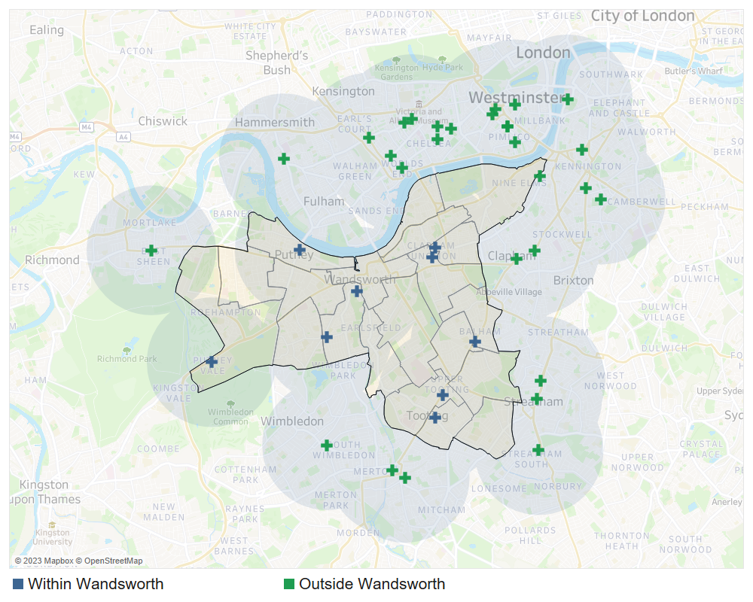
Source: NHSE, 2023

Table 7.6: Community Pharmacies open on Sunday in Wandsworth, February 2023
Pharmacy | Address | Ward
Boots | 153/155 Balham High Road, London, | Balham
Boots | 95/98 The Wandsworth, Shopping Centre, Wandsworth | Southfields
Boots | 45/53 Putney High Street, London, | Thamesfield
Boots | 31-33 Replingham Road, Southfields, London | Southfields
Boots | 59/61 Mitcham Road, London, | Graveney
Tooting Pharmacy Practice | 175 Upper Tooting Road, London, | Tooting
Asda Pharmacy | Asda Superstore, 31 Roehampton Vale, Roehampton | Roehampton and Putney Heath
Boots | 21/23 St.Johns Road, Clapham Junction, London | Northcote
Boots | 10 Falcon Lane, Clapham Junction, | Shaftsbury
 |  | Source: NHSE, 2023
              - All Wandsworth residents can reach a Saturday and Sunday opening pharmacy in 20 minutes if travelling by public transport (OHID, SHAPE Atlas Tool, 2023).

Essential services
              - Essential services are offered by all pharmacy contractors as part of the NHS Community Pharmacy Contractual Framework. All pharmacy contractors are required to deliver and comply with the specifications for all essential services. These are:
- Dispensing Medicines
- Dispensing Appliances
- Repeat Dispensing
- Clinical governance
- Discharge Medicines Service
- Promotion of Healthy Lifestyles
- Signposting
- Support for self-care
- Disposal of Unwanted Medicines

Dispensing
              - Wandsworth pharmacies dispense an average of 6,560 items per month (based on NHS Business Services Authority, 2021/22 financial year data). This is above the London average of 5,295 per month, but below England’s average of 6,675 per month. This suggests there is capacity amongst Wandsworth pharmacies to fulfil current and anticipated need in the lifetime of the PNA.

Advanced pharmacy services
              - Advanced services are NHS England commissioned services that community pharmacy contractors and dispensing appliance contractors can provide subject to accreditation as necessary. The following services may be provided by pharmacies:
- new medicine service
- community pharmacy seasonal influenza vaccination
- community pharmacist consultation service
- hypertension case-finding service
- community pharmacy hepatitis C antibody testing service, and
- community pharmacy smoking cessation service
              - There are two appliance advanced services that pharmacies and dispensing appliance contractors may choose to provide:
- appliance use reviews, and
- stoma appliance customisation.

New medicines service
              - The new medicine service (NMS) supports patients with long-term conditions, who are taking a newly prescribed medicine, to help improve medicines adherence.
              - This service is designed to improve patients’ understanding of a newly prescribed medicine for their long-term condition, and to help them get the most from the medicine. It aims to improve adherence to new medication, focusing on people with specific conditions, including (to name a few):
- Asthma and COPD
- Type 2 diabetes
- Antiplatelet or anticoagulation therapy
- Hypertension
              - New Medicines Service can only be provided by pharmacies and is conducted in a private consultation area to ensure patient confidentiality.
              - Fifty-four pharmacies provided in Wandsworth provided NMS in 2021/22. There were an additional 102 pharmacies in bordering boroughs that provided the service. All of these pharmacies are shown in figure 7.13 and table 7.7 below.
Figure 7.13: Pharmacies providing NMS and their 1-mile coverage, February 2023 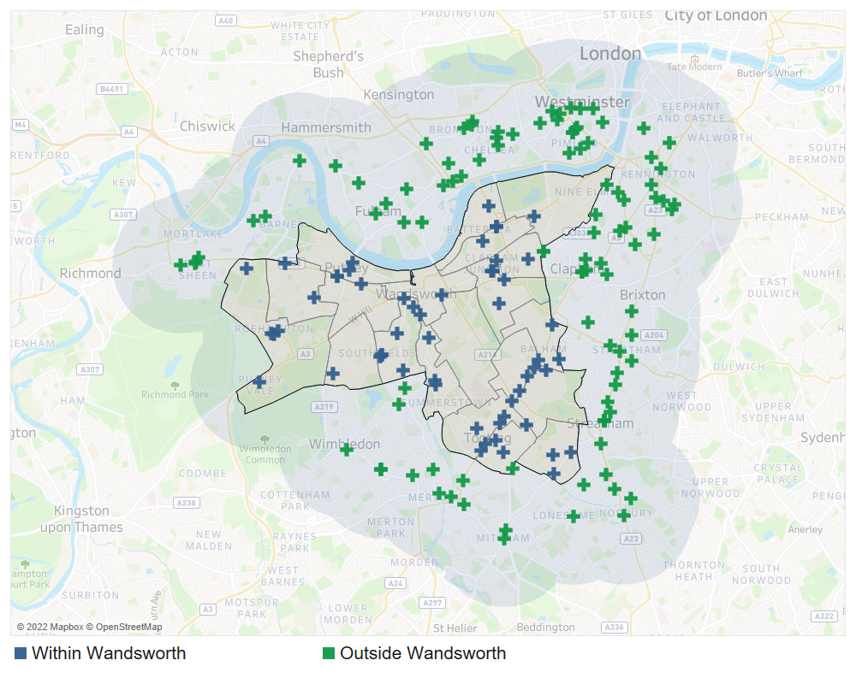
Source: NHSE, 2023

Table 7.7: Number of NMS provided by Wandsworth pharmacies by ward, 2021/22
Ward | Number of Pharmacies | Total Number of NMSs provided | Average NMS per Pharmacy
Queenstown | 1 | 437 | 437
Latchmere | 1 | 427 | 427
West Putney | 2 | 834 | 417
Graveney | 3 | 1,020 | 340
Earlsfield | 3 | 955 | 318
West Hill | 1 | 291 | 291
Bedford | 1 | 281 | 281
Tooting | 5 | 1,252 | 250
Furzedown | 3 | 685 | 228
Northcote | 4 | 816 | 204
Roehampton and Putney Heath | 5 | 990 | 198
Shaftesbury | 2 | 325 | 163
Thamesfield | 5 | 746 | 149
Southfields | 8 | 1,052 | 132
Nightingale | 4 | 463 | 116
Balham | 3 | 275 | 92
St Mary's Park | 2 | 112 | 56
Wandsworth Common | 1 | 25 | 25
Source: NHSE, 2023

              - NMS are supplied widely across the borough within areas of high density and need; therefore, the current provision of the NMS is sufficient to meet the needs of this borough.

Community pharmacy seasonal influenza vaccination
              - Flu vaccination by injection, commonly known as the "flu jab" is available every year on the NHS to protect certain groups who are at risk of developing potentially serious complications, such as:
- anyone over the age of 65
- pregnant women
- children and adults with an underlying health condition (particularly long-term heart or respiratory disease)
- children and adults with weakened immune systems
              - GPs currently provide majority of the flu vaccinations and pharmacies can help improve access to this service given their convenient locations, extended opening hours and walk-in service. The National Advanced Flu Service is an advanced service commissioned by NHS England to maximise the uptake of the flu vaccine by those who are ‘at-risk’ due to ill-health or long terms condition.
              - A large proportion of community pharmacies in the borough provided flu vaccines (56/60) in Wandsworth in 2021/22. Another 86 outside but bordering the borough provided the service. The distribution of these pharmacies is shown in Figure 7.14 and Table 7.8.
Figure 7.14: Pharmacies providing Flu vaccination and their 1-mile coverage February 2023
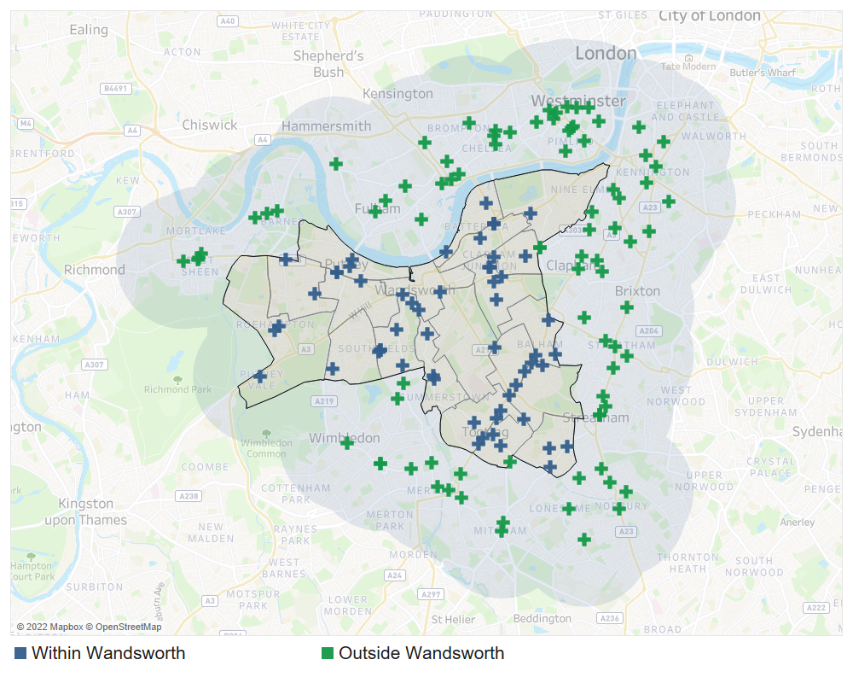
Source: NHSE, 2023

Table 7.8: Pharmacies that provide Flu vaccinations in Wandsworth by ward, October 2022
Ward | Number of pharmacies
Southfields | 8
Tooting | 5
Thamesfield | 5
Northcote | 5
Nightingale | 5
St Mary's Park | 4
Roehampton and Putney Heath | 3
Graveney | 3
Furzedown | 3
Earlsfield | 3
Balham | 3
West Putney | 2
Shaftesbury | 2
West Hill | 1
Wandsworth Common | 1
Queenstown | 1
Latchmere | 1
Bedford | 1
Total | 56
Source: NHSE, 2022

              - Overall, there is strong coverage of this service across Wandsworth. Therefore, the current provision Advanced Flu Service is sufficient to meet the needs of this borough. However, as identified in Chapter 5, flu vaccination uptake in the borough is low among the over 65s and the “at-risk” group. Commissioners should explore with providers ways of working with existing contractors to promote this service, alongside the London Seasonal Influenza Vaccination Service (an Enhanced Service) to increase vaccination uptake among this group.

Community pharmacist consultation service
              - The community pharmacist consultation service (CPCS) is a new service provided by pharmacies, launched in October 2019. The aims of the service are to support the integration of community pharmacy into the urgent care system, and to divert patients with lower acuity conditions or who require urgent prescriptions from the urgent care system to community pharmacies.
              - It also offers patients who contact NHS 111 the opportunity to access appropriate urgent care services in a convenient and easily accessible community pharmacy setting, on referral from an NHS 111 call advisor and via the NHS 111 Online service.
              - There is strong coverage of CPCS in Wandsworth. 50 pharmacies in the borough provided CPCS in 2021/22. There are an additional 90 pharmacies in neighbouring boroughs that provided the service (Figure 7.15 and Table 7.9).
Figure 7.15: Pharmacies providing CPCS and their 1-mile coverage, October 2022 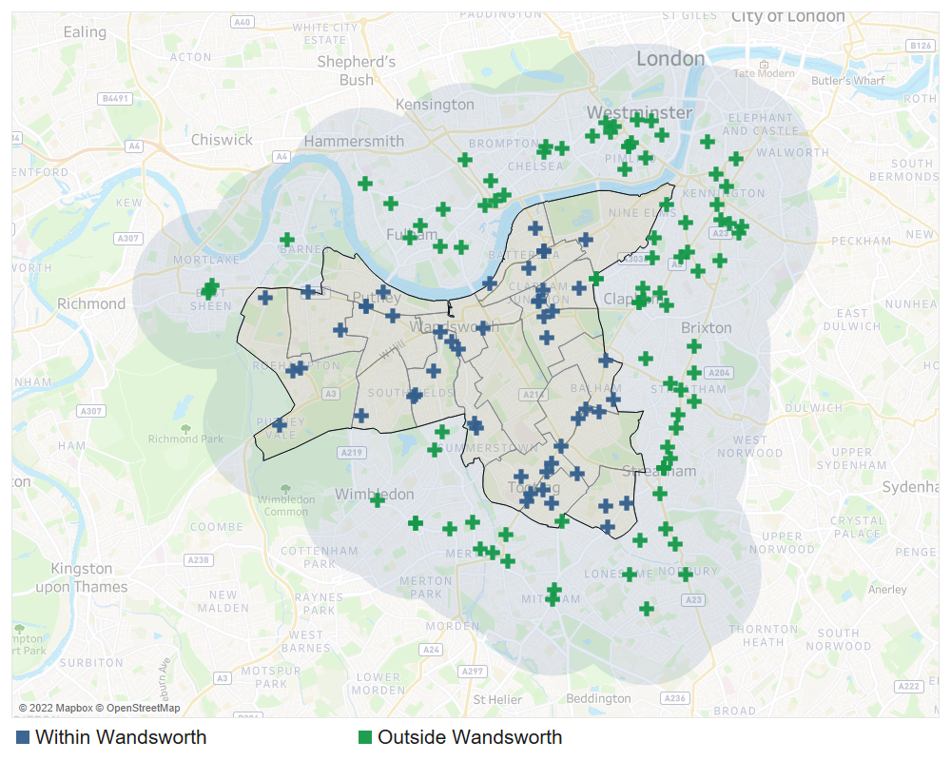
Source: NHSE, 2022

Table 7.9: Pharmacies that provide CPCS in Wandsworth by ward, October 2022
Ward | Number of Pharmacies
Southfields | 6
Tooting | 5
Northcote | 5
St Mary's Park | 4
Thamesfield | 4
Roehampton and Putney Heath | 4
Nightingale | 3
Graveney | 3
Furzedown | 3
West Putney | 2
Shaftesbury | 2
Earlsfield | 2
Balham | 2
West Hill | 1
Wandsworth Common | 1
Queenstown | 1
Latchmere | 1
Bedford | 1
Total | 50
Source: NHSE, 2022

Hypertension case-finding service
              - Hypertension case-finding service is a relatively new service and at the time of publication, 37 pharmacies indicated in the contractor survey that they deliver this service.

Community pharmacy hepatitis C antibody testing service
              - NHSE data did not show any pharmacy offering community pharmacy hepatitis C antibody testing service as of the time of publication as this is a new service. However, all pharmacies can deliver this service if they choose to.

Community pharmacy smoking cessation service
              - This service was introduced in March 2022 as an Advanced Service for patients who started their stop-smoking journey in hospital. This service is identified as a key service to improve the prevention of avoidable illness.
              - Twenty-one pharmacies indicated in the contractor survey that they deliver this service. A further 21 indicated a willingness to provide this service.

Appliance use reviews
              - Appliance use reviews (AUR) are another advanced service that community pharmacy and appliance contractors can choose to provide so long as they fulfil certain criteria.
              - AURs can be carried out by, a pharmacist or a specialist nurse either at the contractor’s premises or at the patient's home. AURs help patients to better understand and use their prescribed appliances by:
- Establishing, the way the patient uses the appliance and the patient's experience of such use
- Identifying, discussing, and assisting in the resolution of poor or ineffective use of the appliance by the patient
- Advising the patient on the safe and appropriate storage of the appliance
- Advising the patient on the safe and proper disposal of the appliances that are used or unwanted.
              - While all pharmacies can provide this service, no pharmacies within or bordering the borough provided this service in 2021/22. AURs are typically provided by prescribing health and social care providers.

Stoma appliance customisation service
              - The stoma appliance customisation (SAC) service involves the customisation of a quantity of more than one stoma appliance, based on the patient's measurements or a template. The aim of the service is to ensure proper use and comfortable fitting of the stoma appliance and to improve the duration of usage, thereby reducing waste.
              - No pharmacies provided SACs within Wandsworth in 2021/22.
              - Residents can also access the SAC service either from non-pharmacy providers within the borough (e.g., community health services) or from dispensing appliance contractors outside of the borough. Therefore, the current provision of SAC service is sufficient to meet the needs of this borough.

Summary of the Advanced Pharmacy Services
It is concluded that there is currently sufficient provision for the following advanced services to meet the likely needs of residents in Wandsworth:
- New medicine service
- Community pharmacy seasonal influenza vaccination
- Community pharmacist consultation service
- Hypertension case-finding service
- Community pharmacy hepatitis C antibody testing service
- Community pharmacy smoking cessation service
- Appliance use reviews
- Stoma Appliance Customisation service

Enhanced pharmacy services
              - NHSE&I currently commission three locally enhanced services in the London Region. These are the London Seasonal Influenza Vaccination Service, the Bank Holiday Rota Service, and the COVID-19 Vaccination Service.

London seasonal influenza vaccination service
              - This service is commissioned by NHSE&I London Region to enhance the delivery of flu vaccination coverage already delivered by the Advanced Flu Service. Any pharmacy in London can chose to deliver this service. They also offer provision for pneumococcal vaccination to eligible cohorts and MenACWY for 18–24-year-olds living permanently or temporarily in London. The aims of the service are to:
- sustain and maximise uptake of flu vaccine in at-risk groups by continuing to build the capacity of community pharmacies as an alternative to general practice attendance
- to provide more opportunities and improve convenience for eligible patients to access flu vaccinations
- include provision of flu vaccinations to a wider patient group, including carers, asylum seekers and the homeless and children from 2 to 18 years.
              - As at the time of publication, NHSE data was not yet available for these services. However, as identified in Chapter 5, the uptake of flu vaccination by the over 65s and the ‘at risk’ population is low in Wandsworth. Commissioners should work with existing pharmacy provision to improve vaccination coverage with this group.

Bank holiday rota service
              - To ensure pharmacy services are available during bank holidays, NHSE&I commission pharmacies to open during bank holidays on a rota basis as an enhanced service. This also ensures pharmacies are accessible to other out of hours providers, thus enabling patients to easily access medication if required.
              - Three pharmacies provide this service in Wandsworth: Barrons Chemist in Tooting, Barkers Chemist in Battersea and R Walji Pharmacy in Tooting.

COVID-19 vaccination service
              - NHSE&I commissioned pharmacies to provide the COVID-19 vaccine service. The purpose of this commissioned service is to maximise uptake of the COVID-19 vaccine and improve availability of choice and convenience for patients, in their accessible locations. This service is commissioned as and when required. At the time of the production of this PNA, six pharmacies provide COVID-19 vaccinations in Wandsworth.

Summary of other NHS pharmacy services
              - It is concluded that there is currently sufficient provision for the following Enhanced pharmacy services to meet the likely needs of residents in Wandsworth:
- London Seasonal Influenza Vaccination Service
- Bank Holiday Rota Service
- COVID-19 Vaccination Service

Other NHS pharmacy services
              - Other NHS pharmacy services are services commissioned by the London Borough of Wandsworth and Southwest London (SWL) ICB to fulfil a local population health and wellbeing need. The Wandsworth enhanced services are listed below:
- Local authority commissioned services:
  - Needle exchange service
  - Supervised consumption service
  - Emergency contraception service
  - Chlamydia screening service
  - Chlamydia treatment service
- SWL ICB commissioned services:
  - Out of hours palliative care dispensing & medicines advice
- The provision of these services is explored.

Needle exchange service
              - The London Borough of Wandsworth commissioned this service to address the needs of problematic drug users and improve their health and social outcomes.
              - Community based needle exchanges are an important and easily accessible public health intervention. They help prevent the spread of blood borne diseases such as HIV and hepatitis and other drug related harm, including drug related deaths. Drug users who use this service are often not in touch with other specialist treatment drug services.
              - The overall aim of the service is to contribute to health protection and health improvement needs of individuals who inject drugs (including but not restricted to opiates, stimulants, new psychoactive substances and performance and image enhancing drugs). Minimising wider community harms linked to unsafe use and disposal of injecting equipment is an integral component of national and local harm reduction strategies.
              - The service objective is to provide a comprehensive open access healthcare package through the provision of needle exchange outlets through community pharmacy, by:
- Embracing and addressing the principles of harm reduction, including the education and training for service users and their significant others on overdose prevention and management, the use of Naloxone and the availability of injecting paraphernalia
- Providing service users with a fair and dignified service, irrespective of their ethnic/cultural background, gender, sexual orientation, employment status, religious beliefs, HIV/Hepatitis status or current drug treatment status
- Providing value for money, with the “best value” principle being applied to each decision about care. This will not over-ride a service user’s social or healthcare needs but will work in conjunction with these
- ensuring that all participating services are resourced in a timely fashion and that public health alerts are disseminated rapidly and effectively; and
- ensuring that the manner and content of service delivery is based upon sound research, best practice principles and practitioner experience.
              - There are 12 pharmacies in Wandsworth that provide this service. These are presented in Figure 16 and listed in Table 7.10.
Figure 16: Location of pharmacies that provide the needle exchange service in Wandsworth, 2022
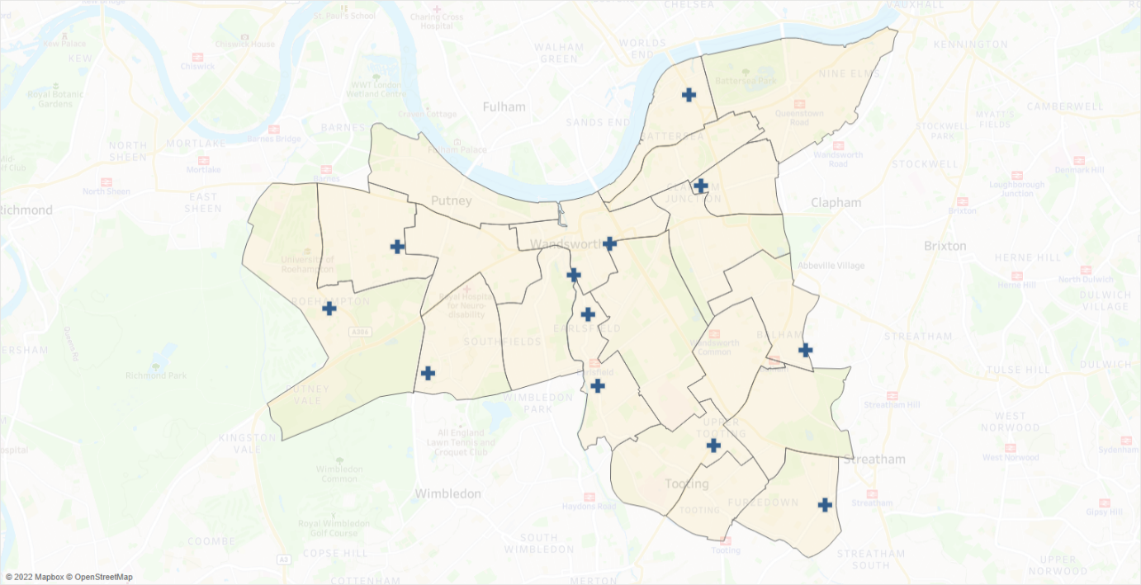
Source: London Borough of Wandsworth, 2022

Table 7.10: Pharmacies that provide the needle exchange services in Wandsworth by ward, 2022
Pharmacy | Address | Ward
Markrise Limited | 121-125 Mitcham Lane, West Streatham, London | Furzedown
Medipharmacy Limited | 30 Chartfield Avenue, London | West Putney
Healthchem (Battersea) Ltd | 166-168 Battersea Bdge Rd, London | St Mary's Park
Pharmalite Limited | 296 Cavendish Road, Balham, London | Balham
Tooting Pharmacy Practice | 175 Upper Tooting Road, London | Tooting
East Hill Pharmacy | 53 East Hill, Wandsworth, London | Wandsworth Common
Barkers Chemist | 245 Garratt Lane, Wandsworth, London | Earlsfield
Dumlers Pharmacy | 436-438 Garratt Lane, London | Earlsfield
Wandsworth Pharmacy | 96 Garratt Lane, Wandsworth, London | Southfields
Aura Pharmacy | 78 Inner Park Road, Wimbledon Parkside, London, | West Hill
Well | 31A Danebury Avenue, Roehampton, London | Roehampton and Putney Heath
Boots | 10 Falcon Lane, Clapham Junction, London | Shaftesbury
Source: London Borough of Wandsworth, 2022

Supervised consumption service
              - The London Borough of Wandsworth also commission pharmacies to deliver a supervised consumption service. This service enables drug users to access pharmacologically assisted treatment, to aid their recovery from addiction to opioids. It supports service user compliance with a prescribed regime by supervised consumption of Methadone, Buprenorphine and Buprenorphine with Naloxone / Buprenorphine Oral Lyophilisate (Espranor) and other prescribed medicines.
              - The purpose of this service is to minimise misdirection of controlled drugs leading to a reduction of drug related deaths in the community due to opioid toxicity.
              - Forty-five pharmacies in Wandsworth provide this service. These are presented in Figure 7.17 and Table 7.11.
Figure 7.17: Location of pharmacies that provide the supervised consumption service in Wandsworth, 2022
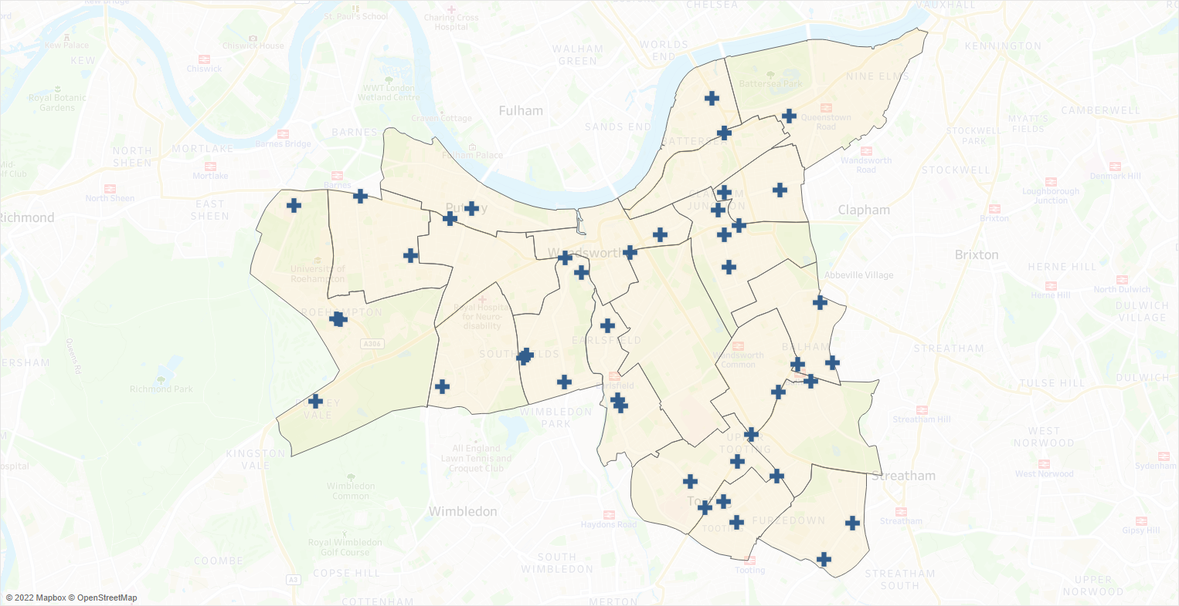Source: London Borough of Wandsworth, 2022

Table 7.11: Number of Pharmacies that provide the supervised consumption services in Wandsworth by ward, 2022
Ward | Number of Pharmacies
Southfields | 6
Roehampton and Putney Heath | 4
Northcote | 4
Tooting | 3
Thamesfield | 3
St Mary's Park | 3
Graveney | 3
Earlsfield | 3
Balham | 3
West Putney | 2
Shaftesbury | 2
Nightingale | 2
Furzedown | 2
West Hill | 1
Wandsworth Common | 1
Queenstown | 1
Fairfield | 1
Bedford | 1
Source: London Borough of Wandsworth, 2022

Emergency contraception service
              - The provision of Emergency Contraception (EC) to women plays an important role in the prevention of unplanned pregnancies by reducing the risk of pregnancy after unprotected sexual intercourse.
              - Pharmacies provide an excellent opportunity to reach young people due to their high street location; long opening hours and non-medical setting.
              - The aim of the service is to improve access to emergency contraception via Patient Group Directions (PGD) in Community Pharmacies to support work to reduce unplanned pregnancies in Wandsworth. Its objectives include:
- To increase access to emergency contraception to people aged 13 and above.
- To increase knowledge, especially among young people, of all types of contraception, including EC and Long-Acting Reversible Contraception (LARC).
- To reach sexually active young people who do not access their General Practitioner or Integrated Sexual Health Services (ISH).
- Improve the sexual health of young people by integrating EC with other related services including Chlamydia and Gonorrhoea screening / treatment and provision of free condoms.
- To safeguard children and vulnerable adults who are experiencing or may have experienced abuse and/or sexual exploitation.
- To situate the provision of EC in Community Pharmacies within the wider landscape of sexual health and contraception provision in the borough to ensure smooth pathways both to and from ISH including Sexual Health London so that patients get the appropriate level of care to meet their needs at the right level of service.
- To increase partnership working between Community Pharmacists and other providers including General Practitioners, ISH Services, and Safeguarding Agencies.
              - Thirty-one pharmacies provide this service in Wandsworth. These are presented in Figure 7.18 and Table 7.12.
Figure 7.18: Location of pharmacies that provide emergency contraception service in Wandsworth, 2022
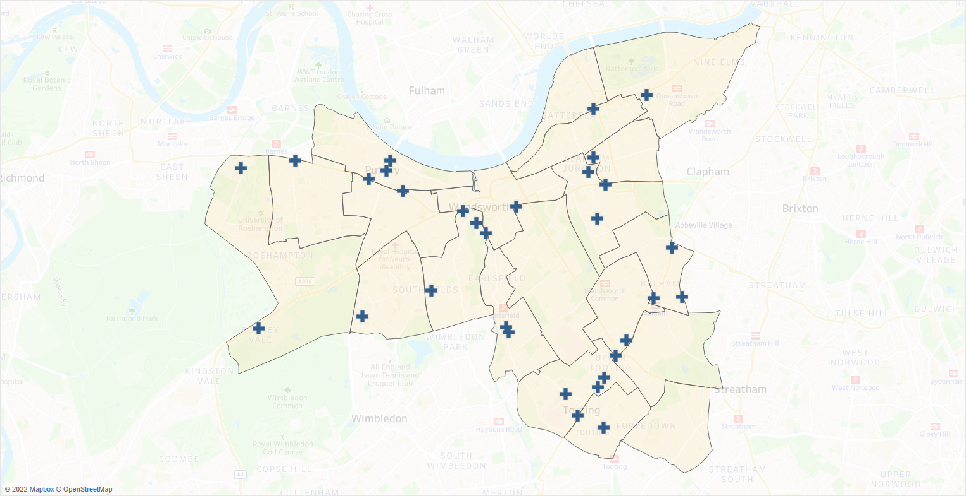
Source: London Borough of Wandsworth, 2022

Table 7.12: Number of Pharmacies that provide emergency contraception services in Wandsworth by ward, 2022
Ward | Number of Pharmacies
Tooting | 4
Thamesfield | 4
Southfields | 4
Northcote | 3
Balham | 3
Roehampton and Putney Heath | 2
Nightingale | 2
Earlsfield | 2
West Putney | 1
West Hill | 1
Wandsworth Common | 1
St Mary's Park | 1
Shaftesbury | 1
Queenstown | 1
Graveney | 1
Source: London Borough of Wandsworth, 2022

Chlamydia screening service
              - In line with the National Chlamydia Screening Programme the London Borough of Wandsworth commission pharmacies to deliver chlamydia screening to improve screening coverage in under 25s. The aim of this service is to provide easier access to chlamydia screening to prevent and control Chlamydia and Gonorrhoea through early detection and treatment of asymptomatic infection. Its objectives are to:
- To increase the number of young people aged under 25 who are screened - including young men who are not accessing sexual health services - in a safe and confidential environment.
- To offer Chlamydia screening opportunistically to young people accessing Community Pharmacies for related reasons, e.g. condoms, contraceptive pills, EHC and LARC.
- To increase early detection and treatment of Chlamydia and Gonorrhoea and therefore reduce transmission and related health complications.
- To respond faster to client needs by:
  - strengthening and increasing partnership work between local services
  - improving referral and signposting
- To increase understanding - and raise awareness - of the importance of Chlamydia and other sexually transmitted infections in sexually active young people.
- To de-stigmatise Chlamydia infection, raise awareness of safer sexual practices and normalise sexual health screening.
- To ensure widely accessible dual screening to avoid undermining gains already made to normalise Chlamydia screening and reduce stigma.
- To improve professionals’ confidence around discussing sexual health issues with young people.
              - In Wandsworth 29 pharmacies provide this service. These are presented in Figure 7.19 and Table 7.13.
Figure 7.19: Location of pharmacies that provide chlamydia screening service in Wandsworth, 2022
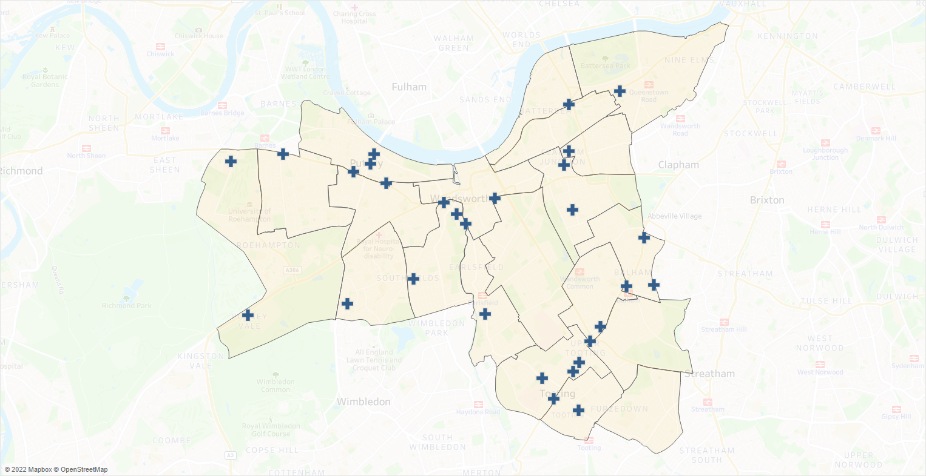
Source: London Borough of Wandsworth, 2022

Table 7.13: Number of Pharmacies that provide chlamydia screening services in Wandsworth by ward, 2022
Ward | Number of Pharmacies
Tooting | 4
Thamesfield | 4
Southfields | 4
Balham | 3
Roehampton and Putney Heath | 2
Northcote | 2
Nightingale | 2
West Putney | 1
West Hill | 1
Wandsworth Common | 1
St Mary's Park | 1
Shaftesbury | 1
Queenstown | 1
Graveney | 1
Earlsfield | 1
Source: London Borough of Wandsworth, 2022

Chlamydia treatment service
              - The aim of delivering Chlamydia treatment in community pharmacies is to facilitate easy and fast access to treatment for asymptomatic chlamydia as part of efforts to prevent and control chlamydia through early detection and treatment. It is delivered in conjunction with the Chlamydia Screening service in Wandsworth.
              - Its objectives are to:
- Improve access to treatment of asymptomatic individuals with Chlamydia infection aged 15 – 24 years old.
- Improve access to treatment of asymptomatic partners (any age) of Chlamydia positive index service users.
- Increase re-testing and partner/contact notification.
- Strengthen the network of sexual health services in the community.
- Help provide easy and swift access to advice and Chlamydia treatment.
              - Six pharmacies provide this service in Wandsworth. These are presented in Figure 7.20 and Table 7.14.
Figure 7.20: Location of pharmacies that provide chlamydia screening service in Wandsworth, 2022
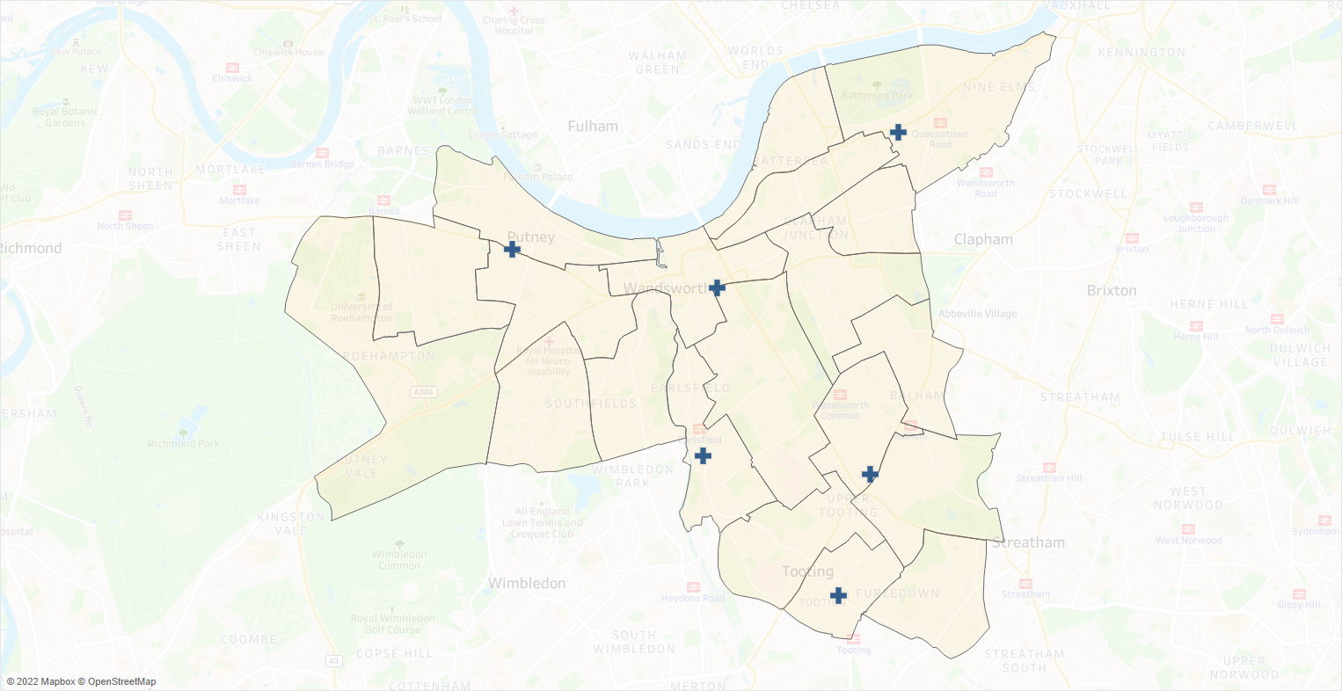
Source: London Borough of Wandsworth, 2022

Table 7.14: Pharmacies that provide chlamydia screening services in Wandsworth, 2022
Pharmacy | Address | Ward
Pearl Chemist | 159-161 Mitcham Road, Tooting, London | Graveney
Trinity Pharmacy | 278A-280 Balham High Road, London | Nightingale
Putney Pharmacy | 278 Upper Richmond Road, Putney, London | Thamesfield
East Hill Pharmacy | 53 East Hill, Wandsworth, London | Wandsworth Common
Day Lewis Pharmacy | 299-303 Battersea Park Rd, Battersea, London | Queenstown
Dumlers Pharmacy | 436-438 Garratt Lane, London | Earlsfield
Source: London Borough of Wandsworth, 2022

Out of hours palliative care dispensing & medicines advice
              - This service has been developed to ensure that patients and healthcare professionals have secure access to specialist palliative care drugs in the community outside normal dispensing hours, when required.
              - It was developed to fill a gap that had been identified in Wandsworth out of hours dispensing of palliative care drugs. This service will improve of dispensing and best practice in the management of end-of-life care and safe and effective symptom management for palliative care patients at home. Its aims are to deliver care closer to home and reduce unnecessary and avoidable hospital admissions.
              - One pharmacy delivers this service in Wandsworth: Pearl Pharmacy, Tooting.

Summary of other NHS pharmacy services
              - It is concluded that there is currently sufficient provision for the following other NHS services to meet the likely needs of residents in Wandsworth:
- Needle exchange service
- Supervised consumption service
- Emergency contraception service
- Chlamydia screening service
- Chlamydia treatment service
- Palliative Care Dispensing & Medicines Advice

Additional considerations from contractor survey responses

Languages spoken in pharmacies
              - According to the contractor survey responses, there is a wide range of languages spoken in Wandsworth pharmacies. The most common languages besides English spoken by pharmacy staff are Gujarati, Hindi and Urdu. As identified in chapter 4, the most common non-English languages for the borough’s residents are Polish, Urdu and French.
              - Thirteen pharmacies have staff that speak Polish, 26 have staff that can speak Urdu and ten have staff who can speak French.
              - Table 7.15 lists the most common languages spoken by a member of staff in Wandsworth pharmacies.
Table 7.15: Top 10 languages spoken by a member of staff at the pharmacies in Wandsworth
Language | Number of Pharmacies
Gujarati | 31
Hindi | 30
Urdu | 26
Polish | 13
French | 10
Spanish | 9
Arabic | 7
Tamil | 6
Mandarin | 5
Farsi | 4

Conclusions and statements
              - This PNA has considered the current provision of pharmaceutical services across the London Borough of Wandsworth and assessed whether it meets the needs of the population and whether there are any gaps in the provision of pharmaceutical services either now or within the lifetime of this document, 22nd June 2023 to 21st June 2026.
              - This chapter will summarise the provision of these services in Wandsworth and its surrounding local authorities.

Current provision
              - The Wandsworth PNA steering group has identified the following services as necessary to this PNA to meet the need for pharmaceutical services:
- Essential services provided at all premises included in the pharmaceutical lists.
              - Other Relevant Services are services provided which are not necessary to meet the need for pharmaceutical services in the area, but which nonetheless have secured improvements or better access to medicines. The Wandsworth PNA steering group has identified the following as Other Relevant Services:
- Adequate provision of advanced, enhanced, and other NHS pharmacy services to meet the need of the local population.

Current access to essential services
              - In assessing the provision of essential services against the needs of the population, the PNA steering group considered access as the most important factor in determining the extent to which the current provision of essential services meets the needs of the population. To determine the level of access within the borough to pharmaceutical services, the following criteria were considered:
- Distance and travel time to pharmacies
- Opening hours of pharmacies
- Proximity of pharmacies to GP practices
              - There are 1.8 community pharmacies per 10,000 residents in Wandsworth. This ratio is below the national average of 2.2.
              - All of the borough’s population is within 1 mile of a pharmacy. Additionally, all residents are within a 20-minute commute of a pharmacy via public transport. All current GP practices are also within 1 mile of a pharmacy.
              - All pharmacies are open for at least 40 hours each week. There are 60 community pharmacies in the borough, and a further 111 within a mile of the border of Wandsworth, providing good access as determined in Chapter 7.
              - On weekdays, ten pharmacies are open before 9am and seven are open after 7pm. These are mapped out on Chapter 7 and show good coverage of services available on weekdays outside normal working hours.
              - Fifty of the borough’s 60 community pharmacies are open on Saturday. Nine pharmacies in the borough are open on Sunday.
              - The opening of the health centre in Nine Elms (currently Queenstown Ward) along with the accompanying housing development represents a change in demand of pharmaceutical services in the area. However, the health centre is within a mile of 10 pharmacies, four of which are less than 20 minutes’ walk from the health centre.
The results of the PNA conclude that there are no current gaps in the provision of essential services for the lifetime of this PNA.

Current access to advanced services
              - The following advanced services are currently available for provision by community pharmacies: new medicine service, community pharmacy seasonal influenza vaccination, community pharmacist consultation service, hypertension case-finding service, community pharmacy hepatitis C antibody testing service, community pharmacy smoking cessation service, appliance use reviews and stoma appliance customisation.
              - NMS is widely available with 54 pharmacies in the borough providing it.
              - Flu vaccinations are also widely provided, with 56 pharmacies in the borough offering them. However, commissioners should explore with providers ways of working with existing contractors to promote the services to increase vaccination uptake in over 65 and the ‘at-risk’ populations.
              - The hepatitis C antibody testing service is a new service which all pharmacies can deliver.
              - Fifty of the borough’s community pharmacies offer the Community Pharmacy Consultation Service.
              - Thirty-seven pharmacies provide the Hypertension case-finding service.
              - Twenty-one indicated that they provide the community pharmacy smoking cessation service in the contractor survey.
              - No Wandsworth pharmacy recorded providing AURs in the last year. However, pharmacies have indicated they are able to provide these if there is a need. Advice on the use of appliances is also offered by the hospital or clinic prescribing appliances or from a DAC.
              - Though no pharmacy provided the Stoma Appliance Customisation service in the past year, the service is available from non-pharmacy providers within the borough such as community health services.
              - It is therefore concluded that there is sufficient provision of advanced services to meet the needs of the residents of Wandsworth.
              - The results of the PNA conclude that there are no current gaps in the provision of advanced services for the lifetime of this PNA.

Current access to enhanced pharmacy services
              - There are currently three enhanced services commissioned by the London region of NHSE&I. These are the London Seasonal Influenza Vaccination Service, the Bank Holiday Rota Service (provided by three pharmacies) and the COVID-19 Vaccination Service (delivered by six pharmacies). These are commissioned as and when required.
              - The results of the PNA conclude that there are no gaps in the provision of enhanced pharmacy services for the lifetime of this PNA.

Current access to Other NHS pharmacy services
              - These services are commissioned by the London Borough of Wandsworth and South West London ICB. Pharmacies are commissioned to deliver these services to fulfil the specific health and wellbeing of the Wandsworth population. These services include needle exchange, supervised consumption, emergency contraception, chlamydia screening, chlamydia treatment and Community Pharmacy Out of Hours Palliative Care Dispensing & Medicines Advice services.
              - Twelve pharmacies offer the needle exchange while 45 offer supervised consumption services. The emergency contraception service is available from 31 pharmacies, chlamydia screening from 29 while chlamydia testing is available from six pharmacies. One pharmacy delivers the Community Pharmacy Out of Hours Palliative Care Dispensing & Medicines Advice service.
              - Overall, there is very good availability of Other NHS pharmacy services in the borough.
              - The results of the PNA conclude that there are no current gaps in the provision of other NHS pharmacy services in the lifetime of this PNA.

Future Provision
              - The Health and Wellbeing Board has considered the following future developments:
- Forecasted population growth
- Housing Development information
- Regeneration projects
- Changes in the provision of health and social care services
- Other changes to the demand for services

Future access to essential services

Future access to essential services during normal working hours
              - There are a number of large new dwelling developments planned in Wandsworth. The largest are located within Queenstown Ward and Fairfield Ward. A total of 4,476 new units are planned for Queenstown Ward. The largest development areas include:
- Royal Mail Group Site, Ponton Road (Nine Elms Park) in Queenstown Ward with 1,725 net units planned
- New Covent Garden Market, Nine Elms Lane in Queenstown Ward with 981 net units planned
- Market Towers, 1 Nine Elms Lane (One Nine Elms) in Queenstown Ward with 494 units planned
- South Lambeth Goods Depot, Cringle St./Battersea Park Rd., Kirtling Street (Battersea Power Station) in Queenstown Ward with 425 units planned
              - It is projected that the population size of the Queenstown ward will increase by 16.8% to 26,914, in the lifetime of this PNA. It will increase by 63.4% by 2032. There is currently one pharmacy within this ward.
              - In addition, a new health centre is opening in Nine Elms which will lead to an increase demand of pharmaceutical services in the area.
              - A total of 1,207 new dwelling development units are planned for Fairfield Ward in the lifetime of this PNA, the largest being: Homebase, Swandon Way in Fairfield Ward with 480 units planned. The population of Fairfield Ward is projected to increase by 5.7% to 16,973. There is enough provision of pharmacies to service this population increase.
There will be a gap in the future provision of essential pharmaceutical services in Nine Elms Ward (previously known as the Queenstown Ward) due to likely increased demand of pharmaceutical services as a result of projected population. increases in the area. This will need to be monitored and addressed in a planned way with reference to the new health centre development and its opening hours.

Future access to essential services outside normal working hours
              - The Health and Wellbeing Board is not aware of any notifications to change the supplementary opening hours for pharmacies at the time of publication.
The results of the PNA conclude that there are no gaps in the future provision of essential services outside of normal working hours in the lifetime of this PNA.

Future access to advanced services
              - Through the contractor survey, local pharmacies have indicated that they have capacity to meet future increases in demand for advanced services.
The results of the PNA conclude that there are no gaps in the future provision of advanced services in the lifetime of this PNA.

Future access to enhanced services
              - Through the contractor survey, local pharmacies have indicated that they have capacity to meet future increases in demand for enhanced services.
The results of the PNA conclude that there are no gaps in the future provision of enhanced services in the lifetime of this PNA.

Future access to other NHS pharmacy services
              - Through the contractor survey, local pharmacies have indicated that they have capacity to meet future increases in demand for other NHS pharmacy services.
The results of the PNA conclude no gaps in the future provision of locally commissioned Other NHS services in the lifetime of this PNA.

Improvements and better access

Current and future access to essential services
              - In consideration of population health and wellbeing needs and needs of those who share protected characteristics, the PNA did not identify any services, that if provided, either now or in future, would secure improvements or better access to essential services. Further, there is sufficient capacity to meet any increased future demand.
The results of the PNA conclude that there are no unmet pharmaceutical needs in essential services, that if provided now or in the future, would secure improvements or better access to essential services during the lifetime of this PNA.

Current and future access to advanced services
              - NMS, flu vaccination, CPCS, hypertension case finding, hepatitis C antibody testing and smoking cessation services are all widely available throughout Wandsworth and there is sufficient capacity for more pharmacies to provide them.
              - While there are no pharmacies delivering AURs or SACs, these are provided by other community health services and pharmacies can provide them if required.
              - The PNA analysis has concluded that there is sufficient capacity to meet any increased demand of advanced services.
              - The results of the PNA conclude that there is no additional need in the provision of advanced services at present or in the future, that would secure improvements or better access to advanced services in the lifetime of this PNA.

Current and future access to enhanced pharmacy services
              - There is good provision of services commissioned by NHE&I, the London Region. The PNA did not find any evidence to conclude that the services these pharmacies offer should be expanded.
              - The results of the PNA conclude that there are no gaps, either now or in the future, that if provided would secure improvements or better access to Enhanced Pharmacy Services in the area.

Current and future access to other NHS pharmacy services
              - These are commissioned as and when required. The PNA did not identify any services, that if provided either now or in future would secure improvements or better access to the enhanced services offered. Local pharmacies have also indicated that they have capacity for future increases in demand for other NHS pharmacy services through the contractor survey.
              - Due the uncertainty of the demographic make-up of the population of the new residents in the Battersea developments, the needs of these residents with respect to specific commissioned services cannot be determined but should continue to be considered.
              - The results of the PNA conclude that there is no additional need, either now or in the future, that if provided would secure improvements or better access to other locally commissioned services in the area in the lifetime of this PNA.

Appendix A – PNA Steering Group Terms of Reference
RICHMOND AND WANDSWORTH
PHARMACEUTICAL NEEDS ASSESSMENT STEERING GROUP
TERMS OF REFERENCE

Purpose:
The purpose of this steering group is to support the production of the Pharmaceutical Needs Assessments on behalf of Richmond and Wandsworth Health and Wellbeing Boards.
The team will be a task and finish group, meeting over a period of approximately 1 year, beginning May 2022.

Membership:
The steering group contains representatives from: -
- The Public Health Teams
- Local Pharmaceutical Committees
- Local Medical Committees
- Healthwatch
- South West London CCG/Integrated Care Board
- NHS England/NHS Improvement
- Insight and Analytics Team
- Communication and Engagement Team
- Others can be co-opted as required

Quoracy
The Steering Group shall be quorate if there are one or more representatives from the following groups in attendance:
- The Public Health Team
- Local Pharmaceutical Committee for each borough
- SW London CCG/Integrated Care Board

Frequency of meetings
The group will initially meet monthly, followed by less frequent meetings as required.

Governance and accountability
- The steering group will report to the Director of Public Health, Shannon Katiyo.
- We will request the HWB to delegate the sign-off of the pre-consultation version of the PNA to the steering group.
- We will request the HWB to sign off the final version of the PNA for publication.
- Papers will be circulated at least 5 days before the meeting, and notes of meeting to go out within 4 working days of the meeting.

Key responsibilities
Group
- To oversee PNA production including developing processes and advising on project timeline and document structure.
- To ensure that development of the PNA meets the statutory responsibilities of the HWBs.
- To ensure active engagement from stakeholders.
- To support public and contractor engagement e.g. advise on questionnaires.
- To agree how the areas will be divided up into localities.
- To review information on health and demographic data and pharmaceutical service provision.
- To consider any current or future gaps in provision of pharmaceutical services and ensure the needs of the populations are articulated in the PNAs.
- To sign off the pre-consultation version of the PNA document.
- To review responses to the formal consultation and agree the response and any amendments required to the PNA.
- To sign off a final draft of PNA to go to the HWB for approval prior to publication.

Individual Members
- Representatives from Healthwatch will work in a purely advisory capacity and will not contribute to decision making/sign-off of PNA documents.
- The meeting will be administered by the provider and will be co-chaired by the consultant in public health

Updated June 2022

Appendix B – Pharmacy provision within Wandsworth and one mile of its border
HWB | Contract Type | ODS Code | Pharmacy | Address | Post Code | Early Opening | Late Closing | Open on Saturday | Open on Sunday
Wandsworth | Community | FAJ87 | Markrise Limited | 121-125 Mitcham Lane, West Streatham, London | SW16 6LY | No | No | Yes | No
 |  | FC061 | Boots | 153/155 Balham High Road, London | SW12 9AU | Yes | Yes | Yes | Yes
 |  | FC815 | Boots | 95/98 The Wandsworth, Shopping Centre, Wandsworth, London | SW18 4TG | No | No | Yes | Yes
 |  | FCG60 | Day Lewis Pharmacy | 256-258 Balham High Road, Balham, London | SW17 7AW | No | No | No | No
 |  | FCK89 | Walji R | 6 Rockingham Close, Lennox Estate Putney, London | SW15 5RW | No | No | Yes | No
 |  | FCL10 | Husbands Pharmacy | 124 Upper Richmond Road, Putney, London | SW15 2SP | No | No | Yes | No
 |  | FD303 | Boots | 45/53 Putney High Street, London | SW15 1SP | No | No | Yes | Yes
 |  | FDC47 | Pearl Chemist | 159-161 Mitcham Road, Tooting, London | SW17 9NH | No | No | Yes | No
 |  | FDN74 | Boots | 31-33 Replingham Road, Southfields, London | SW18 5LT | No | Yes | Yes | Yes
 |  | FDQ20 | Medipharmacy Limited | 30 Chartfield Avenue, London | SW15 6HG | No | No | No | No
 |  | FDV93 | Lords Pharmacy | 98 Tooting High Street, Tooting, London | SW17 0RR | No | No | No | No
 |  | FE297 | Revelstoke Pharmacy | 492A Merton Road, Southfields, London | SW18 5AE | No | No | Yes | No
 |  | FFD49 | Nettles Pharmacy | 18 Upper Tooting Road, London | SW17 7PG | No | No | Yes | No
 |  | FFE83 | Bellevue Pharmacy | 13 Bellevue Road, Wandsworth Common, London | SW17 7EG | No | No | Yes | No
 |  | FFH00 | Healthchem (Battersea) Ltd | 166-168 Battersea Bdge Rd, London | SW11 3AW | No | Yes | Yes | No
 |  | FG141 | Pharmalite Limited | 296 Cavendish Road, Balham, London | SW12 0PL | Yes | No | Yes | No
 |  | FG402 | The Olde Pharmacy | 50 Chatfield Road, Battersea, London | SW11 3UY | No | No | No | No
 |  | FG756 | Cooks Pharmacy | 6 Replingham Road, Southfields, London | SW18 5LS | No | No | No | No
 |  | FGW45 | Earlsfield Pharmacy | 607-609 Garratt Lane, Wandsworth, London | SW18 4SU | No | No | Yes | No
 |  | FH098 | Day Lewis Pharmacy | 123 Lavender Hill, London | SW11 5QL | No | No | No | No
 |  | FH481 | Barrons Chemist | 158A Tooting High Street, Tooting, London | SW17 0RT | Yes | No | Yes | No
 |  | FHL06 | Auckland Rogers Pharmacy | 892 Garratt Lane, London | SW17 0NB | No | No | No | No
 |  | FHM82 | Superdrug Pharmacy | 36 St.Johns Road, Battersea, London | SW11 1PW | Yes | No | Yes | No
 |  | FJE22 | Boots | 59/61 Mitcham Road, London | SW17 9PB | Yes | No | Yes | Yes
 |  | FJL27 | Paydens Pharmacy | 266A Upper Richmond Road, Putney, London | SW15 6TQ | Yes | No | Yes | No
 |  | FK076 | Tooting Pharmacy Practice | 175 Upper Tooting Road, London | SW17 7TJ | No | Yes | Yes | Yes
 |  | FKE89 | East Chemist | 16 High Street, Roehampton, London, | SW15 4HJ | No | No | Yes | No
 |  | FKF82 | Asda Pharmacy | Asda Superstore, 31 Roehampton Vale, Roehampton, London | SW15 3DT | Yes | Yes | Yes | Yes
 |  | FKP10 | Trinity Pharmacy | 278A-280 Balham High Road, London | SW17 7AL | No | No | Yes | No
 |  | FKP46 | Boots | 109 High Street, Putney, London | SW15 1SS | No | No | Yes | No
 |  | FLL81 | Northcote Pharmacy | 130 Northcote Road, London | SW11 6QZ | No | No | Yes | No
 |  | FM656 | Putney Pharmacy | 278 Upper Richmond Road, Putney, London | SW15 6TQ | No | No | Yes | No
 |  | FMC35 | East Hill Pharmacy | 53 East Hill, Wandsworth, London | SW18 2QE | No | No | Yes | No
 |  | FML18 | Day Lewis Pharmacy | 299-303 Battersea Park Rd, Battersea, London | SW11 4LX | No | No | Yes | No
 |  | FMT36 | Barkers Chemist (Tooting) Ltd | 223 Upper Tooting Rd, London | SW17 7TG | No | No | Yes | No
 |  | FN030 | Day Lewis Pharmacy | 145 Franciscan Road, Tooting, London | SW17 8DS | No | No | Yes | No
 |  | FNE38 | Healthchem Pharmacy | 4-5 Station Parade, Balham High Road, London | SW12 9AZ | No | No | Yes | No
 |  | FNG23 | Mansons Dispensing Chemist | 195 Wandsworth High St, London | SW18 4JE | No | No | Yes | No
 |  | FNR03 | Care Chemists | 43 Danebury Avenue, Roehampton, London | SW15 4DQ | No | No | No | No
 |  | FP107 | Krystal Pharmacy | 248 Battersea Park Road, London | SW11 3BP | No | No | Yes | No
 |  | FQM69 | Wellbeing Pharmacy | 13 Replingham Road, Southfields, London | SW18 5LT | No | No | Yes | No
 |  | FQY68 | Paydens Pharmacy | 100 Bedford Hill, Balham, London | SW12 9HR | Yes | No | Yes | No
 |  | FR218 | Barkers Chemist | 245 Garratt Lane, Wandsworth, London | SW18 4DU | No | Yes | Yes | No
 |  | FRF12 | Barkers Chemist | 49 Falcon Road, Battersea, London | SW11 2PH | No | No | Yes | No
 |  | FRF80 | C Bradbury | 86 Moyser Road, Streatham, London | SW16 6SQ | No | No | Yes | No
 |  | FT016 | Boyes Wj Pharmacy (Amichem Ltd) | 61 Balham Hill, London | SW12 9DR | No | No | Yes | No
 |  | FT780 | Dumlers Pharmacy | 436-438 Garratt Lane, London | SW18 4HN | No | No | Yes | No
 |  | FTV91 | Wandsworth Pharmacy | 96 Garratt Lane, Wandsworth, London | SW18 4DH | No | No | Yes | No
 |  | FV141 | Fazal Pharmacy | 225 Merton Road, Southfields, London | SW18 5EE | No | No | No | No
 |  | FV302 | Aura Pharmacy | 78 Inner Park Road, Wimbledon Parkside, London, | SW19 6DA | No | No | Yes | No
 |  | FV807 | Saturn Pharmacy | 75 Mitcham Lane, London | SW16 6LY | No | No | Yes | No
 |  | FVK09 | Boots | 21/23 St.Johns Road, Clapham Junction, London | SW11 1QN | No | No | Yes | Yes
 |  | FVL59 | Boots | 383 Upper Richmond Rd, Putney, London | SW15 5QJ | No | No | Yes | No
 |  | FX183 | Well | 31A Danebury Avenue, Roehampton, London | SW15 4DG | Yes | No | Yes | No
 |  | FX689 | Jennings Chemist | 262 Battersea Park Road, London | SW11 3BP | No | No | Yes | No
 |  | FXN95 | Fairoak Pharmacy | 270 Mitcham Lane, Streatham, London | SW16 6NU | No | No | No | No
 |  | FY670 | Goys The Chemist | 27 Northcote Road, London | SW11 1NJ | No | No | Yes | No
 |  | FYE95 | Clarke Pharmacy | 217 St Johns Hill, Battersea, London | SW11 1TH | No | No | Yes | No
 |  | FYH80 | Robards Dispensing Chemist | 15 Battersea Rise, London | SW11 1HG | Yes | No | Yes | No
 |  | FYN24 | Boots | 10 Falcon Lane, Clapham Junction, London | SW11 2LG | No | Yes | Yes | Yes
Croydon | Community | FPM10 | Superdrug Pharmacy | 1491-1493 London Road, Norbury, London | SW16 3LU | No | No | Yes | No
 |  | FW670 | Bids Chemists | 1495 London Road, Norbury | SW16 4AE | No | No | Yes | No
Hammersmith & Fulham | Community | FCJ02 | Day Lewis Pharmacy | 117-121 Wandsworth Brg Rd, Fulham, London | SW6 2TP | No | No | Yes | No
 |  | FD872 | Palace Pharmacy | 331 Fulham Palace Road, London | SW6 6TE | No | No | Yes | No
 |  | FD905 | Fontain Pharmacy | 290 Munster Road, London, | SW6 6BQ | Yes | No | Yes | No
 |  | FE147 | C.E. Harrod Chemist | 207 New Kings Road, Fulham, London | SW6 4SR | No | No | Yes | No
 |  | FF775 | Oza Chemist | 9 Fulham Broadway, Fulham, London | SW6 1AA | No | No | Yes | No
 |  | FWC05 | Fulham Pharmacy | 608 Fulham Road, London | SW6 5RP | No | No | Yes | No
 |  | FXQ10 | Kanari Pharmacy | 682-684 Fulham Road, London | SW6 5SA | No | No | Yes | No
 |  | FY324 | Boots | 198-200 Fulham Palace Rd, Hammersmith, London, | W6 9PA | No | No | Yes | Yes
Kensington & Chelsea | Community | FE207 | Medicine Chest | 413-415 Kings Road, London | SW10 0LR | No | No | Yes | Yes
 |  | FG051 | Boots | 148-150 Kings Road, Chelsea, London | SW3 4UT | Yes | Yes | Yes | Yes
 |  | FGG58 | It Lloyd | 255 Kings Road, Chelsea, London, | SW3 5EL | No | No | Yes | No
 |  | FJ365 | Zafash Ltd Chemists | 233-235 Old Brompton Road, London | SW5 0EA | Yes | No | Yes | Yes
 |  | FJA08 | Dajani Pharmacy | 92 Old Brompton Road, London | SW7 3LQ | No | Yes | Yes | Yes
 |  | FL862 | Worlds End Pharmacy | 469 Kings Road, London | SW10 0LU | No | No | Yes | No
 |  | FLA67 | Harley'S Pharmacy | 35-37 Old Brompton Road, London | SW7 3HZ | No | Yes | Yes | Yes
 |  | FLR83 | Boots | 228-232 Fulham Road, London | SW10 9NB | No | Yes | Yes | Yes
 |  | FMD22 | Chelsea Green (Astell) Pharmacy | 6 Elystan Street, London | SW3 3NS | No | No | Yes | No
 |  | FN445 | Stickland Chemist | 4-6 The Arcade, S.Kensington Underground, London | SW7 2NA | Yes | No | Yes | No
 |  | FP803 | Andrews Pharmacy | 149B Sloane Street, London | SW1X 9BZ | No | No | Yes | No
 |  | FQH86 | Jhoots Pharmacy | 513 Kings Road, London | SW10 0TX | No | No | No | No
 |  | FRM07 | Chelsea Pharmacy | 61-63 Sloane Avenue, London | SW3 3DH | Yes | Yes | Yes | Yes
 |  | FRP77 | Boots | 60 Kings Road, Chelsea, London | SW3 4UD | Yes | Yes | Yes | Yes
Lambeth | Community | FA196 | Harfleur Chemist | 219 Clapham Road, London | SW9 9BE | No | No | Yes | No
 |  | FA287 | Pulse Pharmacy | 310 Clapham Road, London | SW9 9AE | Yes | No | Yes | No
 |  | FAD50 | Springfield Pharmacy | 110 Union Road, London | SW8 2SH | No | No | No | No
 |  | FAF00 | Shacklock Chemist | 239 Streatham High Road, London | SW16 6EN | No | No | Yes | No
 |  | FAN35 | Boots | 206/208 Streatham High Rd, London | SW16 1BB | Yes | No | Yes | Yes
 |  | FC394 | Superdrug Pharmacy | 156-158 Clapham High St, Clapham, London | SW4 7UG | No | No | Yes | No
 |  | FC525 | Kamsons Pharmacy | The Manor Health Centre, 86 Clapham Manor Street, Clapham, London | SW4 6EB | Yes | No | No | No
 |  | FCV61 | Westbury Chemist | 84-92 Streatham High Road, Streatham, London | SW16 1BS | No | Yes | Yes | Yes
 |  | FD807 | Lloydspharmacy | Sainsburys Store, 480 Streatham High Road, London | SW16 3PY | Yes | Yes | Yes | Yes
 |  | FDA72 | Day Lewis Pharmacy | Palace Rd Surgery, 1A&1B Palace Road, London | SW2 3DY | No | No | Yes | No
 |  | FDF87 | Phillips Pharmacy | 70A Clarence Avenue, London | SW4 8JP | No | No | Yes | No
 |  | FFV30 | Pearl Pharmacy | 31 Clapham High Street, Clapham, London | SW4 7TR | Yes | Yes | Yes | Yes
 |  | FGL32 | Upper Tulse Hill Chemist | 23 Upper Tulse Hill, London | SW2 2SD | No | No | Yes | No
 |  | FGV47 | Watts Pharmacy | 2 Streatham Vale, Streatham, London | SW16 5TE | No | No | Yes | No
 |  | FGV60 | Vitelow Pharmacy | 26 Clapham Road, Clapham, London | SW9 0JG | No | No | Yes | No
 |  | FH226 | Medimex Pharmacy | 222 Kennington Park Road, London | SE11 4DA | No | No | No | No
 |  | FJA88 | Halls Chemist | 240 Wandsworth Road, Battersea, London | SW8 2JS | No | No | Yes | No
 |  | FK643 | Reenas Pharmacy | 165 South Lambeth Road, London | SW8 1XW | Yes | No | Yes | No
 |  | FKE12 | Copes Pharmacy | 570 Streatham High Road, Streatham, London | SW16 3QQ | No | No | Yes | No
 |  | FKF80 | Hills Pharmacy | 99 Kennington Lane, London | SE11 4HQ | Yes | No | Yes | No
 |  | FKG31 | Queens Pharmacy | 12 Queenstown Road, Battersea, London | SW8 3RX | No | No | Yes | No
 |  | FKG40 | Boots | 174-180 Clapham High St, London | SW4 7UG | Yes | Yes | Yes | Yes
 |  | FL836 | Fairlee Pharmacy | 26 Queenstown Road, Battersea, London | SW8 3RX | No | No | Yes | No
 |  | FM548 | Lloydspharmacy | St Thomas' Hospital, Lambeth Palace Road, London | SE1 7EH | Yes | Yes | Yes | Yes
 |  | FMH89 | Boss Pharmacy | 85 Bedford Road, London | SW4 7RD | No | No | Yes | No
 |  | FN058 | Millennium Pharmacy | 68 Brixton Road, London | SW9 6BH | Yes | Yes | Yes | Yes
 |  | FN623 | Millennium Pharmacy | Unit 12-14 Cromwell Road, Myatts Field, London | SW9 7BJ | Yes | Yes | Yes | Yes
 |  | FN753 | Streatham Pharmacy | 95 Streatham Hill, Streatham, London | SW2 4UD | No | No | Yes | No
 |  | FND49 | Day Lewis Pharmacy | 8-10 Cromwell Road, Brixton, London | SW9 7RX | No | No | No | No
 |  | FP364 | Millennium Pharmacy | 83 Ramsey House, Vassall Road, London | SW9 6NB | No | No | No | No
 |  | FP436 | Paterson Heath & Co Ltd | 143 Lambeth Walk, Kennington, London | SE11 6EE | No | No | Yes | No
 |  | FPK59 | Touchwood Pharmacy | 240 Streatham High Road, Streatham, London | SW16 1BB | No | No | Yes | No
 |  | FPN02 | Sg Manning Pharmacy | 294 Brixton Hill, London | SW2 1HT | No | No | Yes | No
 |  | FPT27 | Day Lewis Pharmacy | 136-138 Stockwell Road, London | SW9 9HR | No | No | No | No
 |  | FQ054 | Orbis Pharmacy | 148 Clapham High Street, London | SW4 7UH | No | No | Yes | No
 |  | FQH76 | Day Lewis Pharmacy | 110 Brixton Hill, West Lambeth, London, | SW2 1AH | No | No | Yes | No
 |  | FRR07 | Unipharm Pharmacy | 290 Brixton Road, Brixton, London | SW9 6AG | No | No | Yes | No
 |  | FTF71 | Day Lewis Pharmacy | 9A Gracefield Gardens, London | SW16 2SZ | Yes | Yes | Yes | No
 |  | FV549 | New Park Pharmacy | 85 New Park Road, Brixton, London | SW2 4ES | No | No | Yes | No
 |  | FVD25 | Tesco Instore Pharmacy | Tesco Store, 227 Kennington Lane, London | SE11 5QU | Yes | No | Yes | Yes
 |  | FW536 | Jackson Chemist | 88 Streatham Hill, Brixton, London | SW2 4RD | Yes | Yes | Yes | No
 |  | FW742 | Superdrug Pharmacy | 202-204 Streatham High Rd, Streatham, London | SW16 1BB | No | No | Yes | No
 |  | FX060 | Medirex Pharmacy | 28-29 Wilcox Close, South Lambeth, London | SW8 2UD | No | No | Yes | No
 |  | FXM20 | Lloydspharmacy | 62 Wandsworth Road, London | SW8 2LF | Yes | Yes | Yes | Yes
Merton | Community | FA400 | T.J. Chemist | 385 Durnsford Road, London | SW19 8EF | No | No | Yes | No
 |  | FAY09 | Rays Chemists | 167 London Road, Mitcham, Surrey | CR4 2JB | No | No | Yes | No
 |  | FGV31 | Fairlight Pharmacy | 186 Rowan Road, London | SW16 5HX | No | No | Yes | No
 |  | FH039 | Boots | 6-7 Majestic Way, Mitcham, Surrey | CR4 2JS | No | No | Yes | No
 |  | FJV58 | D Parry | 124 Arthur Road, Wimbledon, London, | SW19 8AA | No | No | Yes | No
 |  | FL774 | Ap Chemist | 129 High Street, Colliers Wood, London | SW19 2HR | No | Yes | Yes | No
 |  | FL795 | Boots | Unit 9, Tandem Retail Park, Colliers Wood, London | SW19 2TY | No | Yes | Yes | Yes
 |  | FLA96 | Boots | Unit 1 Lsu3 (121), Centre Court Shopping Ctr, 4 Queens Road, Wimbledon, London | SW19 8YE | Yes | Yes | Yes | Yes
 |  | FLK20 | Wimbledon Pharmacy | 80 High Street, Wimbledon, London | SW19 5EG | No | No | Yes | No
 |  | FMT66 | Lloydspharmacy | Sainsbury'S Superstore, 1 Merton High Street, Priory Park,Merton, London | SW19 1DD | Yes | Yes | Yes | Yes
 |  | FRF76 | Eagle Chemist | 301 Northborough Road, London | SW16 4TR | No | No | Yes | No
 |  | FRH18 | Cospharm Pharmacy | 281/283 Mitcham Road, Tooting, London | SW17 9JQ | No | No | Yes | No
 |  | FT248 | Superdrug Pharmacy | 104-105 Centre Court, Shopping Centre, Wimbledon, London | SW19 8YE | No | Yes | Yes | No
 |  | FV463 | Haydons Pharmacy | 130 Haydons Road, Wimbledon, London | SW19 1AE | No | No | Yes | No
 |  | FVN70 | Chemco Pharmacy | 268 The Broadway, Wimbledon, London | SW19 1SB | No | No | Yes | No
 |  | FWJ80 | Abbey Pharmacy | 12A Abbey Parade, Merton High Street, London | SW19 1DG | No | No | No | No
Richmond upon Thames | Community | FCN10 | Superdrug Pharmacy | Unit 2 The Bull, 262 Upper Richmond Road, East Sheen, London | SW14 7JE | No | No | Yes | No
 |  | FDM96 | Prime Pharmacy | 198 Castelnau, Barnes, London | SW13 9DW | No | No | Yes | No
 |  | FDN22 | Boots | 381-383 Upper Richmond Rd, East Sheen, London | SW14 7NX | No | No | Yes | Yes
 |  | FLD67 | Dumlers Pharmacy | 495-497 Upper Richmond, Road West, East Sheen, London | SW14 7PU | No | No | Yes | No
 |  | FLJ40 | Barnes Pharmacy | 5 High Street, Barnes, London | SW13 9LB | No | No | Yes | No
 |  | FLW92 | Spatetree Pharmacy | 113 Sheen Lane, East Sheen, London | SW14 8AE | No | No | Yes | No
 |  | FNR02 | Verdun Pharmacy | 1 Verdun Road, Barnes | SW13 9AN | No | No | Yes | No
 |  | FP266 | Round The Clock Pharmacy | 69 Church Road, Barnes, London, | SW13 9HH | No | No | Yes | No
 |  | FPG04 | Forward Pharmacy | 90 Church Road, Barnes, London | SW13 0DQ | No | No | Yes | No
 | DSP | FFN37 | Green Cross Health Limited | Citibase, Mortlake Bus Ctr, 20 Mortlake High Street | SW14 8JN | No | No | No | No
Westminster | Community | FA467 | Victoria Pharmacy | 22 Page Street, Westminster, London | SW1P 4EN | Yes | No | Yes | No
 |  | FAT36 | Walden Chemists | 65 Elizabeth Street, Eaton Square, London | SW1W 9PJ | No | No | Yes | No
 |  | FC401 | Boots Uk Limited | 42-44 Warwick Way, Pimlico, London | SW1V 1RY | Yes | No | Yes | Yes
 |  | FER55 | Keencare Ltd | 6 Lower Belgrave Street, London | SW1W 0LJ | No | No | Yes | No
 |  | FHD19 | Greens Pharmacy | 29-31 Ebury Bridge Road, London | SW1W 8QX | No | No | No | No
 |  | FHT60 | Warwick Pharmacy | 34-36 Warwick Way, London | SW1V 1RY | No | No | Yes | No
 |  | FHV67 | Boots | Unit 13, Cathedral Walk, Cardinal Place, London | SW1E 5JH | Yes | Yes | Yes | No
 |  | FKE09 | Dolphins Pharmacy | 9-11 The Broadway, London | SW1H 0AZ | No | No | No | No
 |  | FLR73 | Boots | Unit 42B, Victoria Station, London | SW1V 1JU | Yes | Yes | Yes | Yes
 |  | FMH15 | Portmans Pharmacy | 93-95 Tachbrook Stret, London | SW1V 2QA | No | No | Yes | No
 |  | FN761 | Gees Chemist | 27-29 Warwick Way, London | SW1V 1QT | No | No | Yes | No
 |  | FNM42 | Cotswolds Prescriptions Limited | 42-44 Warwick Way, Pimlico, London | SW1V 1RY | Yes | No | Yes | Yes
 |  | FNW76 | Paxall Chemist | 44 Lupus Street, London | SW1V 3EB | Yes | Yes | Yes | Yes
 |  | FQT75 | Boots | 107 Victoria Street, London | SW1E 6RA | Yes | Yes | Yes | Yes
 |  | FRE01 | Star Pharmacy | 33 Strutton Ground, St James's Park, Westminster, London | SW1P 2HY | Yes | No | No | No
 |  | FV172 | Boots | Unit 6, 115 Buckingham Palace Rd, London | SW1W 9SJ | Yes | Yes | Yes | Yes
 |  | FYR46 | Clinichem | 29 Upper Tachbrook Street, London | SW1V 1SN | No | No | Yes | No
 |  | FYX89 | Simmonds Chemist | 105 Lupus Street, London | SW1V 3EN | No | No | Yes | No
 | DAC | FJM43 | Charles S Bullen Stomacare | 34 Page Street, London | SW1P 4ES | No | No | No | No

Appendix C - Consultation report
This report presents the findings of the consultation for the Wandsworth PNA for 2023 to 2026.
For the consultation, the draft PNA was sent to a list of statutory consultees outlined in Chapter 1, paragraph 1.13. In total four people responded to the consultation via email or via our consultation survey, they represented:
- London Borough of Wandsworth (via survey)
- Members of the public (via survey)
- NHS England (via email)

The PNA steering group constituted the majority of the stakeholders we must consult with for this consultation who fed into this PNA before it was presented for the 60-day consultation.

The responses to the survey regarding the PNA were positive. They are presented in the table below. Additional comments received via are presented in the table that follows.
Consultation survey Question | Yes | No | Unsure or not applicable
Has the purpose of the pharmaceutical needs assessment been explained? | 3
Does the pharmaceutical needs assessment reflect the current provision of pharmaceutical services within your area? | 3
Are there any gaps in service provision i.e. when, where and which services are available that have not been identified in the pharmaceutical needs assessment? | 1 | 1
Does the draft pharmaceutical needs assessment reflect the needs of your area’s population? | 3
Has the pharmaceutical needs assessment provided information to inform market entry decisions i.e. decisions on applications for new pharmacies and dispensing appliance contractor premises? | 2 |  | 1
Has the pharmaceutical needs assessment provided information to inform how pharmaceutical services may be commissioned in the future? | 2 |  | 1
Has the pharmaceutical needs assessment provided enough information to inform future pharmaceutical services provision and plans for pharmacies and dispensing appliance contractors? | 2 | 1
Do you agree with the conclusions of the pharmaceutical needs assessment? | 2 | 1

The table below presents the comments received via email during the statutory 60-day consultation period and the response to those comments from the steering group.

Comments from members of the public | PNA Steering Group response
Wandsworth Council:  General concern regarding the decline of the pharmacy workforce, increasing expenses due to the cost-of-living crisis has not been sufficiently explored. This was highlighted at a recent sexual health strategic group as an area of concern. Please can you include reference to the recent sexual health stories for Wandsworth.  The needs assessment does not explore workforce issues or reliance on locum pharmacists or economic costs.  Menopause services, period poverty e.g. access to free sanitary wear, enhancing reproductive services - access to on-line STI screening and testing beyond Chlamydia - access to contraception other than EHC, LARC fitting for pharmacies with appropriate clinical space? | Thank you for taking the time to review the PNA and sharing your feedback. Workforce concerns have been acknowledged in paragraph 1.3 and discussed further with the LPC and NHS England.  While it is outside the scope of the PNA it is an important issue the LPCs and NHS England are aware of and are working together to address.  Commissioned sexual health services are explored in this PNA. Online screening and testing for STIs is also available at https://sh24.org.uk/. Other sexual health services are outside the scope of this PNA.
NHS England:  Page 100: **there appears to be a typo here as this should read essential services  Page 4 of the PNA says that there are 61 pharmacies and one DSP in Wandsworth. There are however 60 pharmacies and no DSPs in Wandsworth.  One pharmacy Krystal Pharmacy at Battersea Park Road is listed twice with 2 different ODS codes. However, there is only 1 contract FP107. Further in the PNA on page 63, it states that there are no DSPs. There appears to be a typo on page 4 that will need to be corrected.  The following discrepancies have been found in relation to opening hours.  ODS Code Name Address Hours When changed  FC815 Boots 95/98 Southside Shopping Centre SW18 4TG No longer opens after 7pm 27 February 2022  FCG60 Day Lewis Pharmacy 256 Balham High Road SW17 7AW No longer opens after 7pm nor on Saturdays 28 June 2022  FCK89 R Walji Pharmacy 6 Rockingham Close SW15 5RW No longer opens on Saturdays 4 July 2022  FD303 Boots 45-53 Putney High Street SW15 1SP No longer opens after 7pm 27 February 2022  FDQ20 Ashburton Pharmacy 30 chartfield Avenue SW15 6HG No longer opens after 7pm nor on Saturdays 19 Oct 2022  FDV93 Lords Pharmacy 98 Tooting High Street SW17 0RR No longer opens on Saturdays 19 Nov 2021  FG756 Cooks Pharmacy 6 Replingham Road SW18 5LS No longer opens on Saturdays 11 October 2022  FH098 Day Lewis Pharmacy 123 Lavender Hill SW11 5QL No longer opens on Saturdays 27June 2022  FH481 Barrons Chemist 158a Tooting High Street SW17 0RT No longer opens before 9am 27 July 2022  FHL06 Aukland Rogers Pharmacy 892 Garratt Lane SW17 0NB Is open on Saturdays 1 August 2021  FKP46 Boots 109 Putney High Street SW15 1SS No longer opens on Sundays 27 Feb 2022  FNR03 Care Chemist 43 Danebury Avenue SW15 4DQ Is open on Saturdays  FRF12 Barkers Chemist 49 Falcon Road SW11 2PH No longer opens on Saturdays 1 May 2021  FT780 Dumlers Pharmacy 438 Garratt Lane SW18 4HN No longer opens on Saturdays 19 Nov 2021  FVK09 Boots 21-23 St John's Road SW11 1QN No longer opens after 7pm 27 February 2022  FXN95 Fairoak Pharmacy 270 Mitcham Lane SW16 6NU Does not open on Saturdays  FYE95 Clarke Pharmacy 217 St John's Hill SW11 1TH Does not open after 7pm  The HWBB should also note that the Lloyds Pharmacy at 62 Wandsworth Road has given notice to close and will be closing in April 2023. This is a pharmacy in Lambeth, but has been identified in the PNA in relation to Nine Elms.  The PNA should be clear when discussing the housing development situation. Nine Elms Ward indicates that the developments here will necessitate new pharmaceutical services but not in Queenstown Ward. Queenstown appears to be where most of the housing development will occur during the lifetime of the PNA. If the HWBB believes that no new services are needed in this area then this should be clearly stated. It is not clear if there is no need for new services, services in the Nine Elms ward would cover both areas or that there is sufficient in the area already. | This has been amended.  This has been amended.  This has been amended.  Updated opening hours reflected in the latest document.  This has been noted. Once the closure proceeds, the change will be reflected in a supplementary statement.  Nine Elms Ward was created with new ward boundary changes in May 2022. It is where Queenstown ward was previously situated. Ward boundary changes are presented in Chapter 3. We have also added reference to the Queenstown Ward where Nine Elms is discussed. The document states that no new pharmaceutical services are needed in Queenstown Ward and Fairfield Ward.

Department of Health & Social Care. Policy paper: Integration and innovation: working together to improve health and social care for all (updated February 2021). Available at: https://www.gov.uk/government/publications/working-together-to-improve-health-and-social-care-for-all/integration-and-innovation-working-together-to-improve-health-and-social-care-for-all-html-version#executive-summary
NHS. The NHS Long Term Plan (2019). https://www.longtermplan.nhs.uk/
Next Cteps for Intergrated Primary Care: Fuller stocktake report (2022): https://www.england.nhs.uk/wp-content/uploads/2022/05/next-steps-for-integrating-primary-care-fuller-stocktake-report.pdf
Health Equity in London: The Marmot Review 10 years on. Executive summary (2020): https://www.health.org.uk/sites/default/files/2020-03/Health%20Equity%20in%20England_The%20Marmot%20Review%2010%20Years%20On_executive%20summary_web.pdf
NB: As of October 2021, PHE ceased to exist. Responsibilities formally undertaken by PHE are now the responsibility of OHID, UKHSA and NHS England.
Public Health England Strategy 2020-2025 (2019).
Community Pharmacy Contractual Framework (2019). https://assets.publishing.service.gov.uk/government/uploads/system/uploads/attachment_data/file/819601/cpcf-2019-to-2024.pdf
NHS Pharmacy Integration Programme. https://www.england.nhs.uk/primary-care/pharmacy/pharmacy-integration-fund/
Wandsworth JSNA (2021): https://www.wandsworth.gov.uk/media/9890/wandsworth_jsna_overview.pdf
Healthy eating, weight and nutrition plan (2022-2026): https://www.wandsworth.gov.uk/media/12481/healthy_eating_weight_nutrition_plan.pdf
Wandsworth sexual health strategy (2019-2024): https://www.datawand.info/wp-content/uploads/2019/04/LBW_SexualHealthStrategy_2019-2024.pdf
Wandsworth public health adult physical activity plan (2021-2031): https://www.wandsworth.gov.uk/media/10337/public_health_adult_physical_activity_plan_executive_summary.pdf
The Wandsworth sexual health story 2020: service delivery in primary care settings:
https://www.wandsworth.gov.uk/jsna
At the time of writing, the findings of the 2021 census were due for publication shortly.
NICE guideline (2018) Community pharmacies: promoting health and wellbeing [NG102]
Fair Society Healthy Lives (The Marmot Review): http://www.instituteofhealthequity.org/resources-reports/fair-society-healthy-lives-the-marmot-review
Marmot Review 10 Years On (February 2020): http://www.instituteofhealthequity.org/resources-reports/marmot-review-10-years-on
London Borough of Wandsworth (2020): Air Pollution and Health Richmond and Wandsworth Brief
Community Pharmacy Contractual Framework (2019). https://assets.publishing.service.gov.uk/government/uploads/system/uploads/attachment_data/file/819601/cpcf-2019-to-2024.pdf
Wandsworth Wellbeing Hub: https://swlondonccg.nhs.uk/your-health/wandsworth-wellbeing-hub/
London Borough of Wandsworth: Healthy Eating, Weight and Nutrition Plan 2022-2026
Pharmacy Quality Scheme (2022/23): https://www.nhsbsa.nhs.uk/provider-assurance-pharmaceutical-services/pharmacy-quality-scheme-pqs
London Borough of Wandsworth (2022). Wandsworth Mental Health Needs Assessment.
Badenhurst J, Husband A, Ling J, Lindsey L and Todd A, Do patients with cancer alarm symptoms present at the community pharmacy? International Journal of Pharmacy Practice, volume 22, supplement 2, page 32
Social Care Institute for Excellence (2020) Why early diagnosis of dementia is important.
Local Government Association: LG Inform. Ratio of pharmacies per 10,000 population (Snapshot: 29 November 2014) https://lginform.local.gov.uk/reports/lgastandard?mod-area=E92000001&mod-group=DEFRA2009_OtherUrbanList&mod-metric=3707&mod-type=namedComparisonGroup (Accessed in November 2022).
NB: Lloyds pharmacy is expected to close in June 2023, this is not expected to affect pharmacy need in the Wandsworth.

