WANDSWORTH PUBLIC HEALTH BOARD
Public Health Outcomes Framework Analysis – August 2019 Data Update

GLOSSARY
PHOF: Public Health Outcomes Framework
TB: Tuberculosis
STAR-PU: Specific Therapeutic group Age-sex weightings Related Prescribing Unit

RECOMMENDATIONS
1. The Public Health Board is recommended to review the PHOF data update and consider the indicators identified for consideration.

SUMMARY
2. Below is a summary of Wandsworth’s performance regarding the high priority indicators as well as the other indicators that have been updated in this report:
High priority indicators
- Chlamydia detection rate in 15-24-year olds saw an increase of 16% from a rate of 3063/100,000 in 2017 to 3553/100,000 in 2018. The borough’s rate was higher than the London and England averages of 2610/100,000 and 1975/100,000 respectively. Compared to the inner London boroughs, Wandsworth was in the 2nd quartile.
- TB (three-year average) incidence rate declined by 11% to a rate of 15/100,000 in 2016-18, which was lower than the London average 21.9/100,000 but higher than the England average of 9.2/100,000. Compared to the inner London boroughs, Wandsworth was in the 1st quartile.

Other indicators
- Improvement was seen in the cumulative percentage of the eligible population aged 40-74 who received an NHS health check (Wandsworth’s 2019-20 performance currently on track to meet corporate indictors)³; chlamydia detection rate in 15-24-year olds and the adjusted antibiotic prescribing in primary care by the NHS.

- Wandsworth’s performance worsened on the following indicators: Cumulative percentage of the eligible population aged 40-74 offered an NHS health check who received an NHS health check (however, Wandsworth’s performance remains above the London and national averages of 48.6% and 48.1% respectively), as well as emergency readmissions within 30 days of discharge from hospital.

- Wandsworth’s performance remained the same on other indicators presented in the table below

- The latest update to the Public Health Outcomes Framework was published by Public Health England in May. The PHOF contains a range of indicators covering:
  - Overarching health (e.g. life expectancy)
  - The wider determinants of health (e.g. education, employment, housing)
  - Health improvement (e.g. smoking, physical activity)
  - Health protection (e.g. vaccination)
  - Healthcare and premature mortality (e.g. hospital emergency readmission)
- The full list of new and updated indicators is available online. The online tool allows trends, maps and comparisons with national, regional and other similar local authorities to be viewed.
- The appended table identifies the current level of performance in Wandsworth and compares it to the borough’s previous year’s performance showing absolute and relative changes. The relative performance is now reported both as inner London rank position and quartile position, as requested by the Board.
- All comparisons made below are to inner London and all London boroughs. Where Wandsworth is “1st or 2nd quartile” its performance is good, where it is “ 3rd quartile” its performance is borderline , and where it is “4th quartile” its performance is worse compared to the other boroughs.

Prepared by Sally Bahri, Business Intelligence Analyst
Reviewed by Salman Klar, Manager Business Intelligence Team and Public Health Senior Management Team

Appendix
Public Health Outcome Framework- Indicator updates
August 2019
Borough quartile positioning
Quartile 1- best/top ranking compared to London /inner London boroughs
Quartile 2
Quartile 3
Quartile 4- worst/lowest ranking compared to London/inner London boroughs

Recent Trend | Higher/Getting  worse | Higher/ Getting  better | No significant  change
 | Lower/ Getting  worse | Lower/ Getting  better | Could not be  calculated

CATEGORY | INDICATOR | TIME PERIOD | LOCAL | REGION | ENGLAND | PREVIOUS VALUE | TREND/CHANGE FROM PREV. VALUE |  | LONG-TERM TREND | LONDON QUARTILE | INNER LONDON QUARTILE
Wider determinants of health | Sickness absence - the percentage of employees who had at least one day off in the previous week - % | 2015 - 17 | 1.3 | 2.2 | 2.1 | 1.4 |  | -7.1% |  | 1 | 1

Previous indicator value
Percentage change from previous time period.
Overarching
domain
Comparing the indicator value against London and inner London boroughs. This shows the local value quartile positioning.
The direction the local value is going over the time series.
This shows the region and England values. The colour of the box shows whether the local value is statistically significant to London/England.
Indicator full name and unit of measurement.

Arrow colour shows whether the local value is statistically significant to the previous time period ; direction of the arrow shows whether the local value has increased or decreased or stayed the same from the previous time period. Where there is a dashed line shows that the value cannot be compared to the previous time period.
Most recent time period that data is available.

3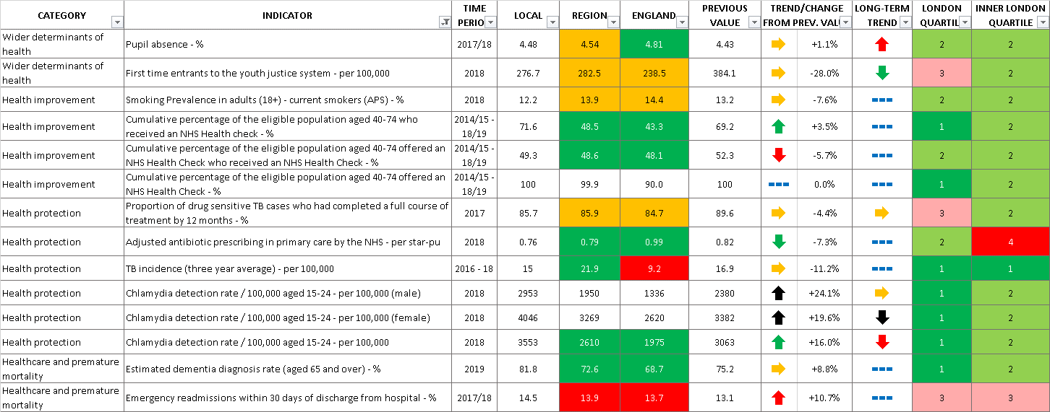

Chlamydia detection rate: is defined as all chlamydia diagnosis in 15-24 year olds attending a sexual health services. This is a measure of chlamydia control activity, aimed at reducing the incidence of reproductive sequelae of chlamydia infection and interrupting transmission to others. An increased detection rate is indicative of increased control activity. PHE recommends that LA should be working towards achieving a detection rate of at least 2,300/100,000 population aged 15-24. This encourages high volume screening and diagnoses.
This is the total number of antibiotic items prescribed in practices located within the area. Reductions in antibiotic consumption is a well-recognised target in AMR (Antimicrobial Resistance) policies across PHE (Public Health England), the NHS (National Health Service), DH (Department of Health) and internationally, including WHO (World Health Organisation). In order to fully appreciate antimicrobial prescribing, it is necessary to take into consideration demographic characteristics of the population as it may influence levels of prescribing. For that reason STAR-PU is adjusted for both age and sex.
Percentage of eligible population aged 40-74 offered an NHS health check who received an NHS health check ; this refers to the uptake rate of the programme: number of checks received divided by number of offers times 100. The reason for the decrease is due to an increased number of offers being made compared with checks received.

