

Mental Health Needs Assessment for the Adult Population of Wandsworth

July 2009

Dr Katie Hunter, Public Health Department, Wandsworth PCT

Executive Summary
Introduction

The mental health needs assessment describes the mental health need within Wandsworth residents aged 18-65 years using nationally and locally available data sources. However, wherever possible and appropriate it includes information relevant to the transitional ages of 16-18 and 65-75 years.

General Population Characteristics

Wandsworth has a resident population of 289,000 in 2009. A high proportion of the population are aged 20-44 (54%) compared to the same age group for London (43%). In 2006 the GLA population estimates for each ethnic group were: White 78.0%, Black 10.3%, Asian 7.2%, Other 4.0% and it was estimated that the ethnic make up of the population will change minimally by 2011. The Wandsworth PCT GP registered population is significantly higher than the resident population and was 337,000 on 31st December 2008.

Indicators of Mental Health Need

Wandsworth has a greater mental health need than the four other PCTs in SW London as demonstrated by the Mental Illness Needs Index 2000 (MINI 2K) - Wandsworth 1.45 compared to an English average of 1.00 and scores of 0.82 in Sutton, 0.79 in Croydon, 0.70 in Merton and 0.63 in Kingston and Richmond and Twickenham. Benefit claimant rates can also be used as an indicator of mental health need. Although the rate of benefit claimants (jobseekers, incapacity benefits, lone parents and carers) in Wandsworth is below the London average, the rates vary between wards with jobseeker’s allowance (JSA) and lone parent claimant rates above the London average in the most deprived wards in Wandsworth. The six most deprived wards in Wandsworth by IMD score (Latchmere, Roehampton, Queenstown, Tooting, Graveney and Furzedown) also have the highest MINI 2K scores, JSA claimant rates and lone parent claimant rates in Wandsworth. This indicates the need to target mental health promotion and other resources at those wards.

Prevalence of Mental Illness in Wandsworth

Common mental health disorders include different types of depression and anxiety. They cause marked emotional distress and interfere with daily function. Wandsworth has the highest estimated annual prevalence rates of all types of common mental disorder and rate of people experiencing symptoms of severe mental illness in SW London. The rate for neurotic disorders is 200 per 1,000 population in Wandsworth compared to 182 in London. For phobias the rate is 24 per 1,000 population in Wandsworth (22 in London), depressive episodes 38 per 1,000 (35 in London), generalised anxiety disorder 57 per 1,000 population (53 in London), mixed anxiety depression 94 per 1,000 (84 in London) obsessive compulsive disorder 17 per 1,000 (15 in London) and panic disorder 9 per 1,000 (8 in London).

It is estimated that the number of people requiring a new psychological therapy initiative in Wandsworth in a year is 8803 for any neurotic disorder, 1067 for all phobias, 1653 for depressive episodes, 2514 for generalised anxiety disorders, 4155 for mixed anxiety and depression, 739 for obsessive compulsive disorder and 410 for panic disorder.

This increased mental health need in Wandsworth compared to the other boroughs in SW London and London should be taken into account when planning mental health services in Wandsworth.

Links between mental health and physical health

Mental health and physical health problems are closely linked;

- Having a mental health problem increases the risk of premature death
- Deaths from infectious disease, endocrine, circulatory, respiratory, digestive and genitor –urinary system disorders are significantly more likely to occur in adults with severe mental health problems
- It is estimated that 70% of new cases of depression in older adults are caused by poor physical health.

People with mental health problems are also more likely to engage in behaviours that increase the risk of poor mental health for example people with severe mental health problems are more likely to have poor diets, take less exercise, smoke heavily and be dependent on alcohol thus increasing the risk of illness such as cardiovascular disease. Those with mental health problems are also less likely to be offered or receive regular health review and reviews of their medication.

Smoking prevalence is greater in people with mental health problems and those that smoke are more likely to be heavy smokers. The ONS survey of psychiatric morbidity amongst adults found that 44% of people with common mental health problems were smokers compared with 27% of people without these problems and were twice as likely to be heavy smokers. Stopping smoking can result in significant reductions in dosages of mental health medications thereby reducing the long-term side effects. Increased investment in smoking cessation services for people with mental health problems is necessary to prevent widening health inequalities in this group.

GP Serious Mental Illness (SMI) Registers

As part of the Quality and Outcomes Framework general practices produce a register of people with schizophrenia, bipolar affective disorder and other psychoses. The total number of patients on GP registers of serious mental illness (SMI) in Wandsworth in January 2009 was 2772; a rate of 8.22 per 1000 GP registered population.

The number of patients on GP SMI registers in each PCT varies from 2.2 to 2.8 times the estimated number of people experiencing symptoms of severe mental illness in a year in Croydon, Kingston, Richmond & Twickenham and Sutton & Merton, however in Wandsworth there are less patients on GP SMI registers than the estimated number experiencing symptoms of severe mental illness. This could be due to:
- Variation in SMI register inclusion criteria between PCTs (under-inclusion of patients in Wandsworth and over-inclusion in other PCTs).
- The estimated numbers of people experiencing symptoms may not be a true reflection of the mental health need in the different boroughs.
- Undiagnosed SMI in Wandsworth.
- Inflation of the size of the GP registered population may result in lower rates than expected in Wandsworth.

Suicide Prevention

Since 2003 there have been 30 or fewer annual deaths from suicide and undetermined injury in Wandsworth. Wandsworth has the highest all age mortality rate by suicide in SW London reflecting the higher suicide rate in Inner London compared to Outer London. The Government’s White Paper ‘Saving Lives: Our Healthier Nation’ set a target to reduce the death rate from suicide and undetermined injury by at least 20% by 2010 compared to the 3 year pooled average death rate in 1995-97. A 25% reduction in death rate has already been achieved in Wandsworth based on 2005-07 data but this reduction needs to be maintained in 2009-11 in order to achieve the target.
In England and Wales, suicide rates have been found to be twice as high for those living in the most deprived areas compared to those living in the least deprived. Research has shown that suicide rates tend to rise during periods of high unemployment and therefore it is possible that the current global economic recession may lead to a rise in suicide rates in Wandsworth. In view of this, suicide prevention work should continue to be a priority within the PCT and be targeted at residents of the most deprived areas in Wandsworth. The PCT must ensure that the current suicide audit is completed and that its findings are used to update the Suicide Prevention Strategy for Wandsworth by September 2009.

Community Mental Health Services

There is significant variation in caseload rates between the Community Mental Health Teams (CMHTs) in Wandsworth. The highest rate is in Central Wandsworth CMHT and the lowest rates are in Putney and Roehampton CMHTs. It is recommended that the reasons for variation in caseload rates are examined as part of the current review of CMHTs by Mental Health Strategies.

The number of episodes of home treatment performed by the Crisis Resolution and Home Treatment Teams (CRHT) has risen markedly from 363 in 2006/07 to 810 in 2008/09 surpassing the target of 714 treatment episodes per year. There has also been an increase in the number of patients on the Early Intervention Service (EIS) caseload from 60 in the first quarter of 2007/08 to 164 in the last quarter of 2008/09.

Daycare services in Wandsworth are funded by Wandsworth Borough Council & WPCT. From 2007/08 to 2008/09 three out of five centres (Bedford Hill, Edward Wilson House and Triangle) were significantly underutilised. Several measures have been introduced to address this but this should continue to be monitored.

The percentage of adults in Wandsworth receiving secondary mental health care who are in employment remains low at 14% despite investment in employment support.

Inpatient Services

The number of WPCT registered patients admitted to acute adult wards at SWL & StG MHT reduced by 18% from 800 in 2006/07 to 654 in 2007/8 and remained stable between 2007/8 and 2008/9. The average length of stay (LOS) reduced from 35 to 27 days from 2007/8 to 2008/9. The number of occupied bed days (OBDs) excluding leave reduced by 15% from 2006/7 to 2007/8 and then remained stable from 2007/8 to 2008/9. Despite the significant reduction in average LOS from 2007/8 to 2008/9 and no change in the number of admissions, the total number of OBDs has reduced by less than 200 days - this requires further analysis to understand:
- the relationship between number of admissions, average LOS and occupied bed days.
- the impact of increased investment in Crisis Resolution and Home Treatment teams (CRHTs) and Early Intervention Service (EIS) on number of admissions, average LOS and occupied bed days.

Ethnicity of Service Users

The proportion of patients from black ethnic groups admitted to acute adult wards or detained under section at SWL & StG MHT in the last three years has been consistently more than double the general population of Wandsworth. The proportion of patients from black ethnic groups on the CMHT caseload is also raised compared to Wandsworth’s resident population. Further work needs to be done to reduce the rate of admission of people from black ethnic groups to SWL & StG MHT and the disproportionate rates of compulsory detention of black ethnic groups as per the Delivering Race Equality action plan.

Recommendations

The needs assessment has identified a number of areas where further work is required.

Further analysis of data

- As part of their review of CHMT’s Mental Health Strategies should be requested to examine the reasons for the differences in CMHT caseload per 100,000 population.

- Analysis should be undertaken of the factors contributing to the low percentage of adults receiving secondary mental health care who are in employment in order to create an action plan to increase the percentage of adults in employment.

- Further analysis should be undertaken to understand:
  - the relationship between number of admissions, average LOS and occupied bed days.
  - the impact of increased investment in Crisis Resolution and Home Treatment teams (CRHTs) and Early Intervention Service (EIS) on CMHT caseload, number of admissions, average LOS and occupied bed days.

Targeting of resources or planning of services

- Planning of mental health services should take into account the increased mental health need in Wandsworth compared to the rest of SW London. This needs assessment should be used to inform current strategic work including the CMHT review, inpatient review and mental health commissioning strategy for Wandsworth.

- Mental health promotion and other resources should be targeted to support mental well-being at the most deprived wards in Wandsworth (Latchmere, Roehampton, Queenstown, Tooting, Graveney and Furzedown) which have the highest IMD scores, MINI 2K scores, JSA claimant rates and lone parent claimant rates in Wandsworth.

- Suicide prevention work should continue to be a priority within the PCT and be targeted at residents of the most deprived areas in Wandsworth. The PCT must ensure that the current suicide audit is completed and that its findings are used to update the Suicide Prevention Strategy for Wandsworth by September 2009.

- The impact of interventions to address the underutilisation of daycare services at Bedford Hill, Edward Wilson House and Triangle should be monitored.

- Smoking cessation advice and NHS Health Checks should be targeted to people with mental health problems to reduce the risk of cardiovascular disease and to ensure that inequalities do not widen.

- Further work needs to be done to reduce the rate of admission of people from black ethnic groups to SWL & StG MHT and the disproportionate rates of compulsory detention of black ethnic groups as per the Delivering Race Equality action plan.

The following recommendations are based on the findings from the SWL & St George’s Mental Health NHS Trust 2007/8 survey of community teams.

- All clients should have their diagnosis fully discussed with them.

- All clients should have possible side effects of medication fully explained.

- All clients should be given information about local support groups.

- All clients should be asked whether they have mobility/sensory impairments, long-term physical health conditions or learning disabilities and provided with any help or adjustments they require as a consequence of these.

- All clients should be given help with the following if required:
  - to get/ keep work
  - benefits
  - housing problems
  - relationship problems
  - social activities.

Mental Health Needs Assessment for the Adult Population of Wandsworth

1.0 Introduction

This paper describes the mental health need within Wandsworth residents aged 18-65 years using nationally and locally available data sources. However, wherever possible and appropriate it includes information relevant to the transitional ages of 16-18 and 65-75 years.
It describes this need in terms of population demographics, socioeconomic risk factors, estimates of the numbers of people resident in Wandsworth with mental ill health and specialist mental health service use, including financial spend. Where possible Wandsworth is compared with the other PCTs in South West London (SWL).

2.0 South West London Population Demographics

According to the 2001 Census just over 1.3 million people live in SWL in 6 London Boroughs that vary significantly in areas of density and deprivation, both within and between them. The population is highly mobile, has a higher than London and England average of young adults (20 to 39 years) and is highly diverse in terms of ethnicity and socio-economic measures.¹

2.1 Wandsworth specific demographics and population projections

The 2009 population of Wandsworth was estimated to be 289,000 (GLA population projections - low). 74% of the population in Wandsworth are aged 16-64 years and 8% are aged 65+ years. Wandsworth has a high proportion of the population aged 20-44 (54%) compared to the same age group for London (43%). The population of Wandsworth is projected to grow by 3.1% by 2019 and 7.6% by 2029 from the 2009 baseline.

According to the 2001 Census people classifying themselves as White British account for 65% of the total population. The next largest group is White Other (including White Irish) which accounts for 13% of the population.

In 2006 the GLA population estimates for each ethnic group were: White 78.0%, Black 10.3%, Asian 7.2%, Other 4.0%. The 2006 GLA ethnic group population projections estimate that the ethnic make up of the population will change minimally by 2011.

The Wandsworth PCT GP registered population on 31st December 2008 was 337,000.

3.0 Mental Health Need

3.1 Risk Factors for Mental Illness¹

Increasing rates of mental illness – both common and severe and enduring – are associated with the following sociodemographic factors:

- Socioeconomic factors – socioeconomic deprivation and poor material circumstances, such as inadequate housing, debt and levels of social support at both an individual and community level are risk factors for poor mental health
- Unemployment – this is both a cause and a result of mental ill health. Employment protects against mental illness through the effects of increased income and social inclusion, but is also a risk factor for common mental illness, in particular stress.
- Social exclusion – rates of mental illness are higher in socially excluded groups such as offenders, refugees, some immigrant groups and the homeless.
- Ethnicity – African Caribbean people are more likely to be diagnosed with and admitted to hospital for psychosis than any other group. Rates of depression have been shown to be higher in Indian and Pakistani women.
- Gender – schizophrenia is more commonly diagnosed in men, whereas rates of diagnosed anxiety and depression are higher in women. This may in part be explained by health seeking behaviour - men are less likely to seek help for common mental health symptoms
- Age – dementia is an illness of older age with approximately one third of people aged over 85 affected. The prevalence of schizophrenia decreases with increasing age and is in part due to the shorter average life expectancy of individuals with this condition (10 years less than the population as a whole).

3.2 Mental Health Indices¹

Mental health needs indices have been developed which attempt to describe the mental health need within an area as a single numerical value. Two indices that have been used in London are the MINI and the London Health Observatory Local Index of Need.

3.2.1 Mental Illness Needs Index 2000 (MINI 2K)

The MINI is a tool designed specifically to aid resource allocation and planning for local mental health services. It was developed in the early 1990s by identifying population characteristics that explained variations in the prevalence of hospital admission to psychiatric services. The original index was based on data relating to 1991. The variables used in the model included the number of people or households:

- who were single/widowed/divorced
- who were permanently sick
- who were unemployed
- which were without a car
- living in a household that was not self-contained
- living in a hostel/lodging house etc

The updated index (MINI 2K) was published in 2004 based on data relating to 1998.

An area that has large numbers of individuals in the above categories is likely to experience more inpatient admissions to psychiatric services. The MINI 2K provides estimates for 3 diagnostic categories – schizophrenia and other psychoses, affective disorders and other. The MINI 2K index gives a score for each local authority area, which shows how the area relates to the standard score of 1 for England. A score of less than 1 indicates mental health needs likely to be lower than expected for England as a whole, and greater than 1 indicates a higher need.

The MINI2K schizophrenia index is the ratio between the expected admission rates for schizophrenia and psychotic illnesses for the PCT compared to the rate for the whole of England, where England is 1. An index of 1.25 would suggest that the PCT had expected admission rates that are 25 per cent higher than the England average. An index of 0.75 suggests that expected admissions rates are 25 per cent lower than the England average.

3.2.2 Local Index of Need (LIN)

This is a composite score of many weighted variables that reflect the socio-demographic composition of a defined geographical area (in this case Local Authority areas) such as population density, ethnicity and local crime rates.
The mean LIN scores for boroughs in England is 0, with a borough with a negative score indicating a lower than average mental health need. The LIN differs from the MINI 2K in that it is not based on previous service utilisation.

3.2.3 SWL Mental Health Indices Scores

Table 1: MINI 2K and LIN scores in SW London

Local Authority | MINI 2K Index | MINI 2K Schizophrenia Index | LIN⁶
Croydon | 0.79 | 1.0 | 47.7
Kingston | 0.63 | 0.8 | -29.9
Merton | 0.70 | Sutton & Merton 0.8 | 12.4
Richmond and Twickenham | 0.63 | 0.7 | -33.2
Sutton | 0.82 |  | -23.0
Wandsworth | 1.45 | 2.4 | 56.3
London average |  | 1.6
England average | 1.00 | 1.0 | 0

Figure 1 shows the LIN scores of all London Boroughs grouped according to level of mental health need, with category A signifying the lowest level of need. Wandsworth has the highest level of mental health need in SWL and is placed in category C, although it’s LIN score is just above the London average suggesting that it’s total mental health need is no greater than the London average. The difference in the LIN and the MINI 2K scores can in part be explained by the different underlying variables used to derive them. Three SWL boroughs, Richmond upon Thames, Kingston and Sutton are in category A for LIN scores and have correspondingly low MINI 2K scores. Richmond upon Thames has the lowest LIN score of all London boroughs.

Figure 1: LIN scores by London Borough
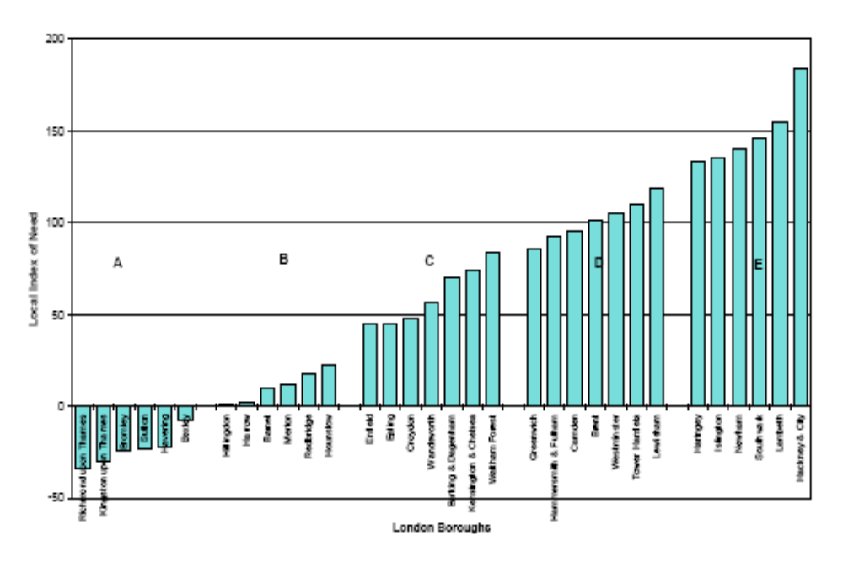

The LIN describes mental health need across all ages and takes into account such factors as the proportion of the population that is aged between 0-17 and over 65. However it is a single measure and as such cannot describe the variation in mental health need that exists within an area.

Figure 2 shows the distribution of MINI 2K scores in all wards in London, with the wards in Wandsworth highlighted in red. Only one ward in Wandsworth, Thamesfield has a MINI 2K score below the mean for England.

MINI 2K scores have been shown at a ward level to demonstrate the variation in MINI 2K scores across Wandsworth and show that the outlying wards are Latchmere with the highest score and Thamesfield with the lowest score. It should be noted that the publisher of these scores, Gyles Glover at the Centre for Public Mental Health, Durham University, did not intend that these scores would provide figures at the level of the wards themselves. It was assumed that the scores would be grouped into population clusters of 30k-40k to reduce problems arising from boundary splits and natural variation errors in the predictions.

Table 2: MINI 2K scores for wards in Wandsworth ranked in descending order

Ward Name | MINI 2K Score | Rank
Latchmere | 2.06 | 1
Furzedown | 1.69 | 2
Tooting | 1.68 | 3
Queenstown | 1.67 | 4
Roehampton | 1.67 | 5
Graveney | 1.61 | 6
St Mary's Park | 1.59 | 7
West Hill | 1.53 | 8
Balham | 1.53 | 9
Shaftesbury | 1.45 | 10
Fairfield | 1.41 | 11
Nightingale | 1.38 | 12
Bedford | 1.29 | 13
Wandsworth Common | 1.28 | 14
West Putney | 1.27 | 15
Earlsfield | 1.25 | 16
Northcote | 1.22 | 17
East Putney | 1.15 | 18
Southfields | 1.15 | 19
Thamesfield | 0.92 | 20

Source: MINI and NPMS Needs Indices Data. Available at: http://www.mentalhealthobservatory.org.uk/mho/mini

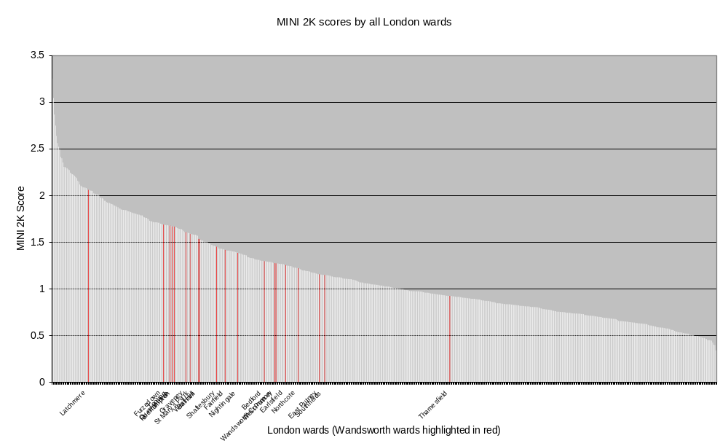
3.2.4 Index of Multiple Deprivation 2007

The Index of Multiple Deprivation (IMD) 2007 combines 37 different indicators which cover specific aspects or dimensions of deprivation: Income, Employment, Health and Disability, Education, Skills and Training, Barriers to Housing and Services, Living Environment and Crime.

The IMD scores for wards in Wandsworth are shown in table 3 below. It is useful to be aware of these deprivation scores when interpreting other indicators of mental health need and service use included in this needs assessment.

Table 3: IMD scores for wards in Wandsworth

Wards | Index of Multiple Deprivation 2007 | Rank (1= most deprived)
Latchmere | 36.9 | 1
Roehampton | 31.7 | 2
Queenstown | 28.9 | 3
Tooting | 24.9 | 4
Graveney | 24.3 | 5
Furzedown | 22.8 | 6
St. Mary's Park | 22.3 | 7
West Hill | 21.6 | 8
Shaftesbury | 20.7 | 9
Bedford | 20.1 | 10
Earlsfield | 19.4 | 11
West Putney | 18.8 | 12
Fairfield | 16.5 | 13
Nightingale | 16.4 | 14
Balham | 15.3 | 15
East Putney | 14.9 | 16
Wandsworth Common | 14.8 | 17
Southfields | 14.1 | 18
Northcote | 13.8 | 19
Thamesfield | 10.4 | 20
Wandsworth | 20.3

Source: Department of Communities and Local Government, Indices of Deprivation 2007

3.3 Benefit Claimant Rates

People from deprived backgrounds are at significantly greater risk of developing mental health problems . Individuals who are unemployed, live in rented accommodation and have low educational achievements are at greater risk of depression. There is also a well documented association between poverty, unemployment, social isolation and the first incidence and prevalence of schizophrenia. Studies have demonstrated higher rates in deprived inner city areas . Benefit claimant rates are therefore an indicator of mental health need in an area.

3.3.1 Jobseeker’s Allowance

Jobseeker’s Allowance can be used as a measure of unemployment bearing in mind the following caveats.

To be eligible for JSA a person must be out of work or working less than 16 hours a week on average and:
- capable of working
- available for work
- actively seeking work
- below state pension age

Unemployed 16 and 17 year olds are only eligible for JSA in specific circumstances. People with savings over £6,000 will receive a reduced rate of JSA and those with savings over £16,000 probably won't qualify for JSA. People who have previously been self-employed may not be eligible for JSA if their partner works 24 hours or more a week.

It is likely that JSA claimant rates are lower than the actual unemployment rates as they do not reflect unemployment in higher socioeconomic groups, previously self-employed or in 16 and 17 year olds. Unemployment in these groups is also likely to have a significant impact on mental health.

Table 4: Total JSA claimants in Wandsworth in February 2009 by sex

 | Number of JSA claimants in Wandsworth | Percentage of resident working age people claiming JSA in:
 | Number of JSA claimants in Wandsworth | Wandsworth (%) | London (%) | Great Britain (%)
All people | 5,481 | 2.7 | 3.8 | 3.8
Males | 3,730 | 3.6 | 5.0 | 5.5
Females | 1,751 | 1.7 | 2.4 | 2.1

Source: ONS claimant count with rates and proportions

Figure 3: Percentage of resident working age people claiming JSA from Jan 2006 - Feb 2009

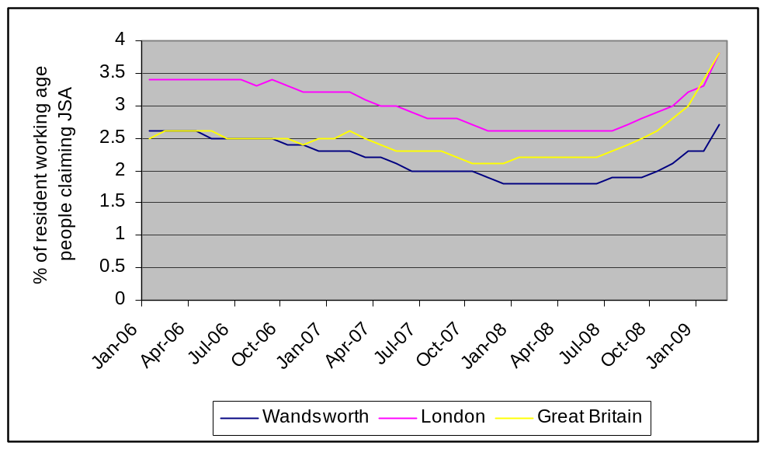

Source: ONS claimant count with rates and proportions

Figure 4: Percentage of resident working age people claiming JSA in Wandsworth from 2006 -2009 by sex

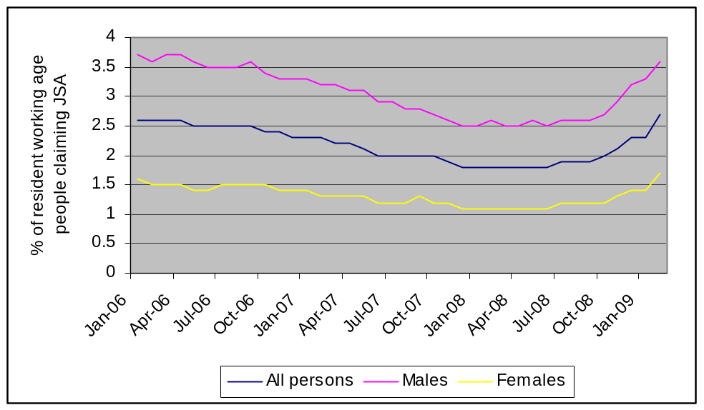

Source: ONS claimant count with rates and proportions

Figure 5: Jobseeker’s Allowance claimants in London – February 2009

% of all resident working age people claiming JSA

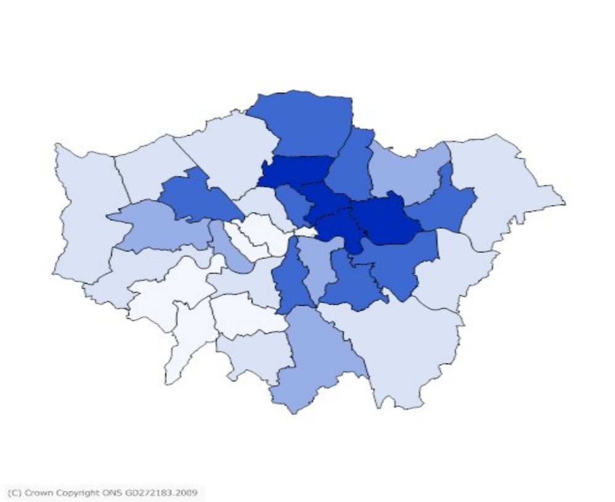

< 2.5 | < 3.4 | < 4.3 | < 5.2 | < 6.1

Local Authority | Number of JSA claimants | % of resident working age people claiming JSA
Croydon | 8,049 | 3.7
Wandsworth | 5,481 | 2.7
Sutton | 3,040 | 2.6
Merton | 3,265 | 2.4
Richmond-upon-Thames | 2,174 | 1.9
Kingston-upon-Thames | 1,997 | 1.9
London | 189,930 | 3.8
Great Britain |  | 3.8

Source: ONS claimant count with rates and proportions [February 2009]

Figure 6: Jobseeker’s Allowance claimants in Wandsworth – February 2009

% of all resident working age people claiming JSA

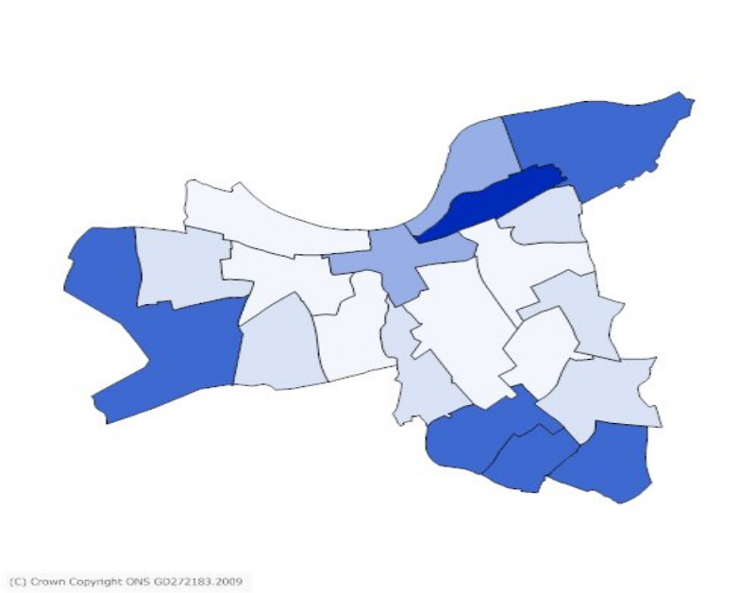
< 1.94 | < 2.68 | < 3.42 | < 4.16 | < 4.9

Ward | Number of JSA claimants | % of resident working age people claiming JSA | IMD ranking  (1=most deprived)
Latchmere | 452 | 4.9 | 1
Furzedown | 390 | 4.1 | 6
Queenstown | 394 | 4.0 | 3
Graveney | 372 | 3.8 | 5
Tooting | 355 | 3.6 | 4
Roehampton | 335 | 3.5 | 2
St Mary's Park | 289 | 2.9 | 7
Fairfield | 286 | 2.7 | 13
West Hill | 285 | 2.6 | 8
West Putney | 233 | 2.6 | 12
Bedford | 285 | 2.6 | 10
Shaftesbury | 260 | 2.5 | 9
Earlsfield | 264 | 2.3 | 11
Balham | 221 | 2.2 | 15
Wandsworth Common | 184 | 1.9 | 17
Nightingale | 189 | 1.8 | 14
Northcote | 184 | 1.8 | 19
Southfields | 209 | 1.8 | 18
East Putney | 187 | 1.7 | 16
Thamesfield | 127 | 1.2 | 20
Wandsworth | 5501 | 2.7

Source: ONS claimant count with rates and proportions [February 2009]
3.3.2 Other Key Benefit Claimants

The table below shows a summary of all the key benefit claimants in Wandsworth in August 2008.

Table 5: Key benefit claimants (August 2008)

 | Number of benefit claimants in Wandsworth | Percentage of resident working age people claiming benefits in:
 | Number of benefit claimants in Wandsworth | Wandsworth  (%) | London  (%) | Great Britain  (%)
Total claimants | 20,700 | 10.0 | 14.0 | 14.2
Job seekers | 3,800 | 1.8 | 2.7 | 2.4
Incapacity benefits | 9,280 | 4.5 | 6.0 | 7.0
Lone parents | 4,320 | 2.1 | 3.0 | 2.0
Carers | 1,000 | 0.5 | 0.8 | 1.1
Others on income related benefits | 930 | 0.5 | 0.6 | 0.5
Disabled | 1,100 | 0.5 | 0.7 | 1.0
Bereaved | 260 | 0.1 | 0.2 | 0.3
Key out-of-work benefits† | 18,340 | 8.9 | 12.3 | 11.9

Source: DWP benefit claimants - working age client group

† Key out-of-work benefits consists of the groups: job seekers, incapacity benefits, lone parents and others on income related benefits

Figure 7: Lone parent claimants in Wandsworth (August 2008)

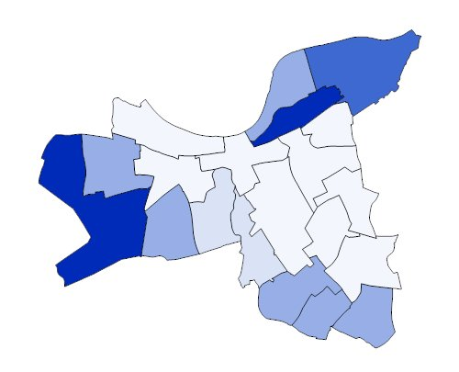
< 1.5 | < 2.5 | < 3.5 | < 4.5 | < 5.5
Table 6: Lone parent claimants in Wandsworth by ward (August 2008)

Ward | Number of lone parent claimants | % of resident working age population | IMD ranking  (1=most deprived)
Latchmere | 505 | 5.5 | 1
Roehampton | 470 | 5.0 | 2
Queenstown | 375 | 3.8 | 3
Furzedown | 290 | 3.0 | 6
Tooting | 275 | 2.8 | 4
Graveney | 265 | 2.7 | 5
St Mary's Park | 260 | 2.6 | 7
West Hill | 290 | 2.6 | 8
West Putney | 230 | 2.5 | 12
Earlsfield | 180 | 1.6 | 11
Southfields | 175 | 1.5 | 18
Bedford | 155 | 1.4 | 10
Fairfield | 150 | 1.4 | 13
Shaftesbury | 145 | 1.4 | 9
Nightingale | 135 | 1.3 | 14
East Putney | 105 | 1.0 | 16
Top of Form  Balham | Bottom of Form  90 | 0.9 | 15
Northcote | 90 | 0.9 | 19
Wandsworth Common | 90 | 0.9 | 17
Thamesfield | 50 | 0.5 | 20
Wandsworth | 4325 | 2.1

Source: ONS benefit claimants - working age clients for small areas [August 2008]

Table 7: Carer claimants in Wandsworth by ward (August 2008)

Ward | Number of carer claimants | % of resident working age population | IMD ranking  (1=most deprived)
Latchmere | 70 | 0.8 | 1
Roehampton | 75 | 0.8 | 2
Furzedown | 80 | 0.8 | 6
Tooting | 65 | 0.7 | 4
West Hill | 75 | 0.7 | 8
West Putney | 60 | 0.7 | 12
Graveney | 60 | 0.6 | 5
Queenstown | 45 | 0.5 | 3
Earlsfield | 60 | 0.5 | 11
Wandsworth Common | 45 | 0.5 | 17
St. Mary's Park | 40 | 0.4 | 7
Bedford | 45 | 0.4 | 10
Nightingale | 40 | 0.4 | 14
East Putney | 40 | 0.4 | 16
Shaftesbury | 35 | 0.3 | 9
Fairfield | 35 | 0.3 | 13
Balham | 30 | 0.3 | 15
Southfields | 40 | 0.3 | 18
Thamesfield | 30 | 0.3 | 20
Northcote | 25 | 0.2 | 19
Wandsworth | 995 | 0.5

Source: ONS benefit claimants - working age clients for small areas [August 2008]

Although the rate of benefit claimants in Wandsworth is below the London average in all the categories shown in table 5 the rates vary between wards with JSA and lone parent claimant rates above the London average in the most deprived wards in Wandsworth. The six most deprived wards in Wandsworth by IMD score (Latchmere, Roehampton, Queenstown, Tooting, Graveney and Furzedown) also have the highest MINI 2K scores, JSA claimant rates and lone parent claimant rates in Wandsworth. This indicates the need to target mental health promotion and other resources at those wards.

  - Levels of limiting long-term illness

Evidence summarised in the Social Exclusion Unit's report on mental health shows that mental health and physical health problems are closely linked.
- Having a mental health problem increases the risk of premature death. For example, having a diagnosis of schizophrenia can reduce the average life expectancy by 10 years, largely due to physical health problems.
- Deaths from infectious diseases, endocrine, circulatory, respiratory, digestive and genito-urinary system disorders are significantly more likely to occur in adults with severe mental health problem.
- It is estimated that 70% of all new cases of depression in older adults are caused by poor physical health.
- It has been suggested that sustained stress or trauma may damage the immune system and thus increase susceptibility to viral infections and physical illness.
People with mental health problems are also more likely to engage in behaviours that increase the risk of poor health. For example people with severe mental health problems are more likely to have poor diets, take less exercise, smoke heavily and be dependent on alcohol thus increasing the risk of illness such as cardiovascular disease. However, it has been suggested that those with mental health problems are less likely to be offered or receive regular health review and reviews of their medication. Therefore mental health problems are a prominent factor in health inequalities.
Limiting long-term illness or disability that restricts daily activities is calculated from a 'Yes' response to the question in the 2001 Census: 'Do you have any long-term illness, health problem or disability which limits your activities or the work you can do?'
13.4% of the Wandsworth resident population reported having a limiting long-term illness. The wards with the highest percentage of residents with a limiting long-term illness are Roehampton (19.2%) and Latchmere (17.5%). The percentage for each ward is included in the table below.

This data may not accurately reflect the true prevalence of limiting long-term illness in the population as limiting long-term illness is self-defined by Census respondents. It is possible that residents with better mental health underreport limiting long-term illness and those with poorer mental health over report it.

Table 8: Levels of limiting long-term illness in wards in Wandsworth

Ward | % of people with limiting long term illness | IMD ranking  (1=most deprived)
Roehampton | 19.2 | 2
Latchmere | 17.5 | 1
West Putney | 15.8 | 12
Furzedown | 15.3 | 6
West Hill | 15.2 | 8
Tooting | 14.3 | 4
St. Mary's Park | 14.3 | 7
Queenstown | 13.9 | 3
Graveney | 13.7 | 5
Earlsfield | 13.6 | 11
Nightingale | 13.4 | 14
Bedford | 12.7 | 10
East Putney | 12.6 | 16
Wandsworth Common | 12.4 | 17
Shaftesbury | 12.2 | 9
Southfields | 10.9 | 18
Balham | 10.8 | 15
Fairfield | 9.9 | 13
Northcote | 9.8 | 19
Thamesfield | 9.5 | 20
WANDSWORTH | 13.4

Source: Census 2001. Provided by M Cottington, WPCT

3.5 Levels of smoking
Smoking causes premature death and poor health, with at least half of all regular smokers dying as a result of tobacco. Over 10,500 deaths of people aged 35 and over were due to smoking in London in 2001 (more than one in six of all deaths in London). About 31% of males and 26% of females in London smoked in 2001. In the general population, increased prevalence of smoking has been associated with deprivation and manual workers.
People with mental health problems are more likely to smoke than those without. The ONS survey of psychiatric morbidity amongst adults found that 44% of people with common mental health problems were smokers, compared with 27% of people without these problems. Further, people with common mental health problems were twice as likely to be heavy smokers (20 cigarettes or more per day) than people without (16% compared with 7%). Rates of heavy and moderate smoking increased if a person had more than one common mental health problem.
For people with psychotic disorders, 64% were smokers and 9% were ex-smokers, compared with 29% and 23% of those with no evidence of psychosis. In addition, people with psychotic disorders were over three times more likely to be heavy smokers (20 cigarettes or more per day) compared with those without psychosis (35% compared with 9%). Deaths from smoking related diseases are twice as high amongst people with schizophrenia.
Evidence suggests there is a link between the amount smoked and the number of depressive and anxiety symptoms. On stopping, these symptoms are seen to reduce, although a minority of people with depression who stop smoking experience an increase in depressive symptoms.

There is little evidence to show any worsening of symptoms in people with schizophrenia following stopping smoking. Stopping smoking can result in significant reductions in the dosages of mental health medications and reducing doses will reduce the long-term consequences such medication can have. Supporting people with mental health problems in stopping smoking can therefore have a direct impact on reducing health inequalities. However, health inequality experienced by people with mental illness will widen if investment in smoking cessation services for this group is not greater than for the general population.

4.0 The Burden of Mental Ill Health

4.1 Common Mental Disorders

Common mental disorders (CMDs) include different types of depression and anxiety. They cause marked emotional distress and interfere with daily function but do not usually affect insight or cognition.¹⁵

4.1.1 Prevalence estimates

The Adult Psychiatric Morbidity Survey (APMS) 2007 is a survey of psychiatric morbidity in adults aged 16 and over living in private households in England that was carried out in 2006/07. It did not include adults living in institutions.

CMDs were assessed in the phase one interview using the revised Clinical Interview Schedule (CIS-R), which covers non-psychotic symptoms in the past week. Responses were used to generate an overall score and to diagnose six types of CMD. A score of less than 12 indicated the presence of no clinically significant neurotic symptoms in the week prior to interview.

Summary of the main findings of the survey:

- 16.2% of adults met the diagnostic criteria for at least one CMD in the week prior to the interview.
- The proportion of people aged 16-64 meeting the criteria for at least one CMD was 17.6% in 2007.
- Women were more likely than men to have a CMD (19.7% and 12.5% respectively), and rates were significantly higher for women across all categories of CMD with the exception of panic disorder and obsessive compulsive disorder.
- Rates of CMD varied by age: those aged 75 and over were the least likely to have a CMD (6.3% of men, 12.2% of women). In women, the rate peaked among 45-54 year olds, with a quarter (25.2%) of this group meeting the criteria for at least one CMD. Among men the rate was highest in 25-54 year olds (14.6% of 25-34 year olds, 15.0% of 35-44 year olds, 14.5% of 45-54 year olds).
- After age-standardisation, there was little variation between white, black and South Asian men in the rates of any CMD. However, in women all CMDs (except phobias) were more prevalent in the South Asian group. The number of South Asian women in the sample was small, so while the differences were pronounced they were only significant for CMD as a whole, generalised anxiety disorder and panic disorder.
- People living in households with the lowest levels of income were more likely to have a CMD than those living in the highest income households.
- A quarter (24%) of people with a CMD were in receipt of treatment for an emotional or mental problem, mostly in the form of medication. The level and nature of treatment varied by type of CMD. Over half (57%) of adults with a phobia were in receipt of treatment, but only 15% of those with mixed anxiety and depressive disorder.
- Half of respondents with two or more CMDs (48%) were receiving treatment for a mental or emotional problem.
- 39% of those with a CMD had used some type of health care service for a mental or emotional problem, compared with 6% of people without a CMD. Those with two or more CMDs were more than twice as likely (73%) as those with one CMD (34%) to have used health care services for a mental or emotional reason.

In May 2008 the North East Public Health Observatory published estimates of the prevalence of common mental health problems in PCTs in England based on prevalence estimates from the 2000 Adult Psychiatric Morbidity Survey and adjusted for local mental health need. (There has been no change in the proportion of people aged 16-64 meeting the criteria for at least one CMD since the previous Adult Psychiatric Morbidity Survey was performed in 2000 - 17.5% in 2000, 17.6% in 2007.)

Table 9 shows the prevalence estimates for common mental disorders in PCTs in SW London compared to the prevalence rate in London. Wandsworth has the highest prevalence rates of all types of common mental disorder in SW London.

The 2007 APMS survey found that 50% of adults with a CIS-R score indicating neurotic symptoms had symptoms of a level of severity likely to require treatment¹⁵. The North East Public Health Observatory has estimated that the number of people with CMDs requiring a new psychological therapy is approximately one fifth of the number of cases of CMD. This is based on the proportion of cases that have not already received psychological therapy, are likely to benefit and are willing to have therapy. The author acknowledges that this proportion is likely to vary across the country according to previous availability of psychological therapies.¹⁶

Table 10 shows the estimated number of cases of CMD in Wandsworth likely to require treatment and the number of people with CMDs requiring a new psychological therapy.

Table 9: Estimated prevalence of common mental disorders in SW London.

PCT Name | Croydon |  | Kingston |  | Richmond and Twickenham |  | Sutton and Merton |  | Wandsworth |  | London
Resident population aged 16-74 | 244981 |  | 115925 |  | 132013 |  | 280785 |  | 220004
 | Estimated cases | Rate/1000 pop | Estimated cases | Rate/ 1000 pop | Estimated cases | Rate/ 1000 pop | Estimated cases | Rate/ 1000 pop | Estimated cases | Rate/ 1000 pop | Rate/ 1000 pop
Any neurotic disorder | 42245 | 172 | 19044 | 164 | 21965 | 166 | 46764 | 167 | 44013 | 200 | 182
All phobias | 5076 | 21 | 2265 | 20 | 2643 | 20 | 5598 | 20 | 5335 | 24 | 22
Depressive episode | 8264 | 34 | 3725 | 32 | 4376 | 33 | 9131 | 33 | 8266 | 38 | 35
Generalised anxiety disorder | 12470 | 51 | 5574 | 48 | 6691 | 51 | 13922 | 50 | 12570 | 57 | 53
Mixed anxiety depression | 19464 | 79 | 8761 | 76 | 9994 | 76 | 21493 | 77 | 20774 | 94 | 84
Obsessive compulsive disorder | 3571 | 15 | 1637 | 14 | 1836 | 14 | 3922 | 14 | 3694 | 17 | 15
Panic disorder | 1967 | 8 | 896 | 8 | 1038 | 8 | 2204 | 8 | 2048 | 9 | 8

Source: North East Public Health Observatory (2008) Mental Health Brief no 4: Estimating the prevalence of common mental health problems in PCTs in England. Available at: http://www.mentalhealthobservatory.org.uk/mho/briefs

Table 10: Estimated prevalence of common mental disorders likely to require treatment in Wandsworth

 | Estimated number of cases | Estimated number of cases with symptoms of a level of severity likely to require treatment | Approximation of the number of people requiring a new psychological therapy initiative
Any neurotic disorder | 44013 | 22007 | 8803
All phobias | 5335 | 2668 | 1067
Depressive episode | 8266 | 4133 | 1653
Generalised anxiety disorder | 12570 | 6285 | 2514
Mixed anxiety depression | 20774 | 10387 | 4155
Obsessive compulsive disorder | 3694 | 1847 | 739
Panic disorder | 2048 | 1024 | 410

Source: North East Public Health Observatory (2008) Mental Health Brief no 4: Estimating the prevalence of common mental health problems in PCTs in England. Available at: http://www.mentalhealthobservatory.org.uk/mho/briefs

4.2 Severe Mental Illness

The main types of severe mental illness are schizophrenia and affective psychosis, such as bipolar disorder and manic depression. Psychoses produce disturbances in thinking and perception severe enough to distort perception of reality. Symptoms include auditory hallucinations, delusional beliefs and disorganised thinking.¹⁵

4.2.1 GP registers

As part of the Quality and Outcomes Framework general practices produce a register of people with schizophrenia, bipolar affective disorder and other psychoses. The total number of patients on GP registers of serious mental illness (SMI) in Wandsworth in January 2009 was 2772; a rate of 8.22 per 1000 GP registered population. It must be noted that the size of the Wandsworth PCT registered population is greater than the Wandsworth resident population and this may be partly due to patients not being removed from GP lists when they move out of Wandsworth. Inflation of the size of the GP registered population may result in a lower rate of patients on SMI registers than expected.

The number of patients on the SMI register of each GP practice in Wandsworth is shown in the table overleaf.

Practice Code | Ward of GP | Number of patients on SMI register | GP List size | Rate per 1,000 GP registered population
H85691ª | Nightingale | 7 | 202 | 34.65
H85052 | Furzedown | 105 | 4876 | 21.53
H85688 | Graveney | 84 | 5042 | 16.66
H85075 | Southfields | 35 | 2268 | 15.43
H85006 | Roehampton | 71 | 5466 | 12.99
H85643 | West Hill | 40 | 3336 | 11.99
H85047 | St Mary's Park | 130 | 11389 | 11.41
H85107 | Graveney | 28 | 2483 | 11.28
H85111 | Queenstown | 106 | 9460 | 11.21
H85695 | Furzedown | 43 | 3841 | 11.20
H85067 | Roehampton | 39 | 3547 | 11.00
H85009 | Bedford | 119 | 11031 | 10.79
H85005 | Nightingale | 123 | 12500 | 9.84
H85003 | Queenstown | 81 | 8302 | 9.76
H85100 | West Hill | 44 | 4704 | 9.35
H85088 | Latchmere | 39 | 4298 | 9.07
H85066 | Nightingale | 114 | 12641 | 9.02
H85680 | Graveney | 37 | 4112 | 9.00
H85048 | Earlsfield | 143 | 16207 | 8.82
H85002 | Latchmere | 94 | 10669 | 8.81
H85082 | Southfields | 44 | 5073 | 8.67
H85659 | Fairfield | 25 | 2916 | 8.57
H85087 | Nightingale | 91 | 10806 | 8.42
Y01132 | West Putney | 78 | 9340 | 8.35
H85065 | Roehampton | 34 | 4079 | 8.34
H85636 | Northcote | 16 | 1932 | 8.28
H85008 | Roehampton | 61 | 7379 | 8.27
H85011 | Furzedown | 67 | 8284 | 8.09
H85045 | St Mary's Park | 104 | 13030 | 7.98
H85069 | Shaftesbury | 94 | 12072 | 7.79
H85682 | West Hill | 48 | 6498 | 7.39
H85001 | Southfields | 59 | 8655 | 6.82
H85077 | Northcote | 44 | 6816 | 6.46
H85061 | East Putney | 88 | 14087 | 6.25
H85041 | Earlsfield | 72 | 11580 | 6.22
H85007 | Southfields | 75 | 12219 | 6.14
H85650 | East Putney | 9 | 1542 | 5.84
H85114 | Balham | 53 | 9959 | 5.32
H85004 | West Putney | 23 | 4378 | 5.25
H85637 | Bedford | 11 | 2310 | 4.76
H85104 | Thamesfield | 33 | 7062 | 4.67
H85049 | Northcote | 34 | 7375 | 4.61
H85056 | Balham | 12 | 2620 | 4.58
H85012 | Thamesfield | 56 | 13578 | 4.12
H85039 | Graveney | 22 | 5471 | 4.02
H85057 | Southfields | 26 | 6723 | 3.87
H85633 | Balham | 5 | 1388 | 3.60
H85685 | Nightingale | 5 | 1625 | 3.08
H85664 | Bedford | 1 | 1905 | 0.52
Y00367 ^{b} | West Putney |  | 23
PCT Total |  | 2772 | 337099 | 8.22
Source: QOF data January 2009. Accessed on QMAS by M Cottington, WPCT, 20/02/2009
ª GP practice within residential nursing home
^{b} GP list for violent patients

4.2.2 Prevalence estimates

In the Adult Psychiatric Morbidity Survey (APMS) 2007 respondents were diagnosed with ‘psychotic disorder’ only if they completed a phase two SCAN (Schedule for Clinical Assessment in Neuropsychiatry) interview and it was positive: weighting was used to adjust for those who did not do a SCAN. A diagnosis of ‘probable psychosis’ was given for a positive SCAN interview, or where no SCAN was conducted if two or more psychosis screening criteria were endorsed in the phase one interview.

Summary of the main findings of the survey:

Probable Psychosis

- The overall prevalence of probable psychosis was 0.5% of 16-74 year olds (the same as in the previous survey performed in 2000).
- The difference in rate of probable psychosis between men and women was not significant in either 2000 or 2007. However, in 2000 the observed rate of probable psychosis was slightly higher in men (0.6% of men, 0.5% of women) and in 2007 it was slightly higher in women (0.4% of men, 0.6% of women). In both survey years the highest prevalence was observed among those aged 35 to 44 years (1.0% in 2000, 0.8% in 2007).
- The level and nature of treatment and service use among people with probable psychosis in 2000 and 2007 was very similar. The proportion receiving some form of treatment (medication and/or counselling) was 85% in 2000, and 81% in 2007.

Psychotic Disorder

- The overall prevalence of psychotic disorder in the past year was 0.4% (0.3% of men, 0.5% of women). In both men and women the highest prevalence was observed in those aged 35 to 44 years (0.7% and 1.1% respectively).
- The age standardised prevalence of psychotic disorder was significantly higher among black men (3.1%) than men from other ethnic groups (0.2% of white men, no cases observed among men in the South Asian or ‘other’ ethnic group). There was no significant variation by ethnicity among women.
- The prevalence of psychotic disorder varied by equivalised household income, increasing from 0.1% of adults in the highest income quintile to 0.9% of adults in the lowest income quintile. This trend was more prominent among men than women.
- Only two-thirds (65%) of people with ‘psychotic disorder’ in the past year were in receipt of treatment. The lower treatment levels among people with psychotic disorder - who are less likely to have had a previous episode of psychosis compared with those identified with probable psychosis - suggests a need for a continued focus on improving early intervention and support for people with a first episode.

Table 11 shows the estimated number of people experiencing symptoms of severe mental illness in a year and number of patients on a GP SMI register. The prevalence figures were based on the 2000 APMS age specific prevalence rates applied to GLA 2007 Round Ethnic Group Population Projections and adjusted by the MINI2K schizophrenia index. The percentage of the resident population aged 16-74 years experiencing symptoms of SMI has been calculated using the ONS normally resident population estimates for mid 2005 as data for 2007 was not readily available. This caveat should be considered when interpreting this data.

Table 11: Estimated prevalence of severe mental illness in SW London

PCT | Estimated number of people experiencing symptoms of severe mental illness in a year (percentage of resident population aged 16-74 years) | Number of patients on a GP SMI register in 2006/07
Croydon | 1322 (0.54%) | 3431
Kingston | 470 (0.41%) | 1170
Richmond & Twickenham | 518 (0.39%) | 1475
Sutton & Merton | 1266 (0.45%) | 2753
Wandsworth | 2880 (1.31%) | 2729

Source: LHO London mental health and wellbeing scorecard. Available at: http://www.lho.org.uk/DATAANDMETHODS/Local_Data/MentalHealthScoreCard.aspx

Wandsworth has the highest estimated number of people experiencing symptoms of severe mental illness in a year. The prevalence rate in Wandsworth is 2.4 times greater than in Croydon which has the second highest rate in SW London. This reflects the increased mental health need in Wandsworth compared to the other boroughs in SW London.

The number of patients on GP SMI registers in each PCT varies from 2.2 to 2.8 times the estimated number of people experiencing symptoms of severe mental illness in a year in Croydon, Kingston, Richmond & Twickenham and Sutton & Merton, however in Wandsworth there are fewer patients on GP SMI registers than the estimated number experiencing symptoms of severe mental illness. This could be due to:
- Variation in SMI register inclusion criteria between PCTs (under-inclusion of patients in Wandsworth and over-inclusion in other PCTs)
- The estimated numbers of people experiencing symptoms may not be a true reflection of the mental health need in the different boroughs
- Undiagnosed SMI in Wandsworth.
4.3 Rates of suicide in Wandsworth

The Government’s White Paper ‘Saving Lives: Our Healthier Nation’ published in 1999, set a target to reduce the death rate from suicide and undetermined injury by at least 20% by 2010 compared to the 3 year pooled average death rate in 1995-97.

Table 12: Number of Wandsworth residents who died in and outside of Wandsworth by suicide/ undetermined injury from 2003 to 2007.

 | 2003 | 2004 | 2005 | 2006 | 2007
England & Wales Males actual figure | 3565 | 3557 | 3470 | 3355 | 3286
England & Wales Females actual figure | 1220 | 1291 | 1223 | 1126 | 1009
London Males actual figures | 469 | 461 | 449 | 436 | 411
London Females actual figures | 192 | 166 | 170 | 151 | 140
Wandsworth Males actual figure | 22 | 17 | 16 | 18 | 10
Wandsworth Females actual figure | 8 | 3 | 10 | 6 | 6
Wandsworth All persons actual figure | 30 | 20 | 26 | 24 | 16

Source: Clinical and Health Outcomes Knowledge Base, Provided by T Morgan, WPCT 29.4.09

Since 2003, there have been 30 or fewer annual deaths from suicide and undetermined injury in Wandsworth. Because of the small number of deaths and wide variation in the observed annual data, it is useful to calculate mortality rates over a three year period. The all age mortality rates from suicide and undetermined injury for rolling three-year pooled averages from 2002-04 to 2005-07 are shown in figure 8 with the mortality rate in 1995-97 added to show the baseline for the ‘Our Healthier Nation’ target. The vertical lines represent the 95% confidence intervals around the mortality rate observed in the London Borough of Wandsworth. The interval represents the variation that could be expected given the number of events observed; the smaller the actual number of events, the wider the confidence interval.

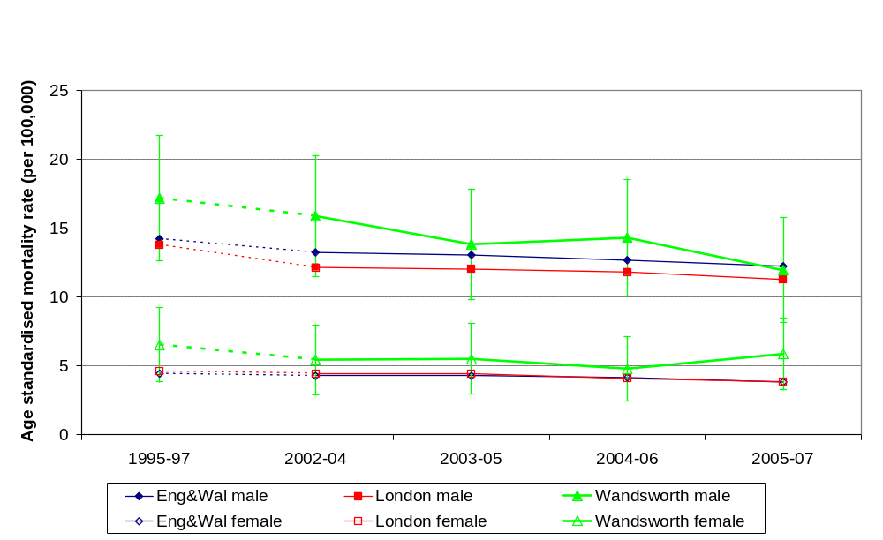
Figure 8: Mortality rate from suicide and injury undetermined, all age
(ICD 10 X60-X84, Y10-Y34 excl. Y33.9)

Source: Clinical and Health Outcomes Knowledge Base, Provided by T Morgan, WPCT 13.5.09

Figure 8 shows:

- The all age mortality rate is higher in males than females
- The all age mortality rate for males in Wandsworth is generally higher than the average rates for England & Wales and London, but the difference is not statistically significant
- The all age mortality rate for females in Wandsworth is generally higher than the average rates for England & Wales and London, but the difference is not statistically significant
- The all age mortality rates in England & Wales and London show a slight downward trend
- The overall reduction in death rate from suicide and undetermined injury in Wandsworth residents from 1995-97 to 2005-07 is 30% in males and 10% in females with an overall reduction of 25% in all persons but these differences are not statistically significant. The ‘Our Healthier Nation’ target is to reduce the death rate by 20% from 1995-97 to 2009-11. Although a 25% reduction has been achieved in Wandsworth based on 2005-07 data this reduction needs to be maintained in 2009-11 in order to achieve the target.

Table 13: Directly age-standardised suicide rates per 100,000 population in the boroughs in SW London, 2005-07. All persons, all ages.

London Borough | Number of suicides | Suicides per 100,000 population | 95% confidence interval
Croydon | 88 | 8.17 | 6.45 – 9.90
Kingston | 29 | 5.49 | 3.44 – 7.55
Merton | 39 | 6.91 | 4.67 – 9.15
Richmond & Twickenham | 26 | 4.63 | 2.80 – 6.47
Sutton | 42 | 6.78 | 4.66 – 8.90
Wandsworth | 66 | 8.78 | 6.52 – 11.04
London | 1757 | 7.49 | 7.13 – 7.85
England | 12607 | 7.89 | 7.75 – 8.03

Source: ONS mortality data analysed by National Centre for Health Outcomes Development

Table 13 shows that the all age mortality rate for all persons in Wandsworth in 2005-07 was higher than the average rates for London and England but the difference is not statistically significant. It also shows that Wandsworth had the highest all age mortality rate in SW London but the differences are not statistically significant except between Wandsworth and Richmond & Twickenham. These differences reflect the higher suicide rate in Inner London (9.3 deaths per 100,000 population) compared to a rate of 6.5 in Outer London in 2005-07. ²²

4.3.1 Risk factors for suicide
Suicide rates are significantly higher in males than females as illustrated in figure 8. In London in 2005-07 age-specific suicide rates showed peaks for men and women aged 45 to 59 years and for men aged 80-84 and women aged 85 and over. Although the highest suicide rates are found in these older age bands, suicide represents a far greater proportion of the total number of deaths in the younger age groups, males aged 20-39 and females aged 15-29. These proportions then fall with increasing age.²²

The five year report of the National Confidential Inquiry into Suicide and Homicide by People with Mental Illness found that a quarter of all people who died by suicide had been in contact with mental health services within the previous year. The highest number of those who died within three months after discharge from an inpatient unit, committed suicide within the first one to two weeks.²² In view of this the National Suicide Prevention Strategy for England recommends that all patients with severe mental illness and patients with a history of self-harm in the previous 3 months should be followed up within 7 days of discharge from hospital.

In England and Wales, suicide rates have been found to be twice as high for those living in the most deprived areas compared to those living in the least deprived and around three times higher in single and divorced people than married people.²² Other high risk groups include people misusing alcohol and drugs, prisoners and high risk occupational groups including farmers, nurses and doctors. Suicide rates are highest in social class V.²³ Research has shown that suicide rates tend to rise during periods of high unemployment. Although it is difficult to prove causality between unemployment and suicide it is possible that the current global economic recession may lead to a rise in suicide rates. ²²

These findings suggest that suicide prevention work needs to be targeted at people living in the more deprived areas of Wandsworth and other high risk groups. NHS Wandsworth needs to effectively link suicide prevention activities with SWL & StG MHT and HMP Wandsworth.

A detailed audit of suicides in Wandsworth residents (and non-residents who died in Wandsworth) is currently being conducted. The results are due to be reported at the end of July 2009 and will be used to update the Suicide Prevention Strategy for Wandsworth. This strategy will make further more detailed recommendations for suicide prevention work in Wandsworth.
5.0 Secondary care mental health service use

Four PCTs within the sector, Kingston, Sutton & Merton, Richmond & Twickenham and Wandsworth, are served by South West London and St George’s Mental Health Trust (SWL & StG MHT). The South London and Maudsley (SLAM) Mental Health Trust provides specialist mental health services to Croydon PCT.

5.1 Community mental health service activity

The majority of mental health interventions take place outside of inpatient services, within a wide range of community services.

5.1.1 Community mental health teams (CMHTs)

There are currently seven CMHTs in Wandsworth providing community mental health and social care to adults between the ages of 18 to 75 years who live in the borough. Each team is multidisciplinary and includes a Team Manager, Community Psychiatric Nurses (CPNs), Occupational Therapists (OTs), Psychiatrists, Clinical Psychologists and social care staff employed by the Local Authority.

CMHTs are aligned with GP practices in Wandsworth. Patients are referred to the CMHT that is linked with their GP practice as long as they are a Wandsworth resident. If they are not a Wandsworth resident they will be referred to the CMHT that covers their postcode within their borough of residency. If a Wandsworth resident is registered with a GP outside of Wandsworth they will be referred to the CMHT in Wandsworth that covers their postcode.

The number of GP referrals to the CMHTs from Q1 2006/07 to Q3 08/09 is shown in the table 14 below.

Table 14: Number of GP referrals to CMHTs from 06/07 to 08/09

 | Balham & Tooting | Battersea Junction | Central Wandsworth | Putney | Roehampton | Tooting Furzedown | West Battersea | Wandsworth CMHTs
Q1 06/07 | 60 | 77 | 78 | 52 | 74 | 47 | 51 | 439
Q2 | 75 | 94 | 105 | 80 | 100 | 72 | 67 | 593
Q3 | 82 | 90 | 74 | 68 | 95 | 94 | 64 | 567
Q4 | 62 | 107 | 79 | 74 | 81 | 80 | 73 | 556
Q1 07/08 | 66 | 94 | 94 | 77 | 82 | 60 | 81 | 554
Q2 | 70 | 74 | 63 | 84 | 76 | 65 | 46 | 478
Q3 | 72 | 94 | 75 | 69 | 68 | 84 | 55 | 517
Q4 | 70 | 104 | 60 | 84 | 61 | 53 | 51 | 483
Q1 08/09 | 64 | 102 | 81 | 58 | 67 | 67 | 59 | 498
Q2 | 64 | 94 | 82 | 84 | 79 | 68 | 57 | 528
Q3 | 63 | 83 | 55 | 84 | 76 | 62 | 68 | 491
Total | 748 | 1013 | 846 | 814 | 859 | 752 | 672 | 5704

Source: RiO. Provided by Jane Healey, SWL & StG MHT 10.3.09

Table 15: Number of accepted standard GP referrals to CMHTs from 06/07 to 08/09

 | Balham & Tooting | Battersea Junction | Central Wandsworth | Putney | Roehampton | Tooting Furzedown | West Battersea | Wandsworth CMHTs
06/07 Q1 | 45 | 67 | 67 | 27 | 49 | 37 | 36 | 328
Q2 | 53 | 67 | 64 | 47 | 51 | 48 | 51 | 381
Q3 | 47 | 73 | 48 | 45 | 55 | 57 | 49 | 374
Q4 | 40 | 75 | 42 | 43 | 41 | 54 | 44 | 339
07/08 Q1 | 45 | 75 | 67 | 54 | 48 | 40 | 62 | 391
Q2 | 53 | 59 | 48 | 59 | 42 | 46 | 33 | 340
Q3 | 43 | 69 | 52 | 44 | 47 | 49 | 38 | 342
Q4 | 36 | 72 | 38 | 60 | 29 | 105 | 33 | 373
08/09 Q1 | 40 | 71 | 56 | 38 | 36 | 42 | 39 | 322
Q2 | 44 | 60 | 66 | 37 | 47 | 41 | 39 | 334
Q3 | 36 | 52 | 40 | 58 | 56 | 41 | 45 | 328
Total | 482 | 740 | 588 | 512 | 501 | 560 | 469 | 3852

Source: RiO. Provided by Jane Healey, SWL & StG MHT 10.3.09

Table 16: Number of accepted urgent GP referrals to CMHTs from 06/07 to 08/09

 | Balham & Tooting | Battersea Junction | Central Wandsworth | Putney | Roehampton | Tooting Furzedown | West Battersea | Wandsworth CMHTs
06/07 Q1 | 7 | 9 | 5 | 21 | 20 | 9 | 11 | 82
Q2 | 9 | 6 | 15 | 25 | 13 | 10 | 9 | 87
Q3 | 8 | 6 | 7 | 15 | 11 | 6 | 9 | 62
Q4 | 3 | 6 | 10 | 19 | 15 | 6 | 13 | 72
07/08 Q1 | 4 | 4 | 8 | 11 | 8 | 4 | 9 | 48
Q2 | 0 | 5 | 5 | 7 | 7 | 11 | 8 | 43
Q3 | 11 | 2 | 6 | 8 | 6 | 6 | 9 | 48
Q4 | 15 | 9 | 10 | 7 | 10 | 6 | 6 | 63
08/09 Q1 | 7 | 7 | 11 | 6 | 12 | 6 | 9 | 58
Q2 | 6 | 12 | 10 | 6 | 11 | 7 | 8 | 60
Q3 | 10 | 12 | 8 | 3 | 7 | 7 | 16 | 63
Total | 80 | 78 | 95 | 128 | 120 | 78 | 107 | 686

Source: RiO. Provided by Jane Healey, SWL & StG MHT 10.3.09

Table 17: Number of accepted emergency GP referrals to CMHTs from 06/07 to 08/09

 | Balham & Tooting | Battersea Junction | Central Wandsworth | Putney | Roehampton | Tooting Furzedown | West Battersea | Wandsworth CMHTs
06/07 Q1 | 1 | 0 | 1 | 1 | 0 | 1 | 2 | 6
Q2 | 1 | 0 | 3 | 2 | 3 | 2 | 0 | 11
Q3 | 2 | 0 | 1 | 2 | 3 | 3 | 1 | 12
Q4 | 3 | 0 | 1 | 1 | 1 | 3 | 0 | 9
07/08 Q1 | 2 | 0 | 1 | 1 | 1 | 1 | 0 | 6
Q2 | 0 | 0 | 0 | 2 | 2 | 0 | 0 | 4
Q3 | 1 | 2 | 1 | 2 | 1 | 0 | 0 | 0
Q4 | 0 | 0 | 0 | 0 | 0 | 0 | 0 | 0
08/09 Q1 | 0 | 1 | 3 | 1 | 0 | 0 | 0 | 5
Q2 | 0 | 0 | 2 | 1 | 2 | 0 | 0 | 5
Q3 | 0 | 0 | 2 | 3 | 1 | 0 | 0 | 6
Total | 10 | 3 | 15 | 16 | 14 | 10 | 3 | 64

Source: RiO. Provided by Jane Healey, SWL & StG MHT 10.3.09

The size of each CMHT caseload is shown in figure 9 on the first y axis on the left hand side of the graph. The highest caseloads are in Central Wandsworth and West Battersea CMHTs and lowest caseloads are in Putney and Tooting & Furzedown CMHTs. There has been an overall downward trend in the size of caseloads at Central Wandsworth, Roehampton, Putney and Tooting & Furzedown CMHTs. The caseload of Balham & Tooting CMHT peaked in October 2007 and since then there has been a downward trend. There has been no significant change in caseload overall in Battersea Junction and West Battersea CMHT.

Figure 9: Number of patients on CMHT caseloads in Wandsworth Oct 06 to Feb 09.

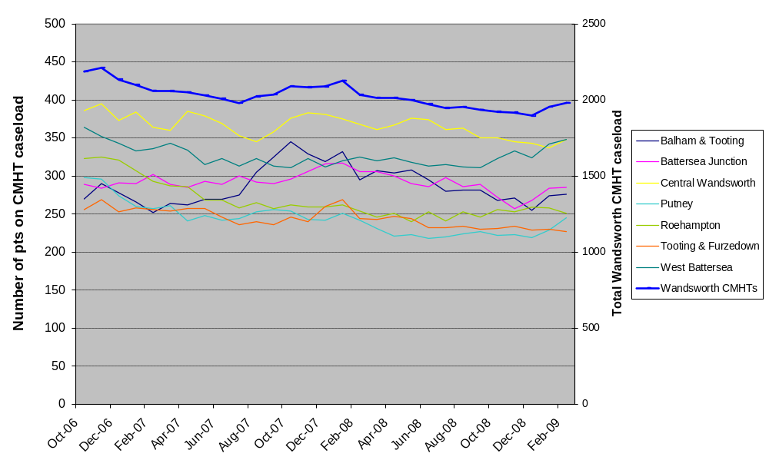

Source: RiO. Provided by Jane Healey, SWL & StG MHT 10.3.09
Table 18: Number of patients on CMHT caseloads in Wandsworth Oct 06 to Feb 09.

 | Balham & Tooting | Battersea Junction | Central Wandsworth | Putney | Roehampton | Tooting & Furzedown | West Battersea | Wandsworth CMHTs
Oct-06 | 270 | 289 | 386 | 298 | 323 | 256 | 364 | 2186
Nov-06 | 290 | 284 | 395 | 296 | 325 | 269 | 352 | 2211
Dec-06 | 278 | 291 | 373 | 274 | 321 | 253 | 343 | 2133
Jan-07 | 266 | 290 | 384 | 260 | 307 | 258 | 333 | 2098
Feb-07 | 252 | 302 | 364 | 257 | 293 | 256 | 336 | 2060
Mar-07 | 264 | 289 | 360 | 261 | 287 | 254 | 343 | 2058
Apr-07 | 262 | 285 | 385 | 241 | 286 | 257 | 334 | 2050
May-07 | 270 | 293 | 379 | 248 | 268 | 257 | 315 | 2030
Jun-07 | 270 | 289 | 369 | 242 | 268 | 246 | 323 | 2007
Jul-07 | 275 | 300 | 353 | 244 | 258 | 236 | 313 | 1979
Aug-07 | 305 | 292 | 345 | 253 | 265 | 240 | 323 | 2023
Sep-07 | 325 | 290 | 358 | 256 | 257 | 236 | 313 | 2035
Oct-07 | 345 | 296 | 376 | 254 | 262 | 246 | 311 | 2090
Nov-07 | 329 | 306 | 383 | 243 | 259 | 240 | 323 | 2083
Dec-07 | 319 | 316 | 381 | 242 | 259 | 260 | 312 | 2089
Jan-08 | 332 | 317 | 375 | 251 | 262 | 269 | 320 | 2126
Feb-08 | 295 | 306 | 368 | 242 | 254 | 244 | 325 | 2034
Mar-08 | 307 | 306 | 361 | 231 | 246 | 243 | 320 | 2014
Apr-08 | 304 | 300 | 367 | 221 | 251 | 247 | 324 | 2014
May-08 | 308 | 290 | 376 | 223 | 240 | 244 | 318 | 1999
Jun-08 | 295 | 286 | 374 | 218 | 253 | 232 | 313 | 1971
Jul-08 | 280 | 298 | 361 | 220 | 241 | 232 | 315 | 1947
Aug-08 | 282 | 286 | 363 | 224 | 253 | 234 | 312 | 1954
Sep-08 | 282 | 289 | 350 | 227 | 246 | 230 | 311 | 1935
Oct-08 | 268 | 272 | 350 | 222 | 256 | 231 | 323 | 1922
Nov-08 | 271 | 257 | 345 | 223 | 253 | 234 | 333 | 1916
Dec-08 | 255 | 268 | 343 | 219 | 259 | 229 | 324 | 1897
Jan-09 | 274 | 284 | 337 | 229 | 258 | 230 | 342 | 1954
Feb-09 | 276 | 285 | 348 | 245 | 251 | 227 | 348 | 1980

Source: RiO. Provided by Jane Healey, SWL & StG MHT 10.3.09

There was a 9% reduction in the overall number of patients on CMHT caseloads in Wandsworth from October 2006 to February 2009 (as seen in figure 9 on the second y axis on the right hand side of the graph). The total caseload peaked in November 2006 at 2211 and fell by 14% to a low of 1897 in December 2008. This reduction may be related to an increase in the Crisis Resolution and Home Treatment team caseload from Q4 of 2006/7. (See page 39)

In order to calculate each CMHT’s monthly caseload rate per 100,000 population it was necessary to determine the size of the population to which each CMHT is responsible for providing services. This has been calculated from the number of Wandsworth residents aged 18-75 years registered to each GP practice within each CMHT as shown in the table below. On 1.7.08 Dr Qaiyum’s patients, who would previously have been referred to Battersea Junction CMHT, were transferred to Dr Nicholas & Partners’ practice which refers to Balham & Tooting CMHT. The population sizes have been adjusted to reflect this and this table therefore provides the population sizes of the CMHTs prior to 1.7.08.

Table 19: Size of Wandsworth resident populations aged 18-75 years registered to GP practices aligned to each CMHT, pre July 2008.

CMHT | GP registered and Wandsworth RESIDENT population aged 18-75 years | %
Balham & Tooting | 34192 | 13.1
Battersea Junction | 38252 | 14.6
Central Wandsworth | 41037 | 15.7
Putney | 42437 | 16.2
Roehampton | 35380 | 13.5
Tooting & Furzedown | 30603 | 11.7
West Battersea | 39661 | 15.2
Total | 261562 | 100.0

Source: NSTS download 1.7.09. (Adjusted for the transfer of Dr Qaiyum’s patients (H85633) to Dr Nicholas’ practice (H85005) on 1.7.08.) Provided by Tom Morgan, WPCT

The CMHT monthly caseload per 100,000 population is shown in figure 10. The highest rate is in Central Wandsworth CMHT and the lowest rate is in Putney CMHT which has a significantly lower caseload per 100,000 population than the other CMHTs. From July 2007 the second lowest caseload rate was in Roehampton CMHT. Further analysis is required to determine the reasons for variation in caseload rates between the CMHTs.

Figure 10: CMHT monthly caseload per 100,000 GP registered and Wandsworth resident population

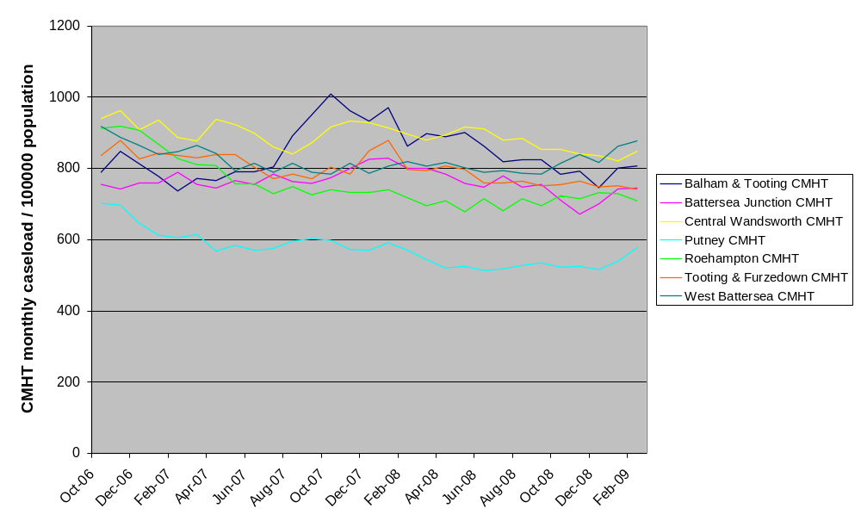
Source: RiO. Provided by Jane Healey, SWL & StG MHT 10.3.09

5.1.1.1 Care Programme Approach

The term Care Programme Approach (CPA) has been used since 1990 to describe the framework that supports and co-ordinates effective mental health care for people with severe mental health problems in secondary mental health services. Until October 2008 there were two levels of support and co-ordination:

- standard CPA for individuals receiving care from one agency, who are able to self-manage their mental health problems and maintain contact with services.

- enhanced CPA for individuals with multiple care needs from a range of agencies, who are likely to be at higher risk and to disengage from services and require intense intervention.

Since October 2008 the term CPA has been changed to refer only to the provision of secondary mental health services for people who have complex needs and is no longer used to describe provision of services to those with more straightforward needs (formerly standard CPA).

Figure 11 shows the number of patients on enhanced CPA by CMHT. Data was not available for February 2007 or May 2007. There was an 11% fall in total enhanced CPA caseload in Wandsworth from April 2006 to December 2008. The majority of the reduction occurred prior to July 2007 and may be related to increases in the Crisis Resolution and Home Treatment team caseload. It is important to note that guidance describing characteristics of those needing enhanced CPA rather than standard CPA has been subject to variation in interpretation.
Figure 11: Number of patients on enhanced CPA by CMHT

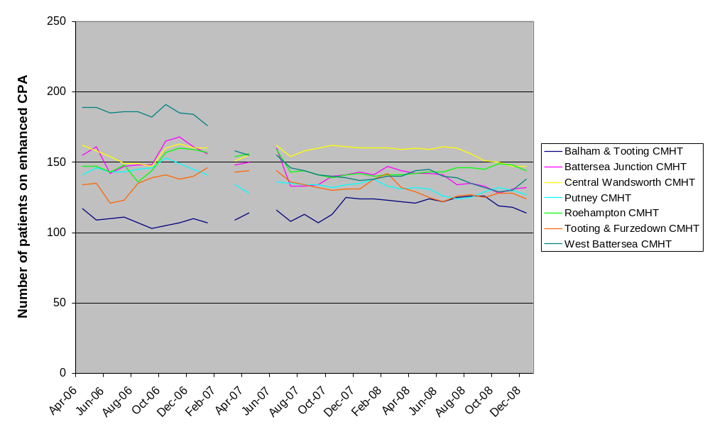

Source: RiO. Provided by Jane Healey, SWL & StG MHT 10.3.09

Figure 12: CMHT enhanced CPA monthly caseload per 100000 GP registered and Wandsworth resident population

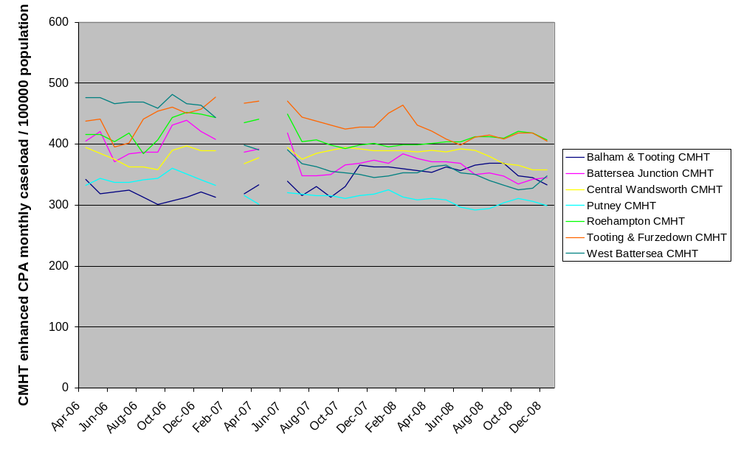

Source: RiO. Provided by Jane Healey, SWL & StG MHT 10.3.09
Table 20: Number of patients on enhanced CPA by CMHT

 | Balham & Tooting | Battersea Junction | Central Wandsworth | Putney | Roehampton | Tooting & Furzedown | West Battersea | Wandsworth CMHTs
Apr-06 | 117 | 155 | 162 | 141 | 147 | 134 | 189 | 1045
May-06 | 109 | 161 | 158 | 146 | 147 | 135 | 189 | 1045
Jun-06 | 110 | 142 | 154 | 143 | 143 | 121 | 185 | 998
Jul-06 | 111 | 147 | 149 | 143 | 148 | 123 | 186 | 1007
Aug-06 | 107 | 148 | 149 | 145 | 136 | 135 | 186 | 1006
Sep-06 | 103 | 148 | 147 | 146 | 144 | 139 | 182 | 1009
Oct-06 | 105 | 165 | 160 | 153 | 157 | 141 | 191 | 1072
Nov-06 | 107 | 168 | 163 | 149 | 160 | 138 | 185 | 1070
Dec-06 | 110 | 161 | 160 | 145 | 159 | 140 | 184 | 1059
Jan-07 | 107 | 156 | 160 | 141 | 157 | 146 | 176 | 1043
Feb-07
Mar-07 | 109 | 148 | 151 | 134 | 154 | 143 | 158 | 997
Apr-07 | 114 | 150 | 155 | 128 | 156 | 144 | 155 | 1002
May-07 |  |  |  | 1
Jun-07 | 116 | 160 | 162 | 136 | 159 | 144 | 155 | 1032
Jul-07 | 108 | 133 | 154 | 135 | 143 | 136 | 146 | 955
Aug-07 | 113 | 133 | 158 | 134 | 144 | 134 | 144 | 960
Sep-07 | 107 | 134 | 160 | 134 | 141 | 132 | 141 | 949
Oct-07 | 113 | 140 | 162 | 132 | 139 | 130 | 140 | 956
Nov-07 | 125 | 141 | 161 | 134 | 141 | 131 | 139 | 972
Dec-07 | 124 | 143 | 160 | 135 | 142 | 131 | 137 | 972
Jan-08 | 124 | 141 | 160 | 138 | 140 | 138 | 138 | 979
Feb-08 | 123 | 147 | 160 | 133 | 141 | 142 | 140 | 986
Mar-08 | 122 | 144 | 159 | 131 | 141 | 132 | 140 | 969
Apr-08 | 121 | 142 | 160 | 132 | 142 | 129 | 144 | 970
May-08 | 124 | 142 | 159 | 131 | 143 | 125 | 145 | 969
Jun-08 | 122 | 141 | 161 | 126 | 143 | 122 | 140 | 955
Jul-08 | 125 | 134 | 160 | 124 | 146 | 126 | 139 | 954
Aug-08 | 126 | 135 | 156 | 125 | 146 | 127 | 135 | 950
Sep-08 | 126 | 133 | 151 | 129 | 145 | 125 | 132 | 941
Oct-08 | 119 | 128 | 150 | 132 | 149 | 128 | 129 | 935
Nov-08 | 118 | 131 | 147 | 130 | 148 | 128 | 130 | 932
Dec-08 | 114 | 132 | 147 | 127 | 144 | 124 | 138 | 926

Source: RiO. Provided by Jane Healey, SWL & StG MHT 10.3.09

5.1.2 Crisis resolution and home treatment teams (CRHT teams)

The number of episodes of home treatment performed by the CRHT teams has risen markedly from 363 in 2006/7 to 810 in 2008/9, surpassing the target of 714 treatment episodes per year.

Table 21: Number of episodes of treatment by CRHT teams from 2006/07 to 2008/09.

 | 2006/2007 | 2007/2008 | 2008/2009
Q1 | 80 | 155 | 198
Q2 | 63 | 224 | 196
Q3 | 76 | 163 | 232
Q4 | 144 | 213 | 184
Total | 363 | 755 | 810

Source: SWL & St G Wandsworth Borough Performance Reports. Provided by Jane Healey, SWL & StG MHT

5.1.3 Early intervention in psychosis service

There has also been an increase in the number of patients on the Early Intervention Service (EIS) caseload from 2006/7 to 2008/9 which is shown in table 21. The EIS treatment target is 161 cases over three years which was achieved in Q4 of 2008/9. There is currently no wait for this service.

Table 22: Early intervention service caseload from 2006/07- 2008/09

2006/2007 | Number of patients on EIS caseload
Q1 | 50
Q2 | 55
Q3 | 54
Q4 | 62

From 2007/08 the figures are cumulative over 3 years:

 | Number of patients on EIS caseload
Q1 2007/2008 | 60
Q2 | 62
Q3 | 62
Q4 | 82
Q1 2008/2009 | 100
Q2 | 116
Q3 | 134
Q4 | 164

Source: SWL & St G Wandsworth Borough Performance Reports. Provided by Jane Healey, SWL & StG MHT

5.1.4 Number of people helped to live at home

The number of people with a mental health problem helped to live at home in Wandsworth in 2007-08 was 637. This is the number of patients who are receiving homecare or daycare along with the caseload of the Early Intervention, CRHT & WAORT teams.

Daycare Services

There are 4 resource centres (2 run by Together and 2 run by Family Action). Sound Minds is an additional service giving people with mental health problems the opportunity to become involved with music, theatre, art, film making and poetry. It also provides access to sound studios and training.

The table below shows active membership at the end of each quarter. These services are funded by Wandsworth Borough Council & NHS Wandsworth (approx. 70:30 split) through block funded contracts. The contracts are based on capacity. The data shows underutilisation at Bedford Hill, Edward Wilson House and Triangle. In order to reduce underutilisation the promotion of services has been increased and regular meetings with CMHT managers to discuss any difficulties with referrals have been introduced. Performance pay will be included in the contracts for 2010-11 leading to a reduction in pay of up to 20% in under performing centres.

Table 23: Active membership of daycare services at the end of each quarter

Year | Centre | Capacity | Active Caseload
Year | Centre | Capacity | QTR 1 | QTR 2 | QTR 3 | QTR 4 | Yearly average
2007/08 | Bedford Hill | 125 | 84 | 84 | 79 | 93 | 85
 | Edward Wilson House | 125 | 92 | 75 | 80 | 87 | 84
 | Heathside | 125 | 137 | 138 | 141 | 148 | 141
 | Triangle | 90 | Not available | 20 | 34 | 42 | 32
 | Sound Minds | 52 | Not available | 55 | 74 | 84 | 71
2008/09 | Bedford Hill | 125 | 90 | 92 | 101 | 109 | 98
 | Edward Wilson House | 125 | 94 | 95 | 98 | 85 | 93
 | Heathside | 125 | 139 | 147 | 137 | 131 | 139
 | Triangle | 90 | 53 | 53 | 40 | 64 | 53
 | Sound Minds | 52 | 56 | 68 | 77 | 81 | 71

Source: Data provided by S Rushton, Wandsworth Council, 8.6.09

5.1.5 Adults in contact with secondary mental health services in employment

The percentage of adults receiving secondary mental health services in paid employment at the time of their most recent assessment, formal review or other multi-disciplinary care planning meeting has been recorded as a new national indicator NI 150 since October 2008.

Table 24 shows the percentage of adults receiving secondary mental health care in employment in the boroughs of SW London in 2008/9.

Table 24: Percentage of adults receiving secondary mental health care in employment in the boroughs of SW London in 2008/9.

Borough | % of adults receiving secondary mental health care in employment
Wandsworth | 14
Sutton | 12
Richmond | 13
Merton | 18
Kingston | 23

Source: RiO. Provided by Paul Lewis, SWL & StG MHT.

Since October 2008 data has been collected by SWL & StG MHT for the NI 150 indicator in 51% of eligible patients in Wandsworth. The employment status of those patients in Wandsworth where it has been recorded is shown in the table below.

Table 25: Employment status of Wandsworth patients where the NI 150 indicator was completed in Q4 2008/9.

Employment status | Percentage %
In employment | 14
In education or training | 14
Unemployed | 59

Source: SWL & StG Wandsworth Borough Performance Report Q4 2008/09. Provided by Jane Healey, SWL & StG MHT.

There is funding for 3.5 WTE employment support workers in Wandsworth but not all these posts have been filled. Despite investment in employment support the percentage of adults receiving secondary mental health care who are in employment remains low. Further analysis of the factors contributing to this are required in order to create an action plan to increase the percentage of adults in employment.

5.2 Inpatient services

There was an 18% reduction in admissions of WPCT registered patients to acute adult wards at SWL & StG MHT from 2006/7 to 2007/8 and between 2007/8 and 2008/9 the number of admissions has remained stable. The table below shows the number of admissions to each of the acute adult wards excluding John Meyer Ward and Shamrock Unit which are the psychiatric intensive care units (PICUs) at the trust. Patients are transferred in and out of the PICUs from the acute wards and therefore admissions to the PICUs are excluded from this data to avoid double counting of admissions.

Table 26: Number of admissions of WPCT registered patients to acute adult wards at SWL & StG MHT excluding specialist services

Acute adult wards | Number of admissions
Acute adult wards | 2006/2007 | 2007/2008 | 2008/2009
Bluebell | 165 | 147 | 147
Crocus - Adult | 31 | N/A | N/A
Jasper | 14 | 13 | 6
Jupiter | 57 | 56 | 75
Laurel | 180 | 152 | 176
Lavender | 43 | 19 | 26
Lilacs | 41 | 27 | 7
Orchids | 24 | 12 | 8
Rose | 206 | 192 | 180
Seacole | 39 | 36 | 35
All acute adult wards | 800 | 654 | 660

Source: RiO, extracted from Pulse 30.6.09. Provided by Glynn Dodd, SWL & StG MHT 30.6.09

Table 27: Average length of stay (LOS) of WPCT registered patients admitted to acute adult mental health wards at SWL & StG MHT excluding leave

Acute adult wards | Average length of stay (days)
Acute adult wards | 2006/2007 | 2007/2008 | 2008/2009
Bluebell | 51 | 35 | 29
Crocus - Adult | 49 | N/A | N/A
Jasper | 21 | 25 | 14
Jupiter | 27 | 22 | 21
Laurel | 42 | 49 | 29
Lavender | 6 | 27 | 29
Lilacs | 13 | 7 | 26
Orchids | 11 | 13 | 14
Rose | 38 | 37 | 26
Seacole | 32 | 21 | 25
All acute adult wards | 37 | 35 | 27

Source: RiO, extracted from Pulse 30.6.09. Provided by Glynn Dodd, SWL & StG MHT 30.6.09

The average length of stay of WPCT registered patients admitted to acute adult wards at SWL & StG MHT reduced by 23% between 2007/8 and 2008/9 from 35 to 27 days.

Table 28: Occupied bed days (OBDs) excluding leave for WPCT acute admissions to adult mental health wards at SWL & StG MHT

Acute adult wards | OBDs excluding leave
Acute adult wards | 2006/2007 | 2007/2008 | 2008/2009
Bluebell | 6638 | 4885 | 4996
Crocus - Adult | 1213 | N/A | N/A
Jasper | 197 | 166 | 117
Jupiter | 2461 | 1504 | 1576
Laurel | 7235 | 7478 | 7616
Lavender | 409 | 428 | 797
Lilacs | 310 | 229 | 145
Orchids | 201 | 99 | 287
Rose | 7339 | 7354 | 6585
Seacole | 2065 | 1576 | 1415
All acute adult wards | 28068 | 23719 | 23534

Source: RiO, extracted from Pulse 30.6.09. Provided by Glynn Dodd, SWL & StG MHT 30.6.09

There was a 15% reduction in the number of occupied bed days excluding leave for WPCT acute admissions to adult wards at SWL & StG MHT from 2006/7 to 2007/8. The number of OBDs has remained stable from 2007/8 to 2008/9.

Despite the significant reduction in average LOS from 2007/8 to 2008/9 and no change in the number of admissions, the total number of OBDs has reduced by less than 200 days. This requires further analysis to understand:
- the relationship between number of admissions, average LOS and occupied bed days.
- the impact of increased investment in Crisis Resolution and Home Treatment teams (CRHTs) and Early Intervention Service (EIS) on number of admissions, average LOS and occupied bed days.
6.0 Ethnicity of Service Users

6.1 Acute admissions

The volume of admissions of WPCT registered patients to acute adult wards at SWL & St George’s Mental Health Trust by ethnic group is shown in the table below.

Table 29: Number of admissions of WPCT registered patients to acute wards by ethnic group

Ethnic Group | 2006/2007 |  | 2007/2008 |  | 2008/2009 |  | Wandsworth population ethnicity estimates (%)
Ethnic Group | Number of admissions | Percentage of admissions by ethnic group (%) | Number of admissions | Percentage of admissions by ethnic group (%) | Number of admissions | Percentage of admissions by ethnic group (%) | Wandsworth population ethnicity estimates (%)
White | 510 | 63.8 | 375 | 57.2 | 409 | 62.0 | 78.0
Black | 173 | 21.6 | 182 | 27.7 | 149 | 22.6 | 10.2
Asian | 72 | 9.0 | 46 | 7.0 | 44 | 6.7 | 7.6
Mixed | 19 | 2.4 | 17 | 2.6 | 13 | 2.0 | -
Other ethnic groups | 11 | 1.4 | 11 | 1.7 | 25 | 3.8 | 4.2
Not stated | 15 | 1.9 | 25 | 3.8 | 20 | 3.0 | -
All Ethnicity | 800 |  | 656 |  | 660

Source: RiO, extracted from Pulse. Provided by Glynn Dodd, SWL & StG MHT 9.7.09

The proportion of patients from black ethnic groups admitted to acute adult wards has been consistently more than double the general population of Wandsworth and peaked in 2007/08.

The proportion of patients from asian ethnic groups admitted to acute adult wards was greater than the general population of Wandsworth in 2006/07 but has since fallen to lower than the resident population.

6.2 Compulsory Detentions under the Mental Health Act

The number of compulsory detentions (sections) performed at SWL & StG MHT by ethnic group in the last three years is shown in the table below. The data includes the following sections: 2, 3, 4, 5, 7, 25, 35, 36, 37, 38, 43, 47, 48, 135 and 136. The data was not available broken down by borough of residence.

Table 30: Number of sections performed at SWL & StG MHT by ethnic group from 1/4/06 to 31/3/09 for patients in all boroughs

Ethnic Group | 2006/2007 |  | 2007/2008 |  | 2008/2009 |  | Population ethnicity estimates (%)²⁶
Ethnic Group | Number of sections | Percentage of sections by ethnic group (%) | Number of sections | Percentage of sections by ethnic group (%) | Number of sections | Percentage of sections by ethnic group (%) | Wands-  worth | South  West  London
White | 1106 | 62.6 | 1021 | 60.7 | 999 | 58.6 | 78.0 | 75.7
Black | 414 | 23.4 | 388 | 23.1 | 403 | 23.6 | 10.2 | 9.8
Asian | 116 | 6.6 | 130 | 7.7 | 118 | 6.9 | 7.6 | 7.0
Mixed | 26 | 1.5 | 24 | 1.4 | 40 | 2.3 | - | -
Other ethnic groups | 52 | 2.9 | 48 | 2.9 | 48 | 2.8 | 4.2 | 7.4
Not stated | 54 | 3.1 | 70 | 4.2 | 98 | 5.7 | - | -
TOTAL | 1768 |  | 1681 |  | 1706

Source: Protocol database. Provided by T Knight, Deputy Mental Health Act Manager, SWL & StG MHT 26.6.09

The proportion of patients from black ethnic groups detained under section at SWL & StG MHT in the last three years has been consistently more than double the general population of SW London and of Wandsworth.

The number of sections performed under section 136 at SWL & StG MHT by ethnic group in the last three years is shown in the following table. Section 136 allows a police officer to take a person who appears to be mentally ill and in immediate need of care or control, from a public place to a place of safety for assessment for up to a maximum of 72 hours.

Table 31: Number of Section 136s performed at SWL & StG MHT by ethnic group from 1/4/06 to 31/3/09 for patients in all boroughs

Ethnic Group | 2006/2007 |  | 2007/2008 |  | 2008/2009 |  | Population ethnicity estimates (%)²⁶
Ethnic Group | Number of Section 136s | Percentage of Section 136s by ethnic group (%) | Number of Section 136s | Percentage of Section 136s by ethnic group (%) | Number of Section 136s | Percentage of Section 136s by ethnic group (%) | Wands-  worth | South  West  London
White | 173 | 73.0 | 212 | 71.9 | 216 | 72.2 | 78.0 | 75.7
Black | 39 | 16.5 | 46 | 15.6 | 46 | 15.4 | 10.2 | 9.8
Asian | 14 | 5.9 | 18 | 6.1 | 14 | 4.7 | 7.6 | 7.0
Mixed | 1 | 0.4 | 3 | 1.0 | 8 | 2.7 | - | -
Other ethnic groups | 7 | 3.0 | 10 | 3.4 | 8 | 2.7 | 4.2 | 7.4
Not stated | 3 | 1.3 | 6 | 2.0 | 7 | 2.3 | - | -
TOTAL | 237 |  | 295 |  | 299

Source: Protocol database. Provided by T Knight, Deputy Mental Health Act Manager, SWL & StG MHT 26.6.09

The proportion of patients from black ethnic groups detained under section 136 at SWL & StG MHT has been consistently greater than the general population of SW London and of Wandsworth but reduced by 5% from 2006/7 to 2007/8 and a further 1% from 2007/8 to 2008/9.

6.3 CMHT caseload

Table 32: Ethnicity of Wandsworth CMHT caseload

Ethnic group | Ethnicity of CMHT caseload (%) |  |  | Wandsworth population ethnicity estimates (%)²⁶
Ethnic group | 2006/07 | 2007/08 | 2008/09 | Wandsworth population ethnicity estimates (%)²⁶
White | 66.9 | 66.0 | 65.7 | 78.0
Black/ Black British | 15.7 | 16.2 | 16.8 | 10.2
Asian/ Asian British | 8.2 | 7.8 | 8.0 | 7.6
Mixed | 2.3 | 2.0 | 1.8 | -
Other ethnic groups | 1.2 | 1.6 | 1.8 | 4.2
Not stated (Refused/ not collected) | 5.7 | 6.4 | 6.0 | -

Source: RiO. Provided by H Nettle, SWL & StG MHT 30.4.09

The proportion of patients from black ethnic groups on the CMHT caseload has increased from 1.5 to 1.6 times the proportion of Wandsworth’s resident population in black ethnic groups from 2006/7 to 2008/9.

The proportion of patients from asian ethnic groups on the CMHT caseload in the last three years was approximately equal to the proportion of Wandsworth’s resident population in asian ethnic groups.

7.0 User experience equality surveys

7.1 2007/8 Survey of Community Teams

Local surveys of the experience of using SWL & St George’s Mental Health NHS Trust community teams have been conducted using a slightly modified version of the National Service User Survey questionnaire. They allow users the opportunity to provide anonymous feedback about their experience of using adult services including CMHTs, Older People’s Teams, Assertive Outreach Teams, Early intervention Services and Psychotherapy Services. In 2007/8 1650 people returned questionnaires in ‘freepost’ envelopes to the Quality Assurance Department. These local surveys allow the Trust to evaluate differences in the experience of people from different black and minority ethnic communities, disabled/non-disabled people and men/women. The results from the survey are taken from the report issued by SWL & St George’s Mental Health NHS Trust.

    - Ethnicity

98% of respondents provided information about their ethnicity:

Ethnic group | Percentage of respondents (%) | Ethnicity of CMHT caseload 2007/08 (%)
White | 81.3 | 66.0
Black/ Black British | 7.2 | 16.2
Asian/ Asian British | 5.2 | 7.8
Mixed race | 2.9 | 2.0
Other | 1.0 | 1.6
Not stated | 2.4 | 6.4

The table above demonstrates that all ethnic minority groups were underrepresented in the survey compared to data for the CMHT caseload in 2007/08. The following results need to be interpreted in light of this.

Black/Black British clients
The experience of Black/Black British clients using the service appears to have been less good than that of white clients in some areas. Black/Black British clients were LESS likely to:

- Have seen the same psychiatrist at their last two appointments (white 84%, Black/Black British 73%, p<0.05)

- Feel that their CPN had treated them with respect and dignity (92% white, 87% Black/Black British, p<0.05)

- Have received counseling/talking therapy in the last 12 months (36% white, 29% Black/Black British, p<0.05)

- Be in paid employment (16% white, 5% Black/Black British, p<0.05)

- Have their needs for help with work met (13% white, 18% Black/Black British said they wanted help to get/keep work but did not get it, p<0.05)

They were MORE likely to have been compulsorily detained in the last 12 months (6% white, 16% Black/Black British, p<0.1)

Asian/Asian British clients
The experience of Asian/Asian British clients using the service appears to have been less good than that of white clients in some areas. Asian/Asian British clients were LESS likely to:

- Have received information about local support groups (white 32%, Asian/Asian British 20%) and more likely to have wanted such information but not received it (white 21%, Asian/Asian British 32%, p<0.1)

- Have their needs for help with work, benefits, housing, relationships and social activities met.

Area clients would have liked help with but didn’t receive help | Percentage of clients in each ethnic group (%) |  |  | p value
 | White | Asian/Asian British | Black/ Black British | p value
To get/keep work | 13 | 23 | 18 | <0.05
Benefits | 12 | 16 | 6 | <0.05
Housing problems | 10 | 16 | 10 | <0.05
Relationship problems | 14 | 18 | 11 | <0.05
Social Activities | 14 | 25 | 19 | <0.05

They were MORE likely to have been compulsorily detained in the last 12 months (6% white, 11% Asian/Asian British, p<0.1)

The experience of Black/Black British clients and Asian/Asian British clients using the service appears to have been better than that of white clients in some areas. Black/Black British clients and Asian/Asian British clients were MORE likely to:

- Feel that the purposes and possible side effects of their medication had been fully explained.

- Have been told who their care co-ordinator is (77% white, 86% Black/Black British, 81% Asian/Asian British, p<0.05)

- Have received help with relationships (18% white, 29% Black/Black British, 31% Asian/Asian British, p<0.05)

Black/Black British clients were MORE likely to:

- Have received help with benefits, housing problems and social activities.

- Have been given the out-of-hours crisis line number (52% white, 71% Black/Black British, p<0.05)

It is possible that some of the aspects of the service that appear to be better for BME groups than for white clients actually reflect differences in need. However the survey has demonstrated higher levels of unmet need in white clients compared to Black/Black British clients wanting help with benefits and help with relationship problems.

    - Disability

85% of respondents provided information about whether or not they were disabled:
48% said they were disabled
52% said they were not disabled

194 of the patients who said that they were disabled (29%) said that they required special help or adjustments because of their disability.

Percentage of disabled clients requiring special help or adjustments whose needs were met:

Special help or adjustments required because of disability | Percentage %
Fully met | 46
Met to some extent | 33
Not met | 21

The overall experience of using services reported by disabled people was significantly less good than that reported by non-disabled people:

- A smaller proportion rated the services they had received ‘very good’ or ‘excellent’ (disabled 64% non-disabled 72%)

- A smaller proportion said they had enough say in decisions about their treatment and care (disabled 46%, non-disabled 58%)

- A smaller proportion said that their diagnosis had been fully discussed with them (disabled 50%, non-disabled 59%)

There were also some significant inequalities in more specific areas:

- A smaller proportion said they had definitely had a say in decisions about their medication (disabled 43%, non-disabled 50%)

- A smaller proportion said they had the crisis line number that they could call out of hours in an emergency (disabled 49% non-disabled 57%)

- A significantly greater unmet need in a number of areas of social support i.e. help with benefits, housing problems, and social activities.

    - Gender

99% of respondents provided information about their gender
45% were male
55% were female

There were no significant differences reported by men and women in terms of overall ratings of services or the extent to which people felt involved in decisions about their treatment and care, the extent to which their diagnosis had been discussed with them and the way in which they felt they were treated by professionals.

However some responses highlighted areas where improvement is required for all persons:

- Only 58% of males and 54% of females had their diagnosis fully discussed with them

- Only 49% of males and 44% of females had possible side effects of medication fully explained

- Only 34% of males and 30% of females received information about local support groups

A few significant differences were reported by men and women in the following areas:

- A significantly smaller proportion of women knew of the existence of their care plan (74% men, 68% women), had a review of their care in the previous 12 months (61% men, 51% women) and had been told what would happen at the review before the meeting (71% men, 62% women).

- A significantly higher proportion of men had seen a CPN (58% men, 52% women) or a social worker (25% men, 21% women) while a significantly higher proportion of women had seen a psychologist (16% men, 21% women).

- A significantly smaller proportion of women had attended a day centre (29% men, 21% women)

- A significantly larger proportion of women were in paid employment (17% men, 24% women)

8.0 Specialist Mental Health Services

8.1 Forensic Services

The activity for forensic services at SWL & St Georges Mental Health Trust for 2008/9 for Wandsworth PCT compared to the total activity provided for SWL PCTs (Kingston, Richmond & Twickenham, Sutton & Merton and Wandsworth) is shown in the table below.

Table 33: Forensic services activity at SWL & StG MHT in 2008/9

 | Wandsworth PCT |  |  | All SWL PCTs
 | Activity YTD | Activity YTD £ | % of all activity in SWL | Activity YTD | Activity YTD £
Inpatient Medium Secure OBD (Men only) | 5771 | 2,602,721 | 64 | 8990 | 4,054,490
Inpatient Medium Secure Ruby OBD (Women only) | 1460 | 724,160 | 52 | 2825 | 1,401,200
Inpatient Minimum Secure Hume OBD (Men only) | 2957 | 1,170,972 | 59 | 5025 | 1,989,900
Inpatient Assessment | 30 | 29,160 | 44 | 68 | 66,096
Outpatient Assessment | 146 | 107,748 | 53 | 278 | 205,164
Outpatient Attendance | 474 | 110,442 | 43 | 1093 | 254,669
Sex Offender Assessment | 19 | 14,573 | 26 | 73 | 55,991
Sex Offender Outpatient Individual Treatment Contacts | 6 | 1,842 | 17 | 36 | 11,052
Sex Offender MDT Group Treatment Attendance | 20 | 17,040 | 11 | 178 | 151,656
Total |  | 4,778,658 |  |  | 8,190,218

Source: RiO. Provided by E Martin, Commissioning Manager Specialist Mental Health SWL, 30.4.09

Wandsworth PCT has higher activity than each of the other PCTs for occupied bed days in medium secure and minimum secure wards, outpatient assessments and outpatient attendances. The sex offender service in Sutton & Merton has greater capacity than the service in Wandsworth resulting in a lower percentage of all activity in SW London occurring in Wandsworth compared to other forensic services.

WPCT also has a similar amount of inpatient activity provided by private sector placements out of the borough in addition to the activity reported in the table above. Detailed data was not available for this report.

8.2 Deaf Services

The activity for deaf services at SWL & St Georges Mental Health Trust for 2008/9 for Wandsworth PCT compared to the total activity provided for all five PCTs in SWL (Croydon, Kingston, Richmond & Twickenham, Sutton & Merton and Wandsworth) and all London PCTs is shown in the table below.

Table 34: Deaf services activity at SWL & StG MHT in 2008/9

 |  | Wandsworth PCT |  |  | All SWL PCTs | All London PCTs
 |  |  | % of all activity in SWL | % of all activity in London | All SWL PCTs | All London PCTs
Adult OBDs | Activity | 481 | 70 | 14 | 685 | 3,369
Adult OBDs | Activity £ | 269,360 | 70 | 14 | 383,600 | 1,886,640
Adult Assessments | Activity | 6 | 38 | 10 | 16 | 63
Adult Assessments | Activity £ | 2,148 | 38 | 10 | 5,728 | 22,554
Adult Treatment Months | Activity | 467 | 68 | 25 | 689 | 1,868
Adult Treatment Months | Activity £ | 131,694 | 68 | 25 | 194,298 | 526,776
Total Activity £ |  | 403,202 | 69 | 17 | 583,626 | 2,435,970

Source: RiO. Provided by E Martin, Commissioning Manager Specialist Mental Health SWL, 30.4.09

Wandsworth PCT has the highest activity in number of adult OBDs, adult treatment months and overall spend of all London PCTs. It also has the highest number of adult assessments in PCTs in SW London and second highest of all London PCTs. This is likely to be due to the large deaf community in Wandsworth who have been attracted to Wandsworth by the increased availability of facilities such as deaf schools and healthcare services.

Further in depth needs analysis of the forensic and deaf service and other specialist services such as eating disorders and personality disorders was beyond the scope of this paper.

9.0 Access to mental health services by BME groups

Two reports on barriers to Black and Minority Ethnic (BME) communities accessing mental health services in Wandsworth have been written by the BME Mental Health Community Development Coordinators at Wandsworth PCT. These reports are summarised below.

9.1 ‘Barriers to Black and Minority Ethnic communities accessing mental health services in Wandsworth’ by L Coupland, January 2009.

Aim: To discover the barriers for BME communities accessing mental health services.

Method:
The BME MH community development coordinator contacted 31 organisations, including statutory, community and voluntary organisations to discuss: 1) possible reasons why their respective clients/ communities did not access mental health services and 2) gaps in existing services.

Key issues reported as barriers to accessing mental health services:

- The stigma of mental illness including fear of implications of diagnosis on employment, education and lifestyle.
- Lack of understanding of cultural and social influences by statutory organisations.
- Lack of knowledge of mental health services in Wandsworth (primary and secondary care and community services) and lack of information for signposting.
- Lack of clear referral processes.
- Lack of resources and training in community and voluntary organisations.

Key recommendations:

- Increase the availability of information about mental ill health, the ways to recognise it and how to tackle it.
- Provide information for linguistic minorities which reflects the needs of the community.
- Improvement in interpretation services.
- Increase the provision of mental health promotion in Wandsworth.
- Positive publicity needed to tackle the stigma of seeking help with mental health problems.
- Training in community, religious and voluntary organisations to identify symptoms of mental illness as these organisations are often the first point of contact for members of BME communities when they are distressed.
- BME mental health workers to work in partnership with community organisations to address the needs of BME groups.
- Cultural awareness training for organisations providing mental health services.
- Clear referral processes needed to primary and secondary care.

9.2 ‘Access to primary care and community based mental health services for BME communities in Wandsworth; an assessment of the experiences of individuals, health professionals, and other community based service providers’ by A Allwood, December 2008.

Aim: To inform mental health commissioning at WPCT of the needs of BME communities. The report focused on African Caribbean communities.

Method:
The BME MH community development coordinator used questionnaires, focus group discussions and interviews with statutory and voluntary sector service providers and community members to gather information.

Key issues:
- African Caribbean people with mental health concerns prefer to seek help from friends, family and faith based organisations than go to the GP.
- Overall, people think the GP does not have enough time to discuss mental health problems, and does not understand mental distress enough, particularly issues faced by migrants.
- Lack of African Caribbean culturally specific mental health service provision.
- The high rate of attendance of people from African Caribbean communities at the ‘Living and Learning’ self-help courses at South Thames College demonstrates that this is an appropriate service for this ethnic group.

Recommendations:
- To include the African Caribbean communities in the Delivering Race Equality (DRE) action point concerning widening design, access and participation in psychotherapeutic service provision.
- To make ethnic monitoring mandatory for all of the service referral points so that gaps can be highlighted and addressed.
- Development of an African Caribbean peer support programme.
- Examine whether primary care early intervention strategies meet the needs of the African Caribbean community.
- Provide adequate mental health information in GP surgeries and provide GPs with appropriate training on mental health issues.
- Develop the role of faith groups as service providers to African Caribbean people with mental health concerns.
- Provide a support service for African Caribbean young carers.
- Target young males who do not seek help or go to the GP.
- Undertake further work with the African Caribbean prison population to adequately address their mental health needs.

10.0 Recommendations

The needs assessment has identified a number of areas where further work is required.

Further analysis of data

- Request Mental Health Strategies to examine the reasons for the differences in CMHT caseload per 100,000 population as part of the review of CMHTs (see page 35).

- Analyse the factors contributing to the low percentage of adults receiving secondary mental health care who are in employment in order to create an action plan to increase the percentage of adults in employment (see page 41).

- Perform further analysis to understand:
  - the relationship between number of admissions, average LOS and occupied bed days (see page 43).
  - the impact of increased investment in Crisis Resolution and Home Treatment teams (CRHTs) and Early Intervention Service (EIS) on CMHT caseload, number of admissions, average LOS and occupied bed days.

Targeting of resources or planning of services

- Planning of mental health services should take into account the increased mental health need in Wandsworth compared to the rest of SW London. This needs assessment should be used to inform the current CMHT review, inpatient review and mental health commissioning strategy for Wandsworth.

- Target mental health promotion and other resources to support mental well-being at the most deprived wards in Wandsworth (Latchmere, Roehampton, Queenstown, Tooting, Graveney and Furzedown) which have the highest IMD scores, MINI 2K scores, JSA claimant rates and lone parent claimant rates in Wandsworth (see page 19).

- Suicide prevention work should continue to be a priority within the PCT and be targeted at residents of the most deprived areas in Wandsworth. The PCT must ensure that the current suicide audit is completed and that its findings are used to update the Suicide Prevention Strategy for Wandsworth by September 2009 (see page 30).

- Monitor the impact of interventions introduced to address the underutilisation of daycare services at Bedford Hill, Edward Wilson House and Triangle (see page 40).

- Target smoking cessation advice and NHS Health Checks to people with mental health problems (see page 21).

- Further work needs to be done to reduce the rate of admission of people from black ethnic groups to SWL & StG MHT and the disproportionate rates of compulsory detention of black ethnic groups as per the Delivering Race Equality action plan (see pages 44 - 46).

Findings from Survey of Community Teams

The following recommendations are based on the findings from the SWL & St George’s Mental Health NHS Trust 2007/8 survey of community teams (see page 47):

- All clients should have their diagnosis fully discussed with them

- All clients should have possible side effects of medication fully explained.

- All clients should be given information about local support groups.

- All clients should be asked whether they have mobility/sensory impairments, long-term physical health conditions or learning disabilities and provided with any help or adjustments they require as a consequence of these.

- All clients should be given help with the following if required:
  - to get/ keep work
  - benefits
  - housing problems
  - relationship problems
  - social activities

This paper builds and expands on a mental health needs assessment for SW London by Dr Anita Jolly, entitled ‘Mental Health in South West London’, January 2009.
GLA 2007 Round Population Projections. Regional London Plan Low.
Wandsworth Joint Strategic Needs Assessment 2008
National Strategic Tracing Service
Source: McCrone P, Thornicroft G, Boyle S, Knapp M and Aziz F. The development of a Local Index of Need (LIN) and its use to explain variations in social services expenditure on mental health care in England. (2006) Health & Social Care in the Community 14(3): 254-263.
Source: http://www.mentalhealthobservatory.org.uk/mho/workbook.php
Source: LHO London mental health and wellbeing scorecard. Available at: http://www.lho.org.uk/Download/Public/13682/1/Mental_Health_Scorecard_London_Comparison_Tool.xls
De Ponte P, Hughes G, Jacobsen B. Benchmarking Specialist Mental Health Services in London. London Health Observatory and Care Services Improvement Partnership (May 2006)
Social Exclusion Unit. Mental Health and Social Exclusion, June 2004.
Harvey C, Pantelis C, Taylor J, McCabe P, Lefevre K, Campbell P et al. The Camden schizophrenia surveys: II. High prevalence of schizophrenia in an inner London borough and its relationship to socio-demographic factors (1996) Br J Psychiatry; 168(4):418-426
Office of the Deputy Prime Minister (2004) Mental Health and Social Exclusion: Social Exclusion Unit Report ODPM: London.
http://www.lho.org.uk/HIL/Disease_Groups/MentalHealth_HealthBehaviours.aspx
http://www.lho.org.uk/HIL/Disease_Groups/MentalHealth_HealthBehaviours.aspx
NHS Stop Smoking Services: Service and monitoring guidance 2009/10
The Health & Social Care Information Centre. Adult psychiatric morbidity in England, 2007. Results of a household survey.
North East Public Health Observatory (2008) Mental Health Brief no 4: Estimating the prevalence of common mental health problems in PCTs in England. Available at: http://www.mentalhealthobservatory.org.uk/uploads/doc261_1_mho_brief_4.pdf
ONS normally resident population estimates for mid 2005
The estimated number of cases of any neurotic disorder is not the sum of the 6 types of neurotic disorder since individuals may suffer from more than one disorder.
This estimation is based on findings from the 2007 APMS survey that 50% of adults with a CIS-R score indicating neurotic symptoms had symptoms of a level of severity likely to require treatment.
One fifth of the number of cases of CMD.
based on the age specific prevalence rates in the Adult Psychiatric Morbidity Survey, 2000, applied to GLA 2007 Round Ethnic Group Projections PLP Low, and adjusted by the MINI2K schizophrenia index.
Mole G and Baker A (2009) Suicide in London 2005-2007, An update. London Health Observatory and the London Development Centre.
Department of Health (2002) National suicide prevention strategy for England.
Department of Health, Refocusing the Care Programme Approach March 2008
Crocus ward was closed as an acute adult admission ward and reopened as an older people’s ward.
GLA 2007 Round Ethnic Group Projections – PLP Low
Mind (2008) The Mental Health Act 1983 an outline guide. Available at: http://www.mind.org.uk/NR/rdonlyres/79BC5B14-B4D5-4865-A7D3-6DEC83A2F674/6986/MHAoutlineguide2008.pdf
Perkins R. 2007/8 Local Surveys of the Experience of Using South West London and St George’s Mental Health NHS Trust Community Teams. Available at: http://www.swlstg-tr.nhs.uk/about/user_experience_equality_surveys.asp

