

Health Needs Assessment for People with Learning Disabilities in Wandsworth
Public Health Directorate, Wandsworth PCT
Draft September 2010

Dyfed Thomas – Public Health Project Manager, Public Health Directorate.
Amanda Cranston – Consultant in Public Health, Public Health Directorate.
Table of Contents
Glossary 4
Acknowledgements 4
Executive summary 5
Recommendations 6
1. Introduction 7
1.1 Purpose 7
1.2 The target population (What is learning disability?) 7
1.3 The health needs of people with learning disabilities 8
1.4 Policy context 8
2. National estimates and how they relate to Wandsworth 10
2.1 National estimates for people with learning disabilities 10
2.2 Geographical variation of estimates 10
2.3 Ethnicity of people with learning disabilities 11
2.4 Applying national rates to Wandsworth 11
3. People with learning disabilities in Wandsworth 13
3.1 People with learning disabilities – GP registered and council registered (Framework-i) 13
3.2 Severity of disability 14
3.3 The distribution of people with a learning disability by GP practice registered at 14
3.4 Where do people with a learning disability reside in Wandsworth 15
3.5 People with a learning disability (GP registered) and Index of Multiple Deprivation (IMD) in Wandsworth 17
3.6 Number of people with learning disabilities known to the community learning disabilities team 18
3.7 Summary on the learning disability population in Wandsworth 19
4. Health status of people with learning disabilities (GP registered population) 20
4.1 Obesity 20
4.2 Diabetes 22
4.3 Coronary heart disease (CHD) 23
4.4 Chronic obstructive pulmonary disease (COPD) and asthma 23
4.5 Epilepsy 24
4.6 Mental health and learning disabilities 25
4.7 Health status summary for people with learning disabilities in Wandsworth 26
5. Health services for people with learning disabilities in Wandsworth 28
5.1 Screening services 28
5.2 Lifestyle services/advice 28
6. Adult Social Services 30
6.1 People with learning disabilities who are new clients 30
6.2 Learning disability clients receiving services during the period, provided or commissioned by the CASSR 30
6.3 Adults (18-64 years) with learning disabilities in settled accommodation 32
6.4 Adults (18-64 years) with learning disabilities resident in CASSR and independent homes and those supported outside the CASSR area 32
6.5 Council supported admissions for adults (18-64 years) with learning disabilities in temporary registered residential and nursing care 33
6.6 Cost for provision for services for people with learning disabilities known to the local authority 33
6.7 Adult social services summary 34
7. Programme budgeting for people with learning disabilities in Wandsworth 35
7.1 Programme coverage 35
7.2 Benchmarking 35
8. Statements of special educational needs (SEN) associated with learning disabilities 37
8.1 Primary statements of special educational need by learning difficulty 37
8.2 Maintained primary schools 38
8.3 Maintained secondary schools 40
8.4 All special schools 41
8.5 Summary on statements for special educational need in Wandsworth associated with learning disabilities 42
9. Carers of people with learning disabilities 43
10. Learning disability services in Wandsworth 44
10.1 Primary care services 44
10.2 Adult Social Services Department 44
10.3 Residential and day centre care 44
10.4 Wandsworth learning disability partnership board 45
10.5 Other services and activities 45
11. Conclusion 46
12. Recommendations 47
References 49
Appendix A: Index of Multiple Deprivation 55
Appendix B: List of learning disability services in Wandsworth 56

Glossary
AIT Assessment and Intervention Team
ADHD Attention Deficit Hyperactivity Disorder
ASD Autistic Spectrum Disorder
BMI Body Mass Index
CASSR Councils with Adult Social Services Responsibilities
CHD Coronary Heart Disease
CI Confidence Interval(s)
CMHLD Child Mental Health Learning Disability Service
COPD Chronic Obstructive Pulmonary Disease
DCSF Department for Children, Schools and Families
DES Directed Enhanced Service
DNA Did Not Attend
FWi Framework-i
GP General Practitioner
ICD International Statistical Classification of Diseases and Related Health Problems
10th Revision Version for 2007
JBC Joan Bicknell Centre
JSNA Joint Strategic Needs Assessment
LD Learning Disability or Disabilities
MLD Moderate Learning Difficulty
NHS National Health Service
NICE National Institute for Clinical Excellence
NVQ National Vocational Qualifications
PCT Primary Care Trust
PLD People with Learning Disabilities
PMLD Profound & Multiple Learning Difficulty
QOF Quality and Outcomes Framework
SEN Special Educational Need
SHA Strategic Health Authority
SHARE Self Help Association for Rehabilitation and Employment for People with Disabilities
SIGN Scottish Intercollegiate Guidelines Network
SIGASC Strategic Information Group on Adult Social Care
SLD Severe Learning Difficulty
WCLDT Wandsworth Community Learning Disability Team

Acknowledgements
Wandsworth Council, Wandsworth Community Learning Disability Team and Paul Chapman (Learning Disabilities Commissioner).

Executive summary
The learning disability health needs assessment describes the learning disability need within Wandsworth residents for those aged 18-64 years primarily and where data is available for those under 18. Nationally and locally available data sources are used.
The learning disability population in Wandsworth
It is estimated that there are 5,212 adults (18-64 years) with learning disabilities (of all severity type) living in Wandsworth. It is estimated that this population will increase by 10% by 2020. One thousand and one people (818 adults) with learning disabilities are registered with a GP practice in Wandsworth (September 2010), accounting for 0.29% of the registered population. Only an estimated 20% to 30% of people with learning disabilities access specialist services or require specialised support. Therefore there should be between 1100 and 1500 people noted on registers (20-30% of estimated 5,212). Nine hundred and nineteen of the registered learning disabilities population reside in Wandsworth, accounting for 0.32% of the projected resident population. This proportion is similar to that estimated for the profound and multiple learning disabilities population for the UK. In 2008 there were 804 children with a statement of special educational need associated with a learning difficulty attending school in Wandsworth. An estimated one in five learning difficulties statements were for children with autistic spectrum disorder and a learning disability. Overall, the learning disability population in Wandsworth is estimated to increase by 24% by 2030.
The wards of Latchmere, Graveney and Roehampton have the highest proportion of people with learning disabilities living in them (GP registered population). Two and a half times the proportion of people with learning disabilities live in areas of highest deprivation (relative to Wandsworth) compared to least deprived areas.
Learning disability population health status
The life expectancy at birth for people with learning disabilities can be more than 25 years less than the general population. For males with learning disabilities the current life expectancy is 67 and for women 69. For those with Down’s syndrome it is 55 years. The general population life expectancy is 77.9 years for men and 82.0 years for women. Persons with learning disabilities have more and more complex health needs when compared with the general population which result in large health inequalities between the two groups. The leading cause of death amongst people with learning disabilities is from respiratory disease followed by heart disease. Almost half of people with Down’s syndrome are affected by congenital heart problems. People with learning disabilities have higher rates of obesity, coronary heart disease, respiratory disease, hearing impairment, dementia, osteoporosis and epilepsy. In Wandsworth of those with a BMI recorded by their GP a third (16+ years) are obese (BMI >= 30). A further 25% are considered to be overweight. Seven percent are underweight. Just over eight percent (17+ years) are diabetic, the national prevalence is 4-5%. The prevalence of asthma is 10.9% and is more than twice rate in the general registered population and nearly one in five persons with learning disabilities has epilepsy.
The health status of people with learning disabilities (that have been recorded) show that this group is in poor health compared to the general registered population (comparing with 2008-09 prevalence) in Wandsworth. The prevalence of obesity, epilepsy, diabetes, COPD and asthma is higher compared to the general registered population.

Recommendations
- The strategic health facilitator to continue to work with GPs to ensure practices many as possible are signed up to the Directed Enhanced Service for learning disabilities and that patients get appropriate health checks covering:
  - BMI/Obesity
  - Diabetes
  - Smoking status
  - Coronary heart disease and diabetes
  - COPD and asthma
  - Ethnicity
  - Screening (offered and whether screened including DNA)
- Ensure that there is a reliable system in place to identify patients with a learning disability in GP practices and annual health checks and number of hospital passports are audited.
- Ensure that people with learning disabilities have equal access to disease prevention, screening and health promotion activities in line with the requirements of the National Service Frameworks. To include having promotional information in accessible formats.
- Encourage GPs to provide NHS Health Checks to patients at the same time as other checks. Information to be provided to GPs by NHS Health Checks programme manager.
- Ensure mental health diagnosis is coded on the GP register, if still relevant. This should not only include those on the current caseload of the Wandsworth Community Learning Disability and Assessment and Intervention Teams but also those that still have the diagnosis, but are being looked after by their GP and are therefore no longer reflected on the team’s caseload.
- Establish formal process to append information regarding clients from the Community Mental Health Team into the GP/Framework-i LD register to improve data access and assessment of need. This is already occurring on an ad-doc basis.
- Investigate the level of diabetes in children under 17 years old. In November 2009 only 3 children identified.
- Ensure cross-matching of children on GP registers against those held on council learning disability lists (e.g. Records held by Child Learning Disability and Social Services team, statements of special educational need associated with learning disabilities).
- Cleanse and improve data quality of the client database/list held by the Wandsworth Community Learning Disability Team (WCLDT). These improvements then to be fed into the GP/Council register.
- Collect more comprehensive data on the number of people with learning disabilities from BME Communities to better address their health needs.
- Develop better data on the number of adults with autism and learning disabilities in Wandsworth.
- Identification and assessment of the needs of PLD to be included in the PCT’s Joint Strategic Needs Assessment (JSNA).
- This needs assessment to be circulated to the Long-term Conditions Steering Group and the Cardiovascular Reference Group through which any actions resulting from this document will be agreed.

Introduction

Purpose
This document aims to provide a descriptive epidemiological assessment of the health needs of people with a learning disability in Wandsworth. This assessment aims to:
- to contribute to reducing the health inequalities experienced by people with learning disabilities and make a difference to their quality of life, that of their families and social experiences
- align with the vision of the Valuing People Now (Department of Health 2009a) strategy and Wandsworth’s Health and Well-being Action Plan for people with learning disabilities: 2009- 2012.
- Support the aims of Wandsworth’s Joint Commissioning Strategy for Learning Disability (2010-2013)

The target population (What is learning disability?)
Valuing people (Department of Health 2001) defines a learning disability as including “the presence of a significantly reduced ability to understand new or complex information, to learn new skills (impaired intelligence) with a reduced ability to cope independently (impaired social functioning): which started before adulthood, with lasting effect on development.” This definition covers adults with autism who also have learning disabilities, but not those with autistic spectrum disorder (ASD) with a higher level of functioning. Persons with a learning disability usually have an IQ below 70, however IQ whilst a necessary measurement, is not sufficient on its own.
Learning disability is a UK specific term and not widely used internationally to describe this population group. ‘Learning disabilities’ and ‘Learning difficulties’ are often used interchangeably in the UK however, ‘learning difficulty’ is an educational term that is very wide and not only encompasses people with a learning disability, but also people with a learning difficulty without a cognitive impairment such as dyslexia. In Wandsworth the term learning disability is used.
Learning disabilities are often categorised as mild, moderate, severe or profound. People with a learning disability vary a great deal in the help they may need in meeting their basic needs. Some people may require help with washing and dressing for example, while many others will live quite independently with much less support (Foundation for people with learning disabilities 2009). People with a higher functioning ASD who may be of average or even above average intelligence such as some people with Asperger syndrome do not come under the remit of the Valuing People strategy; but those with autism and a learning disability do (Department of Health 2001, 2006). Currently the Wandsworth Community Learning Disability Team is not commissioned to provide services to people with ASD unless they also have a learning disability (Wandsworth Community Learning Disability Team (2010a).
Therefore, in the context of this assessment the target population are all those that fall under the above definition residing and/or registered in the Wandsworth PCT/Borough area, whether they are known to services currently or not. In Sections 2 and 3 this population is quantified based on the best information available.

The health needs of people with learning disabilities

Much of the health needs of people with learning disabilities are unrecognised and unmet. It is important to recognise that some types of health needs experienced by people with learning disabilities differ from the general population (NHS Health Scotland 2004). An independent inquiry report (initiated by the Secretary of State for Health), Healthcare for all, stated that “people with learning disabilities appear to receive less effective care than they are entitled to receive” (Department of Health 2007a). There are many factors that contribute to this, including biological factors, social factors, and wider community and environmental factors including cultural, economic and religious factors. Persons with learning disabilities experience barriers to health needs being met resulting in a lack of basic health promotion and under identification of ill-health. It has been consistently found that there is insufficient attention to the health needs of people with learning disabilities (Turner and Moss 1996, Walsh et al. 2003, Backer et al. 2009).

Policy context
In 2001 the Department of Health produced the white paper, Valuing People: A New Strategy for Learning Disability for the 21st Century (Department of Health 2001). The paper provided a vision for the lives of people with learning disabilities and their families based on the four principles of rights, independence, choice and inclusion. This was taken further by the Department of Health in 2007 with the production of the cross-government agreement, Putting People First (Department of Health 2007b). Most recently a new paper was issued, Valuing People Now: A new three-year strategy for people with learning disabilities (Department of Health 2009a), which is an updated strategy in response to the 2006 Disability Rights Commission report (Department of Health 2007c) and the Putting People First agreement.
One of the Valuing People Now objectives states that there will be a clear position for learning disabilities in the performance frameworks for the NHS and local authorities along with a comprehensive dataset range and reporting mechanisms. In order for NHS Wandsworth to support and fulfil this requirement a baseline is needed to be set for the current learning disabilities population in Wandsworth. This needs assessment will cover certain data items required for monitoring services under Wandsworth’s Health and Well-being Action Plan for people with learning disabilities: 2009- 2012 (NHS Wandsworth 2009a), providing a reference for future assessment. Following on from these papers the Department of Health’s Commissioning and System Management Directorate recommend to PCTs to undertake health needs assessment of the learning disability population in their area (Department of Health 2009b).The information given in this health needs assessment is also presented with respect to the ethos of the Better Metrics Project (Healthcare Commission 2007a, Foundation for people with learning disabilities 2006) and where appropriate will reference recommended metrics.

National estimates and how they relate to Wandsworth

Existing information collected nationally concerning people with learning disabilities does not reflect the importance of outcomes, being largely focused on the resources and activities of particular services. As a result, often it is not possible to estimate the number or percentage of people with learning disabilities in England using centrally held data or from large-scale population based surveys (Emerson & Hatton 2008a). For example data held centrally by the Department of Health record the uptake of social care services which will only record those engaging with services.

National estimates for people with learning disabilities
For the Valuing People (2001) strategy the Department of Health estimated the number of people with learning disabilities in England to be just over 1.4 million. Emerson and Hatton (2004) estimated the known learning disability population (users of LD services) to be around 177,000 (18 and over) and 187,000 in 2005-06 (Emerson & Hatton 2008b).
Table 1 summarises the most recent estimates of the learning disability population in England.
Table 1: The most recent estimates for learning disabilities in England.
 | Number | Percentage of population | Year
Adults (18+) with learning disabilities known to social services | 177,000¹ | 0.47% | 2004
People (All ages) with learning disabilities engaging with services | 140,000² | 0.28% | 2007-08
Number of children (under 18) with learning disabilities (incl. unknown) | 457,000³ | N/A | 2008
Number of children (under 18) with moderate learning disabilities (incl. unknown) | 394,078³ | N/A | 2008
Number of children (under 18) with severe learning disabilities (incl. unknown) | 50,896³ | N/A | 2008
Number of children (under 18) with profound multiple learning disabilities (incl. unknown) | 14,744⁴ | N/A | 2008
Number of people (All ages) with learning disabilities in England (incl. unknown) | 985,000¹ | 2% | 2004
¹ Emerson and Hatton 2004. ² The Information Centre 2008a N/A – Not available
³ Emerson & Hatton 2008b ⁴ Emerson 2009

Geographical variation of estimates
The above data are national estimates and therefore care must be taken in applying these rates to the local situation. Rob Greig in his review of the first four years of the Valuing People strategy comments that most learning disability related statistics broken down to sub-national level show a large variation (Greig 2005). This variation can be partly explained by:
- Inconsistencies or errors in the data provided by local agencies.
- Variations in the size, population and socio-economic circumstances of localities.
- Historical patterns of service provision influencing the current location of people with learning disabilities.
- Variations in eligibility and assessment criteria across localities.
Despite this the Valuing People support team state that due to the lack of learning disability data, that applying national estimates to the local level is acceptable since it provides a baseline to work from (Valuing People Support Team 2003).

Ethnicity of people with learning disabilities
The ‘Count Me In’ census for 2008 (Commission for Healthcare Audit and Inspection 2008 ) provide an ethnicity breakdown (Table 2) of people with learning disabilities as inpatients in the NHS and independent learning disability hospitals and facilities in the London SHA area.
Table 2: Ethnicity breakdown by percentage of all inpatients with learning disabilities in NHS and independent learning disability hospitals and facilities in the London SHA area.
Ethnicity | Percentage
White | 78.8%
Mixed (White & Black, White & Asian and mixed other) | 2.0%
Asian or British Asian | 1.5%
Black | 9.8%
Other (incl. Chinese) | 3.1%
Not Stated | 4.7%
Care Quality Commission 2008.

Applying national rates to Wandsworth
Using the Department of Health’s Projecting Adult Needs and Services Information (PANSI) system this section provides estimates based on a national report by Emerson and Hatton (2004). The estimates (Table 3) take account of ethnicity (i.e. the increased prevalence of learning disabilities in South Asian communities) and of mortality (i.e. both increased survival rates of young people with severe and complex disabilities and reduced mortality among older adults with learning disabilities). Estimates for those older than 64 years were not available.
Table 3: Adult Learning disability numbers in Wandsworth based on national estimates.
Age group | 2009 | 2015 | 2020 | 2025 | 2030
18-24 | 685 | 668 | 638 | 656 | 731
25-34 | 2,131 | 2,171 | 2,219 | 2,151 | 2,094
35-44 | 1,316 | 1,491 | 1,517 | 1,583 | 1,610
45-54 | 638 | 766 | 864 | 921 | 950
55-64 | 431 | 423 | 483 | 551 | 606
18-64 | 5,212 | 5,519 | 5,721 | 5,863 | 5,991
Projecting Adult Needs and Service Information System (PANSI), Department of Health (2010).
Using the estimates from the same study by Emerson and Hatton (2004), below are estimates (Table 4) from the PANSI system for varying levels of disability as well as Down’s syndrome in Wandsworth.
Table 4: Adult Moderate or severe learning disabilities projected population estimates for Wandsworth (18+ years). (Does not include PMLD)
Disability | 2009 | 2015 | 2020 | 2025 | 2030
Moderate or severe | 1,136 | 1,236 | 1,304 | 1,360 | 1,411
Severe | 310 | 336 | 352 | 366 | 381
Down’s syndrome | 132 | 140 | 145 | 149 | 152
Based ONS population projections.
These estimates show that the learning disability population in Wandsworth will increase by 24% by 2030. The reasons for the believed increase in the size of the learning disability population include decreasing mortality among people with learning disabilities, the impact of changes in fertility over the past two decades in the general population; and the ageing of the ‘baby boomers’, among whom there appears to be an increased incidence of learning disabilities (Emerson and Hatton 2008b). Note that the figures in Table 3 and Table 4 do not add up since figures for people with a mild learning disability are not included in Table 4.

People with learning disabilities in Wandsworth

People with learning disabilities – GP registered and council registered (Framework-i)
Under the Valuing People White Paper (Department of Health 2001), identifying and registering patients with learning disabilities with a GP practice is a target. The rationale for registration is to enable appropriate support for patients to access the full range of primary care provision and the monitoring of access to a range of routine health screening opportunities. The GP registration data presented in this section relates to metric 8.01 for learning disability under the Better Metrics Project (Healthcare Commission 2007a).
In addition to the GP register there is a register developed by Wandsworth Borough Council stored on the social service system, Framework-i. Currently (January 2010) the learning disability portion of the system is not complete; therefore only limited information has been able to be extracted. Under the PLD Health and Wellbeing Plan 2009-2012 the aim is to combine these two registers for learning disability into one (NHS Wandsworth 2009a).
As at September 2010 there are 1,001 people recorded as having a learning disability on the Wandsworth GP register (Table 5). This is an increase of 15.2% or of 132 patients since November 2009. The latest figure accounts for 0.29% of the registered population. This rate equates to half the estimated proportion nationally of the general population known to social services. However the proportion in reality is higher as not all patients with a learning disability will have been recorded. Also, the total registered population may be overstated due to the possible presence of historical patients (e.g. people still registered but have moved away) on the register.
Table 5: Breakdown of learning disability (LD) data held on the GP and council (Framework-i) register.
LD group | GP Register (Sept 2010) | Proportion/Prevalence (GP) | Framework-I (Jan 2010) | Proportion/Prevalence (FWi)
Recorded as having a LD | 1001 | 0.29% | 852 | -
Male | 611 | 61.0% of LD population | Not recorded | -
Females | 390 | 39.0% of LD population | Not recorded | -
Children (under 18) | 183 | 18.3% of LD population | 0 | 0% of LD population
Adults (18+) | 818 | 81.7% of LD population | 715 | 83.9% of LD population
People over the age of 65 | 66 | 6.6% of LD population | 137 | 16.1% of LD population
Source: Quality and Outcomes Framework (QOF) data extract through EMIS 2009.
Framework-i shows there are 852 people with learning disabilities known to the council January 2010, (Table 5). There were no people under the age of 18 years registered on Framework-i, while nearly two hundred are on the GP register. There are more people 65 years old and over on the council register (137) compared to the GP register (66). The GP registered population shows that more men have learning disabilities compared to women in terms of numbers and proportion. These differences will be due in part to different criteria/tests used to determine whether a person has a learning disability or not. The WCLDT (Psychologists) may apply criteria/tests that are not easily accessible to GPs or self-assessors (Wandsworth Community Learning Disability Team 2010b).
Currently an updating process is underway at GP practices with more persons with a learning disability being identified through the Directed Enhanced Service (DES) contract. This is outlined in the Health and Well-being Action Plan for people with learning disabilities: 2009- 2012 and the Learning Disabilities Performance and Self Assessment Framework. Once the GP register is updated the patients on it will be cross-checked against people on Framework-i and clients known to the Wandsworth Community Learning Disability Team (WCLDT) to create a joint learning disabilities register with Wandsworth local authority (NHS Wandsworth 2009a).

The number of people with learning disabilities on the register will rise. Between June 2009 and November 2009 the number of people with learning disabilities on the GP register increased from 592 to 869 as a result of increased identification through the DES, followed by an increase to 1001 in September 2010. The number of children with learning disabilities on the GP register may be lower initially since data recorded within the QOF previously were for those 18 years and older.

Severity of disability
The Framework-i system records the severity of disability, however it is self-assessed, in most cases by a carer, therefore it is not a clinical assessment. The proportions of mild, moderate and severe disability on the council register are similar (Table 6).
Table 6: Severity of learning disability as recorded on Framework-i.
Severity | Number | Proportion of all PLD on system
Mild | 266 | 31.2%
Moderate | 267 | 31.4%
Severe | 259 | 30.4%
Profound & Multiple | 43 | 5.1%
Un-diagnosed or no category recorded | 17 | 2.0%
Source: Framework-I (Social service system)
The actual figures recorded above (known to authorities) and the estimated figures presented in Table 4 reflect the paradigm that those with a learning disability known to authorities are those at the extreme end of the spectrum of learning disability. The number of people with a severe disability known to authorities is near to the estimate (in Table 4); whereas the number of people with a moderate disability known to the authorities is much lower than the estimate.

The distribution of people with a learning disability by GP practice registered at
The proportion of people with a learning disability registered at a GP varies across the PCT. The highest proportion are registered at Balham Health Centre where 1.23% (95%CI 0.85 – 1.78) of the registered population have a learning disability (Figure 1). This is followed by The Alton (1.02% 95%CI 0.76 – 1.37) and Haider (0.81% 95%CI 0.53 – 1.26) practices. Two practices record no people with learning disabilities on their register, these are Mitcham Road Medical Centre and Tooting Bec Surgery. Nightingale House recorded no people with a learning disability, however this is care home for older people. Small proportions (<0.1%) are recorded for St Paul`s Cottage, Battersea Rise Group Practice and Elborough Street Surgery.
Figure 1: Prevalence of people with learning disabilities by registered GP practice.
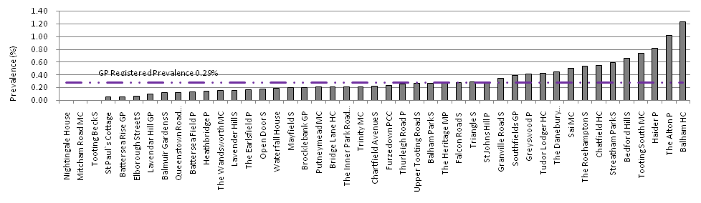
Source: Quality and Outcomes Framework (QOF) data extract through EMIS 2009.

Where do people with a learning disability reside in Wandsworth
From the total of 1001 people with learning disabilities recorded on the Wandsworth GP register, 919 reside within the borough of Wandsworth (Table 7) (At present locational data for people with learning disabilities recorded on Framework-i is not possible to be extracted). It is possible that a person can be registered with a GP in the Wandsworth area but may live outside. Using the projected population for Wandsworth (Greater London Authority 2009) results in a prevalence of 0.32% (Table 7), which is similar to the estimated proportion of people with profound and multiple disabilities in the general population (Table 1). Therefore it is possible that GPs only record those at the severe end of the spectrum of learning disabilities who are the easiest to identify while those with mild and moderate disabilities are not identified (Department of Health 2007a). Also, people who fall at the lower end of the spectrum of average intelligence who may have additional specific learning difficulties such as dyslexia and/or has statements of educational needs, who may have attended a special needs school for a number of reasons other than a learning disability may describe themselves as having a learning disability (Wandsworth Community Learning Disability Team 2010b).
Table 7: Breakdown of people with learning disability registered with a GP and residing in Wandsworth.
 | Number | Proportion/Prevalence
Recorded as having a learning disability | 919 | 0.32%
Males recorded as having a learning disability | 556 | 0.39% (60.5% of LD population)
Females recorded as having a learning disability | 363 | 0.24% (39.5% of LD population)
Children (under 18) recorded as having a learning disability | 168 | 0.31% (18.3% of LD population)
Adults (18+) recorded as having a learning disability | 751 | 0.31% (81.7% of LD population)
Source: Quality and Outcomes Framework (QOF) data extract through EMIS 2009.
The wards of Roehampton, Graveney and Latchmere have the highest proportions of people with learning disabilities residing within them at 0.66%, 0.54% and 0.53% respectively, compared to the lowest prevalence ranging from 0.09% to 0.21% in Queenstown, Southfields, Shaftsbury, East Putney, Wandsworth Common and Thamesfiled. (Figure 2 and ).

Figure 2: Percentage of people with learning disabilities by ward.
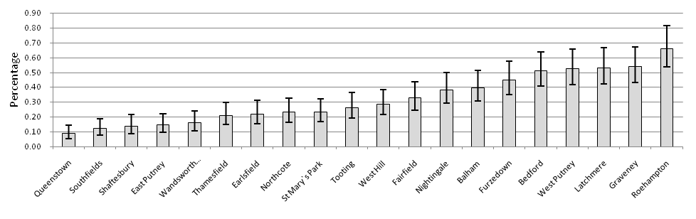
Source: Quality and Outcomes Framework (QOF) data extract through EMIS 2009.
The highly deprived wards of Roehampton, Graveney and Latchmere have the highest proportions of people with a learning disability. Thamesfield, Southfields and East Putney, amongst the least deprived wards in Wandsworth have the lowest proportions. The confidence intervals are produced to indicate possible variation of each proportion and not to determine significant differences between wards. Care must be taken in interpreting this data since it is known that the learning disability register is not complete. The confidence intervals calculated cannot wholly account for this (Altman et al 2000). Once the register updating process is complete it is possible that the distribution of people with learning disabilities in Wandsworth could change. One factor that is certain, for most wards the proportions will increase as currently the number of people with learning disabilities is under-reported on the GP register. In some cases the location of residence of people with learning disabilities will be biased by the location of supported and residential care homes (). This is especially true if people at the extreme end of the learning disability spectrum are currently identified through the registered population and are more likely to live in residential care (not supported living).
shows that many care homes are located in the wards of Graveney and Roehampton which also show a relatively high proportion of people with learning disabilities. However Latchmere has a high proportion of people with learning disabilities but no residential care home (WCLDT 2009a). displays registered care homes in terms of the number of places available for people with learning disabilities. They may not be at full occupancy at any particular time.

Map 1: Proportion of people with a learning disability by Ward.
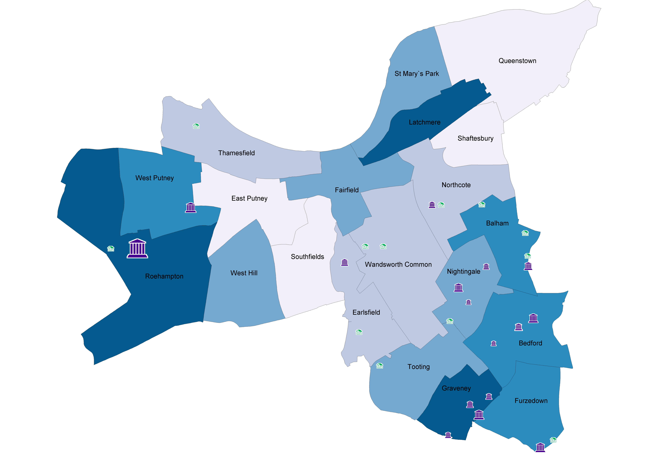
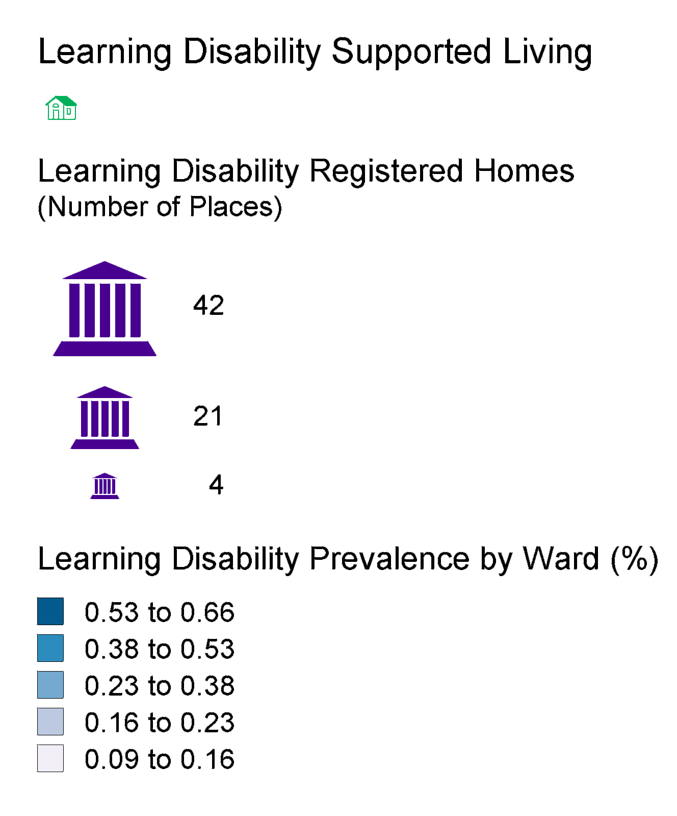
Source: Quality and Outcomes Framework (QOF) data extract through EMIS and Community Learning Disability Team (CLDT) 2009.

People with a learning disability (GP registered) and Index of Multiple Deprivation (IMD) in Wandsworth
The environment children experience in their early years and prenatally affect the development of the central nervous system which experiences rapid development during these periods. These environments range from the intimate unit of the family to the broader socio-economic situation shaped by governments and civil society (Irwin et al. 2007). Early exposure to adversity shapes interlinked trajectories through childhood relating to physical and emotional health, health behaviours, social identities, and cognition and education (Graham and Power 2004). Emerson et al (2009) comment that intergenerational transmission of socially patterned health impairments is likely to play a significant role in certain contexts such as mild intellectual impairments. In the UK, another study by Emerson et al. (2005) found that household income was related to a range of health indicators for children and adolescents including learning disabilities or intellectual disabilities (these are the same in the UK). Furthermore, people with learning disabilities are missing out on good health not just in relation to their disability but because social deprivation, unequal access to health services and other factors put them at greater risk of illnesses that in many cases could be prevented.
In the UK there is a socio-economic gradient in the prevalence of learning disability (Emerson et al 2009) which results in people with learning disabilities experiencing poorer health outcomes and are consequently more likely to die at a younger age (Department of Health 2009a). Children and adults with learning disabilities are more likely (compared to their peers) to be exposed to general socio-economic conditions that are detrimental to health. Poorer socioeconomic circumstances appear to both increase the risk of impairments and exacerbate their impact. Furthermore, people with learning disabilities have a higher risk of encountering discrimination and social exclusion leading, to amongst other consequences, reduced access to healthcare and restricted social mobility.
Figure 3: Proportion (of total population) of people with learning disabilities by Index of Multiple Deprivation (IMD) 2007 Quintile (1-5) (Wandsworth scale). 1=Least Deprived, 5= Most Deprived.
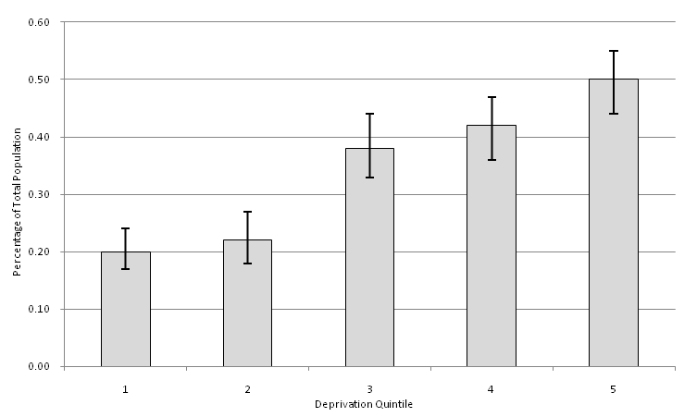
Source: Quality and Outcomes Framework (QOF) data extract through EMIS 2009.
The proportion of people with learning disabilities, who reside and are registered with a GP in Wandsworth, varies across socio-economic deprivation. Figure 3 reveals that the highest proportion of people with learning disabilities, 0.50%, is resident in areas that experience the highest relative deprivation. Conversely areas of least deprivation have the lowest proportion of registered people with a learning disability at 0.20%. Confidence intervals indicate possible variation in proportions in each quintile and are not generated for determining significant differences.
For further information on the Index of Multiple Deprivation and how the above proportions were calculated, see Appendix A.

Number of people with learning disabilities known to the community learning disabilities team
The Wandsworth community learning disabilities team is based at the Joan Bicknell Centre at Springfield hospital, Tooting. In December 2009 (date of audit) 1,474 people with learning disabilities were known to them (WCLDT 2009b) and engage in their services. Nine-hundred and twenty-three of these live in the Wandsworth borough area and 366 reside outside Wandsworth, while 185 have incomplete address records. Many of those known to the JBC have addresses that are a considerable distance away, beyond the greater London area. This list provided by the WCLDT is higher than the total recorded on the FWi system.
Table 8: Age distribution of people with learning disabilities known to the Joan Bicknell Centre.
Age Group | Number | Proportion (%)
Under 18 Years | 9 | 0.6%
18-64 Years | 1275 | 86.5%
65+ Years | 156 | 10.6%
Not or incorrectly recorded | 34 | 2.3%
Source: The Joan Bicknell Centre
There are 9 people recorded as being under 18 years of age. The WCLDT only hold information on people who are transitioning from child to adult services. There are 1,275 people with learning disabilities aged 18 years to 64 years old and 156 people aged 65 years and over.
The level of learning disability or gender information was not provided with the dataset.

Summary on the learning disability population in Wandsworth
The PLD numbers known to the WCLDT are substantially higher than that recorded on either the council or GP register. A total of 1,474 people with learning disabilities are listed on the WCLDT list of clients while just over 600 less are on the council and 473 less on the GP registers. However, 551 of the listed clients either resided outside Wandsworth or had an incomplete address. The dataset is required to be cleaned and the additional number of people with learning disabilities held by the WCLDT should be placed on the GP/council register to allow easy access to the wealth of extra information they hold. Part of the reason for the difference between numbers will be due to GPs still building up their registers as well as not all GPs have signed up to the Directed Enhanced Service (DES). This process may also bias the prevalence of people with learning disabilities by practice whereby identifying this population group within their registers are more advanced at some practices compared to others. Also some practices are not involved in the DES.
Referring back to Emerson and Hatton’s (2004) estimates in section 2.4, there are an estimated 5,212 adults with learning disabilities in Wandsworth. It is estimated that only about 20 to 30% (Wandsworth Community Learning Disability Team 2010b) of people with learning disabilities access specialist services or require specialised support. Therefore there should be between 1100 and 1500 people on the registers, however, a number of factors affect this. At the time of audit there were 818 adults on the GP register.

Health status of people with learning disabilities (GP registered population)
The gap between healthy and less healthy people is growing and government targets cannot be met to reduce premature death and health inequalities unless focus is placed on groups with the poorest health. People with learning disabilities are one of these groups.
Persons with learning disabilities have more and more complex health needs when compared with the general population which result in large health inequalities between the two groups (Walsh et al. 2003). Mortality in adults with learning disabilities is higher, as much as three times higher in some cases (Tyrer and McGrother 2009). The leading cause of death amongst people with learning disabilities is from respiratory disease followed by heart disease. Almost half of people with Down’s syndrome are affected by congenital heart problems (NHS Sutton and Merton 2009). People with learning disabilities have higher rates of obesity, coronary heart disease, respiratory disease, hearing impairment, dementia, osteoporosis and epilepsy. Some 26% of people with learning disabilities are admitted to hospital each year (Department of Health 2009b). Although increasing in parallel with the general population, life expectancy at birth for people with learning disabilities can still be as much as 25 years less (NHS Health Scotland 2004). Currently the life expectancy of people with learning disabilities is 67 for men, 69 for women and 55 years for people with Down’s Syndrome (Valuing People 2009). Life expectancy at birth in the general population of England for men is 77.9 years and 82.0 years for women.
The health status data presented here was obtained through the GP registration system which relates to metric 8.01 outlined in the Better Metrics Project (Healthcare Commission 2007a).

Obesity
A number of studies in the UK have shown that people with learning disabilities are at a higher risk of being obese and developing associated health conditions such as diabetes and hypertension (Hamilton S et al 2007, Stewart et al 2009, Department of Health 2009). The causes are believed to be multi-factorial and include genetic syndromes such as Down’s syndrome, environmental such as geographical location and living situation (Melville et al 2007) and physical factors such as age, gender and level of learning disability (Bhaumik et al 2007). In addition, a lack of education/knowledge of information on health promotion/healthy living/eating also plays its part.
Just under a quarter of (198) of people with learning disabilities registered in Wandsworth and aged 16 and over did not have their BMI recorded by their GP. This is an improvement of 10% since November 2009. This left a total of 651 people (16+ years old) with learning disabilities having had their BMI recorded by the GP. A study looking at asthma and BMI across 28 primary care practices in Bristol (Ghale et al. 2009) found 37.2% of the learning disability population had no BMI recorded. Table 9 below shows the breakdown of this data for Wandsworth.

Table 9: Recorded BMI of people (Aged 16+) with learning disabilities registered with a Wandsworth GP.
BMI | All – Proportion (Number) | Male - Proportion | Female - Proportion
Obese (BMI = 30+) | 35% (231) | 29% (108) | 43% (123)
Overweight (25 to 29.9) | 25% (160) | 24% (87) | 26% (73)
Healthy weight (18.6 to 24.9) | 33% (214) | 39% (143) | 25% (71)
Underweight (18.5 or below) | 7% (46) | 8% (28) | 6% (18)
Source: Quality and Outcomes Framework (QOF) 2009
According to QOF data, the prevalence of obesity for people registered with a GP in Wandsworth for 2007-08 is 5.5%, however BMI recorded for QOF purposes is considerably under-recorded in the general population. The mean BMI for people with learning disabilities and aged 16 years and over in Wandsworth was 28.08 (30+ = obese). The proportion of people with learning disabilities that are obese (35%) in Wandsworth (Figure 4) is higher than the latest prevalence estimate (Health Survey for England 2007) for the general population which is estimated to be 22% (The Information Centre 2009a). Conversely the proportion that are overweight (25%) is lower compared to the national estimate of 37%. Seven percent are underweight, higher than the national estimated average of 2%. The proportion of people with learning disabilities registered in Wandsworth that have a healthy weight (33%) is less than the national figure (38%).
Figure 4: Distribution of BMI levels (by percentage) for GP registered people with learning disabilities having their BMI recorded in Wandsworth.
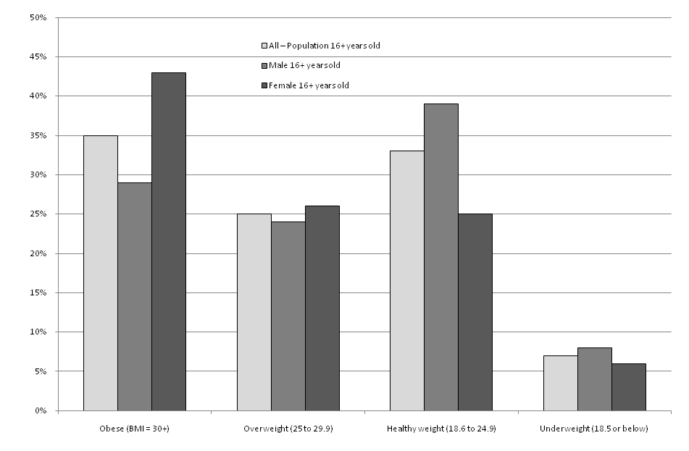
Source: Quality and Outcomes Framework (QOF) data extract through EMIS 2009.
The mean BMI for women (29.39) with learning disabilities was higher than the mean BMI for men (27.06) with learning disabilities. The prevalence of obesity amongst women (43%) with learning disabilities was higher compared to men (29%) and similar to those found by Melville et al (2007), at 39% and 28% respectively. These proportions are higher than the national estimates for the general population (2009), which are 22% for both genders. Similar proportions of males and females with learning disabilities are overweight, 24 and 26% respectively; these figures are below the national average for both sexes. This is due to a higher proportion of people with learning disabilities falling in the obese category. There were a higher proportion of men with learning disabilities with a healthy BMI (39%) compared to women (25%). The estimated proportions for the general population of England are 34% and 42% respectively. Only 40 people with learning disabilities under the age of sixteen had their BMI recorded. This was only 26% of all under 16 year olds on the GP register. This is an improvement of 10% since November 2009.

Diabetes
Advances in health care for people with learning disabilities that have resulted in increased longevity put in focus the adequacy of chronic disease management for the growing number of middle aged and elderly persons in this population. Diabetes is believed to be more prevalent in people with learning disabilities (Marshall et al 2003, McGuire et al 2007)
The prevalence of diabetes in the registered learning disability population (17+ years) in Wandsworth is 8.2% (95% CI 6.5% to 10.2%). This is higher than recorded for all registered population (QOF) in Wandsworth for 2008-09 which is 2.96% (The Information Centre 2009b). The prevalence given by Diabetes UK (2009) for the general population lies between 4% and 5%. The National Diabetes Audit (2008) expected a prevalence of 4.6% while GP registered prevalence was reported at 3.7% for 2005/06, for those covered by the audit. A higher prevalence (as shown here) is expected for people with learning disabilities as indicated in the literature. Furthermore, due to the current audit of patients with learning disabilities this group is more likely to have their diabetes status checked compared to the general registered population. The London and England averages for diabetes prevalence are 3.8% and 3.9% respectively (The Information Centre 2009b). Only two people with learning disabilities under 17 years of age were recorded as having diabetes.
Figure 5: Percentage of GP registered people with learning disabilities (17+) who have diabetes (Type I or II).
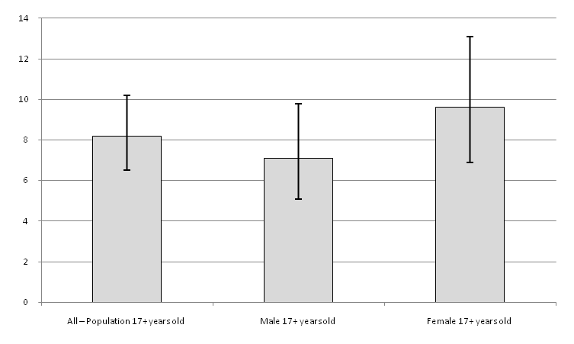
Source: Quality and Outcomes Framework (QOF) data extract through EMIS 2009.
The split between men and women are identical in terms of numbers, 34 each. However when looking at proportions (Figure 5), there is a higher proportion of women (9.6%) registered as being diabetic compared to registered men (7.1%) with learning disabilities.

Coronary heart disease (CHD)
Coronary Heart Disease is the second most common cause of death amongst people with learning disabilities, (Hollins et al.1998), with rates increasing amongst people with learning disabilities due to them living longer, and increased exposure to risk factors as a result of lifestyle changes associated with living in community settings (Turner and Moss 1996, Wells et al. 1997). Almost half of all people with Down’s syndrome are affected by congenital heart problems, a much higher rate than the general population (Brookes and Alberman 1996, Hermon et al. 2001).

The number of people with learning disabilities recorded as having CHD is 5, accounting for 0.5% of the learning disability population in Wandsworth. Given that the overall CHD rate for the general registered population was 1.61% for the period 2008-09 and that the rates for diabetes and obesity are higher than the general population it is believed that the recording of the prevalence of CHD in the learning disability population is underreported. Despite the register showing a lower aged population distribution for people with learning disabilities compared with the general population, the prevalence rate is still lower than expected.

Chronic obstructive pulmonary disease (COPD) and asthma
The prevalence of COPD amongst people with learning disabilities in Wandsworth is 1.00% (95% CI 0.54% to 1.83%) compared to a general registered population prevalence of 0.8% (2008-09). Numbers were too small to distinguish by gender. The prevalence of COPD may be under-reported for people with learning disabilities.
The prevalence of asthma (Figure 6) among people with learning disabilities is high at 10.9% (95% CI 9.1% to 13.0%). The PCT average for all registered population in Wandsworth for 2008-09 was 4.1%. Men with learning disabilities in Wandsworth have an asthma prevalence of 11.1% (95% CI 8.9% to 13.9%) and women have a slightly lower prevalence of 10.5% (95% CI 7.8% to 14.0%). Just over a fifth (23 patients) of all asthma cases were under the age of 18 years old.

Figure 6: Percentage (prevalence) of GP registered people with learning disabilities with asthma, all ages.
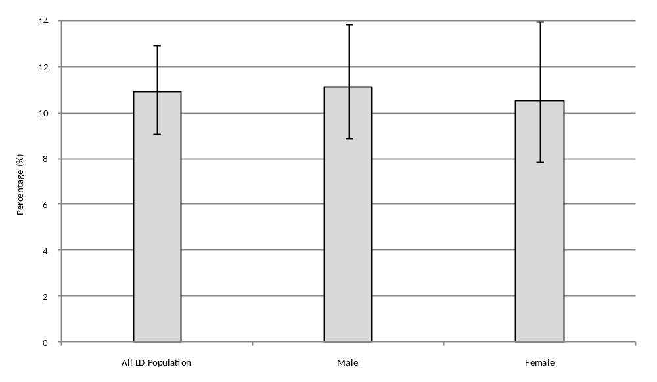
Source: Quality and Outcomes Framework (QOF) data extract through EMIS 2009.

Epilepsy
Epilepsy occurs in around 0.5% of the population (Epilepsy Research UK 2009, SIGN 2003) but has a more common association with people with learning disabilities (NICE 2004). The prevalence of epilepsy can be up to 50% in those with severe learning disability (Sillanpaa 1996) and has a higher mortality (Forsgren et al 1996).
The prevalence of epilepsy in the GP registered learning disability population in Wandsworth is high, with nearly one in five or 19.4% (95% CI 17.1% to 21.9%) of people recorded has having epilepsy (Figure 7). The prevalence for the 18 and over population (as reported by the QOF) is slightly higher at 20.8% (95% CI 18.1% to 23.7%). The QOF reported prevalence for the general registered population for 2008-09 was 0.5% (The Information Centre 2009b) which is the same as estimates given for the general population. Twenty-four or 13.1% (95% CI 9.0% to 18.8%) of children with learning disabilities (under 18) suffer from epilepsy in Wandsworth. Twenty-one and a half percent (95% CI 17.8% to 25.9%) of females with learning disabilities had epilepsy compared to 18.0% (95% CI 15.2% to 21.3%) for men. This translates to 84 females and 110 males, giving a total of 194 persons with learning disabilities and epilepsy registered in Wandsworth.

Figure 7: Percentage (prevalence) of GP registered people with learning disabilities with epilepsy, all ages.
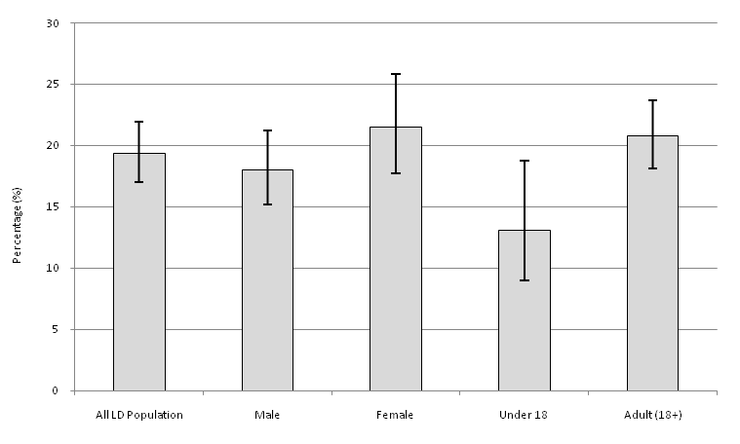
Source: Quality and Outcomes Framework (QOF) data extract through EMIS 2009.

Mental health and learning disabilities
The quoted prevalence of psychiatric illness among people with a learning disability has varied widely from 10% to 39% (Deb et al. 2001) across various studies undertaken. This is due to differences in methodologies and difficulties encountered in applying methodologies with such issues as sampling error and determining case definition. Applying this range quoted by Deb et al. in their review to the Wandsworth registered GP data, there are between 100 and 390 adults with learning disabilities who have a psychiatric disorder. While exact figures are hard to determine, what is sure is that people with learning disabilities are more likely to suffer from mental ill-health than the general population (Department of Health 2009a), with depression particularly common in adults with intellectual (learning) disabilities (Perez-Achiaga et al. 2009). Furthermore rates of dementia are four times higher and the rate of schizophrenia three times higher than in the general population (Hollins et al 1998). There are (May 2010) 160 adults on the mental health caseload of the WCLDT and Assessment and Intervention Team (AIT) (Wandsworth Community Learning Disability Team 2010d). Some people still have the diagnosis, however, and are being looked after by their GP but are no longer reflected in the team’s caseload. This subgroup should be identified through the health check process. Of those adults on the team’s caseload it is estimated that around 80% have a mild to moderate learning disability. The types of referrals cover the following:

- ADHD
- Anxiety Disorder
- Autism
- Bereavement
- Best Interest/Capacity
- Challenging Behaviour
- Dementia
- Eating Disorder
- Epilepsy
- Gender Identity Disorder
- Inappropriate
- Mood Disorder
- Neuropsychiatry
- Offending/Criminal Behaviours
- Parenting
- Personality Disorders
- Liaison for Physical Health
- Psychosis
- Review of Medication
- Substance (Alcohol) Misuse Inpatients

Emerson and Hatton (2007) estimated that 36% of children and adolescents with a learning disability also have a diagnosable psychiatric disorder. Assuming national estimates hold true at the local level, there are an estimated 66 children and adolescents with a psychiatric disorder registered with a GP practice in Wandsworth. This may be higher in reality for the borough as not all children with learning disabilities are registered with a GP or have been identified as having a learning disability by a GP. Furthermore they determined that Children and adolescents with learning disabilities are over six times more likely to have a diagnosable psychiatric disorder than their peers who do not have a learning disability.
In Wandsworth the Wandsworth Community Learning Disability and Assessment and Intervention Teams operate. They are responsible for the assessment and mental health care of those clients referred to them. They provide one-to-one support which may take the form of visits in the home or a community setting and referral to other appropriate services, such as a day centre, or home care service or housing service. Some of this information is already being appended to the GP LD register, however establishing a formal process may be beneficial so that this occurs for every patient.

Health status summary for people with learning disabilities in Wandsworth
Overall in Wandsworth the proportion of GP registered people (Aged 16+ who have had their BMI recorded) with learning disabilities that are obese or overweight (60%) is comparable to the estimated national average for 2007 (61%). Broken down, the national picture reveals the largest proportion is seen in those overweight (37%) but for people with learning disabilities in Wandsworth the largest proportion is found in the obese category (35%).
The data only showed that two people under the age of 17 years had diabetes, from a total of 167 children and young adults with learning disabilities on the register. Diabetic registers are believed to be well maintained therefore this should be investigated. An initial investigation could involve an audit at a couple of practices to establish “missing” diabetics with learning disabilities. However under 17 year olds may not be recorded as under the QOF, figures are reported only for people that are 17 years and older while the learning disability DES is for people aged 18 years and older. For the 17+ years old learning disability population the prevalence of diabetes is 8.2%, above the national average of 3.9%.
Data for coronary heart disease was too small to undertake any analysis, with only 5 people with learning disabilities recorded as having CHD. Given people with learning disability have an increased risk of developing CHD and is the second most common cause of death, further investigation is required.
The prevalence of COPD and asthma is much higher for people with learning disabilities compared to those in the general population for 2008-09 (The Information Centre 2009b). As expected the prevalence of epilepsy is high among the learning disability community of Wandsworth, the importance of which is recognised in the Health and Well-being Action Plan, in terms of training around epilepsy and the provision of a care pathway for epilepsy.
While confidence intervals have been presented to provide an indication of the possible variation for figures, it is not appropriate to draw any statistical significance between groups for each disease since we know that the learning disability register is not complete. It is possible that those already on the register are people with the most severe learning disability. Research has shown that the prevalence of certain health behaviours such as smoking and physical activity (Emerson and Hatton 2008a) can vary across level of learning disability. Therefore, due to this it is not appropriate to draw any significant differences from the data. Smoking status has not been included since currently this is not well recorded by Wandsworth PCT. For example the fourth reporting quarter for 2008-09 showed that around only half the registered population had had their smoking status recorded in Wandsworth (Department of Health 2009c). However this should be revisited once the WCLDT data quality improvement process is completed on the GP register. Finally, it is difficult to determine the exact number of people with a learning disability and a psychiatric illness in Wandsworth; estimates show a 100 to 390 people, whom are registered with a GP, fall into this category.
In accordance with recommendation 4 of the Valuing People Now strategy (Department of Health 2009a), the health status and needs of the learning disability population and their carers in Wandsworth should be accounted for in the Joint Strategic Needs Assessment. This needs assessments is undertaken to provide a baseline to work from for this purpose.

Health services for people with learning disabilities in Wandsworth

Screening services
Life expectancy for people with learning disabilities is increasing which is more than likely to increase the incidence of cancer in this population group. However, historically research shows that people with learning disabilities attend breast screening and cervical screening services less frequently than other women generally (Cowie and Fletcher 1998, Stein and Allen 1999).
The closure of institutions for people with a learning disabilities and community resettlement has changed the nature and degree of health surveillance for this group of people with the shift from specialist hospital doctors to general practitioners. This independence may result in people with learning disabilities being less likely to be exposed to or understand the implications of media-led cancer awareness campaigns (Davies and Duff 2001). This leads to low demand (which can be amendable) for screening from people with a learning disability as they may be less capable of self advocacy and be less likely to report symptoms to their doctor at early, more treatable stages of disease (Sullivan et al. 2004). Additional factors include perceived difficulty in obtaining consent for screening; disabilities with using appointment systems and waiting rooms; uncertainty about whether general practitioners or specialist teams are responsible for routine care; poor liaison with specialist services; inadequate training of general practitioners in communication skills and pressure of competing demands from other groups of patient (Stein and Allen 1999).
Currently there is no data regarding the amount of people with learning disabilities regularly receiving cancer screening (cervical, breast, prostate and colorectal) in Wandsworth. Provision of screening opportunity and the capture of this information are to be addressed under the DES initiated health checks under the Health and Well-being Plan 2009-2012. In addition, it is not coded if learning disability patients have attended or did not attend (Savage 2010). This should be recorded.

Lifestyle services/advice
Under the Valuing People Now strategy each PCT has a responsibility to include provision aimed at reaching the health targets for people with learning disabilities within their own local mainstream and specialist health agendas. The Department of Health’s good practice guidance document states that people with learning disabilities should have accessible to them “…health information and opportunities for people with learning disabilities and family carers to participate fully in health action planning and related initiatives...” (Department of Health 2009d). Historically though, across the country, the evidence points towards unmet health needs of people with learning disabilities, the failings of the NHS to address the inequalities experienced by them and growing concern about lack of progress against the health targets in Valuing People.
While not complete and experiencing bias, the GP register data (section 4) suggests that people with learning disabilities in Wandsworth experience higher rates of obesity, diabetes, COPD and epilepsy. The provision of lifestyle services/advice aim to tackle these issues and help people with learning disabilities to make better health choices and manage current conditions. Each new health action plan for people with learning disabilities aims to incorporate these aspects.
Currently there are a number of services available in Wandsworth to help people with learning disabilities to improve their health. For example there is a 'Tune Up' exercise and healthy eating group for people with learning disabilities living in Battersea. There are walking groups, street league football and dance classes. In addition Platform 1 café in Clapham Junction provide a location where people with learning disabilities can learn about making food and work in catering. SHARE runs a whole range of initiatives including healthy eating courses, life skills and NVQ courses (Share Community 2009).
In addition there are more intensive services such as the Assessment and Intervention Team (AIT). It offers tertiary health service facilities on an intensive outreach basis for adults who have a learning disability and mental health and/or challenging needs. The service is intensive, time-limited and designed to complement existing mental healthcare provided by WCLDT as well as to provide additional resources. There is also a dental service based at the Joan Bicknell centre.

Adult Social Services
Councils with Adult Social Services Responsibilities (CASSRs) are required to report annually on a range of community care statistics (SIGASC 2007). This data relates to referrals and residential care funded by local authorities and delivered by both local authorities and the independent sector.

People with learning disabilities who are new clients
The people in this group are known to the local authority but may not be registered with a Wandsworth GP practice.
Table 10: Number of new clients with learning disabilities in Wandsworth.
Year | Number | Per 100,000 population | Percent difference from previous year
2005/06 | 550 | 240
2006/07 | 470 | 205 | -14.3%
2007/08 | 650 | 280 | +38.1%
2008/09 | 510 | 215 | -21.9%
Source: A1 (RAP), National Adult Social Care Intelligence Service (NASCIS)
A feature of this data is that there is much variability from year to year in the number and rate of new clients in each borough (Table 10 and Figure 8). The rate of new referrals in Wandsworth for the most recent period (2008/09) is higher than Sutton and Richmond boroughs but lower than Kingston, Croydon and Merton which recorded the highest rate.
Figure 8: Learning disability new clients, per 100,000 population.
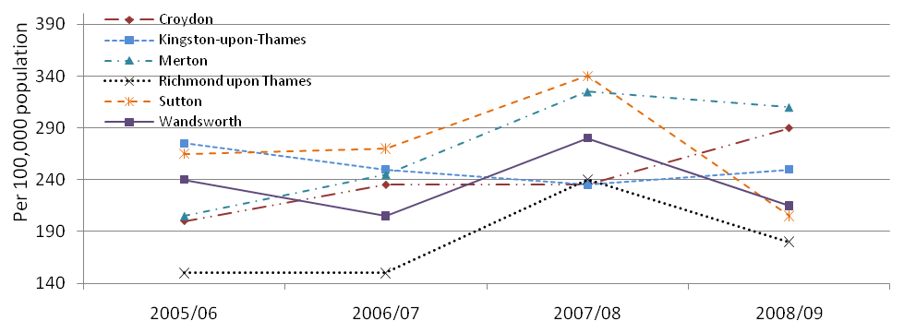
Source: National Adult Social Care Intelligence Service (NASCIS) 2009.

Learning disability clients receiving services during the period, provided or commissioned by the CASSR
The rate of clients known and accessing services through the local authority and PCT has varied over the last four years (Figure 9) compared to other PCTs. The trend has been opposite to that of the level of new clients. When there has been an increase in learning disability clients receiving services (Figure 9) reported there has been a decrease in new clients (Figure 8).

Figure 9: Learning disability clients receiving services, per 100,000 population, adults (18+),
2005/06- 2008/09. (People with learning disabilities known to services)
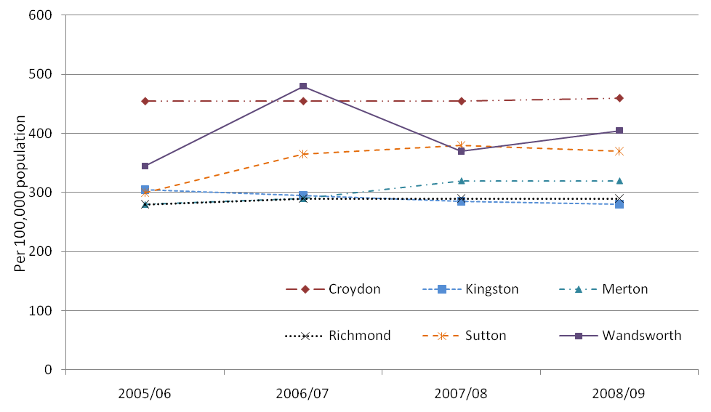
Source: National Adult Social Care Intelligence Service (NASCIS) 2009.
For the period 2008-09, 950 people (18+ years) with learning disabilities were receiving services from the local authority in Wandsworth. There are 734 (18+) on the GP register, 852 (18+) on framework-i and 1,474 (all ages) known to the WCLDT. The larger number known to the WCLDT is partly due those placed in Wandsworth from other Boroughs who do not receive Social Service input from Wandsworth. However, GPs do provide input and therefore the discrepancy is unclear except that GPs are still building up their registers. Furthermore, not all GPs have signed up to the DES.
There is a definite distinction between the two age groups in Figure 10 compared to other boroughs in SW London. The rate of clients that are 65 and over in Wandsworth are much higher. There were 775 18-64 year olds and 175 people who are 65 years and older, totalling 950 adults known to the local authority in Wandsworth.
Figure 10: Learning disability clients receiving services, per 100,000 population by age group, 2008/09. (People with learning disabilities known to services)
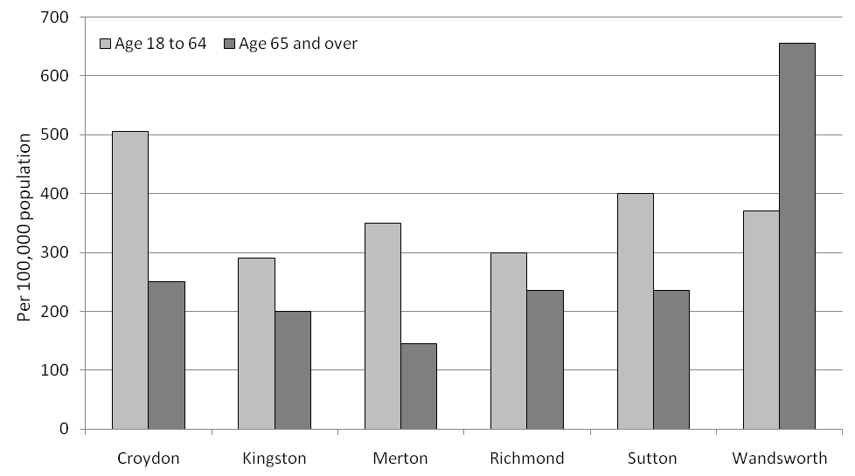
Source: National Adult Social Care Intelligence Service (NASCIS) 2009.

Adults (18-64 years) with learning disabilities in settled accommodation
Settled accommodation arrangements is where the occupier has security of tenure/residence in their usual accommodation in the medium- to long-term, or is part of a household whose head holds such security of tenure/residence (The Information Centre 2008b). Figure 11 shows that Wandsworth has a low proportion (21.7%) of adults with learning disabilities in settled accommodation compared to other boroughs in the SW London sector for 2008/09. Richmond has the next lowest proportion in settled accommodation at 35.5%.
Figure 11: Proportion (%) of adults (18-64 years) with learning disabilities in settled accommodation, 2008/09.
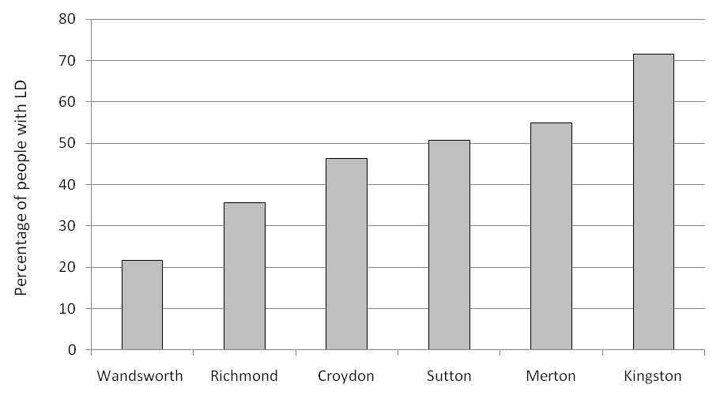
Source: The Information Centre 2009.

Adults (18-64 years) with learning disabilities resident in CASSR and independent homes and those supported outside the CASSR area
The number of adults with learning disabilities living in supported accommodation was highest during the 2004-05 period for within and outside the CASSR area (Figure 12). Sixty-eight percent (470) of adults with learning disabilities living in supported accommodation during this period were in CSSR accommodation, while 32% (220) were supported outside the CASSR area. After 2004-05 the number of adults in supported accommodation decreased substantially, down to 285 within the CSSR area and 165 for outside. Following this decrease the number in CASSR supported accommodation increased each year to 345 for the year 2007-08, while the number outside the CASSR area remained reasonably constant with 155 adults residing in non CASSR accommodation in 2007-08. For the year 2007-08 69% of adults with learning disabilities living in supported accommodation lived in CASSR supported homes, while 31% were outside CASSR.

Figure 12: Number of adults with learning disabilities living in council supported CASSR and independent homes (Light) and those supported outside the CASSR area in registered accommodation (Dark).
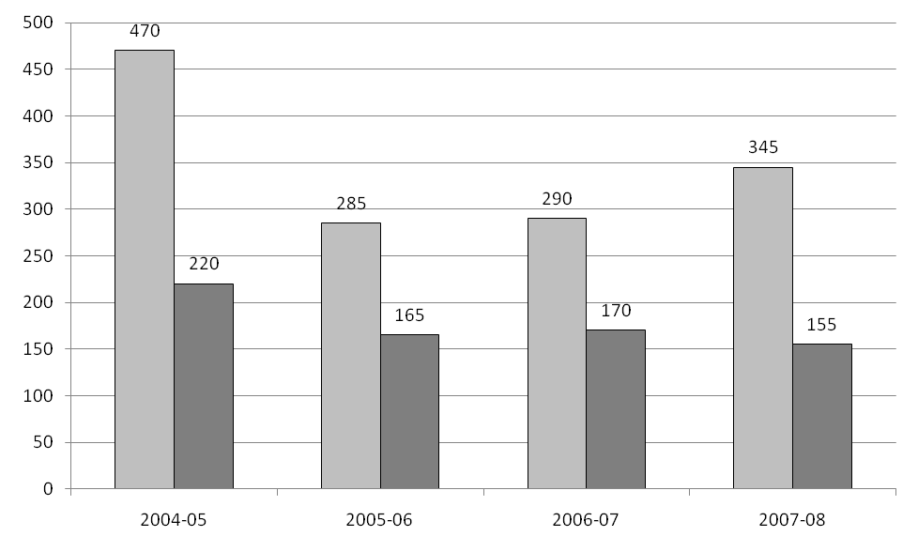
Source: The Information Centre 2009.

Council supported admissions for adults (18-64 years) with learning disabilities in temporary registered residential and nursing care
The number of adults with learning disabilities admitted to temporary residential and nursing care showed the highest number again in 2004-05 (Table 11). In 2004-05 there were 35 adults were admitted to temporary registered residential and nursing care in Wandsworth, followed by a decrease to 20 adults in 2005-06 and then to 10 adults in 2006-07. In 2007-08 the number increased for the first time in at least four years to 15 adults.
Table 11: Number of adults with learning disabilities admitted to temporary registered residential and nursing care.
 | 2004-05 | 2005-06 | 2006-07 | 2007-08
Number in temporary registered residential and nursing care | 35 | 20 | 10 | 15
Source: The Information Centre.

Cost for provision for services for people with learning disabilities known to the local authority
For the year ending 31st March 2009, the total spent on adults (18-64 years) with learning disabilities in Wandsworth was £27,279,000 (The Information Centre 2009c). Wandsworth spends the most per capita (£11,610,000 – 2008/09) on people with learning disabilities in the SW London sector (Figure 13), and this has been consistent over the last four years. The amount spent has also been increasing over this period.
Figure 13: Total cost of services for people with learning disabilities, per 100,000 population, 2005/06 – 2008-09.
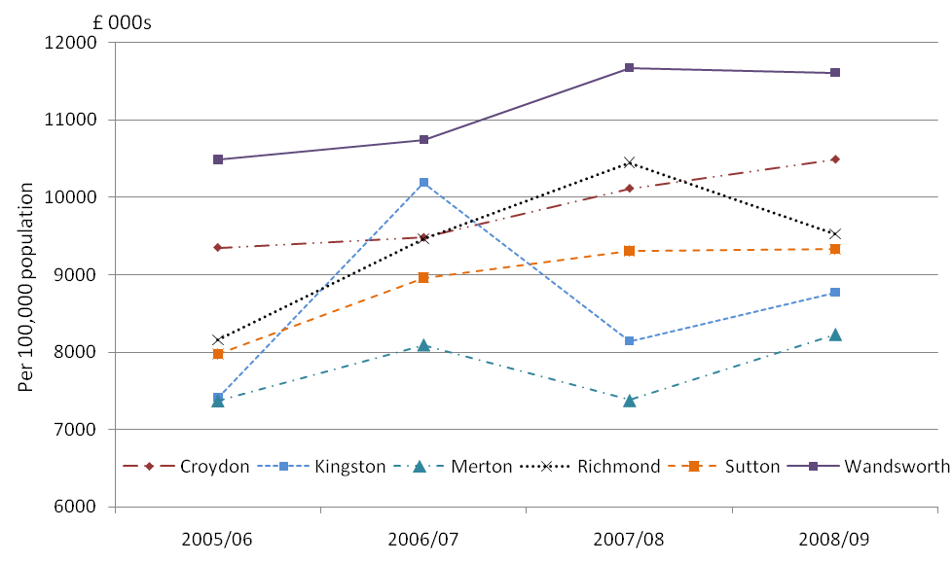
Source: National Adult Social Care Intelligence Service (NASCIS) 2009.
Broken down, the total cost in Wandsworth for nursing care for adults was £455,000 and for residential care it is was £12,517,000 for 2008/09. This translates to £1,077 and £934 respectively per person per week. The unit cost for residential care shows a large decrease from 2007/08 which was at £1,212.

Adult social services summary
Wandsworth recorded a similar level of new referrals of 510 in 2008/09 and in 2005/06 but experienced much variability in the intervening years. However the rate per 100,000 of people with learning disabilities engaging with local authority has also varied below and above 400 per 100,000 population. Wandsworth has a low proportion (21.7%) of adults with learning disabilities (that are known to the local authority) in settled accommodation compared to other boroughs in the SW London sector for 2008/09. Just over two thirds of those in settled accommodation are resident in council supported accommodation as opposed to independent homes. Very few people with learning disabilities are in temporary residential and nursing care. For the period 2008/09 the unit cost per week for residential care was £1,077, a decrease of £135 from the previous year.

Programme budgeting for people with learning disabilities in Wandsworth

Programme coverage
Expenditure in the learning disabilities programme budget covers spending on the treatment of all people with learning disabilities, including those with autistic spectrum disorders. The majority of services are jointly funded with the local authorities using pooled budgets; it is therefore difficult to accurately compare expenditure between PCTs.

Benchmarking
Wandsworth spends considerably more than the cluster average on learning disabilities (£50 per head of population, compared to the cluster average of £35 a head, a variance of 29%). This expenditure in Wandsworth is similar to the London average (£48) and the national average (£54). Expenditure is this area has fallen by 9% since the previous year. It is noticeable that there is considerable variation between expenditure by PCTs in the cluster, with Hammersmith and Fulham spending almost £60 a person, and Camden spending less than £5 (Table 12).
Table 12: Expenditure and outcomes in the learning disabilities category.
 | Expenditure (£ per person) 2007-08 | Prevalence of learning disabilities 2008-09
England | 54.2 | 0.40%
London | 48.2 | 0.30%
Cluster | 35.7 | 0.23%
Tower Hamlets | 19.6 | 0.35%
Hammersmith and Fulham | 59.1 | 0.19%
Camden | 4.7 | 0.22%
Islington | 43.1 | 0.29%
Kensington and Chelsea | 51.2 | 0.15%
Westminster | 34.0 | 0.22%
Wandsworth Teaching | 50.5 | 0.22%

Comparison of expenditure across PCTs (Figure 14) in this category is made difficult by differing funding arrangements between PCTs. Funding in this area is often done jointly with social services and the local authority, sometimes in the form of pooled budgets. This may be responsible for the very low spend in Camden, and so comparison of these results should be made with caution.
It is noticeable that while Wandsworth has a slightly lower prevalence of people with learning disabilities (0.22%) compared with the cluster average (0.23%), it spends 29% more than the cluster average. As with other QOF prevalence results, these must be interpreted with caution due to high levels of patient turnover and lack of list cleaning.

Figure 14: Graph of learning disability expenditure.
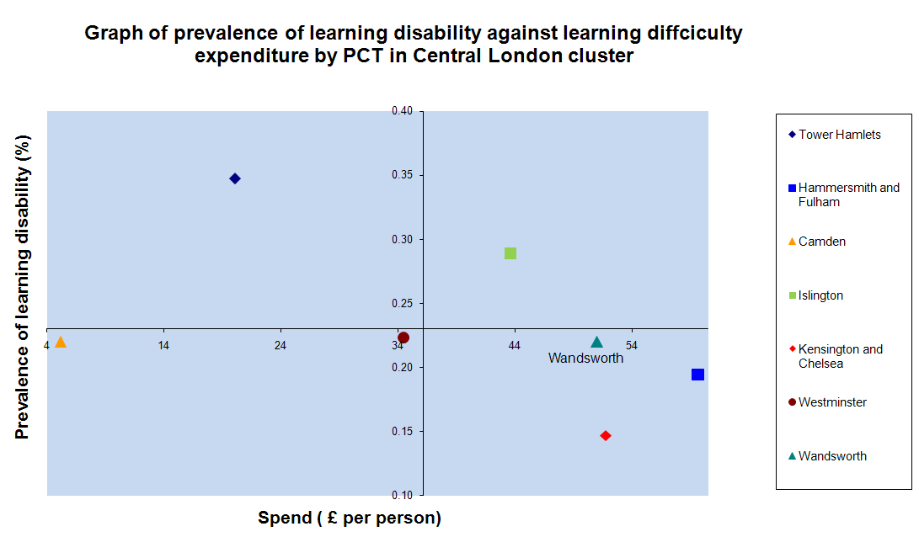

Statements of special educational needs (SEN) associated with learning disabilities
Children have special educational needs (SEN) if they have a learning difficulty which calls for special educational provision to be made for them. A statement of SEN sets out a child's needs and the help that they should have. A local authority in most cases will make a statement if they determine that the help a child needs cannot be provided within the normal child environment (Department for Education and Skills 2001). The majority of statements are implemented in mainstream local authority maintained schools. School action plus is the highest stage in a graduated response in the provision of suitable interventions to a child with SEN. In the following sections both terms will be referred to collectively as statements of special educational need (SEN).

The data presented on Special Educational Need (SEN) is drawn from two sources: the Annual Schools Census and SEN2 Survey (DCSF 2008). This dataset provides information on the incidence and placement of pupils with SEN associated with learning difficulties. The categories of SEN related to learning disabilities include:
Moderate Learning Difficulty (MLD) Severe Learning Difficulty (SLD)
Profound & Multiple Learning Difficulty (PMLD) (Emerson and Hatton 2008b)
In addition to this 50% of children with Autistic Spectrum Disorder (ASD) are included since it is known 50% of children with ASD also have a learning disability (Baird 2006 and Newschaffer 2007). Therefore when talking about learning difficulties in this section we are referring to the SEN categories of moderate, severe and profound and multiple difficulties as well as 50% of children with ASD. The latest available data is for 2008.

Primary statements of special educational need by learning difficulty
In 2008 there were 804 children (4-18 years) with a learning difficulty (MLD, SLD, PMLD, 50% ASD) with a statement of special educational need attending either a maintained primary, secondary or special school. This accounts for 21.2% of all statements. This is lower than the proportion for London (30.2%) and England (35.7%). Previously in Wandsworth the total number of children has steadily decreased with the numbers for 2006 and 2007 being 859 and 836 respectively. Two thirds (65.8%) of statements in Wandsworth were for those with a moderate learning difficulty (i.e. MLD) (Figure 15). This is slightly below the rate for London and England which are 71.2% and 73.6% respectively. Children with moderate learning difficulties are the largest group with statements.
There has virtually been no change in the number of children with a severe learning difficulty (i.e. SLD) between 2007 (102) and 2008 (101) since decreasing from a high of 121 in 2006. Children with a severe learning difficulty with a statement of SEN account for nearly one in eight (12.6%) of all statements for children with learning difficulties in Wandsworth.
The number of children with profound and multiple learning difficulties (i.e. PMLD) that have statements of SEN has remained constant from 2006 to 2008 in Wandsworth. In 2008 there were 29 children with PMLD that had statements accounting for 3.6% of all learning difficulty statements (Figure 15). This was below the London and England averages at 4.8% and 3.9% respectively. Estimates for children with ASD and a learning disability increased each year from 2006 at 115 statements to 145 in 2008. This accounts for 14.3% of all learning difficulty SENs in 2008. This is higher than the London proportion of 11.9% and the national proportion at 10.1%.
Figure 15: Proportion of statements of special educational need (SEN) associated with learning difficulty in all schools for children (by SEN learning difficulty category 2008 for Wandsworth, London, England).
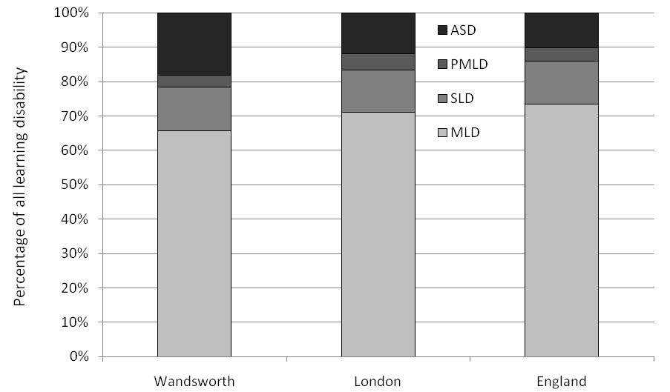
Source: Department for Children, Schools and Families (DCSF).

Maintained primary schools
In 2008 in maintained primary schools, just under a quarter (388) of all statements of SEN were for learning difficulties. This proportion was less than the average for London (26.3%) and England (32.4%). Since 2006 the proportion of statements of SEN for children with learning difficulties has remained constant with only a slight increase in 2008 (from 22.5% to 23.3%). The proportion of statements associated with learning difficulties overall for London and England have experienced small decreases over the three years (Figure 16).

Figure 16: Percentage of all statements of special educational need (SEN) in maintained primary schools for children with learning difficulties.
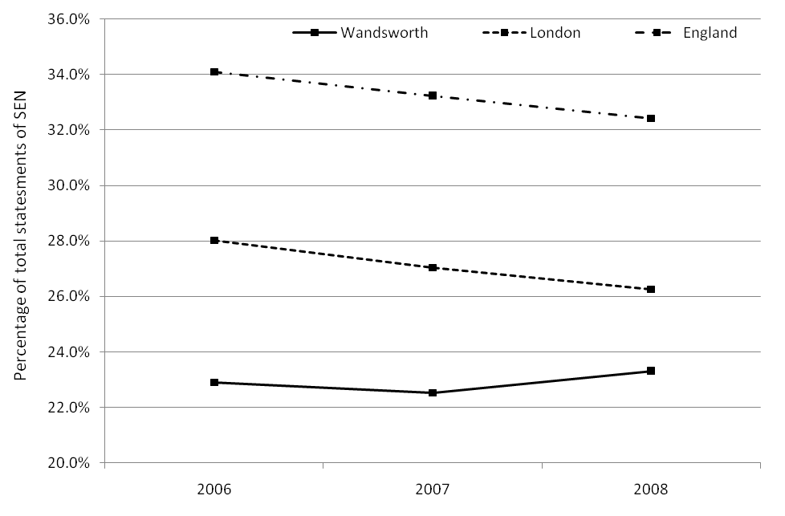
Source: Department for Children, Schools and Families (DCSF).
Over the three year period the majority of children with learning difficulties that have a statement of special educational need (SEN) in Wandsworth, have moderate learning difficulties. For 2008, there were 284 statements for children with moderate learning difficulties, 14 with severe learning difficulties, 3 with profound and multiple learning difficulties and an estimated 87 with autistic spectrum disorder (ASD) and a learning disability. Table 13 provides a breakdown of figures over the three year period 2006 to 2008.
Table 13: Statements of special educational need (SEN) in maintained primary schools for children with learning difficulties 2006-2008.
 |  | MLD |  |  | SLD |  |  | PMLD |  |  | ASD
 |  | 2006 | 2007 | 2008 | 2006 | 2007 | 2008 | 2006 | 2007 | 2008 | 2006 | 2007 | 2008
Wandsworth | N | 289 | 277 | 284 | 22 | 13 | 14 | 5 | <3 | 3 | 70 | 82 | 87
Wandsworth | % | 17.1 | 16.8 | 17.1 | 1.3 | 0.8 | 0.8 | 0.3 | <3 | 0.2 | 4.2 | 5.0 | 5.2
London | % | 22.0 | 21.0 | 20.4 | 2.3 | 2.1 | 1.8 | 0.6 | 0.6 | 0.6 | 3.1 | 3.3 | 0.0
England | % | 28.6 | 27.8 | 27.2 | 2.1 | 1.9 | 1.7 | 0.4 | 0.4 | 0.4 | 3.0 | 3.1 | 3.1
Source: Department for Children, Schools and Families (DCSF).
Note: % - Percentage of total statements of SEN for all client types in maintained primary school.
The proportion of moderate learning difficulties is lower in Wandsworth compared to the London and national rate (Table 13). The number of children with profound and multiple learning difficulties (PMLD) were too small to generate a proportion and therefore too small (under 3) to be publicly released. Overall for Wandsworth the proportion of children in each group has remained constant over the last three years.

Maintained secondary schools
Compared to the London and England averages Wandsworth has a low proportion of children with statements associated with learning difficulties in secondary schools. Only 11.6% of all statements of SEN for children at secondary schools were for children with learning difficulties in 2008. The London and national averages were 26.9% and 30.2% respectively. During the period of data availability (2006-08) the proportion of statements of SEN for children with learning difficulties in secondary schools in Wandsworth has been below the London and national averages (Figure 17). In Wandsworth there was a large increase in learning difficulty statements in 2007, a jump of nearly 3.5% accounting for 60 additional children from 2006, before a slight decrease in 2008.
Figure 17: Percentage of all statements of special educational need (SEN) in maintained secondary schools for children with learning disabilities.
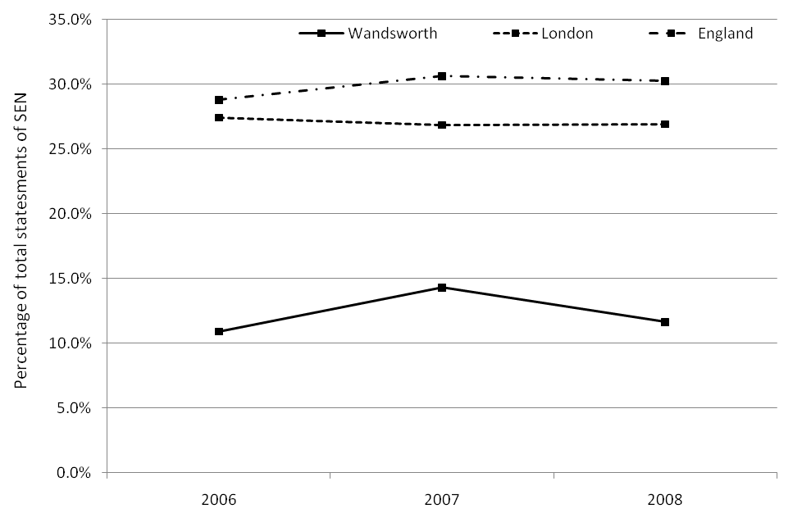
Source: Department for Children, Schools and Families (DCSF).
In 2008, there were 164 statements for children with moderate learning difficulties and an estimated 12 children with ASD and a learning disability. There were no statements for secondary children with severe and profound and multiple learning difficulties.
Table 14: Statements of special educational need (SEN) in maintained secondary schools for children with learning difficulties 2006-2008.
 |  | MLD |  |  | SLD |  |  | PMLD |  |  | ASD
 |  | 2006 | 2007 | 2008 | 2006 | 2007 | 2008 | 2006 | 2007 | 2008 | 2006 | 2007 | 2008
Wandsworth | N | 113 | 177 | 164 | 4 | 0 | 0 | 0 | 0 | 0 | 13 | 13 | 12
Wandsworth | % | 9.5 | 13.3 | 10.8 | 0.3 | 0.0 | 0.0 | 0.0 | 0.0 | 0.0 | 1.1 | 1.0 | 0.8
London | % | 24.3 | 23.7 | 23.7 | 1.3 | 1.3 | 1.0 | 0.3 | 0.2 | 0.2 | 3.1 | 1.7 | 1.9
England | % | 27.3 | 26.7 | 26.2 | 1.3 | 1.2 | 1.1 | 0.2 | 0.1 | 0.1 | 2.2 | 2.5 | 2.8
Source: Department for Children, Schools and Families (DCSF).
It is unusual to find children with learning disabilities in secondary school, therefore the figures revealed here are likely to be related to other learning difficulties rather than learning disabilities (see conclusion of this section for further clarification).

All special schools
Compared to the London and England averages the proportions of statements for children with learning difficulties from Wandsworth in special schools were substantially lower (Figure 18). In 2006, half of statements in Wandsworth were for children with learning difficulties, 343 pupils at 49.9%. The figure for London and England were 61.8% and 65.1% respectively. Overall the figures for London and England have been constant, only decreasing around 1% from 2006 to 2008. In Wandsworth there was a decrease of 10% over the same period from 343 pupils in 2006 to 240 in 2008.
Figure 18: Percentage of all statements of special educational need (SEN) in maintained special schools for children with learning difficulties.
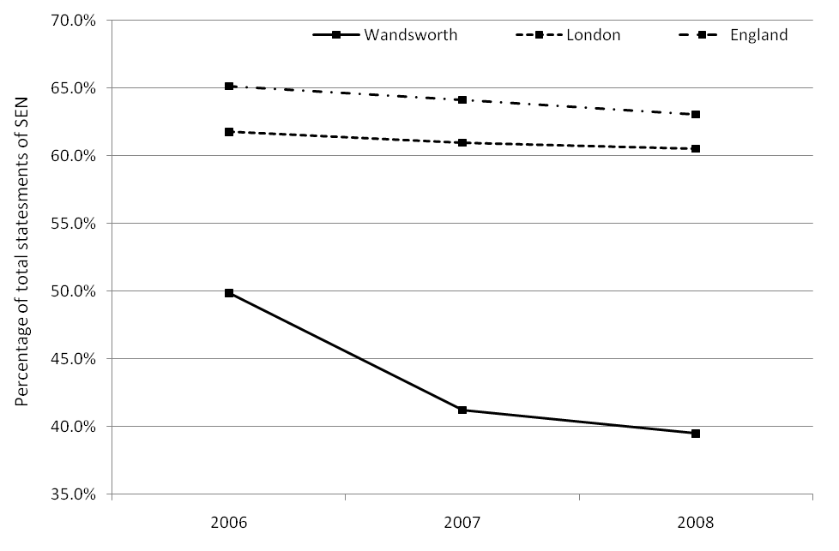
Source: Department for Children, Schools and Families (DCSF).
Again children with moderate learning difficulties accounted for the largest proportion of statements associated with learning difficulties to begin with. However there is a clear trend over the three year period where children with moderate learning difficulties have been taken out of special schools in Wandsworth (Highlighted in Table 15). There is a corresponding increase in pupils with moderate learning difficulties attending secondary schools but not of the same magnitude while primary school numbers stayed constant. Some of these pupils may have switched to secondary schools but also pupil numbers will also have reduced as a result of moving to other boroughs or reaching leaving school age. Over the same period a reduction was also seen in the London and national average but not as large as in Wandsworth. In 2006 the proportion of children with moderate learning difficulties attending special schools in Wandsworth was similar to the London and national average. However, by 2008 there were nearly 10% less children with a moderate learning difficulty in Wandsworth attending a special school compared to the national average.
For 2008, there were 81 statements for children with moderate learning difficulties, 87 for children with severe learning difficulties, 26 for children with profound and multiple learning difficulties and an estimated 46 for children with ASD and a learning disability.
Table 15: Statements of special educational need (SEN) in maintained special schools for children with learning difficulties 2006-2008.
 |  | MLD |  |  | SLD |  |  | PMLD |  |  | ASD
 |  | 2006 | 2007 | 2008 | 2006 | 2007 | 2008 | 2006 | 2007 | 2008 | 2006 | 2007 | 2008
Wandsworth | N | 187 | 112 | 81 | 95 | 89 | 87 | 29 | 30 | 26 | 32 | 43 | 46
Wandsworth | % | 27.2 | 16.8 | 13.3 | 13.8 | 13.4 | 14.3 | 4.2 | 4.5 | 4.3 | 4.7 | 6.5 | 7.6
London | % | 24.5 | 21.0 | 18.6 | 20.9 | 21.8 | 21.8 | 8.6 | 9.3 | 9.8 | 7.8 | 8.9 | 10.3
England | % | 27.3 | 24.9 | 22.9 | 23.9 | 24.1 | 23.7 | 7.6 | 8.0 | 8.4 | 6.3 | 7.1 | 8.0
Source: Department for Children, Schools and Families (DCSF).
The number of children with severe and profound and multiple learning difficulties has remained constant over time in Wandsworth with little variation (Table 15). They are all lower than the London and England averages.

Summary on statements for special educational need in Wandsworth associated with learning disabilities
Emerson and Hatton (2008b) state:
“The categories MLD, SLD and PMLD refer to general learning difficulties (i.e. what would be termed learning disabilities in non-educational settings). They do not include children with specific learning difficulties (e.g. dyslexia) who are identified separately in the School Census.”
This would suggest that all children in these SEN categories have learning disabilities. It is believed this is not the case with other learning difficulties grouped with learning disabilities in these categories. In the first instance the International Classification of Diseases 10th edition (ICD 10) categorises learning disabilities (mental retardation) into Mild (IQ 50 – 69), Moderate (IQ 35 – 49), Severe (IQ 20 – 34) and Profound (IQ below 20). Clearly these to do not fit with the SEN learning difficulties categories. Secondly, it is unusual to find a person with a learning disability attending a secondary school. Thirdly, in the case of Wandsworth 804 pupils (age 4 to 18 years) have statements related to learning difficulties. If these were all related to learning disabilities, an average of 54 pupils would transition to adult services each year. It is believed this is too high of a number (WCLDT 2010c). It may be indicative of better information capture because children have access to more organised services and so have better statistics. On the other hand, it means that a service such as WCLDT would expect about 54 people in transition every year. This is not the case. Therefore the proportion of the 804 people with ‘learning difficulties' having ‘learning disabilities’ is needed to be determined. This information is not currently published. However identification of this group would provide details of all children needing to be registered with GPs as having a ‘learning disability’ as part of the DES. Currently there are only 135 children (under 18) registered at Wandsworth GPs. Identifying this group is important for promoting health for the future particularly for those that are approaching adulthood and will transition from child service needs to adult ones.

Carers of people with learning disabilities
In the Valuing People Now strategy (Department of Health 2009) it is emphasised that carers of people with learning disabilities are entitled to the same aspirations and life chances as other citizens. However carers of people with learning disabilities are difficult to identify at the national and local level and little is known about them (Department of Health 2008). The majority of carers are family members with an estimate that 60% of people with learning disabilities are living at home with their family (Department of Health 2001). Carers face many challenges such as access to better information and support services and better assessments of their needs. However their involvement in such initiatives as learning disability partnership boards, begun as a result of the 2001 Valuing People strategy, has provided improvements.
Previously information regarding carers was held on the local authority run learning disability register. This register has been discontinued to be replaced by the social care services system, Framework-i. Currently we have not been able to extract data on carers from the system.
It is estimated that there are 32,000 carers for all types of need in the borough of Wandsworth (Careline 2009). The Borough of Wandsworth has 144 carers (2009) of people with learning disabilities recorded through various schemes. The breakdown is shown below in Table 16.
Table 16: Breakdown of carers of people with learning disabilities.
Scheme | Number of carers
Data from newly launched Carers' workflow | 4
Data from old Carers' workflow | 87
Data from Carers take a break scheme | 53
Total | 144
Source: Borough of Wandsworth Council, 2009.
No further breakdown in terms of gender, age or whether the carer is a family relative was available. (Wandsworth Council could not supply desired breakdown due to its commitments on statutory returns).
In 2009 a new Carers Strategy was launched in Wandsworth and as a result carers are now working alongside senior staff within NHS Wandsworth, Adult Social Services and the Mental Health Trust. Now carers are able to voice their views about the issues that matter to them, placing them at the heart of discussions and decisions about local services (Wandsworth Carers Centre 2010).

Learning disability services in Wandsworth
There are numerous services available in Wandsworth for people with learning disabilities. A list of those known to the Borough of Wandsworth Council is shown in Appendix B.

Primary care services
In Wandsworth there are two main primary care services, the Wandsworth Community Learning Disability Team (WCLDT) and the Child Mental Health Learning Disability Service (CMHLD). The Wandsworth Community Learning Disability Team (WCLDT) is a multi-disciplinary team comprising of professionals from both Social Services and the NHS. The aim of the team is to provide advice and support to people with learning disabilities and their carers/family. The WCLDT works with adults 18 years of age and over, who have a learning disability. The WCLDT are also engaged in working with Wandsworth GPs in identifying people with learning disabilities on their registers with the aim of improving health care for them. For example each person identified is to be offered a complete health check followed by subsequent monitoring and management if needed (NHS Wandsworth 2009).

The CMHLD offers assessment and treatment for children with severe learning disability and their families as well as consultation to professionals. All interventions start with an initial assessment before the health professionals and family decide together how to proceed. The service is for children up to their 18th birthday who have severe learning disabilities and mental health problems. The service is for Wandsworth but is open nationwide. Referrals are via GP’s, health, education or social services.

Adult Social Services Department
The Adult Social Services Department cares for and provides support for adults who are unable to care for themselves because they are frail, disabled or have a long-term illness. However, it aims to support people to live as securely and independently as possible and to contribute as full citizens to life in the community. The Department also supports friends and relatives who are caring for people who cannot look after themselves.

Residential and day centre care
In Wandsworth there are currently 29 residential care homes and living support (Map 2) for people with learning disabilities ranging in the number of people they can accommodate from two at the privately run Elwin Lodge to 42 at the St. Mary’s home. St Mary’s Adult Care Service provides Residential Care, Day Care, Respite and Holiday Care.

Map 2: Learning disability facilities with index of multiple deprivation by LSOA.
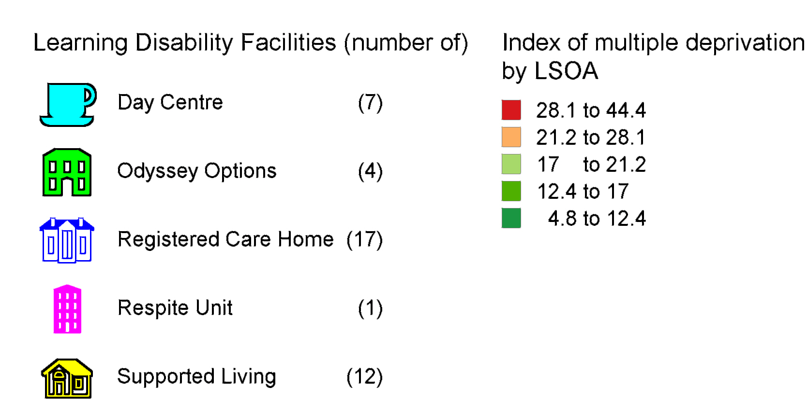

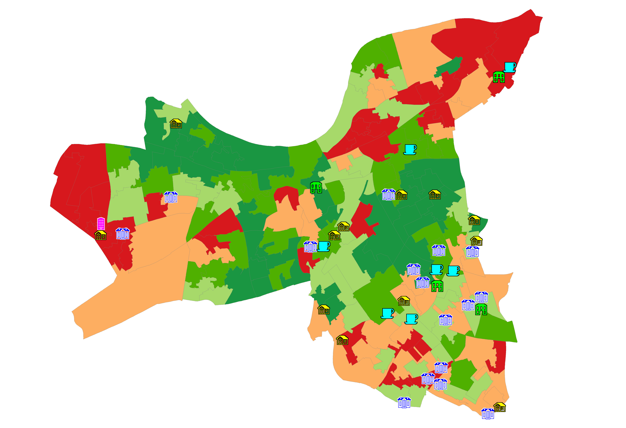
There are four day centres catering for people with learning disabilities, Battersea Social Education Centre, Burntwood Social Education Centre, Balham Gateway club and Atheldene Resource Centre, with latter being the main location with places for 190 people.

Wandsworth learning disability partnership board
As part of Valuing People, each local council has a partnership board. These aim to improve the lives of people with learning disabilities. The board meets regularly and discusses opportunities and ways of supporting people with learning disabilities. This includes addressing issues around well-being and ensuring there is good availability of information and access to services. The partnership board is co-chaired by Social Services and a person with learning disability, who resides within the borough of Wandsworth.

Other services and activities
Other services and initiatives based in Wandsworth for people with learning disabilities include Act 2 the Baked Bean Theatre company, Generate (Education/ Platform one café Employment project), the Thrive garden project, Tooting Tryers (Sports Club), Action space (visual arts project) and the Balham Gateway club. In addition, a carers support group is held on the first Thursday of each month for carers of adults with learning disabilities as well as a support group held once every two months for carers of young adults with learning disabilities (Wandsworth Carers Centre 2010).

Conclusion
This needs assessment has been carried out in support of NHS Wandsworth’s Health and Well-being Action Plan for people with learning disabilities: 2009- 2012 (NHS Wandsworth 2009a), which is directly a result of the new Valuing People Now strategy. One of strategy’s objectives is that ‘there will be a clear position for learning disabilities in the performance frameworks of the NHS’; this means that NHS Wandsworth are producing a learning disability strategy and developing metrics for measuring performance on learning disability provision. In order for NHS Wandsworth to support and fulfil this requirement this needs assessment has been undertaken.
The health status of people with learning disabilities (that have been recorded) show that this group is in poorer health than the general registered population (comparing with 2008-09 prevalence) in Wandsworth. The prevalence of obesity, epilepsy, diabetes, COPD and asthma is higher compared to the general registered population. While these two sets (general and LD) of prevalences have been calculated through different processes and therefore are not strictly directly comparable the magnitude of disparity lend to the conclusion that prevalence rates in Wandsworth for people with learning disabilities are higher compared to the general population. Furthermore, not only higher rates have resulted but also it is believed that under-reporting is occurring for some conditions. This is likely to have improved as GPs build up their registers through the DES. To assess this process (as well as providing knowledge on health conditions) undertaking another health status check (section 4) again in 2011 will reveal how enriched the GP register has become.
Overall there is a wealth of information available on people with learning disabilities from a number of sources that together builds a comprehensive picture of the learning disability need in Wandsworth. There is disparity between those identified through GP registers and the numbers for example receiving services through the council Social Services department or the number recorded on the Framework-i system. Amalgamating these sources will result in a comprehensive register allowing identification of those not registered with a GP and therefore not had a health check. Furthermore, not many children have been identified through the GP registers. Undertaking a cross-matching process between children on the GP register and records held by the council’s Child Learning Disability and Social Services teams could improve this.

Recommendations
Below are recommendations resultant from this needs assessment:
- The strategic health facilitator to continue to work with GPs to ensure practices many as possible are signed up to the Directed Enhanced Service for learning disabilities and that patients get appropriate health checks covering:
  - BMI/Obesity
  - Diabetes
  - Smoking status
  - Coronary heart disease and diabetes
  - COPD and asthma
  - Ethnicity
  - Screening (offered and whether screened including DNA)
- Ensure that there is a reliable system in place to identify patients with a learning disability in GP practices and annual health checks and number of hospital passports are audited.
- Ensure that people with learning disabilities have equal access to disease prevention, screening and health promotion activities in line with the requirements of the National Service Frameworks. To include having promotional information in accessible formats.
- Encourage GPs to provide NHS Health Checks to patients at the same time as other checks. Information to be provided to GPs by NHS Health Checks programme manager.
- Ensure mental health diagnosis is coded on the GP register, if still relevant. This should not only include those on the current caseload of the Wandsworth Community Learning Disability and Assessment and Intervention Teams but also those that still have the diagnosis, but are being looked after by their GP and are therefore no longer reflected on the team’s caseload.
- Establish formal process to append information regarding clients from the Community Mental Health Team into the GP/Framework-i LD register to improve data access and assessment of need. This is already occurring on an ad-doc basis.
- Investigate the level of diabetes in children under 17 years old. In November 2009 only 3 children identified.
- Ensure cross-matching of children on GP registers against those held on council learning disability lists (e.g. Records held by Child Learning Disability and Social Services team, statements of special educational need associated with learning disabilities).
- Cleanse and improve data quality of the client database/list held by the Wandsworth Community Learning Disability Team (WCLDT). These improvements then to be fed into the GP/Council register.
- Collect more comprehensive data on the number of people with learning disabilities from BME Communities to better address their health needs.
- Develop better data on the number of adults with autism and learning disabilities in Wandsworth.
- Identification and assessment of the needs of PLD to be included in the PCT’s Joint Strategic Needs Assessment (JSNA).
- This needs assessment to be circulated to the Long-term Conditions Steering Group and the Cardiovascular Reference Group through which any actions resulting from this document will be agreed.

References
Altman D G, Machin D, Bryant T N, et al. (2000). Statistics with Confidence, Second Edition. London: British Medical Journal Books.
Backer C, Chapman M, Mitchell D (2009). Access to secondary healthcare for people with intellectual disabilities: A review of the literature. Journal of Applied Research in Intellectual Disabilities 20 (6) 514-525.
Baird G, Simonoff E, Pickles A, Chandler S et al. (2006). Prevalence of disorders of the autism spectrum in a population cohort of children in South Thames: the Special Needs and Autism Project (SNAP). Lancet 368:210-15.
Bhaumik S, Watson J M, Thorp C F, et al. (2007). Body mass index in adults with intellectual disability: distribution, associations and service implications: a population-based prevalence study. Journal of Intellectual Disability Research 52 (4) pp287-298.
Brookes, M.E. & Alberman, E (1996). Early mortality and morbidity in children with Down’s syndrome diagnosed in two regional health authorities in 1988. Journal of Medical Screening 3: 7-11.

Careline (2009). Services for carers. Viewed 18th December, http://www.careline.org.uk/carers.asp?catid=21275

Care Quality Commission (2008). Data tables: Count me in census 2008: Learning disabilities results tables: ethnicity - London SHA (XLS, 659KB, opens in new window). Accessed 6th January 2010.

Commission for Healthcare Audit and Inspection (2008). Count me in 2008 Results of the 2008 national census of inpatients in mental health and learning disability services in England and Wales. London: Commission for Healthcare Audit and Inspection.
Communities and Local Government (2008). The English Indices of Deprivation 2007. London: Department for Communities and Local Government, Stationary Office.
Cowie M, Fletcher J (1998) Breast awareness project for women with a learning disability. British Journal of Nursing 7: 774–778.
Davies N, Duff M (2001). Breast cancer screening for older women with intellectual disability living in community group homes. Journal of intellectual disability research Vol. 45 Part 3 253-257.
Deb S, Matthews T, Holt G, et al. (2001). Practice Guidelines for the Assessment and Diagnosis of Mental Health Problems in Adults with Intellectual Disability. Brighton: The European association for mental health in mental retardation.
Department for Children, Schools and Families – DCSF (2008). Special Educational Needs in England January 2008. London: Department for Children, Schools and Families.
Department for Education and Skills (2001). Special educational needs – Code of practice. London: Department for Education and Skills Ref DfES/581/2001.
Department of Health (2001). Valuing People: A New Strategy for Learning Disability for the 21st Century (Cm 5086), London: Department of Health. London: Department of Health.
Department of Health (2006). Better Services for People with an Autistic Spectrum Disorder. A Note Clarifying Current Government Policy and Describing Good Practice.
Department of Health (2007a). Healthcare for All. Report of the Independent inquiry into access to healthcare for people with learning disabilities. Sir Jonathan Michael July 2008. London: Department of Health.
Department of Health (2007b). Putting People First: A shared vision and commitment to the transformation of Adult Social Care. London: Department of Health.
Department of Health (2007c). Promoting equality: Response from Department of Health to the Disability Rights Commission Report, “Equal Treatment: Closing the Gap“. Gateway 7540. London: Department of Health.
Department of Health (2008). Carers at the heart of 21st-centrury families and communities. Social care, local government and care partnerships directorate. London: Department of Health.
Department of Health (2009a). Valuing People Now: A New Three-Year Strategy for People with Learning Disabilities. London: Department of Health.
Department of Health (2009b). World class commissioning for the health and wellbeing of people with learning disabilities. London: Department of Health Commissioning and System Management Directorate.
Department of Health (2009c). Health of the Population Indicator NHS Feedback as at Q4 2008/09. GP recorded Smoking Prevalence. London: Department of Health.
Department of Health (2009d). Health Action Planning and Health Facilitation for people with learning disabilities: good practice guidance. London: Department of Health.
Department of Health (2010). Projecting Adult Needs and Service Information System (PANSI), Learning Disability. Website accessed 29th April 2010, http://www.pansi.org.uk.
Diabetes UK (2009). Viewed 9th December, http://www.diabetes.org.uk/Guide-to-diabetes/Introduction-to-diabetes/What_is_diabetes/.
Emerson E (2009). Estimating Future Numbers of Adults with Profound Multiple Learning Disabilities in England. CeDR Research Report 2009:1 June 2009. Lancaster: Centre for Disability Research, Lancaster University.
Emerson E, Madden R, Robertson J, et al. (2009). Intellectual and Physical Disability, Social Mobility, Social Inclusion & Health. CeDR Research Report 2009:2 May 2009. Lancaster: Centre for Disability Research, Lancaster University.
Emerson E, Graham H, Hatton C (2005). Household income and health status in children and adolescents in Britain. European Journal of Public Health, Vol. 16, No. 4, 354–360.
Emerson E, Hatton C (2004). Estimating the Future Need/Demand for Supports for People with Learning Disabilities in England. Lancaster: Institute for Health Research, Lancaster University.
Emerson E Hatton C (2007). The Mental Health of Children and Adolescents with Learning Disabilities in Britain. Institute of Health Research, Lancaster University. London: Foundation for people with learning disabilities.
Emerson E Hatton C (2008a). People with Learning Disabilities in England. CeDR Research Report 2008:1 May 2008. Lancaster: Centre for Disability Research, Lancaster University.
Emerson E, Hatton C (2008b). Estimating Future Need for Adult Social Care Services for People with Learning Disabilities in England. CeDR Research Report 2008:6 November 2008. Lancaster: Centre for Disability Research, Lancaster University.
Epilepsy Research UK (2009). Viewed 9th December 2009 http://www.epilepsyresearch.org.uk/about_epilepsy/ERUK_introduction_what_is_epilepsy.htm
Forsgren L, Edvinsson S O, Nystrom L, et al. (1996). Influence of epilepsy on mortality in mental retardation: an epidemiologic study. Epilepsia 37 956-63.
Foundation for people with learning disabilities (2006). Better Health Better Metrics - A project to use clinically relevant measures of performance to improve local service quality. London: Foundation for people with learning disabilities.
Foundation for people with learning disabilities (2009). Viewed 10th December 2009, http://www.learningdisabilities.org.uk/information/learning-disabilities-introduction/
Ghale L, Naqvi H, Russ L (2009). Asthma, smoking and BMI in adults with intellectual disabilities: a community-based survey. Journal of Intellectual Disability Research 53 (9) 787-796.
Graham H and Power C (2004). Childhood Disadvantage and Health Inequalities: A framework for Policy Based on Lifecourse Research. Child: Care, Health and Development 30 671-8.
Greater London Authority (2009). 2008 Round Low SYA population projections, Greater London Authority.
Greig R (2005). Valuing People: The Story So Far. Report from the Valuing People support team. London: Department of Health.
Hamilton S, Hankey C R, Miller S, et al. (2007). A review of weight loss interventions for adults with intellectual disabilities. Obesity Reviews 8 (4) 339-345.
Hatton C, Emerson E, Lobb C (2005). Evaluating the Impact of Valuing People. Report of Phase 1:
A review of existing national datasets. Part of the Department of Health’s Learning Disability Research Initiative. Lancaster: Institute of health research.
Healthcare Commission (2007a) The better metrics project. Version 8. London: Healthcare Commission.
Hermon, C., Alberman, E., Beral, et al. (2001). Mortality and cancer incidence in persons with Down’s syndrome, their parents and siblings. Annals of Human Genetics, 65, 167-176.
Hollins S, Attard M T, Von Fraunhofer N, et al. (1998). Mortality in people with learning disability: risks, causes, and death certification findings in London. Developmental Medicine & Child Neurology 40 50-56.
Irwin LG, Siddiqi A and Hertzman C (2007). Early Child Development: A Powerful Equalizer. Geneva: World Health Organisation.
Marshall D, McConkey R, Moore G (2003). Obesity in people with intellectual disabilities: the impact of nurse led health screenings health promotion activities. Journal of Advanced Nursing 41 pp147-53.
McGuire B E, Daly P Smyth F (2007). Lifestyle and Health Behaviours of Adults with an Intellectual Disability. Journal of Intellectual Disability Research 51 (7) 497-510.
Melville C A, Cooper S A, Morrison J, et al. (2007). The prevalence and determinants of obesity in adults with intellectual disabilities. Journal of App. Res. Intellectual Disabilities 21 (5) 425-437.
National Diabetes Audit (2008). National Diabetes Audit (NDA) Summary: 2003/4 to 2005/06.National Diabetes Support Team. Factsheet No. 26 November 2008.
National Institute for Clinical Excellence – NICE (2004). The epilepsies: The diagnosis and management of the epilepsies in adults and children in primary and secondary care. Clinical Guideline 20 October 2004 Developed by the National Collaborating Centre for Primary Care. London: National Institute for Clinical Excellence.
Newschaffer CJ, Croen LA, Daniels J et al. (2007). The epidemiology of autism spectrum disorders. Annual Review of Public Health 28:235-58.
NHS Health Scotland (2004). People with learning disabilities in Scotland. Health Needs Assessment Report – Summary. Glasgow: NHS Health Scotland.
NHS Wandsworth (2009a). Health and Well-being Action Plan for people with learning disabilities: 2009- 2012. Commissioning Directorate, NHS Wandsworth.
NHS Wandsworth (2009b). Learning Disabilities Performance and Self Assessment Framework Top Targets, Key objectives and Progress Criteria – 2010. Commissioning Directorate, NHS Wandsworth.
NHS Sutton and Merton (2009). Merton register for people with learning disabilities. December 2009 Report 16. London: Register services NHS Sutton and Merton.
ONS (2005). Mid-2004 Population Estimates: Quinary age groups for England; estimated resident population (experimental). Newport: Office for National Statistics.
ONS (2009). Mid-2008 LSOA Broad Age Estimates (experimental). Newport: Office for National Statistics.
Opinion Leader (2010). Overarching report of findings from the Adult Autism Strategy consultation activities. Prepared for COI and the Department of Health by Opinion Leader. London: Department of Health.
Parliament (2005). Disability Discrimination Act 2005 Elizabeth II - Chapter 13. London: The Stationary Office.
Perez-Achiaga N, Nelson S, Hassiotis A (2009). Instruments for the detection of depressive symptoms in people with intellectual disabilities. Journal of Intellectual Disabilities 13 (1) 55-76.
Savage R (2010). Email correspondence with Dr. Rosie Savage, Principal in General Practice
Falcon Road Medical Centre, London SW11 2PH, dated 6th August 2010.
Scottish Intercollegiate Guidelines Network - SIGN (2003). 70 Diagnosis and Management of Epilepsy in Adults: A national clinical guideline. Edinburgh: Scottish Intercollegiate Guidelines Network.
Share Community (2009). Training courses. Viewed 11th January 2010, http://www.sharecommunity.org.uk/training-courses.shtml.
Sillanpaa M (1996). Epilepsy in the mentally retarded. In: Wallace S, editor. Epilepsy in children. London: Chapman and Hall Medical p417-27.
Stein K, Allen N (1999). Cross sectional survey of cervical cancer screening in women with learning disability. British medical journal Vol. 318 641.
Stewart L, Van de Ven L, Katsarou V, et al. (2009). High prevalence of obesity in ambulatory children and adolescents with intellectual disability. Journal of Intellectual Disability Research 53 (10) 880-886.
Strategic Information Group on Adult Social Care (SIGASC) (2007). Terms of reference. London: The Information Centre.
Sullivan S G, Hussain R, Threlfall T et al. (2004). The incidence of cancer in people with intellectual disabilities. Cancer causes and control 15: 1021-1025.
The Information Centre (2008a). Referrals, Assessments and Packages of Care - National Tables 2007-08. London: The Information Centre.
The Information Centre (2008b). New PSA data items for inclusion in the KS1 (or it’s equivalent) from 2008/09. Accessed 18th June 2010, http://www.ic.nhs.uk/webfiles/Services/Social%20care/Collections%20200708/Learning%20disabilities_collection.pdf.
The Information Centre (2009a). Statistics on obesity, physical activity and diet: England, February 2009, Health Survey for England 2007. London: The Information Centre.
The Information Centre (2009b). QOF0809_PCTs_Prevalence. Prevalence calculated using estimated relevant population - Quality and Outcomes Framework (QOF) for April 2008 - March 2009, England. London: The Information Centre.
The Information Centre (2009c). NASCIS Tools, National Adult Social Care Intelligence Service (NASCIS). Accessed 10th December 2009, http://nascis.ic.nhs.uk/Portal/Tools.aspx
Turner S, Moss S (1996). The health needs of adults with learning disabilities and the Health of the Nation strategy. Journal of Intellectual Disability Research 40 438-450.
Tyrer F and McGrother C (2009). Cause-specific mortality and death certificate reporting in adults with moderate to profound intellectual disability. Journal of Intellectual Disability Research 53 11 898-904
United Nations (2007). International Convention on the Rights of Persons with Disabilities. New York: United Nations.
Valuing People (2009). The A-Z of health issues affecting people with learning disabilities. Accessed from Valuing People website 7th January 2010. http://valuingpeople.gov.uk/echo/filedownload.jsp?action=dFile&key=671
Valuing People Support Team (2003). How to estimate the number of people with a learning disability in your area; or check your current results. Valuing people support team.
Walsh P N, Kerr M, Van Schrojenstein Lantman de Valk H M J (2003). Health indicators for people with intellectual disabilities: A European perspective. European Journal of Public Health 13 (3 SUPPLEMENT): 47–50.
Wandsworth Carers Centre (2010). Wandsworth Carers’ Centre Bulletin. Issue 49, February/March 2010.
Wandsworth Community Learning Disability Team (2009a). Care Homes supplied by CLDT. List of care homes provide by Tarlochan Ghale 24th December 2009.
Wandsworth Community Learning Disability Team (2009b). Joan Bicknell Centre Clients, supplied by Tarlochan Ghale, Strategic Health Facilitator - Learning Disabilities, December 2009.
Wandsworth Community Learning Disability Team (2010a). Statement arising from Wandsworth Health Action Group meeting, 18th March 2010.
Wandsworth Community Learning Disability Team (2010b). Correspondence received from Dr Oyepeju Raji, Consultant Psychiatrist in Learning Disabilities, Wandsworth Community Learning Disability Team. Dated 1st March 2010.
Wandsworth Community Learning Disability Team (2010c). Correspondence received from Dr Oyepeju Raji, Consultant Psychiatrist in Learning Disabilities, Wandsworth Community Learning Disability Team. Dated 31st August 2010.
Wandsworth Community Learning Disability Team (2010d). Correspondence received from Dr Oyepeju Raji, Consultant Psychiatrist in Learning Disabilities, Wandsworth Community Learning Disability Team. Dated 10th May 2010.
Wandsworth Council (2010). Correspondence dated 18th February 2010 with Sam Browne, Performance & Management Information Officer, Management Information Team, Adults Social Services, Wandsworth Council.
Wells, M.B., Turner, S., Martin, D.M. & Roy, A. (1995). Health gain through screening - coronary heart disease and stroke: developing primary health care services for people with intellectual disability. Journal of Intellectual & Developmental Disability 22 251-263.
World Health Organisation (2001). International Classification of Functioning, Disability and Health. Geneva: World Health Organisation.
World Health Organisation (2007). International Classification of Functioning, Disability and Health – Children and Youth Version. ICF-CY. Geneva: World Health Organisation.

Appendix A: Index of Multiple Deprivation
The Index of Multiple Deprivation 2007 (IMD 2007) is a measure of relative multiple deprivation at the small area level (Communities and Local Government 2008). It is an important tool for identifying the most disadvantaged areas in England so that resources can be appropriately targeted. It is based on the idea of distinct dimensions of deprivation which can be recognised and measured separately, and experienced by individuals living in an area. Consequently the index is constructed from a combination of more specific types of deprivation called domains. These domains cover income, employment, health & disability, education, barriers to housing, crime and the living environment. The dataset is released for the whole of the UK with deprivation for each area classed relative to the whole of the UK. The scale for deprivation in our analysis has been reset to the Wandsworth scale. This means that the deprivation scale has been set relative to Wandsworth i.e. areas have been re-grouped (equal number of areas) into quintiles ranging from the least deprived areas in the Wandsworth borough to the most deprived.
When interpreting the deprivation data (Figure 3) it must be remembered that it is only an indication of the current possible situation since the QOF data is not complete. Also the proportions are calculated from Lower Super Output Areas (LSOA), to mirror deprivation data as it is calculated at this level. LSOAs are small area statistical output areas. Population projections are not calculated for this small area, but the Office for National Statistics (ONS) has produced experimental 2008 population estimates (ONS 2009). This population data has been used as the denominator population for calculating the proportions (Figure 3) since this is the most recent data available for LSOAs. This results in a data mismatch, 2010 QOF data (numerator) and population data (denominator) estimated for 2008. This introduces an extra dimension of error. However aggregating the data up to Index of Multiple Deprivation quintiles will avoid the impact of unstable proportions at the smaller area level (LSOA). As stated this work is provided as a possible indication of how the distribution of people with learning disabilities may vary across deprivation in Wandsworth and these factors must be considered. Furthermore, the distribution of people with learning disabilities in Wandsworth will be biased towards high deprivation areas since most residential care homes are located in these areas (e.g. St. Mary’s).

Appendix B: List of learning disability services in Wandsworth
Organisation | Description
Act Too | Act Too provide drama based services for adults with learning disabilities. Services include Baked Bean Theatre Company.
Action Space (London  Events Ltd) | Action Space is London's leading visual arts organisation for people with learning disabilities, run a project on a Tuesday, Friday and Saturday in Wandsworth.
Advocacy Partners:  IMCA service | Provides Independent Mental Capacity Advocate (IMCA) services for adults who are assessed to lack capacity to make certain key decisions.
Artsline | Artsline is the leading information service for disabled people worldwide who want to access arts and entertainments venues in London (also many tourist attractions). Attitude is Everything aimed at improving accessibility to live music venues and recording studios across the UK and Cultural Diversity extends all of Artsline's services to disabled people from black ethnic minority and refugee communities within London. Online access information database is part of website.  If people register on the web site there is a monthly electronic newsletter and an events page with information for disabled people. If venues want to use these services they must be on the database so that disabled people can check the accessibility at the same time. Venues can contact Artsline to arrange this if they want an activity or event at their venue to be included free of charge.
Asian Elders Support  Scheme (AESS) | AESS provides homecare services to Asian older people, and Asian people with learning disabilities. A lunch club is in operation Monday to Friday; Asian vegetarian meals are cooked on the premises on a daily basis.  Also manage a sheltered housing scheme for Asian older people.  Have recently started a day centre, again Monday to Friday, providing transport, meals and daily activities.  Access to the homecare and day centre is via assessment by social services.
Asian People's  Disability Alliance | Day and respite care for elderly & disabled Asian people carers, offers advice & information etc. Home support for housebound Asian disabled and carers.
Atheldene Resource  Centre | Combined centre includes provision for people with learning and physical disabilities. Access can be made only by referrals from Social Services.
Balham Gateway Club | Social club for people over 16 years with mild to moderate learning disabilities. Meet at St Mary's School, Balham Park Road, London, SW12 8DR.
Battersea Social  Education Centre | Offers a range of day activities for people with learning disabilities.
Burntwood Social  Education Centre | Offers a range of day activities for people with learning disabilities.
Carers of Adults with Learning Disabilities  Group | Support group people who care Disabilities 25 1st Thursday of each month: for adults with Learning Disabilities, aged over 25. Offers an opportunity to meet other carers, to find out about services and discuss ways of coping.
Carers of Younger  Adults with Learning  Disabilities Group | Support group for people who care for younger adults with Learning Disabilities, aged 15-25. Offer an opportunity to meet other carers, to find out about services and discuss ways of coping with transition from school to adult services.
Companion Cycling | Provides partnered cycling, in Bushey Park, for children and adults with special needs. This is done on specially designed side-by-side "duo" cycles and wheelchair tandems, in co-operation with family members, friends & care workers.
Connexions Battersea | This Connexions centre offers advice and practical support to 13-19 year olds who live in the Central part of Wandsworth or the Battersea area. They can provide specialist careers advice and guidance, information and help in getting a job, finding a course or training. They offer benefits advice and registration for Jobseekers Allowance and work based training for 16-19 year olds. A list of vacancies is updated daily and computers are available for producing CVs.  They also have a specialist borough-wide team for young people under 25 who have learning or physical disabilities. They have 1 computer that is specially set-up for young people with visual impairment.
Disability and Social  Care Advice Service  (DASCAS) | Offers an independent telephone information service on any aspect of disability and social care. Helps clients claim benefits. Assists clients to complete forms. Gives advocacy and support up to tribunal level in disputed cases. Offers advice and support to professionals working with disabled and frail people. Gives priority to the housebound.
Dolphins Swimming  Club | Swimming & tuition for young people & adults with learning or physical disabilities.
Down's Syndrome  Association | To provide information and support to people with Down's Syndrome their families & carers and interested  professionals. Can put parents and carers in touch with affiliated local support groups.
Generate | Supports people with moderate Learning Disabilities through a range of activities, e.g. courses, 1:1 support, training,  clubs, employment and holidays. 6 projects: Individual Community Support, Employment, Stepping Stones, Health  Matters, and Youth. There are twenty groups run per week.
Generate Employment | Provides support to people with learning disabilities in accessing employment through sheltered placement schemes,  work experience programmes, and open employment, supporting both employees and employers in the workplace.
Generate Youth Project | Youth club for young people with moderate Learning Disabilities aged 11-25 years.
George Shearing After  School Club | The club operates in a specialist centre for young people with special needs on three afternoons a week during term  time school holidays Mon-Weds: 4-6pm. Este Road London, SW11 2TF Phone: 020 8871 7553 / Fax: 020 7978  time. It also has a daytime scheme during most holidays.
Independent Living  Funds | The funds aim is to support long term independent living for severely disabled people by helping them pay for private  care to enable them to live at home instead of in residential care. They are unable to provide funding for equipment.  People must be:  Aged between 16 & 65 years of age  Be in receipt of the Highest Rate Care Component of DLA  Have savings less than £18,500  Be in receipt of at least £200 worth of services p.w., or direct Payments, net of any charges, from Social Services  H i ffi i t i t th t f th i d  Mon-Weds: 9am-4.30pm, Thurs:  9am-2pm & 3.30-4.30pm, Fri: 9am-  4pm  PO Box 7525 Nottingham, NG2 4ZT  Phone: 0845 601 8815 / Fax: 0115 945  0948 / Minicom: 0845 601 8816 / email:  funds@ilf.org.uk / Web: www.ilf.org.uk  Have insufficient income to cover the cost of their care needs  Expect to live in the community for the next 6 months  Be a UK resident  the fund can pay up to a maximum of £455 on top of Social Services input and the persons assessed contribution,  (subject to the combined input not exceeding £715 per week).
John Morris House  Community Centre | Community centre which meets local needs. Meeting rooms available for hire. IT Training, Homework Club, Digital  Photography, school holiday projects, various other one off projects i.e. mental health, lone parents; some adult  education classes i.e. calligraphy, literacy and numeracy. Some office space available for local voluntary organisations.
Keep Able | Wide range of specialist domestic equipment for elderly and disabled and a vast range of mobility items to view.
Lady Allen Adventure  Playground | To encourage & enable children aged 5-14 with special needs & disabilities to play adventurously in a safe &  stimulating environment. Under-fives with a carer are also welcome - especially on Tuesdays. Welcome the inclusion of  local mainstream children.
Lambeth Chinese  Community Association | Provide homecare & respite care for the Chinese & Vietnamese communities.
London Dial-a-Ride | London Dial-a-Ride is a door to door public transport service for people with mobility problems, who find it hard or  impossible to use conventional public transport. It can be used for all sorts of journeys such as shopping, visiting  friends, attending meetings, doctors or dentists appointments. However it cannot be used to attend hospital  appointments or local authority day centres.  New eligibility criteria have been introduced, bringing Dial-a-Ride in line with the Taxicard scheme. All new applicants  for the Dial a Ride service must have a permanent or long term disability or health problem and be unable or virtually  bl t bli t t i i l di b d d d dt i  Bookings: 9am-4pm, Enquiries:  9am-5pm, Transport 365 days a  year: 6am-2am.  Progress House 5 Mandela Way London, SE1 5SS Phone: 0845 9991 999 / Fax: 020 7027  5801 / Web: www.tfl.gov.uk/dial-a-ride/  unable to use public transport services including buses, overground and underground trains.  You should note that when you use Dial-a-Ride you will often be travelling with other people in the vehicle, and this may  extend the journey time of the trip.
Merton and South West  London Dyslexia  Association | Information and advice to parents of children with dyslexia and adult dyslexics.
Mushkil Aasaan  (Community Care for  Asian Families in  Crisis) | Mushkil Aasaan supports Service Users through a range of mainstream activities, embracing cultural, religious, and  diversities  linguistic diversities.  Advocacy; Counselling; Mediation/Conciliation; Crisis Intervention; Ongoing Emotional Support; Home Support;  Respite; Support and Befriending Networks; Parenting Support; Adolescent/ Youth Support; Welfare Rights;  Escort/Transport; Interpreting for Users; Bereavement; Adoption & Fostering; Meditation Classes; English Classes;  Elderly Mehfil; Graveney Madressa; Domiciliary Care; Interpreting/Translations; Consultancies/Advisory Service; and  Self-Help Support Groups.
Parallel Board /  Partnership Support | A service for people with a learning difficulty. A user involvement project, enabling people with learning difficulties to  have their voices heard in the planning and provision of services they use.
Penderels Trust | Penderels Trust is responsible for supporting people who are using or wish to use Wandsworth Social Services Direct  Payments Scheme.
Platform 1 Cafe | Provides training, careers advice and work placements for residents of the borough with learning disabilities. Areas of  training include food preparation and cooking, food hygiene, customer services, health and safety and team work skills.
RADAR (Royal Association for  Disability and  Rehabilitation) | RADAR is the UK s leading pan-disability campaigning organisation and network of disability organisations and disabled people. They represent their members by fast-tracking their opinions and concerns to policy-makers and legislators in Westminster and Whitehall, and launching their own campaigns to promote equality for all disabled people.
Rainbow Art Club | Art group for people with learning disabilities aged 18 years and over.
Ready To Start | Ready to Start is a unique programme that provides the right training, sign-posting and support to enable disabled  people to start their own business.  The programme is being provided by Leonard Cheshire in partnership with Barclays. In this way Ready to Start  combines a unique understanding of disability and enterprise which is ideal for disabled people who are thinking about  going into self-employment.  In order to be eligible for the Ready to Start programme, you must meet the following criteria:  You must be a disabled person. This means you have a physical or mental impairment that has a substantial and  long-term adverse effect on your ability to carry out normal day-to-day activities.  You must be aged 19 or over  You must have adequate levels of English and maths to take part in the programme. This will usually mean GCSE or  an equivalent Level 2 standard, although you do not need to have gained an actual qualification.  You must be actively seeking to establish your business idea in order to benefit from the resources available during  Phone: 08456 717173 / email:  info@readytostart.org.uk / Web:  www.readytostart.org.uk  the programme.  You must be legally resident in the UK.  You must be living within a reasonable geographical distance of Wandsworth.
Remploy | Provides training and job opportunities within a commercial environment and via local employers for people who are  able to make a significant contribution to the economy, but who because of the nature or severity of their disability  would benefit from individually tailored support in the workplace.
Richmond Advice &  Information on disability (Richmond AID) | To provide information and advice on disability and disability issues including housing, health, local services and  employment for Richmond and surrounding boroughs. A dedicated benefits advice and form-filling service available by  appointment and a free basic gardening to older residents of the Borough of Richmond upon  Thames.
Shaftesbury Christian  Centre | Community Centre. Disabled access. A number of activities / groups taking place and new activities regularly starting.  First Sunday every month: 1.30 to 5pm 'Friends Together' bring & share lunch club for single parents and people alone.  Monday: 7 to 9pm: Swimming club for adults & children, qualified instructors.  Monday: 7pm to 8pm: Tai Chi.  Tuesday - weekly 10.30am to 12.30pm The Oak Tree Club - Games and activities for older people - contribution of  50p.  Tuesday - weekly 6pm to 7pm & 7pm to 8pm - Tai Chi.  Wednesday - weekly 5.30pm to 6.30pm Children's Jazz/Street Dance Class £3.00 per class.  Wednesday - weekly 6.45pm to 7.45pm - Aerobics & Body Conditioning for over 16's - £4.00 per class.  Thursday: 10am to 12pm: Sure Start Family Club for parents and toddlers under five.  Thursday: 1pm to 3pm: 'Tune Up' exercise and healthy eating group for people with learning difficulties living in  Battersea (group run by Generate).  Thursday: 7pm to 8pm; Tai Chi classes.  Friday - 11am to 1.30pm - alternate weeks - Minnie's Parlour - a cook & eat group for older people, tasty carribean  food. £1.00 contribution for lunch.  Friday - weekly 4.30pm to 5.30pm - Flamenco Dancing for under 16's - £3.00.  Friday - 7 30pm - 16's - £7 00  There are lots of other one off activities such as shows, training, fun days, music evenings, youth events. Holidays / outings arranged for single parents and children. Aiming to start debt advice and money management workshops soon.  Hall hire: Two halls / kitchen and small room for private hire and training at reasonable rates. Reduced rated for any individual or group wanting to run a group or activity for the community. Special rates for afternoon children's parties.
Shape | Shape is the country's leading disability arts organisation, we aim to improve access to the arts for deaf and disabled people whilst supporting deaf and disabled artists to challenge perceptions and promote Deaf and Disability Culture. Through our work, we have gained the respect of disabled and non disabled people alike. Shape celebrates Disability and Deaf Culture, providing a new dynamic forum for artistic, social and cultural change. Long before legislation like the Disability Discrimination Act existed, deaf and disabled people used the arts to raise awareness of deaf and disability issues, and campaign for social equality. Today, Shape continues to support deaf and disabled artists to challenge society's perceptions, develop audiences and promote Deaf and Disability culture into the 21st century.
Share a Family  Wandsworth | Provides short-term breaks for children 0-19yrs with autism, or physical, learning, sensory or multiple disabilities. Domiciliary worker for children who have multiple profound disabilities. Run 2 monthly clubs.
SHARE Community Ltd | Vocational training and education to disabled adults and those facing health related barriers to employment. Vocational training courses in IT, horticulture, life skills and basic skills. Extra activities including, sports, healthy eating courses, creative writing, yoga and arts & crafts sessions.  Employment training; one to one advice and guidance on applying for further education and employment. The training for the I.T and Life skills & Basic Skills projects takes place at our site in Clapham and our Horticulture  project is based at Springfield Hospital, Tooting. Clients are referred either through their Social Worker/ Key Worker etc or through self referral. If a client expresses an interest in attending SHARE, they are invited for a show-round and an informal interview with Pamela Dale to discuss their requirements, at which point the necessary forms for each project will be completed. Subject to funding being approved by the relative London Borough, a start date will then be fixed.
Sports Development -  Community Links Team | The Sports Development Team works with the local community and targets those groups who do not traditionally participate in sport or physical activity, including people over 50 and those with disabilities. Programmes and initiatives have also been developed for youth, women and black and ethnic minority group. The team works in partnership with groups, agencies and sports clubs to support and improve the sustainability of the local sporting community in Wandsworth. Programmes and support packages have been developed to ensure the ongoing development of coaches, volunteers and athletes. The Sports Development Team aims to increase participation in sport and physical activities through a variety of regular sessions, events, competitions, initiatives and holiday programmes. Current programmes include: swimming lessons, football coaching, a coach education and club development programme and a wide variety of session for people with disabilities and those over 50years old. The Sports Development Team also works extremely closely with the Borough's schools to assist and support with physical education and school sport helping to facilitate a pupils' transition from a high quality introduction to sport through to local sport clubs and other exit routes. The team also provides a comprehensive calendar of competitions
The Bridge | Centre for deaf people. Provides tailor-made skills training such as IT, gardening, cookery and sewing. Run paid qualification-based training placements in real jobs for people on benefits. These placements are offered alongside a varied programme of learning and leisure activities run at the centre. At the moment, training placements are offered in IT, cookery, cleaning, administration and DIY, support groups, information and advice. Have a Farm group which visit a farm in Surrey weekly. There users can help to feed the animals, spread out hay for them in the winter, dig up poisonous plants and get involved with other farm activities. Free transport from the Bridge is provided. In addition, services are offered for the wider Deaf community such as a one-to-one Business Advice service for Deaf people who want to set up their own business. Have Yoga sessions using British Sign Language where Deaf people can relax and de-stress at the end of the working day. The Bridge hosts Healthy Deaf Weekends which provide workshops and seminars on a range of issues to improve wellbeing. They also run a cafe which is operated by the service users (open to the public Tuesday to Thursday from 9am to 3pm).
The National Centre for  Young People with  Epilepsy (NCYPE) | The National Centre for Young People with Epilepsy (NCYPE) is the UK's leading provider of education, assessment, rehabilitation, treatment and care for children and young people aged 5 to 25 with complex epilepsy and other neurological conditions. It provides day and residential education places for students aged 5 to 25 through its onsite St Piers school and further education college. It also provides a fully-staffed health centre and a range of epilepsy diagnostic, assessment, rehabilitation and outreach services to assist children aged 3 and upwards.
The Percy Bilton  Charity | Grants are made to organisations and individuals in need throughout the UK. Organisations assisting disadvantaged youth, people with disabilities and older people may apply for grants towards capital expenditure.  Social workers may apply on the behalf of individuals who have a disability or mental health problem, or who are over 65, for grants to purchase basic furniture, equipment and clothing.
Thrive - Garden Project  Battersea | Thrive disabled people and adults achieve their full potential through horticultural therapy, life skills, prevocational and vocational training programmes, (including work shadowing and work experience), at its gardens in Battersea Park. Thrive is open to people with physical, mental health and learning disabilities or in physical or mental recovery/rehab. Referral to Thrive is generally through a social worker, key worker etc although self referrals are also welcome. Thrive's programmes are tailored to individual needs with outcomes derived specifically from personal goals established with the client. The aim is to progress towards maximum independence including independent living, volunteering and employment. Thrive invites potential clients to visit Battersea Park to see our gardens, find out what we do and to discuss their needs. Following that and subject to securing funding, we agree a suitable programme.  The project is located on East Carriage Drive in Battersea Park just north of the Millennium Sports Arena. Thrive also runs a supported volunteer programme as a stepping stone from service user to independence. Supported
Tooting Tryers | Sports club for people with Learning Disabilities aged over 18 years. Held at Tooting Leisure Centre, Greaves place, Tooting SW17 0NE.
Wandsworth Access  Association of People  with Disabilities | The association is run by people with disabilities and the aim is to improve access to buildings and services for all disabled people within the borough of Wandsworth.
Wandsworth Care Alliance | To promote the views of local care service users, their carers and the voluntary sector.
Wandsworth Carers Centre | If you are supporting someone by providing practical or emotional support, and live in Wandsworth, or care for someone who lives in the borough then the Centre is here for you. The Carer's Centre is part of the national network of the Princess Royal Trust for Carers.  What Services does the Centre Provide?  Advice & Information  Asian Development Project  Carers Breaks Project  Mental Health  Support Group Meeting  Therapies  Back Care Project
Wandsworth  Crossroads | A free service which provides paid, trained care attendants for carers looking after someone over the age of 16 at home. This service enables the carer to take a break from caring on an occasional, weekly or nightly basis. If the carer needs a longer break for health reasons, Crossroads can provide respite for periods of up to one week. Crossroads also provides telephone support, and will access services and liaise with statutory authorities and other voluntary organisations on the carer's behalf.
Wandsworth Gateway  Club | Social club for people over 16 years of age with mild to moderate learning difficulties.
Wandsworth MENCAP | To support people with learning disabilities their families & carers, offering advice & information, campaign for better services. Telephone and appointment service.
Wandsworth Resource Room | Information and resource centre for carers, users, professionals or anyone else with an interest in any disability in Wandsworth. Provide information on courses, employment, learning services and health services. Provide internet connected computers to use (along with someone to show how to use them), a digital camera, massage and exercise facilities in a gym.
Wandsworth  Shopmobility | Assist anyone with mobility problems to access Wandsworth town centre. Provide wheelchairs and scooters for the disabled and elderly, an escort service and door to door transport in accessible transport.
Wandsworth Voluntary  Sector Development  Agency | Formerly The Wandsworth Volunteer Bureau; Wandsworth Voluntary Sector Development Agency are the new Council for Voluntary Service (CVS) for Wandsworth. Provide information and advice for residents of Wandsworth on opportunities for volunteering throughout the Borough. Provide advice and training to local organisations wishing to involve volunteers in their work. Please note are unable to supply volunteers direct to local residents.

