

Falls prevention, management and bone health needs assessment
Final version

Dyfed Thomas, Public Health Project Manager, NHS Wandsworth
Bernadette Kennedy, Integrated Falls Service, NHS Wandsworth
Amanda Cranston, Consultant in Public Health, NHS Wandsworth
4.1. Introduction
This section describes the need around older people and falls in Wandsworth along with the associated risk factors. The risk of falling increases as people get older and falls represent the most frequent type of serious injury in the over 65s age group and the commonest reason for hospital attendance. The most serious consequence of falling is hip fracture. The majority of fractures in older people occur as a result of a fall from standing height (fragility fracture).

Falling is associated with increased morbidity and mortality. It is the main cause of accidental death in people aged 85 and over (DTI, 1997, 1999). The resulting mortality is often as a consequence of sustaining a hip fracture as 30% of this patient group will die within the first year. For those that survive, up to 50% are no longer able to live independently, with 80% not regaining their pre-fracture level of function (Poor et al, 1995).

4.2. Definitions
Fall - A fall is “an unexpected event in which the participants come to rest on the ground, floor or lower level”. This is the most recent definition agreed by a work stream through ProFane (European special interest group in falls) (Lamb et al. 2005, Hauer et al. 2006).
Also within this needs assessment terms such as fragility fractures, non-hip fractures and neck of femur fractures will be referred to. Here we list their definitions.
Fragility fracture – fractures that result from a fall from standing height. This fact is not coded when a person with a fragility fracture enters hospital, only that the person has suffered a fracture will be recorded. Therefore, for analysis purpose we assume that all fractures for the following diagnoses in the over 65 are due to fragility fracture from falls:
- Fractured neck of femur
- Proximal humerus
- Wrist fracture (commonly referred to as smiths and colles fractures)
- Fractured pelvis
- Vertebral fracture (thoracic and lumbar only) (British Orthopaedic Association 2007 and Department of Health 2009a)

Non-hip fragility fractures - All of the above except a fracture of the neck of femur.

Neck of femur (the hip) – a short, constricted, strong bar projecting at an obtuse angle (about 125°) from the upper end of the shaft of the thigh bone and supporting its head.
4.3. Population profile
The Wandsworth PCT GP registered population at 31st October 2009 was 363,776. The projected resident population for 2010 is 287,964. The population is highly mobile, has a higher than London and England average of young adults (25 to 44 years) and is highly diverse in terms of ethnicity and socio-economic indicators.

The National Audit of the Organisation of Services for Falls and Bone Health of Older People (Healthcare Quality Improvement Partnership 2009a) refers to older people as being 65 years old and over. The projected number of people that are 65 years and older in Wandsworth for 2010 are 24,204 accounting for an estimated 8.4% of the resident borough population.

4.3.1. Resident population projections over the next five years
Table 1 shows the breakdown of the current projected resident 65 years and over population and its likely change over the next five years. The data is broken down into male, female and total population as well as age groups.
Table 1: Projected 65 years and older population in Wandsworth.
 | 65-74 |  |  | 75-84 |  |  | 85+ |  |  | Total
 | M | F | T | M | F | T | M | F | T | M | F | T
No. in 2010 | 5,998 | 6,848 | 12,845 | 3,418 | 4,633 | 8,051 | 1,056 | 2,252 | 3,308 | 10,472 | 13,733 | 24,204
No. in 2015 | 6,015 | 7,182 | 13,197 | 3,440 | 4,382 | 7,822 | 1,108 | 2,065 | 3,173 | 10,564 | 13,628 | 24,192
Source: GLA 2008 Round Projections, Greater London Authority, 2008
Over the next five years the older population in Wandsworth is projected to remain constant overall. By age group, the population is projected to rise by 2.7% in age group 65-74 years whereas in age groups 75-84 and 85+ the population is projected to decrease by 2.8% and 4.1% respectively.
Splitting by gender reveals that there are more women than men over the age of 64 living in Wandsworth. The proportional difference between genders will remain the same over the next five years. For 2010 it is projected that there are 24% less men aged 65 years or more compared to women residing in Wandsworth. In 2015 the projected difference is estimated to be 22%. Reflecting the fact that females experience a longer life expectancy than men, the difference in the number of females against males increase with age. For 2010 for example there are 12% more women than men in the 65-74 age group increasing to 53% in the 85+ age group.
Overall Wandsworth’s 65 and over population is not projected to change largely until 2020 and beyond, however large increases will be experienced within specific wards (Figure 1). St. Mary’s Park sees the largest proportional increase, 20% over the next 10 years, while by 2031 the 65 plus population in Thamesfield is projected to increase by 68%, followed by Queenstown and Southfields at 60% and 57% respectively. The majority of wards will witness a proportional increase of 12-45% over the next 20 years. Some wards such as Nightingale and East Putney will see a reduction in the older population, 6% and 13% for these two wards respectively.

Figure 1: 65+ population projected increase from 2010 baseline for selected wards for 2011-2031 period.
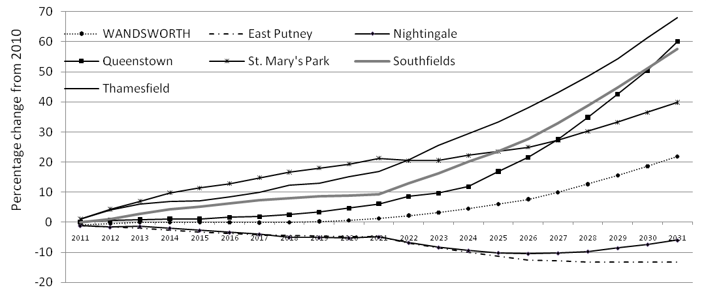
Source: Ward Population Projections - GLA 2008 Round Low, London Health Observatory.
4.3.2. The distribution of the 65+ years old projected population
As can be seen (Map 1) the highest proportions of people (projected population) aged 65 years and older reside in the West of the borough, specifically in the wards of Roehampton and, East and West Putney. Tooting is the other ward in the highest quintile (groups of 4 wards) of older population. Roehampton and Tooting are also considered to be in the group of wards which experience the most socio-economic deprivation in Wandsworth. Just over one in eight people in Roehampton are projected to be over the age of 64 years old and nearly one in ten in the ward of Tooting. The two other wards with the highest proportions of those aged 65 and over are not considered to be deprived. East and West Putney are shown to be of middle to low deprivation.
Map 1: The distribution of the 65+ projected population for 2010.
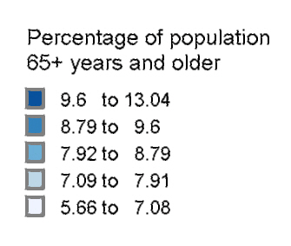
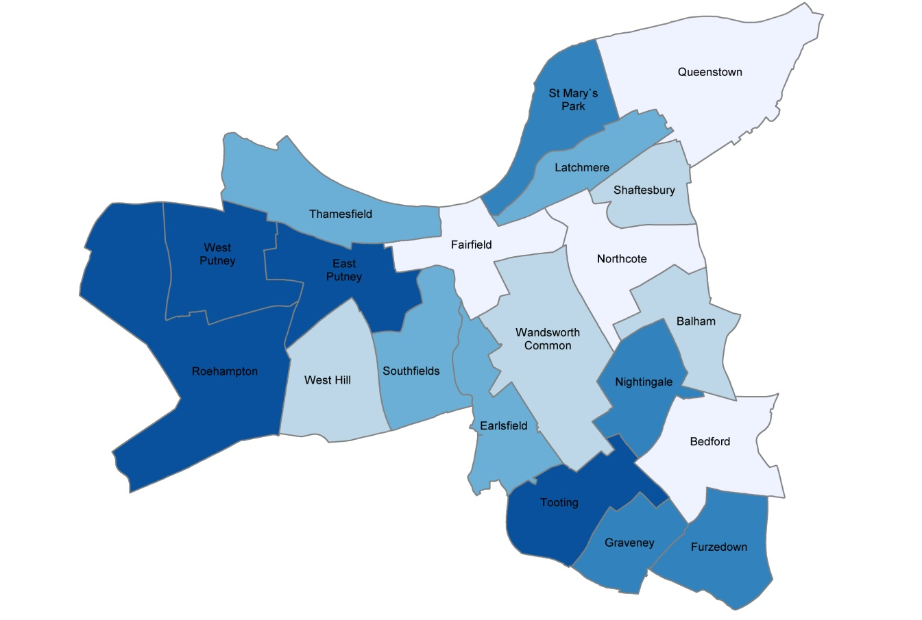
Source: ONS and GLA 2008 Round Projections, Greater London Authority 2008.
4.3.3. The distribution of the 80+ years old projected population
There are a projected 6,773 people (2,442 M, 4,331 F) aged 80 years and over residing in the borough of Wandsworth. West and East Putney, Roehampton and Nightingale have the highest proportions of the 80 years and older population (Map 2), similar to the 65 and over population. However, West Hill does not have a relatively high proportion of 80 plus population, meaning it has a greater proportion in the 65 to 79 age group. It is also worth noting that the high deprivation areas of Furzedown and Latchmere have a relatively high proportion of people aged 80 and over. In summary the population projection figures indicate that a two pronged population based strategy is required; a short term plan that covers the next 5 years and a long term plan that incorporates the significant changes to the older people population in the borough of Wandsworth over the next 20 years.

Map 2: The distribution of the 80+ projected population for 2010.
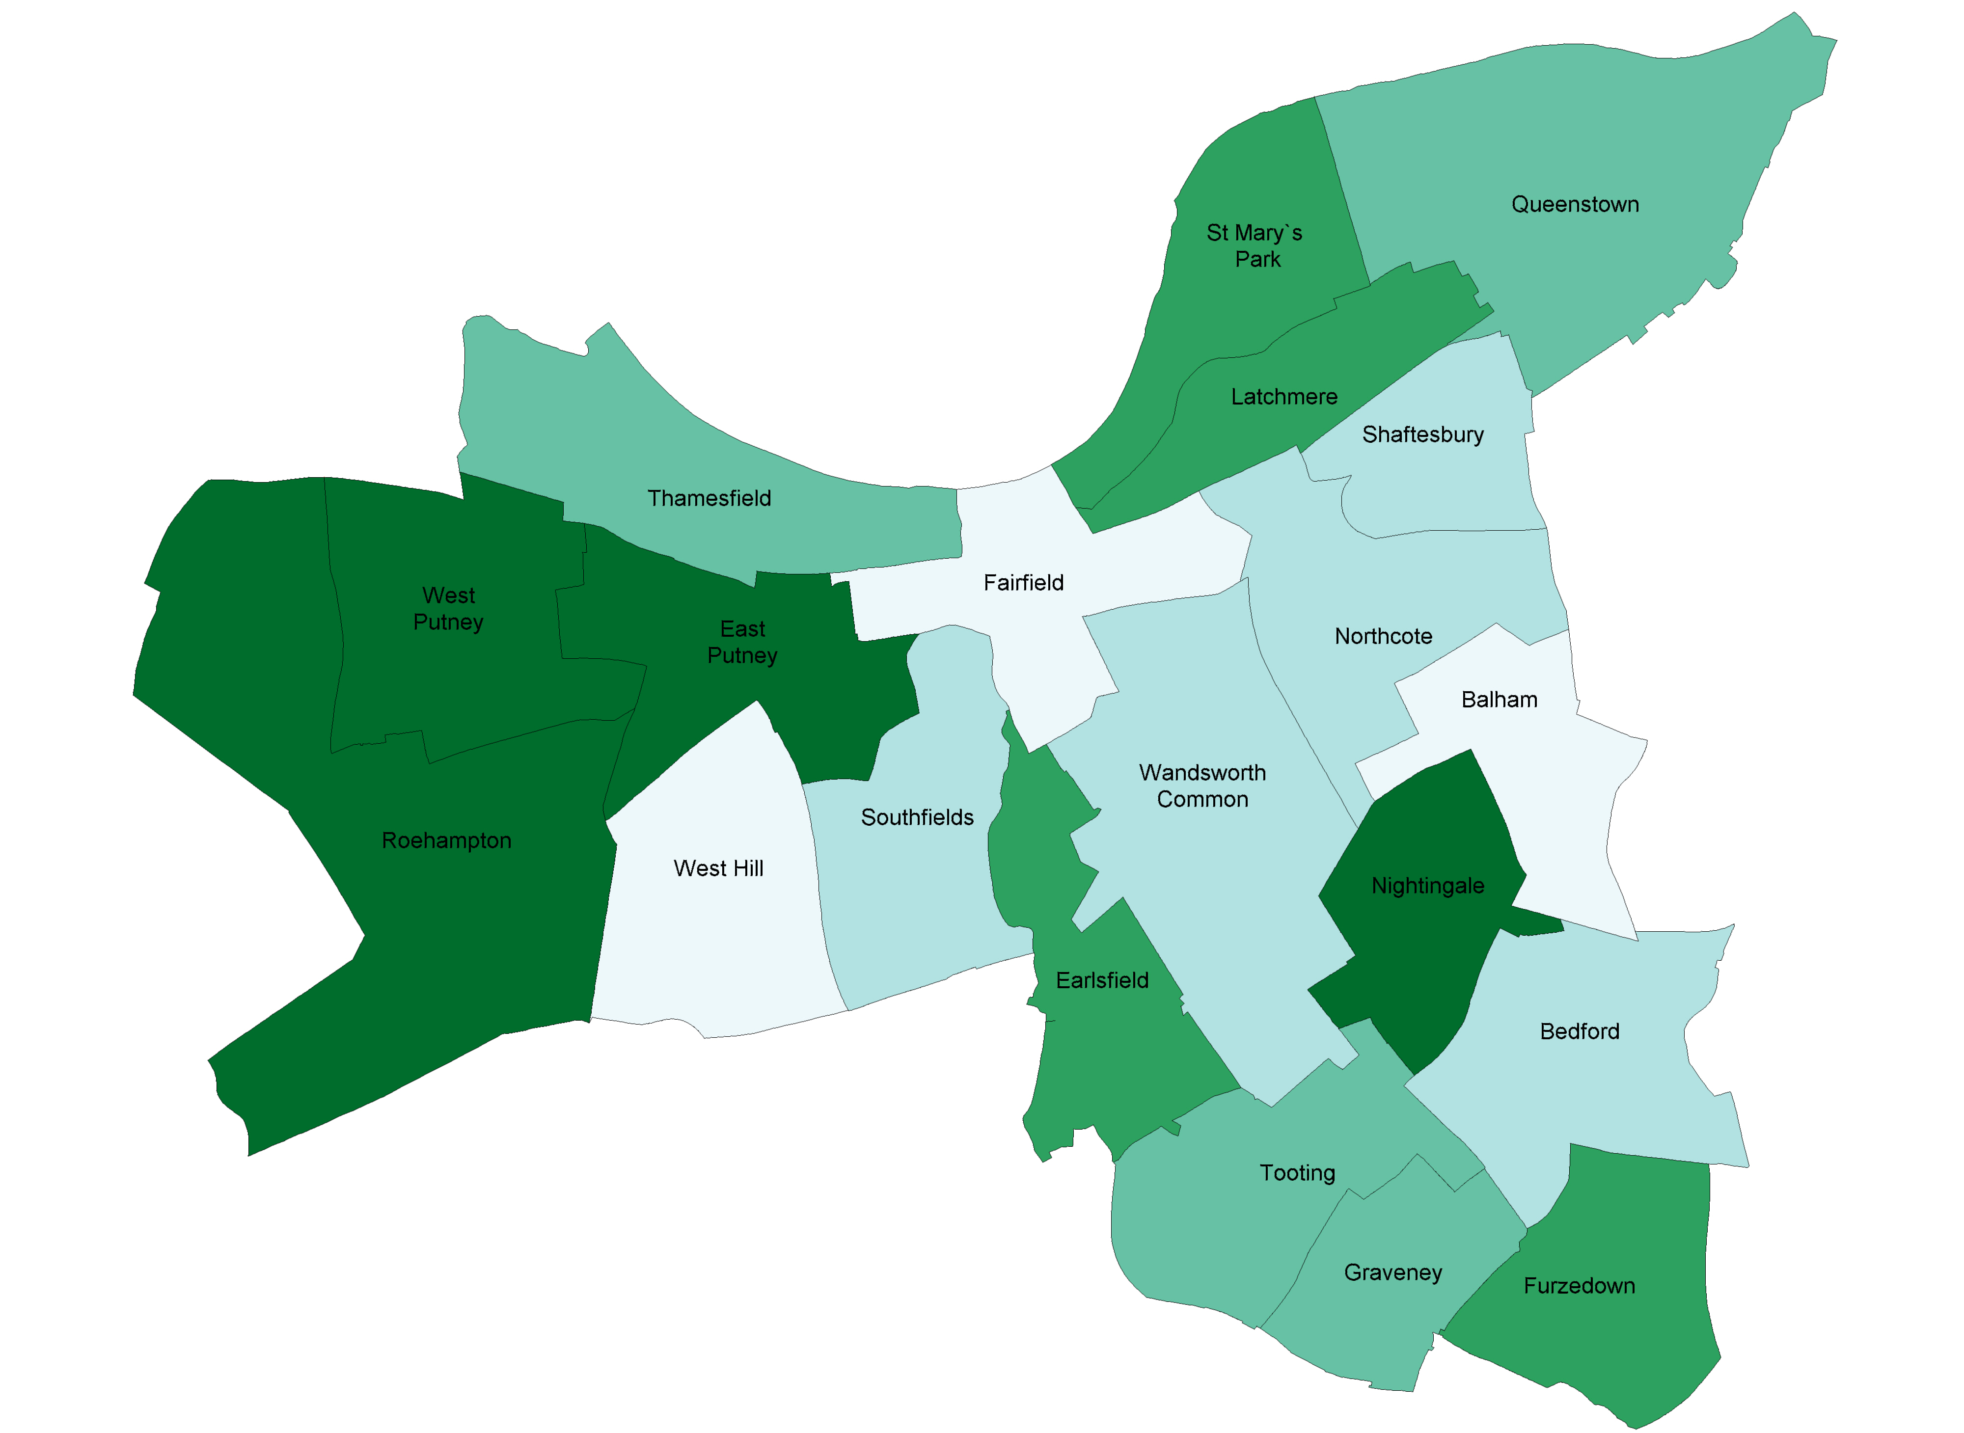
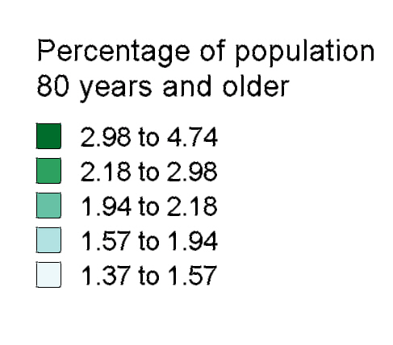
Source: ONS and GLA 2008 Round Projections, Greater London Authority 2008.
4.3.4. Ethnicity and older people
The latest projected population shows that the ethnic (non-white) 65 years and older population in Wandsworth for 2010 accounts for 21.5% of the 65+ population at 5,234 in number. Over the next five years the ethnic population of Wandsworth is not projected to vary much, with an increase in number to 5,556 which translates to an increase of 1.32% in the proportion of the borough population being non-white. The exact breakdown between ethnicities is shown in Table 2.
Table 2: Projected ethnicity population breakdown (65+ years old) in Wandsworth 2010 & 2015.
 | Black Caribbean |  | Black African |  | Black Other |  | Indian |  | Pakistani |  | Bangladeshi |  | Chinese |  | Other Asian |  | Other
 | 2010 | 2015 | 2010 | 2015 | 2010 | 2015 | 2010 | 2015 | 2010 | 2015 | 2010 | 2015 | 2010 | 2015 | 2010 | 2015 | 2010 | 2015
Persons | 1,940 | 1,794 | 595 | 680 | 230 | 230 | 999 | 1,084 | 437 | 479 | 82 | 84 | 184 | 251 | 490 | 536 | 278 | 417
Male | 841 | 711 | 260 | 257 | 112 | 102 | 439 | 460 | 258 | 248 | 46 | 40 | 83 | 103 | 238 | 242 | 129 | 182
Female | 1,099 | 1,083 | 334 | 423 | 117 | 128 | 560 | 624 | 179 | 231 | 35 | 44 | 101 | 149 | 252 | 294 | 150 | 235
Source: 4. Ethnicity Projections GLA 2007 PLP Low, London Health Observatory.
Besides “Other” the largest increase in number between 2010 and 2015 will be among the Chinese 65+ years old population with an increase of 36% in number over 5 years. The largest ethnic group, “Black Caribbean”, sees a drop of 7.5% in number while Indian, Pakistani and Bangladeshi experience an increase ranging from 2.4% to 9.6%.
However there are inherent difficulties around predicting migration rates of older relatives and ethnicity rates should be reviewed regularly.
4.3.5. Registered versus resident population
There is a differentiation between registered and resident population. The registered population refers to the population that are registered with a GP practice that is located in the Wandsworth borough. It can include people who do not live in Wandsworth but are registered with a GP in the borough as well as people who live and are registered in the borough. The resident population refers to the population that live in the borough only. The projected figures in the previous section relate to resident population. The GP registered population total is higher than the resident population.
4.4. Falls
Falls account for the largest proportion of accidents in the UK and approximately 30% of people aged 65 and over fall each year, and for those over 75 the rates are higher (World Health Organisation 2004). A fall may be the first indication of an undetected illness. The prevention of falls is of major importance because they engender considerable mortality, morbidity and suffering for older people and their families, and incurs social costs due to hospital and nursing home admissions.
4.4.1. Risk factors for falls
It is important to identify those people most at risk of falling in order to maximize the effectiveness of any proposed intervention. Published studies have identified specific risk factors for falls and related injuries. However, direct comparison of studies is hampered by a number of methodological issues, including the use of different study populations, lack of clarity and consistency in definitions, variability in periods of follow up, and the inevitable difficulties of retrospective recall of events (Todd, Skelton 2004). However, most falls are associated with one or more identifiable risk factors (e.g. weakness, unsteady gait, confusion and certain medications), and research has shown that attention to these risk factors can significantly reduce rates of falling (Rubenstein 2006)
Risk factors for falls can be classed into three groups:

- intrinsic factors (non-modifiable)
- intrinsic factors (modifiable)
- extrinsic (exposure to risk).

Intrinsic (Non-modifiable);

- Age – the incidence of falls increases with age

- History of falls – associated with increased risk of falls.

- Gender – among the younger old, fall rates are similar between men and women but older old women fall more often than men

- Ethnicity – caucasian ethnic groups fall more frequently than African-Caribbeans, Hispanics or South Asians.

- Burden of chronic disease – conditions such as circulatory, COPD, depression, arthritis, diabetes (peripheral neuropathy) and impaired cognition are all associated with an increase risk of falling as is the general burden of long term conditions. The modifiable component of these conditions is the optimisation of the management.

Intrinsic (Modifiable);

- Loss of muscular strength and power, deficiencies of balance and gait – probably the most significant of modifiable risk factors

- Sedentary behaviour – those who are inactive fall more frequently
- Medicines – the risk of falling increases significantly in patients on four or more medications, regardless of the type of medication; Drugs such as psychotropics, class 1a anti-arrhythmics, digoxin, diuretics, and sedatives are all associated with increased falls risk.

- Impaired cognition can result in a lack of recognition of risk behaviour and inability to follow instructions (Tinetti et al. 1988).

- Psychological status – depression and fear of falling are associated with increased risk of falling; a decrease in physical activity which in turn increases muscle weakness.

- Nutritional deficiencies – a low BMI (suggesting malnutrition) and vitamin D deficiency are associated with muscle weakness, abnormal gait, osteomalacia and osteoporosis.

- Visual impairments – many forms of visual impairment lead to an increased risk of falls, as does the wearing of multifocal glasses.

- Lone living has been found to be an important predictor for falls (Kharicha et al 2007).

- Foot problems – many treatable foot problems and general pain on walking increase balance difficulties and risk of falls; worn or poorly fitting footwear may also increase risk.

Extrinsic.

The precise contribution of extrinsic factors such as poor lighting slippery floors, uneven surfaces to falls risk among community dwelling older people is uncertain (Todd, Skelton 2004). In addition considering only one risk factor ignores the role of confounding whereby one risk factor may explain another if evaluated through a multivariate approach.
4.4.2. Prevalence of falls
Falling is a serious and frequent occurrence in people aged 65 and over, however not all falls are recorded. The Department of Health (2009) estimates that each year, 35% of over-65s experience one or more falls and about 45% of people aged over 80 who live in the community fall each year. Between 10 and 25% of such fallers will sustain a serious injury.
Among older people, incidence rates of hip, proximal humerus, and vertebral fractures increase with age and most fractures of the hip, distal forearm, and proximal humerus in older people result from a fall (Kelsey and Samelson 2009). Frail people are likely to fracture their hip or proximal humerus whilst those who maintain a saving reaction with the upper limbs will be more likely to sustain a wrist fracture.
4.5. Osteoporosis
Underlying the risk factors for fracture following a fall is a common condition known as osteoporosis, which weakens bone strength. It is the most common bone disorder and is a skeletal disorder characterized by compromised bone strength, predisposing a person to an increased risk of fracture (North American Menopause Society 2010). It affects one in three women and one in 12 men aged over 50 (Department of Health 2009a). Osteoporosis particularly affects postmenopausal women. The incidence in both sexes rises rapidly as the population ages. Its onset is asymptomatic and it is often only recognised after a person falls and sustains a fragility fracture. Currently, almost half of all women and one in six men experience a painful and disabling fragility fracture in later life (Department of Health 2009a).
Some of the main areas where fractures occur are in the hips and spine; additionally many wrist fractures occur. Although these are the three main areas of osteoporotic related fractures, it is possible for osteoporotic fractures to occur in any part of the skeleton. Incidence of osteoporosis is rising rapidly as the population ages but there is little recognition of the nature of osteoporosis as a long-term condition (British Orthopaedic Association 2007). Osteoporosis can be diagnosed using specialist bone density or DXA scans and treated with drugs, although many fragility fractures occur in people with a milder form of the disease, known as osteopenia.
4.5.1. Risk factors for osteoporosis
People who have experienced a fracture previously are at increased risk of a further fracture. Bone mass density decreases, and consequently the risk of osteoporosis increases with age. Women are at greater risk of osteoporosis as they have smaller bones and hence lower total bone mass. Additionally, women lose bone mass more quickly following the menopause, and typically live longer. Osteoporosis is less common in men but is still a substantial problem. There does appear to be a strong genetic component as parental hip fracture is a risk factor. Other significant risk factors are: Caucasian origin, early menopause, low BMI, smoking, sedentary lifestyle and long term steroid use.
Evidence shows that individuals can take steps throughout their lives to build and maintain healthy bones and reduce the risk of osteoporosis and fragility fractures (National Osteoporosis Society 2009). These include; taking weight bearing exercise, eating a healthy balanced calcium – rich diet and/or vitamin D supplement, avoiding smoking and drinking only a moderate amount of alcohol.
4.5.2 Osteoporotic drug use in Wandsworth
The gold standard for diagnosis of osteoporosis is bone density measurement by dual energy X-ray absorptiometry (DXA) scanning, although the availability of DXA facilities is variable across the UK (SIGN, 2003). For first-line pharmacological management of osteoporosis, current guidelines recommend a bisphosphonate in combination with calcium and vitamin D supplements (NICE 2008a, NICE 2008b, amended 2010). SIGN guidance and clinical evidence suggest that calcium/vitamin D supplementation is also beneficial if given on its own, in the absence of other osteoporosis treatments (Chapuy et al, 1992; Chapuy et al, 1994; SIGN, 2003). However the study populations were specific (eg:care homes) and this may not apply to the general population.
There are two main groups of drugs that are important. The first is the bisphosphonates and the second, is combined Calcium and Vitamin D preparations. NICE guidance has recommended that alendronate is the drug of choice in the bisphosphonates group (NICE 2010a, NICE 2010b). This advice is based both on cost and effectiveness grounds with a yearly cost for a non-proprietary version costing £1.28 per month (Department of Health 2010) and Vitamin D preparations costing between £2 and £8 per month (Department of Health 2010). Compliance is poor in relation to both bisphosphonates and the Calcium and Vitamin D preparations.
In 2008-09 there were 28,637 bisphosphonate and 48,683 calcium and vitamin D prescriptions issued by Wandsworth PCT practices (ePACT 2010). Figure 2 shows the cost per 1,000 patients for bisphosphonate drug prescription for each practice in Wandsworth. The cost of bisphosphonates drug prescription varies across all GP practices in Wandsworth. The highest cost is attributed to Inner Park Road Health Centre at £3,912.09 which is nearly four times as high as the London average. The lowest cost is found at Sai Medical Centre at £21.58.
Figure 2: Bisphosphonate cost per 1,000 patients at Wandsworth GP practices 2008-09.
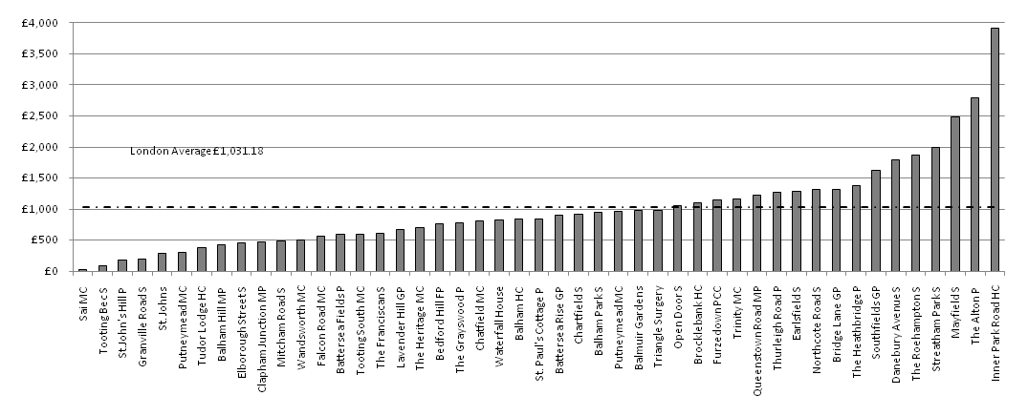
Source: Electronic Prescribing Analysis and CosT (ePACT) 2010.
Seventeen practices reveal costs which are higher than the London average.
This data is not standardised to account for the variation in the number of older people across practices. Inner Park Road Health Centre shows a cost (£3,912.09) which is much higher than all other practices in the borough. This could be due to prescribing high cost bisphosphonate drugs or could be due to a higher number of cases of osteoporosis registered at the practice. The next highest cost is much lower at £2,795.49 (Alton Practice). The location of the 17 practices which have costs higher than the London average are distributed across Wandsworth, with a third of practices (6 of 18) located in relatively high deprivation areas of Furzedown and Roehampton. Four of the practices are located in Roehampton. details the ranking of practices in accordance to the cost per 1,000 patients for Calcium and Vitamin D preparations. It must be noted that not all of these prescriptions will be in relation to osteoporosis or osteopenia treatment. However it is worth noting that this drug combination is used to address Vitamin D deficiency which has been identified as a risk for falling due to proximal muscle weakness and effect on bone. At this point it is appropriate to raise the issue of Vitamin D deficiency in the older population. The standard dose of 800 units (2x400 units daily) per day is adequate for maintenance of vitamin D levels however it may be insufficient for deficiency (Pearce and Cheetham 2010, Holick 2007). Once Vitamin D deficiency is identified from blood tests it needs to be addressed with the relevant dose of treatment – a minor deficiency requires at least 1000 units and Adcal D3 dose is 400 units (normally recommended to take 2 doses daily). A major deficiency requires 300,000 units in the format of intramuscular injection (or 10 000 IU calciferol daily or 60,000 IU calciferol weekly for 8-12 weeks). This is a national issue and work is continuing on this subject through the PCT’s Clinical Effectiveness Group.

The highest cost per 1,000 patients is seen at Streatham Park Surgery at £1,348.22 which is double the London average at £704.52. Inner Park Road Health Centre which has the highest bisphosphonates cost has the third highest calcium and vitamin D cost. Putneymead branch practice in Disraeli Road has the lowest cost per 1,000 patients at £173.48.
Seventeen practices have costs which are above the London average. Twelve practices feature with above average (London) costs for both bisphosphonates and calcium and vitamin D preparations. They are:
Streatham Park Surgery Inner Park Road Health Centre
Northcote Road Surgery Southfields Group Practice
The Roehampton Surgery Furzedown Primary Care Centre
Mayfield Surgery Queenstown Road Medical Practice
Open Door Surgery Danebury Avenue Surgery
Bridge Lane Group Practice The Alton Practice

Figure 3: Calcium and Vitamin D cost per Wandsworth GP practice 2008-09.
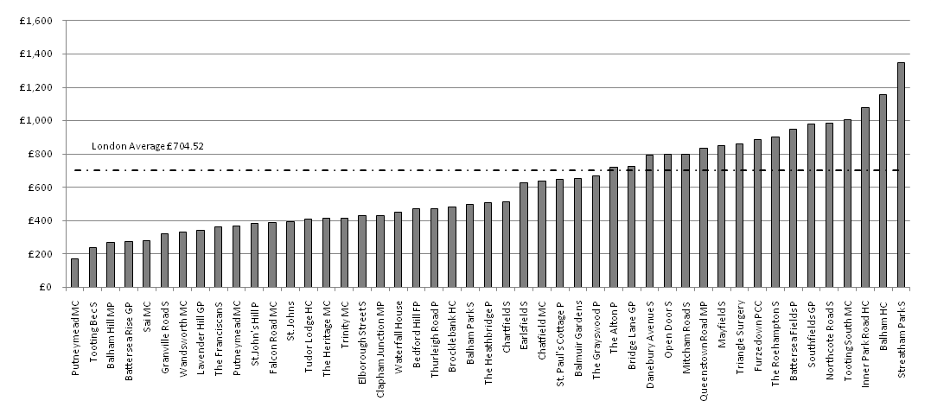
Source: Electronic Prescribing Analysis and CosT (ePACT) 2010.
The Pharmacy department at NHS Wandsworth has an agreement with pharmaceutical company, ProStrakan Group PLC to fund resources independent of the drug company to assist practices in an audit of patients who require calcium and vitamin D3. This work was agreed at no additional cost to the PCT and quarterly data reports were part of the original contract along with detailed practice data which was to be given to individual practices to link with the osteoporosis Directed Enhanced Services (DES). The audit has been ongoing since 2007, with an annual review. The audit aims to identify those patients who have experienced falls and who are most at risk of fracture to ensure they receive calcium and vitamin D3 supplements, when appropriate, as detailed in the agreed protocols. The criteria for example include patients with a diagnosis of osteoporosis currently untreated, patients currently treated with a bisphosphonate or strontium and not receiving calcium & vitamin D3. The protocol has been tailored to meet requirements of Std 6 of the NSF for older people, NICE TA 160, 161 and DES for Osteoporosis. Any possible assessment at practice level around prescribing should consult with this audit and the information collected should be made available to guide the best course of action. Currently only a sample of the data from ProStrakan has been provided to the Public Health Department, despite repeated efforts to obtain data from the previous 2 year’s worth of audit. This needs to be pursued as the sample provided shows that this is a potential rich source of information.

4.5.3 Number of people with osteoporosis
Currently it is not possible to determine the number of people with osteoporosis. Using the Department of Health’s figures (2009) of 1:3 women and 1:12 men (over 50) suffer from osteoporosis, there are an estimated 12,276 (2,141 male and 10,135 women) over 50s with osteoporosis in Wandsworth. There is a Directed Enhanced Services (DES) for osteoporosis, which aims to encourage practices to confirm the diagnosis and prescribe appropriate pharmacological secondary prevention in female patients over 65 with osteoporosis (NHS Employers 2008). Initially this was funded for two years, 2008/09 to 2009/10 and now it has been extended for a further year, 2010/11. The data for this register is not held centrally but is collected and stored at each participating GP practice, making access difficult. It is recommended in future this data should be held centrally by the Primary Care Directorate.

It is possible to estimate the minimum number of people receiving the most popular bisphosphonates prescriptions (specifically related to osteoporosis or osteopenia). These prescriptions include:

Alendronic Acid Tab 70mg (first line recommendation)
Fosamax Once Weekly Tab 70mg
Alendronic Acid 10mg (male population)
Risedronate Sod Tab 35mg (second line recommendation)

Strontium which is a third line recommendation has not been included as it is rarely used and would create a large error in the costings due to its significantly higher cost.
For the third quarter of 2009-10 (October – December 2009) it is estimated that 3,239 people were prescribed the above prescriptions. To arrive at this figure we have assumed that over a period of 12 weeks (October – December 2009) each prescription for a week’s supply equated to one patient. Furthermore if we assume that all of these prescriptions were for people aged 50 years and above, then this figure accounts for around 5-6% of the 50 and over registered population of Wandsworth. It is believed that in any one quarter (e.g. Oct – Dec 2009) a person will be issued with their prescription only once, therefore choosing only a one year quarter for this analysis will minimise double counting. However, this figure (3,239) is well below the figures calculated in relation to the proportional estimates (12,276) stated by the Department of Health (2009). This suggests that a large number of people with osteoporosis are not receiving appropriate drug treatment. Estimating across all prescriptions related to osteoporosis is not possible as the distinction in regard of purpose is not made. For example, Calcium and Vitamin D prescriptions are not only given to people with osteoporosis or osteopenia.
The question that this data raises is whether the prescription of calcium and vitamin D for osteopenia and the combination of calcium and vitamin D with Bisphosponate for the management of osteoporosis is appropriately prescribed. It is very difficult to address the prevention treatment with the limited data; however the management of osteoporosis following fracture presentation can be partially addressed by comparing Figure 2 with data around hip fracture and non-hip fragility fracture in the subsequent sections of this document.

The structure of the document will follow a progressive journey from the postmenopausal female younger age group to the lesser fragility fracture, hip fracture and then mortality rates associated with falls and fractures.

4.6. Post menopausal women prior to entering old age – 55 – 64 years old
This section looks at fractures to women in the 55 to 64 years old age group. The data available is only for fracture patients who were admitted to hospital and due to a small number of fractures overall, hip fractures and non-hip fragility fractures have been grouped. It is also not possible to provide analysis at GP or ward level due to the small number of fractures involved. In total there were 104 fragility fracture patients who required hospital admission over the five year period of 2005-10.The very low number perhaps reflects the high level of function of this group and therefore to a large extent non-hip fractures in this population will largely be the “walking wounded” who do not require admission and as such are lost to the current data collection.
Figure 4 shows that the trend of fragility fractures in women aged 55 to 64 years follows the same pattern as the hip fractures and non-hip fractures for the 65+ age group across the PCT (see sections 4.7 and 4.8). The age specific rate has increased year on year with a slight decrease for 2009-10. The 95% confidence intervals provide an indication of the possible variation from year to year.
Figure 4 shows an increase for 2008-09 in fractures for the female 55-64 age group, while for the 65 and over age group there was a decrease in both non-hip fragility fractures (Figure 5) and hip fractures (Figure 8). It is possible that due to the high functional activity levels of this client group, that environmental factors such as weather may play a more significant role in the yearly incidence figures.
Figure 4: Fragility fractures 55-64 years old women (Age specific (55-64 years) rate per 100,000 population 2005-2010).
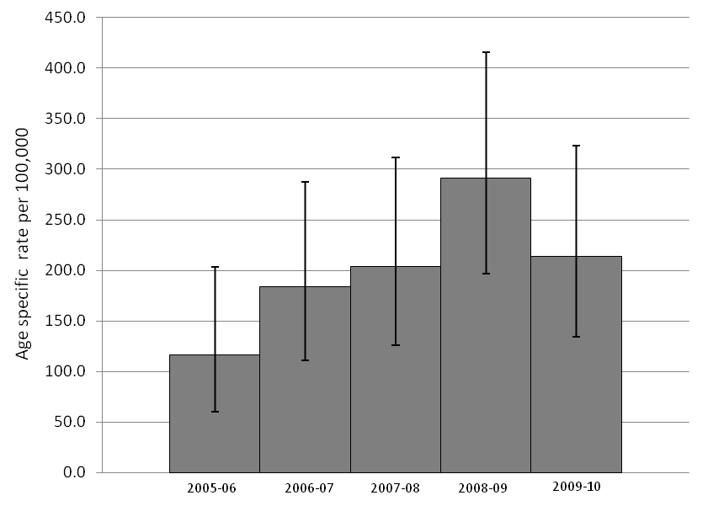
Source: Secondary User Service Data, Vital Signs, Wandsworth PCT (2010).
With regard to the link with osteoporosis medication, all of this client group should have been referred as per NICE guidelines for a DEXA scan and then started on medication following the results. However the current systems in place do not enable tracking of this process. In addition this client group would not be identified from the DES (over 65).

In summary the information about this client group remains largely hidden in the current systems. Consideration needs to be given to ways of collecting data to enable analysis of fragility fractures for all patients who attend A&E – this data is not currently available.
4.7 Non-hip fragility fractures
On average 50% of people experiencing a non-hip fragility fracture will go on to sustain a hip fracture, this population group are a prime target for early intervention (Healthcare Quality Improvement Partnership 2009c). Non-hip fragility fractures considered are:

- Proximal humerus
- Wrist fracture (commonly ref to as smiths and colles fractures)
- Fractured pelvis
- Vertebral fracture (thoracic and lumbar only).
(Department of Health 2009a)
Non-hip fragility fracture admission data extracted are non-elective. The fracture data captured are purely admissions to hospital. Instances where patients attend hospital for treatment and are discharged on the same day are not available in an extractable format. As a result there are many fractures not included in this analysis, as evidenced by the number of fractures recorded for each year, e.g. 101 non-hip fragility fractures for 2009-10. For further details on this see Appendix A. It is recommended that this issue be resolved by addressing systems for data collection for non-admissions (i.e. all attendances).
Risk factors associated with fragility factors include diabetes, and for men, hospitalization for mental health issues and for women previous fractures (Naves et al. 2005, Holmberg et al. 2006). Figure 5 shows data on the incidence of low trauma fractures. The coding system does not reveal the causes of these trauma events i.e. whether they are falls from a standing height. Therefore the assumption is made that all fractures for the above diagnosis in the over 65 are due to falls from a standing height. Falls from a standing height are termed fragility fractures and include the above diagnosis as well as hip fractures (hip fractures are not included here). The crude rates generated in Figure 5 are for those registered with a GP in Wandsworth. Figure 5 shows that the crude rate of female non-hip fracture admissions are consistently higher than that for males. Since 2005-06 the overall trend has been an increase in fractures for both genders, except for 2008-09 for women and 2009-10 for men where slight decreases are seen. For the latest period, 2009-10, the crude rate was 618.95 per 100,000 for women accounting for 85 fractures, while the rate for men was 152.8 per 100,000 accounting for 16 fractures. While latest admissions data for hip fractures may be showing signs of levelling off (Figure 7 and Figure 8) this trend of increasing non-hip fractures in combination with the expected population increase in 20 years time are predictive of a substantial increase in the hip fracture rate as 50% of non-hip fractures in the over 65s result in hip fractures at a later date (Healthcare Quality Improvement Partnership 2009a).

Examining non-hip fractures admissions by ward shows that the wards of Bedford, West Hill, Wandsworth Common and Graveney experience higher than expected admissions that are significantly higher than the PCT average (Figure 6). West Hill also experiences significantly higher admissions for hip fractures compared to the PCT average. Queenstown and West Putney show non-hip fracture admission ratios that are significantly lower than the PCT average. They also have significantly lower admission ratios for hip fractures.

Figure 5: Crude rate per 100,000 population of non-hip fracture admissions (non-elective) for those aged 65+ years and resident in Wandsworth.
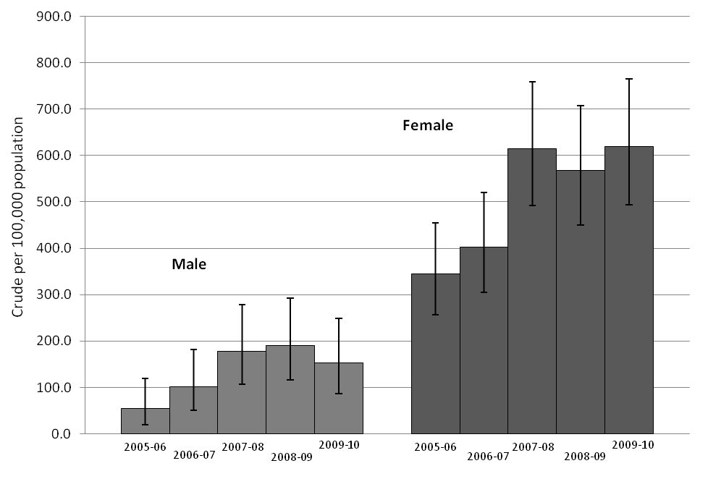
Source: Secondary User Service Data, Vital Signs, Wandsworth PCT (2010).
However, again it is worth reflecting on the client group – in order to require admission following a non-hip fragility fracture it is likely that the injury is a complex fracture or that there are underlying health problems/difficulties with activities of daily living. As such these people are likely to be at the frailer end of the spectrum. With this in mind the geography would indicate that the 3 Wards with the highest incidence may require more focused work to address prevention of admission post lesser fragility fracture. In fact a review of the care homes and residential accommodation in the Wandsworth wards (Appendix B) shows the highest availability of nursing home beds are in Nightingale and West Putney. These wards do not have high admission rates. Wards with a low number of nursing homes do. This could possibly mean that admissions from these wards are more likely to be for lone household pensioners.
Figure 6: Standardised admission ratios for non-hip fractures, 2006-10. (Horizontal line equals NHS Wandsworth average)
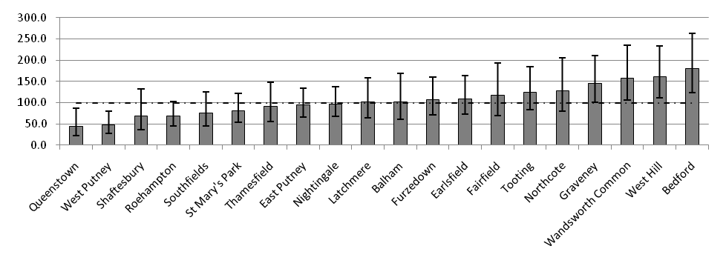
Source: Secondary User Service Data, Vital Signs, Wandsworth PCT (2010).
From the National Audit 2009 the average number of non-hip fragility fractures presenting in A&E in the study period across England was 63% radius/ulna fractures. Locally 70% of patients at St Georges and 75% at Kingston hospital were radius/ulna fractures (Healthcare Quality Improvement Partnership 2009a). This type of fragility fracture is more suggestive of a less frail (more active) population group in comparison to humerus and hip fracture populations. This in itself would suggest that the data in Figure 5 and Figure 6 which only captures admissions are only portraying a very small part of the fragility fractures. Effective analysis and formation of strategies are needed to address low trauma fracture.
4.8. Neck of femur fractures (Hip fractures)
“Hip fracture is all too often the final destination of a 30 year journey fuelled by decreasing bone strength and increasing falls risk” (Department of Health 2009b).
Hip fractures account for 50% of injury related hospital admissions and 66% of bed days for people aged over 75 years (Department of Health 2007). Suffering a hip fracture can result in the loss of mobility, the permanent loss of the ability to live at home as well as bring pain, confusion and disruption. Due to the change in demographics generally the national picture shows that the number of hip fractures is increasing (Ahloborg et al. 2010), however in Wandsworth the 65+ population figures are projected to remain constant over the next five years but show an increase in 20 years.
Approximately half of those who were previously independent become partly dependent following a hip fracture, while one-third become totally dependent (Department of Health 2009a). The Falls and Bone Health Organisational Audit Report 2009 recommended that the PCT should report on the number and rate per 100,000 of both hip fractures and other fragility fractures (Healthcare Quality Improvement Partnership 2009a).
4.8.1. Risk factors for hip fracture
There are a number of risk factors associated with hip fracture, the obvious one being osteoporosis (Kanis et al. 2000, Benson et al. 2005, Stolee et al. 2009). Previous low trauma fractures after the age of 50 years is also a factor (Cummings 1993, Klotzbuecher et al. 2000), for example a study in the US found that white women suffering a proximal humeral fracture independently increased their risk of a subsequent hip fracture more than five times in the first year after the humeral fracture (Clinton et al. 2009). Another study states that an inability to rise from a chair was the most readily identifiable risk factor for a hip fracture (Bensen et al. 2005), an aspect that can be identified through risk assessments. Chronic inflammatory diseases such as rheumatoid arthritis and inflammatory bowel disease are considered to be risk factors (World Health Organization 2010). In addition immobility due to a stroke or multiple sclerosis is also a risk factor.

An important risk factor is low bone mineral density, particularly in the femoral neck of postmenopausal women aged 65 years or more (Cummings et al. 1995). Other factors include disorders with increased bone loss, untreated premature menopause and corticosteroid users (Peng et al 2006). Furthermore a variety of studies have identified smoking as a risk factor (Law & Hackshaw 1997, Law et al. 1997, Honkanen R et al. 1998).

4.8.2. Admissions rates for fractured neck of femur (hip fracture) 65+ Years and older
For the year 2006-07 (latest data available) Wandsworth (581.5 per 100,000 population) experienced a significantly higher than the national rate (479.8) of admissions for fractured neck of femur in the over 65’s (Figure 7). In relation to Wandsworth’s WCC clusters (PCTs of comparable populations) the admissions rate for both years are not significantly different to other PCTs in the cluster except one. The admission rate for 2006-07 in Wandsworth is significantly higher than Kensington and Chelsea LB. While admissions rates in Wandsworth are comparable to our cluster PCTs, they are higher than many other London PCTs indicating the need for a falls and bone health strategy in Wandsworth. Fractures include the following ICD-10 codes:
- S72.0 Fracture of neck of femur
- S72.1 Pertrochanteric fracture (World Health Organisation 2007)
Figure 7: Directly standardised admission rates for fractured neck of femur for people aged 65 years old and over.
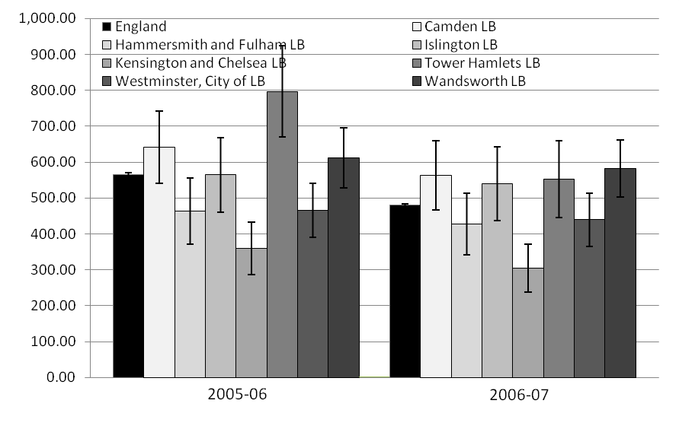
Source: London Health Observatory (2010)
Figure 7 shows data that allows comparisons between WCC cluster PCTs, however the data is not recent. Figure 8 shows more recent data but only for the Wandsworth borough where the rates displayed are crude rates and are not directly age standardised as the previous data are, and therefore not comparable. The figures extracted from the Wandsworth Secondary User Service (SUS) database (Figure 8 and Figure 9) are for non-elective admissions; those admitted for rehabilitation are not included.
The overall trend for both male and females is that the rate of hip fractures in the 65 years and older population is increasing, although the rate of increase is slowing down (Figure 8). Male rates experienced a decrease in 2006-07 but the trend has continued upwards since. Females experienced a decrease in 2008-09 but the latest figures show the rate has returned to an increasing trend. For 2009-10 an increase in the hip fracture rate from 848.3 per 100,000 to 1041.3 was seen for females. This represents a 23% increase in one year and an increase from 118 fractures per year to 143. For males the increase was not as much but still a rise of 18%, from 370.3 per 100,000 to 439.3 and from 39 fractures to 46. This refers to all patients registered with a Wandsworth GP.
The inequality between genders can be seen especially by looking at the latest year of data (2009-10) with the admission rate for females (1041.3 per 100,000) nearly three times that of males (370.3). In total there were 832 fractures of neck of femurs over the five year period for those aged 65 and over and registered with a Wandsworth GP. One hundred and eighty-six of these were male fractures and 646 were female.
Figure 8: Wandsworth admissions (Crude rate per 100,000 population) for fractured neck of femur for people aged 65 years old and over (SLA contracted only).
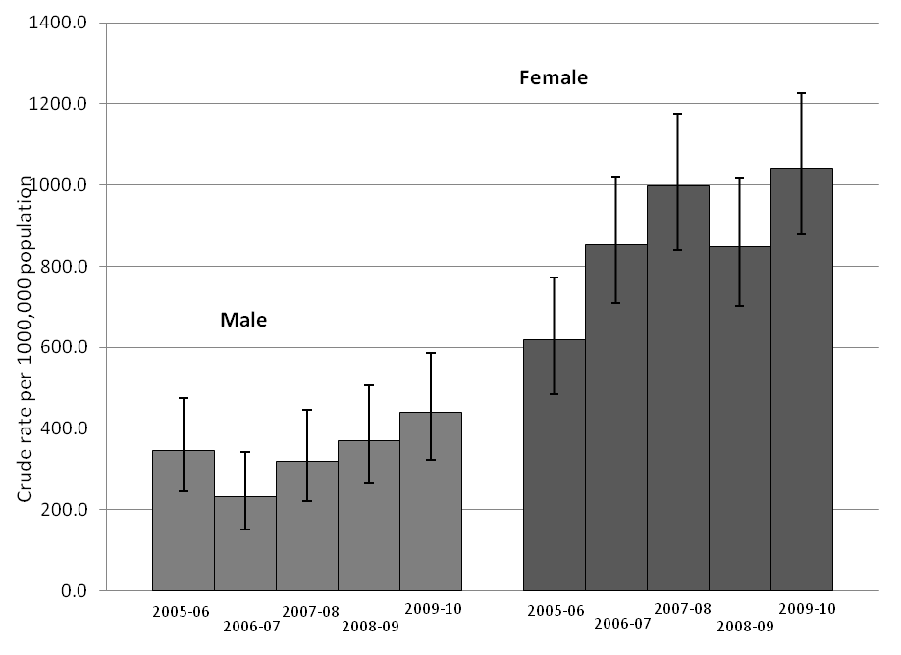
Source: Secondary User Service Data, Vital Signs, Wandsworth PCT (2010).
It was not possible to obtain historical population figures for those registered with a Wandsworth GP practice (denominator population) in order to calculate standardised rates. However by extracting fracture information by ward of residence it is possible to calculate standardised admission ratios and examine within PCT variation. Figure 9 shows standardised admission ratios (SAR) for hip fractures by ward for the period of 2005-10. The SARs are presented in relation to the Wandsworth PCT average, whereby a SAR greater than 100 means that more admissions are seen than is expected. Where the 95% confidence intervals do not range across the Wandsworth average (100) there is a statistically significant difference.
The ward of West Hill is the only ward that experiences admission ratios that are significantly higher than the PCT average. There were 45 admissions for a hip fracture from this ward over the 5-year period. West Hill has a relatively low older population in residence but a higher than expected number of hip fracture admissions. There is only one care home (which would be considered a high risk population group) in West Hill. This is Park Lodge Care Home which has a small number of residents (population of 60).This is in comparison to some wards with a high density of nursing homes such as Nightingale which has a care home total population in excess of 300.This “hotspot” ward of West Hill does warrant further focussed work.
The wards of Graveney and Furzedown, both high deprivation wards, have higher than expected numbers of hip fractures. However the ratio is not significantly higher than the PCT average but very close. The highest numbers of hip fractures were recorded in Nightingale, Roehampton and West Putney at 80, 73 and 65 respectively over the 5-year period. This is to be expected as these wards have the highest proportion of older people residing in them and a high density of care homes. The wards of Queenstown and East Putney have significantly lower incidences of hip fractures compared to the PCT average. East Putney has one of the highest proportions of older people residing there but the number of fractures is lower than expected.
Figure 9: Standardised admission ratios for fracture of neck of femur in the 65+ years old population 2006-10 (Horizontal line equals NHS Wandsworth average)
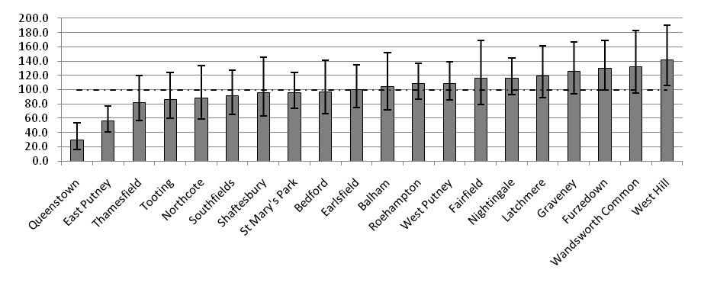
Source: Secondary User Service Data, Vital Signs, Wandsworth PCT (2010).
In total there were 812 hip fractures over the 5-year period. In the analysis a second hip fracture is counted as two separate incidences.
Analysing hip fractures in the frailer population, those aged 80 years and over, reveals similar patterns with a few exceptions (Figure 10). Again West Hill has a higher than expected standardised admission ratio (SAR) in the over 80 population as well as over 65, however Furzedown a high deprivation area has a SAR for hip fractures which is significantly higher than the PCT average. Latchmere also a high deprivation area reveals a higher admission ratio, higher than when looking at the broader 65+ age group. However it is not significantly higher than the PCT average. All other wards show similar figures to the 65 and over age group.
Figure 10: Standardised admission ratios for fracture of neck of femur in the 80+ years old population 2006-10 (Horizontal line equals NHS Wandsworth average)
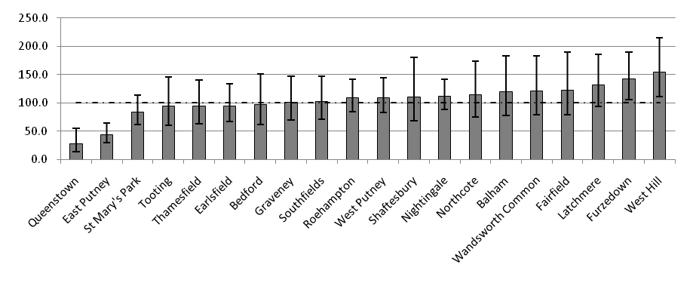
Source: Secondary User Service Data, Vital Signs, Wandsworth PCT (2010).
4.8.3. Hospital location for admissions for fractured neck of femur (hip fracture) 65+ Years and older (Wandsworth GP registered)
Table 3 shows where people aged 65 and over who are registered to a GP in Wandsworth are admitted when they have broken their hip. The majority of hip fractures are admitted to St. George’s hospital; however this has decreased in proportion of all hip fractures since 2006-07. In 2006-07, over 70% of all hip fractures were admitted to St. George’s while this has decreased to half for 2009-10. During the same period admissions to Kingston hospital has increased in proportion by 13%. Admissions to hospitals beyond those noted here (Other) have also increased during this period, from 1.4% to 6.3% of all hip fractures. Chelsea and Westminster admit one in ten hip fractures of those registered in Wandsworth.
Reflecting on the current process in place around conveyance it would seem that LAS crews make the decision around the hospital that is closest to the call-out location. However this process may need to be challenged further as the speed of conveying the patient to the hospital is only one of the many variables involved in the final outcome (and hence mortality rates).The significant changes in conveyance and the optimum location for management will need to be explored further alongside mortality figures and data that will reflect upon the quality of care (shortly to be available from the National Hip Fracture Database http://www.nhfd.co.uk/). In this joint initiative between the British Orthopaedic Society and the British Geriatric Society it is acknowledged that “delivering good care for patients with hip fracture is challenging and involves many health professionals including nurses, surgeons, anaesthetists, geriatricians and rehabilitation staff. The quality of that care varies considerably across the country”. Consideration of this issue on a local level will help to identify the optimum pathway for the patient.
Table 3: Breakdown of neck of femur fracture admissions by hospital admitted to (65+ age group).
NHS Trust | 2005-06 |  | 2006-07 |  | 2007-08 |  | 2008-09 |  | 2009-10
 | N | % | N | % | N | % | N | % | N | %
St. George's Healthcare | 97 | 65.1 | 106 | 71.6 | 96 | 54.9 | 91 | 58.0 | 95 | 50.3
Kingston Hospital | 24 | 16.1 | 16 | 10.8 | 44 | 25.1 | 34 | 21.7 | 45 | 23.8
Guy's and St. Thomas' | 0 | 0.0 | 3 | 2.0 | 4 | 2.3 | 2 | 1.3 | 11 | 5.8
Chelsea and Westminster | 19 | 12.8 | 17 | 11.5 | 17 | 9.7 | 20 | 12.7 | 19 | 10.1
Hammersmith Hospitals | 4 | 2.7 | 4 | 2.7 | 5 | 2.9 | 7 | 4.5 | 7 | 3.7
Other | 5 | 3.4 | 2 | 1.4 | 9 | 5.1 | 3 | 1.9 | 12 | 6.3
Total | 149 | 100.0 | 148 | 100.0 | 175 | 100.0 | 157 | 100.0 | 189 | 100.0
Source: Secondary User Service Data, Vital Signs, Wandsworth PCT (2010).
Hip fractures considered here are those ICD-10 codes; S72.0 Fracture of neck of femur and S72.1 Pertrochanteric fracture (the same codes in section 4.8.2).
4.9 Fracture neck of femur by GP practice and prescriptions
Section 4.5.2 presented data on osteoporotic drug prescription and the cost per 1,000 patients by GP practice, specifically bisphosphonates and calcium and vitamin D supplements. This section looks at this information in relation to the number of fractures of neck of femur for the year 2008-09 at each practice for the 65 years and older registered population. For a complete list of figures against practices see Appendix C. Crude rates have been generated as a basis for assessment against drug prescription. It is not appropriate to us these crude rates to assess change in fracture rates over time due to the small number of hip fractures occurring each year in each GP practice.
Simple correlation shows overall that high bisphosphonates costs do not equate to high incidence of hip fractures or low costs equating to high hip fracture incidence. Also many practices have low costs and no fractures recorded. However there are some practices to note. Five practices (see Group A in Table 4) show a below London average costs for both prescription types but show a relatively high rate of fractures, however two of the practices reveal only 3 fractures over 2008-09. These five practices have high crude rates of hip fracture (7-13 fractures per practice) and the cost per 1,000 patients for bisphosphonates in the highest quartile. Brocklebank Health Centre (Group B) shows above average bisphosphonates costs, however, despite having the highest fracture rate in the borough the bisphosphonates costs are not in the highest quartile. This could be a good example of cost effective prescribing.
The highest cost per 1,000 patients for bisphosphonates was at Inner Park Road Health (Group C) centre at £3,915.09 where no hip fractures were recorded for 2008-09. This could be due to other fractures or extensive primary prevention. This practice also had high calcium and vitamin D costs also, at £1,078.68 per 1,000 patients. Streatham Park surgery also had high bisphosphonates costs with a low fracture rate recorded. Eleven practices showed below average costs for bisphosphonates and calcium and vitamin D while recording zero or one hip fracture. Sai Medical Centre had the lowest bisphosphonates costs per 1,000 patients at £21.58. This low figure may be due to only 90 people 65 years and older being registered at the practice, as it also has low calcium and vitamin D costs (£279.73). There were no fractures recorded for this practice for 2008-09 either.
To recap, given the small number of fractures, from the data available, across Wandsworth practices and that only one year’s worth of data is presented, this section should be utilised as an indication of possible areas for further work. With this in mind the following GP practices are highlighted in Table 4 (For a list of all GP practices, see Appendix C).
It is possible that a low cost (Group A) may be due to a low older population registered or it may be due to under-performance in relation to NICE guidelines for osteoporotic drug prescribing or it may be due to the prescribing of low acquisition cost drugs. The analysis presented here alone cannot determine this and requires further investigation. Obtaining audit data collected by ProStrakan Group PLC (see section 4.5.2) would aid this process (despite not all GP practices being involved in the audit).
Table 4: Selected GP Practices showing hip fracture rates and osteoporotic drug prescribing (2008-09)
GP Practice | No. of fractures | Crude fracture rate per 100,000 | Bisphosphonates cost per 1,000 patients (£) | Calcium & Vit D cost per 1,000 patients (£)
The Falcon Road Medical Centre | 6 | 374.53 | 561.76 | 389.6 | Group A  High fracture rate  Low costs
Bedford Hill Family Practice | 5 | 351.12 | 761.51 | 474.24 | Group A  High fracture rate  Low costs
Waterfall House | 5 | 545.85 | 823.74 | 449.68 | Group A  High fracture rate  Low costs
Elborough Street Surgery | 3 | 397.74 | 461.45 | 431.29 | Group A  High fracture rate  Low costs
Putneymead MC (Disreali Street branch) | 3 | 409.84 | 310.83 | 173.48 | Group A  High fracture rate  Low costs
Brocklebank Health Centre | 12 | 583.66 | 1,098.08 | 484.51 | Group B  High fracture rate High bisphosphonates costs
Mayfield Surgery | 7 | 424.76 | 2,480.18 | 851.08 | Group B  High fracture rate High bisphosphonates costs
Southfields Group Practice | 8 | 286.12 | 1,626.75 | 978.94 | Group B  High fracture rate High bisphosphonates costs
The Roehampton Surgery | 13 | 567.19 | 1,867.32 | 904.56 | Group B  High fracture rate High bisphosphonates costs
Earlsfield Surgery | 8 | 346.62 | 1,292.24 | 629.19 | Group B  High fracture rate High bisphosphonates costs
Bridge Lane Group Practice | 7 | 262.76 | 1,319.58 | 728.65 | Group B  High fracture rate High bisphosphonates costs
Danebury Avenue Surgery | 3 | 370.37 | 1,790.07 | 792.66 | Group B  High fracture rate High bisphosphonates costs | 370.37 | 1,790.07 | 792.66
Inner Park Road Health Centre | 0 | Fracture number too small to generate rate | 3,915.09 | 1,078.68 | Group C  Low fracture rate  High costs
Northcote Surgery Road | 1 | Fracture number too small to generate rate | 1,315.96 | 985.83 | Group C  Low fracture rate  High costs
Thurleigh Road Practice | 2 | Fracture number too small to generate rate | 1,273.56 | 474.53 | Group C  Low fracture rate  High costs
Streatham Park Surgery | 3 | Fracture number too small to generate rate | 1,992.12 | 1,348.22 | Group C  Low fracture rate  High costs
Source: Electronic Prescribing Analysis and CosT (ePACT), provided by NHS Prescription Services (previously known as the Prescription Pricing Division or PPD), part of NHS Business Services Authority

4.10. Fractured neck of femur and London Ambulance Service (LAS) conveyance to hospital
A review of LAS data over a seven year period shows that there is a consistently high conveyance rate for fallers (Figure 11). In comparison data for 2003–4 for the whole of London shows 8% of all 999 calls in London were for older people who had fallen, with 40% not then conveyed to hospital (Snooks et al. 2006). Although the management of this issue will require some input around admission avoidance it must equally address the issues around the high risk of readmission and mortality around non-conveyance (Boyle et al. 2006, and (Snooks et al. 2006). This warrants some close partnership working between CSW, LAS and acute providers.
Figure 11: Number of fall incidences (65+ population) conveyed (to hospital) or not conveyed by the London Ambulance Service (LAS)
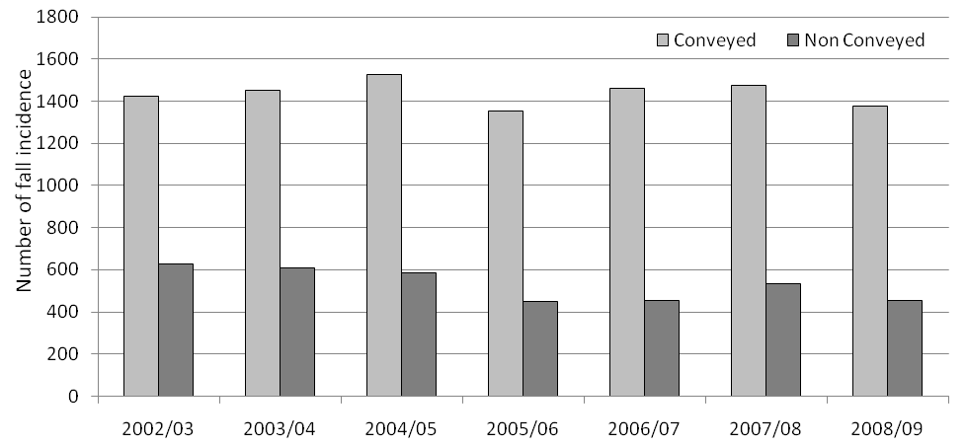
Source: London Ambulance Service (LAS).
A more detailed focus follows on current London Ambulance Service (LAS) conveyance (2009-10) for fall incidents in the 65 years and older population and hip fractures rates by electoral ward also for 2009-10. When comparing the data available around these two variables it is important to be clear about the different data collection sets:
- Fractured neck of femur data is patient identified and as such the address of the patient identifies the electoral ward.
- LAS data is based around the location of the fall – so somebody who lives in one ward may fall in another electoral ward. However older more frail members of the population are more likely to remain within the home and the immediate community, whilst the more mobile older people are likely to travel beyond their resident electoral ward during daily activity.
Two separate issues are considered in this section:
- A high positive correlation (Pearson’s coefficient 0.854 p<0.01) is seen between LAS conveyance by ward and the proportion of the population which is 65 years and older. This shows that where the 65s and over account for a relatively high proportion of the population there is a high proportion of conveyances for falls.
- When looking at the conveyance rate it is expected that a substantial proportion are hip fractures rather than other diagnostic groups, as non-injurious falls where the patient is identified as medically stable and should not require admission but may require immediate therapy intervention by ICT. In addition, falls identified due to treatable acute episodes such as urine infection should be managed by urgent community intervention services such as GP/ Virtual Ward – again these should not require conveyance to hospital.
With this in mind, closer observation of the map (Map 3) shows that some wards produce an expected picture such as Nightingale, West Putney and Roehampton: each experienced a high rate of fractures and conveyance in 2009-10 (Map 3). It is expected as these areas have relatively high proportions of the 65 years and older population residing in them with a particularly high number of care homes.
Queenstown and East Putney experienced low fracture and callout rates. The standardised admission ratios (SAR) for the 5-year period (2005-10) were also significantly lower than the PCT for these two wards. This is appropriate use of LAS conveyance. East Putney has a low number of fractures as well as a low rate of conveyance for falls despite being one of the wards with the highest proportion of older people residing in it. It is possible that this population are less sedentary and in addition have low falls risk factors. Less exposure to environmental risk is a possibility, i.e. high socio-economical groups who may drive their own cars and not use public transport/walk long distance on the streets. Again environmental factors may be important in that the condition of the streets may be better in this ward minimising the incidence of falls.
The wards of Furzedown and West Hill experienced high fracture rates for 2009-10 but only average rates of conveyance in the individual Wards. This may be affected by location of falls not matching up with location of residence of those suffering a hip fracture. The SAR for West Hill over 2005-10 is significantly higher than the PCT average. This would suggest that the populations within these two wards are more mobile and that people are moving beyond the immediate ward. Within some of the recommended workstreams it is suggested that more information around the location of fall is captured to identify environmental issues that may require cross organisational groups i.e. falls on public transport and falls on the street.
Map 3: Neck of femur fracture rates per 1,000 population and London Ambulance Service conveyance for calls by ward (2009-10)
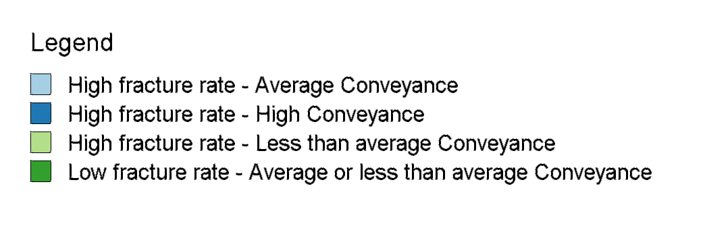
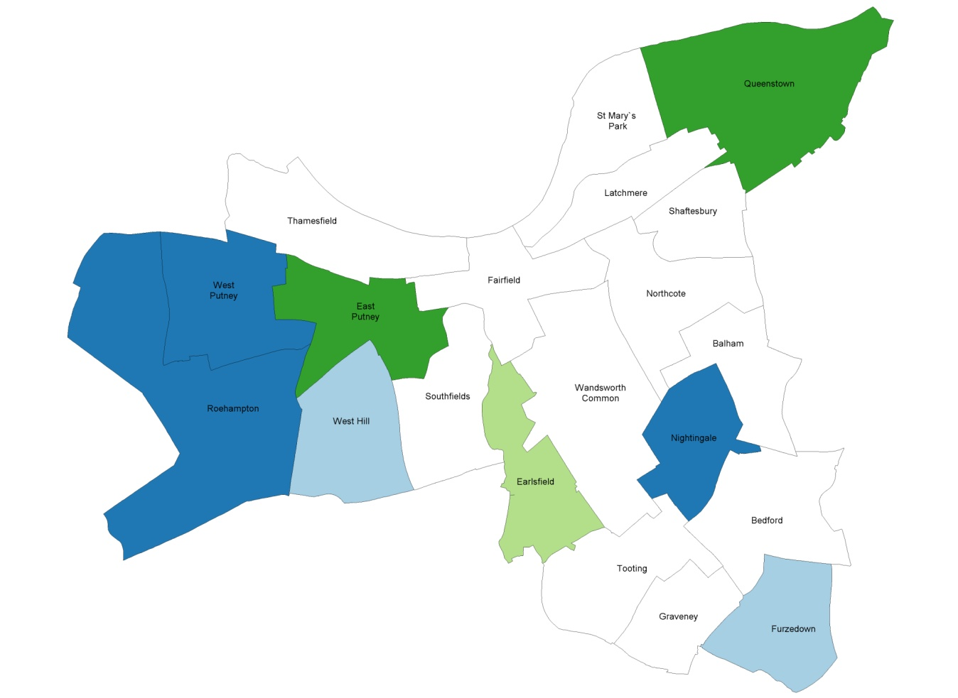
Source: Secondary User Service Data, Vital Signs, Wandsworth PCT (2010) and London Ambulance Service (LAS).
4.11. Length of stay for people with fractured neck of femur.

Figure 12 shows the average length of stay in hospital as a result of a fractured neck of femur for the year 2005-06, the latest available data from the London Health Observatory. Wandsworth ranks in the middle (shaded bar) order of PCTs in London for length of stay as shown to its closeness to the London average. The Wandsworth average length of stay was 25.8 days and the London average was 25.0 days.

Figure 12: Average length of stay in hospital (Fracture neck of femur) 2005-06.
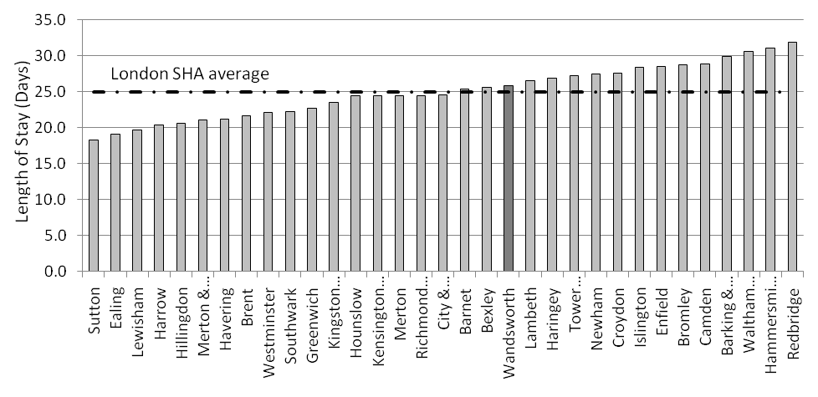
Source: London Health Observatory (2010)
Note that this dataset relates to patients of all ages, however the vast majority of people fracturing their femurs are older and in the 65 years and over age group. Furthermore, this data is 5 years old. Recent findings from the national audit (2009) reveal that St. George’s hospital’s average length of stay for a hip fracture is 36 days. The national average is 16 days. This large difference may be characteristic of a frail population and the delay in operating. However, length of stay figures may be influenced by lack of capacity from other services i.e. social services and community health services leading to a delayed discharge. More information would be required from the acute providers in order for the causes of delay to be analysed.

Sourcing data from the PCT’s Secondary User Service (SUS) dataset shows that the average length of stay for the PCT for 2008-09 was 28.2 days (Figure 13) a substantial difference to that reported in the national audit (36 days). There may be a number of reasons for this large difference, amongst them but not restricted by them are; different case definition, different length of time period i.e. less than a year and different data collection method and processing.
The data (Figure 13) shows that the average length of stay has decreased substantially since a peak of 35.3 days in 2006-07. The latest figure, for 2009-10, reveals the average length of stay to be 26.8 days.

Figure 13: Average length of stay in St. George’s hospital for fracture neck of femur (exact figure by each point).
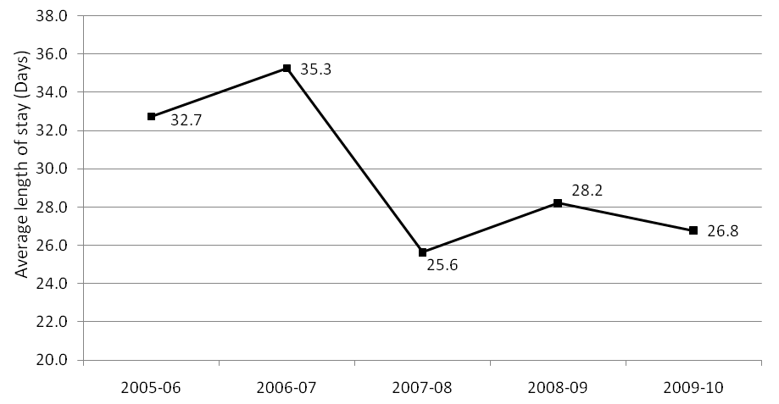
Source: Secondary User Service Data, Vital Signs, Wandsworth PCT (2010).
In addition a snapshot (April 2009 to January 2010) analysis by Dr. Foster Intelligence (NHS Wandsworth 2010) shows an average length of stay of 24.6 days at St. George’s Healthcare NHS Trust. This is more in line with the data extracted from the SUS database which records 26.8 days for the same time period (plus 2 months) as the Dr. Foster Intelligence analysis.
4.12. Mortality from an accidental falls
In the 65 years and older population group of Wandsworth there were 17 deaths during the 2006-08 period due to an accidental fall, with 15 of these deaths in the 75 and over age group. Twelve of these deaths involved women aged 75 years and older. For the period 2006-08, the mortality rate from an accidental fall in the 65-74 years age group in Wandsworth (22.6 per 100,000 population) was substantially higher than national (8.3) and London (5.8) averages as well as being higher than all other PCTs in Wandsworth’s WCC cluster ().
Figure 14: Age specific (65-74years old) mortality rate from an accidental fall (2006-08).
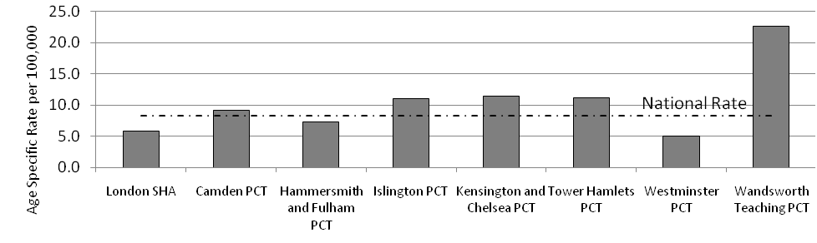
Source: National Centre for Health Outcomes Development, The Information Centre (2010).
The same pattern is seen for the 75 years and older age group (Figure 15) with Wandsworth’s (129.9 per 100,000) mortality much higher than the national (53.2) and London (35.3) averages as well as the other cluster rates (33.7 – 78.2). In fact Wandsworth’s mortality rate from accidental falls (75+ years) is two-thirds higher than that of the next highest cluster PCT, Westminster. The mortality rate for 65-74 year olds is the eighth highest in the country while the rate for those 75 years and older in Wandsworth is the 13th highest PCT in the country. Projected population figures show that Wandsworth PCT has up to one third more females compared to males; this may be a higher proportional difference compared to the other PCTs and may account partly for the higher mortality rate. Additionally mortality has been associated to persons with reduced mental status, reduced somatic health and low physical ability (Fitzpatrick et al. 2001, Meyer et al. 2001, Hasegawa et al. 2007).
Figure 15: Age specific (75+years old) mortality rate from an accidental fall (2006-08).
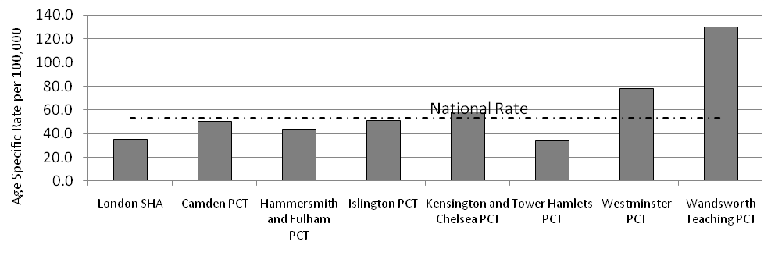
Source: National Centre for Health Outcomes Development, The Information Centre (2010).
Hip fractures remain the most serious consequence of a fall and the commonest cause of accident-related death in older people – 20% die within four months and 30% within a year (NHS Institute for Innovation and Improvement 2006).
4.13. Mortality from a fractured femur
The inequality between PCTs seen in admissions for fractured neck of femur (Figure 7) is also seen in mortality rates (directly standardized rates – DSR) from fractures of femurs, which are amongst the highest in London. Figure 16 shows that in Wandsworth PCT, for the period 2006-08, the mortality from a fractured femur for 65 to 84 year olds, is significantly higher than the London average. The graph also shows that the mortality rate in Wandsworth is significantly higher than in Hammersmith and Fulham PCT and while higher than all other PCTs, the rate is not significantly higher. Wandsworth mortality rate from a fractured femur is the 15th highest in the country.
Figure 16: Directly standardised rates for mortality from a fractured femur, age group 65- 84 years (2006-08).
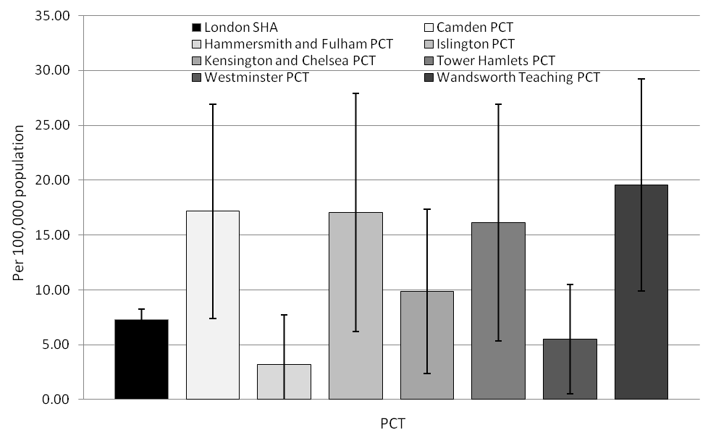
Source: National Centre for Health Outcomes Development, The Information Centre (2010).
A similar pattern is seen in the 85 and older age group also. The directly standardised rate for Wandsworth for the period 2006-08 was 256.34 per 100,000 which is significantly higher than the London average (128.24) but not the national average.

The information from the previous graphs around mortality indicates that some Trusts such as Camden have an average rate of mortality for falls with a large percentage due to hip fracture. However with Wandsworth there is a very high mortality rate for falls and a hip fracture mortality that has a lower proportional value. This may indicate that there is a high rate of mortality due to other conditions and falls is in effect the presenting symptom. This again warrants further data and analysis.

4.14. Related factors that contribute to mortality post hip fracture

Postoperative complications arising which can lead to increased mortality include chest infection and heart failure (Roche et al. 2005). These groups provide clear targets for specialist medical attention.
Environmental aspects also contribute to the risk of mortality as these will influence the pre-morbid status of the patient. Factors such as low social class and low income have been linked to mortality for older people in a number of studies (Banks et al. 2006, Harding 1995, Marang van de Mheen et al. 2000, Marang van de Mheen et al. 2001) while deprivation has also been associated with mortality (Boyle et al. 2004, Harding 1995, Smith et al. 1998, Wilkinson et al. 2004). In Wandsworth there is much variation with areas of high deprivation next to areas of low deprivation. An analysis of deprivation and the projected 65+ years old population at ward level shows that these two do not correlate (Section 4.8.3.). However there are particular wards where high deprivation is experienced and a relatively high proportion of the population is considered to be older. These wards include Roehampton, Tooting, Graveney and Furzedown. In Roehampton and Tooting one in every ten is 65 years old or above (Map 1, Map 2 and Map 4).
Map 4: A map of Wandsworth borough index of multiple deprivation by Lower Super Output Area with ward boundaries overlaid (Wandsworth scale).
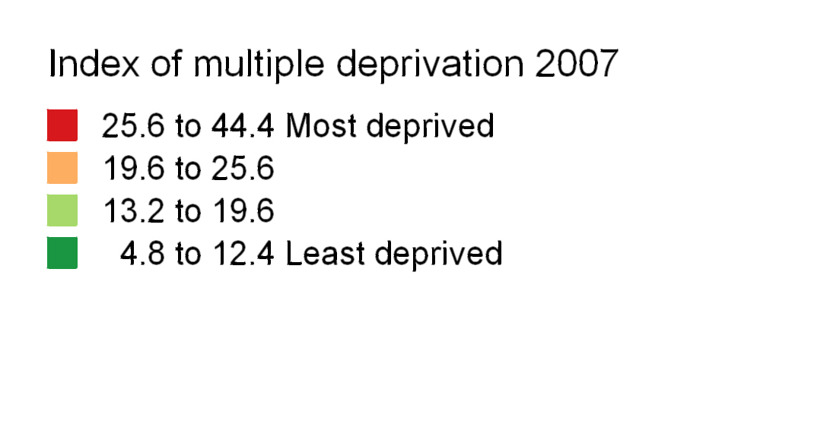
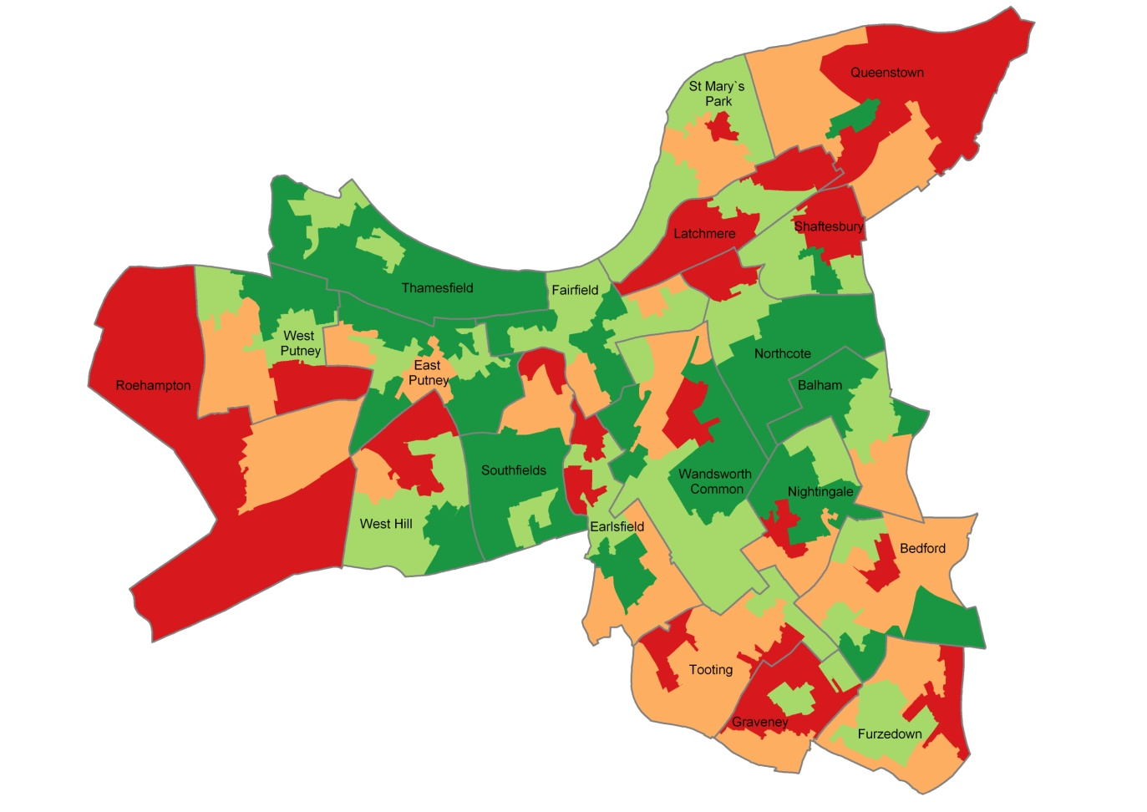
Source: The English Indices of Deprivation 2007. Department for Communities and Local Government.
Furzedown also has a 65 and over population which accounts for just under 10% of the ward population, while Graveney shows a proportion of nearly 9%. Both of these wards also experience near to highest deprivation in the borough. The wards of Queenstown and Latchmere do not exhibit relatively higher proportions of older population residing in them even though the range in proportions are narrow across the borough, 5.66% to 13.04% (see Map 1). This narrow range indicates that older people are distributed throughout Wandsworth.
4.15. Fracture of neck of femur admissions and subsequent mortality while in hospital
Hip fractures are associated with substantially increased risk of mortality (Cauley et al, 2000). This section looks at the percentage of people aged 65 years and over that die in hospital after experiencing a fracture of their neck of femur. The data does not include those that may die after discharge. For 2009-10, 9.1% of women died in hospital after suffering a hip fracture. However from year to year it could vary from 5.4% to 14.9%. This is confirmed by looking at previous levels of mortality. Figure 17 overall shows a constant trend in mortality for females with a large decrease 2008-09. This may be due to data issues plus the susceptibility of these rates to large changes due to small numbers of deaths overall from year to year. However this may be negated by a lack of intervention in regard of those suffering non-hip fragility fractures, i.e. it is estimated that 50% of people suffering these fracture go on to suffer a hip fracture.
Figure 17: Percentage of Wandsworth GP registered people 65 years and older suffering a fracture of the neck of femur and subsequently dying in while in hospital.
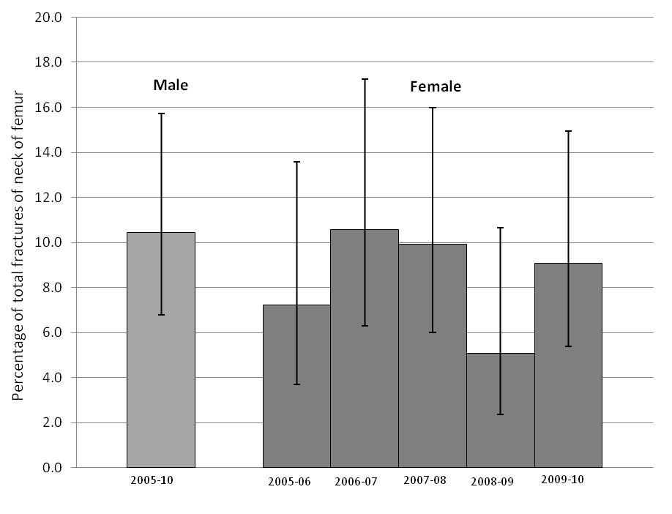
Source: Secondary User Service Data, Vital Signs, Wandsworth PCT (2010).
Due to the number for men dying being small the figures have been combined for the five year period. This shows that 10.4%, or just over one in ten men admitted due to a hip fracture have died between 2005 and 2010. It is estimated that this could vary from 6.8% to 15.7% from year to year. Comparable data for other PCTs was not available.

Analysis supplied by Dr. Foster Intelligence shows a proportion of 16.4% dying in hospital for both genders for the period April 2009 to January 2010. This is higher than the figures above for 2009-10. Some differences may be due to different data collection parameters and case definition as the data is sourced through two different methods.
The data presented in this section was extracted from NHS Wandsworth’s Secondary User Service database - Vital Signs. An audit of patients who have been admitted to St George’s and died following a fractured neck of femur is being undertaken by Public health. It initially identified 40 cases for the year 2008-09 through the ONS’ Public Health Mortality Files. There is a discrepancy between these two sources with Vital Signs showing many less cases. This audit is at an initial stage at time of writing and the cause of the discrepancy is yet to be determined.
4.16 Conclusion

While Wandsworth PCT has a relatively young population and the 65 years old and over population is projected to remain constant over the next 5-10 years, for those that do live in the borough there is need around falls and their prevention. Non-hip fractures have been increasing year on year since 2005-06 for both men and women. Considering that research shows that around 50% of people 65 and over that suffer a non-hip fragility fracture go onto have a hip fracture, this is an important factor pointing to the need for intervention strategies. Most recent data shows that admissions for fracture of neck of femur is continuing to increase and is likely to carry on due to non-hip fragility fractures increasing and the population changes expected in 20 years. The wards of Bedford, West Hill, Wandsworth Common and Graveney experience higher than expected admissions of non-hip fractures, while West Hill also shows significantly higher rates of hip fractures compared to the PCT average. Fracture (hip and non-hip) rates for post menopausal women (55-64 years old) follow the same trend as in the older age groups with year on year increases in fractures (with a slight decrease for 2009-10 from 291.6 per 100,000 population to 213.7). Again this has implications for a long term strategy as prevention strategies will need to be directed at this client group.
The other key points of the needs assessment are:
- Continuation of work and assessment around bisphosphonates and Vitamin D prescribing. Analysis presented here provides a basis for further assessment but is not conclusive. Older People’s Strategy Group are working with the PCT’s Clinical Effectiveness Group on their work and recommendations on Vitamin D deficiency, which is a relevant factor in falls prevention.
      - Around one in ten people (65+) die while still in hospital after a hip fracture.
- Wandsworth experiences much higher rates (66% higher than nearest) of mortality due to an accidental fall compared to similar PCTs in London (WCC Cluster PCTs).
- There are nearly a third more women over the age 64 years than men projected to be resident now and in the future in Wandsworth.
- Mortality from a fractured femur shows Wandsworth with a directly age standardised rate higher than all other similar (WCC cluster) PCTs. However, the rate is only significantly higher than the London average and Hammersmith and Fulham PCT.
- London ambulance service (LAS) conveyance for falls (2009-10) is highly correlated with where the largest proportion of the 65 years and over reside, despite the conveyance incidence being logged at the location of fall rather than the fallers home address.
- Older people living in areas of high deprivation (Roehampton, Tooting, Graveney and Furzedown) should be given particular attention. Graveney experiences higher than expected non-hip fragility fracture (2005-10) while Graveney and Furzedown also experience higher than average rates of hip fractures (2005-10). Furzedown also experiences significantly higher hip fractures compared to the PCT average in the 80 years and over age group.
- While incidence of hip fractures and non-fragility fractures are not particularly correlated to areas of highest deprivation, any initiatives should also target these areas so as not to increase overall health inequalities as well as the fact that the highest proportions of older people live in these wards.
- Furthermore the future configuration of services need to be considered as the 65 and over population in Wandsworth is projected to increase steadily over the next 10 years and exponentially in some wards from 2020 to 2030. These wards include Thamesfield, Southfields, Queenstown and St. Mary’s Park.
4.17 Recommendations arising from needs assessment

- Data collected by individual GP Practices as part of the osteoporosis DES should be submitted to the Performance and Primary Care Contracting Directorate as a requirement of payment (currently data is held at individual practice level and is not available at PCT level for public health analysis).
- The Pharmacy Department should review current contractual arrangements with ProStrakan to ensure that data collected as part of the ongoing audit undertaken by ProStrakan is made available on a regular basis to the PCT and individual practices. (The audit is of patients who have experienced falls and who are most at risk of fracture to ensure that they receive calcium and vitamin D3 supplements when appropriate as detailed in agreed protocols). These results then need to feed into a central integrated forum for consideration.
- Consideration needs to be given to ways of collecting data to enable analysis of fragility fractures for all patients who attend A&E – this data is not currently available.
- To fulfil the recommendations from the Falls and Bone Health Organisational Audit Report 2009 the number and rate of both hip fractures and other fragility fractures should be calculated annually in the borough.
- Integrated work streams incorporating falls prevention services, bone health, Primary Care and commissioning are required within the allocated wards of; West Hill, Wandsworth Common, West Putney, Graveney, Bedford, to focus on those populations with greatest need with regard to the prevention of falls and fractures. There will need to be clear leadership for this work within NHS Wandsworth. The priority ward for additional work is West Hill.
- The Older Peoples Strategy Group should be used as the forum for integrating working and the sharing of information between different directorates in areas where this has not always happened.
- Further joint work needs to be undertaken to look at the high mortality rate for falls. This will need to be led and coordinated through the Older People’s Strategy Group.
- Joint work needs to be undertaken to look at the high mortality rate for fractured neck of femur. Public health is already undertaking an audit of patients who have been admitted to St George’s and died following a fractured neck of femur. The results of this audit will be fed back to the Older People’s Strategy Group.
- Work need to take place to review length of stay at St George’s to bring this into line with national guidelines.
- Joint work needs to take place with regard to LAS conveyance rates – this will require agreed leadership to enable partnership working with LAS around developing effective pathways to prevent unnecessary conveyance to hospital whilst ensuring that systems, services and data collection are in place to ensure the close monitoring of the impact of non-conveyance on the patient. Joint work between commissioning, LAS, Social Services, care homes, CSW and acute hospitals around prevention and avoidance of conveyance should focus on Roehampton, Nightingale and West Hill. This again will require agreed leadership and clear reporting structures.
- Consideration should be given to mechanisms for identifying fragility fractures at acute providers other than St Georges to ensure that bone health and falls prevention interventions are targeted equitably across the borough. Admission rates for hip fracture suggest that only 50% of patients are accessing St Georges – hence the need to consider that lesser fractures may well present with a similar picture.

References
Ahloborg H G, Rosengren B E, Järvinen T L et al. (2010). Prevalence of osteoporosis and incidence of hip fracture in women - secular trends over 30 years. BMC Musculoskelet Disord. 2010 Mar 11;11(1):48.
Avenell A, Gillespie WJ, Gillespie LD, O’Connell DL (2005) Vitamin D and vitamin D analogues for preventing fractures associated with involutional and post-menopausal osteoporosis. Cochrane Database of Systematic Reviews, Issue 3. Art No.: CD000227. DOI: 10.1002/14651858.CD000227.pub2
Banks J., Breeze E., Nazroo J. Retirement, health and relationships of the older population in England: The 2004 English Longitudinal Study of Ageing (Wave 2). London: Institute for Fiscal Studies, 2006.
Bensen R, Adachi J D, Papaioannou A et al. (2005). Evaluation of easily measured risk factors in the prediction of osteoporotic fractures. BMC Musculoskeletal Disorders 6:47.
Boyle M, Archer F, Smith E (2006). Is mechanism of injury alone a useful predictor in pre-hospital trauma triage. Abstracts selected through 999 EMS Research Forum peer review process and presented orally or by poster at Ambex 2005. Emerg Med J. 2006 April; 23(4): e31.doi: 10.1136/emj.2005.032946. http://ukpmc.ac.uk/articlerender.cgi?artid=1732773
Boyle P., Norman P., Rees P. Changing places. Do changes in the relative deprivation of areas influence limiting long-term illness and mortality among non-migrant people living in non-deprived households? Social Science and Medicine 2004; 58(12): 2459-71.
British Orthopaedic Association (2007). The care of patients with fragility fracture. London: British Orthopaedic Association.
Brown MA, Bradlow J, Gray AM (2001) Cost effectiveness of bone density measurements. J Br Menopause Soc 7:130–135

Cauley JA, Thompson DE, Ensrud KC et al (2000) Risk of mortality following clinical fractures. Osteoporos Int 11:556–561

Chapuy MC, Arlot ME, Duboef F et al (1992) Vitamin D₃ and calcium to prevent hip fractures in elderly women. N Engl J Med 327:1637–42

Chapuy MC, Arlot ME, Delmas PD, Meunier PJ (1994) Effect of calcium and colecalciferol treatment for three years on hip fractures in elderly women. Br Med J 308:1081–1082

Chapuy MC, Pamphile R, Paris E et al (2002) Combined calcium and vitamin D3 supplementation in elderly women: confirmation of reversal of secondary hyperparathroidism and hip fracture risk: the Decalyos II study. Osteoporos Int 13:257–264.
Cizza G, Primma S, Csako G (2009). Depression as a risk factor for osteoporosis. Trends in endocrinology and metabolism: TEM, October 2009, vol./is. 20/8(367-73), 1879-3061.
Clinical Standards Department, Royal College of Physicians, London. London: Healthcare Quality Improvement Partnership.
Clinton J, Franta A, Polissar N L et al. (2009). Proximal Humeral Fracture as a Risk Factor for Subsequent Hip Fractures. Journal of Bone and Joint Surgery 91: 503-11.
Cramer JA et al. Systemic Review published 2007 Aug 18(8) 1023-31. NHS Evidence.
Cumming RG, Nevitt MC (1997) Calcium for prevention of osteoporotic fractures in postmenopausal women. J Bone Miner Res 12:1321–1329.
Cummings S R, Black D M, Nevitt M C et al (1993). Bone density at various sites for prediction of hip fractures. The study of osteoporotic fractures research group. Lancet 341: 72-75.
Cummings S R, Nevitt M C, Reid D M (1995). Risk factors for hip fracture in white women. Study of osteoporotic fractures research group. New Eng J Medicine 332: 767-773.
Department of Health (2001) National Service Framework for Older People. Standard six: falls:76–89
Department of Health (2003). How can we help older people not to falls again? Implementing the Older People's NSF Falls Standard: support for commissioning good services. London: Department of Health.
Department of Health (2007). Urgent care pathways for older people with complex needs, Best practice guidance. London: Department of Health.
Department of Health (2009a). Falls and fractures: effective interventions in health and social care. Best practice guide. London: Department of Health.
Department of Health (2009b). Osteoporosis review 2009. London: Department of Health.
Department of Health (2010). Drug Tariff May 2010. London: Department of Health. Stationary Office.
Dolan P, Torgerson DJ (1998) The cost of treating osteoporotic fractures in the United Kingdom female population. Osteoporosis Int 8:611–617.
Electronic Prescribing Analysis and CosT – ePACT (2010). Data extracted 28/03/2010.
Fitzpatrick P, Kirke P N, Daly L, van Rooij I (2001). Predictors of first hip fracture and mortality post fracture in older women. Irish Journal of Medical Science, Vol. 170 , No. 1.

Grant AM, Avenell A, Campbell MK et al; RECORD Trial Group (2005) Oral vitamin D3 and calcium for secondary prevention of low-trauma fractures in elderly people (Randomised Evaluation of Calcium Or vitamin D, RECORD): a randomised placebo-controlled trial. Lancet 365:1621–1628.
Harding S. Social class differences in mortality of men: recent evidence from the OPCS Longitudinal Study. Population Trends 1995; 80: 31-37.
Hasegawa Y, Suzuki S, Wingstrand H (2007). Risk of mortality following hip fracture in Japan. J Orthop Sci 12: 113-117.
Hauer K, Lamb SE, Jorstad E, Todd C, Becker C (2006). Systematic review of definitions and methods of measuring falls in randomized controlled fall prevention trials. Age and Ageing 2006;35:5-10.

Healthcare Quality Improvement Partnership (2009a). National Audit of the Organisation of Services for Falls and Bone Health of Older People. Report for Wandsworth Teaching Primary Care Trust (Site code 061391WWT). Commissioned by: Healthcare Quality Improvement Partnership. Conducted by: The Clinical Effectiveness and Evaluation Unit, Clinical Standards Department, Royal College of Physicians, London. London: Healthcare Quality Improvement Partnership.

Healthcare Quality Improvement Partnership (2009b). National Audit of the Organisation of Services for Falls and Bone Health of Older People. Commissioned by: Healthcare Quality Improvement Partnership. Conducted by: The Clinical Effectiveness and Evaluation Unit,
Healthcare Quality Improvement Partnership (2009c). National Audit of the Organisation of Services for Falls and Bone Health of Older People. Report for St George's Healthcare NHS Trust. Commissioned by: Healthcare Quality Improvement Partnership. Conducted by: The Clinical Effectiveness and Evaluation Unit, Clinical Standards Department, Royal College of Physicians, London. London: Healthcare Quality Improvement Partnership.
Holick MF (2007). Medical progress: Vitamin D Deficiency. Review article. N Engl J Med 2007;357:266-81.
Holmberg A H, Johnell O, Nilsson P M et al. (2006). Risk factors for fragility fracture in middle age. A prospective population-based study of 33,000 men and women. Osteoporos Int 17: 1065-1077.
Honkanen R, Tuppurainen M, Kroger H et al. (1998). Relationships between risk factors and fractures differ by type of fracture: a population-based study of 12,192 perimenopausal women.
Kanis J A, Johnell O, Oden A et al. (2000). Risk of hip fracture according to World health Organisation criteria for osteoporosis and osteopenia. Bone 27: 585-590.
Kanis JA, Brazier JE, Stevenson M et al (2002) Treatment of established osteoporosis: a systematic review and cost–utility analysis. Health Technology Assessment 6(29).
Kelsey JL and Samelson EJ (2009). Variation in risk factors for fractures at different sites. Current osteoporosis reports, December 2009, vol./is. 7/4(127-33), 1544-2241.
Kharicha K, Iliffe S, Harari D et al. (2007). Health Risk appraisal in older people, 1: are older people living alone an “at-risk” group? Br JGen Pract. 2007;57:271–276.
Klotzbuecher C M, Ross P D, Landsman P B et al. (2000). Patients with prior fractures have an increased risk of future fractures: a summary of the literature and statistical synthesis. J Bone Miner Res 15:721-739.
Lamb SE, Jorstad-Stein E, Hauer K, Becker C (2005). Development of a Common Outcome Data Set for Fall Injury Prevention Trials: The Prevention of Falls Network Europe Consensus. JAGS.2005;53:1618-1622.
Lan T Y, Hou S M, Chen C Y, Chang WC et al. (2009). Risk factors for hip fracture in older adults: a case-control study in Taiwan. Osteoporosis international : a journal established as result of cooperation between the European Foundation for Osteoporosis and the National Osteoporosis Foundation of the USA, 14 July 2009, 1433-2965.
Law M R, Hackshaw A K (1997). A meta-analysis of cigarette smoking, bone mineral density and risk of hip fracture: recognition of a major effect. BMJ 315:841-846.
Law M R, Cheng R, Hackshaw A K et al. (1997) Cigarette smoking, sex hormones and bone density in women. Eur J Epidemiol 13: 553-558.
Lilliu H, Pamphile R, Chapuy MC, Schulten J, Arlot M, Meunier PJ (2003) Calcium-vitamin D₃ supplementation is cost-effective in hip fractures prevention. Maturitas 44:299–305

Lindsay R (1995) The burden of osteoporosis: Cost. Am J Med 98(2a):9S–11S.

Marang-van de Mheen P.J., Smith G.D., Hart C.L., Hole D.J., Phillips A.N. The influence of gender, social circumstances and smoking on survival: the Renfrew and Paisley study. Public Health 2000; 114(2): 117-22.

Marang-van de Mheen P.J., Shipley M.J., Witteman J.C., Marmot M.G., Gunning-Schepers L.J. Decline of the relative risk of death associated with low employment grade at older age: the impact of age related differences in smoking, blood pressure and plasma

Meyer H E, Tverdal A, Falch J A, Pedersen J I (2001). Factors associated with mortality after hip fracture. Osteoporos Int. 2001;12(6):516-7.
Myint P K, Poole K E S, Warburton E A (2007). Hip fractures after stroke and their prevention. Q J Med: 100: 539-545.
National Osteoporosis Society (2006) Osteoporosis facts and figures, v1.1. http://www.nos.org.uk/dr_media/nos/Osteoporosis_Facts_and_Figures_20-Nov-07.pdf (last accessed November 2007).
National Osteoporosis Society (2009). Protecting fragile bones: a strategy to reduce the impact of osteoporosis and fragility fractures in Wales. London: National Osteoporosis Society.
Naves N, Diaz-Lopez, Gomez C et al. (2005). Determinants of incidence of osteoporotic fractures in the female Spanish population older than 50. Osteoporos Int 16: 2013-2017.
NHS Employers (2008). Clinical directed enhanced services (DES) guidance for GMS contract 2008/09. Delivering investment in general practice. April 2008. Leeds: NHS Employers.

NHS Institute for Innovation and Improvement (2006). Delivering Quality and Value Focus on: Fractured Neck of Femur. Nottingham: NHS Institute for Innovation and Improvement.
NHS Wandsworth (2010). Dr. Foster Intelligence analysis figures supplied by Bernadette Kennedy from the Integrated Falls Service on 12th April 2010.
NICE (2005) Technology Appraisal 87: Bisphosphonates (alendronate, etidronate, risedronate), selective oestrogen receptor modulators (raloxifene) and parathyroid hormone (teriparatide) for the secondary prevention of osteoporotic fragility fractures in postmenopausal women. London: Department of Health.
NICE (2010a) Alendronate, etidronate, risedronate, raloxifene, strontium ranelate and teriparatide for the secondary prevention of osteoporotic fragility fractures in postmenopausal women (amended). Includes a review of NICE technology appraisal guidance 87, which covered alendronate, etidronate, risedronate, raloxifene and teriparatide. NICE technology appraisal guidance 161 (amended).
NICE (2010b). Alendronate, etidronate, risedronate, raloxifene and strontium ranelate for the primary prevention of osteoporotic fragility fractures in postmenopausal women (amended). London: National Institute for Health and Clinical Excellence.
Nguyen TV, Center JR, Eisman JA (2004) Osteoporosis: underrated, underdiagnosed and undertreated. Med J Aust 180:S18–22.
North American Menopause Society (2010). Management of osteoporosis in postmenopausal women: 2010 position statement of The North American Menopause Society. Menopause Vol. 17 No.1.
Pearce SHS, Cheetham TD (2010). Diagnosis and management of vitamin D deficiency. BMJ 2010;340:b5664 doi: 10.1136/bmj.b5664.

Peng E W K, Elnikety S, Hatrick N C (2006). Preventing fragility hip fracture in high risk groups: an opportunity missed. Postgrad Med J 82: 528-531.
Porthouse J, Cockayne S, King C et al (2005) Randomised controlled trial of calcium and supplementation with cholecalciferol (vitamin D3) for prevention of fractures in primary care. Br Med J 300:1003–1008.
Rensink M, Schuurmans M, Lindeman E et al. (2009). Falls: incidence and risk factors after stroke. A systematic literature review. Tijdschrift voor gerontologie en geriatrie, September 2009, vol./is. 40/4(156-67), 0167-9228.
Roche J J W, Wenn R T, Sahota O et al. (2005). Effect of comorbidities and postoperative complications on mortality after hip fracture in elderly people: prospective observational cohort study. BMJ (Clinical research ed) December 2005 Vol. /is 331.

Royal College of Physicians (1999) Osteoporosis: clinical guidelines for prevention and treatment

Royal College of Physicians (2001) Osteoporosis: clinical guidelines for prevention and treatment – Update on pharmacological interventions and an algorithm for management.

Rubenstein L Z (2006). Falls in older people: epidemiology, risk factors and strategies for prevention. Age Ageing. 2006 Sep;35 Suppl 2:ii37-ii41.

Scottish Intercollegiate Guidance Network (SIGN) (2003) Guideline no. 71: Management of osteoporosis: a national clinical guideline.

Smith G.D., Hart C., Watt G., Hole D., Hawthorne V. Individual social class, area-based deprivation, cardiovascular disease risk factors and mortality: the Renfrew and Paisley study. Journal of Epidemiology and Community Health 1998; 52: 399-405.
Snooks H, Halter M, Close J, Cheung W, Moore F, Roberts S. Emergency care of older people who fall: a missed opportunity. Qual Saf Health Care 2006;15:390-392.
Stolee P, Poss J, Cook R J et al. (2009). Risk factors for hip fracture in older home care clients. J Genrontol A Biol Sci Med Sci Vol. 64A No.3 403-410.
St. George’s Healthcare NHS Trust (2010). Information supplied through correspondence with the hospital’s Consultant Rheumatologist, Dr. Kate Moss.

Tang BM, Eslick GD, Nowson C et al (2007) Use of calcium or calcium in combination with vitamin D supplementation to prevent fractures and bone loss in people aged 50 years and older: a meta-analysis. Lancet 370(9588):657–666.

Tinetti ME, Speechley M, Ginter SF (1988). Risk factors for falls among elderly persons living in the community. N Engl J Med. 1988; 319:1701–1707.
Todd C, Skelton D (2004). What are the main risk factors for falls among older people and what are the most effective interventions to prevent these falls? Copenhagen, WHO Regional Office for Europe (Health Evidence Network report; http://www.euro.who.int/document/E82552.pdf, accessed 15/03/10).

Van Diepen S, Majumder S R, Bakal J A et al. (2008). Heart Failure Is a Risk Factor for Orthopedic Fracture. A Population-Based Analysis of 16 294 Patients. Circulation 118:1946-1952.
Vestergaard P, Rejnmark L, Mosekilde L (2005) Osteoporosis is markedly underdiagnosed: a nationwide study from Denmark. Osteoporos Int 16:164–141

Wilkinson P., Pattenden S., Armstrong B., Fletcher A., Kovats R.S., Mangtani P., McMichael A.J. Vulnerability to winter mortality in elderly people in Britain: population based study. British Medical Journal 2004; 329(7467): 647.
World Health Organisation (2004). What are the main risk factors for falls amongst older people and what are the most effective interventions to prevent these falls? Copenhagen: World Health Organisation Regional Office for Europe.
World Health Organisation (2007). International Statistical Classification of Diseases and Related Health Problems, 10th Revision, Version for 2007. World Health Organisation.
World Health Organization (2010). WHO fracture risk assessment tool (FRAX), World Health Organization Collaborating Centre for Metabolic Bone Diseases 2010), University of Sheffield. Website visited 05/05/2010, http://www.shef.ac.uk/FRAX/tool.jsp?locationValue=1.

Appendix A – Hospital admissions and hospital attendances
Currently the database system, Vital Signs (Wandsworth’s Secondary User Service (SUS) database), does not allow hospital attendance data to be collected by specific fracture type. Hospital attendances are those instances that are recorded of patients attending hospital for treatment irrespective of whether they are admitted to stay in hospital or not.
Admissions data are recorded within the Inpatient data cube of Vital Signs. This cube allows identification of disease and injury under the World Health Organisation’s International Statistical Classification of Diseases and Related Health Problems (ICD-10). Using this classification allows specific fracture data to be extracted for analysis.
Hospital attendance data is recorded in the Accident and Emergency Attendances data cube. This records injury and disease using Healthcare Resource Group (HRG) codes. This codes groups fractures under one heading and therefore not allowing for extraction of data by fracture type.

Appendix B - Care Homes with Nursing Care for Older People in Wandsworth
Name | Address |  | County | Postcode | Phone | Contact | Description
Ashmead Care Centre | 201 Cortis Road | Putney | London | SW15 3AX | 020 8246 6430 | Mr Moise Jennah | Care home with nursing. Dementia (60 places). Old age, not falling within any other category (50 places).
George Potter House | 130 High Street |  | London | SW11 3JR | 020 7223 3224 | Adri Skipper | Care home with nursing providing 69 places. Old age, not falling within any other category (36 places). Dementia (33 places).
Hazel Court Nursing Home | Haydon Way | 162 St Johns  Hill | London | SW11 1SP | 020 8870 6933 | Mohamed  Dusmohamed | Care home with nursing, that has places for 24 people with dementia.
Hazlewell | 29‐31 Hazlewell Road |  | London | SW15 6LT | 020 8788 8753 | Mrs Rosemary  Molloy | Care home with nursing, that has places for 29 elderly people.
Heritage Care Centre | 30 Gearing Close |  | London | SW17 6DJ | 020 8682 9050 | Praxedes Priscillia  Chibanda | Care home with nursing for 72 residents. Dementia (35 places), old age (37 places).
Meadbank Nursing Home | 12 Parkgate Road |  | London | SW11 4NN | 020 7801 6000 | Sarah Rayner | Care home offering nursing care with 176 total places. Terminally ill (176 places). Physical disability (176 places). Old age, not falling within any other category (176 places). Dementia (176 places). Mental disorder, excluding learning disability or dementia (10 places).
Nightingale House | 105 Nightingale Lane |  | London | SW12 8NB | 020 8673 3495 | Soobhug Awatar ‐  Manager | Care home for elderly Jews. Places for 253 residents.
Park Lodge Care Home | 6 Victoria Drive |  | London | SW19 6AB | 020 8789 5822 |  | Care home providing nursing care for 60 elderly residents, 40 of whom may have dementia.
Pines (The) | 104 West Hill |  | London | SW15 2UQ | 020 8877 1951 | Ms Annette  Huskisson | Care home with nursing for 50 residents. Old age, not falling within any other category (50 places). Dementia ‐ over 65 years of age (50 places). Physical disability (50 places).
Ronald Gibson House | 236 Burntwood Lane |  | London | SW17 0AN | 020 8877 9998 | Ms Heather Butler‐  Gallie | Care home with nursing for 56 residents. Dementia ‐ over 65 years of age (16 places), learning disability (2 places), old age, not falling within any other category (56 places).
Rosedene | 141/147 Trinity Road |  | London | SW17 7HJ | 020 8672 7969 | Miss Patricia  Barber | Care home with nursing for 67 residents. Dementia ‐ over 65 years of age (67 places), learning disability (1 place), mental health, excluding learning disability or dementia (67 places), mental health, excluding learning disability or dementia ‐ over  65 years of age (67 places).

Name | Address |  | County | Postcode | Phone | Contact | Description
Sir Jules Thorne Court and  Mary Court | Servite Houses | 29‐35 Prince of Wales Drive | London | SW11 4BQ | 020 7738 0280 | Mr K A Mooniaruck | Care home with nursing for 31 residents. Mental Disorder, excluding learning disability or dementia ‐ over 65 years of age (30 places). Dementia ‐ over 65 years of age (30 places). Old age, not falling within any other category (31 places).
Trinity Court | 165/167 Trinity Road |  | London | SW17 7HL | 020 8767 8767 | Savitribai Gooljar | Care home with nursing for 50 residents. Old age, not falling within any other category (50 places). Dementia ‐ over 65 years of age (11 places). Mental disorder, excluding learning disability or dementia (5 places). Mental Disorder, excluding learning disability or dementia ‐ over 65 years of age (1 place).

Appendix C - 2008-09 hip fractures by GP & cost per 1,000 patients for bisphosphonates and calcium and vitamin D prescriptions.
Average cost per 1,000 patients: Bisphosphonates £1,031.18
Calcium & Vitamin D £704.52
Practice Code | Practice | No. of fractures | 65+ Pop | Crude Rate fractures per 100k | Bisphosphonates cost per 1,000 patients (£) | Calcium & Vitamin D cost per 1,000 patients (£)
H85002 | THE FALCON ROAD MEDICAL CENTRE | 6 | 1602 | 374.53 | 561.76 | 389.60
H85003 | QUEENSTOWN ROAD MEDICAL PRACTICE | 1 | 1476 | 67.75 | 1,220.67 | 835.59
H85004 | THE SURGERY | 1 | 840 | 119.05 | 983.06 | 654.75
H85005 | DR NICHOLAS & PARTNERS | 3 | 2606 | 115.12 | 1,156.50 | 415.10
H85006 | MAYFIELD SURGERY | 7 | 1648 | 424.76 | 2,480.18 | 851.08
H85007 | SOUTHFIELDS GROUP PRACTICE | 8 | 2796 | 286.12 | 1,626.75 | 978.94
H85008 | THE ROEHAMPTON SURGERY | 13 | 2292 | 567.19 | 1,867.32 | 904.56
H85009 | BEDFORD HILL FAMILY PRACTICE | 5 | 1424 | 351.12 | 761.51 | 474.24
H85011 | THE GRAYSWOOD PRACTICE | 1 | 1712 | 58.41 | 780.92 | 666.86
H85012 | PUTNEYMEAD MEDICAL CENTRE | 2 | 1482 | 134.95 | 970.29 | 368.02
H85039 | WATERFALL HOUSE | 5 | 916 | 545.85 | 823.74 | 449.68
H85041 | EARLSFIELD SURGERY | 8 | 2308 | 346.62 | 1,292.24 | 629.19
H85045 | BRIDGE LANE GROUP PRACTICE | 7 | 2664 | 262.76 | 1,319.58 | 728.65
H85047 | CHATFIELD MEDICAL CENTRE | 2 | 2022 | 98.91 | 814.23 | 636.55
H85048 | BROCKLEBANK HEALTH CENTRE | 12 | 2056 | 583.66 | 1,098.08 | 484.51
H85049 | BATTERSEA RISE GROUP PRACTICE | 3 | 858 | 349.65 | 908.98 | 274.30
H85052 | STREATHAM PARK SURGERY | 3 | 1572 | 190.84 | 1,992.12 | 1,348.22
H85056 | BALHAM HILL MEDICAL PRACTICE | 1 | 550 | 181.82 | 426.04 | 268.96
H85057 | ELBOROUGH STREET SURGERY | 3 | 760 | 394.74 | 461.45 | 431.29
H85061 | THE HEATHBRIDGE PRACTICE | 5 | 2438 | 205.09 | 1,378.26 | 510.62
H85065 | THE ALTON PRACTICE | 2 | 856 | 233.64 | 2,795.49 | 720.65
H85066 | BALHAM PARK SURGERY | 3 | 1798 | 166.85 | 955.71 | 497.92
H85067 | DANEBURY AVENUE SURGERY | 3 | 810 | 370.37 | 1,790.07 | 792.66
H85069 | LAVENDER HILL GROUP PRACTICE | 1 | 1530 | 65.36 | 678.58 | 341.16
H85075 | ST JOHNS | 1 | 514 | 194.55 | 285.22 | 396.31
H85077 | THE HERITAGE MEDICAL CENTRE | 1 | 992 | 100.81 | 704.23 | 413.12
H85082 | TRIANGLE SURGERY | 3 | 852 | 352.11 | 986.07 | 859.31
H85087 | OPEN DOOR SURGERY | 2 | 2220 | 90.09 | 1,054.49 | 798.21
H85088 | CLAPHAM JUNCTION MEDICAL PRACTICE | 2 | 700 | 285.71 | 476.54 | 432.95
H85100 | ST PAUL'S COTTAGE PRACTICE | 2 | 642 | 311.53 | 845.16 | 646.74
H85104 | PUTNEYMEAD MEDICAL CENTRE | 3 | 732 | 409.84 | 310.83 | 173.48
H85107 | MITCHAM ROAD SURGERY | 1 | 502 | 199.20 | 494.99 | 800.85
H85111 | BATTERSEA FIELDS PRACTICE | 5 | 1284 | 389.41 | 599.11 | 950.42
H85114 | THURLEIGH ROAD PRACTICE | 2 | 1106 | 180.83 | 1,273.56 | 474.53
H85636 | NORTHCOTE ROAD SURGERY | 1 | 492 | 203.25 | 1,315.96 | 985.83
H85637 | BALHAM HEALTH CENTRE | 0 | 374 | 0.00 | 834.30 | 1,157.96
H85643 | INNER PARK ROAD HEALTH CENTRE | 0 | 840 | 0.00 | 3,915.09 | 1,078.68
H85650 | GRANVILLE ROAD SURGERY | 0 | 262 | 0.00 | 199.48 | 321.77
H85659 | ST. JOHN'S HILL PRACTICE | 0 | 224 | 0.00 | 182.62 | 384.51
H85664 | TOOTING BEC SURGERY | 0 | 166 | 0.00 | 87.33 | 239.95
H85680 | TOOTING SOUTH MEDICAL CENTRE | 0 | 498 | 0.00 | 602.08 | 1,003.79
H85682 | TUDOR LODGE HEALTH CENTRE | 2 | 644 | 310.56 | 387.71 | 411.84
H85685 | SAI MEDICAL CENTRE | 0 | 90 | 0.00 | 21.58 | 279.73
H85688 | THE FRANCISCAN SURGERY | 0 | 734 | 0.00 | 612.15 | 365.36
H85695 | FURZEDOWN PRIMARY CARE CENTRE | 3 | 738 | 406.50 | 1,143.54 | 886.05
Y01132 | CHARTFIELD SURGERY | 5 | 1784 | 280.27 | 923.46 | 514.91
Y02423 | DR FREEMAN AND PARTNERS | 3 | 3002 | 99.93 | 0.00 | 0.00

