Diabetes Health Needs Assessment 2010

NHS Wandsworth

Department of Public Health

Anupam Garrib and Melissa Cottington

Contributors to this report:

Nigel Bain

Neil Bamford

Gary Bradley

Lucy Chadder

Melissa Cottington

Nigel Crawford

Vanessa Flagg

Josephine Ruwende

Contents

1. Executive summary 7

2. Introduction and background 8

2.1 Aim of a health needs assessment 8

2.2 Approach to health needs assessment 8

2.3 What is diabetes? 8

2.4 Diabetes incidence and prevalence in England 10

2.5 UK policies on diabetes 10

2.6 Risk factors for developing diabetes 12

3. Understanding our population 13

3.1 Prevalence of non-modifiable risk factors for diabetes in Wandsworth 13

3.1.1 Age 13

3.1.2 Ethnicity 14

3.2 Prevalence of modifiable risk factors for diabetes in Wandsworth 15

3.2.1 Deprivation 15

3.2.2 Obesity 15

3.2.3 Gestational diabetes 16

3.2.4 Impaired glucose tolerance 16

3.3 Expected prevalence of diabetes in Wandsworth 17

3.4 Actual prevalence of types 1 and 2 diabetes mellitus in Wandsworth 19

3.5 Comparison of expected and recorded prevalence of diabetes 21

3.6 Diabetes in children and young people 22

3.6.1 Type 1 diabetes 22

3.6.2 Type 2 diabetes 23

3.7 Diabetes prevention 23

3.8 Complications of diabetes 24

4. Provision of Service and Care 25

4.1 Description of service delivery in Wandsworth 25

4.1.1 Primary care 25

4.1.2 Community diabetes specialist nursing service 25

4.1.3 Secondary care 26

4.2 Monitoring of diabetic control 26

4.3 Lower limb amputation 28

4.4 Renal disease 30

4.5 Cardiovascular disease 32

4.6 Diabetic retinopathy 35

4.7 Diabetic ketoacidosis and coma 37

4.8 Deaths from diabetes 38

4.9 Hospital admissions 40

4.10 Prescriptions for people with diabetes 41

4.11 Programme budgeting 44

4.12 Stakeholder analysis 46

4.13 Diabetes E 48

5. Discussion and recommendations 49

6. Appendix 1: Details of trends in drug prescriptions and costs 50

7. Appendix 2: Detailed DiabetesE results 52

8. Appendix 3: Diabetic Retinal Screening equity audit for NHS Wandsworth 60

**Table of Figures**

Figure 1: Age breakdown for Wandsworth population showing % in each age group for males and females 14

Figure 2: Map of percentage of Asian or Asian British in Wandsworth wards 15

Figure 3: Map of percentage of Black or Black British in Wandsworth Wards 15

Figure 4: Map showing deprivation in Wandsworth PCT 16

Figure 5: Estimated growth in diabetes prevalence in Wandsworth, 2010-2025 19

Figure 6: Estimated prevalence of Type 1 and 2 diabetes by ethnic group, 2005 20

Figure 7: Diabetes prevalence by practice and ratio of actual to expected numbers of diabetic patients 21

Figure 8: Diabetes prevalence by ward based on QOF data for 2008/09 21

Figure 9: The percentage of patients with diabetes in whom the last HbA1c is 7.5% or less in the previous 15 months, QOF 2008/9 27

Figure 10: The percentage of patients with diabetes in whom the last HbA1c is 10% or less in the previous 15 months, QOF 2008/9 28

Figure 11: Lower limb amputation in people with diabetes 29

Figure 12: The percentage of patients with diabetes with a record of the presence or absence of peripheral pulses in the previous 15 months, QOF 2008/9 30

Figure 13: The percentage of patients with diabetes with a record of neuropathy testing in the previous 15 months, QOF 2008/9 30

Figure 14: The percentage of patients with diabetes who have a record of micro-albuminuria testing in the previous 15 months, QOF 2008/9 32

Figure 15: The percentage of patients with diabetes who have a record of estimated glomerular filtration rate (eGFR) or serum creatinine testing in the previous 15 months, QOF 2008/9 32

Figure 16: Proportion of diabetic patients with a last blood pressure reading of 145/85 or less by GP practice, QOF 2008/09 34

Figure 17: The percentage of patients with diabetes who have a record of total cholesterol in the previous 15 months, QOF 2008/09 34

Figure 18: The percentage of patients with diabetes whose last measured total cholesterol within previous 15 months is 5 mmol/l or less, QOF 2008/09 35

Figure 19: The percentage of patients with diabetes whose notes record BMI in the previous 15 months, QOF 2008/09 36

Figure 20: The percentage of patients who have a record of retinal screening in the previous 15 months, QOF 2008/09 37

Figure 21: Admission rates for DKA and coma 39

Figure 22: Trends in diabetes mortality in Wandsworth, MFP All Ages, 1993-2007 40

Figure 23: Mortality from Diabetes, Persons, <75, 2005-2007 41

Figure 24: Directly age standardised emergency hospital admission rates for Diabetes, 2006/7 41

Figure 25: Total costs and number of items prescribed for diabetes in primary care 43

Figure 26: Number of prescriptions and total costs of oral anti-diabetic drugs 44

Figure 27: Mean spend on diabetes drugs in Wandsworth PCT per person 44

Figure 28: Spend per person on diabetes register by practice versus average spend for all practices 45

Figure 29: Programme budgeting data relating to endocrine dysfunction, Wandsworth 2007/8 46

Figure 30: Time trends 60

Figure 31: Target percentages time trend 60

**Table of Tables**

Table 1: National Service Framework Standards for Diabetes 11

Table 2: Estimated numbers of obese or overweight population in Wandsworth aged 16 or over, 2010 17

Table 3: Estimated prevalence of diabetes 2005 19

Table 4: Estimated number of people with type 1 and type 2 diabetes in Wandsworth by age group in 2010 23

Table 5: Summary of numbers of people in Wandsworth with modifiable risk factors for developing diabetes 23

Table 6: Caseload of paediatric diabetic patients, 2002-2009 24

Table 7: Blind registrations in England, London and South West London boroughs, 2006-2008 37

Table 8: Diabetes Standardised Mortality Ratios, <75, 2005-2007, MFP 40

Table 9: Average LoS, total number of bed days, total number of admissions for Diabetes, 2006/7 42

Table 10: Expenditure and outcomes in the endocrine category 47

Table 11: Diabetes E Results Dashboard for PCT 49

Table 12: Number of prescriptions and costs for top ten insulin types used in Wandsworth 51

Table 13: Number of prescriptions and costs for top ten oral antidiabetic drugs used in Wandsworth in primary care 52

Table 14: Early identification categories 53

Table 15: Psychological support categories 53

Table 16: Education Categories 54

Table 17: Care for Children Categories 54

Table 18: Telephone Support Categories 55

Table 19: Agreed Shared Care Plan Categories 55

Table 20: Healthy eating and physical activity categories 56

Table 21: Policies and systems for appropriate options for diabetes management 56

Table 22: Provision of care in different settings 57

Table 23: Support for pregnancy and conception 57

Table 24: Commissioning diabetes services 58

Table 25: Involving people with diabetes 58

Table 26: Key annual processes for diabetes care 59

Table 27: All care processes recorded (%) by PCTs in the SHA 59

# Executive summary

Diabetes is a significant cause of morbidity and premature mortality. In Wandsworth we conservatively estimate that there are just over 11,000 people known to have diabetes at present. A 15% increase in diabetes prevalence is expected over the next 15 years. This will be fuelled by an ageing population and a growing obesity epidemic as well as increasing numbers of paediatric diabetics. This will contribute significantly to the burden diabetes presents on population health, on the health system, and to health inequalities in the borough.

The age and ethnicity profile of the Wandsworth population show that we have concentrations of people at high risk of developing diabetes resident in the borough, in particular in Wandsworth South and in Battersea (Figures 2 & 3). This corresponds closely with estimates that show high prevalence of diabetes in those areas as well as in wards in West Wandsworth (Figure 8). Diabetes should therefore be a health priority in these areas based on its prevalence and its contribution to the burden of disease.

The 23% difference between the expected prevalence of 3.69% based on the PBS diabetes model and the 3% prevalence from our Quality and Outcomes Framework (QOF) data, indicate that there are a number of undiagnosed diabetics in Wandsworth. In addition, we estimate that there are at least 28,000 people in Wandsworth with potentially modifiable risk factors for developing diabetes in the future. These include patients that are overweight or obese, patients with gestational diabetes and those with impaired glucose tolerance. The newly implemented NHS health checks programme provides an opportunity for both early identification of undiagnosed diabetics and those with modifiable risk factors. A PCT strategy to address obesity also exists however there is a lack of an integrated diabetes prevention strategy to ensure that a comprehensive approach to the prevention of diabetes exists within NHS Wandsworth and is focussed on areas of high prevalence and groups at high risk of developing diabetes. This is a key gap and needs to be addressed.

Over the last five years considerable work has gone into improving primary and secondary care diabetes services in line with the National Service Framework (NSF) for diabetes. Progress against the NSF in Wandsworth has been good and Wandsworth is host to some innovative work in terms of diabetes care. There has been success in the retinal screening programme and the needs assessment shows that there have been no increases in blind registrations in Wandsworth. In order to build on this success however it is important to address the findings of a recent equity audit that:

* uptake of retinal screening is particularly low amongst type 1 diabetics and younger patients,
* there is variation in screening uptake by primary care provider which is particularly important as primary care providers have been shown to have a positive impact on influencing uptake of screening,
* ethnicity data are not adequately recorded so it is not possible to assess the impact of language or other barriers on screening uptake. Certain ethnic populations have been shown to have a higher prevalence of diabetic retinopathy.

An important finding of this needs assessment is that variation in the care provided to diabetics in primary care continues to exist. Our analysis of QOF data shows that while many practices are performing well on indicators of care provided to diabetic patients, some practices perform consistently poorly. Although Wandsworth has low diabetes related mortality we do not perform as well in the incidence of diabetes related complications. In Wandsworth 58.7% of diabetic patients have good diabetes control (an HbA1c level of <7.5%) compared to the England average of 66.3%. We also find that Wandsworth has higher incidence rates of some types of diabetes related complications including minor and major lower limb amputations, and emergency admissions for diabetic ketoacidosis (Table 8). QOF data show that in Wandsworth we have lower proportions of patients being checked for indicators of these complications than the England average.Further work with commissioners needs to occur to understand the reasons for this variation and to address these as this is likely to have a direct impact on patient outcomes.

Although most diabetes related care occurs in the community, hospitals provide essential management of paediatric diabetics, complex cases and diabetes related emergencies and complications. We find that Wandsworth patients have relatively low emergency hospital admission rates compared to other PCTs in the sector and to London and England levels, however patients that are admitted stay in hospital significantly longer than in other PCTs or the London and England average. This highlights a potential area for clinical audit to further understand the reasons for this difference.

The costs of treating diabetes is increasing year on year and a recent analysis has shown that despite the high levels of expenditure, outcomes for diabetics in Wandsworth are not as good as those of our peers. Some of this will be related to the issues discussed above. Major changes in the way care is to be provided to diabetics in Wandsworth are underway, including a shift of care from secondary into primary care services. This provides an opportunity to improve quality of care by creating a more seamless patient pathway and by maximise links with other prevention programmes, however the variations in care discussed above need to be addressed and the impact of the shift of care needs to be prospectively evaluated to assess its effect on patient outcomes.

Although significant improvement has been made in the care of diabetics in Wandsworth, the challenge of managing increasing numbers of patients within a resource constrained environment remains. The core of the approach to addressing this problem should be prevention and at present there is no overall strategy for the prevention of diabetes in Wandsworth.

# Introduction and background

## Aim of a health needs assessment

Health needs assessment is a systematic method for reviewing the health issues facing a population, leading to agreed priorities and resource allocation that will improve health and reduce inequalities. Comprehensive health and social needs assessment is an essential starting point for the development of any intervention strategy, service development or health improvement programme.[1]

Health needs assessment provides a tool that can help meet policy objectives through targeting populations most in need of support. Health needs assessment also provides an opportunity for different agencies to work in partnership to reconfigure services.[2]

## Approach to health needs assessment

The health needs assessment combines epidemiological, corporate and comparative approaches in assessing need. The epidemiological approach to health needs assessment provides an understanding of the make-up of the population in question, risk factors for disease they are likely to encounter, examination of the incidence of disease within a community and how these factors relate to the demand on services. The corporate approach in health needs assessment looks at the perceived major health and healthcare issues from the perspective of professionals and stakeholders. The comparative approach to the needs assessment benchmarks services in question against those for a different provider.

For the health needs assessment of diabetes in Wandsworth epidemiological data were collated from a range of national and local sources. Comparative analysis was undertaken using available national and local data, latest evidence and targets. Semi-structured interviews were undertaken with a range of stakeholders to obtain corporate views.

## What is diabetes?

Diabetes is a chronic condition that occurs when the pancreas does not produce enough insulin or when the body cannot effectively use the insulin it produces. Hyperglycaemia and other related disturbances in the body’s metabolism can lead to serious damage to many of the body’s systems, especially the nerves and blood vessels.[3]

Diabetes is the leading cause of blindness in people of working age, the largest single cause of end stage renal failure, and, excluding accidents, the biggest cause of lower limb amputation. Compared with other European countries, Britain has a poor record of blood glucose control and blood pressure control: we have higher rates of heart attacks and strokes, foot ulcers, renal failure and nerve damage.[4]

There are different types of diabetes mellitus, including:

* Type 1: an autoimmune condition whereby insulin-producing cells in the pancreas are destroyed by the body leading to a complete deficiency of insulin.
* Type 2: caused by a shortage of insulin or a fault in the way the body responds to insulin.
* Gestational diabetes: affects women during pregnancy though often disappears after delivery. Women who have had gestational diabetes are at higher risk of developing diabetes later in life than women who have not had gestational diabetes.[5]

Type 1 diabetes is most often diagnosed in children and young people under 15, although it can occur at any age. It is the least common of the two types and accounts for around 10% of all people with diabetes.[6] Symptoms are often marked and diagnosis usually follows quickly.

Type 2 diabetes mainly affects people over the age of 40. The symptoms of Type 2 diabetes are less marked than those for Type 1, with the result that Type 2 diabetes may go undetected for many years. The onset of Type 2 diabetes occurs on average between nine and 12 years before a diagnosis is made, by which time between one-third to around 50 per cent will already have signs of complications.[7] This is the more common of the two types and accounts for 90% of cases of diabetes.

Diabetes is a life-long condition and consequently can have a profound impact on lifestyle, relationships, work, income, health, well-being and life expectancy.[8] below shows some facts and figures about diabetes.

Box : Diabetes facts

* Life expectancy is reduced, on average, by more than 20 years in people with Type 1 diabetes and by up to 10 years in people with Type 2 diabetes
* Mortality rates from heart disease in adults with diabetes are between two to four times higher than in adults without diabetes, while the risk of stroke is also two to four times higher
* Diabetes is the leading cause of renal failure, accounting for more than one in six people starting renal replacement therapy; the second commonest cause of lower limb amputation; and the leading cause of blindness in people of working age
* Diabetes leads to additional risks in pregnancy: women with diabetes have an increased chance of losing the baby during pregnancy, or at birth; of the baby having a congenital malformation, or of the baby dying in infancy
* Type 2 diabetes incurs significant direct personal costs, for people with diabetes, including costs associated with managing their diabetes. The costs of diabetes are not restricted to health care expenditure, approximately 5,960,000 working days were lost to type 2 diabetes in 1998, valued at £ 256,131,000

*Source: National Service framework for diabetes: standards. DH 2001 & Diabetes in England. Yorkshire and Humber Public Health Observatory and the National Diabetes Support Team, November 2008.*

## Diabetes incidence and prevalence in England

The number of people developing diabetes is increasing around the world. In England, the estimated prevalence of diabetes (diagnosed and undiagnosed) in 2008 was 4.67% of the population or approximately 2.5 million persons. By 2025 it is forecast that 6.48% of the population or approximately 3.6 million people will have diabetes. This rise will be fuelled both by the ageing population and the increasing prevalence of obesity.[9]

In England we know that

* The incidence of Type 1 diabetes is increasing in all age groups but the rise is particularly steep among children under five years old
* The prevalence of Type 2 diabetes is increasing across all age groups and is being diagnosed in children as well; it is likely that this is due to the increase in childhood obesity.[10]

Diabetes prevalence has been increasing in both men and women, and prevalence is higher in men in all adult age groups than women.[11]

## UK policies on diabetes

The Department of Health published the *Diabetes National Service Framework* in 2001 which set out 12 national standards for the care of people with diabetes ().[12] This was followed in 2003 with a *Delivery Strategy* which set out how the Diabetes NSF could be achieved.[13] In 2010, a six year update on performance on the Diabetes NSF standards was published, which highlighted progress made on each of the 12 standards.[14]

Table 1: National Service Framework Standards for Diabetes

|  |  |  |
| --- | --- | --- |
| **Preventing and identifying diabetes** | **Standard 1** | The NHS will develop, implement and monitor strategies to reduce the risk of developing type 2 diabetes in the population as a whole and to reduce the inequalities in the risk of developing type 2 diabetes. |
| **Standard 2** | The NHS will develop, implement and monitor strategies to identify people who do not know they have diabetes. |
| **Partnership in decision-making** | **Standard 3** | All children, young people and adults with diabetes will receive a service which encourages partnership in decision-making, supports them in managing their diabetes and helps them to adopt and maintain a healthy lifestyle. This will be reflected in an agreed and shared care plan in an appropriate format and language. Where appropriate, parents and carers should be fully engaged in this process. |
| **Clinical care of adults with diabetes** | **Standard 4** | All adults with diabetes will receive high-quality care throughout their lifetime, including support to optimise the control of their blood glucose, blood pressure and other risk factors for developing the complications of diabetes. |
| **Clinical care of children and young people with diabetes** | **Standard 5** | All children and young people with diabetes will receive consistently high-quality care and they, with their families and others involved in their day-to-day care, will be supported to optimise the control of their blood glucose and their physical, psychological, intellectual, educational and social development. |
| **Standard 6** | All young people with diabetes will experience a smooth transition of care from paediatric diabetes services, whether hospital or community-based, either directly or via a young people’s clinic. The transition will be organised in partnership with each individual and at an age appropriate to and agreed with them. |
| **Diabetic emergencies and inpatient care** | **Standard 7** | The NHS will develop, implement and monitor agreed protocols for rapid and effective treatment of diabetic emergencies by appropriately trained healthcare professionals. Protocols will include the management of acute complications and procedures to minimise the risk of recurrence. |
| **Standard 8** | All children, young people and adults with diabetes admitted to hospital, for whatever reason, will receive effective care of their diabetes. Whenever possible, they will continue to be involved in decisions concerning the management of their diabetes. |
| **Diabetes and pregnancy** | **Standard 9** | The NHS will develop, implement and monitor policies that seek to empower and support women with pre-existing diabetes and those who develop diabetes during pregnancy to optimise the outcomes of their pregnancy. |
| **Detection and management of long-term complications** | **Standard 10** | All young people and adults with diabetes will receive regular surveillance for the long-term complications of diabetes. |
| **Standard 11** | The NHS will develop, implement and monitor agreed protocols and systems of care to ensure that all people who develop long-term complications of diabetes receive timely, appropriate and effective investigation and treatment to reduce their risk of disability and premature death. |
| **Standard 12** | All people with diabetes requiring multi-agency support will receive integrated health and social care. |

In 2007, *Healthcare for London: A Framework for Action* was published which set out plans to improve the health and healthcare of Londoners. Within the Healthcare for London (HfL) programme, diabetes was selected as the focus of the first long-term conditions project. The case for focussing on diabetes includes the significant inequalities in the way diabetes is prevented, diagnosed and treated across London; prevalence of diabetes is predicted to increase, spending on diabetes now accounts for an estimated 10% of the NHS budget, the standards of service offered in the capital are poor compared with the rest of the country. [15] This is important as poor quality routine care will lead to greater use of the emergency services, poorer outcomes for patients and greater cost to the NHS. A further *Diabetes Guide for London* was published, which outlined a model of care for London as well as made commissioning recommendations.

NICE has developed guidance on various aspects of the management of diabetes including:

* The management of Type 1 diabetes, an update of which is currently in preparation
* The management of Type 2 diabetes
* Diabetes in pregnancy
* Technology appraisals have been completed on inhaled insulin, long acting insulin analogues, patient education models and insulin pump therapy
* Interventional procedure guidance has been published on allogenic pancreatic islet cell transplantation for Type 1 diabetes, autologous pancreatic islet cell transplantation for improved glycaemic control after pancreatectomy and pancreatic islet cell transplantation.

There is NICE public health guidance currently in development on preventing pre-diabetes in adults and on preventing the progression from pre-diabetes.

Guidance on commissioning services for children and young people with diabetes was provided in *Making Every Young Person with Diabetes Matter: Report of the Children and Young People with Diabetes Working Group* which was published by the Department of Health Diabetes Policy Team in 2007. This document puts forward a number of standards to guide the delivery of care to young people.

## Risk factors for developing diabetes

The risk factors are different for Type 1 and Type 2 diabetes. Whilst the risk of developing diabetes increases with age, anyone can get it. The following groups are identified as being at increased risk of developing diabetes:

**Type 1 diabetes**

* People with a strong family history of type 1 diabetes
* Although the onset of type 1 diabetes is typically in childhood it also occurs in adults

**Type 2 diabetes**

* People with a family history of diabetes
* Ethnicity: higher rates of Type 2 diabetes are reported in people of South Asian and African origin, and in indigenous peoples of the Americas and Australasia.
* Adults and children who are overweight or obese and are physically inactive
* Deprivation is strongly linked with higher levels of obesity, physical inactivity, unhealthy diet, smoking and poor blood pressure control, all factors which are linked to the development of diabetes or which increase the risk of developing complications in those who already have the disease[16]. Those in the most deprived fifth of the population are one-and-a-half times more likely than average to have diabetes at any given age. Both mortality and morbidity are increased by socio-economic deprivation.[17]
* People with impaired glucose tolerance
* Women who have had gestational diabetes mellitus

**Risk factors for type 1 diabetes are not thought to be modifiable whereas overweight/obesity and physical inactivity are modifiable risk factors for type 2 diabetes.**

# Understanding our population

## Prevalence of non-modifiable risk factors for diabetes in Wandsworth

The following sections of this report describe Wandsworth’s population in terms of non-modifiable risk factors for diabetes. Non-modifiable risk factors cannot be changed however understanding the distribution of these will highlight groups of the population that are at high risk.

### Age

Type 1 diabetes is most often diagnosed in children and young people under 15, although it can occur at any age. Type 2 diabetes mainly affects people over 40. Increasing prevalence of type 2 diabetes is now seen in younger people as a result of changing lifestyle factors such as higher levels of inactivity and the increasing prevalence of overweight and obesity.

Figure 1: Age breakdown for Wandsworth population showing % in each age group for males and females

Source: GLA Round 2008 Population Projections Low

The population of Wandsworth is young with 40% of the total population falling into the 25-39 year age group. This is a large pool of people at risk of developing type 2 diabetes, who we anticipate will remain in Wandsworth in their 40’s, when they are at risk of developing diabetes.

27% of the population are aged between 0-24 years and this group are at risk of developing diabetes at an earlier age than previous generations due to changes in lifestyle. This group are also likely to still be living in Wandsworth when they develop diabetes.

### Ethnicity

Prevalence of Type 2 diabetes is up to 6 times higher in people of South Asian decent and up to 3 times higher in African and African-Carribean populations in the UK. There is also increasing evidence of higher incidence of Type 2 diabetes in South Asian children.

Figure 2: Map of percentage of Asian or Asian British in Wandsworth wards

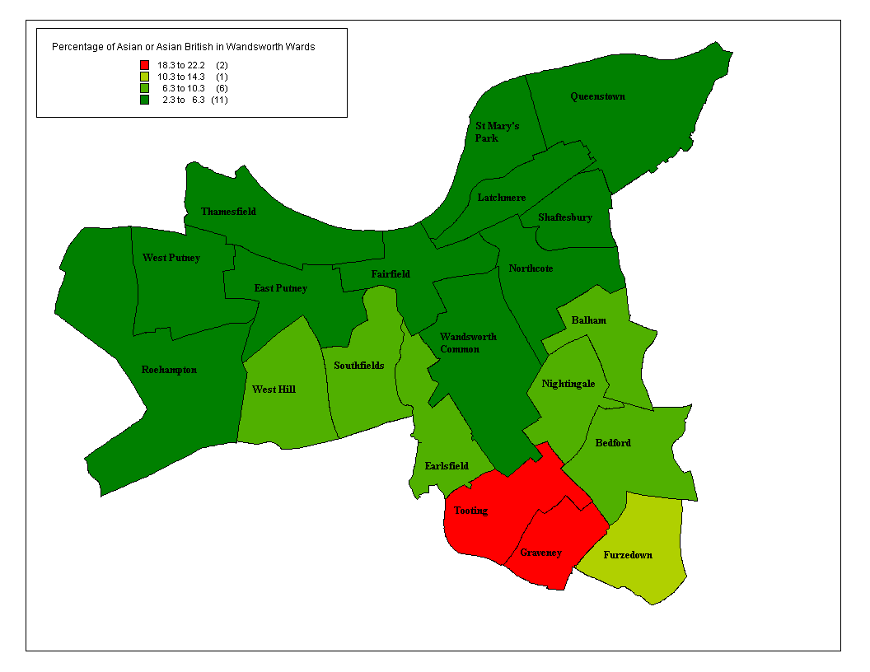

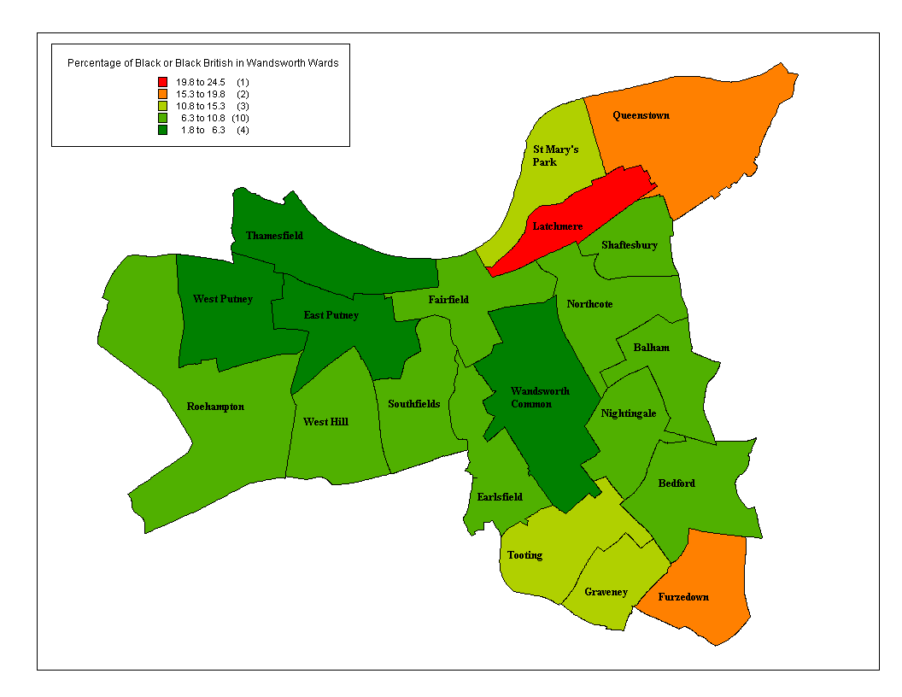Figure : Map of percentage of Black or Black British in Wandsworth Wards

and above show that large parts of Wandsworth - particularly Wandsworth South and Battersea localities have high numbers of people at increased risk of developing diabetes as a result of their ethnicity.

## Prevalence of modifiable risk factors for diabetes in Wandsworth

Modifiable risk factors for diabetes can be reduced or prevented through lifestyle interventions and active management.

### Deprivation

Strong links exist between income, attained level of education and poverty. Deprivation is strongly linked with higher levels of obesity, physical inactivity, unhealthy diet, smoking and poor blood pressure control, all factors which are linked to the development of diabetes or which increase the risk of developing complications in those who already have the disease. We would therefore expect to see higher prevalence of diabetes and its risk factors in the wards with highest levels of deprivation. Mortality rates from diabetes for those living in the poorest postcodes are 2.3 times the national average, compared to 1.3 times the national average in wealthier areas.[18]

Figure 4: Map showing deprivation in Wandsworth PCT

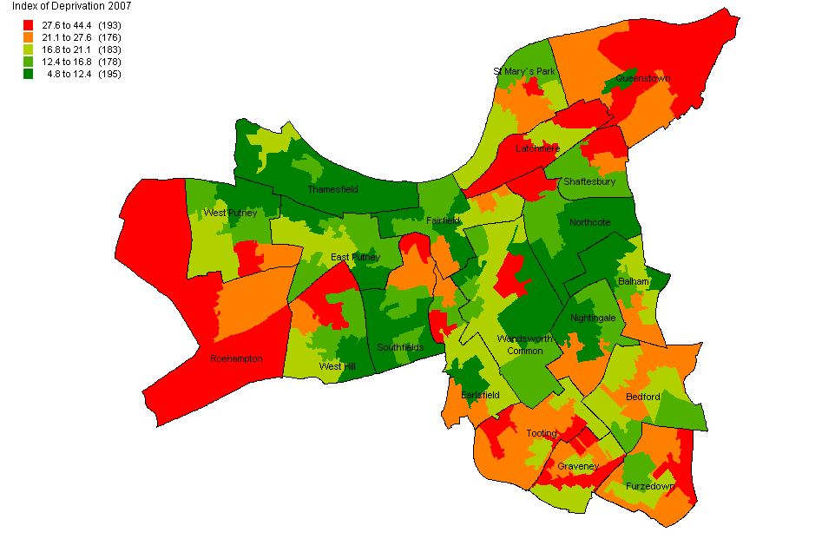

Source: IMD 2007

above shows that all localities in Wandsworth have wards of high deprivation with an increased risk of developing ill-health including diabetes.

### Obesity

The risk of developing Type 2 diabetes increases by up to ten times in people with a BMI of more than 30.[19] In Wandsworth, the number of patients aged 16 or over who are registered as obese is 15,462 (QOF 2008/9). These numbers provided from QOF are likely to be an underestimate of the prevalence of obesity in Wandsworth.

The Health Survey for England (HSE) report “Forecasting Obesity to 2010” was revised to include data from the 2003 HSE and showed that in England 43% of males and 33% of females aged 16 and over were overweight. For the same age group, 22% of males and 23% of females were obese. Applying these figures to the Wandsworth population for 2010, we have estimated the numbers of our population who might be overweight or obese (table 2).

Table 2: Estimated numbers of obese or overweight population in Wandsworth aged 16 or over, 2010

|  |  |  |
| --- | --- | --- |
| Individuals aged 16 or over | Males | Females |
| Overweight | 49,765 | 40,622 |
| Obese | 25,461 | 28,312 |

Source: Forecasting Obesity to 2010, DOH & GLA 2008 Population Projections

Based on these figures there are between 15,000 and 50,000 obese people in Wandsworth who are at increased risk of developing diabetes.

### Gestational diabetes

Gestational diabetes affects up to 5% of all pregnancies, and women who are overweight or obese are at increased risk of developing it. A study conducted in inner-city London in 1995 revealed an overall prevalence of gestational diabetes of 2%.[20] A higher prevalence of gestational diabetes is seen in women from ethnic minority groups: 2.9% in ethnic groups; 0.4% in the white population.[21]

Type 1 diabetes is more common than type 2 diabetes during the reproductive years, although with increasing levels of obesity and associated increases in type 2 diabetes, this is likely to change. A recent BMA report suggests that 10% of diabetes in pregnancy is pre-gestational and 90% is gestational. The same report estimates a prevalence of gestational diabetes as between 2-5% of all pregnancies.[22] In white Europeans, 20-40% of gestational diabetes will develop in to diabetes type 2 within 20 years.[23]

We estimate that we can expect 93 pregnant women to get gestational diabetes in a year in Wandsworth. Of this group, we can expect between 19 and 37 of these women to go on to develop diabetes within 20 years.

### Impaired glucose tolerance

Impaired glucose tolerance is defined as a fasting plasma glucoseconcentration of less than 7.8 mmol/l and between 7.8 and 11.1mmol/l two hours after a 75 g oral glucose load. Impaired glucose tolerance is common and is thought to affect 17% of thoseaged 40-65 years in Britain. Impaired glucose tolerance is a very strong risk factor for type 2 diabetes: between 4% and 9% of people with impaired glucose tolerance develop diabetes each year.[24]

In a 10 year follow up study, 15% of people with impaired glucosetolerance went on to develop non-insulin dependent diabetes,22% remained glucose intolerant, and the majority (53%) improved. By the time they develop diabetes, 50% will already haveestablished complications, 16% coronary artery disease, and30% retinopathy.

Evidence shows that intensive courses aimed at modifying diet and increasing physical activity in people with impaired glucose tolerance over a few months followed by sustained, but less frequent reinforcing sessions, reduce the risk of developing type 2 diabetes compared with standard written and oral advice, in China, Finland and the United States. The effect was very strong – about a halving of the risk of diabetes – and consistent, despite the very different settings. This makes it likely that this magnitude of effect could be reproduced in other settings, such as Wandsworth.

If left unchecked, of the 75,000 people in Wandsworth currently aged 40-65 years we can expect that:

* in 10 years time 12,761 people in Wandsworth will have impaired glucose tolerance
* in 10 years time 1,972 people of these 12,761 will go on to develop type 2 diabetes
* by the time they develop diabetes 986 will have established complications

## Expected prevalence of diabetes in Wandsworth

The Health Survey for England 2006 found that the prevalence of diabetes in males was 5.6% and for females was 4.2%. Data from Quality and Outcomes Framework (QOF) for 2008 showed that 2,088,335 adults in England have been diagnosed with diabetes. However, not all diabetes is diagnosed. Studies which have examined the total prevalence of diabetes (both diagnosed and undiagnosed) suggest that as many as half of those with diabetes may go undiagnosed [25] although in more recent publications it has been estimated that 25% of diabetics in London are undiagnosed.[26]

The PBS diabetes model is a spreadsheet model that generates expected total numbers of persons with Type 1 and Type 2 diabetes mellitus (diagnosed plus undiagnosed combined) in England, Government Office Regions, Strategic Health Authorities, Local Authority Districts, Primary Care Trusts, electoral wards and user-defined populations including GP practices. The model applies age, sex and ethnic group-specific estimates of diabetes prevalence rates, derived from epidemiological population studies, to 2005 mid-year population estimates. The model allows forecasts of diabetes prevalence up to 2025 to be calculated for sub-national areas based on projected population change and current trends in obesity.

Using the PBS model, the following predictions (Table 3) are made for the numbers of people with Type 1 and Type 2 diabetes mellitus in Wandsworth based on 2005 population data.

Table 3: Estimated prevalence of diabetes 2005

|  |  |  |  |  |  |  |
| --- | --- | --- | --- | --- | --- | --- |
|  | Persons | | Males | | Females | |
|  | Number | % rate | Number | % rate | Number | % rate |
| England | 2,262,484 | 4.48 | 940,502 | 3.80 | 1,321,983 | 5.14 |
| London | 342,029 | 4.59 | 146,710 | 3.98 | 195,319 | 5.18 |
| Wandsworth Borough | 10,194 | 3.69 | 4,210 | 3.15 | 5,984 | 4.20 |
| SW London Sector | 54,860 | 4.15 | 23,170 | 3.58 | 31,690 | 4.70 |

Source: PBS model phase 3, April 2008

The model shows that Wandsworth has an overall expected prevalence rate of 3.69% for diabetes mellitus in 2005. This is a lower rate than for South West London, London and England, which have prevalence rates of 4.15%, 4.59% and 4.48% respectively. The diabetes prevalence rate is higher for women (4.20%) than men (3.15%) in Wandsworth.

Forecasts of diabetes prevalence are also presented for sub-national areas based on projected population change and trends in obesity. Figure 5 below illustrates how the diabetes prevalence is predicted to increase in Wandsworth from 2010–2025.

Figure 5: Estimated growth in diabetes prevalence in Wandsworth, 2010-2025

Source: PBS Model Phase 3, April 2008

Figure 6 below shows the estimated prevalence of Type 1 and type 2 diabetes by ethnic group for 2005. This shows that diabetes is most prevalent in the Asian population.

Figure 6: Estimated prevalence of Type 1 and 2 diabetes by ethnic group, 2005

Source: PBS Model Phase 3, April 2008

## Actual prevalence of types 1 and 2 diabetes mellitus in Wandsworth

There is now a requirement as part of the new GMS contract for all GPs to maintain disease registers for certain conditions including diabetes. Out of a total of 364,358 people registered with a GP practice in Wandsworth, 11,014 people are registered as having diabetes and are on a “diabetes register” within their practice. This represents a diabetes (Types 1 and 2) prevalence rate of 3% within Wandsworth PCT. These data relate to the financial year 2008/9. The local prevalence of diabetes based on the Quality and Outcomes Framework data is likely to be an underestimate as almost half of diabetes may go undiagnosed as well as due to under-reporting. In addition, the Quality and Outcomes Framework data are not age-standardised and so Wandsworth’s high proportion of residents aged below 40 years, is likely to “dilute” higher prevalence rates in the over 40’s age group.

Figure 7 shows the diabetes prevalence for the population aged 17+ by GP Practice based on QoF data for 2008/9 as well as the ratio of actual to expected numbers of diabetes patients by practice. This shows that practices that have a low prevalence of diabetes generally also have a ratio of actual to expected numbers of diabetic patients of <1, implying that fewer numbers of diabetics patients than expected are being identified in these practices. This should be interpreted with caution however as ethnicity and deprivation are not controlled for in the estimates of expected numbers of diabetic patients.

Figure 7: Diabetes prevalence by practice and ratio of actual to expected numbers of diabetic patients

Source: Diabetes prevalence by practice based on QOF 2008/9. Ratio of actual to expected numbers of diabetic patients is from NHS Comparators.

Using GP data we have been able to estimate diabetes prevalence at ward level. The diabetes register data at practice level has been applied to the ward breakdown of registered patients. For this reason, the figures should be treated with caution. shows that prevalence of diabetes is higher in the more deprived wards and wards with a higher proportion of Asian and Black residents.

Figure 8: Diabetes prevalence by ward based on QOF data for 2008/09

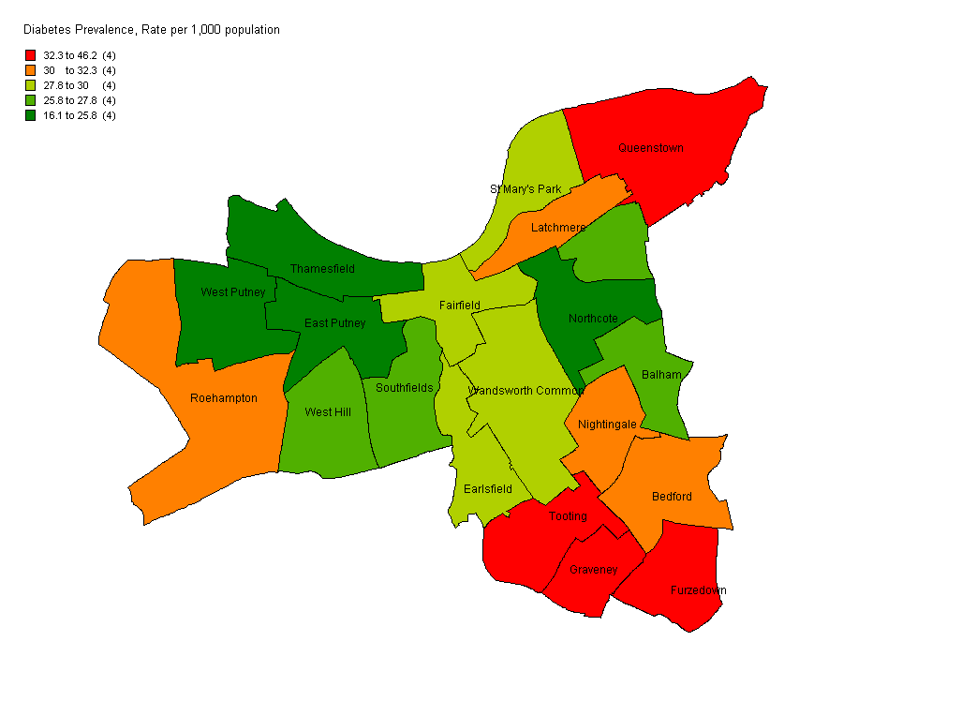

Source: QMAS 2009, NSTS 2008

The following figure shows prevalence by ward based on the PBS modelled estimates which shows largely a similar distribution of high prevalence areas.

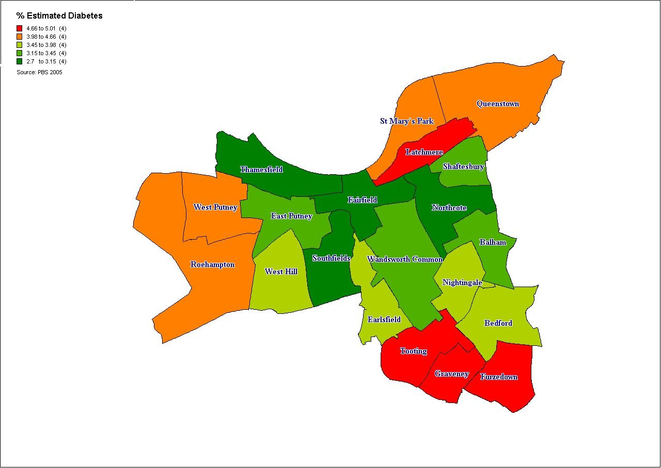

## Comparison of expected and recorded prevalence of diabetes

The 23% difference between the expected prevalence of 3.69% from the PBS model and the 3% prevalence from our 2008/9 QOF data, which is likely to be an underestimate, indicate that there are potentially a number of undiagnosed patients in Wandsworth, and this is in line with the 25% undiagnosed estimate suggested in the literature. The actual numbers of people predicted to have diabetes and those on the GP practice lists are however very close. In 2008/9 11,014 people were on a diabetes register within their general practice and the PBS model estimated that in 2010 in Wandsworth there are 10,700 diagnosed and undiagnosed people with Type 1 and Type 2 diabetes.[27] The potential reasons for this could include: inaccuracies in the GP practice lists, that the model has underestimated the number of diabetics in the area, or potentially that most cases of diabetes in Wandsworth have actually been diagnosed.

We estimate that the approximate age breakdown of people with diabetes by age in Wandsworth in 2010 is as shown below in .

Table 4: Estimated number of people with type 1 and type 2 diabetes in Wandsworth by age group in 2010

|  |  |
| --- | --- |
| **Age groups** | **Type 1 and Type 2 Diabetes** |
| 0-29 | 506 |
| 30-59 | 4,369 |
| 60+ | 5,352 |

Source: estimates use diabetes PBS prevalence model and GLA 2008 population projections for Wandsworth, 2010.

There are many people in Wandsworth who are at risk of developing diabetes in the future. Many risk factors for diabetes are modifiable i.e. the development of diabetes can be prevented or reduced. below shows a summary of the number of people estimated to be at risk of developing diabetes in Wandsworth in the future.

Table 5: Summary of numbers of people in Wandsworth with modifiable risk factors for developing diabetes

|  |  |
| --- | --- |
| **Modifiable risk factor** | **Estimated number of people with risk factors for**  **developing diabetes in Wandsworth** |
| Obesity | 15,462 |
| Gestational diabetes | 93 |
| Impaired glucose tolerance | 12,761 |

This estimate shows that there are potentially at least 28,000 people in Wandsworth with modifiable risk factors for developing diabetes ie. with suitable interventions, we can influence and help prevent 28,000 people in Wandsworth from developing diabetes.

## Diabetes in children and young people

As already discussed, the incidence of type 1 diabetes is known to be increasing in the UK and across Europe, particularly in the under 5 age group; and the incidence of type 2 diabetes is increasing in children as a result of the obesity epidemic.[28] Much of the attention in the UK has been focused on the anticipated growth of Type 2 diabetes however, there is a significant increase in the number of children and young people diagnosed with all types of diabetes. These increases have significant implications for the development of services in order to meet the needs of this group of patients.

In the UK we have the both the highest number of children diagnosed with diabetes in Europe and the lowest number of children attaining good diabetes control.[29]

### Type 1 diabetes

Recent literature suggests that there will be a doubling of new cases of type 1 diabetes in European children young than 5 years between 2005 and 2020 and that prevalent cases will increase by 70%.[30] The peak age for diagnosis of type 1 diabetes in the UK is 10-14 years but is becoming younger with a steep rise in under 5’s. The current estimate of prevalence of Type 1 diabetes in children in the UK is one per 700–1,000 children.

### Type 2 diabetes

The prevalence figures for children are limited but as many as 1,400 children may have Type 2 diabetes in the UK. In the last five years there has been a significant increase in the number of diagnosed cases. There is an ethnic component to this as well with children of South Asian origin found to be 13 times more likely to have Type 2 diabetes than white children. If the current trends of increased childhood obesity continue and follow the pattern seen in North America, the UK will develop similar rates of Type 2 diabetes in children over the next ten to 15 years.

The following data from St Georges Hospital illustrate the increasing numbers of paediatric patients with type1 diabetes. The numbers of patients with type 2 diabetes have remained fairly constant. A detailed activity audit for paediatric diabetes at St Georges Hospital Trust is currently underway.

Table 6: Caseload of paediatric diabetic patients, 2002-2009

|  |  |  |  |  |  |  |
| --- | --- | --- | --- | --- | --- | --- |
| Year (to March) | 2002 | 2003 | 2004 | 2005 | 2006 | 2007 |
| Type 1 | 71 | 83 | 89 | 95 | 97 | 103 |
| Type 2 | * | * | * | * | * | * |
| Maturity Onset Diabetes in the Young (MODY) |  |  | * | * | * | * |

*Numbers suppressed as are <5

## Diabetes prevention

Primary prevention of diabetes (the prevention of onset of diabetes) protects susceptible individuals i.e. those with risk factors as discussed above, from developing diabetes. It reduces or delays both the need for diabetes care and the need to treat diabetes complications.

Lifestyle modifications in several different settings: intensive courses over a few months followed by sustained but less frequent reinforcing sessions aimed at modifying diet and increasing physical activity in people with impaired glucose tolerance, reduce the risk of developing type 2 diabetes compared with standard written and verbal advice.[31] This is an area that will be further addressed in the forthcoming NICE public health guidance on prevention of pre-diabetes.

The newly implemented NHS Health Check programme is a universal and systematic programme for everyone between the ages of 40 and 74 that will assess people’s risk of heart disease, stroke, kidney disease and type 2 diabetes, and will support people to reduce or manage that risk through individually tailored advice. This programme commenced in 2009 and it is anticipated that it will help identify those with modifiable risk factors in Wandsworth. There are in addition ongoing activities in the borough to address rising obesity and to improve physical activity of Wandsworth residents. The impact of these programmes however will only be realised in the long term.

Secondary prevention of diabetes includes early detection, prevention of disease progression, and appropriate treatment. Early identification of diabetes can be increased by:

* Raising both public and professional awareness of the signs of diabetes
* Regular testing of anyone known to be at risk
* Targeted and opportunistic screening of individuals with multiple risk factors

## Complications of diabetes

By the time they are diagnosed with Type 2 diabetes, 50 per cent of people have evidence of complications. Complications from diabetes result in morbidity, hospital admissions, and in many cases premature death for many people with diabetes:

* Between 50% and 80% of people with diabetes will die from cardiovascular disease
* people with diabetes are 2-3 times more likely to have a stroke compared to those without the condition
* 1,000 people with diabetes start kidney dialysis every year in the UK
* diabetes is the leading cause of blindness in people of working age in the UK
* The rate of lower limb amputation in people with diabetes is 15 times higher in people with diabetes than without diabetes. [32]

Primary prevention of diabetes, prompt diagnosis and good control of diabetes can prevent and reduce the incidence of complications of diabetes, thus reducing hospital admissions and saving money.

# Provision of Service and Care

Several indicators are used to monitor the quality of prevention, diagnostic and care services provided to diabetics in Wandsworth. National and local data are also available on diabetes related mortality, hospital admissions and prescribing practices and costs. GP’s record data relating to disease management using the QOF system. There are sixteen QOF indicators relating to the ongoing management of diabetes, which are a useful indicator of the quality of care provided to diabetic patients as well. There are however several caveats to acknowledge with respect to the use of QoF data. These include: there may be inconsistencies in the diagnosing and coding of diseases between clinicians, practice disease registers may be incomplete, the clinical indicators that relate to each chronic condition are measures of process rather than outcome for patients with chronic conditions, exception reporting may be used inappropriately to exclude patients from the denominator,

The following sections will discuss Wandsworth PCTs performance with respect to diabetes indicators related to screening for, preventing and treating complications of diabetes.



## Description of service delivery in Wandsworth

There are significant changes anticipated in the way services to diabetic patients are to be provided in Wandsworth. Key changes include the integration of community based services into the St Georges Hospital Trust and a redesign of the care pathway that will be associated with that change; and the proposal to shift some care for diabetic patients from secondary into primary care. As these developments are already underway any description of how services are currently provided is likely to be outdated in the near future.

## Primary care

The majority of care to patients with diabetes is delivered in primary care, and much of this is done by practice nurses. The community diabetes specialist nurses are now in place to support practice nurses. There has been a gap in the past in the delivery of care to housebound patients or those in care homes, however this should now be covered by the community specialist nurses. Section 4.2 describes in greater detail some of the process measures that are used to monitor the quality of care delivered.

## Community diabetes specialist nursing service

This service has been in place for approximately 6 months and is aimed at improving the quality and cost-effectiveness of community diabetes services, and improving the health outcomes of all diabetic patients through improving access to care. The nurses support diabetics to develop capacity for self-management; they are involved in identifying potential undiagnosed patients and also provide a service to those patients who through reduced mobility are unable to access care.

Patients are referred by either GPs, community nurses or from secondary care. When patients are referred to the service they are offered a comprehensive assessment and screening for their diabetes management needs. Patients are offered a programme of education and 1:1 support until the management of their diabetes is optimised. Access is then provided according to need and a further referral from primary care may be made if needed. The service is provided in various locations according to patient need including GP practices, the patient’s home, community clinics, Wandsworth prison or Springfield hospital.

## Secondary care

Specialist diabetes care is provided by various hospital trusts in SWL, predominantly St Georges Hospital for patients in Wandsworth. Paediatric patients, patients with gestational diabetes, management of complications and acute illnesses are all managed within secondary care, as is the provision of retinal screening.

A transition programme is available for paediatric to adult care however, at the main provider St Georges Hospital Trust; this is currently being revised in order to improve it. Paediatric diabetes nurse specialists works across health, social and educational boundaries to integrate diabetes care in to the patient's life; and care may be provided in the home (aim for 2 home visits per year), school, GP practices etc.

Measures of activity in secondary care are included in section 4.9.

## Monitoring of diabetic control

There are several indicators in QOF relating to the quality of diabetes control, which are focussed on the HbA1c level.[33]

Patients who have an HbA1c level of 7.5% or less have a good level of diabetes control (). The Wandsworth average for this indicator was 59% compared to an England average of 66.3%. Under the current QOF 2009/10 guidance, three target levels for HbA1c (7%, 8% and 9%) are included to provide an incentive to improve glycaemic control across the distribution of HbA1c values, recognising however that the lower level may not be achievable for all patients.[34]

Figure 9: The percentage of patients with diabetes in whom the last HbA1c is 7.5% or less in the previous 15 months, QOF 2008/9

is the equivalent picture for patients who have an HbA1c level of 10% or less.

Figure 10: The percentage of patients with diabetes in whom the last HbA1c is 10% or less in the previous 15 months, QOF 2008/9

## Lower limb amputation

In the UK, diabetes is the second most common cause of lower-limb amputation and the most common cause of non-traumatic amputation. The rate of lower limb amputation in diabetics is 15 times higher than in people without diabetes. Five percent of diabetics may develop a foot ulcer in one year, with 15% of foot ulcers resulting in amputation.[35]

The following graph () compares rates of lower limb amputation in people with diabetes per 100,000 population for London and England. The rates for London and England are very similar and have increased in 2007/8.

Figure 11: Lower limb amputation in people with diabetes

Source: NCHOD 2009

An analysis of Hospital Episode Statistics (HES) data by the YHPHO for 2007/8 and 2008/9 (provisional) has shown that NHS Wandsworth has higher incidence rates of minor and major lower limb amputations than a group of PCTs with similar diabetes related characteristics (including age profile, ethnicity, obesity prevalence and deprivation) and higher rates than England.[36]

In order to prevent the occurrence of this complication, diabetics are regularly checked for the presence of peripheral neuropathy and peripheral vascular disease. and

Figure 13 present the QOF data for the indicators related to monitoring for these complications. For Wandsworth PCT overall 91.2% of patients had a record of the presence or absence of peripheral pulses in the previous 15 months the same figure for England. In 14% of Wandsworth practices 85% or less of patients had had a peripheral pulse check in the previous 15 months.

Figure 12: The percentage of patients with diabetes with a record of the presence or absence of peripheral pulses in the previous 15 months, QOF 2008/9

Figure 13: The percentage of patients with diabetes with a record of neuropathy testing in the previous 15 months, QOF 2008/9

## Renal disease

Nephropathy is one of the most serious microvascular complications of diabetes and is a major cause of kidney failure and death. Diabetic nephropathy is a clinical syndrome characterised by albuminuria on at least two occasions separated by 3–6 months, in people with diabetes. It can progress to end-stage renal failure.

* Diabetic nephropathy develops in about one third of people with diabetes
* Diabetes is now the leading cause of end-stage renal failure in the UK accounting for 20% of all cases
* Kidney disease accounts for 20% of deaths in Type 1 diabetes and 11% in Type 2[37]
* The risk of kidney damage increases with the duration of diabetes. 25 years following diagnosis the risk is 40-50% for both Type 1 and Type 2 diabetes.[38]

The NEOERICA[39] study provides estimates of chronic kidney disease (CKD) stages 3-5 for the population aged 18+ at borough level. These estimates suggest that in Wandsworth there are 12,636 individuals with end stage CKD. The estimated prevalence is 5.4%. This is lower than the estimated prevalence for London (6.8%) and England (8.8%).

End-stage renal failure resulting from diabetes is more common in Black and Asian people than Caucasian. Prevalence of end-stage renal disease in the Thames region is estimated at 409 / 1,000,000 people (all causes of end-stage renal failure) with higher rates among black and Asian populations. [40]

Tight control of hyperglycaemia and blood pressure can slow the progression to nephropathy, however once nephropathy is established blood glucose control is ineffective in reversing the process.

The average proportions of patients tested for microalbuminuria in the previous 15 months in Wandsworth primary care practices was 83.8% for 2008/09, compared to 87.1% for England. Approximately 45% of practices fall below the Wandsworth average (). The average proportion of patients who have had an eGFR or serum creatinine test () was 94.8% for Wandsworth and 96.9% for England. Approximately 39% of Wandsworth practices achieved below the Wandsworth average for this indicator.

Figure 14: The percentage of patients with diabetes who have a record of micro-albuminuria testing in the previous 15 months, QOF 2008/9

Figure 15: The percentage of patients with diabetes who have a record of estimated glomerular filtration rate (eGFR) or serum creatinine testing in the previous 15 months, QOF 2008/9

## Cardiovascular disease

Cardiovascular disease (CVD) includes both stroke and coronary heart disease (CHD) and is the most common microvascular complication of diabetes. 50% of type 2 diabetes will have evidence of CVD at diagnosis. Between 50% and 80% of people with diabetes will die from cardiovascular complications.

Diabetes substantially increases the risk of CHD.[41] Men with Type 2 diabetes have a two to fourfold greater annual risk of CHD, with an even higher (three to fivefold) risk in women with Type 2 diabetes.[42] Diabetes not only increases the risk of CHD but also magnifies the effect of other risk factors for CHD such as raised cholesterol levels, raised blood pressure, smoking and obesity.

Diabetics are also at two to three times increased risk of having a stroke compared to those without the condition. At least 15% of deaths in people with type 2 diabetes are the result of a stroke. African-Caribbean and South Asian men with diabetes have a 40% and 70% respectively, higher risk of stroke than the general population. [43]

In Wandsworth 8,560 people with diabetes at the moment are likely to die from CVD complications in the future. Blood pressure lowering in people with diabetes reduces the risk of macrovascular and microvascular disease. Hypertension in people with diabetes should be treated aggressively with lifestyle modification and drug therapy. Monitoring of blood pressure (BP), cholesterol and BMI are covered in the QOF data. The most commonly identified target level for blood pressure in patients with diabetes is 140/80, which is the level that health professionals should aim for. A slightly higher level (145/85) is used as the audit standard in common with other indicators. shows the indicator of BP control. Overall in Wandsworth practices 78.8% of diabetic patients had a last blood pressure reading of 145/85 or less. The England average was 79.9%.

Overall in Wandsworth though, premature cardiovascular disease related mortality as reflected by directly age-standardised annual mortality rates in those aged under 75 years, has been decreasing year on year. The QOF indicators reported on in this section are referred to as process indicators in that they measure the number of patients checked for a variety of risk factors, however there is currently no outcome indicator on the incidence of cardiovascular related mortality amongst diabetics in Wandsworth.

Figure 16: Proportion of diabetic patients with a last blood pressure reading of 145/85 or less by GP practice, QOF 2008/09

Figure 17: The percentage of patients with diabetes who have a record of total cholesterol in the previous 15 months, QOF 2008/09

In Wandsworth practices 94% have had their total cholesterol checked in the previous 15 months, compared to the England average of 96%. There are few practices (10%) where <90% of diabetic patients have had their cholesterol tested. A further indicator of how well cholesterol is controlled in diabetic patients is the proportion of patients whose last cholesterol measurement was 5 mmol/l or less (). The average in Wandsworth practices was 77.6% for this indicator, compared to the England average of 82.6%. 73% of Wandsworth practices fall below the England average for this indicator.

Figure 18: The percentage of patients with diabetes whose last measured total cholesterol within previous 15 months is 5 mmol/l or less, QOF 2008/09

A further measure of cardiovascular risk is the BMI. In Wandsworth practices an average of 93.3% of patients had a record of BMI in the previous 15 months, compared to an England average of 94.8%. 45% of Wandsworth practices had ≥ 95% of patients with a record of BMI.

Figure 19: The percentage of patients with diabetes whose notes record BMI in the previous 15 months, QOF 2008/09

The figure below highlights some of the key aspects of the clinical management of diabetes related to cardiovascular disease, comparing NHS Wandsworth to a group of PCTs that have similar diabetes related characteristics (including age profile, ethnicity, deprivation and obesity levels) and to England. This shows that the care processes in Wandsworth are worse than that of peer PCTs and England averages.



Taken from Yorkshire and Humber Public Health Observatory and Diabetes Health Intelligence, 2009. Diabetes Community Health Profile – An overview. Wandsworth PCT.

## Diabetic retinopathy

Prolonged exposure to raised blood glucose levels can result in visual impairment and blindness (diabetic retinopathy). The Diabetes National Service Framework Delivery Strategy set a challenging target that by the end of 2007, 100% of people with diabetes would be offered screening, and treatment if needed, of diabetic retinopathy as part of a systematic screening programme. The Department of Health has included this target in the Operating Framework 2008/9. The increasing numbers of people being identified as having diabetes makes this a particularly challenging target to meet.

Data for 2008/9 shows that in Wandsworth 86% of people with diabetes were offered screening for retinopathy in the previous 15 months. This compares favourably with 89.4% of people with Diabetes in England offered screening in the previous 12 months, based on data from April 2008.[44] shows for each GP practice the proportion of patients on diabetes registers who have a record of retinal screening during the past 15 months. 53% of Wandsworth GP’s have screened 90% or more of patients who are on the diabetes register; however 18% have screened fewer than 80% of patients.

Figure 20: The percentage of patients who have a record of retinal screening in the previous 15 months, QOF 2008/09

To illustrate the impact of diabetic retinopathy, shows the number of people registered as blind in England, London and South West London boroughs in 2006, 2008 and the percentage change calculated from these time periods. London has seen an increase in the number of people registered as blind over the past few years. This is not evident in the South West London boroughs where the number of blind registrations has either remained constant or decreased. The borough of Merton has seen a 22% decrease in blind registrations from 2006-2008. Wandsworth has seen no increase in the number of blind registrations, which potentially illustrates a positive impact of the screening programme.

Table 7: Blind registrations in England, London and South West London boroughs, 2006-2008

|  |  |  |  |
| --- | --- | --- | --- |
|  | **2006** | **2008** | **% diff** |
| England | 152,455 | 152,980 | 0.34 |
| London | 20,835 | 21,650 | +3.91 |
| Wandsworth | 785 | 785 | 0 |
| Croydon | 955 | 955 | 0 |
| Kingston | 360 | 345 | -4.17 |
| Merton | 760 | 590 | -22.37 |
| Richmond and Twickenham | 420 | 370 | -11.91 |
| Sutton | 610 | 595 | -2.46 |

Source: Information Centre 2009

The PCT has joined NHS Richmond in commissioning diabetic retinopathy screening from St Georges Hospital. A multidisciplinary board has been formed and is leading on the strategic development and quality improvement of the programme. An equity audit has been conducted to further understand the factors associated with uptake of retinal screening. This document is attached as appendix 3. Briefly the key findings were:

* The uptake of screening was particularly low in the 18 to 29 year age group, and in type 1 diabetics. This is consistent with the findings of other studies.
* Deprivation was not association with a lower uptake of screening in Wandsworth.
* There was poor data on ethnicity which did not allow an assessment of the impact of this on screening uptake.
* There was also no clear pattern associated with duration of diagnosis.
* There was substantial variation in the uptake of screening by GP practice, although this was not associated with the size of diabetic registers at each practice.
* There have been recent changes in the administration of the programme which should result in better uptake as there is now a systematic call-recall system in operation from St Georges Hospital.

Recommendations from the equity audit included the following:

* Further qualitative work is required to explore the reasons behind low uptake amongst younger patients and type 1 diabetics and to inform an intervention strategy.
* Data on ethnicity of diabetic patients is poor both in the primary care database and on the database currently used at SGH. Ethnicity needs to be recorded by the retinal screening service provider so that it can be considered in subsequent analyses.
* The variation in screening uptake by primary care provider is particularly worrying and a targeted intervention focussed on poorly performing practices is needed.
* The prevalence of diabetes by ward needs to be taken into account in any decisions regarding siting of retinal screening services.
* The provision of information on retinal screening for diabetes should be part of other general health promotion activities undertaken by NHS Wandsworth.
* Other interventions that have been used across the country to increase uptake of retinal screening have included measures to improve accessibility including increased numbers of weekend and evening clinics, more screening locations and increasing transport options; improved communication and advertising of the screening programme, and the use of primary care providers to promote the uptake of screening.

## Diabetic ketoacidosis and coma

Diabetic ketoacidosis (DKA) occurs almost exclusively in Type I diabetes, and is stimulated by severe insulin deficiency coupled with absolute or relative increases in glucagon. The EURODIAB study found that 8.6% of 3250 insulin - dependent diabetic patients in Europe had been admitted to hospital with a DKA one or more times in the previous 12 months.

Common causes of DKA are:

* infections (30%)
* non-compliance with treatment (20%)
* newly diagnosed diabetes (25%)

The following graph ( below) compares rates of admissions (per 100,000 people) in London Strategic Health Authority for DKA and coma compared to England. The graph shows that admission rates for DKA and coma during the period 2005/6 to 2007/8 have decreased in London but increased in England. 2007/8 was the first period in these 3 years where the London rate was lower than the rate for England.

Figure 21: Admission rates for DKA and coma

Source: NCHOD 2009

Table : Incidence of diabetes related complications

|  |  |  |  |
| --- | --- | --- | --- |
|  | Rate per 1000 | | |
| Wandsworth PCT | Blue Group* | England |
| Emergency admissions for ketoacidosis and coma | 6.1 | 1.8 | 1.1 |
| Minor lower limb amputations | 5.6 | 1.3 | 0.7 |
| Major lower limb amputations | 5.1 | 1.5 | 1.0 |

*A comparative group of PCTs that have similar diabetes related characteristics including age profile, ethnicity, deprivation and obesity levels.

Source: Hospital Episode Statistics (HES) The NHS Information Centre for Health and Social Care, 2007/08 and 2008/09 (provisional). Taken from Yorkshire and Humber Public Health Observatory and Diabetes Health Intelligence, 2009. Diabetes Community Health Profile – An overview. Wandsworth PCT.

However Hospital Episode Statistics (HES) data from 2007/08 and 2008/09 (provisional) analysed by the YHPHO (Table 8), show that NHS Wandsworth has higher rates of emergency admissions for ketoacidosis and coma, than a group of PCTs that have similar diabetes related characteristics (including age profile, ethnicity, deprivation and obesity levels) and higher rates than England.[45]

## Deaths from diabetes

Life expectancy is reduced on average by more than 20 years in type 1 diabetes and up to 10 years in type 2 diabetes. Mortality rates are up to five times higher for people with diabetes compared to those without the disease. It is estimated that diabetes accounts for one in seven deaths in the UK from diabetes.[46] Although diabetes is listed as an official cause of death for approximately 7000 people each year in the UK, death certificates often fail to take diabetes as an underlying cause into account.

shows that there have been significant fluctuations in deaths from diabetes during the past 15 years. Mortality rates for males peaked in 2002. Although they dropped to their lowest point in 2004, they have steadily increased since this point in time. Diabetes mortality for females has decreased steadily between 2004 and 2007. Diabetes mortality overall has decreased between 2001 and 2006, but increased between 2006 and 2007.

Figure 22: Trends in diabetes mortality in Wandsworth, MFP All Ages, 1993-2007

Source: NCHOD 2009

**Table 9** shows that Wandsworth has low standardised mortality ratios compared to England and Wales, lower than in the South West London Sector and London; and in **Figure 23** directly standardised mortality rates from diabetes in Wandsworth are lower than PCT’s in the South West London sector, London and England. Croydon PCT has the highest mortality rate from diabetes.

Table 9: Diabetes Standardised Mortality Ratios, <75, 2005-2007, MFP

|  |  |  |  |
| --- | --- | --- | --- |
|  | **Male** | **Female** | **Persons** |
| England | 100 | 100 | 100 |
| London | 120 | 104 | 113 |
| Wandsworth | 49 | 93 | 68 |
| Croydon | 131 | 138 | 134 |
| Kingston | 72 | 81 | 75 |
| Richmond and Twickenham | 96 | 66 | 83 |
| Sutton and Merton | 97 | 110 | 102 |

Source: NCHOD 2009

Figure 23: Directly standardised mortality rates from diabetes, persons, <75, 2005-2007



Source: NCHOD 2009

In Wandsworth in 2007 there were 19 deaths due to diabetes. Between 2005 and 2007, 120 years of life were lost due to diabetes (crude rate of 1.53 years of life lost per 10,000 people).[47]

## Hospital admissions

Hospital admission rates show patterns of demand and of events. shows emergency hospital admission rates for diabetes across all South West London boroughs, compared with London and England. Data is only available at borough level as opposed to PCT level. The rate for South West London SHA is lower than the rate for London and England. Croydon has the highest rate for diabetes admissions, followed by Sutton.

Figure 24: Directly age standardised emergency hospital admission rates for Diabetes, 2006/7

There are a number of length of stay (LoS) parameters that can be used to compare hospital activity – the commonest is the average LoS which uses the mean value of the interval between date of admission and date of discharge. shows average LoS, total number of bed days and total number of admissions for diabetes. The average LoS is highest in Wandsworth, followed by Richmond and Twickenham PCT. The numbers of bed days due to diabetes admissions were highest in Croydon PCT, followed by Wandsworth PCT. The highest numbers of admissions for diabetes were in Croydon PCT. The data presented here were obtained from the Disease Management Information Toolkit which presents data at PCT level on conditions contributing to high numbers of emergency bed days.

Table 10: Average LoS, total number of bed days, total number of admissions for Diabetes, 2006/7

|  |  |  |  |
| --- | --- | --- | --- |
|  | **Average LoS** | **Bed days** | **Admissions** |
| Croydon PCT | 7.5 | 1,988 | 267 |
| Kingston PCT | 8.0 | 654 | 82 |
| Richmond and Twickenham PCT | 9.1 | 483 | 63 |
| Sutton and Merton PCT | 6.4 | 1,309 | 202 |
| NHS Wandsworth | 10.6 | 1,443 | 141 |
| London | 7.3 | 251,314 | 34,928 |
| England | 7.5 | 37,727 | 5,116 |

Source: Disease Management Information Toolkit

## Prescriptions for people with diabetes

The total number of items prescribed in primary care for diabetes management in NHS Wandsworth has increased by 18% over the last three financial years. In 2007/8 142,199 items were prescribed increasing to 168,362 in 2009/10. Figure 25 below shows the breakdown of items prescribed for diabetes management in Wandsworth over the last five years and the associated changed in cost. The graph reflects an upward trend in prescriptions of insulin and oral anti-diabetic drugs during this period. However, despite the relatively small increase in the number of prescriptions of insulin, the cost of insulin has increased substantially. Prescriptions of hypoglycaemia drugs (not reflected in the graph due to small numbers) have also increased but only marginally. Prescriptions for screening and monitoring agents have been decreasing, but have increased in the financial year 2009/10. Data from the 2005 Diabetes HNA showed that screening and monitoring agents were the most expensive items. Work has been undertaken with Wandsworth pharmacies to reduce the prescriptions for these items, thereby lowering the cost.

Figure : Total costs and number of items prescribed for diabetes in primary care

Source: EPACT May 2010

The total spend on items for the management of diabetes in primary care has increased over the last three years from just over £2.3 million in 2007/08 to over £2.6 million in 2009/10. Looking in further detail in where the spending has occurred, the costs of newer oral anti-diabetic agents has contributed significantly to the increased drug costs relative to the number of items prescribed (**Figure 26**). Further detail on the breakdown of drugs and insulin types that have contributed to these costs are included in the tables in Appendix 1.

Figure 26: Number of prescriptions and total costs of oral anti-diabetic drugs

The figures above do not take into account changes in the population in Wandsworth over the last three years. The mean spend on diabetes drugs per person registered with a GP in Wandsworth (with or without diabetes) has stabilised over recent years, as shown in below.

Figure 27: Mean spend on diabetes drugs in Wandsworth PCT per person

Source: EPACT 2009

Mean spend on diabetes drugs per person can be broken down further to look at mean spend by GP practice for each person with diabetes on a practice’s diabetes register. below compares drug spend per person on diabetes registers at each practice with an average for all GP practices in Wandsworth.

Figure 28: Spend per person on diabetes register by practice versus average spend for all practices

Source: EPACT 2009

highlights the variation in spend per person with diabetes at each practice (in 2008/9 range of spend per person was £121- £538). These data are not adjusted for the type of diabetes or the complexity of case management. The variation seen may therefore result from genuine differences in spend per person with diabetes which could be due to the complexity of individual cases, or may be due to inaccuracies in diabetes registers at practices. One of the outliers seen on the graph above is a practice that has now closed and this is therefore difficult to interpret. The mean spend per person on diabetes register (for all practices) for 2008/9 is approximately £227.

## Programme budgeting

NHS Wandsworth has in 2009 published a report on programme budgeting for the PCT. Programme budgeting is a retrospective appraisal of where money has been invested in health programmes and allows this expenditure to be compared with clinical outcomes achieved. Programme budgeting enables commissioners to look at activity and outcomes that have been generated in programmes, to monitor investments and to link expenditures with local and national objectives. It also allows commissioners to readjust investment to meet local need and to reduce health inequalities. This should lead to improvements in efficiency, effectiveness and equity.

Expenditure and outcomes for 2007/08 in Wandsworth were compared for 23 programme budgeting categories with six demographically similar PCTs in London (Tower Hamlets, Hammersmith and Fulham, Kensington and Chelsea, Camden, Islington and Westminster). Programme budgeting category 4 represents a group of illnesses relating to endocrine dysfunction (including diabetes, thyroid disease and disease of the adrenal glands), vitamin deficiencies, and metabolic disease (including cystic fibrosis). Diabetes accounts for 52% of the expenditure in this category.

A diagrammatic representation of outcomes and expenditures for the 23 categories is included below. This shows that a combination of high expenditure and poor outcomes is seen for endocrine disease. A further analysis by the Yorkshire and Humber Public Health Observatory, found a similar picture for Wandsworth.[48]

Figure 29: Programme budgeting data relating to endocrine dysfunction, Wandsworth 2007/8

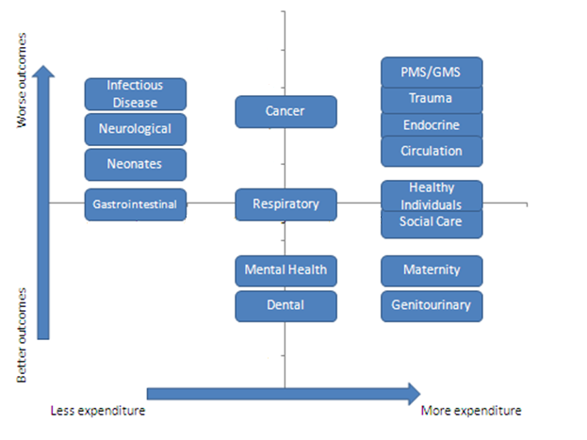

Benchmarking

In this category Wandsworth spends more than the other PCTs in its cluster, £38 per head, as opposed to £34 (a difference of 12%), and slightly less than the national average (£39). Expenditure in this area in 2007/2008 has risen by 0.17% compared to the previous year. Forty six per cent (46%) of the diabetes expenditure is spent within primary care through QoF payments for diabetes care and the prescribing costs.

Table : Expenditure and outcomes in the endocrine category

|  |  |  |  |  |  |  |
| --- | --- | --- | --- | --- | --- | --- |
|  | Expenditure (£ per person)  (2007/8) | Diabetes Prevalence (%)  (2008/9) | Controlled blood glucose levels in patients with diabetes mellitus (%)  (2007/8) | Emergency hospital admissions for diabetes  (Rate per 1,000)  (2008/9) | Percentage of diabetics screened for diabetic retinopathy (%)  (2008/9) | Mortality from diabetes  (2005-7) |
| ENGLAND | 39.39 | 5.10 | 66.80 | 0.6 | 89.74 | 6.29 |
| London | 36.42 | 5.00 | 63.34 | 0.6 | 86.60 | 6.39 |
| Cluster | 34.25 | 4.71 | 63.57 | 0.5 | 83.67 | 6.11 |
| Tower Hamlets | 45.12 | 6.00 | 58.85 | 0.5 | 74.90 | 10.43 |
| Hammersmith and Fulham | 32.21 | 3.82 | 65.66 | 0.5 | 83.40 | 7.23 |
| Camden | 23.79 | 3.64 | 64.90 | 0.5 | 79.60 | 6.27 |
| Islington | 30.13 | 4.40 | 67.91 | 0.6 | 84.40 | 7.47 |
| Kensington and Chelsea | 25.05 | 3.29 | 64.25 | 0.5 | 89.20 | 4.13 |
| Westminster | 41.48 | 3.45 | 62.74 | 0.4 | 86.40 | 3.02 |
| Wandsworth | 38.30 | 3.63 | 60.67 | 0.7 | 87.80 | 6.53  (95% CI:  4.73-8.34) |

The prevalence of diabetes in Wandsworth is lower than the national, London and cluster average. This is to be expected as a result of the younger age profile of the population. Clinical outcomes in Wandsworth are distributed around the cluster average. The coverage of retinal screening is higher than average. On the other hand, mortality from diabetes is just above the cluster average, the proportion of diabetic patients with controlled blood sugar levels is slightly lower than average and rates of emergency admissions to hospital with diabetic conditions are higher than average.

## Stakeholder analysis

Discussions were held with a variety of stakeholders including hospital staff, commissioners, primary care staff, community-based specialist nurses and patient representatives. The following key messages have emerged from these discussions.

* An integrated prevention strategy for diabetes was not developed in Wandsworth following recommendations from the last needs assessment and this is recognised as a gap in the response to diabetes.
  + Education and health promotion work in the community has occurred in the past but not consistently. There is a need to have a more consistent way of identifying education or health promotion opportunities with high risk groups and educating those with modifiable risk factors for diabetes on how to avoid developing the disease.
  + There is a need to develop more ways of identifying undiagnosed diabetics. Although there is much focus on the Health Checks vascular risk assessment programme as a means for doing this, there is recognition that this may not reach all those at risk of developing diabetes.
* The availability of a risk assessment tool for diabetes, as is available for vascular disease, would be useful and this will be looked into.
* The Diabetes Reference Group has been an important mechanism for the delivery of the interventions to support the Diabetes NSF standards, and also provides a forum for those working in diabetes across community, primary and secondary care to meet and share experiences and discuss problems.
* As the delivery of care to diabetic patients in primary care is very dependent on practice nurses, practices are vulnerable to staff turnover and this has an impact on care provided to patients.
* A need was expressed for the availability of specialist skills in diabetes management in primary care for Wandsworth. Attempts to recruite a GP with a special interest in diabetes have however been unsuccessful and although the availability of a community diabetologist has been discussed, this not occurred as there are concerns around clinical governance.
* There is a lot of support for moving more diabetes care from secondary into primary care however there are concerns that the impact of this shift on patient outcomes should be appropriately monitored.
* There is a gap in the provision of psychological services to diabetic patients.
* There is insufficient IT capability to support some of the work in the community; in particular community specialist nurses are not able to access EMIS remotely. The available systems also do not allow sufficient capture of data needed to be able to assess their effectiveness and monitor the operational aspects of their work.

In 2009, a series of focus groups were held under the title ‘What is it like being a patient with diabetes in Wandsworth?’ Seventeen people with diabetes participated in these discussions. All the patients except one had type II diabetes and ranged from being newly diagnosed to having had the disease for over twenty years.

The following key points emerged from the discussions held:

* A need was expressed for more information on diabetes to be made available to the general public and to diabetes patients, including general information on the signs and symptoms of diabetes and contributory factors like family history etc.
* There is also a need to improve awareness of services and their availability, including greater access to self management programmes and support with self management.
* The quality of care experienced across the borough was variable.
* The patients would also like to have a support group based in Wandsworth, which is currently being taken forward by PALS at NHS Wandsworth.
* Patients were very supportive of the idea of a handheld patient record (HHR). A previous small audit of the HHR had suggested that this resource was not required.

## Diabetes E

NHS Wandsworth has participated in the Diabetes E a web-based, self-assessment, diabetes care performance improvement tool that supports the implementation of the Diabetes NSF. DiabetesE measures and benchmarks the performance of all aspects of a system of diabetes care and actively encourages continuous improvement to meet and surpass the Diabetes NSF standards. Results of the assessment are presented below.

Table : Diabetes E Results Dashboard for PCT



The 3 areas in which the PCT performed worst in this assessment was footcare and lower limb complications, clinical information systems and policy and strategy.

Diabetes E Top 5 Priority Recommendations

1. The PCT should consider giving the diabetes service leaders (clinical and managerial) the authority to manage and control resources in such a way that the diabetes service/network can be organised to deliver the structured programme of care effectively and efficiently.
2. The PCT's structured programme of care should require that all staff involved in the diabetes service/network are trained in the assessment of individual patient learning needs.
3. The diabetes specialist team should work towards introducing patient held records.
4. The PCT's structured programme of care should require that all staff involved in the diabetes service/network are trained in the use of a variety of teaching techniques to meet the different needs personal choices and learning styles of people with diabetes.
5. The PCT should have guidelines that require the agreement of personal care plans with people with newly diagnosed diabetes.

The detailed results of the DiabetesE assessment for Wandsworth and peer PCT comparators are included in Appendix 2.

# Discussion and recommendations

The needs assessment highlights the rising diabetes prevalence in the borough and the cost implications of this, as well as inequalities in the way the disease is diagnosed and treated; as is seen across London. As expected ethnic minority populations are particularly affected, contributing to health inequalities in the borough.

The anticipated 15% increase in the prevalence of diabetes over the next 15 years, expected as a result of increases in the incidence of type 1 diabetes, population ageing, population growth and the obesity epidemic will create a substantial health burden for Wandsworth. Increases in the costs of diabetes to the PCT are already evident.

Recently a Diabetes Consensus Panel[49] called for greater leadership in tackling obesity and advised that structural changes were needed to address the epidemic and produce radical lifestyle changes in those affected. While the PCT can certainly contribute to the structural changes, these are likely to need to occur at a national level. Locally however innovative approaches are needed to induce behaviour change in diabetics and those at risk of developing the disease.

The needs assessment has identified a large number of people with modifiable risk factors for the development of diabetes. There are a number of activities ongoing within the PCT that will address these risk factors including a strategy to address obesity, and the recent NHS health checks programme.

An integrated diabetes prevention strategy is required to ensure that a comprehensive approach to the prevention of diabetes is adopted within the PCT. This strategy should include education and awareness raising activities. (Diabetes NSF Standards 1 & 2)

As diabetes incidence is increasing and programmes like the NHS health checks begin to identify increasing numbers of people with diabetes, commissioners need to ensure that increased capacity within the health service to cater for these patients is available.

On a range of indicators related to diabetes control as well as the control of other risk factors including cholesterol and BP, Wandsworth performed consistently poorer than the England average as well as the average for a group of PCTs with similar diabetes related characteristics as identified by the YHPHO.[50]

The review of QoF data suggests that there is unacceptable variation in the quality of care provided to diabetic patients within Wandsworth, with some practices consistently performing worse than others. This is linked to other variations in for example the average spend on diabetes per practice.

Patients have also highlighted the variability in the quality of care provided across the borough, and differences in the availability of services within primary care.

Further analysis of QoF data and other data sources is required to assess the reasons for this variation, and practices that are underperforming need to be performance managed via commissioning. (Diabetes NSF Standards 4 & 10)

The shift of care from secondary into primary care services is a major development in the delivery of health care to diabetic patients in the borough with the potential to significantly improve the quality of care provided.

The impact of these changes on patient outcomes needs to be prospectively evaluated within a monitoring and evaluation framework.

To improve patient outcomes and to support the shift of care, access to and attendance at structured patient education programmes (DESMOND, DAFNE and BERTIE) should be improved. (NICE guidance)

Community specialist nurses should be given the necessary IT support to enable an assessment of their effectiveness and impact on patient outcomes. The development of this service is important to the expansion of care for diabetics in the community and the service may need to be expanded in the future to respond to increasing demand and changes in the service organisation.

# Appendix 1: Details of trends in drug prescriptions and costs

Table : Number of prescriptions and costs for top ten insulin types used in Wandsworth

|  |  |  |  |  |  |  |  |  |  |  |
| --- | --- | --- | --- | --- | --- | --- | --- | --- | --- | --- |
|  | Total number of items* | | | | | Total cost | | | | |
| Drug names | 2005/06 | 2006/07 | 2007/2008 | 2008/09 | 2009/10 | 2005/06 | 2006/07 | 2007/2008 | 2008/09 | 2009/10 |
| Insulin Glargine | 3,290 | 3,442 | 3,924 | 4,313 | 4,464 | £175,125.71 | £185,591.58 | £213,440.78 | £237,990.86 | £249,996.59 |
| Insulin Aspart | 2,514 | 3,230 | 3,857 | 4,444 | 4,915 | £129,793.49 | £166,605.07 | £197,747.33 | £226,200.78 | £244,661.13 |
| Biphasic Protamine Insulin | 2,615 | 3,572 | 3,916 | 4,445 | 4,981 | £122,543.68 | £170,164.03 | £189,059.48 | £217,125.41 | £242,393.62 |
| Insulin Detemir | 1,051 | 1,552 | 2,062 | 2,656 | 3,279 | £58,807.89 | £93,259.84 | £120,577.95 | £157,520.79 | £197,439.78 |
| Biphasic Isophane Insulin | 4,533 | 3,486 | 2,947 | 2,522 | 2,404 | £159,684.03 | £125,366.03 | £113,259.66 | £97,207.21 | £88,472.28 |
| Insulin Lispro | 1,404 | 1,474 | 1,438 | 1,466 | 1,688 | £79,376.01 | £83,948.04 | £77,522.22 | £79,279.84 | £87,285.55 |
| Biphasic Insulin Lispro | 1,065 | 1,048 | 1,026 | 958 | 1,049 | £57,983.15 | £55,305.87 | £51,586.20 | £46,007.73 | £53,496.44 |
| Isophane Insulin | 1,872 | 1,625 | 1,505 | 1,273 | 1,193 | £58,787.98 | £49,044.97 | £47,950.87 | £43,576.92 | £38,448.60 |
| Soluble Insulin (Neutral Insulin) | 710 | 396 | 334 | 295 | 249 | £27,243.13 | £13,902.37 | £13,635.21 | £12,055.05 | £10,762.79 |
| Insulin Glulisine | 1 | 25 | 129 | 180 | 253 | £133.92 | £1,438.58 | £5,177.70 | £7,166.97 | £10,029.33 |

*The number of items is used as a measure of volume of prescriptions, and does not take into account the quantity or duration prescribed on prescriptions

Table : Number of prescriptions and costs for top ten oral antidiabetic drugs used in Wandsworth in primary care

|  |  |  |  |  |  |  |  |  |  |  |
| --- | --- | --- | --- | --- | --- | --- | --- | --- | --- | --- |
|  | Total number of items* | | | | | Total cost | | | | |
| Drug names | 2005/06 | 2006/07 | 2007/2008 | 2008/09 | 2009/10 | 2005/06 | 2006/07 | 2007/2008 | 2008/09 | 2009/10 |
| Metformin Hydrochloride | 42,644 | 47,411 | 53,095 | 59,112 | 67,386 | £165,800.21 | £219,830.13 | £210,091.80 | £183,626.27 | £269,907.02 |
| Pioglitazone Hydrochloride | 1,527 | 1,827 | 2,097 | 2,616 | 3,514 | £62,578.80 | £70,989.92 | £82,368.43 | £102,696.80 | £121,341.05 |
| Gliclazide | 22,025 | 23,823 | 26,353 | 29,414 | 33,062 | £75,705.24 | £86,073.79 | £75,235.97 | £64,962.28 | £83,091.29 |
| Sitagliptin | 0 | 0 | 67 | 445 | 1,375 | £0.00 | £0.00 | £3,352.88 | £19,226.10 | £57,835.13 |
| Exenatide | 0 | 0 | 23 | 217 | 635 | £0.00 | £0.00 | £2,125.18 | £19,240.00 | £56,757.60 |
| Rosiglitazone | 3,598 | 4,203 | 3,701 | 2,817 | 1,852 | £156,469.47 | £181,051.97 | £150,950.78 | £88,283.64 | £50,336.75 |
| Metformin Hydrochloride/Rosiglitazone | 703 | 1,930 | 2,943 | 2,004 | 1,365 | £25,810.80 | £79,560.48 | £116,395.45 | £66,048.81 | £39,862.79 |
| Metformin Hydrochloride/Pioglitazone | 0 | 0 | 47 | 157 | 367 | £0.00 | £0.00 | £1,908.60 | £5,647.96 | £10,969.40 |
| Liraglutide | 0 | 0 | 0 | 0 | 79 | £0.00 | £0.00 | £0.00 | £0.00 | £10,006.17 |
| Glimepiride | 2,738 | 2,703 | 2,489 | 2,400 | 2,352 | £34,334.23 | £29,725.49 | £19,477.60 | £12,249.49 | £8,063.88 |

*The number of items is used as a measure of volume of prescriptions, and does not take into account the quantity or duration prescribed on prescriptions

# Appendix 2: Detailed DiabetesE results

Table : Early identification categories

**rganisation Name**

Table : Psychological support categories



Table : Education Categories



Table : Care for Children Categories



Table : Telephone Support Categories



Table : Agreed Shared Care Plan Categories



Table : Healthy eating and physical activity categories



Table : Policies and systems for appropriate options for diabetes management



Table : Provision of care in different settings



Table : Support for pregnancy and conception



Table : Commissioning diabetes services



Table : Involving people with diabetes

|  |  |  |
| --- | --- | --- |
| **Organisation Name** | **Do the PCT/service leaders measure patient satisfaction?** | **Does the PCT ask people with diabetes their experiences, views and access to diabetes care?** |
| Tower Hamlets PCT | Yes | Yes |
| Hammersmith and Fulham PCT | Yes | Yes |
| Camden PCT | Yes | N/A |
| Islington | N/A | N/A |
| Kensington and Chelsea PCT | Yes | Yes |
| Westminster PCT | Yes | N/A |
| Wandsworth PCT | Yes | N/A |

Care Process and Treatment Target Achievement

Table : Key annual processes for diabetes care



Table : All care processes recorded (%) by PCTs in the SHA

|  |  |
| --- | --- |
| **Organisation Name** | **% of registered patients** |
| Tower Hamlets PCT | 33.19 |
| Hammersmith and Fulham PCT | 40.87 |
| Camden PCT | 44.55 |
| Islington | 45.76 |
| Kensington and Chelsea PCT | 42.99 |
| Westminster PCT | 38.15 |
| Wandsworth PCT | 52.33 |

Figure : Time trends



Figure : Target percentages time trend



# Appendix 3: Diabetic Retinal Screening equity audit for NHS Wandsworth

1. **Introduction**

Type 2 diabetes is the leading cause of blindness in the United Kingdom among the working age population. However early detection of sight-threatening diabetic retinopathy and treatment (usually with laser therapy) halves the risk of sight loss. The diabetic retinal screening programme (DRS) aims to reduce the risk of sight loss amongst people with diabetes, by the prompt identification and effective treatment, if necessary, of sight threatening diabetic retinopathy, at the appropriate stage during the disease process. The National Retinal Screening Programme began in 2002.

The Priorities and Planning Framework 2003 – 2006 (PPF) and Diabetes NSF Delivery Strategy both include a target that “by 2006, a minimum of 80% of people with diabetes to be offered screening for the early detection (and treatment if needed) of diabetic retinopathy as part of a systematic programme that meets national clinical standards, rising to 100% coverage of those at risk of retinopathy by end of 2007.”

1. **Delivery of retinal screening in Wandsworth**

NHS Wandsworth and NHS Richmond currently jointly commission a diabetic retinal screening service from St Georges NHS Acute Trust, Moorfields Eye hospital and the Kingston Hospital NHS Trust (Royal Eye Unit).

The screening administration is currently based at St Georges Hospital (SGH) and all GPs in NHS Wandsworth and NHS Richmond refer patients into the SGH network. The administration was recently transferred to St Georges Hospital. Prior to this, patients could be screened at any service provider and there was no central data repository that allowed proper data collection and follow up of patients who had not attended screening. Operation of a call-recall system is the responsibility of the SGH Diabetic Retinopathy Screening Office.

Patients are then invited for screening at Queen Mary’s Roehampton, St John’s Therapy Centre, St Georges Hospital or Teddington Memorial Hospital. Patients with referable diabetic retinopathy and ungradable images are referred either to Moorfields Eye Hospital or Kingston Hospital Royal Eye Unit.

All patients aged eighteen years and older who have a diagnosis of diabetes will be identified primarily from GP diabetic registers. All patients with a diagnosis of diabetes aged between 12 and 17 are identified from searches of GP patient lists. SGH has also recently undertaken a list cleaning exercise to optimise the running of the programme.

The population eligible for screening is as follows:

1. Inclusions
   1. Every person with diabetes aged 12 years and over who is registered with a general practice in Wandsworth and Richmond (approximately 15, 000 patients)
   2. To support inclusion and reduce inequalities among eligible patients those with learning disabilities, from ethnic minorities, those with mental health problems and those that are homeless are supported to ensure attendance for screening
2. Exclusions
   1. A person with diabetes who has made his or her own informed choice that he or she no longer wishes to be invited for screening.
   2. A person with diabetes who is under the age of 12 years (in which case he or she should not have been referred to the programme until they have reached the eligible age)
   3. A person with diabetes who does not have perception of light in either eye;
   4. A person with diabetes who is terminally ill;
   5. A person with diabetes has a physical or mental disability preventing either screening or treatment;
   6. A person with diabetes who is currently under the care of an ophthalmologist for the treatment and follow-up management of diabetic retinopathy, and then only for that period
3. **What is an equity audit?**

Health equity audit is a process by which partners systematically review inequities in the causes of ill health, and access to effective services and their outcomes, for a defined population and ensure that further action is agreed and incorporated into policy, plans and practice. Actions taken are reviewed to assess whether inequities have been reduced. A health equity audit focuses on ***how fairly resources are distributed in relation to the health needs of different groups***. The overall aim is not to distribute resources equally, but rather in relation to need. Changes in investment and services as a result of health equity audits would aim to reduce avoidable health inequalities.

There is an important distinction between health equity audit concerned with health issues and those focused on health care.

1. **Why do an equity audit?**

This equity audit was conducted in order to determine if there were any differences in the uptake of retinal screening by the diabetic population of Wandsworth that may contribute to health inequalities in the borough. It will be used to identify groups that may not be taking up screening and to inform an intervention strategy to address poor uptake in these groups.

A brief literature review revealed that there are differences in the incidence of diabetic retinopathy by ethnicity and that there are variations in the quality of care provided to diabetic patients by deprivation. (Raymond, Varadhan, Reynold, & al, 2009) (Hippisley-Cox, O'Hanlon and Coupland 2004)

A primary care–based study showed that U.K. resident South Asians with diabetes had a significantly higher prevalence of any retinopathy and maculopathy than indigenous white Europeans. (Raymond, Varadhan, Reynold, & al, 2009) The South Asian group in this study was also younger at diagnosis and had a shorter duration of diabetes. This differential risk may be explained by different levels of the potentially modifiable risk factors hyperglycemia and hypertension, with varying diabetes duration possibly reflecting earlier disease onset in these population groups.

Studies have also shown that practices in areas of high deprivation and with high ethnic minority populations, have poorer achievement with respect to indicators of quality of diabetic care, including the proportion of patients who have been recorded as having retinal screening. (Hippisley-Cox, O'Hanlon and Coupland 2004)

Work done in other areas has shown that working age people and males may have more difficulty accessing screening and therefore have lower uptake. (Coates 2010)

1. **Methods**

In further investigating the factors that may influence the uptake of retinal screening, the following were considered; age, sex, ethnicity, duration of diagnosis, type of diabetes, primary care provider and deprivation. Data were received from the SGH DRS administration office for the period 01/04/2009 to 31/03/2010 for all patients on primary care diabetic registers in Wandsworth. This included data on eligibility for screening, service providers, age, sex and place of residence represented by postcode. Additional data were extracted from EMIS on primary care provider, ethnicity, diabetes diagnosis and diabetes duration. Data were also added on ward and postcode level deprivation. These data were analysed in STATA 10.

1. **Results of retinal screening equity audit**

There were a total of 12073 patients from Wandsworth who were included on the retinal screening list during the period 01/04/2009 to 31/03/2010. There were 46 patients under the age of 12 who were excluded from the dataset leaving a total of 12,027 patients.

Table 29: Status of all Wandsworth patients on diabetes registers in primary care

|  |  |  |
| --- | --- | --- |
| Status | Number | % |
| Active | 10,438 | 86.8 |
| Diabetes 'resolved' | 51 | 0.4 |
| Housebound | 10 | 0.1 |
| Not suitable for screening (reason in patient notes) | 9 | 0.1 |
| Patient opted out of screening | 10 | 0.1 |
| Unable to contact | 38 | 0.3 |
| Screened at another service provider | 32 | 0.3 |
| Under care of another eye unit | 1439 | 12.0 |
| Total | 12,027 | 100.0 |

* 1. **Demographic data of all patients on the list**

The age distribution of the eligible patients (including those who had an active status, those who were screened at another service provider and those under the care of another eye unit) is shown in the figure below.

**Figure 1: Age distribution of male and female patients eligible for retinal screening**

Of the 10,438 patients who had an ‘active’ status, i.e. they should have been screened at St Georges Hospital Trust, 6,214 (59.5%) of patients were screened once, and 411 (3.9%) were screened between 2 and 4 times during the period. 3,813 patients were not screened at all. Of the 3,813 who were not screened at all, 2132 (55.9%) were not sent an appointment date. In 2010 all Wandsworth patients who were eligible for screening were transferred from other service providers to St Georges. These patients were added to the screening list in February and appointments had not yet been generated for them. Of those who had been screened at the other service providers not all this data was transferred to St Georges. As the inclusion of these 2132 patients will not accurately reflect the proportion o those who take up screening and those who don’t, for the remainder of the analysis they have been excluded.

Table 30: Number of screens conducted per eligible patient at St Georges

|  |  |  |
| --- | --- | --- |
| Number of screens conducted per patient | N | Percent |
| 0 | 3,813 | 36.53 |
| 1 | 6,214 | 59.53 |
| 2 | 351 | 3.36 |
| 3 | 55 | 0.53 |
| 4 | 5 | 0.05 |
| Total | 10,438 | 100 |

* 1. **Age and sex**

Data on sex were not available in 549 (4.6%) of patients. In both men and women, the proportion of patients screened increases with age to reach a peak in the 60-69 year age group and decreases thereafter. The lowest proportion of patients screened is in the 18-29 year age group.

Figure 2: Proportion of patients screened by age group and sex

**6.3 Screening by type of diabetes**

Data were available on the type of diabetes diagnosed for 11,332/12,026 (94.2%) of all Wandsworth patients. The vast majority of patients are type 2 diabetics. For approximately 9% of patients the type of diabetes was not clearly specified.

Table 31: Type of diabetes in patients on diabetes registers in primary care in Wandsworth

|  |  |
| --- | --- |
|  | Total |
| Type 1 diabetes mellitus | 848 (7.5%) |
| Type 2 diabetes mellitus | 9,502 (83.9%) |
| Diabetes mellitus NOS | 975 (8.6%) |
| Secondary diabetes mellitus | 7 (0.06%) |
| Total | 11,332 (100%) |

Of the 7,884 patients eligible for screening at St Georges on whom the data on type of diabetes were available, 80.8% were screened within the year. A much lower proportion of patients with type 1 than type 2 diabetes were screened (66.7% vs. 81.8%).

Table 32: Proportions of patients screened by type of diabetes

|  |  |  |  |
| --- | --- | --- | --- |
| Type of diabetes | Not screened | Screened | Total |
| Type 1 diabetes mellitus | 157 (33.3%) | 315 (66.7%) | 472 |
| Type 2 diabetes mellitus | 1,244 (18.2%) | 5,585 (81.8%) | 6,829 |
| Diabetes mellitus NOS | 109 (18.8%) | 470 (81.2%) | 579 |
| Secondary diabetes mellitus | 2 (50.0%) | 2 (50.0%) | 4 |
| Total | 1512 (19.2%) | 6,372 (80.8%) | 7,884 |

The patterns of uptake of screening by age group were similar in those who had type 1 and type 2 diabetes with the 18-29 year age group still having the lowest uptake. For all types of diabetes, men have marginally higher uptake of screening than women ().

Figure 3: Uptake of screening by age group and type of diabetes

Figure 4: Uptake of screening by sex and type of diabetes

* 1. **Duration of diabetes and uptake of screening by type of diabetes**

and show the numbers and proportions of patients who have been screened by the duration of their diabetes diagnosis and the type of diagnosis. Patients with type 1 diabetes have lower proportions of screening for all durations of diagnosis.

Table 33: Numbers of patients screened by type of diabetes and duration of diabetes diagnosis

|  |  |  |  |  |  |  |  |  |  |
| --- | --- | --- | --- | --- | --- | --- | --- | --- | --- |
|  | Type 1 diabetes mellitus | | | Type 2 diabetes mellitus | | | Diabetes NOS | | |
|  | Not screened | Screened | Total | Not screened | Screened | Total | Not screened | Screened | Total |
| <2 years | 9 | 23 | 32 | 162 | 789 | 951 | 11 | 36 | 47 |
| 2-5 years | 16 | 36 | 52 | 305 | 1,488 | 1,793 | 15 | 78 | 93 |
| 5-10 years | 29 | 60 | 89 | 380 | 1,801 | 2,181 | 28 | 154 | 182 |
| 10-20 years | 51 | 94 | 145 | 207 | 889 | 1,096 | 40 | 150 | 190 |
| >20 years | 52 | 102 | 154 | 190 | 618 | 808 | 15 | 52 | 67 |
| Total | 157 | 315 | 472 | 1,244 | 5,585 | 6,829 | 109 | 470 | 579 |

Figure 5: Proportion of patients screened by type of diabetes and duration of diabetes diagnosis

**6.5 Screening by ethnicity**

Data to determine ethnicity were extracted from EMIS for all patients included in the screening. Unfortunately for 86.2% of patients, data on ethnicity were not recorded. Therefore ethnicity was not used further in this analysis.

**6.6 Screening by GP practice**

There is substantial variation in the uptake of screening by GP practice with the proportion of patients screened ranging from 13% to 90%.

Figure 6: Proportion of patients screened by GP practice

The uptake of screening was not influenced by the numbers of diabetic patients on diabetes registers at each practice. shows the proportion of patients screened with practices arranged in order of largest to smallest numbers of diabetic patients.

Figure 7: Proportions of patients screened at GP practices with largest (left) to smallest (right) numbers of diabetic patients

6.7 **Screening by ward**

For those patients that live within Wandsworth, the proportion of patients screened by ward was examined with the wards ranked according to their deprivation score, i.e. Latchmere the most deprived ward to Thamesfield the least deprived ward. This shows that there is no clear pattern in the uptake of screening by deprivation in Wandsworth wards.

Figure 8: Uptake of retinal screening by ward in Wandsworth, with wards ranked according to deprivation score

There were an additional 357 patients who lived outside of Wandsworth. The 10 wards with the largest numbers of patients and the corresponding proportion of patients screened are listed in table 6 below, the remaining 49 wards had less than 6 patients in each and are not listed here.

Table 34: Proportions of patients screened in wards outside of Wandsworth

|  |  |
| --- | --- |
| Ward | Proportion of patients screened |
| Figge's Marsh | 85.1 |
| Lavender Fields | 83.7 |
| Colliers Wood | 86.1 |
| Cricket Green | 88.6 |
| Pollards Hill | 85.0 |
| Longthornton | 100.0 |
| Bensham Manor | 72.7 |
| Ravensbury | 90.0 |
| Broad Green | 75.0 |
| St Helier | 100.0 |

**6.8 Uptake of screening by deprivation score**

Deprivation scores by ward were divided into deciles and the proportions of patients in each decile who were screened was examined. Again this did not show any difference in uptake of retinal screening by deprivation score.

Figure 9: Uptake of retinal screening in deciles of wards ranked according to deprivation score

1. **Discussion**

In this analysis of uptake of diabetic retinal screening, lower age in particular the 18 to 29 year age group, and a diagnosis of type 1 diabetes were associated with a reduced uptake of screening. This is consistent with the findings of other studies that have identified younger age and type 1 diabetes to be factors that have influenced the utpake of screening. (Millett and Dodhia 2006)

Deprivation was not association with a lower uptake of screening in Wandsowrth, despite being a factor associated with reduced uptake in other studies. (Millett and Dodhia 2006) (Leese, et al. 2008)

The lack of data on ethnicity did not allow us to assess the impact of this on screening uptake. There was also no clear pattern associated with duration of diagnosis.

There was substantial variation in the uptake of screening by GP practice, although this was not associated with the size of diabetic registers at each practice.

There have been recent changes in the administration of the programme which should result in better uptake as there is now a systematic call-recall system in operation from St Georges Hospital.

1. **Recommendations**

In order to understand the reasons behind the low uptake amongst younger patietns and type 1 diabetics further qualitative work is required to explore the reasons behind low uptake and to inform an intervention strategy.

Data on ethnicity of diabetic patients is poor both in the primary care database and on the database currently used at SGH. Ethnicity needs to be recorded by the retinal screening service provider so that it can be considered in subsequent analyses. It is possible that language or other barriers related to ethnicity could be responsible for poor uptake among certain groups. This is particularly important to assess given the higher prevalence of diabetic retinopathy among ethnic populations.

The literature suggests that primary care providers can have a significant impact on the uptake of screening. (Dervan, et al. 2008) The variation in screening uptake by primary care provider is therefore particularly worrying and a targeted intervention focussed on poorly performing practices is needed.

Other interventions that have been used across the country have included measures to improve accessibility including increased numbers of weekend and evening clinics, more screening locations and increasing transport options; improved communication and advertising of the screening programme, and the use of primary care providers to promote the uptake of screening.

The prevalence of diabetes by ward needs to be taken into account in any decisions regarding siting of retinal screening services. The provision of information on retinal screening for diabetes should be part of other general health promotion activities undertaken by NHS Wandsworth.

1. **References**

Coates, RA. *Diabetic retinopathy and equity audit. NHS Southampton.* Southhampton: NHS Southampton, 2010.

Dervan, E., D. Ellis, L. Flynn, A. Staines, and D. O'Shea. “Factors that influence the patient uptake of diabetic retinopathy screening.” *Ir J Med Sci* 137 (2008): 303-309.

Hippisley-Cox, J., S. O'Hanlon, and C. Coupland. “Association of deprivation, ethnicity, and sex with quality indicators for diabetes: population based survey of 53 000 patients in primary care.” *BMJ* 329 (2004): 1267-70.

Leese, GP., P. Boyle, Z. Feng, A. Emslie-Smith, and JD. Ellis. “Screening Uptake in a Well-Established Diabetic Retinopathy Screening Program. The role of geographical access and deprivation.” *Diabetes Care* 31 (2008): 2131-2135.

Millett, C., and H. Dodhia. “Diabetes retinopathy screening: audit of equity in participation and selected outcomes in South East London.” *J Med Screen* 13 (2006): 152–155.

Raymond, NT., L. Varadhan, DR. Reynold, et al. “Higher Prevalence of Retinopathy in Diabetic Patients of South Asian Ethnicity Compared With White Europeans in the Community. A cross sectional study.” *Diabetes Care*, 2009: 410-415.

1. Rawaf S, Marshall F, Drug misuse: the ten steps for needs assessment, Public Health Medicine 1999; 1:21-26
2. Health needs assessment: a practical guide, National Institute for Health and Clinical Excellence, 2005
3. World Health Organisation www.who.int, 2005
4. National Service framework for diabetes: standards. DH 2001
5. Definition, diagnosis and classification of diabetes mellitus and its complications : report of a WHO consultation. Part 1: Diagnosis and classification of diabetes mellitus. World Health Organization, Department of Noncommunicable Disease Surveillance. 1999. Geneva: WHO (WHO/NCD/NCS/99.2)
6. Diabetes in the UK 2009: Key statistics on diabetes. Diabetes UK, 2009.
7. Diabetes UK factsheet No 2- Diabetes: the figures. Updated September 2000.
8. National Service framework for diabetes: standards. DH 2001
9. Diabetes in England . Yorkshire and Humber Public Health Observatory and the National Diabetes Support Team , November 2008.
10. Diabetes Key Facts, Supplement 2007. Yorkshire and Humber Public Health Observatory, 2007.
11. Diabetes in the UK 2009: Key statistics on diabetes. Diabetes UK, 2009.
12. National Service framework for diabetes: standards. DH 2001
13. National Service Framework for Diabetes: Delivery strategy. DH 2003
14. Six years on. Delivering the Diabetes National Service Framework. Department of Health, 2010.
15. Diabetes guide for London. Health care for London.
16. Diabetes in the UK 2009: Key statistics on diabetes. Diabetes UK, 2009.
17. National Service framework for diabetes: standards. DH 2001
18. Diabetes in the UK 2004, A report from Diabates UK October 2004
19. Diabetes in the UK 2004, A report from Diabetes UK October 2004
20. Difference in prevalence of gestational diabetes and peri-natal outcome in an innercity mutli-ethnic London population. Koukkou E, Taub N, Jackson P; Euro. J. Obs Gyn Repro Biol 1995 Apr; 59 (2): 153-7
21. Diabetes medicine 1992, Nov; 9 (9); 820-5. High prevalence of gestational diabetes mellitus in women from ethnic minority groups.
22. Diabetes mellitus: an update for healthcare professionals. BMA, February 2004
23. BMJ 1997. Should we screen for gestational diabetes. The case for screening for gestational diabetes. Soares et al 315 (7110) 737.
24. Edelstein **SL, Knowler WC, Bain RP, Andres R, Barrett-Connor EL, Dowse GK et al.** Predictors of progression from impaired glucose tolerance to NIDDM: an analysis of six prospective studies. Diabetes 1997;46:701-10
25. Yudkin JS, Forrest RD, Jackson CA, Burnett SD, Gould MM (1993) The prevalence of diabetes

    and impaired glucose tolerance in a British population. Diabetes Care 16:1530
26. Diabetes guide for London. Health care for London.
27. Calculated using PBS total diabetes model predictions
28. Diabetes in the UK 2004. Diabetes UK, October 2004.
29. Making every young person with Diabetes matter. DH Diabetes Policy Team, London 2007.
30. Patterson CC, Dahlquist GG, Gyurus E et al. Incidence trends for childhood type 1 diabetes in Europe during 1989-2003 and predicted new cases 2005-2020: a multicentre prospective registration study. Lancet 2009; 373: 2027-33
31. Lifestyle interventions for preventing type 2 diabetes mellitus, Wandsworth PCT, Clinical Effectiveness Group Evidence Review, March 2005
32. Diabetes in the UK 2004, A report from Diabates UK October 2004
33. Following discussions with the diabetes community, the International Federation of Clinical Chemistry (IFCC) decided to introduce a new reference measurement for HbA1c. From June 2011 HbA1c will be reported in millimoles per mol (mmol/mol) instead of percentage (%). In this report the % values are used.
34. BMA and NHS Employers. Quality and Outcomes Framework Guidance for GMS contract 2009/10. Delivering investment in general practice. March 2009.
35. Diabetes in the UK 2004, A report from Diabetes UK October 2004
36. Yorkshire and Humber Public Health Observatory and Diabetes Health Intelligence, 2009. Diabetes Community Health Profile – An overview. Wandsworth PCT. Accessed March 2010 at <http://yhpho.york.ac.uk/diabetesprofiles/default.aspx>
37. Diabetes in the UK 2009: Key statistics on diabetes. Diabetes UK, 2009.
38. Diabetes in the UK 2004, A report from Diabates UK October 2004
39. Stephens et al, Chronic Kidney disease management in the United Kingdom: NEOERICA project results. Kidney International (2007) 72, 92–99
40. Population need for renal replacement therapy in Thames regions: ethnic dimension *BMJ* 1994;309:1111-1114, **Roderick et al**
41. British Heart Foundation, Coronary Heart Disease Statistics, 2004
42. Garcia MJ, McNamara PM, Gordon T, Kannell WB. Morbidity and mortality in the Framingham population. Sixteen year follow-up. Diabetes 1974; 23:105-111.
43. Diabetes in the UK 2004, A report from Diabetes UK October 2004
44. Five years on. Delivering the Diabetes National Service Framework. Department of Health, 2008.
45. Yorkshire and Humber Public Health Observatory and Diabetes Health Intelligence, 2009. Diabetes Community Health Profile – An overview. Wandsworth PCT. Accessed March 2010 at <http://yhpho.york.ac.uk/diabetesprofiles/default.aspx>
46. Diabetes in the UK 2004, A report from Diabetes UK October 2004
47. Mortality from diabetes ICD10 E10-E14, Compendium of clinical health indicators
48. Yorkshire and Humber Public Health Observatory and Diabetes Health Intelligence, 2009. Diabetes Community Health Profile – An overview. Wandsworth PCT. Accessed March 2010 at <http://yhpho.york.ac.uk/diabetesprofiles/default.aspx>
49. BMJ 2010;340:c2670
50. Yorkshire and Humber Public Health Observatory and Diabetes Health Intelligence, 2009. Diabetes Community Health Profile – An overview. Wandsworth PCT. Accessed March 2010 at <http://yhpho.york.ac.uk/diabetesprofiles/default.aspx>