# COPD in Wandsworth:

# Health Needs Assessment

Felix Greaves

Josephine Ruwende

May 2010

Contents

Executive Summary 3

Aim: 4

Background 5

COPD definition, natural history and burden of disease 5

Global burden 5

Diagnosis 6

Treatment 6

Burden of disease in Wandsworth 7

Prevalence 7

Observed Vs Modelled Prevalence 9

Future Projections of Prevalence 12

Prevalence and inequalities 13

Risk factors 15

Mortality 18

The COPD Service Pathway in Wandsworth 22

Service Pathway 22

Evidence based guidance 22

Measuring performance of services 25

Diagnosis 25

Chronic Disease Management 28

Aggregated measures 31

Management of Acute Exacerbations 32

Discharge services 36

Service costs 40

Elements of innovative Service Provision in NHS Wandsworth 42

Views from local stakeholders 43

Policy context 45

Analysis and Discussion 46

Recommendations to improve services 48

Appendix 1: Management Protocols NICE 49

Appendix 2: Management Protocols NHSW 51

# Executive Summary

### Burden of disease

* COPD is a common chronic disease. The prevalence of COPD in Wandsworth is less than the national average, as a result of the younger population.
* QOF data reveals 2,700 patients who have been diagnosed with the disease. Modelled estimates suggest there may be as many as 7,400 patients who have the disease. This suggests a substantial level of under-diagnosis.
* Mortality from COPD in Wandsworth is similar to national levels.

### COPD Care in Wandsworth

* The services provided by the borough to manage COPD are well developed, with good links between primary and secondary care, a well established community nursing team, and a clearly defined pathway.
* NHS Wandsworth has clearly defined standards of care that it hopes to achieve, with established evidence based protocols, which are based on national NICE guidance. However it does not have complete systems in place to monitor whether these standards are being met.
* The QOF data reveals generally good performance in COPD management in general practice, although it also reveals a small number of GP surgeries that are consistent underperformers across a number of indicators.
* There is variability in general practice COPD management across all of the polysystems, and in particular across the potential South Wandsworth Polysystem.
* Emergency admission rates are higher than the national average, but lower than the cluster average. There is variation in emergency admission rates between practices. The six practices with a statistically significantly level of emergency admission compared to the average are candidates for investigation and improvement.
* While length of stay in hospital for COPD in Wandsworth is above average, readmission rates are lower than average. This suggests there is potential for the improvement of discharge services.
* Data on service performance is available, but not complete. Data is available from national sources to allow evaluation of some aspects of services at the primary and secondary level, but there are few local mechanisms to audit services.

## Recommendations

* NHSW should work to understand and reduce the variation in COPD diagnosis and management between GP practices.
* Existing practice based commissioning clusters or potential future polysystems should take local action to deal with specific local areas of poor performance.
* The PCT needs to work with its partners at St George’s Hospital to strengthen the nature of discharge provision.
* The PCT needs to consider expanding existing provision of pulmonary rehabilitation services, in order to meet the increasingly unmet need for this service.
* The PCT should work with its community respiratory team to develop systems to generate stronger measures of process and activity.
* Audits of COPD management should be undertaken in primary and secondary care, to measure compliance with local and NICE guidance.

# COPD in Wandsworth: Health Needs Assessment

# Aim:

To understand the health needs of all patients, of any age, with chronic obstructive pulmonary disease (COPD) in Wandsworth. To use this information, together with information on current services available in Wandsworth, to inform the design of future services for this disease. It will identify any shortfall in service provision and will make recommendations to address any unmet need.

## 

## Objectives

* Collate and synthesise existing knowledge from local, regional and national policy documents and service plans relating to COPD health services
* Collate and summarise the available epidemiological data on COPD disease frequency and risk factors
* Map and describe the current provision of COPD health services which are commissioned at the local (Wandsworth), sector (South West London) and regional (London) scale.
  + Review access routes to care, and assess the views of the local population on their experiences of existing COPD services
* Assess the views of respiratory health staff on:
  + The needs of the local population
  + COPD service development needs and any gaps in the current provision of COPD services
* Summarise the findings of the needs assessment and make recommendations to NHS Wandsworth and other providers of COPD services.

# Background

## COPD definition and natural history

The World Health Organization describes Chronic Obstructive Pulmonary Disease (COPD) as: “a lung ailment that is characterized by a persistent blockage of airflow from the lungs. It is an under-diagnosed, life-threatening lung disease that interferes with normal breathing and is not fully reversible[1].”

## Global burden

More than 80 million people around the world have moderate to severe chronic obstructive pulmonary disease (COPD) and more than 3 million people died as a result of it in 2005. This makes it the fifth highest cause of death. Total deaths from COPD are projected to increase by more than 30% in the next 10 years.

## National Burden

In the UK, COPD leads to more than 27,000 deaths per year[2], corresponding to 5.7 percent of adult male and 4 percent of adult female deaths. There are currently an estimated 3 million people suffering from COPD in the UK, and only about 900,000 of these patients have been diagnosed and are receiving treatment[3].

COPD is responsible for a large number of hospital admissions: more than one million (1,099,440) hospital bed days a year in England[4]. 1.4% of the population consult their general practitioners (GPs) for COPD each year[5]. The disease accounts for 2% of hospital admissions and over 3% of bed-days in adults, costing the NHS £800 million, and 13% of a population of COPD patients will be hospitalized in a 3 year period[6]. Approximately 16% of patients admitted to hospital for COPD will die within three months, and almost a quarter will die within a year after admission[7].

There is also a substantial burden of morbidity and economic cost. 60% of COPD patients will report some limitation in the daily activities, with 45% unable to work, and 75% having difficulty climbing stairs[8]. The National Institute for Health and Clinical Excellence (NICE) estimates in 2004 that the direct cost of COPD in England is more than £491 million per year and £982 million per year when including indirect costs. It is the cause of 24 million lost working days each year[9].

## Risk Factors

* The main risk factor for COPD is smoking. Between 80% and 90% of people with COPD are or used to be smokers[10].
* There is also a strong association with deprivation[11]. This is largely because of the link between increasing deprivation and increasing smoking rates.
* COPD is also linked to Industrial exposure, such as gases, dust and vapours at work. This is estimated at 15% of attributable risk[12].
* In a very small number of cases, COPD is associated with particular genetic conditions, e.g. Alpha-1 Antitrypsin (AAT) deficiency[13].
* There is debate about whether ethnicity is also a risk factor[14].

## Diagnosis

There is no single diagnostic test for COPD. Making a diagnosis relies on clinical judgement based on a combination of history, physical examination and confirmation of the presence of airflow obstruction using spirometry. Diagnosis of COPD should be considered in any patient who has symptoms of a chronic cough, sputum production, dyspnoea (difficult or laboured breathing) and a history of exposure to risk factors for the disease.

Airflow obstruction is defined as a reduced FEV1 (forced expiratory volume in 1 second) and a reduced FEV1/FVC ratio (where FVC is forced vital capacity), such that FEV1 is less than 80% predicted and FEV1/FVC is less than 0.7. A low peak flow is consistent with COPD, but may not be specific to COPD because it can be caused by other lung diseases and by poor performance during testing. Because COPD develops slowly, it is most frequently diagnosed in people aged 40 years or over.

## Treatment

There are a number of treatment options for COPD depending on the severity and the nature of the disease. The treatments act to provide symptom relief rather than cure, or reversal of pathology. Pharmacological therapies include inhaled bronchodilators, inhaled or oral corticosteroids and theophyline. These are often given in combination. For patients with more severe disease, long term oxygen therapy and pulmonary rehabilitation are also an important component of treatment. Patients with COPD should also be offered pneumococcal and annual influenza vaccination.

Acute exacerbations of the illness, often caused by bacterial co-infection, require specific management measures, including the use of antibiotics. Guidance for both stable management of the condition and management of exacerbations is described by NICE and discussed more fully in a later section.

# Burden of disease in Wandsworth

Burden of disease in Wandsworth can be measured in terms of disease frequency (in the form of prevalence) and mortality.

## Prevalence

Prevalence levels for COPD can be derived from the general practice Quality and Outcomes Framework (QOF), as all patients with a diagnosis of COPD should be on their general practitioner’s COPD register. **For Wandsworth PCT, 2740 people were on a COPD register in 2008/09 (a population prevalence of 0.82%).**There are significant potential inaccuracies with this data. This method of measuring prevalence relies on the diagnostic accuracy of the GPs in the area. It is likely that there will be significant levels of undiagnosed COPD in the community.

Table 1 below shows that the population prevalence in Wandsworth is lower than the national, London and cluster averages. This is likely to be in part due to the age structure of Wandsworth, where the population is predominantly younger than other parts of the country. An analysis of individual practices demonstrates considerable variation in prevalence between the different practices.

Table : Observed COPD Prevalence

|  |  |
| --- | --- |
|  | **Prevalence of COPD (%) 2008/9** |
| **England** | 1.54 |
| **London SHA** | 0.97 |
| **Central London Cluster** | 1.00 |
| **Wandsworth PCT** | 0.82 |

*Source: QOF data, NHS Information Centre, 2008-9*

Figure

*Source: QOF data, NHS Information Centre, 2008-9*

Figure 1 demonstrates the variation in observed COPD rates across practices in the borough. As the PCT is increasing moving its thinking towards a polysystem based approach, this needs assessment will present practice level data, where available, split into the four proposed polysystems that have been outlined, defined as follows:

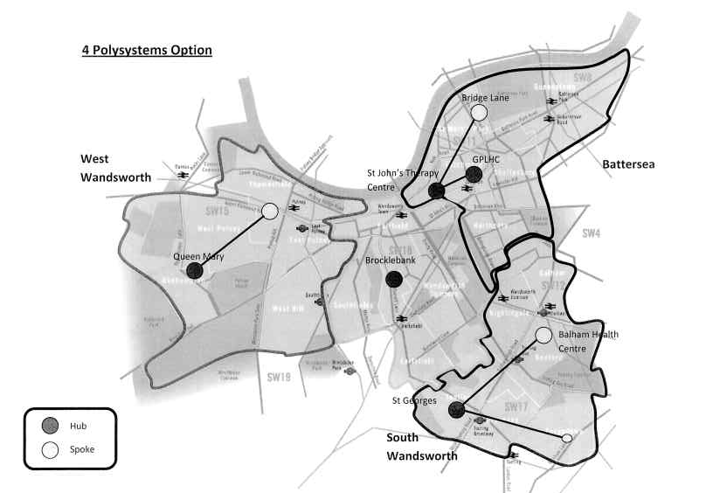

This variable prevalence can also been broken down by the potential polysystems in Wandsworth, revealing a gradient of prevalence across each of the polysystems.

Figure

*Source: QOF data, NHS Information Centre, 2008-9*

## Observed Vs Modelled Prevalence

Another method to measure prevalence is to use synthetic estimates of prevalence calculated from data from the 2001 Health Survey for England. This has been done by the Eastern Region Public Health Observatory (ERPHO for all regions of England. In this model, prevalence been adjusted for the adjusted for the age, sex, ethnicity, smoking status and deprivation of the local population.

According to this methodology, **the estimated COPD prevalence for the borough of Wandsworth was 7,409 in 2008**. This is more than 2.7 times the prevalence from QOF data, suggesting that there is a considerable level of under diagnosis in the community.

Modelled prevalence figures are also available at the practice level, and allow comparison of observed versus modelled prevalence[15] (see Figure 3).

Figure

*Source: QOF data, NHS Information Centre, 2008-9 and ERPHO, 2008-9*

These data demonstrate the existence of variable gaps between observed and expected prevalence in many of the practices. Of concern are a number of practices with very low observed prevalence, but relatively high modelled prevalence. This might suggest variable levels of diagnosis between the practices, and may suggest a list of practices that would benefit from strengthening their diagnostic process and GP awareness.

Looking at the different prevalence by ward, as demonstrated in the maps below, reveals different patterns of prevalence if modelled or measured values are used. In both maps the north and far west of the ward appear to have high prevalence. The modelled prevalence, however, reveals an area of potential high prevalence in the south of the borough, in the more deprived wards of Tooting, Graveney and Furzedown, which do not appear to have been detected by the QOF. Further work would be useful to evaluate whether the model or the QOF records are inaccurate.

This matches national observations, where the overall prevalence of COPD in England is estimated as 1.3 million, of whom as many as 600,000 people may be unaware of their diagnosis, therefore missing the opportunity of benefiting from early interventions[16].

Figure Prevalence observed by QOF (% of total population on COPD register) (2008-9)

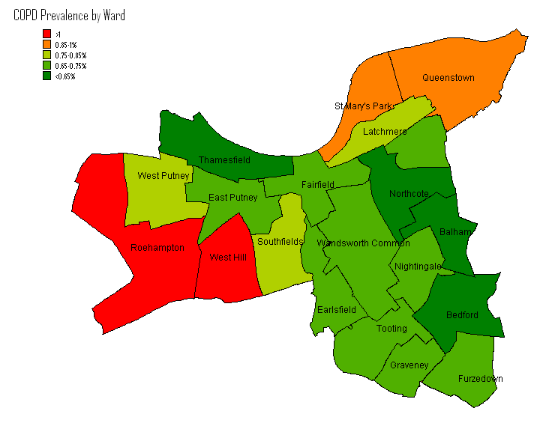

Figure Modelled COPD Prevalence from ERPHO (2008-9) (NB different scales)

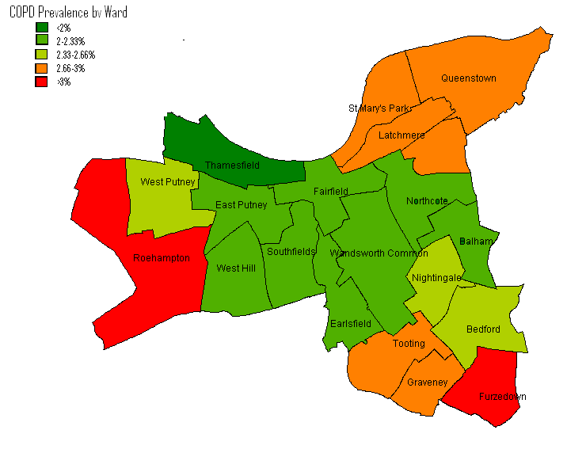

## Future Projections of Prevalence

The Eastern Regional Public Health Observatory has developed estimates and projections of the prevalence of COPD, based on a model developed by Nacul & Soljak3. These projections provide values until 2020.

Figure 6 demonstrates that prevalence both nationally and in Wandsworth is predicted to remain remarkably constant over the next ten years. This figure also demonstrates the lower prevalence in Wandsworth compared to many of the other PCTs in its cluster. This is likely to be a result of the younger population of Wandsworth.

Figure

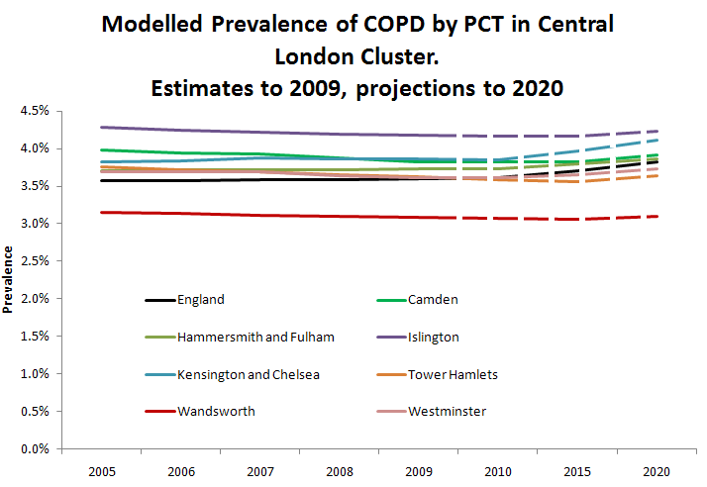

Source: ERPHO, 2009[17]

This pattern of prevalence is observed because the increasing proportion of elderly people is countered by reduced levels of smoking in the population, leading to a relatively flat prevalence of the disease overall in the population over time.

## Prevalence and inequalities

An analysis of COPD prevalence at the practice level compared with the practice level of deprivation (measured as the local index of multiple deprivation) reveals a very weak association between increasing deprivation and increasing prevalence of the disease.

Figure

*Source: QOF data, NHS Information Centre, 2008-9 and London Health Observatory 2009*

At the national level, a similar positive correlation between increasing deprivation and increasing prevalence of COPD is observed, but with a stronger correlation. This is mainly due to the relationship between level of deprivation and prevalence of smoking, the main risk factor for COPD.

### Prevalence and ethnicity

A modelled analysis of prevalence by ethnicity, calculated from Eastern Region model, reveals a variation in prevalence between different ethnic groups. The black population has the highest prevalence (4.6%), the white population has a prevalence of (3.0%), and the Asian population has the lowest prevalence (2.6%).

Figure

*Source: London Health Observatory Health Needs Assessment Toolkit, 2009*

The observed variation in modelled prevalence between different ethnic groups is due to different risk factor distributions between ethnic groups. The main contributing risk factors are smoking and deprivation levels, both of which are higher in the Black population than White and Asian populations.

The difference between modelled COPD prevalence in England compared to Wandsworth is because of local differences in age and risk factor distribution among the various ethnic populations in Wandsworth compared to the national average.

## Risk factors

### Smoking

Smoking is thought to have an attributable fraction of between 80 and 90% for COPD[18]. Understanding the pattern of smoking in Wandsworth is therefore important to understanding the pattern of disease.

Data on smoking prevalence is available from the QOF database, or by using modelled estimates. In comparison with other boroughs, Wandsworth sits at around the London regional average figure when using modelled estimates (Figure 9).

Figure

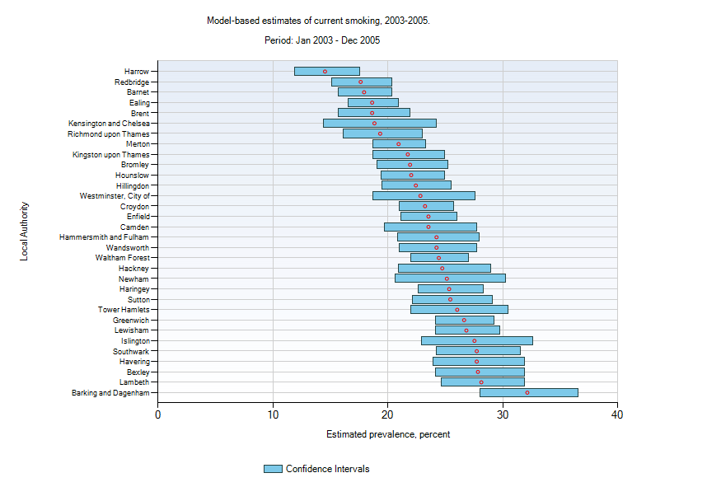

*Source: London Health Observatory*

Looking at QOF data at the practice level, it is noticeable that there is variation in recorded smoking prevalence from less that 10% to greater than 20%. A comparison between smoking prevalence and social deprivation (Figure 11) reveals a weak positive correlation between increasing deprivation and increasing smoking prevalence. This is in line with existing and historical literature which notes higher levels of smoking at lower levels of socio-economic status. On a national level, this positive correlation is observed more strongly.

These data for prevalence and deprivation are also plotted on maps in Figures 13 and 14.

Figure

*Source: QOF, 2008-9*

The following chart also shows that smoking cessation advice rates in Wandsworth are just below the national average, with 91.9% of patients with disease worsened by smoking having been offered smoking cessation advice, compared to a figure of 92.9% nationally.

Figure

Source: NCHOD, 2008-9

Figure 12 Smoking Prevalence in Wandsworth

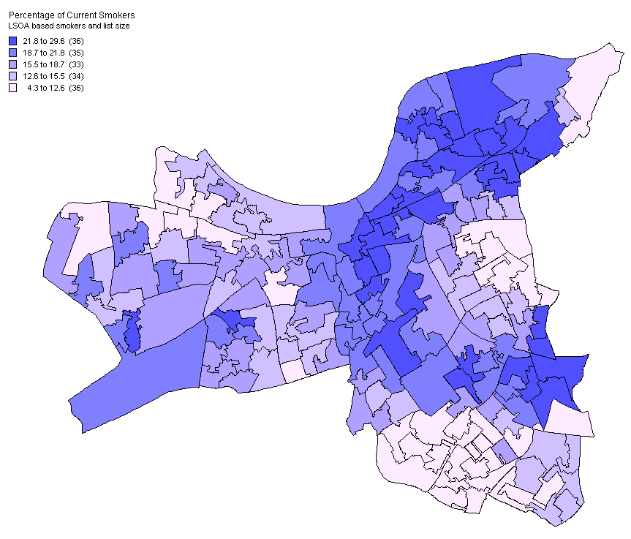

*Source: London Health Observatory 2008*

Figure 13 Deprivation in Wandsworth

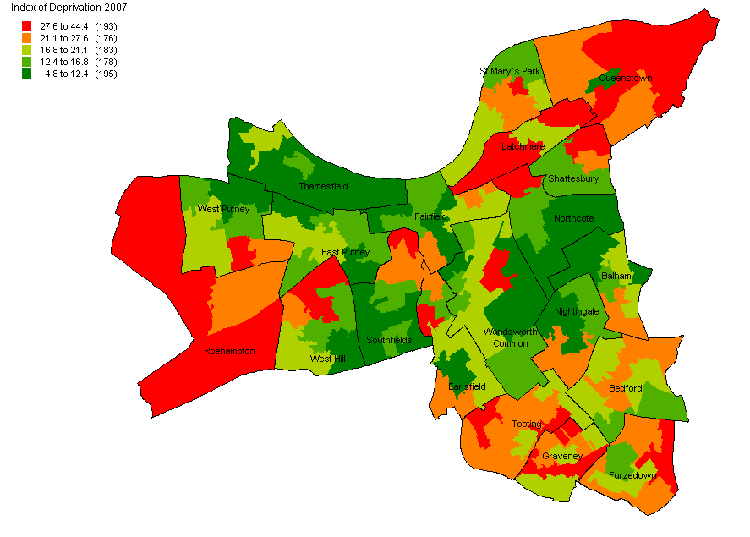

*Source: London Health Observatory 2008*

## Mortality

Data from the National Centre for Health Outcomes, calculated from death certificates, allows comparison of mortality rates between Wandsworth, the national, regional averages, and the average figure in demographically similar PCTs.

In Figure 14 we see that overall, mortality rates in Wandsworth are lower than the London and England averages, and similar to the cluster average. However, mortality in the older age groups is higher than the average in Wandsworth.

Figure

*Source: NCHOD, 2005-7*

Mortality rates from COPD are noticable in their consistancy with observed patterns at the London and national levels. It is not however, possible to tell if there is any statistically significant difference from these figures.

Another figure (Figure 15) from the LHO allows us to look at mortality rates across the London Boroughs. Here we see that Wandsworth sits close to the London average, and certainly not significantly different from the average.

Figure

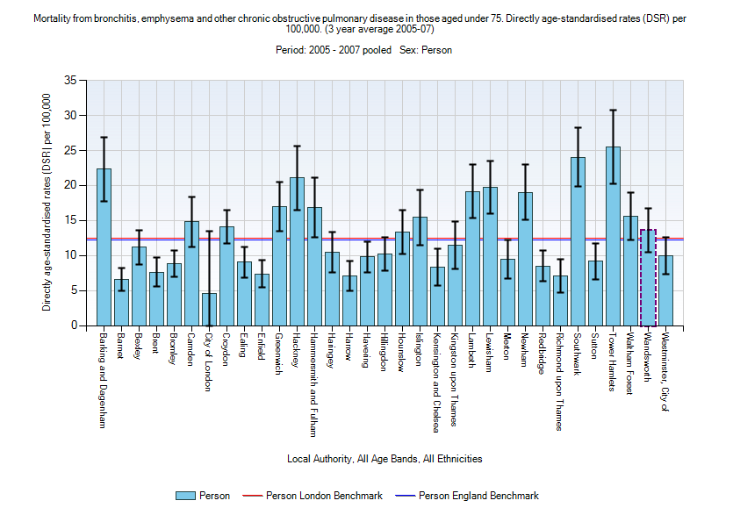

*Source: London Health Observatory, 2005-2007*

Patterns of change in mortality over time demonstrate that Wandsworth is following the established national patterns, with mortality in males falling considerably over the past 15 years, while mortality in females has remained roughly constant (Figure 16). This gender specific pattern is thought to be related to changes in risk factor exposure between genders. The smoking rate in men has been falling considerably faster than smoking rate in women over the last 40 years.

Figure

*Source: NCHOD, 2009*

Figure

*Source: NCHOD, 2009*

The current level of deaths in Wandsworth from COPD per year is recorded as 90 in 2008, although COPD is likely to be a contributory factor is a considerably large number of deaths. The breakdown of the age and gender of these deaths can be seen in Table 2.

Table Numbers of COPD deaths in Wandsworth (2008)

|  |  |  |  |  |  |  |  |
| --- | --- | --- | --- | --- | --- | --- | --- |
|  | Total | 1-4  years | 5-14  years | 15-34  years | 35-64  years | 65-74  years | 75+  years |
| MALES | 41 | 0 | 0 | 0 | * | * | 22 |
| FEMALES | 49 | 0 | 0 | 0 | * | * | 41 |
| PERSONS | 90 | 0 | 0 | 0 | * | * | 63 |

*Source: NCHOD, 2009*

*\* represents numbers that have been suppressed for reasons of confidentiality due to small numbers.*

# The COPD Service Pathway in Wandsworth

## Service Pathway

Wandsworth has a stated service pathway for people with COPD. This is adapted from the pathway set out by the East of England SHA.

The service is based around three escalating levels of clinical care: Primary Care, Specialist care and supra specialist care. At each stage there are suggested diagnostic procedures and treatments that should be decided by the patient and clinician in a shared decision making process on as a part of a care plan.

Community care is delivered by in general practice, supplemented by a team of 4.4 WTE equivalent specialist respiratory nurses. These specialist nurses work closely with GPs and the Respiratory Service at St George’s Hospital.

The respiratory nurses run a network of clinics at a number of practices around the borough. They work with named GP practices, to develop skills of practice teams in managing patients with COPD. They also work with less well patients at home, managing acute exacerbations, working with patients recently discharged from the hospital, and monitoring at risk patients, including through the use of the Telehealth service.

The Respiratory Service at St George’s Hospital is delivered by a team of specialist clinicians, included a nurse consultant, specialist nurses, respiratory consultants and a wider team of associated health professionals.

## Evidence based guidance

### NICE Guidance

Established standards of Care for COPD in primary care have been established, in the form of NICE guidance**[19]**. This guidance includes a number of factors, including the initial diagnosis and management of the disease, going on to cover management of acute exacerbations. NICE guidance is available in Appendix 1.

Wandsworth also has specific protocols for the management of stable COPD and acute exacerbations of COPD. These are set out in the Appendix 2. These protocols are designed to incorporate the national NICE guidance.

## NICE Priorities

The following areas were highlighted by the NICE guidance as priorities for implementation:

**Diagnose COPD**

* A diagnosis of COPD should be considered in patients over the age of 35 who have a risk factor (generally smoking) and who present with exertional breathlessness, chronic cough, regular sputum production, frequent winter ‘bronchitis’ or wheeze.
* The presence of airflow obstruction should be confirmed by performing spirometry. All health professionals managing patients with COPD should have access to spirometry and be competent in the interpretation of the results.

**Stop smoking**

* Encouraging patients with COPD to stop smoking is one of the most important components of their management. All COPD patients still smoking, regardless of age, should be encouraged to stop, and offered help to do so, at every opportunity.

**Effective inhaled therapy**

* Long-acting inhaled bronchodilators (beta2-agonists or anticholinergics) should be used to control symptoms and improve exercise capacity in patients who continue to experience problems despite the use of short-acting drugs.
* Inhaled corticosteroids should be added to long-acting bronchodilators to decrease exacerbation frequency in patients with an FEV1 less than or equal to 50% predicted who have had two or more exacerbations requiring treatment with antibiotics or oral corticosteroids in a 12-month period.

**Pulmonary rehabilitation for all who need it**

* Pulmonary rehabilitation should be made available to all appropriate patients with COPD.

**Use non-invasive ventilation**

* Non-invasive ventilation (NIV) should be used as the treatment of choice for persistent hypercapnic ventilatory failure during exacerbations not responding to medical therapy. It should be delivered by staff trained in its application, experienced in its use and aware of its limitations.
* When patients are started on NIV, there should be a clear plan covering what to do in the event of deterioration and ceilings of therapy should be agreed.

**Manage exacerbations**

* The frequency of exacerbations should be reduced by appropriate use of inhaled corticosteroids and bronchodilators, and vaccinations.
* The impact of exacerbations should be minimised by:
  + giving self-management advice on responding promptly to the symptoms of an exacerbation
  + starting appropriate treatment with oral steroids and/or antibiotics
  + use of NIV when indicated
  + use of hospital-at-home or assisted-discharge schemes.

**Multidisciplinary working**

• COPD care should be delivered by a multidisciplinary team.

Since the introduction of the NICE guidance on the diagnosis and management of the disease, it has issued further specific guidance on the issues of early discharge and pulmonary rehabilitation.

**Early assisted discharge schemes**

NICE has set out specific criteria for the commissioning of early assisted discharged schemes[20].

The key components of an effective assisted-discharge service for patients with chronic obstructive pulmonary disease (COPD) are:

* full assessment of the patient within secondary care to determine if they are appropriate to receive assisted-discharge
* support in the community for patients deemed appropriate for assisted-discharge
* developing a high-quality assisted-discharge service.

**Pulmonary rehabilitation**

NICE has set out specific criteria for the provision of pulmonary rehab services schemes[21].

# Measuring performance of services

The performance of the COPD services can be measured through evaluation of a number of indicators. These include both outcome indicators and process indicators. Some of these indicators include data derived at the general practice level from the QOF system; other indicators included data from hospitals about inpatient admissions from the Hospital Episode Statistics.

Different measures are available to consider different parts of service performance. In some areas, there is a lack of data about the quality of the service available.

## Diagnosis

### Key Performance Measure: FEV1 Measured

Forced expiratory Volume over 1 second is a key test for diagnosis of COPD. It is useful to compare restrictive versus obstructive lung disease, and as a measure of degree of obstruction. Ideally, all patients suspected of, or diagnosed with COPD, should undergo spirometry. Those patients with known disease benefit from monitoring of FEV1, to monitor disease progression.

As the proportion of patients with a diagnosis of COPD with a recent measure of FEV1 is measured routinely in the QOF system, data is available on a practice by practice level.

Figure

Source: Quality and Outcomes Framework, NHS information Centre, 2008-2009

It is also possible to observe an inverse correlation between increasing FEV1 measurement and deprivation index of practices.

Here appetent is observed with central, relatively flat plateau of moderate performance, with a small number of practices that perform very well, and a small number that perform considerably less well.

Figure

*Source: Quality and Outcomes Framework, NHS information Centre, 2008-2009*

*and NHS Comparators 2008-9*

It is also possible to create a chart of aggregated QOF scores, looking across each of the clinical indicators relate to COPD, and comparing scores. Again a pattern of variation in performance occurs. It is noticeable that while some practices are poor at only one or two indicators, there are a number of practices that are consistently poor performing. These practices are potential areas for concern, and might benefit from target education or audit, to better understand their current practices, and improve the quality of care they provide.

### Key Performance Measure: Post Bronchodilator spirometry

NICE guidance suggests that a diagnosis of COPD would be confirmed by the used off post bronchodilator spirometry, which acts to differentiate reversible from irreversible airway obstruction.

Figure 20 shows the variation in QOF achievement in this area. It is noticeable that in these clinical criteria many practices score 100%, while a number of practices (8) score 0%. It would be useful to investigate this phenomenon, and see if these practices truly are not providing this service, or the service is being provided elsewhere, or the practices are recording what they have done incorrectly.

Figure

*Source: Quality and Outcomes Framework, NHS information Centre, 2008-2009*

As these interventions are evidence based, it is likely that those scoring higher score on the QOF will provide higher quality care, and lead to better outcomes.

## Chronic Disease Management

Data on chronic disease management would ideally look at the proportion of patients diagnosed with COPD who are prescribed the appropriate medications. The current data collected by QOF does not measure this, although a useful proxy is STAR-PU (specific therapeutic group age-sex related prescribing units, a standardized measure of prescribing for COPD. An analysis at the practice level shows that there is a correlation between increasing prevalence of disease and increasing use of appropriate medications. There are however some outliers, including one practice which prescribes higher than average amounts of the drug, despite a lower than average prevalence, and two practices which prescribe relatively low levels of the appropriate drugs, despite higher prevalence levels.

Figure  Key measure: Prescribing data

Source: NHS Comparators 2008-9 and QOF 2008-9

### Key Measure: Inhaler Technique

The QOF system measures the percentage of patients in each practice who have their inhaler technique assessed. Figure 22 demonstrates that levels are high in most practices, but does identify 6 practices with levels less than 80%.

Figure

*Source: Quality and Outcomes Framework, NHS Information Centre, 2008-2009*

### Key Measure: Influenza immunization rates

Patients with COPD are in a higher risk group for influenza and other communicable disease. Evidence based guidance suggests that patients with COPD should be offered the influenza vaccine. Mortality rates for those with COPD from influenza are higher than those who do not have COPD. Figure 23 demonstrates variation between practices, of which 8 score less than 80% and 3 less than 70%.

Figure

*Source: Quality and Outcomes Framework, NHS Information Centre, 2008-2009*

## Aggregated measures

A number of different measures can be aggregated together, to provide a snapshot of overall performance at the general practice level. It is noticeable that there are a number of PCTs that perform poorly across a number of indicators. These are practices that might benefit from targeted education around TB diagnosis and management.

*Source: QOF data, NHS Information Centre, 2008-9*

## Management of Acute Exacerbations

### Key measure: Emergency Admissions

Emergency admission rates are a useful process measure that reflects the quality of chronic disease management in the community. All patients with COPD are exposed to risk of acute exacerbations, requiring hospital admission, but ideally there should be developed plans in place in the community for when exacerbations takes place, so that patients either have pre-prescribed medication available, or have rapid access to primary care including the support of respiratory specialist nurses. Higher rates of emergency admission suggest poorer management of the disease in the community.

An analysis of emergency admission rates reveals that admissions per 1000 people are higher in Wandsworth (2.3 per 1,000) than the national average (2.0 per 1,000), but lower than the cluster average (2.7 per 1,000).

Figure

*Source: NHS comparators, NHS Information Centre, 2008-9*

Again, there is also a pattern of variation between individual practices. Using data from NHS comparators, six practices can be identified as having emergency admission rates for patients with COPD that are significantly higher than both the Wandsworth and the national average.

Figure

*Source: NHS comparators, NHS Information Centre, 2008-9*

There is considerable variation in emergency admission rates between practices across the borough, suggesting that some GPs are managing their patients in the community better that others. It is noticeable that six practices have an admission rate that is significantly higher than the Wandsworth average.

Figure

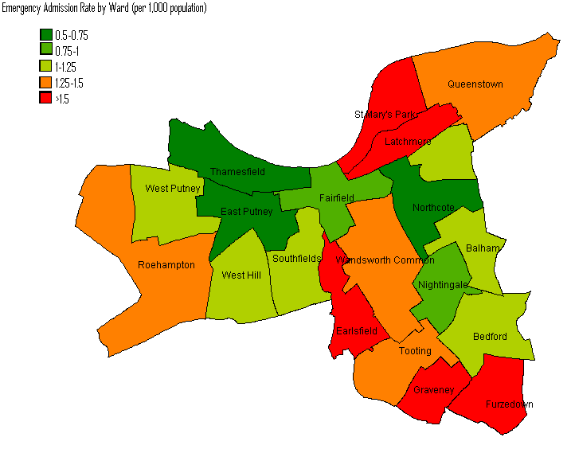

Source: NHS Comparators, NHS Information Centre, 2008-9

Figure

Figure 27 indicates that some of those practices with high emergency admission rates are also those with poor achievement on the QOF score. Conversely, some practices with low admission rates also have low QOF scores, so it is hard to make an association between the two variables.

Those practices with the highest admission rates are also not necessarily the most deprived (as demonstrated in Figure 28). It is hard to see a positive correlation between deprivation and emergency admission.

Figure

*Source: NHS Comparators 2008-2009, LHO 2009*

## Discharge services

### Key measure: Length of Stay

Length of stay in hospital for acute admissions is a useful process measure that reflects on the quality of discharge management in the hospital. Ideally patients would be diagnosed from hospital as soon as possible, but only once the current episode has been adequately treated, and when a robust discharge plan is in place, including appropriate levels of support in the community.

Length of stay in hospital with COPD in Wandsworth does appear to be higher than the London average. The cluster average length of stay is higher than both London and national averages, perhaps reflecting the higher proportion of complex cases and deprivation in the central London cluster, but the Wandsworth average is still just statistically significantly above this.

Source: NHS Comparators, NHS Information Centre, 2008-9

Looking at data at the practice level, it possible to see that there are a small number of practices that have a much higher length of stay than the others, including one significant outlier (Northcote Road Surgery). In part this is a reflection of very small numbers of cases, or even individuals, in some places that have spent a prolonged period in hospital. However, in some other practices with long stays there have been a number of different admission, perhaps reflecting a systematic difficulty in arranging discharge to certain locations.

*Source: NHS Comparators, NHS Information Centre, 2008-9*

## Key Measure: Readmission rates

Readmission rates for patients with COPD are a useful process measure of the quality of discharge coordination services, and support in the community. A well coordinated service would aim to keep readmission to a low level, as patients are only diagnosed when their initial symptoms are adequately treated, and they are discharged into a secure community environment, where appropriate levels of care are available.

Figure 27 shows that Wandsworth does well, with readmission rates lower than the London and England Average. This suggests that although our patients are admitted for slightly longer than average, the extra time is hospital is put to good use, as our discharges are better planned and supported, and less discharges fail and require readmission to hospital.

Figure

*Source: NHS Comparators, NHS Information Centre, 2008-9*

# Pulmonary Rehabilitation

It is thought that it the new national strategy for pulmonary rehabilitation will call for increased availability of pulmonary rehabilitation. A detailed report on this has been done on this by Piers Simey, at St George’s Hospital.

The key findings of this report are that the total current estimated capacity of these services is 168 (134 at St Georges and 34 at Queen Mary’s)people per year, while the total estimated annual need for these services in Wandsworth is at least 666, and possibly up to 1638, people with COPD. This means that there is at least a fourfold gap between service need and service capacity for Wandsworth residents.

This report also states that there is currently a 3 month average waiting list for pulmonary rehabilitation at St George’s (our largest provider), with a similar figure at Queen Mary’s.

The report goes on to recommend that that extra pulmonary rehab capacity is commissioned in Wandsworth from 2010/11 with ongoing service evaluation.

It further states that:

* Capacity needs to increase during 2010/11 to meet the needs of those already identified with COPD. Capacity will also need to increase in future years as the case finding interventions in the COPD National Strategy take effect
* Local rehabilitation services need to demonstrate that they are effective
* Services need to be geographically accessible and promoted in primary care
* Extra capacity should include two new programmes in the community and an extra class at St George’s.

For further details please refer to the report: Pulmonary Rehabilitation Needs Assessment in Wandsworth, by Piers Simey.

# Assisted discharge

The respiratory team at St George’s Hospital endeavour to provide a discharge service to those patients admitted to the hospital with a known diagnosis of COPD. However they are aware that they are not able to identify all such patients admitted. The team is in the process of working towards a structured assisted discharge service working to NICE standards. Further work will need to be undertaken to map the existing service to NICE guidance.

# Service costs

Exact data on expenditure on COPD is difficult to calculate. It is possible to calculate costs in secondary care associated with COPD related admission from the payments by results tariff. One method which might also an estimation of costing is the use of programme budgets.

Programme budgets are a retrospective analysis of expenditure, which can be used to compare relative expenditure and relative outcomes. In this case, Wandsworth PCT has been compared with the six demographically similar PCTs in its cluster. Using this methodology, it appears that NHS Wandsworth spends less than the national average per head on COPD, but more than the cluster average.

Table

|  |  |  |  |  |
| --- | --- | --- | --- | --- |
|  | **Expenditure**  **(£ per person)**  **on respiratory disease**  **2008/9** | **Expenditure**  **(£ per person)**  **on COPD**  **2008/9** | **Prevalence of COPD**  **2008/9** | **Mortality from bronchitis, emphysema and other COPD**  **2005/7** |
| **England** | 77.97 | **12.70** | 1.54 | 12.17 |
| **London** | 65.61 | **9.92** | 0.97 | 12.40 |
| **Cluster** | 64.65 | **9.60** | 1.00 | 14.22 |
| **Tower Hamlets** | 59.27 | **11.01** | 1.19 | 25.49 |
| **Hammersmith and Fulham** | 80.50 | **4.91** | 1.02 | 16.88 |
| **Camden** | 62.02 | **9.25** | 0.97 | 14.82 |
| **Islington** | 68.80 | **11.54** | 1.25 | 15.42 |
| **Kensington and Chelsea** | 48.19 | **7.78** | 0.98 | 8.37 |
| **Westminster** | 68.86 | **8.61** | 0.78 | 9.95 |
| **Wandsworth** | **66.37** | **12.42** | **0.82** | **13.60** |

*Source: NHS programme Budgeting Tool, 2008/9.*

*Using unified weighted population and total expenditure without DFT adjustment***.**

Comparative figure on COPD specific spend across the London boroughs, calculated by NHS comparators according to Programme Budgeting codes, demonstrates that the spent on COPD patients per 1,000 people is slightly higher than the London and national average.

Figure

*Source: NHS Comparators, NHS Information Centre, 2008-9*

# Elements of innovative Service Provision in NHS Wandsworth

## Respiratory Nurse Specialist Clinics

At present the respiratory specialist nurses perform regular COPD clinics at a number of sites around the borough. These sites are:

* Queen Mary’s Hospital
* Brocklebank Surgery
* St John’s Surgery
* Balham Health Centre
* Tudor Lodge

## Telehealth

NHS Wandsworth has developed a telehealth service for the monitoring of patients with certain sever chronic conditions, allowing their health status at home to be monitored from a distance using new technology. This service is available to a limited number of COPD patients, as well as patients with conditions such as cardiac failure.

At present data on the number of patients treated with the telehealth system ho have COPD as their diagnosis is not available. Anecdotal evidence suggests that the telehealth equipment is underutilized relative to its potential capacity at present. Further work to map the usage of telehealth, and an evaluation of its effectiveness would be useful.

## Virtual Wards

NHS Wandsworth is currently running an innovative community virtual ward, operated by specifically employed GPs, in close collaboration with community matrons and the wider GP community. This service has been running for less than a year, and currently has 108 patients registered to the service. An early analysis suggests that 27 patient have a diagnosis of COPD, among other co morbidities, representing 25% of patients on the virtual ward.

Patients in the virtual ward are selected by referral, or by predictive risk modelling, and are thought likely to represent those patients most at risk of admission to hospital. A formal evaluation of the effectiveness of this service is ongoing, but preliminary data suggests that the GPs running the virtual wards are currently estimating that they are preventing approximate 5 acute COPD exacerbation admissions each month (November 2008- January 2010).

## On call nursing team

In a recent service innovation, the respiratory specialist nurse team now provides an on call services during the day on Saturdays. This is a new service, and as such data on usage is currently unavailable, but it provides an extra layer of support for out of hours services over the weekend.

# Views from local stakeholders

Discussions were held with healthcare professionals in Wandsworth, including community respiratory nurses, hospital chest clinic staff and commissioning staff, who work on COPD to gather their views about the services. The following comments were gathered during a series of semi-structured interviews with this group.

## Things that are done well:

There is a good level of communication between respiratory specialist nurses, most GPs and the chest clinic.

The current service has proved open to new innovative ideas, such as the use of telehealth and the development of the weekend on call service.

Recruitment and retention of specialist staff has gone well, leading to a group of knowledgeable local respiratory nurses. This is in contrast to several other boroughs that have had problems recruiting sufficient high quality and specialist staff.

Discharge coordination has been improved by the presence of an electronic patient record that can be accessed from the community, but this is only available from some hospital (SGH) but not other (CWM).

## Areas that could be improved

More resources to provide an assisted discharge service from the hospital would help to improve care.

Community staff would like to time to be proactive and call the less well patients, rather than reactively waiting for patients to reach crisis point.

There are a small number of general practices that have been resistant or unresponsive to messages about COPD management.

The current staff balance sometimes means highly skilled staff are using their time inefficiently on less skilled tasks. Activities highlighted as inefficient included checking inhaler technique, setting up telehealth system and checking vital signs. The specialist nursing tem might benefit from a HCA/technician, so time could be focused on more specialist skills.

Waiting times for Pulmonary Rehabilitation services are too long at present (sometimes 6-12 weeks).

Staff would like more time to evaluate current work, including the effectiveness of specialist clinics, but do not have time at present due to workload.

# Local Stakeholders

Local stakeholders in the process of TB diagnosis, treatment and management include:

* Patients
* The community respiratory nurse team
* General practitioners and practice nurses
* Respiratory services at local hospitals (significantly at St George’s Hospital, but also at Chelsea and Westminster, Kingston Hospital, the Royal Brompton, amongst others)
* Out of hours GPs
* NHS Wandsworth, including the Wandsworth “virtual ward”
* Wandsworth Borough Council (and social services in particular)
* Pulmonary rehabilitation services
* Stop smoking services

# Policy context

In considering the local health needs in relation to COPD in Wandsworth, it is also important to consider the various frameworks, initiatives and agendas that are also either currently in place or likely to become significant in the future.

## High Quality Care for All

Lord Darzi’s report “High Quality Care for All” renewed a focus on quality of care in the NHS. It called for improved quality of treatment for long term conditions, with an increased emphasis on personalized care. In also called for innovation of services, and moving services that have previously been provided in hospital to be moved into community settings. Although initial emphasis on moving care in the community has focussed on other long term conditions, including diabetes and cardiovascular care, it is likely that there will be a significant requirement to move a proportion of specialist provision of COPD care into community settings. No target has yet been set for COPD care provision moving closer to home by WPCT.

## Polysystems

As a part of the healthcare for London consultation, there has been a move towards clustering primary care services in functional units larger than traditional GP practices, offering a more diverse range of services including diagnostics, and some services previously provided in hospital settings, such as speciality out-patient appointments.

This has taken the form initially of polyclinics, which have now transformed to polysystems. It is anticipate that NHS Wandsworth will have four polysystems. These will have an impact of COPD services, in that it will be important to consider the epidemiology of COPD within these different polysystems, and ensure that services available are appropriate to these more local populations.

## New National Service Framework

The forthcoming National Strategy for Chronic Obstructive Pulmonary Disease seeks to ensure that everyone diagnosed with COPD receives high quality health and social care services. It is a ten year strategy that will tackle health inequalities by ensuring better prevention strategies and quicker identification of those at risk. The National Strategy will go on to articulate further national cares standards, including in hospital and for rehabilitation services, although the exact nature of this guidance is not known.

# Analysis and Discussion

The burden of COPD in Wandsworth is not as high as in many other parts of the country. This is driven by the demography of the population of the borough, with large numbers of transient young people, and a much smaller elderly population.

Despite this lower than average prevalence, COPD remains a common disease, affecting a large number of people in the borough (over 2740, and very likely many more), and a disease which accounts for considerable spending by the PCT. Mortality rates for COPD in Wandsworth are similar to the national average.

The services provided by the borough to manage COPD are well developed, with good links between primary and secondary care, a well established community nursing team, and a clearly defined pathway. Significant proportions of care are nurse led, in settings in primary care that are likely to be more convenient to patients than accessing services in hospitals.

NHS Wandsworth has clearly defined standards of care that it hopes to achieve, with established evidence based protocols, which are based on National guidance. In this respect, Wandsworth knows the level of service that it aims to achieve. However it does not have complete systems in place to monitor whether these standards are being met.

When the borough is examined at a smaller geographical unit scale, a number of concerning features arise. There is a mismatch between observed COPD diagnosis, and those predicted from mathematical modelling. Although this is the case in all PCTs nationally, it is noticeable that there is considerable variation on a practice by practice level in Wandsworth. There is a group of practices that are predicted to have high levels of COPD, but in which only low levels are diagnosed. This suggests that there are sporadic areas of under diagnosis of the disease.

Data on service performance is available, but not complete. Data is available from national sources to allow evaluation of some aspects of services at the primary and secondary level, but there are few local mechanisms monitor levels of activity in local services and to audit services.

The QOF data provides useful indicators of a number of areas of performance, although caution must be taken in their interpretation. These data reveal that many practices are performing at a high level. They also however reveal variation in the quality of care provided by individual practices, with some achieving consistently low scores across a number of different indicators. These practices may be a target for closer audit of performance by the PCT, and potential education programmes to ensure that their management of cases is in line with best practice.

Similarly, only a limited number of measures are available from national acute care data sets. The new data provided by NHS comparators provides several interesting streams of data about admission rates, length of stay and readmission rates.

The variation in emergency admission rate observed is a cause for concern. In particular, the six practices with a statistically significantly level of emergency admission compared to the average are candidates for investigation and improvement. The fact that some of the practices with highest emergency admission rates are also some of the practices with the lowest QOF scores is further evidence that some practices are underperforming.

It is interesting to note that while length of stay in hospital in Wandsworth is above average, readmission rates are lower than average, suggesting good and bad points about hospital management and discharge planning. There is potential for the improvement of discharge services.

In both treatment settings there are no systems in place to monitor compliance of treatment practice with the care pathway standards, as defined by NICE and local policy. This might be another potential area for audit.

There is variability on performance across all of the polysystems. The potential South Wandsworth Polysystem is notable in its high levels of variability in performance. This presents a potential target for polysystem/local action to improve areas in what has historically been a poorer and more deprived part of the borough.

Some aspects of the care pathway, although innovative, appear to have not been utilized as much as they potentially could. There is a lack of data about activity, including usage patterns for the nurse led clinics, telehealth and the weekend on call service. It would be sensible to generate data about this activity before making further recommendations about these services.

# Recommendations to improve services

* This report highlights several practices which seem to be performing less well than their peers in the management of COPD across a number of objective indicators. There is a need to understand this variation, and for primary care commissioning to work with the more poorly performing practices to improve performance.
* This report has highlighted gaps in the diagnosis of COPD, particularly in the observed versus expected prevalence of COPD in the community. NHS Wandsworth should work with all GPs, but particularly those with a large “diagnostic gap” to ensure that diagnostic processes are strengthened.
* Existing practice based commissioning clusters or potential future polysystem should take local action to deal with specific local areas of poor performance. This applies in particular to the South Wandsworth Polysystem, which has higher levels of variability in performance than other areas.
* The PCT needs to work with its partners at St George’s Hospital to strengthen the nature of discharge provision, ideally in the form of an assisted discharge service, commissioned to NICE standards. This may lead to shorter stays in hospital, and lower readmission rates.
* The PCT needs to consider expanding existing provision of pulmonary rehabilitation services, in order to meet the increasingly unmet need for this service as outlined in the separate needs assessment.
* The PCT should work with its community respiratory team to develop systems to generate stronger measures of process and activity around COPD service provision. In particular, it should collect and report data on levels of activity at specialist clinics and during the new weekend on call.
* Audits of COPD management should be undertaken in primary and secondary care, to measure compliance with local and NICE guidance.
* Given the prevalence of the main risk factor for COPD, smoking, in the borough of Wandsworth, the PCT should place continued emphasis on the development of smoking cessation services at the primary care level, and also aim to improve health promotion activities in hospitals.

# Appendix 1: Management Protocols NICE

## Diagnosis



## Management of Acute Exacerbations



# Appendix 2: Management Protocols NHSW

## NHSW protocol for the management of stable COPD

Figure

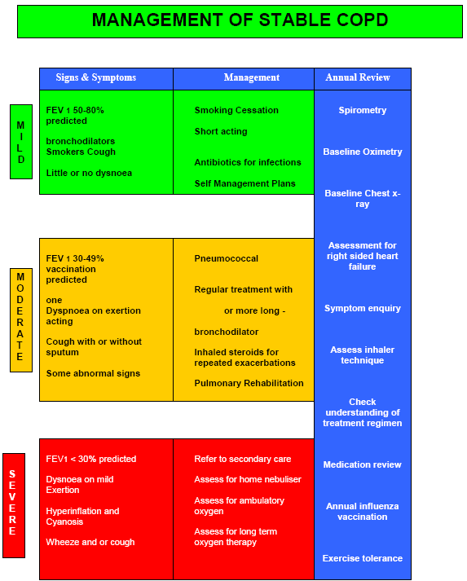

## NHSW protocol for the management of exacerbations of COPD

Figure



## Acknowledgements

We would like to thank the following who gave their time to contribute towards the production of this report:

Jo Jackson, Head of Urgent Care, Community Services Wandsworth

Julie Mariaki, Community Respiratory Specialist Nurse, NHS Wandsworth

Melissa Cottington, Public Health Research Officer, NHS Wandsworth

Nikki Davies, Community Respiratory Specialist Nurse, NHS Wandsworth

Piers Simey, Public Health Registrar, St George’s Healthcare Trust

Sam Prigmore, Respiratory Nurse Consultant, St George’s Healthcare Trust

Sara Corben, Public Health Consultant, NHS Croydon

Seth Rankin, General Practitioner, Wandsworth Medical Centre

Vanessa Flagg, Long Term Conditions Development Manager, NHS Wandsworth

Wendy Kong, Community Respiratory Specialist Nurse, NHS Wandsworth

# References

1. World Health Organization: COPD Definition (Accessed on 30/10/09:

   <http://www.who.int/respiratory/copd/definition/en/index.html>)
2. Gruffydd-Jones K. [A national strategy for the management of chronic obstructive pulmonary disease (COPD) in England: aiming to improve the quality of care for patients.](http://www.ncbi.nlm.nih.gov/pubmed/19137200) Prim Care Respir J. 2008 Dec;17 Suppl 1:S1-8.
3. # [Nacul LC](http://www.ncbi.nlm.nih.gov/pubmed?term=%22Nacul%20LC%22%5BAuthor%5D), [Soljak M](http://www.ncbi.nlm.nih.gov/pubmed?term=%22Soljak%20M%22%5BAuthor%5D), [Meade T](http://www.ncbi.nlm.nih.gov/pubmed?term=%22Meade%20T%22%5BAuthor%5D). Model for estimating the population prevalence of chronic obstructive pulmonary disease: cross sectional data from the Health Survey for England. [Popul Health Metr.](javascript:AL_get(this,%20'jour',%20'Popul%20Health%20Metr.');) 2007 Sep 26;5:8.

  
4. Corben S. Croydon Primary Care Trust.
5. [Nacul LC](http://www.ncbi.nlm.nih.gov/pubmed?term=%22Nacul%20LC%22%5BAuthor%5D), [Soljak M](http://www.ncbi.nlm.nih.gov/pubmed?term=%22Soljak%20M%22%5BAuthor%5D), [Meade T](http://www.ncbi.nlm.nih.gov/pubmed?term=%22Meade%20T%22%5BAuthor%5D). Model for estimating the population prevalence of chronic obstructive pulmonary disease: cross sectional data from the Health Survey for England. [Popul Health Metr.](javascript:AL_get(this,%20'jour',%20'Popul%20Health%20Metr.');) 2007 Sep 26;5:8.
6. Calverley PM. [COPD: what is the unmet need?](http://www.ncbi.nlm.nih.gov/pubmed/18794891) Br J Pharmacol. 2008 Oct;155(4):487-93. Epub 2008 Sep 15. Review.
7. Gruffydd-Jones K. [A national strategy for the management of chronic obstructive pulmonary disease (COPD) in England: aiming to improve the quality of care for patients.](http://www.ncbi.nlm.nih.gov/pubmed/19137200) Prim Care Respir J. 2008 Dec;17 Suppl 1:S1-8.
8. Calverley PM. [COPD: what is the unmet need?](http://www.ncbi.nlm.nih.gov/pubmed/18794891) Br J Pharmacol. 2008 Oct;155(4):487-93. Epub 2008 Sep 15. Review.
9. Department of Health: Annual Report of the Chief Medical Officer 2004

   on the state of public health. London ; 2005.
10. Mannino DM. COPD: epidemiology, prevalence, morbidity and mortality, and disease heterogeneity. Chest 2002; 121: Suppl. 5, 121S–126S.
11. Hansell AL: The epidemiology of chronic obstructive pulmonary disease in the UK: spatial and temporal variations. In PhD Thesis Faculty of Medicine of the University of London, Imperial College, St Mary's Campus; 2004.
12. Rushton L: Review of the literature on chronic bronchitis and emphysema and occupational exposure Leicester, UK: Institute of Environmental Health; 2004.
13. Barnes PJ: Molecular genetics of chronic obstructive pulmonary disease. Thorax 1999, 54:245-52.
14. Chatila WM, Wynkoop WA, Vance G, Criner GJ: Smoking patterns in African Americans and Whites with advanced COPD. Chest 2004, 125:15-21.
15. http://www.apho.org.uk/resource/item.aspx?RID=77180
16. [Nacul LC](http://www.ncbi.nlm.nih.gov/pubmed?term=%22Nacul%20LC%22%5BAuthor%5D), [Soljak M](http://www.ncbi.nlm.nih.gov/pubmed?term=%22Soljak%20M%22%5BAuthor%5D), [Meade T](http://www.ncbi.nlm.nih.gov/pubmed?term=%22Meade%20T%22%5BAuthor%5D). Model for estimating the population prevalence of chronic obstructive pulmonary disease: cross sectional data from the Health Survey for England. [Popul Health Metr.](javascript:AL_get(this,%20'jour',%20'Popul%20Health%20Metr.');) 2007 Sep 26;5:8.
17. Modelled estimates and projections of COPD for Local Authorities in England Available at http://www.erpho.org.uk/viewResource.aspx?id=18024
18. Mannino DM. COPD: epidemiology, prevalence, morbidity and mortality, and disease heterogeneity. Chest 2002; 121: Suppl. 5, 121S–126S.
19. Feb 2004 Management of chronic obstructive pulmonary disease in adults in primary and secondary care. Clinical Guideline 12. Developed by the National Collaborating Centre for Chronic Conditions.
20. NICE guidance on commissioning assisted discharge services for COPD. (Accessed at http://www.nice.org.uk/usingguidance/commissioningguides/assdissvcpatientscopd

    /assisteddischarge_service_for_patients_with_copd.jsp)
21. NICE guidance on commisioing pulmonary rehabilitation services. (Accessed at: http://www.nice.org.uk/usingguidance/commissioningguides/pulmonaryrehabilitatio

    nserviceforpatientswithcopd/pulmonary_rehabilitation_service_for_patients_with_c

    opd.jsp)