

***National Cancer Action Team***

**Baseline Assessment of Female Breast Cancer**

**South West London Cancer Network**

**Dyfed Thomas, Public Health Project Manager, NHS Wandsworth/SWLCN**

**Amanda Cranston, Consultant in Public Health, NHS Wandsworth**

**Julia Ozdilli, Service Improvement Lead, SWLCN**

Contents

Acknowledgements 2

Executive Summary 2

1.0 Introduction 2

2.0 Risk Factors 2

2.0 Age 2

2.1 Ethnicity 2

2.2 Multiple Deprivation 2

2.3 Obesity 2

2.4 Smoking 2

2.5 Physical (in) activity 2

2.6 Alcohol consumption 2

3.0 Breast Screening 2

3.0 Uptake by screening unit 2004-09 2

3.1 Uptake by GP practice – 6th Round 2

3.1.1 Croydon 2

3.1.2 Kingston 2

3.1.3 Richmond & Twickenham 2

3.1.4 Sutton & Merton 2

3.1.5 Wandsworth 2

3.2 Coverage by PCT 2006-09 2

3.3 Coverage by GP practice 2008-09 2

3.3.1 Croydon 2

3.3.2 Kingston 2

3.3.3 Richmond & Twickenham 2

3.3.4 Sutton & Merton 2

3.3.5 Wandsworth 2

3.4 Percentage of those screened within 36 months of last screen (Round Length) by Screening Unit 2006-09 2

3.5 Future age extension of breast screening programme – 2012 2

3.6 Future screening activity 2

4.0 Female Breast Cancer Incidence 2

4.0 Under 75 incidence by PCT 2004-06 2

4.1 All age incidence by PCT 2004-06 2

4.2 All age incidence by PCT 1993-2006 (3-year rolling average) 2

5.0 Female Breast Cancer Prevalence 2

5.0 One-year prevalence by Cancer Network 2006 2

6.0 Female Breast Cancer Staging 2003-07 2

6.0 PCT staging 2

6.1 SWLCN staging 2

7.0 Female Breast Cancer Survival 2

7.0 One-year relative survival by PCT and Cancer Network 2002-07 2

7.1 Five-year relative survival by PCT and Cancer Network 2

8.0 Female Breast Cancer Mortality 2

8.0 Under 75 and all ages mortality by PCT 2006-08 2

8.1 50-69 years old mortality by PCT 1993-2008 (3-year rolling average) 2

9.0 Emergency Admissions 2

9.0 All cancer emergency admissions by GP Practice 2008-09 2

9.0.1 Croydon 2

9.0.2 Kingston 2

9.0.3 Richmond & Twickenham 2

9.0.4 Sutton & Merton 2

9.0.5 Wandsworth 2

9.1 Female Breast cancer emergency bed days by PCT and Cancer Network 2007-08 2

10.0 Breast Cancer Referrals 2

10.0 Urgent two week wait (2WW) referrals with suspected breast cancer 2009 by GP Practice 2

10.0.1 Croydon 2

10.0.2 Kingston 2

10.0.3 Richmond & Twickenham 2

10.0.4 Sutton & Merton 2

10.0.5 Wandsworth 2

10.1 Proportion of cases diagnosed through non-urgent referral by PCT and Cancer Network 2010 2

10.2 Urgent 2 week referrals resulting in female breast cancer diagnosis (‘The Hit Rate’) by PCT and Cancer Network 2010 2

11.0 Primary Care Audit 2010 2

11.0 Avoidable delays (all cancers) 2

11.1 Breast cancer summary 2

12.0 Cancer Awareness Measure (CAM) Survey in South West London 2010 2

13.0 Conclusion 2

13.0 GP practice summaries 2

13.1 PCT summaries 2

13.2 South West London Cancer Network specific summary 2

13.3 Recommendations 2

References 2

Appendix 1: South West London GLA Projected female population by ethnicity, 2010. 2

# Acknowledgements

NHS Wandsworth and The South West London Cancer Network acknowledges the contribution of the following people and organisations in the provision of information for this document: Martin Brealey, SWL Breast Screening Unit; Helena Cooper, Primary Care Support Service; Karen Grey, Public Health NHS Wandsworth; Dee Lychnos, Public Health NHS Wandsworth; Assad Pasha, Public Health NHS Wandsworth; and the Thames Cancer Registry.

# Executive Summary

Late diagnosis is a major factor contributing to poor survival rates in this country, and while survival rates in South West London are good in comparison to other networks in England, when benchmarked against counterparts in Europe it is clear that there is much more to be done. Last year the SWL cancer network successfully bid for funding for a range of initiatives to support local preventative work within the National Awareness and Earlier Diagnosis Initiative (NAEDI) to increase awareness and promote earlier diagnosis in communities and primary care. One of these initiatives that were funded was the development of this Baseline Assessment. The key findings are set out below. On page 7 two matrices (Figure 1 and Figure 2) outline the figures of each PCT and the overall SWLCN figures.

**Croydon**

In 2008-09 the breast screening coverage rate rose above the national target to 71.5% overall for the PCT. It experiences the highest age standardised under 75 years old breast cancer incidence rate in SWL (2004-06) at 110.26 per 100,000. Croydon also has the highest one-year relative survival rate in SWL at 96.1% and is above the EUROCARE-4 study “Average” benchmark while the possible range of survival encompasses the “Good Practice” benchmark of 97.0%. Premature death (under 75) is significantly lower than the national average at 16.16 per 100,000. Croydon also performs well on emergency bed days, with the lowest rate in SWL at 153 per 100,000. The crude rate for all cancer emergency admissions was 610.41 per 100,000 population. There were 35.6% of diagnosed breast cancer cases that were considered to be non-urgent, above the national average. The urgent 2WW crude referral rate for suspected breast cancer in Croydon for 2009 was 186.53 per 100,000 population. However it records the highest proportion (15.9%) of urgent breast cancer referrals that result in a cancer diagnosis, showing that the quality of service in this respect appears better than other PCTs in SWL, since overall SWL performs below the national average.

**Kingston**

As a PCT, Kingston records the highest screening coverage rate in the sector at 72.7%. The PCT has achieved the target for the past 2 years (2007-09). However for the same period (2008-09) twenty GPs are still not achieving the 70% coverage. The age standardised under 75 years incidence rate is 102.02 per 100,000, which is comparable to the London and England averages. The one-year relative survival rate is 94.1%, one of the lowest in SWL and is below the EUROCARE-4 study “Good Practice” benchmark of 97.0%. The premature mortality rate is one of the lowest (after Croydon) in SWL at 15.96 per 100,000. The emergency bed day rate is higher than the national average (200) at 300 per 100,000. The crude rate for all cancer emergency admissions was 506.50 per 100,000 population. Nearly half (44.7%) of Kingston’s diagnosed breast cancer cases were non-urgent referrals. The urgent 2WW crude referral rate for suspected breast cancer in Kingston for 2009 was 255.40 per 100,000 population. Kingston also had a relatively high proportion of urgent 2 week referrals resulting in a breast cancer diagnosis, 13.5% compared to the national average of 11.9%.

**Richmond & Twickenham**

Similarly to Kingston the PCT has achieved the 70% target for breast screening coverage for the last 2 years (2007-09), rising from 66.5% in 2006-07. Despite this thirty-seven GP practices are not reaching the 70% coverage target. The PCT has one of the highest age standardised under 75 years incidence at 108.37 per 100,000. The one-year relative survival rate is 95.4% with the possible true value ranging across both the “Average” (93.8%) and “Good Practice” (97.0%) benchmarks of the EUROCARE-4 study. The under 75 years old mortality is at a rate of 18.80 per 100,000, which is middle ranked in SWL. Richmond & Twickenham has an emergency bed day rate that is higher than the national average (200) at 295 per 100,000. The crude rate for all cancer emergency admissions was 536.97 per 100,000 population. Thirty-three percent of diagnosed breast cancer cases were non-urgent referrals. The urgent 2WW crude referral rate for suspected breast cancer in the PCT for 2009 was 292.85 per 100,000 population. Only 9.6% of these referrals resulted in a breast cancer diagnosis, the lowest in SWL.

**Sutton & Merton**

The breast screening coverage target (70%) has been achieved over the last 2 years with the 2008-09 rate at 72.0%. The age standardised under 75 years incidence is significantly lower than the England average. The one-year relative survival rate is lowest in SWL at 94.0%. The possible range of the true value may include the “Average” EUROCARE-4 study benchmark but is below the “Good Practice” benchmark of 97.0%. The premature (under 75) mortality rate from breast cancer is the second highest (after Wandsworth) in the sector at 20.41 per 100,000. The PCT has the highest rate of emergency bed days at 432 per 100,000 in SWL and is more than double the national average at 200. The crude rate for all cancer emergency admissions was 634.87 per 100,000 population. The proportion of diagnosed breast cancer cases that were non-urgent referrals was 35.7%, 5% higher than the national average. The urgent 2WW crude referral rate for suspected breast cancer in Sutton & Merton for 2009 was 321.88 per 100,000 population. Finally 13.6% of urgent 2 week referrals resulted in a breast cancer diagnosis, above the national average of 11.9%.

**Wandsworth**

Wandsworth is the only PCT in SWL that does not reach the national breast screening coverage target, recording 63.5% in 2008-09. Reflecting this only one GP (from 46) records coverage above the target at 71.8%. The age standardised under 75 years incidence is 107.46 per 100,000. The one-year relative survival rate is 95.6%, second to only Croydon in SWL. The confidence intervals range over both the “Average” EUROCARE-4 study benchmark at 93.8% and the “Good Practice” benchmark at 97.0%. The under 75 years old mortality is 21.09 per 100,000 and is the highest in SWL. Wandsworth also has a higher than national average (200) emergency bed day rate at 242 per 100,000. The crude rate for all cancer emergency admissions was 443.07 per 100,000 population. Only 28.1% of diagnosed breast cancer cases in Wandsworth were non-urgent referrals, considerably lower than any other PCT in SWL. The urgent 2WW crude referral rate for suspected breast cancer in Wandsworth for 2009 was 258.00 per 100,000 population. The proportion of urgent 2 week wait referrals that resulted in a breast cancer diagnosis was 10.8%.

**South West London Cancer Network**

The SWLCN has the highest one-year relative survival rate in London at 95.1%. Confidence intervals range over the EUROCARE-4 study benchmarks of “Average” 93.8% and “Good Practice” 97.0%. While the 5-year survival rate is the highest in London it is still below the national average. Reflecting the picture in nearly all PCTs, the SWLCN has the highest (281 per 100,000) emergency bed day use related to breast cancer in London which is also 40% higher than the national average. The SWLCN has the lowest proportion of breast cancer cases diagnosed through non-urgent referrals at 35.2%. Finally just over one in eight suspected cancer urgent 2 week referrals result in a breast cancer diagnosis. The overall 2WW referral rate per 1,000 women was 6.61.

Figure 1: Matrix of key female breast cancer figures for the PCTs of South West London.

|  |  |  |  |  |  |  |  |  |
| --- | --- | --- | --- | --- | --- | --- | --- | --- |
|  | Croydon | Kingston | Richmond & Twickenham | Sutton & Merton | | Wandsworth |  | |
| 50-64 years as % of PCT female population (2010) | 16.6% | 16.2% | 16.5% | 15.5% (Merton) | 16.5% (Sutton) | 10.9% |  |  |
| 65+ years as % of PCT female population (2010) | 14.1% | 13.4% | 13.5% | 13.4% (Merton) | 15.1% (Sutton) | 9.1% |  |  |
| % of small areas (LSOA) classed as lowest deprivation (2007) | 33% | 5% | 4% | 15% | | 29% | Lowest | Highest |
| Breast screen coverage (2008-09) | 71.5% | 72.7% | 70.2% | 72.0% | | 63.5% | Highest in sector | Not reaching national target |
| Coverage by GP practice - % not reaching 70% target (2008-09) | 73.8% | 71.4% | 71.0% | 68.5% | | 97.9% |  | Only 1 practice reaching 70% target |
| Female Under 75 Incidence (2004-06) | 110.26 | 102.02 | 108.37 | 87.13 | | 107.46 | Significantly lower national average | Significantly higher London average |
| Female Staging (2003-07) | Stage 1: 26.8% Stage 3: 17.6%  Stage 4: 3.3% NK: 52.2% | Stage 1: 40.6% Stage3: 17.1% Stage 4: 3.26% NK: 37.55% | Stage 1: 41.4% Stage 3: 19.3% Stage 4: 4.7% NK: 34.3% | Stage 1: 19.5% Stage 3: 11.5% Stage 4: 4.5% NK: 64.2% | | Stage 1: 39.9% Stage 3: 19.8% Stage 4: 3.4% NK: 35.6% |  |  |
| 1-year survival (2002-07) | 96.1% | 94.1% | 95.4% | 94.0% | | 95.6% | CIs within range of EUROCARE “Good Practice” | CIs below range of EUROCARE “Good Practice” |
| 5-year survival (1998-02) | 79.90% | 82.30% | 81.10% | 80.50% | | 78.70% | Highest | Lowest |
| Female Under 75 mortality (2006-08) | 16.16 | 15.96 | 18.80 | 20.41 | | 21.09 | Significantly lower national average |  |
| 50-69 years % Decrease mortality (1995-2008) | 44.5% | 57.9% | 47.4% | 29.0% | | 21.1% | Highest decrease | Lowest decrease |
| Emergency Bed Days per 100,000 (2007-08) | 153 | 300 | 295 | 431 | | 242 |  | Higher than national average |
| Average all cancer emergency admission crude rate per 100,000 (2008-09) | 610.41 | 506.50 | 536.97 | 634.87 | | 443.07 |  |  |
| 2WW breast cancer referral rate per 100,000 (2009) | 186.53 | 255.40 | 292.85 | 321.88 | | 258.00 |  |  |
| % of cases diagnosed through non-urgent referrals (2010) | 35.6% | 44.7% | 33.0% | 35.7% | | 28.1 | Lowest | Highest |
| % urgent 2 week wait referrals resulting in cancer diagnosis (2010) | 15.9% | 13.5% | 9.6% | 13.6% | | 10.8% | Higher than national average |  |

Figure 2: Matrix of key breast cancer figures for the South West London Cancer Network.

|  |  |  |  |  |  |  |  |
| --- | --- | --- | --- | --- | --- | --- | --- |
|  | SWLCN | NELCN | NLCN | (N)WLCN | SELCN |  |  |
| Female Staging (2003-07) | Stage 1: 22.8% Stage 3: 14.4% Stage 4: 3.6% NK: 53.1% |  |  |  |  |  |  |
| 1-year prevalence (2006) | 106.6 | 92.8 | 89.2 | 99.5 | 107.6 | Lowest | Highest |
| 1-year survival (2002-07) | 95.1% | 91.4% | 93.8% | 93.5% | 94.8% | CIs within range of EUROCARE “Good Practice” | CIs below range of EUROCARE “Good Practice” |
| Five-year survival | 81.9% | 76.9% | 78.6% | 78.9% | 80.1% |  | Lower than national average |
| Emergency Bed Days per 100,000 (2007-08) | 281 | 174 | 203 | 204 | 196 | Lower than national average | Higher than national average |
| % of cases diagnosed through non-urgent referrals (2010) | 35.2% | 38.9% | 36.7% | - | 36.0% | Lowest | Highest |
| % urgent 2 week wait referrals resulting in cancer diagnosis (2010) | 12.8% | 10.2% | 12.0% | 10.4% | 8.8% | Higher than national average |  |

# Introduction

Since the Cancer Plan was published in 2000 more people are surviving cancer and the incidence of cancer is increasing as more people live longer. Late diagnosis is a major factor contributing to poor survival rates in this country, and while survival rates in South West London are good in comparison to other networks in England, when benchmarked against counterparts in Europe it is clear that there is much more to be done. Contemporary lifestyles predispose people to cancer and the Cancer Reform Strategy (CRS) (2007) highlighted that with over half of all cancers being potentially preventable services must now begin to think ‘upstream’ and focus on prevention.

The National Awareness and Earlier Diagnosis Initiative (NAEDI) is a collaboration between the National Cancer Action Team and Cancer Research UK and is a key programme emerging from the CRS. Its aim is to make public and healthcare professionals more aware of the signs and symptoms of cancer and encourage those who may have symptoms to seek advice earlier. This workstream offers a good fit with the policy direction of QIPP, NHS Next Stage Review: High Quality for All and World Class Commissioning.

Last year the SWL cancer network successfully bid for funding for a range of initiatives to support local preventative work within NAEDI to increase awareness and promote earlier diagnosis in communities and primary care. These bids included this Baseline Assessment and the Primary Care Audit and Cancer Awareness Measure highlighted within this document.

In order to aid each local early detection initiative a baseline assessment has been undertaken. In collaboration the National Cancer Intelligence Network (NCIN) and the National Cancer Action Team (NCAT) have produced a guide termed: *Local Awareness and Early Diagnosis Baseline Assessments: A Guide for Cancer Networks and Primary Care Trusts.* This baseline assessment follows these guidelines as a framework (National Cancer Intelligence Network 2009a).

Breast cancer is the most widely diagnosed cancer in Europe (European Union 2006). This document provides a summary of currently available information regarding the epidemiology of breast cancer. Comparisons are made with national data and international data where possible.

The International Statistical Classification of Diseases and Related Health Problems (10th Revision 2007) for breast cancer is C50.

# Risk Factors

## Age

The likelihood of developing breast cancer increases with age, however compared to lung cancer for example, breast cancer can be diagnosed at much younger ages and is comparatively more common at this younger age. For example, in the UK in 2007 more than half of the incidence (54.8%) of breast cancer was in women aged under 65 (Office of National Statistics 2010), the bulk of which (35.4%) were in the 50-64 years age group.

The largest proportional increase in the 50-64 years age group population is seen in Wandsworth (Figure 3), rising to a projected 14.1% of the female population, an increase of 3.0% from 2010. Sutton and Merton boroughs will have the highest proportion of female 50-64 year old population at 18.4% of the total female population. Currently Croydon has the highest projected population at 16.8%.

Figure 3: Female projected increase in the proportion (Percent of total female population) of 50-64 years population in South West London, 2010-2030.

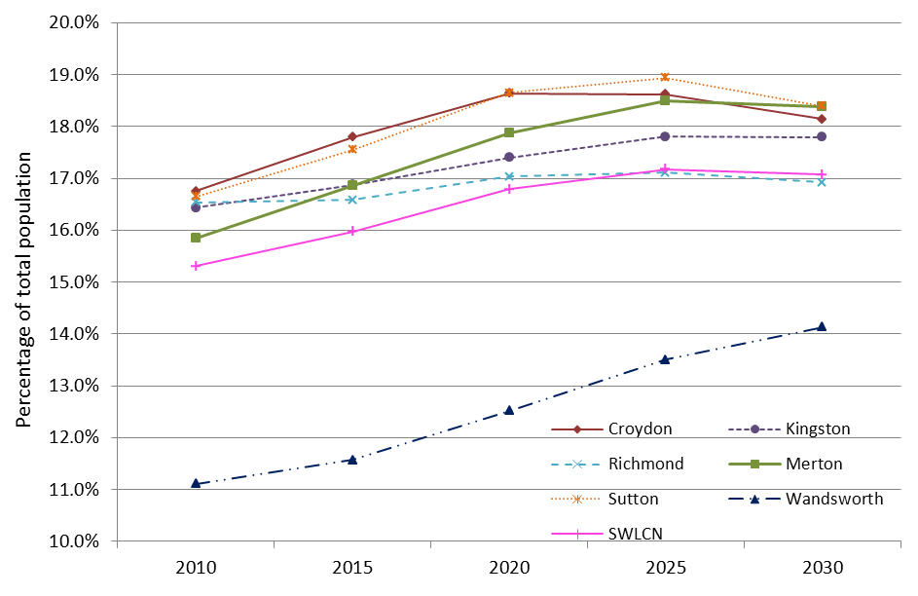

**Source: Greater London Authority, Population Projections 2009 Round, London Plan, Borough SYA.**

Figure 4 overleaf shows that there is a steady projected increase in the 65 and older female population across each borough in SWL except Wandsworth which has a predominantly younger population. The highest proportion of total population that is 65 and over is found in Sutton, accounting for 15.1% of the projected population in 2010. The lowest proportion is in Wandsworth at 9.1% of the population. The highest increase, from 2010 to 2030 is projected to occur in Sutton and Croydon with an increase of 3.7% for both followed by Merton at (3.1%). By 2030 it is projected that nearly one in five (18.8%) women in Sutton will be 65 or older. The Wandsworth female 65 and over population is not projected to increase at all by 2030. Overall, females that are 65 and over account for 12.9% of the female population in SWL. The proportion of the total female population that will be 65 and over is projected to increase to 15.2% by 2030 in SWL. This accounts for around one in every seventh female.

Figure 4: Projected increase in the proportion (as percentage of total female population) of female 65+ population in South West London, 2010-2030.

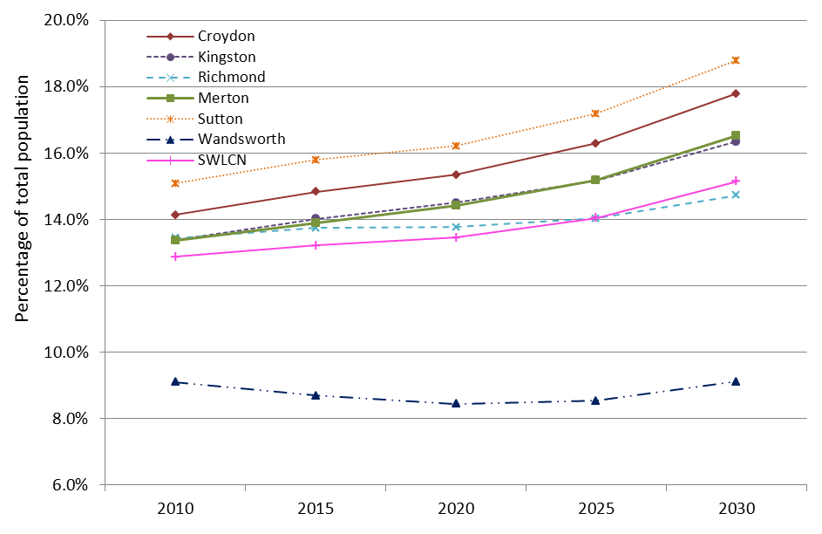

**Source: Greater London Authority, Population Projections 2009 Round, London Plan, Borough SYA.**

## Ethnicity

Ethnicity has an effect on the health and well being of individuals, to a lesser or greater extent depending on the type of cancer. As part of the Cancer Reform Strategy the National Cancer Inequalities Initiative (NCEI) was launched with the aim to reduce inequalities in cancer incidence and survival for several different groups where inequality exists; one such grouping is Black and Minority Ethnic (BME) populations. Historically the recording of ethnicity for routinely collected cancer data has been incomplete and of poor quality (Department of Health 2007). As a result work on cancer and ethnicity has been limited in the UK, with mortality studies using place of birth information (Grulich et al. 1992, Swerdlow et al. 1995, Wild et al. 2006) while incidence work has only been carried out on the south Asian ethnic population (Winter et al. 1999, dos Santos Silva et al. 2003, Farooq and Coleman 2005).

However as part of the National Cancer Inequalities Initiative, the National Cancer Intelligence Network (NCIN) and Cancer Research UK produced analysis on incidence and survival by major ethnic group for the period 2002-2006, in 2009 (National Cancer Intelligence Network 2009b). It found women of Asian and Black ethnicity were at a significantly lower risk of getting breast cancer compared with females of White ethnicity. However these women aged 15-64 years had a significantly reduced survival for breast cancer compared to White women at three years, 89% (Asian), 85% (Black) and 91% (White). Both the Chinese and Mixed ethnic groups tended to have significantly lower incidence rates of breast cancer compared to Whites. Although breast cancer incidence is lower in South Asian and Black patients, studies have suggested that these patients tend to present with larger tumours and at a younger age (Velikova et al. 2004, Farooq et al. 2005, Bowen et al. 2008, Jack et al. 2009).

The national study found that Asian females had a 25% to 52% less chance of getting breast cancer compared to White women. For Black women, they had a 12% to 44% less chance of getting breast cancer compared to White women (National Cancer Intelligence Network 2010).

Figure 5: Projected (2010) 55+ female resident ethnic composition of SWL PCTs.

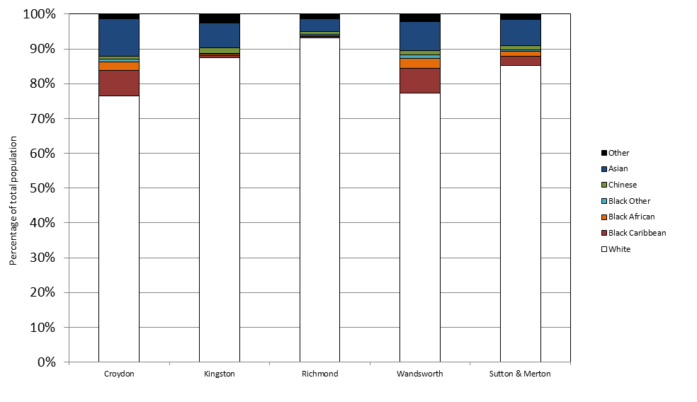

**Source: Greater London Authority Ethnic Group Projections 2008 Round, London Plan, Borough.**

Croydon has the largest non-white female resident ethnicity at 23.5% of the total female population of the PCT followed by Wandsworth with 22.7% (Figure 5). Richmond has the lowest at 6.7%. The largest resident BME group across all PCTs is Asian, which comprises of Pakistani, Indian, Bangladeshi and other Asian. Wandsworth has the largest Black population accounting for 11.1% or one in nine of the PCT female population. For exact figures see Appendix 1.

## Multiple Deprivation

Breast cancer has been known to be more common in affluent women for a number of years although the mechanism for this is not well-understood (Ketcham and Sindelar 1975, Faggiano et al. 1997, Dano et al. 2003, National Cancer Intelligence Network 2008). It is possible that risk factors such as age at first pregnancy, reductions in parity, use of hormone replacement therapy and oral contraceptives and changing patterns in BMI differ across socio-economic deprivation groups to account for this (Robbins et al. 1997, Prehn and West1998, Keating et al. 1999, Brown et al. 2006).

Figure 6 shows the age standardised female breast cancer incidence across England. The graph shows that there is a significant variation between deprivation quintiles, as deprivation decreases the incidence of breast cancer increases. The incidence of breast cancer in the least deprived group is significantly higher than incidence in the most deprived group.

Figure 6: Breast cancer incidence by index of multiple deprivation 2000-2004.

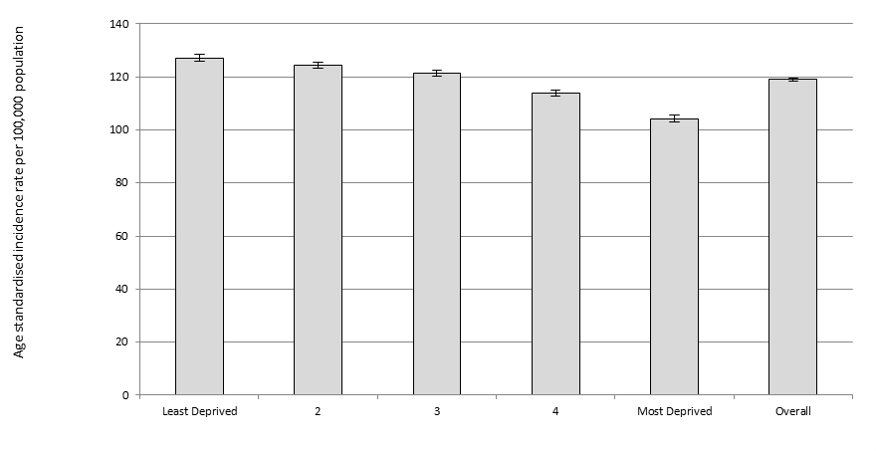

**Source: National Cancer Intelligence Network, 2008.**

In SWL the main affluent areas are in the West in the boroughs of Richmond and Kingston as well as the Western areas of Sutton and Merton (**Error! Not a valid bookmark self-reference.**).

Map 1: Index of multiple deprivation, South West London, 2007 (SWL Scale).

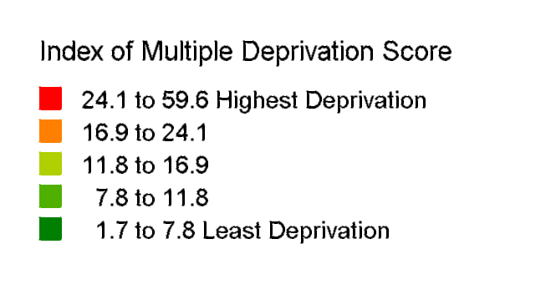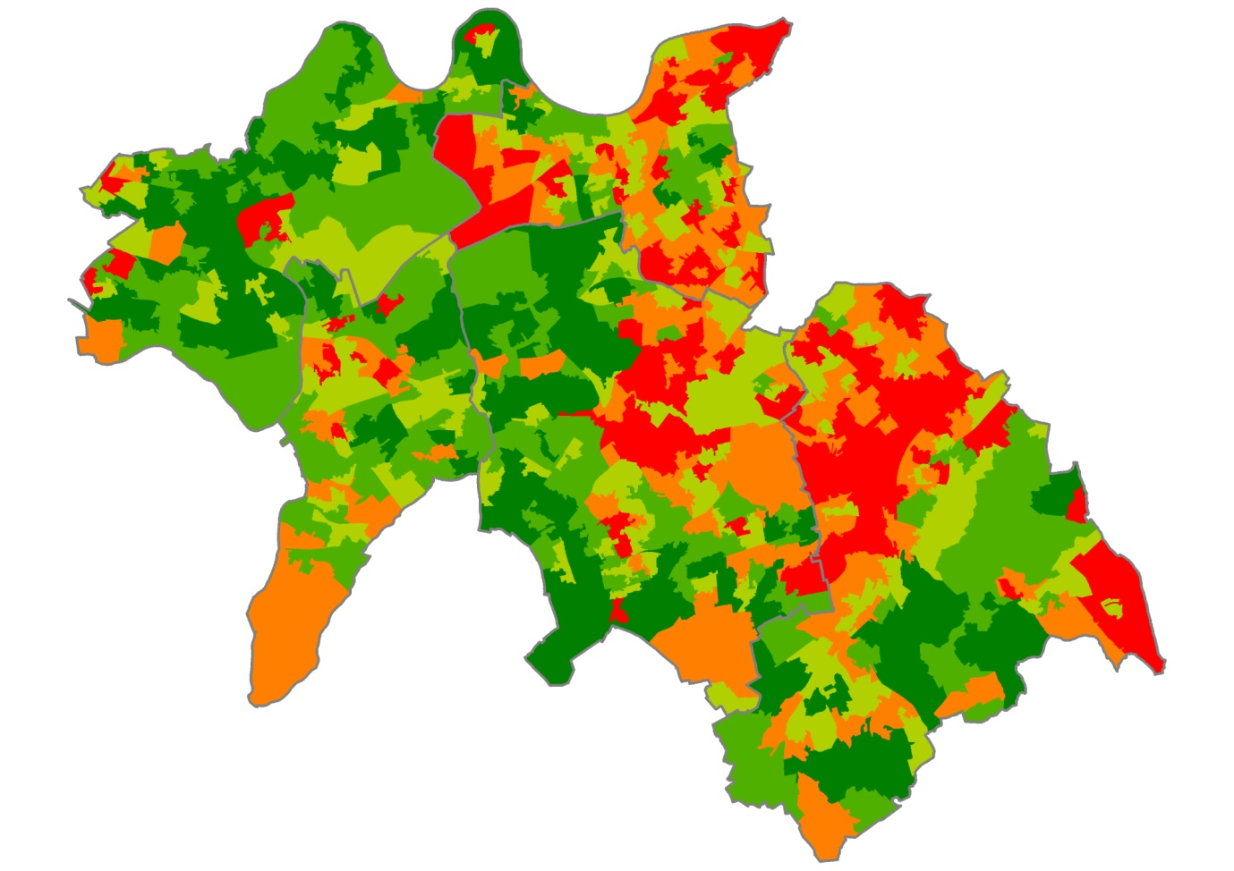

**Source: Department of Local Government and communities, 2007.**

## Obesity

Being overweight or obese moderately increases the risk of post-menopausal breast cancer (Engar et al. 2000, European Union 2006; Bissonauth et al. 2009; Pieta et al. 2009) and is one of the few modifiable risk factors for breast cancer. One of the main causal mechanisms is the increased production and circulation of estrogen and insulin caused by excess weight. These hormones can stimulate cancer growth (Ballard-Barbash et al. 2006; Boyle et al. 2003). Reeves et al. (2007) found that overweight post menopausal women have a 10-20% higher risk of breast cancer compared to women with a BMI of between 22.5 and 24.9. A review by McTiernan (2003) found a 30-50% increase. Obese women had a 30% higher risk. This study (Million Women Study) also estimated that 7% of breast cancers in post-menopausal women in the UK are due to weight and obesity, while a report by the European Union estimated it to be 9% on an Europe wide basis (European Union 2006).

Figure 7: Model based estimates of obesity in Adults in South West London, 2003-2005.

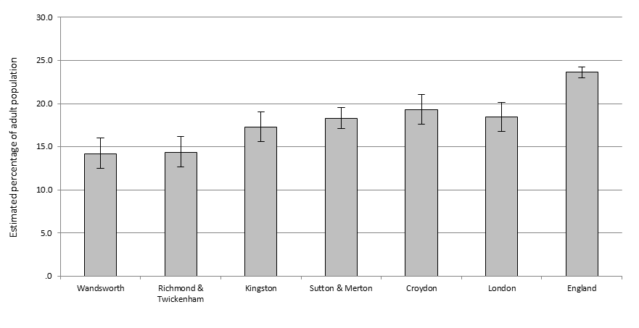

**Source: The Information Centre 2010.**

Model based estimates were not available by gender; therefore total population estimates are presented (Figure 7). Overall, the model estimated obesity prevalence across the 6 boroughs of SWL are similar ranging from 14.2% (95%CI 12.5% - 16.0%) in Wandsworth to 19.3% (95%CI 17.6% - 21.1%) in Croydon. These rates are also comparable with the London and national averages. These estimates are model based i.e. they are based on population characteristics extracted from census data for example and are not based on a survey sample. They also do not take into consideration local variation, for example the effects of local campaigns. Due to this it is not strictly appropriate to compare between areas and these data should not be used to monitor performance (The Information Centre 2008). Also consideration of the 95% confidence intervals is needed when assessing the data. Furthermore, here we are concerned with the female population. Female only obesity levels by local authority were not available. Figure 7 should only be used as a guide due to this (plus the nature of how the estimates are generated), however the survey based estimates from the Health Survey for England 2008 show that nationally male and female obesity levels are similar, 24% and 25% respectively.

The highest overweight or obesity levels in females are in the 55-64 and 65-74 years age groups. At the national level the prevalence for these age groups is around 70% (The Information Centre 2009a).

## Smoking

The relationship between smoking and breast cancer remains unclear. Certain studies have found that smoking raises the chance of breast cancer (Terry and Rohan 2002, Nagata et al. 2006, Conlon et al. 2010), however nearly all studies recommend further work. The results of these studies overall suggest that smoking probably does not decrease risk and indeed suggest that there may be an increased risk with smoking, particularly heavy smoking of long duration (Terry and Rohan 2002, Terry and Goodman 2006).

Results from the Health Survey for England (The Information Centre 2006) shows that there is not much variation between women after age-standardisation, none of the female BME groups were more likely to smoke than the general female population. Black African, South Asian and Chinese women were found to be less likely to smoke than the general female population. These results were however based on self-reported smoking behaviour which is likely to underestimate smoking prevalence.

Overall, the estimated smoking prevalence across the 6 boroughs of SWL are similar (Figure 8) ranging from 19.3% (95%CI 16.1 – 23.0) in Richmond to 25.4% (95%CI 22.1 – 29.1) in Sutton. These rates are also comparable with the London and national averages. Estimates by gender were not available. Trend data from The Information Centre (2009b) for the same period (2003-05) show a national prevalence of 22-24% for women and 25%-27% for men.

Figure 8: Model based estimates of smoking in adults in South West London compared with England, 2003-2005.

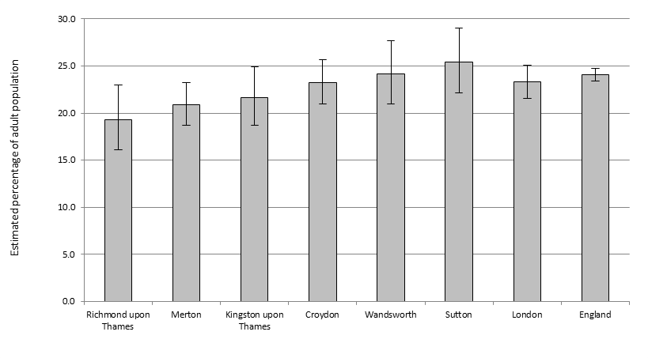

**Source: The Information Centre 2010.**

Although SW London has followed the national trend with a reduction in the prevalence of smoking this masks significant health inequalities with smoking rates highest in the most deprived populations. In some super output areas in Croydon, Wandsworth and Sutton the prevalence reaches 41% (Map 2). Again the smoking prevalence are for both males and females.

Map 2: Estimates of smoking prevalence in adults (16+) in the SWL sector, 2003-05.



**Source: Health Survey for England 2006; map by SWL Public Health Intelligence from Staying Healthy Strategy for South West London 2010-2016.**

## Physical (in) activity

A number of studies have found an inverse relationship between physical activity (self-reported) and breast cancer (Gammon et al 1998 (review), Saxton 2006 (review) Ratnasinghe et al. 2010) while others have also found that engaging in a physically active lifestyle can improve the chance of survival (Holmes *et al.* 2005).

Figure 9 shows that, for the latest figure (2008-09) the boroughs of Kingston (23.4%) and Richmond (23.4%) are estimated to have the largest proportion of adult (16+) females partaking in moderate intensity sport in SWL. The exact definition is to partake in at least 30 minutes of sport at moderate intensity at least three times a week (Further details on this survey can be found at <http://www.sportengland.org/research/active_people_survey.aspx>). Croydon has the lowest proportion at 15.4%. Despite recording the lowest figure, the estimate has increased since 2005-06, as is the case for Sutton and Merton, while estimates for Wandsworth, Richmond and Kingston have decreased. The overall trend over the last three surveys has been a decrease in the proportion of females undertaking moderate intensity exercise in SWL. This follows the national trend, with a national reduction of 0.4% since 2007 (APS2). However the activity levels in the SWL boroughs are higher than the national average, which stands at 12.7% for women.

Figure 9: Females (16+) partaking on at least 3 days a week in moderate intensity sport and active recreation (at least 12 days in the last 4 weeks) for at least 30 minutes.

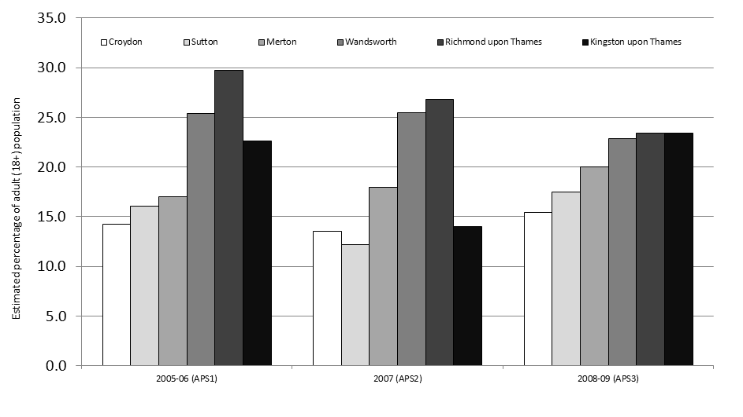

Source: Active People Survey (APS), Sport England.

## Alcohol consumption

A causal association has been established between alcohol consumption and breast cancer (Boffetta and Hashibe 2006, Baan et al. 2007). In a meta-analysis of 38 epidemiological studies, rounded pooled risk estimates were 1·1 (95% CI 1·1–1·2) for one alcoholic drink a day, 1·2 (1·1–1·3) for two drinks a day, and 1·4 (1·2–1·6) for three or more drinks a day, compared with non-drinkers (Longnecker 1994). Other reviews have found similar results as well as showing that there is no difference in risk between those who smoke and those women who have never smoked (Smith-Warner et al. 1998, Hamajima 2002). Increased risk due to alcohol consumption has also been found for both pre and post-menopausal women (Singletary and Gapstur 2001).

National Statistics from 2008 show that 20% of women drink more than the recommended 14 units per week, and 5% more than 35 units per week (The Information Centre 2009c). Again female only figures by local authority were not available for alcohol/binge drinking. It is not appropriate to provide alcohol consumption data for all population as a guide for female levels as the disparity between men and women is large. The average for females in the Greater London area (The Information Centre 2009c) was 7.78% (95%CI 6.55% - 9.01%) compared to 17.88% (95%CI 15.62% - 20.14%) for men.

# Breast Screening

## Uptake by screening unit 2004-09

Uptake corresponds to the percentage of women who, having been sent an invitation for screening, attend a screening unit and undergo a technically adequate mammography in response to that invitation. No allowance is made for letters returned or refusals. Uptake is sometimes referred to as “acceptance” (London Quality Assurance Reference Centre 2010). Uptake is calculated as the percentage of women attending for screening within six months of their invitation. Women who refer themselves are not included in uptake. Self-referrals are however included in coverage figures.

Figure 10 shows yearly screening uptake by screening unit, the minimum standard is 70%. Only Queen Mary’s (QM) Sidcup surpasses this target in 2006-07. South West London consistently achieves higher uptake rates compared to other screening units in London except Queen Mary (QM) Sidcup. For 2008-09, the uptake in South West London was 64.5%, higher than the London average which has consistently been around 60.5%.

Figure 10: Yearly breast screening uptake rates by screening unit, for ages 50-70 years, 2004-09.

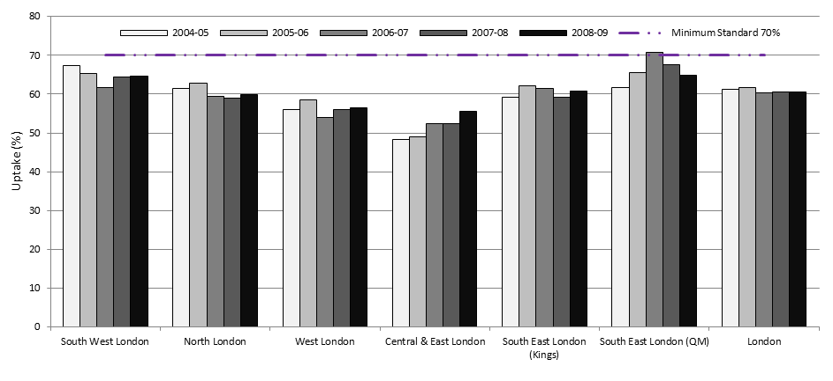

**Source: NHS London Breast Screening Programme – Annual Results 2008-09, London Quality Assurance Reference Centre (QARC).**

When assessing uptake, it’s interesting to compare each year’s performance with that three years before, as this usually represents the same cohort of women, comparing the latest year 2008-09 with uptake in 2005-06. In South West London uptake in 2005-06 was 65.4%, therefore there has been a 0.9% decrease in the cohort from 2005-06 to 2008-09. This decrease follows the same trend across all other screening units in London except Central and East London which shows an increase.

## Uptake by GP practice – 6th Round

This section presents information on breast screening uptake by GP practice. The data was sourced from the Breast Screening Unit at St. George’s Hospital. The uptake data is for all ages including those women older than the eligible age group that have self-referred (BSU 2010).

### Croydon

Table 1 shows highest and lowest achieving GP practices for breast screening uptake. Two practices achieve less than half uptake of the eligible population in the 6th round of screening. Four (H83029, H83035, H83028, H83004) of the highest GP practices for uptake are also in the top 5 of highest coverage rates (Table 6). The highest uptake rate was 77% at practices coded H83040 and H83029.

Table 1: Croydon highest and lowest achieving GP practice for breast screening uptake, 6th Round July 2005 – April 2009.

|  |  |
| --- | --- |
| Practice Code | Uptake |
| H83040 | 77% |
| H83029 | 77% |
| H83035 | 76% |
| H83028 | 75% |
| H83004 | 74% |
|  |  |
| H83005 | 52% |
| H83619 | 52% |
| H83623 | 52% |
| H83031 | 49% |
| H83048 | 49% |

**Source: Breast Screening Unit, St. George’s Hospital.**

Figure 11 shows the breast screening uptake rate across all GP practices located in Croydon PCT for the 6th Round. Only 10 (15.9%) GP practices reach the 70% minimum standard.

Figure 11: Croydon GP practices breast screening uptake rates, percentage, July 2005 – April 2009.

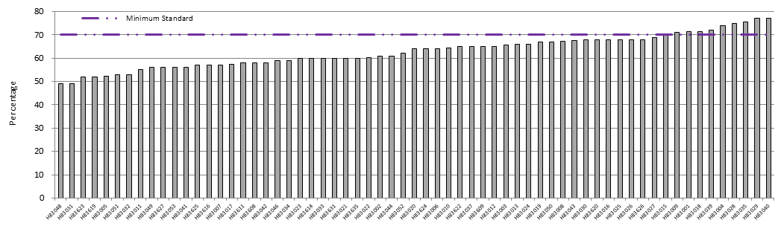

**Source: Breast Screening Unit, St. George’s Hospital.**

### Kingston

The highest uptake rate achieved in Kingston is 77% by H84618 (Table 2). Two of the top five practices also feature in the top five practices for coverage. One GP practice achieves only 50% uptake (H84609), with a further four practices with uptake rates in the 50-59% range. Two of these practices (H84609, H846629) also feature in the bottom five for coverage rates.

Table 2: Kingston highest and lowest achieving GP practice for breast screening uptake, 6th Round July 2005 – April 2009.

|  |  |
| --- | --- |
| Practice Code | Uptake |
| H84618 | 77% |
| H84635 | 76% |
| H84008 | 75% |
| H84042 | 74% |
| H84062 | 72% |
|  |  |
| H84607 | 58% |
| H84021 | 58% |
| H84619 | 54% |
| H84629 | 51% |
| H84609 | 50% |

**Source: Breast Screening Unit, St. George’s Hospital.**

Figure 12 shows the breast screening uptake rate across all GP practices located in Kingston PCT for the 6th Round. Nine (32.1%) GP practices reach the 70% minimum standard. The majority (14 practices – 50%) record uptake rates ranging from 60% to 69%.

Figure 12: Kingston GP practices breast screening uptake rates, percentage, July 2005 – April 2009.

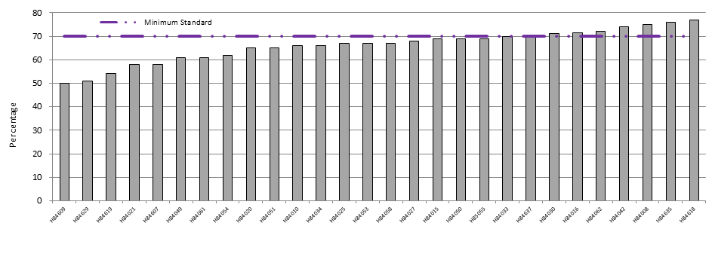

**Source: Breast Screening Unit, St. George’s Hospital.**

### Richmond & Twickenham

Practice H84044 along with H84040 and H84031 achieved the highest uptake rate in Richmond & Twickenham for the 6th round at 75% (Table 3). Four (H84044, H84040, H84031, H84002) of the top five GP practices also are in the top five GP practices for coverage. Similarly to Kingston only one GP practice (H84608) achieves an under 50% uptake rate.

Table 3: Richmond & Twickenham, highest and lowest achieving GP practices for breast screening uptake, 6th Round July 2005 – April 2009.

|  |  |
| --- | --- |
| Practice Code | Uptake |
| H84044 | 75% |
| H84040 | 75% |
| H84031 | 75% |
| H84002 | 74% |
| H84036 | 71% |
|  |  |
| H84006 | 60% |
| H84023 | 57% |
| H84633 | 56% |
| H84632 | 55% |
| H84608 | 43% |

**Source: Breast Screening Unit, St. George’s Hospital.**

Overall nine GP practices, accounting for 30% of practices, reach the 70% uptake minimum standard. Figure 13 shows that the majority of GP practices achieve an uptake of between 60 and 69%. Seventeen GP practices fall into this range accounting for 57% of all GP practices.

Figure 13: Richmond & Twickenham, GP practices breast screening uptake rates, percentage, July 2005 – April 2009.

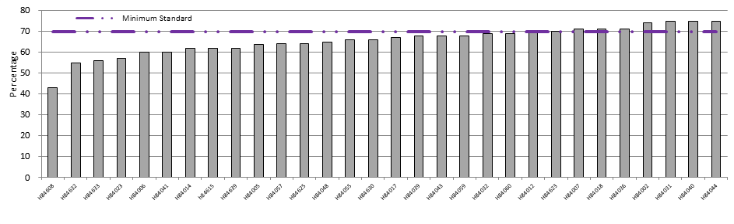

**Source: Breast Screening Unit, St. George’s Hospital.**

### Sutton & Merton

Nineteen GP practices achieve the 70% minimum uptake standard in Sutton & Merton while 2 GP practices record less than 50% uptake (H85634 and H85656) for breast screening for the 6th round (Table 4). Two GP practices (H85662, H85063) in the top five for uptake are also in the top five for coverage. Three GP practices (H85656, H85634, H85086) which are in the bottom 5 for uptake also appear in the bottom 5 of practices for coverage.

Table 4: Sutton & Merton, highest and lowest achieving GP practices for breast screening uptake, 6th Round July 2005 – April 2009.

|  |  |
| --- | --- |
| Practice Code | Uptake |
| H85064 | 79% |
| H85063 | 77% |
| H85662 | 75% |
| H85076 | 74% |
| H85054 | 74% |
|  |  |
| H85693 | 56% |
| H85665 | 55% |
| H85086 | 52% |
| H85634 | 49% |
| H85656 | 47% |

**Source: Breast Screening Unit, St. George’s Hospital.**

The majority of GP practices achieve uptake rates of between 50 and 59% (Figure 14), 33 practices in total.

Figure 14: Sutton & Merton, GP practices breast screening uptake rates, percentage, July 2005 – April 2009.

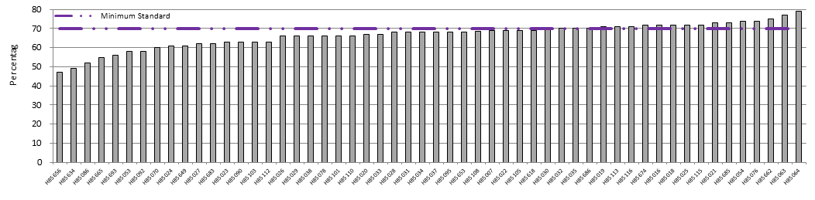

**Source: Breast Screening Unit, St. George’s Hospital.**

### Wandsworth

Only 2 GP practices (H85052 and H85039) achieve the 70% minimum standard in Wandsworth. The highest uptake rate in Wandsworth is 70% (Table 5). Four of the top 5 practices for uptake also feature in the top 5 practices for breast screening coverage. They are H85052, H85039, H85057 and H85114. The bottom five GP practices all record uptakes rates below 50%. Two of these practices (H85065 and H85087) also record coverage rates in the bottom 5 of practices.

Table 5: Wandsworth, highest and lowest achieving GP practices for breast screening uptake, 6th Round July 2005 – April 2009.

|  |  |
| --- | --- |
| Practice Code | Uptake |
| H85052 | 70% |
| H85039 | 70% |
| H85057 | 68% |
| H85114 | 67% |
| H85005 | 67% |
|  |  |
| H85065 | 45% |
| H85680 | 44% |
| H85087 | 44% |
| H85067 | 43% |
| H85104 | 42% |

**Source: Breast Screening Unit, St. George’s Hospital.**

Eight practices (in addition to Table 5: H85695, H85008, H85111) or 17% of GP practices record an uptake rate below 50%. The majority of GP practices achieve an uptake rate of between 50 and 59% (Figure 15). Twenty-two GP practices are in this range accounting for 48% of all practices.

Figure 15: Wandsworth, GP practices breast screening uptake rates, percentage, July 2005 – April 2009.

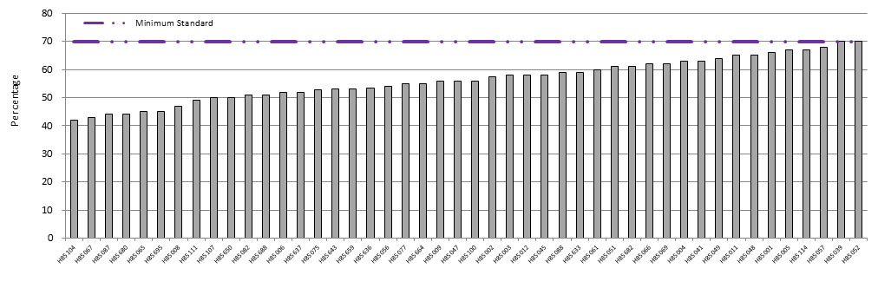

**Source: Breast Screening Unit, St. George’s Hospital.**

## Coverage by PCT 2006-09

Coverage is the proportion of women resident and eligible at a particular point in time (31st March 2007, 2008 & 2009 here) that have had a test with a recorded result at least once in the previous 3 years. (Excluding those ineligible i.e. those who have had a bilateral mastectomy). Currently coverage is best assessed using the 53-70 age group as women may be called at any time between their 50th and 53rd birthdays (The Information Centre 2010).

All PCTs in South West London (Figure 16) have experienced an increase in coverage each year from 2006 to 2009 (except for Richmond & Twickenham which has stayed constant for the last 2 years 2007-08 & 2008-09). The PCTs of Richmond & Twickenham (70.2%), Sutton & Merton (72.0%), Croydon (71.5%) and Kingston (72.7) have seen their coverage rates rise to meet the national target of 70%. Wandsworth PCT has experienced an increase from 60.2% in 2006-07 to 63.5% in 2008-09, however it remains the only PCT in SWL not to reach the national target. This may be partly due to the transient nature of the population in Wandsworth as well as inflation of GP lists from historical patients.

Figure 16: Yearly breast screening coverage rates by Primary Care Trust and for age 53-70 years, 2006-09.

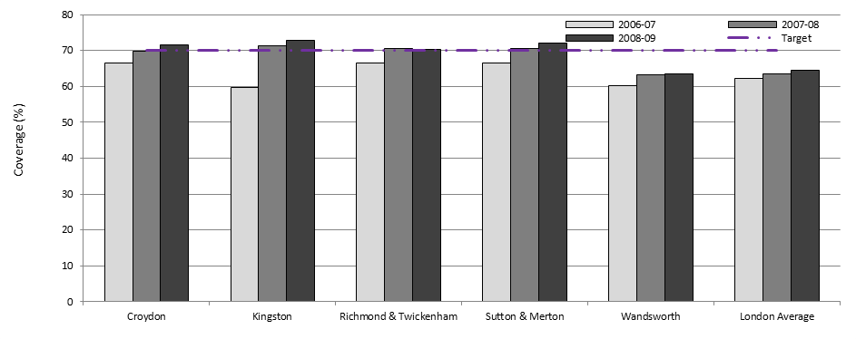

**Source: NHS London Breast Screening Programme – Annual Results 2008-09, London Quality Assurance Reference Centre (QARC).**

## Coverage by GP practice 2008-09

From 244 GP practices across South West London, 192 (78.7%) do not meet the national breast screening target of 70%. The average screening coverage rate for the whole of South West London was 63% (excluding those practices that only have five or less eligible women on their registers).

The breast screening coverage rates by GP presented in this section is sourced from the Exeter system (Primary Care Information Service).

### Croydon

There are forty-seven (from 64 + 3 GPs with 3 or less registered eligible women) GPs not reaching the coverage target in Croydon (Figure 17), accounting for 73% of Croydon GPs. The lowest coverage is at practice H83634 recording a coverage rate of 40.6% (Table 6). The other poor performing GP practices include practices H83049 (47.5%), H83011 (48.2%), H83631 (50.4%) and H83034 (50.6%). Seventeen practices achieve the national target of 70% coverage. The highest coverage rate was 80.2% at practice H83028. Table 6 lists the best and worst performing GP practices for breast screening coverage in Croydon.

Table 6: Highest and lowest achieving GP practices for breast screening coverage (50-70 years), Croydon.

|  |  |
| --- | --- |
| Practice Code | Coverage |
| H83028 | 80.2% |
| H83029 | 78.5% |
| H83035 | 78.5% |
| H83004 | 77.2% |
| H83015 | 77.1% |
|  |  |
| H83034 | 50.6% |
| H83631 | 50.4% |
| H83011 | 48.2% |
| H83049 | 47.5% |
| H83634 | 40.6% |

**Source: Primary Care Information Service (PCIS).**

Figure 17: Croydon GP practices not reaching 70% breast screening target.

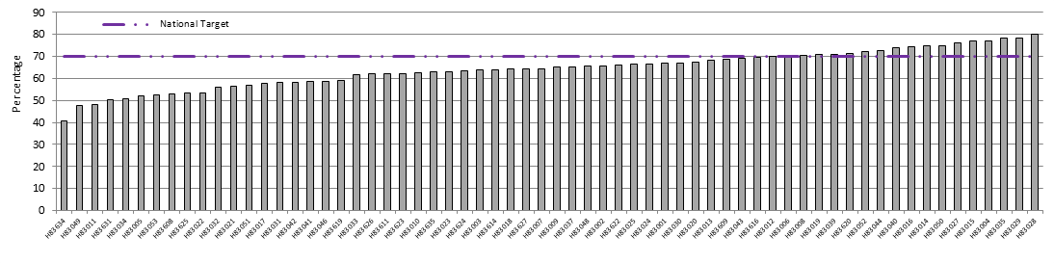

**Source: Primary Care Information Service (PCIS).**

### Kingston

In Kingston, twenty (from 28 + 3 with no or one eligible woman) GPs did not reach the national target (Figure 18), accounting for 71% of Kingston GPs. The lowest coverage was at practice of H84609 recording a coverage rate of 47.1%. It is the only practice recording under 50%. GP practices recording a coverage rate of between 50% and 60% include H84629 (55.2%), Y02379 (56.4%) and H84061 (57.1%). The highest coverage rate is 73.6% at practice H84033. Eight practices achieve the national 70% target.

Table 7: Highest and lowest achieving GP practices for breast screening coverage (50-70 years), Kingston.

|  |  |
| --- | --- |
| Practice Code | Coverage |
| H84033 | 73.6% |
| H84618 | 73.1% |
| H84027 | 72.3% |
| H84637 | 72.3% |
| H84042 | 72.3% |
|  |  |
| H84054 | 61.1% |
| H84061 | 57.1% |
| Y02379 | 56.4% |
| H84629 | 55.2% |
| H84609 | 47.1% |

**Source: Primary Care Information Service (PCIS).**

Figure 18: Kingston GP practices not reaching 70% breast screening target.

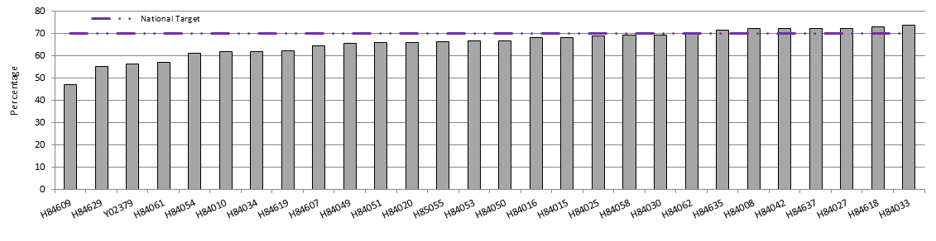

**Source: Primary Care Information Service (PCIS).**

### Richmond & Twickenham

Twenty-two (from 31 + 1 with only one eligible woman) GPs did not reach the target in Richmond & Twickenham for 2008-09 (Figure 19). The lowest coverage was at the practices of H84014 and H84608 recording a coverage rate of 32.7% and 43.1% respectively. There are 10 GP practices recording a coverage rate of between 50% and 59%. The highest coverage rate was 75.6% at practice H84002. Nine practices achieved the national target of 70% coverage.

Table 8: Highest and lowest achieving GP practices for breast screening coverage (50-70 years), Richmond & Twickenham.

|  |  |
| --- | --- |
| Practice Code | Coverage |
| H84002 | 75.6% |
| H84044 | 74.6% |
| H84040 | 74.6% |
| H84623 | 73.9% |
| H84031 | 73.9% |
|  |  |
| H84023 | 55.2% |
| H84615 | 51.5% |
| H84639 | 51.4% |
| H84608 | 43.1% |
| H84014 | 32.7% |

**Source: Primary Care Information Service (PCIS).**

Figure 19: Richmond & Twickenham GP practices not reaching 70% breast screening target.

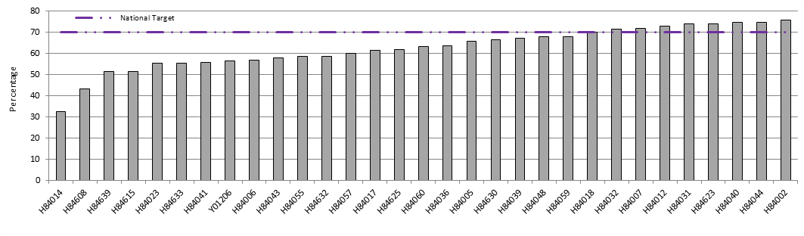

**Source: Primary Care Information Service (PCIS).**

### Sutton & Merton

In Sutton & Merton thirty-seven (from 54 + 4 with no eligible women) GPs did not achieve the 70% target (Figure 20), accounting for 69% of the PCT’s GPs. The lowest coverage was at practice H85693 recording a coverage rate of 52.5%. There are 7 further GP practices recording a coverage rate of between 50% and 59%. The highest coverage rate was 82.9% at practice H85113. Practice H85674 was the only other practice to achieve an above 80% rate. Seventeen GP practices recorded the 70% coverage target or above.

Table 9: Highest and lowest achieving GP practices for breast screening coverage (50-70 years), Sutton & Merton.

|  |  |
| --- | --- |
| Practice Code | Coverage |
| H85113 | 82.9% |
| H85674 | 80.5% |
| H85063 | 76.3% |
| H85662 | 76.0% |
| H85115 | 76.0% |
|  |  |
| H85090 | 56.8% |
| H85656 | 56.6% |
| H85634 | 56.3% |
| H85086 | 55.7% |
| H85693 | 52.5% |

**Source: Primary Care Information Service (PCIS).**

Figure 20: Sutton & Merton GP practices not reaching 70% breast screening target.

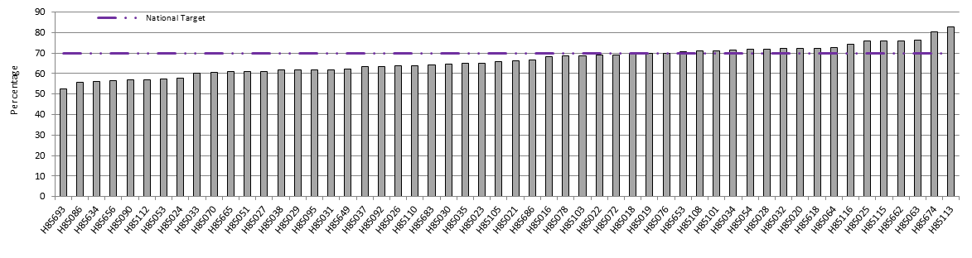

**Source: Primary Care Information Service (PCIS).**

### Wandsworth

Only one GP practice achieved the national target of 70% in Wandsworth for 2008-09. This was practice H85039 at 71.8% coverage. Forty-six (from 47 + 9 with no or one eligible woman) GPs did not reach the target (Figure 21). The lowest coverage was at practice H85685 recording a coverage rate of 38.9%; however this is only resultant of 14 eligible women in the practice. There are 7 further GP practices recording coverage of 50% or below. They include the H85111 (44.4%), H85087 (45.2%), H85065 (45.3%), H85107 (47.2%), H85688 (48.3%), H85077 (49.8%) and H85104 (50.0%).

Table 10: Highest and lowest achieving GP practices for breast screening coverage (50-70 years), Wandsworth.

|  |  |
| --- | --- |
| Practice Code | Coverage |
| H85039 | 71.8% |
| H85007 | 68.7% |
| H85052 | 67.9% |
| H85057 | 67.5% |
| H85114 | 67.4% |
|  |  |
| H85107 | 47.2% |
| H85065 | 45.3% |
| H85087 | 45.2% |
| H85111 | 44.4% |
| H85685 | 38.9% |

**Source: Primary Care Information Service (PCIS).**

Figure 21: Wandsworth GP practices not reaching 70% breast screening target.

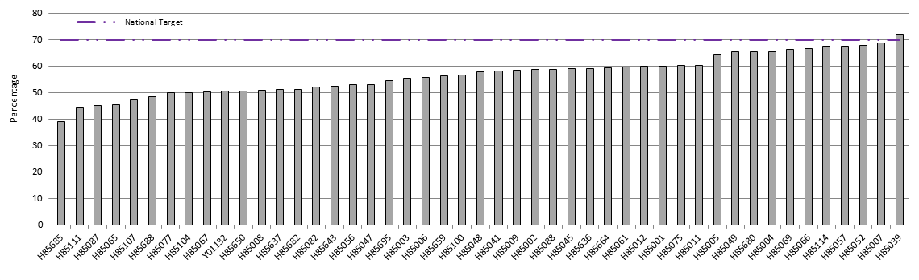

**Source: Primary Care Information Service (PCIS).**

## Percentage of those screened within 36 months of last screen (Round Length) by Screening Unit 2006-09

The breast screening programme is committed to inviting women for screening every three years (36 months) and this is monitored by looking at the percentage of women invited (when 1st invited) for screening within 36 months of their previous screen. A great deal of importance is attached to the achievement of Round Length as it is intrinsic to the success of the screening programme, and has an impact on coverage (London Quality Assurance Reference Centre 2010). The minimum standard is 90% of eligible women offered an appointment with a target of 100%.

In South West London (Figure 22) the proportion of women invited within 36 months of their last screening has increase substantially since 2006-07, from 63.4% to above the minimum standard at 96.2% in 2008-09. South West London’s performance is above the London average and is one of the highest rates in London. The London average is affected by the low rates in North London due to a suspension of the service. Excluding North London from the London average, South West London still performs above the recalculated London average of 88.2% for 2008-09.

Figure 22: Percentage of women invited for screening within 36 months of their last breast screen, 2006-09.

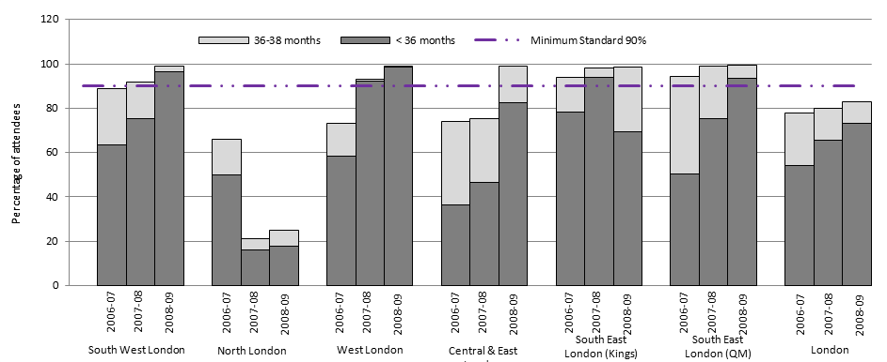

**Source: NHS London Breast Screening Programme – Annual Results 2008-09, London Quality Assurance Reference Centre (QARC).**

## Future age extension of breast screening programme – 2012

In 2007 the Cancer Reform Strategy (Department of Health 2007) announced that the eligible age range for screening would be extended to cover women aged 47-49 and 71-73. Full implementation must be achieved by 2012 (and full coverage by 2015). Table 11 shows an indication of the possible increase in the number of women to screen due to this extension for 2012. These figures may be used to assist the PCTs and Breast Screening Services (BSS) to calculate and plan for the extra capacity that may be needed to screen the additional numbers of women.

Table 11: Indication of possible increase in numbers due to screening age extension in 2012.

|  |  |  |  |  |  |
| --- | --- | --- | --- | --- | --- |
|  | **Current Cohort (50 – 70 years)** | **Screen cohort every 3 years** | **Extension cohort (47 – 49 & 71-73 years)** | **Screen extension cohort every 3 years** | **Percentage increase due to extension** |
| Croydon | 38,651 | 12,884 | 11,745 | 3,915 | 30.39 |
| Kingston | 16,502 | 5,501 | 4,942 | 1,647 | 29.95 |
| Sutton & Merton | 41,328 | 13,776 | 12,616 | 4,205 | 30.53 |
| Richmond & Twickenham | 19,945 | 6,648 | 5,986 | 1,995 | 30.01 |
| Wandsworth | 21,667 | 7,222 | 7,323 | 2,441 | 33.80 |
| SWLBSS | 138,091 | 46,030 | 42,612 | 14,204 | 30.86 |

**Source: Breast screening improvement programme London SCG**

## Future screening activity

In addition to age extension the Cancer Reform Strategy recommends that women aged between 40-49 years with a moderate family history risk of breast cancer should have access to annual mammography follow up. Baseline mammograms will be undertaken in Family History Clinics from 2009 and follow up mammograms within the SWLBSS from 2010. Therefore, combined with age extension and increases in local populations the eligible population in SWL is expect to increase by 50% from the 2007 population by 2013. Table 12 shows how the eligible population will increase.

Table 12: Future breast screening activity in SWL.

|  |  |  |  |  |  |  |
| --- | --- | --- | --- | --- | --- | --- |
|  | **2006-07** | **2009-10** | **2010-11** | **2011-12** | **2012-13** | **2013-14** |
|  | **Actual activity (Baseline)** | **Projected Year 1** | **Projected Year 2** | **Projected Year 3** | **Projected Year 4** | **Projected Year 5** |
| Eligible Population1 | 156,333 | 160,096 | 160,096 | 191,000 | 228,000 | 228,000 |
| Invited1,2 | 55,932 | 55,500 | 55,500 | 65,801 | 78,135 | 78,135 |
| Screened1,2 | 34,678 | 35,520 | 35,520 | 42,113 | 50,006 | 50,006 |
| Family history screening3 | 0 | 0 | 3,000 | 3,000 | 3,000 | 3,000 |
| **Total** | **34,678** | **35,520** | **38,520** | **45,113** | **53,006** | **53,006** |

**Source: Staying Healthy Strategy for South West London 2010-2016**

# Female Breast Cancer Incidence

## Under 75 incidence by PCT 2004-06

Figure 23 shows the under 75 age standardised female breast cancer incidence in SWL for 2004-06. There is not much variation between PCTs in SWL in the incidence rates with no significant difference between PCTs except for Sutton & Merton. The highest rate is in Croydon (110.26 per 100,000 95%CI 100.73 – 119.78), however the confidence intervals range across the London (100.18 95%CI 98.16 – 102.19) and England (112.08 95%CI 111.33 – 112.83) averages. Sutton & Merton (87.13 95%CI 79.06 – 95.20) has an incidence rate which is significantly lower than England and London as well as Wandsworth (107.46 95%CI 95.45 – 119.47), Richmond and Twickenham (108.37 95%CI 95.57 – 121.17) and Croydon.

Figure 23: Directly age standardised (DSR) under 75 years female breast cancer incidence, 2004-06.

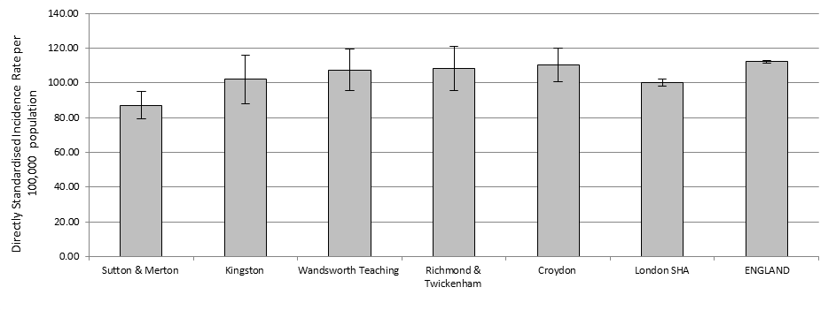

**Source: Clinical and Health Outcomes Knowledge Base, National Centre for Health Outcomes Development (NCHOD).**

## All age incidence by PCT 2004-06

Differently to the under 75 incidence rates, Richmond & Twickenham record the highest all age female breast cancer rate and not Croydon (Figure 24). However the difference between Richmond & Twickenham (120.53 per 100,000 95%CI 107.75 – 133.31) and Croydon (120.28 95%CI 110.80 – 129.77) is minimal with confidence intervals overlapping. Again Sutton & Merton experiences female breast cancer incidence which is significantly lower than the England and London averages as well as all other PCTs except Kingston. All PCTs except Sutton & Merton do not have incidence rates significantly different to the London and national averages.

Figure 24: Directly age standardised (DSR) all ages years female breast cancer incidence, 2004-06.

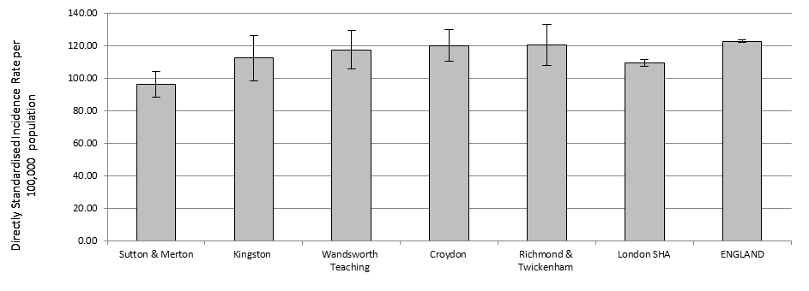

**Source: Clinical and Health Outcomes Knowledge Base, National Centre for Health Outcomes Development (NCHOD).**

## All age incidence by PCT 1993-2006 (3-year rolling average)

The London average for incidence has remained constant since 1997-99 whereas the national average has been slowly increasing over the same period. Except for the PCT of Sutton & Merton, the PCTs of SWL do not exhibit either a prolonged trend downwards or upwards (Figure 25). The peak seen in Richmond & Twickenham in 1997-99 is due to a large spike in incidence for 1997 when the number of cases jumped from 113 in 1996 to 177 in 1997, before decreasing to 133 cases in 1998. For the latest year, 2004-06, Richmond & Twickenham and Croydon have the highest incidence rates in SWL at 120 per 100,000 population, while Sutton & Merton the lowest at 96.21. Sutton & Merton has experienced a large decrease in incidence since 2001-03 with the number of cases decreasing from 276 in 2003 to near the 200 mark in the years 2004-2006. For 2004-06, except for Sutton & Merton all PCTs had incidence rates greater than the London average, indicating that overall PCTs in SWL have incidence rates higher than other PCTs in London.

Figure 25: Female directly age standardised (DSR) all ages breast cancer incidence, 1993-2006 3-year rolling average.

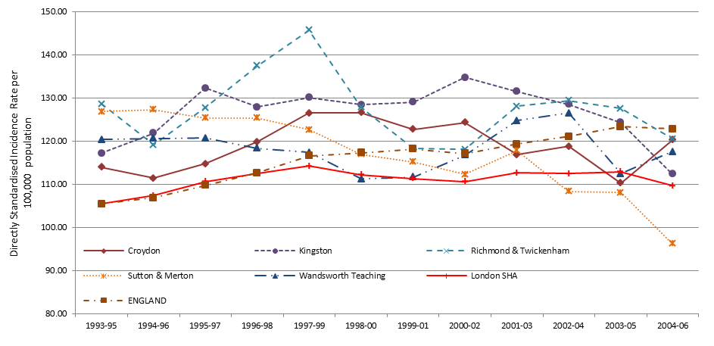

**Source: Clinical and Health Outcomes Knowledge Base, National Centre for Health Outcomes Development (NCHOD).**

# Female Breast Cancer Prevalence

**C**ancer prevalence refers to the number of people who have previously received a diagnosis of cancer and who are still alive at a given time point. Some of these patients will have been cured and others will not. Therefore prevalence reflects both the incidence of cancer and its associated [survival](http://info.cancerresearchuk.org/cancerstats/incidence/prevalence/ssLINK/news-survival) pattern.

## One-year prevalence by Cancer Network 2006

In 2006 the SWLCN had one of the highest age standardised prevalence of female breast cancer in London (Table 13) but is similar to the national average. However, all other cancer networks in London, except SELCN, have a prevalence rate which is significantly lower than the national rate.

Table 13: Age standardised female breast cancer prevalence per 100,000, 2006.

|  |  |  |  |  |  |
| --- | --- | --- | --- | --- | --- |
| Cancer Network | No. of patients | Crude Prevalence | ASP* | 95% Lower CI | 95% Upper CI |
| SWLCN | 880 | 109.7 | 106.6 | 99.3 | 113.9 |
| WLCN | 900 | 97.4 | 99.5 | 92.8 | 106.1 |
| NLCN | 696 | 89.6 | 89.2 | 82.4 | 96.0 |
| NELCN | 675 | 86.7 | 92.8 | 85.6 | 100.0 |
| SELCN | 829 | 106.5 | 107.6 | 100.0 | 115.2 |
| England | 33,640 | 130.2 | 109.6 | 108.4 | 110.8 |

*Age standardised prevalence

**Source: National Cancer Intelligence Network (2010b).**

# Female Breast Cancer Staging 2003-07

The staging data presented reveals that the availability of information on staging, for a cancer at registration is not always present for analysis. Note that this point refers to the availability of information to the Thames Cancer Registry (TCR) for analysis and differs from stating that staging of tumours is not occurring and that medical notes are insufficient. Specifically where the proportion of cases staged by the TCR is low (e.g. SWLCN at 55%), it will be due to the low ascertainment of information used to construct the TCR stage. This is due to the information not being available at the time of registration. It is possible that further information may be added at a later date. This may come from the initial hospital visited or another hospital subsequently visited, for example, in the process of treatment. The sources of information for the TCR are:

* Medical notes
* Pathology
* Electronic data sent by trust (only occurs at some trusts)

Ultimately if the information (listed above) is not available or it is not immediately apparent in the medical notes, then constructing a TCR stage at diagnosis is not possible. Given the extent of paper medical notes possible for each patient, the TCR cannot invest inordinate amounts of time examining every piece of medical notes for each patient. It must be emphasised that the lack of staging data (as reflected in the SWLCN 2007 average proportion – 55%) is due to processes in the ascertainment of the data. It does not mean that the patients did not have their disease staged by their clinician(s) (Thames Cancer Registry 2010a).

The Thames Cancer Registry staging system is as follows:

Table 14: Thames Cancer Registry four level staging system.

|  |  |
| --- | --- |
| **Stage** | **Description** |
| 1 | Local (tumour confined to organ of origin). |
| 2 | Direct extension (tumour has extended into surrounding tissues and organs). |
| 3 | Nodal involvement (local nodes are involved). |
| 4 | Metastases (distant metastases are present). |

**Source: Thames Cancer Registry (2009).**

## PCT staging

As shown in Figure 26 most female breast cancers that are staged are assessed to be at stage 1. Richmond & Twickenham, Kingston and Wandsworth see around 40% of women present at an early stage (one). Sutton & Merton and Croydon have low proportions of women presenting early, possibly due to a higher proportion of “Not Known” in these two PCTs. A noticeable proportion of women are presenting at a relatively late stage (three), nearing one in five women for Croydon, Richmond & Twickenham, Kingston and Wandsworth. It is interesting to note that breast cancer cases in Croydon PCT have not been staged by the TCR for over half of cases, however the proportion of women presenting at stage 3 are similar to Richmond & Twickenham, Kingston and Wandsworth who all have lower ‘non staged’ proportions (Figure 26).

Figure 26: Percentage of female breast cancer incidence by stage (NK = Not Known) 2003-07 (PCT).

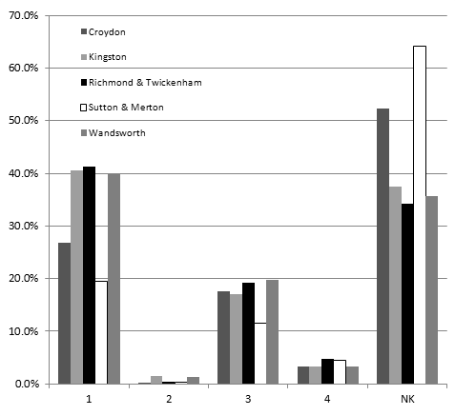

**Source: Thames Cancer Network.**

Female breast cancer cases in the SWLCN area are staged the least out of the main four cancers (lung, female breast, colorectal and prostate) with over a half (53.1%) of cases reported as ‘Not Known’. The highest proportions of cases not staged occur in Sutton & Merton (Figure 26), where over 60% of tumours are not staged. Croydon follows with 52.2% of breast cancers not staged. These two PCTs account for over two-thirds of all non staged breast cancer tumours in the SWLCN area. There are high proportions of non staged female breast cancers across all constituent parts of the SWLCN but Sutton & Merton and Croydon stand out. Consequently basing any conclusions on staging data is not appropriate given the level of missing assessments.

## SWLCN staging

Breast cancer is the most common form of cancer in females. Between 2003 and 2007 there were 5,099 new incidences of breast cancer in the SWLCN area. Figure 27 shows the breast cancer incidence proportions by stage for the SWLCN.

Figure 27: Percentage of female breast cancer incidence by stage (NK = Not Known) 2003-07 (Cancer Network).

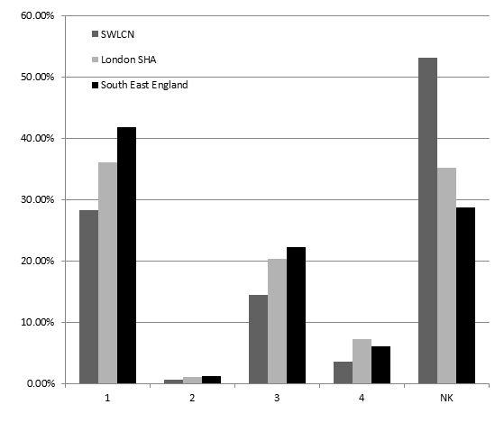

**Source: Thames Cancer Network.**

Of breast cancer cases staged the majority were diagnosed at stage 1 with the SWLCN area lagging behind the London (36.1%) and SEE (41.2%) averages at 28.2%. The next highest proportions are seen for stage 3 at time of diagnosis, with one in seven (14.4%) breast cancers being staged at this level in the SWLCN region. Across London and the SEE the average proportion for stage 3 diagnosis is 20.4% and 22.3% respectively. For stage 4 diagnosis, the highest proportion is seen across London at 7.2% with the SEE average being 6.0%. Stage 4 diagnosis is lowest in SWL at 3.6%. Percentages for the SWLCN area are lowest in each staging group since over half (53.1%) of female breast cancers have not been staged, 17.8% higher than the London SHA average.

# Female Breast Cancer Survival

The Cancer Reform Strategy (Department of Health 2007) emphasizes the importance of diagnosing cancer early by screening, raising public awareness of signs and symptoms of cancer and minimising delays in investigation and referral. The overarching goal of NAEDI is to promote earlier diagnosis of cancer and thereby improve survival rates and reduce cancer mortality. Survival data is provided by the Thames Cancer Registry, which was obtained from the NCIS.

## One-year relative survival by PCT and Cancer Network 2002-07

The Cancer Reform Strategy (Department of Health 2007) acknowledges the lack of data concerning the staging of cancers and suggests that one-year cancer survival rates are a good proxy for late presentation of cases. The survival analysis was based on a cohort of cancer patients aged between 0 and 99 years, diagnosed between 2002 and 2006, and follow-up was to the end of 2007. The cohort approach was used to estimate the relative survival. The NCIN have developed benchmarks of good performance on cancer one-year survival rates. They are based on data from the EUROCARE-4 study where “Average” is based on the average one-year survival rate for those diagnosed between 1995 and 1999. “Good practice” is based on the average achieved across a whole country by the best performing countries (Department of Health 2009). These benchmarks are highlighted in the figures of this section.

Broken down by PCT, Croydon PCT (96.1% 95%CI 94.6 – 97.7) has the highest breast cancer one-year survival rate (Figure 28) followed by Wandsworth at 95.6% (95%CI 63.7 – 97.5). The trend follows the same national positive pattern in incidence for deprived areas where the lowest breast cancer incidence is seen in the most deprived areas; similarly in SWL the highest one-year survival rates are seen in the most deprived areas. Croydon and Wandsworth PCTs ranked considerably higher in terms of deprivation compared to the other 3 PCTs. All PCTs compare favourably against the European “Average” while Croydon, Wandsworth and Richmond & Twickenham possibly have survival rates which reach the European “Good Practice” benchmark (97.0%) as their confidence intervals range over this value. Sutton & Merton (94.0% 95%CI 92.2 – 95.8), which has the lowest one-year relative survival rate in SWL, and Kingston (94.1% 95%CI 91.5 – 96.6) do not reach this benchmark.

Figure 28: Female one-year (2002-07) estimated relative survival rates for breast cancer by PCT with NCIN developed benchmark from the Eurocare 4 study.

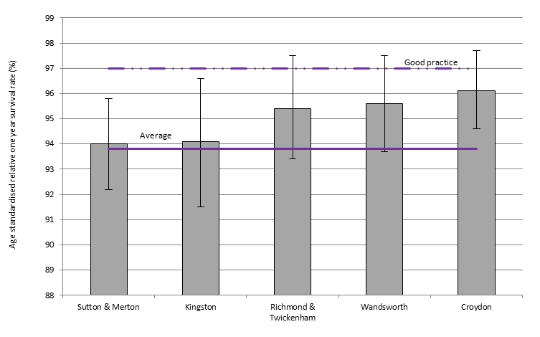

**Source: NCIN/APHO/UKACR from Cancer e-Atlas 2010.**

Figure 29 shows that the SWLCN has the highest breast cancer one-year survival rate in London at 95.1% (95%CI 94.4 – 95.9). This figure is also above the Eurocare “Average” (93.8%) as well as being within range of the Eurocare “Good practice” (97.0%) i.e. there is the possibility that the true survival rate is in line or above the Eurocare “Good practice” value. However the confidence intervals also range below the “Average” value meaning that the true survival rate could also lie below both Eurocare benchmarks. One-year survival rates across the London cancer networks do not show much variation against each other or the national average of 95.2% (95%CI 95.1 – 95.3).

Linking one-year survival data to staging data (previous section 6) is inappropriate since over half of the SWLCN breast cancer incidence (2003-2007) is not staged.

Figure 29: Female one-year (2002-07) survival rates for breast cancer by cancer network with NCIN developed benchmark from the Eurocare 4 study.

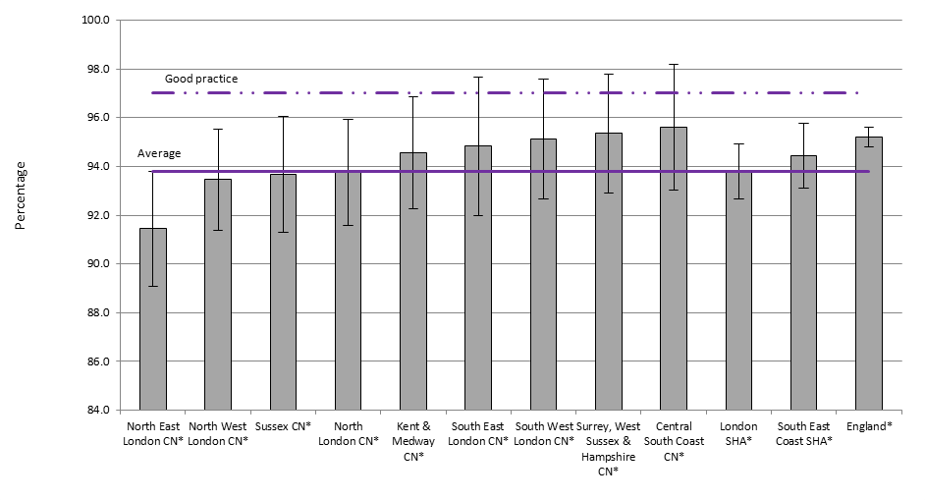

**Source: Cancer in South East England 2007 Report, Thames Cancer Registry, 2010.**

However it is worthwhile commenting that Sutton & Merton have the lowest survival rate while also having the lowest proportion of cases staged at stage 1 in SWL. It must be noted though that over 60% of cases in Sutton & Merton were not staged and may account for the low proportion of cases not staged at stage 1. It merits investigation.

Providing comparisons and a benchmark to aim for is valid. The difference in survival rates between the UK and European rates may not only be due to later presentation in the UK but also additional factors such as data quality, tumour-related factors, host factors and healthcare-related factors (Thomson and Forman 2009, Brewster 2010). However comment and research does state that poor survival in the UK compared to other European countries is associated with more advanced stage at presentation ([Imperatori](http://thorax.bmj.com/search?author1=A+Imperatori&sortspec=date&submit=Submit) et al. 2006, Richards 2009, Brewster 2010, Crawford 2010).

## Five-year relative survival by PCT and Cancer Network

Conversely to one-year relative survival rates the order of highest 5-year survival rates is reversed with Richmond & Twickenham (81.1% 95%CI 76.8 – 85.4) and Kingston (82.3% 95%CI 77.6 - 87) with the highest survival rates (Figure 30). Wandsworth and Croydon PCTs have the lowest 5-year relative survival rates at 78.7% (95%CI 74.7 – 82.7) and 79.9% (95%CI 76.8 – 83.0) respectively. However the confidence intervals are wide showing that there may not be a great variation between PCTs. The survival rate in Sutton & Merton is 80.5% (95%CI 77.4 – 83.7).

Due to small numbers of breast cancer incidence occurring at a PCT level, survival rates are calculated on a 5-year rolling average as opposed to 3 years at sector level. Also PCT data (Figure 30) is for a different time period to the sector data (Figure 31).

Figure 30: Female five-year (1998-2002) estimated relative survival rates for breast cancer by PCT.

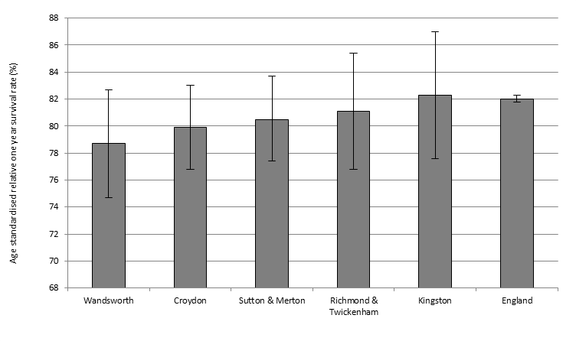

**Source: NCIN/APHO/UKACR from Cancer e-Atlas 2010.**

Five year cohort relative survival estimates for females have been extracted from the Cancer Information Service (CIS) database by rolling 3 year cohorts (1990-1992, 1991-1993 ... 1999-2001) for cancer networks (CNs). The survival estimates from CIS relates to the June 2008 data submission by Registries to CIS, which contains follow up on death information to the end of 2006.

The SWLCN has the highest 5-year breast cancer relative survival in London (other networks outside London are higher) at 81.9% (Figure 31). It is comparable to the national average which is at 82.1%. Confidence intervals were not available. The highest survival rate in the Thames Cancer Registry region is 84.0% in Surrey, West Sussex and Hampshire.

Figure 31: All persons five-year estimated relative survival rates for breast cancer by cancer network.

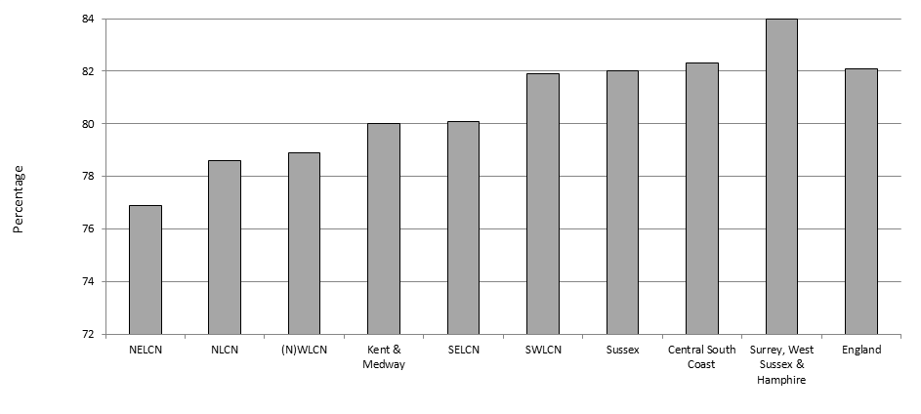

**Source: National Cancer Information Service, Cancer Commissioning Toolkit.**

# Female Breast Cancer Mortality

## Under 75 and all ages mortality by PCT 2006-08

Figure 32 reveals similar patterns to the pattern of breast cancer incidence. NHS Wandsworth records the highest under 75 breast cancer mortality in SWL at 21.09 per 100,000 (95%CI 15.74 – 26.44) population but does not record the highest all age mortality; that occurs in Richmond & Twickenham (27.34 95%CI 21.65 – 33.04) and Sutton & Merton (27.31 95%CI 23.27 – 31.35). This shows that Wandsworth does not experience the highest overall mortality in SWL but it does experience the highest premature death from breast cancer in SWL. It must be noted though the confidence intervals are wide whereby significant difference between PCTs is not established.

The under 75 years old mortality in Croydon PCT (16.16 95%CI 12.56 – 19.77) is significantly lower than the national average. All other PCTs in SWL have similar under 75 years old mortality rates to the national (20.59 95%CI 20.28 – 20.91) and London (19.34 95%CI 18.46 – 20.21) averages. All age mortality is also similar to the London and national average across all PCTs in SWL, ranging from 22.77 per 100,000 population (95%CI 17.00 – 28.53) in Kingston to 27.34 (95%CI 21.65 – 33.04) in Richmond & Twickenham.

Figure 32: Directly age standardised (DSR) under 75 years and all age female breast cancer mortality, 2006-08.

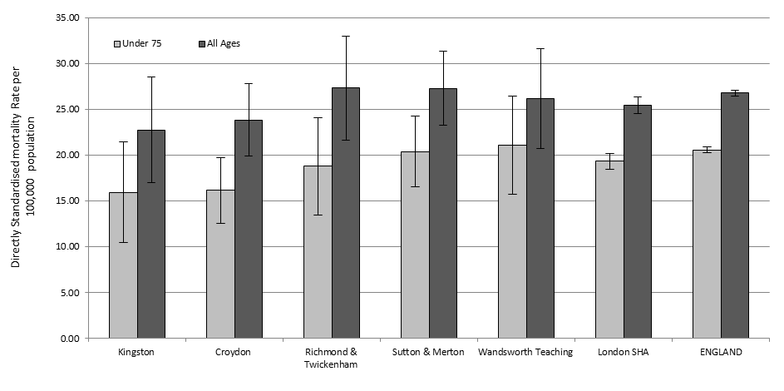

**Source: Clinical and Health Outcomes Knowledge Base, National Centre for Health Outcomes Development (NCHOD).**

## 50-69 years old mortality by PCT 1993-2008 (3-year rolling average)

Figure 33 shows 50-69 years old female breast cancer mortality over time, calculated as a 3-year average. The overall trend follows a downward path with SWL PCTs having similar mortality rates as the London average. Between 1995 and 2002 Richmond and Twickenham experienced high mortality rates compared to the London and national averages as well as other PCTs in SWL. While the number of cases has dropped, not much emphasis should be given to the magnitude of the drop since the number of cases is small; therefore a small drop in the number of cases is seen as a large drop in proportional terms.

Kingston PCT has experienced a steady decline in mortality rate since 2004 while Sutton & Merton and Wandsworth show erratic trends due to small numbers but overall reveal a decreasing trend. Croydon PCT witnessed an increase in mortality for this age group in 2003 and continued to 2006 decreasing sharply afterwards, again a consequence of small numbers.

Figure 33: Female directly age standardised (DSR) 50-69 years old breast cancer mortality, 1993-2008 3-year rolling average.

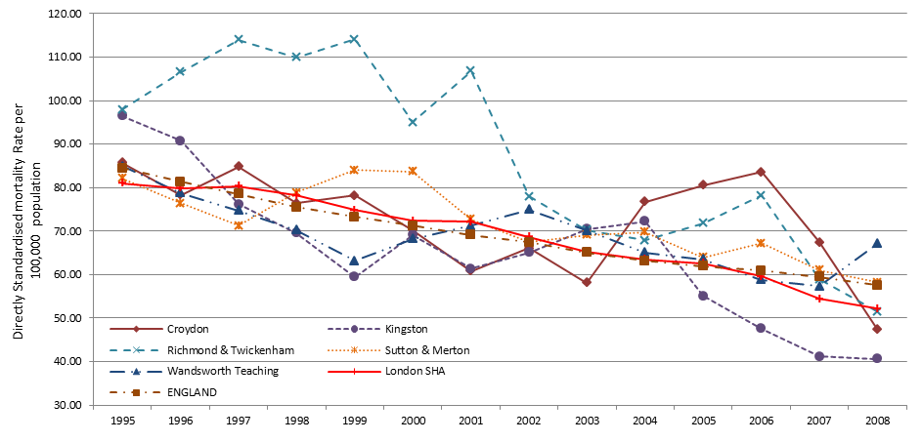

**Source: Clinical and Health Outcomes Knowledge Base, National Centre for Health Outcomes Development (NCHOD).**

# Emergency Admissions

Emergency admissions are a reflection that patients may not be getting diagnosed or treated at an early stage of their cancer, thus it may be an indicator of late presentation, late diagnosis and entry to treatment not through primary care (National Cancer Intelligence Network 2009a). Over the past eight years, although elective day case episodes (usually for chemotherapy) have risen, inpatient admissions for cancer have also risen by 25% (nationally). Most of this increase relates to emergency cancer inpatient episodes and emergency bed days are rising by 2.5% each year. A number of emergency admissions are due to the side effects of treatment, for example chemotherapy, or radiotherapy, or due to progressive disease (NHS Cancer Commissioning Toolkit 2010).

## All cancer emergency admissions by GP Practice 2008-09

Data in this section include all emergency admissions with an invasive cancer code (ICD-10 C00-C97, excluding C44) present in any diagnostic field and were originally extracted from the national HES database. Data by cancer site was not available. The figures are crude rates expressed per 100,000 persons of emergency in-patient or day-case admissions. As these are crude rates it is not suitable to compare between PCTs. Emergency admissions may occur at any stage of the cancer pathway and will include persons diagnosed with cancer in prior years. This indicator may be expected to be higher in practices with an unusually high fraction of persons of 65+ years of age, due to the higher incidence of cancer at these ages. This must be considered when/if GP practices with high rates are investigated. Where the number of referrals for a GP practice was less than 5, no rate has been released nor has the GP practice been identified.

### Croydon

Figure 34 shows the variation in emergency admissions by GP practice across Croydon PCT. The highest admission rate is 1349.21 per 100,000 population (95%CI 1004.49 – 1774.00) at practice H83029 and is significantly higher than the PCT average (610.41 95%CI 585.49 – 636.12). Six other GP practices record admission rates significantly higher than the PCT average. They are practices H83619, H83031, H83033, H83019, H83050 and H83015.

Figure 34: Croydon all cancer emergency admissions crude rate per 100,000 population.

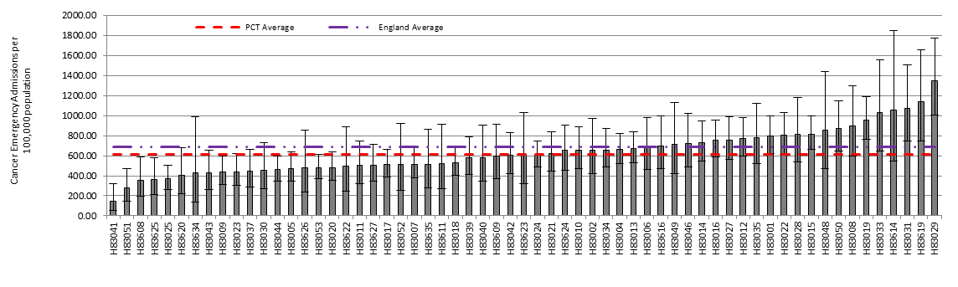

**Source: Practice Profiles, NHS Cancer Commissioning Toolkit.**

The lowest admission rate is 146.88 per 100,000 population (95%CI 53.63 – 319.70) at practice H83041. This rate is also significantly lower than the PCT average. A further three GP practices record cancer admission rates significantly below the PCT average; they are H83051, H83625 and H83025. One GP practice records less than five admissions over 2008-09.

### Kingston

Five GP practices, H84015, H84049, H84607, H84053 and H84033 record an all cancer emergency admission rate that is significantly higher than the PCT average which is calculated at 506.50 per 100,000 population (95%CI 472.50 – 542.27). The highest rate is 1359.91 per 100,000 (95%CI 1090.65 – 1675.48) at practice H84015 (Figure 35).

Figure 35: Kingston all cancer emergency admissions crude rate per 100,000 population.

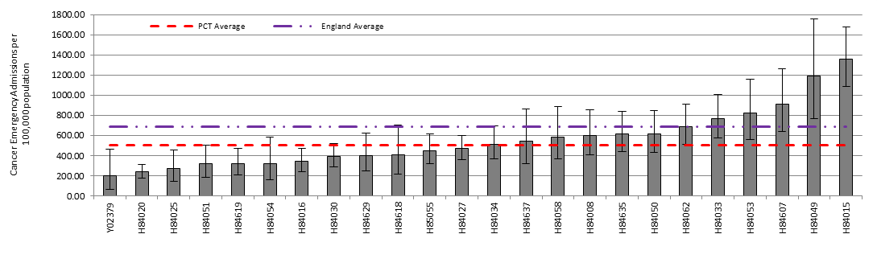

**Source: Practice Profiles, NHS Cancer Commissioning Toolkit.**

The lowest admission rate is 200.32 per 100,000 population (95%CI 64.56 – 467.48) at practice Y02379. This rate is also significantly lower than the PCT average. A further three GP practices record cancer admission rates significantly below the PCT average; they are H84020, H84025 and H84619. One GP practice records less than five admissions in 2008-09.

### Richmond & Twickenham

Richmond & Twickenham has an average cancer admission rate of 536.97 per 100,000 population (95%CI 505.10 – 570.33) (Figure 36). Four GP practices record admission rates significantly higher than the PCT average. These practices include; H84060, H84018, H84031 and H84032. The highest admissions rate was 1272.17 per 100,000 population (95%CI 993.53 – 1604.70) at practice H84060.

Figure 36: Richmond & Twickenham all cancer emergency admissions crude rate per 100,000 population.

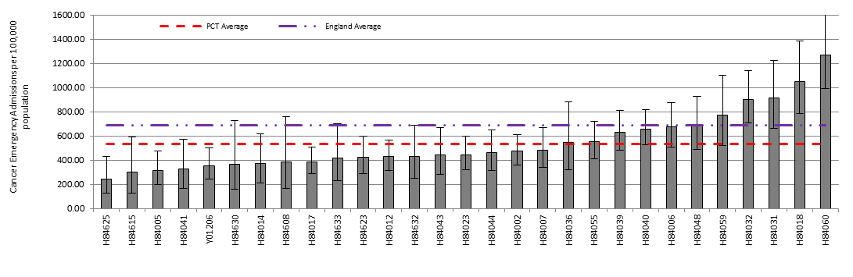

**Source: Practice Profiles, NHS Cancer Commissioning Toolkit.**

The lowest admission rate was 246.36 per 100,000 population (95%CI 127.15 – 430.36) at practice H84625. This rate was significantly lower than the PCT average. Two other GP practices also record an admission rate significantly below the PCT average; they are H84005 and Y01206. Two GP practices recorded less than five admissions.

### Sutton & Merton

Figure 37 shows the variation in cancer emergency admissions by GP practice across Sutton & Merton PCT. The highest admission rate was 1858.19 per 100,000 population (95%CI 1314.79 – 2550.60) at practice H85108 and is significantly higher than the PCT average (634.87 95%CI 609.88 – 660.63). A further seven GP practices record admission rates significantly higher than the PCT average. They are practices H85110, H85683, H85032, H85653, H85038, H85030, and H85037.

Figure 37: Sutton & Merton all cancer emergency admissions crude rate per 100,000 population.

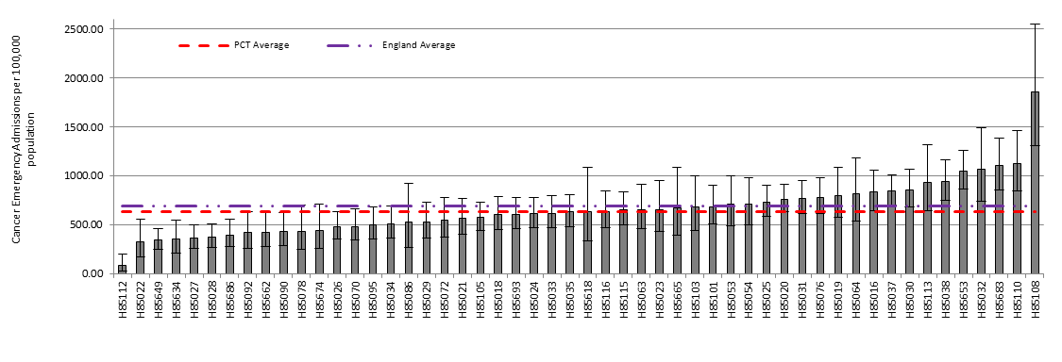

**Source: Practice Profiles, NHS Cancer Commissioning Toolkit.**

The lowest admission rate was 88.42 per 100,000 population (95%CI 28.49 – 206.34) at practice H85112. This rate was also significantly lower than the PCT average. Six other GP practices record cancer admission rates significantly below the PCT average; they are, H85022, H85649, H85634, H85027, H85028 and H85686. One GP practice records less than 5 emergency admissions in 2008-09.

### Wandsworth

Wandsworth has an average cancer admission rate of 443.07 per 100,000 population (95%CI 420.53 – 466.51). Six GP practices record admission rates significantly higher than the PCT average (Figure 38). These practices include; H85006, H85643, H85005, H85067, H85008 and H85045. The highest admissions rate was 840.49 per 100,000 population (95%CI 615.29 – 1121.13) at practice H85006.

Figure 38: Wandsworth all cancer emergency admissions crude rate per 100,000 population.

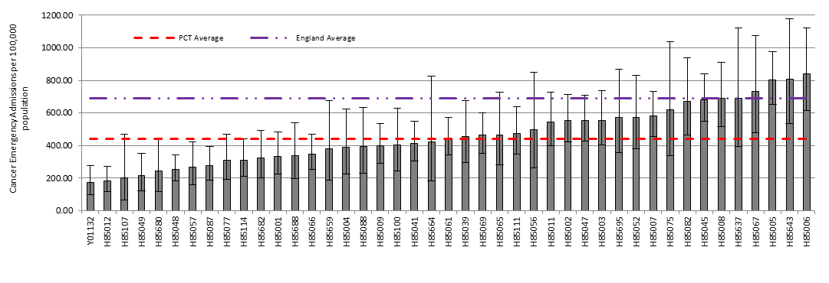

**Source: Practice Profiles, NHS Cancer Commissioning Toolkit.**

Two GP practice recorded no emergency admissions for 2008-09. The lowest rate was 171.56 per 100,000 population (95%CI 98.00 – 278.63) at practice Y01132. This rate was significantly below the PCT average. Four other practices, H85012, H85049, H85680 and H85048 also recorded an emergency admission rate below the PCT average.

## Female Breast cancer emergency bed days by PCT and Cancer Network 2007-08

PCTs, supported by cancer networks, should ensure that emergency bed usage is minimised by the provision of individualised patient care, including a specialist out of hours service and effective community support. This indicator, which measures the number of emergency bed days for cancer per head of unified weighted population, is an indicator for local action in the “Vital Signs”.

Compared to all the cancer networks in London the SWLCN records the highest number of emergency bed days per 100,000 weighted population at 281 per 100,000 for breast cancer (Figure 39). The SWLCN sector also records the highest emergency bed days for lung and colorectal cancer. Split by PCT reveals a large variation between areas with Sutton & Merton at 431 per 100,000 showing a rate more than double the national average and much higher compared to the other PCTs in SWL. The next highest PCT is Kingston with 300 bed days per 100,000. All PCTs except Croydon record rates higher than the national average (200). Croydon records 153 bed days per 100,000.

Figure 39: Female breast cancer emergency bed days per 100,000 weighted population, 2007-08.

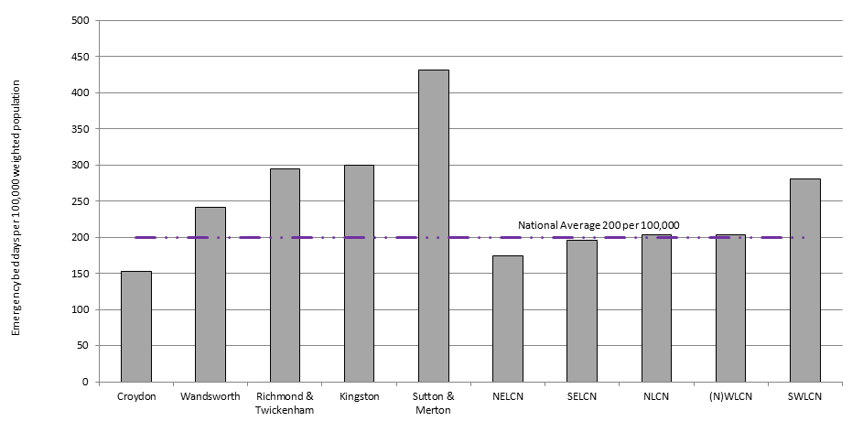

**Source: National Cancer Services Analysis Team (NatCanSAT) from Hospital Episode Statistics (HES).**

# Breast Cancer Referrals

## Urgent two week wait (2WW) referrals with suspected breast cancer 2009 by GP Practice

Patient level Cancer Waiting Times data (including patient identifiers) was sourced from the Department of Health Cancer Waiting Times Database by the Trent Cancer Registry. Each patient was traced to a GP Practice using the Open Exeter Batch Tracing Service. Two Week Wait Referrals were identified for patients with a date first seen on the CWT database in 2009. All records with a ‘Referral Priority Type’ of ‘3’ (Two Week Wait) (excluding patients referred for non-cancer breast symptoms) and a ‘Cancer Referral Type’ of ‘01’ (Suspected Breast Cancer) were included. The data include the number of Two Week Wait referrals with a suspicion of breast cancer, whether or not cancer was subsequently diagnosed. This indicator may be expected to be higher in practices with an unusually high proportion of persons of 65+ years of age, due to the higher incidence of cancer at these ages. In many cases the number of referrals will be small resulting in large confidence intervals. Where the number of referrals for a GP practice was less than 5, no rate has been released nor has the GP practice been identified.

### Croydon

The average 2WW crude referral rate in Croydon for 2009 was 186.53 per 100,000 population (95%CI 172.87 – 200.98) (Figure 40). Three GP practices, H83614, H83035 and H83008, record a referral rate that is significantly higher than the PCT average. The highest referral rate is 617.83 per 100,000 population (95%CI 247.52 – 1273.03) at practice H83614.

Figure 40: Croydon urgent 2WW referrals with suspected breast cancer, crude rate per 100,000 population.

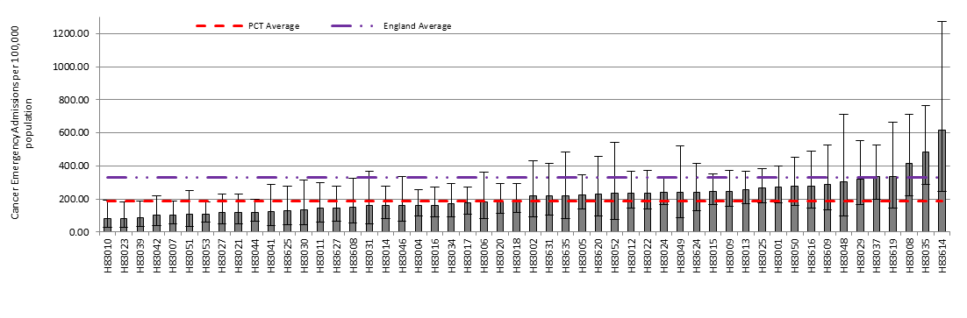

**Source: Practice Profiles, NHS Cancer Commissioning Toolkit.**

Ten GP practices recorded less than 5 referrals in 2009. No GP practice records a referral rate significantly below the PCT.

### Kingston

Four GP practices in Kingston record a suspected breast cancer referral rate that is significantly higher than the PCT average, which is 255.40 per 100,000 population (95%CI 231.44 – 281.16) (Figure 41). The four practices are H84637, H84008, H84034 and H84051. The highest referral rate is 607.72 per 100,000 population (95%CI 371.05 – 938.62) at practice H84637.

Figure 41: Kingston urgent 2WW referrals with suspected breast cancer, crude rate per 100,000 population.

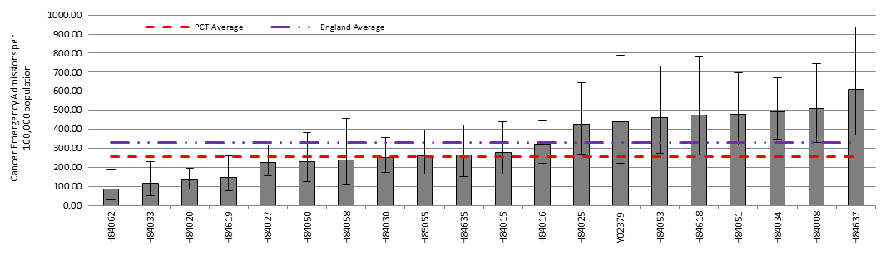

**Source: Practice Profiles, NHS Cancer Commissioning Toolkit.**

Five GP practices record no referrals for 2009, while three other practices record less than 5 referrals. Three practices record a referral rate significantly below the PCT average, these are: H84062, H84033 and H84020.

### Richmond & Twickenham

The average 2WW crude referral rate in Richmond & Twickenham for 2009 was 292.85 per 100,000 population (95%CI 269.43 – 317.75) (Figure 42). Two GP practices, H84060 and H84048, record a referral rate that is significantly higher than the PCT average. The highest referral rate is 627.13 per 100,000 population (95%CI 436.75 – 872.21) at practice H84060.

Figure 42: Richmond & Twickenham urgent 2WW referrals with suspected breast cancer, crude rate per 100,000 population.

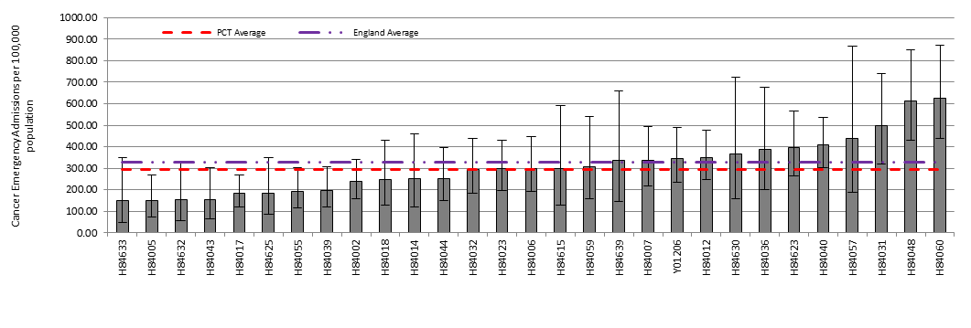

**Source: Practice Profiles, NHS Cancer Commissioning Toolkit.**

Two GP practice record less than five referrals in 2009. There were no GP practices recording a referral rate below the PCT average.

### Sutton & Merton

Ten GP practices in Sutton & Merton record a suspected breast cancer referral rate that is significantly higher than the PCT average, which is 321.88 per 100,000 population (95%CI 304.15 – 340.37) (Figure 46). The ten practices are H85018, H85019, H85105, H85030, H85021, H85025, H85076, H85116, H85693 and H85033. The highest referral rate is 792.63 per 100,000 population (95%CI 615.48 – 1004.87) at practice H85018.

Figure 43: Sutton & Merton urgent 2WW referrals with suspected breast cancer, crude rate per 100,000 population.

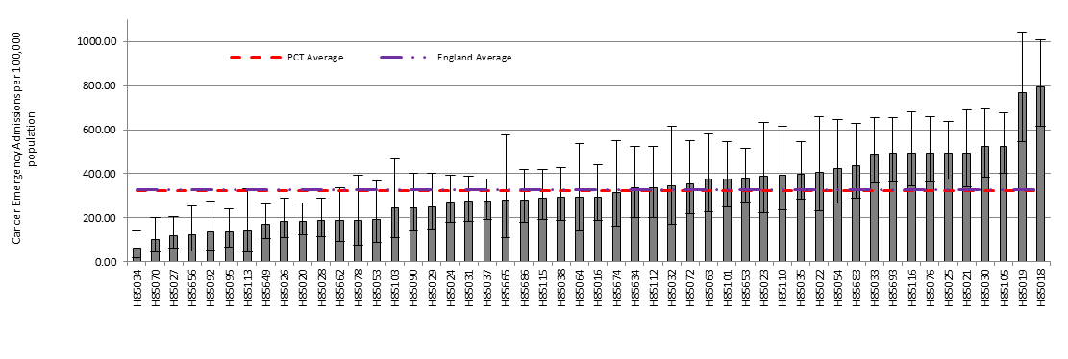

**Source: Practice Profiles, NHS Cancer Commissioning Toolkit.**

Three GP practices in Sutton & Merton recorded less than five suspected breast cancer referrals in 2009. Ten GP practices record a referral rate significantly below the PCT average. The ten practices are: H85034, H85070, H85027, H85656, H85092, H85095, H85649, H85026, H85020, and H85028.

### Wandsworth

The average 2WW crude referral rate in Wandsworth for 2009 was 258.00 per 100,000 population (95%CI 240.86 – 276.03) (Figure 44). Three GP practices, H85006, H85048 and H85005, record a referral rate that is significantly higher than the PCT average. The highest referral rate is 676.05 per 100,000 population (95%CI 475.93 – 931.87) at practice H85006.

Figure 44: Wandsworth urgent 2WW referrals with suspected breast cancer, crude rate per 100,000 population.

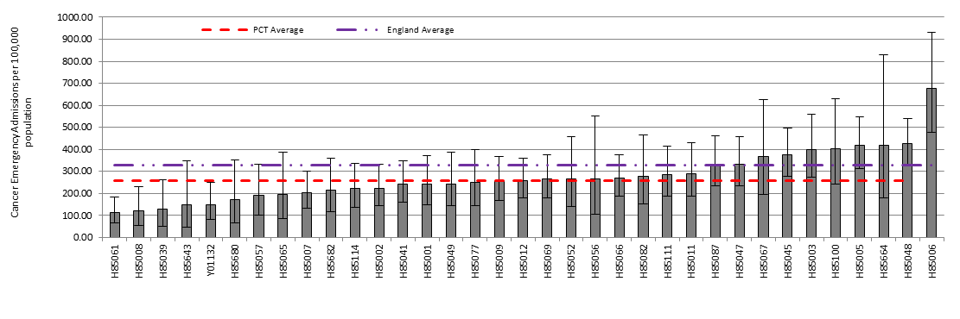

**Source: Practice Profiles, NHS Cancer Commissioning Toolkit.**

One GP practice, recorded zero referrals for 2009, while nine GP practices record less than five referrals for the year. Two GP practice record referral rates significantly below the PCT average. They are H85061 (113.60 per 100,000 95%CI 64.89 – 184.50) and H85008 (112.05 per 100,000 95%CI 55.69 – 231.71).

## Proportion of cases diagnosed through non-urgent referral by PCT and Cancer Network 2010

In general, the earlier a cancer is diagnosed, the greater the prospect of a cure. Evidence suggests that later diagnosis of cancer has been a major factor in the poorer survival rates in the UK compared with some other countries in Europe. One of the priorities of the Cancer Reform Strategy for England is to diagnose more cancers early. The proportion of cases of cancer diagnosed through the two week wait programme (2WW) is an indicator of GPs' recognition of the signs and symptoms of cancer and appropriateness of the referral. There is wide variation across the country in the percentage of cases diagnosed through non-urgent referral routes. If relatively high numbers of patients are diagnosed through non-urgent referrals, this would merit investigation by the PCT (Cancer Commissioning Toolkit 2010).

Figure 45: Percentage of total breast cancer cases diagnosed through non-urgent referral, 2010.

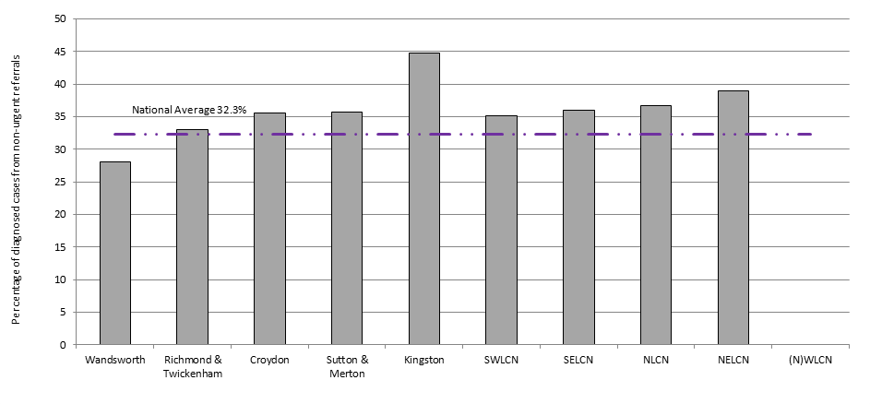

**Source: National Cancer Waiting Times database (CWT-db).**

Kingston records the highest proportion of diagnosed non-urgent breast cancer referrals at 44.7% (Figure 45). This is very high relative to the national average and other PCTs in SWL. Sutton & Merton has the next lowest proportion at 35.7% which is ranked just above the lower quartile for the national range of proportions. Wandsworth records the lowest proportion of non-urgent referrals at 28.1%. The SWLCN has the lowest proportion of non-urgent referrals in London at 35.2%; however this is still above the national average of 32.3%. There was no data available for the (N) WLCN.

## Urgent 2 week referrals resulting in female breast cancer diagnosis (‘The Hit Rate’) by PCT and Cancer Network 2010

Figure 46 shows the percentage of suspected breast cancer referrals that result in an actual diagnosis of breast cancer.

The proportion of cases of cancer diagnosed through the two week wait programme (2WW) is an indicator of GPs’ recognition of the signs and symptoms of cancer and appropriateness of the referral.

Overall a low proportion of cancer diagnoses are made through the 2 week wait (2WW) referral process, 11.9% nationally (Figure 46). In SWL 12.8% of 2WW referrals resulted in a breast cancer diagnosis, the highest in London. Within the SWLCN, Croydon PCT records the highest percentage of referrals resulting in breast cancer at 15.9%, while Richmond & Twickenham records the lowest at 9.6%. The ‘Hit Rate’ in Richmond & Twickenham is within the lower quartile of the range of proportions across all PCTs.

Although not a Department of Health standard, this metric demonstrates the percentage of two week referrals (TWR) found to have cancer, and may be indicative of the quality of service provided by local organisations. If the benchmarked data show the organisation within the lower quartile (i.e. a smaller proportion of patients referred as TWR are diagnosed with cancer than other organisations) then questions could be asked about the interpretation of the TWR NICE Referral Guidelines by primary care. In addition local secondary care teams could be asked to audit the appropriateness of all TWR referrals received (NHS Cancer Commissioning Toolkit 2010).

Figure 46: Percentage of urgent female breast cancer referrals diagnosed with breast cancer.

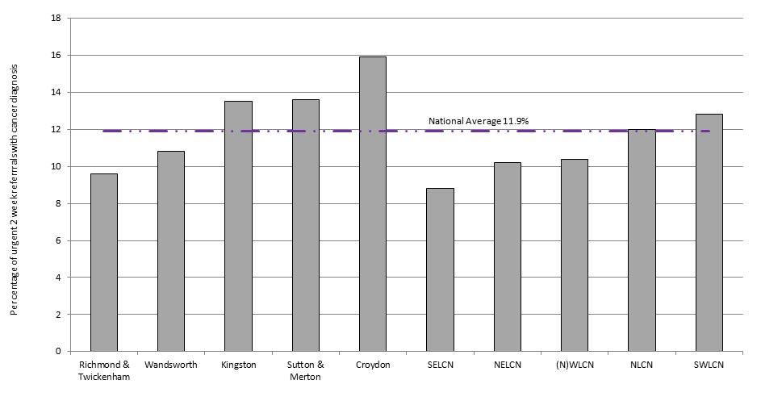

**Source: National Cancer Waiting Times database (CWT-db).**

# Primary Care Audit 2010

The Cancer Reform Strategy 2007 proposed undertaking a national audit in primary care of newly-diagnosed cancers, to inform decisions about how best to support primary care professionals and ensure the earliest diagnosis. During the period April-June 2010 the SWLCN undertook such an audit.

A person’s cancer pathway begins when they recognise and then act on signs and symptoms. A person who has a type of cancer with easily recognisable symptoms will present sooner. For example, breast cancer signs are more recognisable than those of colon cancer. Sometimes, despite recognising symptoms, people are reluctant to present to primary care. The audit covered 39 practices across South West London. One hundred and thirty-seven cases of female breast cancer were found, accounting for 19% of all cancer incidence found in the audit. The majority (54%) of these cases were diagnosed at an early stage (‘Organ’). Just over a third (35%) of cases had been diagnosed at a ‘local spread’ stage while only 3 cases were ‘Not known’ or ‘Not stated’. Nine percent (12 cases) were diagnosed at a stage of ‘distant metastases’. Due to small numbers, the findings presented here are a mixture of breast cancer specific figures as well as data and themes generalised for all cancers.

Of all the cancer patients found in the audit 46% (299 cases) were 2 week referrals, which is similar to the average (45%) recorded across England for 2009-10. Fourteen percent (89) were emergency cases and 15% (101) were classed as routine. The number of emergency cases appears excessive (compared to other networks); this may be due to occurrences of patients that did not visit the GP but were admitted to hospital via A&E being recorded as emergency cases. The correct definition in relation to GPs is only those patients that visit the GP and are immediately (same day) referred to the acute trust. Consultation with participating GP practices and the lead GP for the SWLCN audit confirmed this ambiguity had arisen (SWLCN 2010).

Twelve percent (81) were not referred by the practice. Overall 146 cases (22%) were identified as cases where an avoidable delay had occurred.

The median time for patients noticing and reporting symptoms of breast cancer were 9 days, while the time period between reporting symptoms to a GP referral to secondary care was immediate (by fax) with the median time from referral to first visit to secondary care being 13 days. Comparisons with other cancers are shown in Figure 47.

Figure 47: Median times from patients noticing and reporting symptoms to first being seen in secondary care.

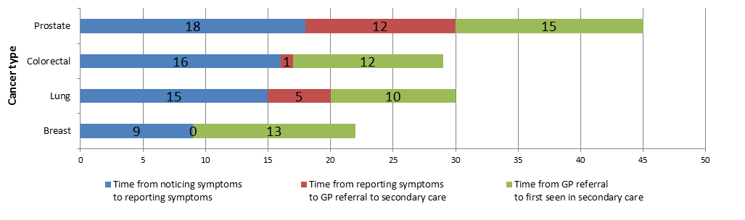

**Source: SWLCN Primary Care Audit 2010.**

## Avoidable delays (all cancers)

GP’s identified **146** cases of avoidable delays as assessed by auditing GP. Of these:

* **31%** (45 cases) due to patient delaying either first presentation, investigation or hospital referral.
* **11%** (16 cases) could have been referred sooner using the 2 week rule.
* **23%** (34 cases) delayed in referral to secondary care, often due to the GP not initially thinking of cancer as a possible diagnosis.
* **9%** (14 cases) delayed due to communication problems between primary and secondary care.
* **18%** (27 cases) delayed after referral to secondary care.
* **7%** (10 cases) delayed due to other causes.

## Breast cancer summary

Ninety-six of the 108 patients presented with a breast lump. Other symptoms that patients presented with were: inverted nipple, breast ache, skin dimpling, chest pain and blood stained discharge from the nipple. Most patients presented within a few days of finding a lump. The two week wait rule was used in all but 6 cases that were instead referred routinely.

One case of breast cancer took 6 months to diagnose (stage: distant metastases) after multiple specialist referrals, recurrent admissions and investigations for an atypical presentation of recurrent abdominal pain. Another case took almost 5 months to diagnose (stage: distant metastases) despite organizing a chest x-ray which returned normal after a patient presented with chest pain.

# Cancer Awareness Measure (CAM) Survey in South West London 2010

Information presented in this section from Ipsos MORI is to be treated as confidential and is subject to copyright. Please see the end of this section in regard of copyright.

This section summarises the findings from research conducted by Ipsos MORI Social Research Institute (2010) and commissioned by the SWLCN on cancer awareness amongst the residents of South West London undertaken between May and August 2010. A total of 5,009 resident people were interviewed across South West London.

The majority of South West London residents report having been affected by cancer in some way, either personally or through friends or family having the disease. One in ten residents (12%) has personally had cancer themselves. Specific groups of residents – particularly women, white residents, those aged 45-54 and those from social grades AB – are particularly more likely to have been affected by cancer. Over half of residents (54%) reported having a close family member having had cancer.

Residents mention a range of possible warning signs and symptoms of cancer, the most commonly mentioned of which is an unusual lump or swelling (59%) (Table 15). This proportion ranged across the PCTs from a high of 67% in Richmond to a low of 52% in Wandsworth. When prompted, an unusual lump or swelling as a warning sign for cancer rose to 94% overall for SWL.

Table 15: Summary of CAM responses (%).

|  |  |  |  |  |  |  |  |  |
| --- | --- | --- | --- | --- | --- | --- | --- | --- |
| Warning Signs of Cancer | | SWL | Croydon | Kingston | Merton | Richmond | Sutton | Wandsworth |
| Unprompted | Unusual lump or swelling | 59 | 60 | 64 | 54 | 67 | 61 | 52 |
| Persistent unexplained pain | 20 | 20 | 22 | 21 | 27 | 13 | 20 |
| Unexplained weight-loss | 18 | 20 | 17 | 15 | 22 | 17 | 15 |
| Loss of appetite | 8 | 7 | 8 | 7 | 11 | 7 | 8 |
| Prompted | Unusual lump or swelling | 94 | 96 | 94 | 90 | 97 | 96 | 91 |
| Persistent unexplained pain | 79 | 79 | 79 | 80 | 81 | 79 | 76 |
| Unexplained weight-loss | 83 | 85 | 81 | 80 | 84 | 85 | 80 |
| On noticing unexplained lump, how long to contact Dr. | | | | | | | | |
|  | 1-3 days | 38 | 45 | 35 | 39 | 37 | 37 | 35 |
|  | 4-6 days | 14 | 11 | 16 | 18 | 14 | 15 | 12 |
|  | 1 week | 21 | 18 | 20 | 20 | 18 | 26 | 25 |
|  | 2 weeks | 14 | 12 | 16 | 14 | 15 | 12 | 14 |
|  | 1 month | 8 | 8 | 9 | 7 | 9 | 6 | 7 |
| How much do you agree or disagree, if at all, that each of these can increase the chance of getting cancer?– - Agree | | | | | | | | |
|  | Smoking | 90 | 90 | 93 | 89 | 92 | 93 | 88 |
|  | Drinking alcohol | 41 | 41 | 42 | 49 | 38 | 36 | 39 |
|  | <5 portions of fruit & veg a day | 39 | 37 | 37 | 41 | 45 | 34 | 39 |
|  | Not doing enough exercise | 38 | 33 | 39 | 41 | 39 | 38 | 41 |
| At what age are women first invited for a breast screen? | | | | | | | | |
|  | 50-53 | 30 | 29 | 31 | 32 | 30 | 36 | 24 |
|  | Within 5 years of correct answer | 8 | 6 | 8 | 10 | 8 | 6 | 10 |

However, the depth of residents’ awareness appears to be quite shallow, with only a relatively small proportion able to identify more than five signs or symptoms of cancer (13%). While prompted awareness of symptoms is significantly higher than unprompted, South West London residents appear to have lower levels of awareness than residents elsewhere in the country. Two fifths of people would contact a GP practice to make an appointment (38%) within 1-3 days of noticing an unexplained lump or swelling, however 8% overall would wait a month.

The majority of South West London residents believe that there is an NHS breast cancer screening programme and an NHS cervical cancer screening programme (78% for both), although these figures are lower than for the country as a whole (87% and 84% respectively). One in twelve (8%) do not think there is a breast screening programme, while one in seven (14%) say they do not know. In contrast, South West London residents are actually more aware of the NHS bowel cancer screening programme than residents across the county. Regardless, knowledge of this screening programme is much lower than for the other programmes (31% compared to 22% nationally). Awareness of the screening programmes appears to be very much linked to personal experience of cancer and relevance (in terms of gender and age). A third of respondents (34%) knew the correct age at which a woman is first invited for breast screening.

In almost identical results to residents across the country as a whole, South West London residents clearly believe that breast cancer is the most common form of cancer among women, with over four in five residents believing this to be true (82%). Few residents highlight other cancers, with breast cancer ten times more likely to be mentioned than the next most popular choice. In reality, the three most common forms of cancer among women in South West London are breast, colorectal (bowel) and lung cancer.

|  |
| --- |
| Legal notice |
| © 2010 Ipsos MORI – all rights reserved.  The contents of this report constitute the sole and exclusive property of Ipsos MORI.  Ipsos MORI retains all right, title and interest, including without limitation copyright, in or to any Ipsos MORI trademarks, technologies, methodologies, products, analyses, software and know-how included or arising out of this report or used in connection with the preparation of this report. No license under any copyright is hereby granted or implied.  The contents of this report are of a commercially sensitive and confidential nature and intended solely for the review and consideration of the person or entity to which it is addressed. No other use is permitted and the addressee undertakes not to disclose all or part of this report to any third party (including but not limited, where applicable, pursuant to the Freedom of Information Act 2000) without the prior written consent of the Company Secretary of Ipsos MORI. |

# Conclusion

## GP practice summaries

**Croydon**

Ten (15.9%) GP practices reached the 70% minimum standard breast screening uptake. The highest uptake was 77% at practices H83040 and H83029. The latter along with practices H83035, H83004 and H83028 were amongst the top 5 performers for uptake and coverage. Seventeen GP practices achieve the 70% national coverage target. Practices H83035 (87.2%) and H83029 (84.0%) both also achieved the highest cervical screening coverage rates in the PCT. Contrastingly the lowest performing GP practices for breast screening uptake were not present in the worst performing for coverage. Practice H83011 had a low screening coverage rate for breast (48.2%) and cervical (63.6%) cancer. The lowest breast screening coverage rate was 40.6% at practice H83634. In total 3 GP practices did not achieve a 50% coverage rate. Seven GP practices recorded all cancer emergency admission rates significantly higher than the PCT average; they were H83029, H83619, H83031, H83033, H83019, H83050 and H83015. Four GP practices recorded emergency admission rates significantly lower than the PCT average; they were H83041, H83051, H83625 and H83025. Three GP practices, H85006, H85048 and H85005, record an urgent two week wait (2WW) referral rate for suspected breast cancer that is significantly higher than the PCT average. The highest referral rate is 676.05 per 100,000 population (95%CI 475.93 – 931.87) at practice H85006.

**Kingston**

Nine (32.1%) GP practices achieve the 70% minimum standard for breast screening uptake. The highest uptake rate was 77% at practice H84618 and the highest coverage rate is 73.6% at practice H84033. Two practices feature amongst the highest for uptake and coverage; they are H84618 and H84042. Eight GP practices reach the 70% coverage rate target. The lowest uptake rate is 50% at practice H84609. They also have the lowest coverage rate at 47.1%. Practice H84629 also has a low uptake (51%) and coverage rate (55.2%) as well as one of the lowest cervical screening coverage rates at 70.2%. Practice H84607 also has the lowest cervical screening coverage rates at 62.7% and one of the lowest breast screening uptake rates at 58%. Five GP practices recorded all cancer emergency admission rates significantly higher than the PCT average; they were H84015, H84049, H84607, H84053, and H84033. Four GP practices recorded rates significantly lower than the PCT average; they were Y02379, H84020, H84025, and H84619. Four GP practices in Kingston record a suspected breast cancer 2WW referral rate that is significantly higher than the PCT average. The four practices are H84637, H84008, H84034 and H84051. The highest referral rate is 607.72 per 100,000 population (95%CI 371.05 – 938.62) at practice H84637. Two GP practices recorded no 2WW referrals for 2009.

**Richmond & Twickenham**

Nine (30.0%) GP practices achieve the 70% minimum standard for breast screening uptake. The highest uptake rate was 75% by practice H84044. Along with practices H84040, H84002 and H84031 these practices achieved the highest uptake and coverage rates for breast screening. The latter two also achieved the highest cervical screening rates at 85.2% and 86.9% respectively. The highest breast screening coverage rate was 75.6% at practice H84002. Ten GP practices achieved the 70% national coverage rate target. The lowest uptake rate was 43% at practice H84608 which also had a low coverage rate at 43.1%. The lowest breast screening coverage was 32.7% at practice H84014. Practices H84608 and H84023 both showed lowest uptake and coverage rates. Practice H84608 also had the lowest cervical coverage rate at 59.6%. Practices H84639 and H84615 has low coverage rates for breast, 51.4% and 51.5% respectively, and cervical at 69.4% and 71.3%. Four GP practices recorded all cancer emergency admission rates significantly higher than the PCT average; they were H84060, H84018, H84031 and H84032. Three GP practices recorded rates significantly lower than the PCT average; they were H84625, H84005 and Y01206. Two GP practices, H84060 and H84048, record a 2WW referral rate that is significantly higher than the PCT average. The highest referral rate was 627.13 per 100,000 population (95%CI 436.75 – 872.21) at practice H84060.

**Sutton & Merton**

Nineteen practices achieve the 70% minimum standard for uptake. The highest uptake rate was 79% at practice H85064. Practices H85662 and H85063 have the highest uptake and coverage rates in the PCT. The practices of H85113 and H85063 have high breast screening coverage rates, 82.9% and 76.3% respectively, as well as high cervical screening rates at 83.0% and 84.5%. Seventeen GP practices achieved the 70% national breast screening coverage rate target. The lowest breast screening uptake rate was 47% at practice H85656. Two practices achieved less than 50% uptake. The practices of H85656 and H85634 both have the lowest uptake and coverage rates. Practice H85634 also has one of the lowest cervical screening rates at 69.0%. The H85090 practice also has one of the lowest breast screening coverage rates at 56.8% and one of the lowest cervical screening rates at 70.3%. Eight GP practices recorded all cancer emergency admission rates significantly higher than the PCT average; they were H 85108, H85110, H85683, H85032, H85653, H85038, H85030, and H85037. Seven GP practices also recorded rates significantly lower than the PCT average; they were H85112, H85022, H85649, H85634, H85027, H85028 and H85686. Ten GP practices in Sutton & Merton record a suspected breast cancer 2WW referral rate that is significantly higher than the PCT average. The ten practices are H85018, H85019, H85105, H85030, H85021, H85025, H85076, H85116, H85693 and H85033. The highest referral rate was 792.63 per 100,000 population (95%CI 615.48 – 1004.87) at practice H85018. Ten GP practices record a 2WW referral rate significantly below the PCT average. These are: H85034, H85070, H85027, H85656, H85092, H85095, H85649, H85026, H85020 and H85028.

**Wandsworth**

Only two GP practices (H85052 and H85039) achieve the 70% minimum standard for breast screening uptake. Four of the practices that achieve top 5 uptake rates feature in the top five coverage rates (the uptake period covers a longer period than the coverage). The practice of H85114 achieves relatively (still below target) high breast screening uptake and coverage as well as high cervical screening coverage. Only one practice achieved the 70% national breast screening coverage target of 70%; this was practice H85039 at 71.8%. The lowest breast screening uptake rate was at practice H85104 at 42%. Eight practices did not reach 50% uptake. The practice of H85065 features in the lowest 5 practices for breast screening uptake and coverage and cervical screening. The practice of H85107 shows lowest breast and cervical screening coverage rates. Six GP practices recorded all cancer emergency admission rates significantly higher than the PCT average; they were H85006, H85643, H85005, H85067, H85008 and H85045. Five GP practices recorded admission rates significantly lower than the PCT average; they were Y01132, H85012, H85049, H85048 and H85087. Three GP practices, H85006, H85048 and H85005, record a 2WW referral rate that is significantly higher than the PCT average. The highest referral rate was 676.05 per 100,000 population (95%CI 475.93 – 931.87) at practice H85006. One GP practice, H85688 recorded zero referrals for 2009. Two GP practices recorded 2WW referral rates significantly below the PCT average, practices H85061 and H85008.

## PCT summaries

Detailed figures of each PCT are shown in the matrix below (Figure 48).

**Croydon**

In the UK the highest incidence of breast cancer occurs in the 50-64 years old age group. Croydon has the largest proportion of this age group in SWL, accounting for one in every six females. It does not have the highest 65+ proportional population. Croydon has the largest non-white resident female aged 55 years and older population in SWL at 23.5%.

While this population group is less likely to suffer from breast cancer compared to white women, if they do suffer their survival rates are significantly lower than white women (3-year survival). In 2008-09 the breast screening coverage rate rose above the national target to 71.5% overall for the PCT. There are more areas of high deprivation in Croydon compared to other PCTs in SWL and therefore we may expect to see lower breast cancer incidence in Croydon (inverse relationship between deprivation and incidence). This is not the case since it experiences the highest age standardised under 75 years old incidence rate in SWL (2004-06) at 110.26 per 100,000. Besides Sutton & Merton, Croydon has the lowest proportion of breast cancers diagnosed at stage 1 (26.8%), however just over half are not staged by the Thames Cancer Registry (TCR). It is possible that a large proportion of the TCR non-staged tumours in reality were stage 1 tumours since the PCT has the highest one-year relative survival rate in SWL at 96.1%. Just under 18% of tumours were diagnosed at stage 3. Proportions of this magnitude diagnosed at stage 3 are seen across the PCTs of SWL. Croydon’s one-year survival rate is above the EUROCARE-4 study “Average” benchmark while the possible range of survival encompasses the “Good Practice” benchmark at 97.0%. While incidence is the highest in SWL, premature death (under 75) is significantly lower than the national average at 16.16 per 100,000. Croydon also performs well on emergency bed days, with the lowest rate in SWL at 153 per 100,000. The crude rate for all cancer emergency admissions was 610.41 per 100,000 population. There were 35.6% of diagnosed breast cancer cases that were considered to be non-urgent, above the national average. The urgent 2WW crude referral rate in Croydon for 2009 was 186.53 per 100,000 population. The PCT records the highest proportion (15.9%) of urgent referrals that result in a cancer diagnosis, showing that the quality of service provided is better than other PCTs in SWL, since overall SWL performs below the national average.

**Kingston**

Examination of the matrix below (Figure 48) shows that Kingston appears as not the worst or best performing PCT in the sector. Kingston has a similar proportion of 50-64 year olds in its female population as Croydon, Richmond & Twickenham and Sutton & Merton with 16.4% in this age group. Only around 10% of the 55 and over female population is non-white. Kingston is among the least deprived areas in SWL.

As a PCT, Kingston records the highest screening coverage rate in the sector at 72.7%. The PCT has achieved the target for the past 2 years (2007-09), increasing from a very low average of 59.7%. However for the same period (2008-09) twenty (71%) GPs are still not achieving the 70% coverage. The age standardised under 75 years incidence is 102.02 per 100,000, which is comparable to the London and England averages. Forty percent of breast cancer tumours were diagnosed at stage 1, the highest PCT in SWL. Despite this and its affluence the one-year relative survival rate is 94.1%, one of the lowest in SWL and is below the EUROCARE-4 study “Good Practice” benchmark of 97.0%. Also it is only slightly higher than the “Average” benchmark at 93.8%. A high 17.7% of tumours are staged at stage 3, while 37.6% were not staged by the TCR. The premature mortality rate is one of the lowest (after Croydon) in SWL at 15.96 per 100,000 but the confidence intervals are wide meaning the true value could range between 10.49 and 21.44 per 100,000. The emergency bed day rate is higher than the national average (200) at 300 per 100,000. The crude rate for all cancer emergency admissions was 506.50 per 100,000 population. Nearly half (44.7%) of Kingston’s diagnosed breast cancer cases were non-urgent referrals. The urgent 2WW crude referral rate in Kingston for 2009 was 255.40 per 100,000 population. Kingston also had a relatively high proportion of urgent 2 week referrals resulting in a breast cancer diagnosis, 13.5% compared to the national average of 11.9%.

**Richmond & Twickenham**

The PCT has s similar proportion (of total female population), 16.5%, of 50-64 year olds as Sutton & Merton, Kingston and Croydon. Richmond & Twickenham has the lowest 55 years old and over non-white population, one in every 15 women.

Similarly to Kingston the PCT has achieved the 70% target for breast screening coverage for the last 2 years (2007-09), rising from 66.5% in 2006-07. Despite this, thirty-seven (71.0%) GP practices are not reaching the 70% coverage target. The PCT has one of the highest age standardised under 75 years incidence at 108.37 per 100,000, following the paradigm of higher incidence rates in more affluent areas. Richmond & Twickenham is the least deprived PCT in SWL. Richmond & Twickenham records the highest proportion of tumours at stage 1, 41.4%. It also records the second highest proportion at stage 3, 19.3%. These higher proportions are likely due to the fact the PCT records the lowest TCR non-staged proportion at 34.3%. The one-year relative survival rate is 95.4% with the possible true value ranging across both the “Average” (93.8%) and “Good Practice” (97.0%) benchmarks of the EUROCARE-4 study. The under 75 years old mortality is at a rate of 18.80 per 100,000, which is middle ranked in SWL. The confidence intervals range across the London and England averages. Continuing the higher trend across SWL, Richmond & Twickenham has an emergency bed day rate that is higher than the national average (200) at 295 per 100,000. The crude rate for all cancer emergency admissions was 536.97 per 100,000 population. Thirty-three percent of diagnosed breast cancer cases were non-urgent referrals. The urgent 2WW crude referral rate in the PCT for 2009 was 292.85 per 100,000 population. Only 9.6% of urgent 2 week referrals resulted in a breast cancer diagnosis, the lowest in SWL. This figure is in the lowest quartile indicating a possible need to investigate the primary care interpretation of the TWR NICE Referral Guidelines by primary care.

**Sutton & Merton**

Similarly to the other boroughs in SWL (except Wandsworth) Sutton and Merton has a 50-64 year old population of around 15.5%-16.5% of the total female population. Fifteen percent of the females population aged 55 and over is non-white.

The breast screening coverage target (70%) has been achieved over the last 2 years with the 2008-09 rate at 72.0%. This has increased from 66.5% in 2006-07. The age standardised under 75 years incidence is significantly lower than the England average. The TCR could not stage nearly two-thirds of breast cancer tumours in Sutton & Merton resulting in low proportions in each staging group; 19.5% stage 1 and 11.5% at stage 3. The one-year relative survival rate is lowest in SWL at 94.0%. The possible range of the true value may include the “Average” EUROCARE-4 study benchmark but is below the “Good Practice” benchmark of 97.0%. The premature (under 75) mortality rate from breast cancer is the second highest (after Wandsworth) in the sector at 20.41 per 100,000. The PCT has the highest rate of emergency bed days at 432 per 100,000 in SWL and is more than double the national average at 200. The crude rate for all cancer emergency admissions was 634.87 per 100,000 population. The proportion of diagnosed breast cancer cases that were non-urgent referrals was 35.7%, 5% higher than the national average. The urgent 2WW crude referral rate in Sutton & Merton for 2009 was 321.88 per 100,000 population. Finally 13.6% of urgent 2 week referrals resulted in a breast cancer diagnosis, above the national average of 11.9%.

**Wandsworth**

Wandsworth has the youngest population in SWL, with only 11.1% of the female population aged 50-64 years. However over the next 20 years Wandsworth experiences the largest proportional increase in SWL in this age group, rising to 14.1% of the total female population of the borough. The 65 and over female population is not projected to increase in proportion at all during this period. Wandsworth has a high proportion of non-white female population aged 55 and over, accounting for 22.7% of the total female population of the borough.

It is the only PCT in SWL that does not reach the national screening coverage target, recording 63.5% in 2008-09. However this has increased from 60.2 in 2007-08. Reflecting this only one GP (from 46) records coverage above the target at 71.8%. The age standardised under 75 years incidence is 107.46 per 100,000. Only 35.6% of tumours were not staged by the TCR. Consequently higher proportions are seen in each group. Wandsworth shows the highest proportion for stage 3 diagnoses at 19.8% and a higher proportion at stage 1, 39.9%. The one-year relative survival rate is 95.6%, second to only Croydon in SWL. The confidence intervals range over both the “Average” EUROCARE-4 study benchmark at 93.8% and the “Good Practice” benchmark at 97.0%. The under 75 years old mortality is 21.09 per 100,000 and is the highest in SWL, however the confidence intervals are wide and range across the London and England averages. Emulating other PCTs in SWL, Wandsworth also has a higher than national average (200) emergency bed day rate at 242 per 100,000. The crude rate for all cancer emergency admissions was 443.07 per 100,000 population. Only 28.1% of diagnosed breast cancer cases in Wandsworth were non-urgent referrals, considerably lower than any other PCT in SWL. The urgent 2WW crude referral rate in Kingston for 2009 was 258.00 per 100,000 population. The proportion of urgent 2 week wait referrals that resulted in a breast cancer diagnosis was 10.8%.

Figure 48: Matrix of key female breast cancer figures for the PCTs of South West London.

|  |  |  |  |  |  |  |  |  |
| --- | --- | --- | --- | --- | --- | --- | --- | --- |
|  | Croydon | Kingston | Richmond & Twickenham | Sutton & Merton | | Wandsworth |  | |
| 50-64 years as % of PCT female population (2010) | 16.6% | 16.2% | 16.5% | 15.5% (Merton) | 16.5% (Sutton) | 10.9% |  |  |
| 65+ years as % of PCT female population (2010) | 14.1% | 13.4% | 13.5% | 13.4% (Merton) | 15.1% (Sutton) | 9.1% |  |  |
| % of small areas (LSOA) classed as lowest deprivation (2007) | 33% | 5% | 4% | 15% | | 29% | Lowest | Highest |
| Breast screen coverage (2008-09) | 71.5% | 72.7% | 70.2% | 72.0% | | 63.5% | Highest in sector | Not reaching national target |
| Coverage by GP practice - % not reaching 70% target (2008-09) | 73.8% | 71.4% | 71.0% | 68.5% | | 97.9% |  | Only 1 practice reaching 70% target |
| Female Under 75 Incidence (2004-06) | 110.26 | 102.02 | 108.37 | 87.13 | | 107.46 | Significantly lower national average | Significantly higher London average |
| Female Staging (2003-07) | Stage 1: 26.8% Stage 3: 17.6%  Stage 4: 3.3% NK: 52.2% | Stage 1: 40.6% Stage3: 17.1% Stage 4: 3.26% NK: 37.55% | Stage 1: 41.4% Stage 3: 19.3% Stage 4: 4.7% NK: 34.3% | Stage 1: 19.5% Stage 3: 11.5% Stage 4: 4.5% NK: 64.2% | | Stage 1: 39.9% Stage 3: 19.8% Stage 4: 3.4% NK: 35.6% |  |  |
| 1-year survival (2002-07) | 96.1% | 94.1% | 95.4% | 94.0% | | 95.6% | CIs within range of EUROCARE “Good Practice” | CIs below range of EUROCARE “Good Practice” |
| 5-year survival (1998-02) | 79.90% | 82.30% | 81.10% | 80.50% | | 78.70% | Highest | Lowest |
| Female Under 75 mortality (2006-08) | 16.16 | 15.96 | 18.80 | 20.41 | | 21.09 | Significantly lower national average |  |
| 50-69 years % Decrease mortality (1995-2008) | 44.5% | 57.9% | 47.4% | 29.0% | | 21.1% | Highest decrease | Lowest decrease |
| Emergency Bed Days per 100,000 (2007-08) | 153 | 300 | 295 | 431 | | 242 |  | Higher than national average |
| Average all cancer emergency admission crude rate per 100,000 (2008-09) | 610.41 | 506.50 | 536.97 | 634.87 | | 443.07 |  |  |
| 2WW breast cancer referral rate per 100,000 (2009) | 186.53 | 255.40 | 292.85 | 321.88 | | 258.00 |  |  |
| % of cases diagnosed through non-urgent referrals (2010) | 35.6% | 44.7% | 33.0% | 35.7% | | 28.1 | Lowest | Highest |
| % urgent 2 week wait referrals resulting in cancer diagnosis (2010) | 15.9% | 13.5% | 9.6% | 13.6% | | 10.8% | Higher than national average |  |

## South West London Cancer Network specific summary

Overall a high percentage of tumours were not staged by the TCR, therefore it is not possible to comment on the relationship between staging and survival rates. Over a half of tumours were not staged by the TCR for the SWLCN. The SWLCN does have the highest one-year relative survival rate in London at 95.1%. Confidence intervals range over the EUROCARE-4 study benchmarks of “Average” 93.8% and “Good Practice” 97.0%. While the 5-year survival rate is the highest in London it is still below the national average. Reflecting the picture in nearly all PCTs, the SWLCN has the highest (281 per 100,000) emergency bed day use in London which is 40% higher than the national average. The SWLCN has the lowest proportion of cases diagnosed through non-urgent referrals at 35.2%. Finally just over one in eight suspected cancer urgent 2 week referrals result in a breast cancer diagnosis. The overall 2WW referral rate per 1,000 women was 6.61.

Overleaf is a matrix summarising the key statistics for breast cancer in the South West London Cancer Network.

Figure 49: Matrix of key breast cancer figures for South West London Cancer Network.

|  |  |  |  |  |  |  |  |
| --- | --- | --- | --- | --- | --- | --- | --- |
|  | SWLCN | NELCN | NLCN | (N)WLCN | SELCN |  |  |
| Female Staging (2003-07) | Stage 1: 22.8% Stage 3: 14.4% Stage 4: 3.6% NK: 53.1% |  |  |  |  |  |  |
| 1-year prevalence (2006) | 106.6 | 92.8 | 89.2 | 99.5 | 107.6 | Lowest | Highest |
| 1-year survival (2002-07) | 95.1% | 91.4% | 93.8% | 93.5% | 94.8% | CIs within range of EUROCARE “Good Practice” | CIs below range of EUROCARE “Good Practice” |
| Five-year survival | 81.9% | 76.9% | 78.6% | 78.9% | 80.1% |  | Lower than national average |
| Emergency Bed Days per 100,000 (2007-08) | 281 | 174 | 203 | 204 | 196 | Lower than national average | Higher than national average |
| % of cases diagnosed through non-urgent referrals (2010) | 35.2% | 38.9% | 36.7% | - | 36.0% | Lowest | Highest |
| % urgent 2 week wait referrals resulting in cancer diagnosis (2010) | 12.8% | 10.2% | 12.0% | 10.4% | 8.8% | Higher than national average |  |

## Recommendations

* Improve screening rates across the sector particularly targeting eligible women at practices where coverage rates are low.
* Work to improve one-year survival rate in Sutton & Merton and Kingston.
* Investigate the relatively low decrease in breast cancer mortality (50-69 years old) in Sutton & Merton and Wandsworth, particular the spike in mortality from 2007 to 2008 in Wandsworth.
* Investigate emergency admissions in Kingston, Richmond & Twickenham, Sutton & Merton and Wandsworth, the emergency bed day rates are above the national average in these PCTs.
* Review the proportion of diagnosed cancer cases referred through a non-urgent route in Croydon, Kingston, Richmond & Twickenham and Sutton & Merton.
* Investigate the interpretation of the NICE Referral Guidelines for breast cancer by primary care at Wandsworth and Richmond & Twickenham (Proportion of urgent 2 week referrals resulting in cancer diagnosis is low).
* Local secondary care teams to consider auditing the appropriateness of all breast cancer urgent 2 week referrals received from Wandsworth and Richmond & Twickenham (Proportion of urgent 2 week referrals resulting in cancer diagnosis is low).
* Implement the recommendations of the Primary Care Audit of Cancer.
* Implement social marketing strategy resultant from the results of the CAM survey.

# References

[Baan R](http://www.ncbi.nlm.nih.gov/pubmed?term=%22Baan%20R%22%5BAuthor%5D), [Straif K](http://www.ncbi.nlm.nih.gov/pubmed?term=%22Straif%20K%22%5BAuthor%5D), [Grosse Y](http://www.ncbi.nlm.nih.gov/pubmed?term=%22Grosse%20Y%22%5BAuthor%5D) et al. (2007). *Carcinogenicity of alcoholic beverages*. [Lancet Oncol.](javascript:AL_get(this,%20'jour',%20'Lancet%20Oncol.');) 2007 Apr;8(4):292-3.

Ballard-Barbash R et al. (2006). *Obesity and body composition New York.* In: Schottenfeld D, Fraumeni J. eds. C*ancer epidemiology and prevention, 3rd edition*. New York, Oxford University Press: 422-448.

Bissonauth V, Shatenstein B, Fafard E et al. (2009). ***Weight History, Smoking, Physical Activity and Breast Cancer Risk among French-Canadian Women Non-Carriers of More Frequent BRCA1/2 Mutations.*** Journal of Cancer Epidemiology Print, 2009, vol./is. 2009/(748367), 1687-8558;1687-8566 (2009).

Boffetta P, Hashibe M (2006). *Alcohol and cancer.**Lancet Oncol* 2006, **7:**149-156.

Bowen RL, Duffy SW, Ryan DA et al. (2008).  ***Early onset of breast cancer in a group of British black women.*** British Journal of Cancer.  2008:98:277-81.

Boyle P et al. (2003). *European Code Against Cancer and scientific justification: third version (2003).* *Ann Oncol*, 14(7):973-1005.

Breasting Screening Unit (2010). Correspondence date 1st September 2010 with Martin Brealey, Programme Manager, South West London Breast Screening.

Brewster DH (2010). *Survival is multifactorial*. BMJ 2010; 341:c5133

Brown SBF, Hole DJ, Cooke TG (2006). *Breast cancer incidence trends in deprived and affluent Scottish women.* Breast Cancer Res Treat (2007) 103:233–238 DOI 10.1007/s10549-006-9361-2.

Centers for Disease Control and Prevention (2004). *Alcohol—attributable deaths and years of potential life lost— United States, 2001. MMWR Morb Mortal Wkly Rep* 2004; **53:** 866–70.

Conlon MS, Johnson KC, Bewick MA et al. (2010). ***Smoking (active and passive), N-acetyltransferase 2, and risk of breast cancer.*** Cancer Epidemiology, Apr 2010, vol./is. 34/2(142-9), 1877-783x (2010 Apr).

Crawford SM (2010). *UK cancer survival statistics reflect clinical realities in the NHS*. BMJ 2010; 341:c5134.

Dano H, Andersen O, Ewertz M et al. (2003) *Socioeconomic status and breast cancer in Denmark.* Int J Epidemiol 32:218–224.

Department of Health (2007). *Cancer reform strategy.* London: Department of Health.

|  |
| --- |
| Department of Health (2009). *Cancer Reform Strategy – Achieving local implementation second annual report.* London: Department of Health. |

dos Santos Silva I, Mangtani P, De Stavola BL et al. (2003). *Survival from breast cancer among South Asian and non-South Asian women resident in South East England.* Br J Cancer. 89:508-12.

Enger SM, Ross RK, Paganini-Hill A et al. (2000). *Body size, physical activity, and breast cancer hormone receptor status: results from two case-control studies.* Cancer Epidemiology Biomarkers and Prevention 9, 681-687.

European Union (2006). *Responding to the challenge of cancer in Europe.* Edited by MP Coleman, D-M Alexe, Tit Albreht, Martin McKee. Ljublljana: Institute of Public Health of the Republic of Slovenia.

Grulich AE, Swerdlow AJ, Head J et al. (1992). *Cancer mortality in African and Caribbean migrants to England and Wales*. Br J Cancer. 66:905-11.

Farooq S, Coleman MP (2005). *Breast cancer survival in South Asian women in England and Wales.* J Epidemiol Community Health. 59:402-6.

Faggiano F, Partanen T, Kogevinas M et al. (1997). *Socioeconomic differences in cancer incidence and mortality.* IARC Sci Publ 138:65–176.

Gammon MD, John EM, Britton JA (1998). *Recreational and occupational physical activities and risk of breast cancer.* Journal of the National Cancer Institute 90, 100-11710.1093/jnci/90.2.1009450570.

Hamajima N, Hirose K, Tajima K, et al. (2002). *Alcohol, tobacco and breast cancer—collaborative reanalysis of individual data from 53 epidemiological studies, including 58 515 women with breast cancer and 95 067 women without the disease.* *Br J Cancer* 2002; **87:** 1234–45.

Holmes MD, Chen MY, Feskanich D et al. (2005) *Physical activity and survival after breast cancer diagnosis*. Journal of the American Medical Association 293, 2479 248610.1001/ jama.293.20.247915914748.

[Imperatori](http://thorax.bmj.com/search?author1=A+Imperatori&sortspec=date&submit=Submit) A, [Harrison](http://thorax.bmj.com/search?author1=R+N+Harrison&sortspec=date&submit=Submit) RN,  [Leitch](http://thorax.bmj.com/search?author1=D+N+Leitch&sortspec=date&submit=Submit) DN et al. (2006). *Lung cancer in Teesside (UK) and Varese (Italy): a comparison of management and survival.* *Thorax* 2006;61:232-239 doi:10.1136/thx.2005.040477.

Ipsos MORI Social Research Institute (2010). *Cancer Awareness in South West London.* Report using the Cancer Awareness Measure for the South West London Cancer Network.

Jack RH, Davies EA Møller H (2009).***Breast cancer incidence, stage, treatment and survival in ethnic groups in South East England.***  British Journal of Cancer.  2009 Feb 10;100(3): 545-550.

Keating NL, Cleary PD, Rossi AS et al. (1999). *Use of hormone replacement therapy by postmenopausal women in the United States.* Ann Intern Med 130:545–5538.

Ketcham AS, Sindelar WF (1975) *Risk factors in breast cancer.* Prog Clin Cancer 6:99–114.

London Quality Assurance Reference Centre (2010). NHS London Breast Screening Programme – Annual Results 2008-09.

Longnecker MP (1994). *Alcoholic beverage consumption in relation to risk of breast cancer: meta-analysis and review. Cancer Causes Control* 1994; **5:** 73–82.

McTiernan A (2003). *Behavioural risk factors in breast cancer: can risk be modified?* Oncologist 8, 326-33410.1634/theoncologist.8-4-32612897329.

Nagata C, Mizoue T, Tanaka K (2006). ***Tobacco smoking and breast cancer risk: an evaluation based on a systematic review of epidemiological evidence among the Japanese population.*** Japanese Journal of Clinical Oncology, Jun 2006, vol./is. 36/6(387-94), 0368-2811;0368-2811 (2006 Jun).

National Cancer Intelligence Network. GOING FURTHER ON CANCER WAITS (GFOCWs) A GUIDE, (VERSION 6.7).

National Cancer Intelligence Network (2008). *Cancer Incidence by Deprivation England, 1995-2004.* National Cancer Intelligence Network.

National Cancer Intelligence Network (2009a). *Local Awareness and Early Diagnosis Baseline Assessments: A Guide for Cancer Networks and Primary Care Trusts.* National Cancer Intelligence Network, National Cancer Action team.

National Cancer Intelligence Network (2009b). *Cancer Incidence and Survival By Major Ethnic Group, England, 2002 – 2006.* In collaboration with: Cancer Research UK Cancer Survival Group, London School of Hygiene & Tropical Medicine.

(National Cancer Intelligence Network 2010). Cancer equality measures by PCT – Ethnicity data, Equalities portal. Accessed 11th June 2010, <http://library.ncin.org.uk/equalities/100319atlases/Ethnicity/atlas.html?select=5LG&indicator=i0>

National Cancer Intelligence Network (2010b). *One, Five and Ten Year Cancer Prevalence by Cancer Network, UK, 2006.* London: National Cancer Intelligence Network.

NHS Cancer Commissioning Toolkit (2010). Accessed 09/06/10, <https://www.cancertoolkit.co.uk>

Office of National Statistics 2010). Cancer registration statistics 2007. Access 4th June 2010, <http://www.statistics.gov.uk/StatBase/Product.asp?vlnk=7720&Pos=5&ColRank=1&Rank=160>

Peto R, Lopez AD, Boreham J et al. (2006). [*Mortality from smoking in developed countries 1950-2000.* Second edition](http://www.ctsu.ox.ac.uk/~tobacco/) pg 498, June 2006.

Pieta B, Samulak D, Opala T et al. (2009). ***Women's lifestyle and the risk of breast tumours*.** European Journal of Gynaecological Oncology, 2009, vol./is. 30/2(186-9), 0392-2936;0392-2936 (2009).

Prehn AW, West DW (1998). *Evaluating local differences in breast cancer incidence rates: a census-based methodology (United States).* Cancer Causes Control 9:511–5179.

Ratnasinghe LD, Modali RV, Seddon MB et al. (2010). ***Physical activity and reduced breast cancer risk: a multinational study.*** Nutrition & Cancer, May 2010, vol./is. 62/4(425-35), 0163-5581;1532-7914 (2010 May).

Royal Marsden NHS Foundation Trust (2010). Email correspondence, dated 13/07/10, with David Marwick, Royal Marsden NHS Found Trust.

Reeves, G.K. et al. [*Cancer incidence and mortality in relation to body mass index in the Million Women Study: cohort study.*](http://www.ncbi.nlm.nih.gov/sites/entrez?Db=PubMed&Cmd=ShowDetailView&TermToSearch=17986756) Bmj 2007;335(7630)1134.

Richards MA (2009). *The size of the prize for earlier diagnosis of cancer in England.* British Journal of Cancer (2009) 101, S125 – S129.

Robbins AS, Brescianini S, Kelsey JL (1997) *Regional differences in known risk factors and the higher incidence of breast cancer in San Francisco*. J Natl Cancer Inst 89:960–965.

Rowan S (2007). [*Trends in cancer incidence by deprivation, England and Wales, 1990-2002.*](http://www.library.nhs.uk/booksandjournals/details.aspx?t=%22lung+cancer%22+deprivation&stfo=True&sc=bnj.pub.MED&p=3&sf=srt.unspecified&sfld=fld.any&sr=bnj.pub&did=18092540&pc=10&id=21) Health statistics quarterly / Office for National Statistics, December 2007(24-35), 1465-1645.

Saxton JM (2006). ***Diet, physical activity and energy balance and their impact on breast and prostate cancers.* Nutrition Research Reviews Vol. 19, Iss 2; 197-216.**

Singletary KW, Gapstur SM (2001). *Alcohol and breast cancer: review of epidemiologic and experimental evidence and potential mechanisms.* *JAMA* 2001; **286:** 2143–51.

Smith-Warner SA, Spiegelman D, Yaun SS, et al. (1998). *Alcohol and breast cancer in women: a pooled analysis of cohort studies*. *JAMA* 1998; **279:** 535–40.

Swerdlow AJ, Marmot MG, Grulich AE et al. (1995). *Cancer mortality in Indian and British ethnic immigrants from the Indian subcontinent to England and Wales.* Br J Cancer. 72:1312-9.

SWLCN (2010). *South West London Cancer Network Report of National Primary Care Cancer Audit.* Written by Dr. Assad Pasha and Amanda Cranston.

Terry PD, Goodman M (2006). [*Is the association between cigarette smoking and breast cancer modified by genotype? A review of epidemiologic studies and meta-analysis.*](http://www.library.nhs.uk/booksandjournals/advanced/search.aspx?ItemSubCollection=bnj.ovi.prmz&ItemId=ovid.com:/bib/medline/16614098&Id=28) Cancer Epidemiology, Biomarkers & Prevention, April 2006, vol./is. 15/4(602-11), 1055-9965;1055-9965 (2006 Apr).

Terry PD, Rohan TE (2002). *Cigarette Smoking and the Risk of Breast Cancer in Women: A Review of the Literature*. Cancer Epidemiology, Biomarkers & Prevention, Vol.11 953-971.

Thames Cancer Registry (2009). Data extract provided by the Thames Cancer Registry, December 2009.

Thames Cancer Registry (2010a). Email conversation with Vivian Mak, Information Team Leader, Thames Cancer Registry, dated 7th January 2010.

The Information Centre (2006).Health survey for England 2006 – Volume 1 - Cardiovascular disease and risk factors in adults. Leeds: The NHS Information Centre for health and social care.

The Information Centre (2008). Healthy Lifestyle Behaviours: Model Based Estimates for Primary Care Organisations in England, 2003-2005: User Guide. Accessed 15th June 2010, <http://www.ic.nhs.uk/webfiles/Popgeog/PCO%20User%20Guide.pdf>

The Information Centre (2009a). Health survey for England 2008 – Volume 1 – Physical activity and fitness. Leeds: The NHS Information Centre for health and social care.

The Information Centre (2009b). Statistics on Smoking 2009. Accessed 4th June 2010, <http://www.ic.nhs.uk/statistics-and-data-collections/health-and-lifestyles/smoking/statistics-on-smoking-england-2009>

The Information Centre (2009c). Statistics on Alcohol 2009. Accessed 14th June 2010, <http://www.ic.nhs.uk/statistics-and-data-collections/health-and-lifestyles/alcohol/statistics-on-alcohol-england-2009-%5Bns%5D>

The Information Centre 2010). *Breast Screening Programme, England 2008-09.* Leeds: The Information Centre.

Thomson CS and Forman D (2009). *Discussion Paper. Cancer survival in England and the influence of early diagnosis: what can we learn from recent EUROCARE results?* British Journal of Cancer (2009) 101, S102 – S109

Velikova G, Booth L, Johnston C et al. (2004). ***Breast cancer outcomes in South Asian population of West Yorkshire.*** British Journal of Cancer. 2004 May 17;90(10):1926-32.

Wild SH, Fischbacher CM, Brock A et al. (2006). *Mortality from all cancers and lung, colorectal, breast and prostate cancer by country of birth in England and Wales*, 2001-2003. Br J Cancer. 94:1079-85.

Winter H, Cheng KK, Cummins C et al. (1999). *Cancer incidence in the south Asian population of England (1990-92)*. Br J Cancer. 79:645-54.

# Appendix 1: South West London GLA Projected female population by ethnicity, 2010.

|  |  |  |  |  |  |  |
| --- | --- | --- | --- | --- | --- | --- |
|  |  | Croydon | Kingston | Richmond | Sutton & Merton | Wandsworth |
| Female | All Ethnicities | 174,456 | 78,296 | 94,926 | 195,372 | 150,618 |
| White | 101,608 | 60,272 | 83,555 | 148,995 | 116,585 |
| Black Caribbean | 19,760 | 564 | 403 | 6,222 | 6,368 |
| Black African | 12,092 | 1,123 | 606 | 6,236 | 5,557 |
| Black Other | 7,283 | 655 | 981 | 4,062 | 3,757 |
| Chinese | 1,037 | 1,591 | 764 | 2,241 | 1,563 |
| Asian | 27,649 | 9,016 | 5,443 | 21,050 | 10,869 |
| Other | 5,028 | 5,077 | 3,175 | 6,565 | 5,919 |

**Source: Greater London Authority Ethnic Group Projections 2008 Round, London Plan, Borough.**